Smart Grid Simulation Platform Architecture & Requirements Specification
A Work Product of the SG Simulations Working Group under the Open Smart Grid (OpenSG) Technical Committee of the UCA International Users Group
Version 0.17.1 – April 26, 2012

This document describes requirements for simulation tools and models for use in the SmartGrid domain. Todo…

Acknowledgements
Company | Name | Company | Name
OFFIS | Steffen Schütte | Ghent University | Chris Develder
OFFIS | Martin Tröschel | Ghent University | Kevin Mets
Enernex | Jens Schoene | EPRI | Jason Taylor

Revision History
Revision  Number | Revision  Date | Revision By | Summary of Changes
0.1 | 10-25-11 | S. Schütte | Initial version
0.11 | 11-17-11 | C. Develder | Added Task Variation
0.12 | 02-02-12 | S. Schütte | Extended M&S chapter (partly based on work by Jens Schoene)
0.12.1 | 03-21-12 | J. Taylor | Added outline for chapter 2 “Power System Analysis”
0.14 | 03-22-12 | S. Schütte | Added figure “Time scales of power system dynamics”. Added first elements in chapter 5 “Requirements”. Extended tools section.
0.15 | 04-12-12 | S. Schütte | Added morphological box and function based ontology (section 3.3 3.4)
0.16 | 04-25-12 | J. Taylor | <Jason please describe your changes here>
0.17 | 04-25-12 | J. Schoene | <Jens please describe your changes here>

Contents

1 Introduction 6
1.1 Purpose & Scope 6
1.2 Motivation 6
1.3 Guiding Principles 6
1.4 Acronyms and Abbreviations 8
1.5 Definitions 8
2 Power System Analysis 9
2.1 Planning and Operations 9
2.2 Bulk System Reliability 9
2.3 Distribution System Power Quality 10
2.4 Classical Mitigation Options 10
3 Modeling & Simulation 12
3.1 General Definitions 12
3.2 Domain Specific Terms 13
3.2.1 Scale and representation 13
3.2.2 Observation types 14
3.2.3 Issues 15
3.2.4 Modeling Capabilities 15
3.2.5 Business Domains 16
3.2.6 Formats 16
3.3 Morphological Box 17
3.4 Function based, ontological representation 19
4 Tasks 21
4.1 <Task Name> 21
4.1.1 Variation - <author/contact name> 21
4.2 Evaluation of EV charging strategies 22
4.2.1 Variation – OFFIS, S.Schütte 22
4.2.2 Variation – Ghent University - IBBT, K. Mets, C. Develder 23
5 Modeling & Simulation requirements 24
5.1 Overview 24
5.2 Approach 26
6 State-of-the-Art 28
6.1 Static Power Flow Analysis 28
6.1.1 CIM-Compliant tool chain for Python – OFFIS, S.Schütte 28
6.2 Co-Simulation 28
6.2.1 Agent-based Coordination & Power Systems 28
6.2.2 Communication Networks & Power Systems 28
7 Tools 29
7.1 Simulation frameworks 29
7.2 Power System Simulation 29
7.3 Agent based modeling (ABM) 30
8 Literature 31

Figures
Figure 1: Scale and representation of models 12
Figure 2: Time scales of power system dynamics 13

Tables
Table 1: Observation types (simulation types? Phenomenon types?) and applicable model representations 13
Table 2: Connection types and characteristics 24

Introduction
In the end of 2010 the Open Smart Grid Subcommittee, a member group of the UCA International Users Group, started the OpenSG Simulations Working Group (SimsWG). It is the purpose of the OpenSG Simulations Working Group to facilitate work on the modeling and simulation of modern electric power systems as they evolve to more complex structures with distributed control based on integrated Information and Communication Technologies (ICTs).
The goal of the WG is to develop a conceptual framework and requirements for modeling and simulation tools and platforms, which support this evolution in power system design, engineering, and operation.

Purpose & Scope
This document contains a collection of issues (e.g. “Effect of reverse current flow on protection”) and related requirements that a simulation tool must meet to allow an investigation of the particular issue. Furthermore, for each issue a list of possible, existing simulation tools that (at least partially meet the requirements) are given, based on the professional experience of the person that provided the issue.

Motivation
What’s the big picture/what are the problems the future electricity grid faces? Why do we need simulation?
We need a more sustainable power supply. However, renewable sources are usually highly stochastic and need to be (1) forecasted as good as possible and (2) integrated into the power grid by (a) using storages or (b) making loads flexible. This is a complex control task that employs much monitoring and communication (ICT technology) which needs to be evaluated carefully beforehand (using simulations).

Guiding Principles
The guiding principles represent high level expectations used to guide and frame the development of the functional and technical requirements in this document.
- Openness: The SimsWG pursues openness in design, implementation and access by promoting open source solutions
- ?

Acronyms and Abbreviations
This subsection provides a list of all acronyms and abbreviations used in this document.

DER | Distributed Energy Resource
EV | Electric Vehicle
FACT | Flexible AC-Transimssion System
PEV | Plug-in Electric Vehicle

Definitions
This subsection provides the definitions of all terms used in this document. For terms related to Modeling & Simulation see next chapter.

Consumer | A person (legal) who consumes electricity.
Demand Response | A temporary change in electricity consumption by a demand  resource (e.g. PCT, smart appliance, pool pump, PEV, etc.)  in response to a control signal which is issued.

Power System Analysis
Smart-grid applications offer the potential to increase power system performance through the increased integration of advanced information and control technologies with the power system. While these applications will provide new mechanisms to improve system visibility and controllability, they will not alter the fundamental physical characteristics of the system nor the directive to design and operate a safe, reliable, and efficient power system. As such, modeling and simulation requirement associated with the smart-grid applications should intrinsically be examined in the terms of their benefit or impact on power system performance and reliability.
This section is intended to provide a high level introduction into power system simulation and modeling applications and practices. Although smart-grid technologies will enable two-way flows of both energy and information between the distribution and transmission system, the scale, scope, and operational differences between these domains necessitates separate examination of each in this case.

Planning and Operations
The type of models and simulation analyses to be applied depends in part on the advanced timeframe which system performance is to be studied. In general, planning time frames are typically dictated by the duration of time required to plan, purchase, and install new system assets. The following are a general set of timeframes for power system operations and planning:
- Real-time operations and operations planning ( < 1 year)
- Short-term planning (1-3 years at MV & LV levels and ~1-10 years at HV level)
- Long-term planning (~3, 10+ years)
Overall, planning seeks to ensure the delivery of reliable power to the end-user at minimal cost. Overall encompasses a number of issues requiring various data and simulation needs. Areas addressed including:
- Reliability
- Load Forecasting
- Capacity
- Efficiency
- Economics
- Expansion Planning
- Protection and Insulation Coordination
- Asset Management

Bulk System Reliability
In the context of the bulk power system, the North American Reliability Corporation (NERC) defines reliability as the ability to meet the electricity needs of end-use customers, even when unexpected equipment failures or other factors reduce the amount of available electricity. NERC breaks down reliability into adequacy and security.
Adequacy - The ability of the electric system to supply the aggregate electrical demand and energy requirements of end-use customers at all times, taking into account scheduled and reasonably expected unscheduled outages of system elements.
Security - The ability of the bulk power system to withstand sudden, unexpected disturbances such as short circuits, or unanticipated loss of system elements due to natural or man-made causes.

Distribution System Power Quality
Power quality is generally an end-user driven issue. As such power quality can be defined as “Any power problem manifested in voltage, current, or frequency deviations that results in failure or misoperation of customer equipment [Dugan 2002].” Categories of power quality issues include:
- Voltage regulation/unbalance
- Voltage sags/swells
- Interruptions
- Flicker
- Transients
- Harmonic Distortion
- Frequency Variations
- Noise
Note that interruptions are included here as a power quality issue. Hence, reliability can be considered a power quality issue at the distribution and end-user level. Conversely, power quality issues such as harmonic distortion are starting to become an increasing concern at the bulk system level.

Classical Mitigation Options
A number of options are available to the utilities to ensure system reliability and mitigate power quality issues on their systems. The “classical” mitigation techniques are listed below. Smart grid technologies may be used to (1) improve upon existing techniques by enhancing them with a communication and control layer or (2) open the door for new innovative mitigation options. Some selected examples of classical mitigation options are
- Capacitor banks for Volt/VAr control
- Passive and active filters for harmonic mitigation
- Power converters systems for Volt/VAr control and harmonic mitigation
- Transformer selection to interrupt the flow of zero-sequence harmonics
- Storage to mitigate voltage interruption, voltage sags/swells, and flicker issues
- Adding transformer or replacing existing transformers with larger ones to “firm up” the system and make it less susceptible to power quality issues (harmonics, flicker, sags/swells, etc.)
- Recircuiting the system to mitigate unbalances

Modeling & Simulation
Definition of M&S terms to have a common terminology.
General information about details and specifics of M&S that can be referenced throughout the document to avoid redundancies.

General Definitions
Within this document (and within the scope of the SimsWG) the following definitions are used:
Co-Simulation | The coupling of two or more simulators to perform a joint simulation.
Conceptual model | A conceptual model is "a non-software specific description of the simulation model that is to be developed, describing the objectives, inputs, outputs, content, assumptions, and simplifications of the model." [Ro08 in WTW09]
Model | “An abstract representation of a system, usually containing structural, logical, or mathematical relationships that describe a system in terms of state, entities and their attributes, sets, processes, events, activities and delays.” [Ba05]
Simulation Model | See “Model”
Simulation | “A simulation is the imitation of the operation of a real-world process or system over time.” [Ba05]
Simulator | A computer program for executing a simulation model.

Domain Specific Terms

Scale and representation
In the Smart Grid domain M&S technology is used to analyze the impact of new technologies or new configurations of existing technologies on the power grid. However, the impact on the power grid can be analyzed on different levels of detail. Figure 1 depicts the different levels of detail and the corresponding types of representations (model classes) applicable to the different levels of detail.
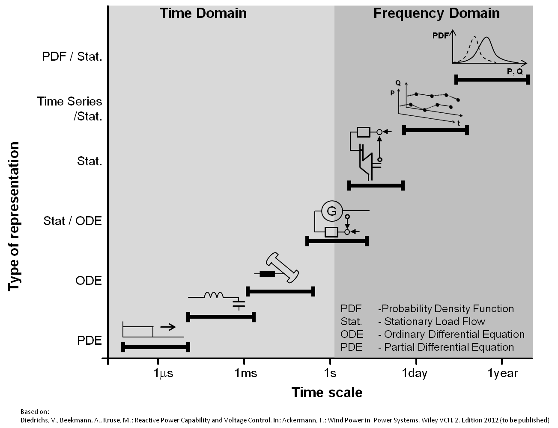
Figure 1: Scale and representation of models
On the x axis the time scale for the simulation is shown. Dependent on this scale, the appropriate modeling approaches are shown on the y-axis. The scale can generally be split into “Time Domain” analysis (subsecond) and “Frequency domain” analysis (>1 second).
<TODO: Detailed description of the different representations>

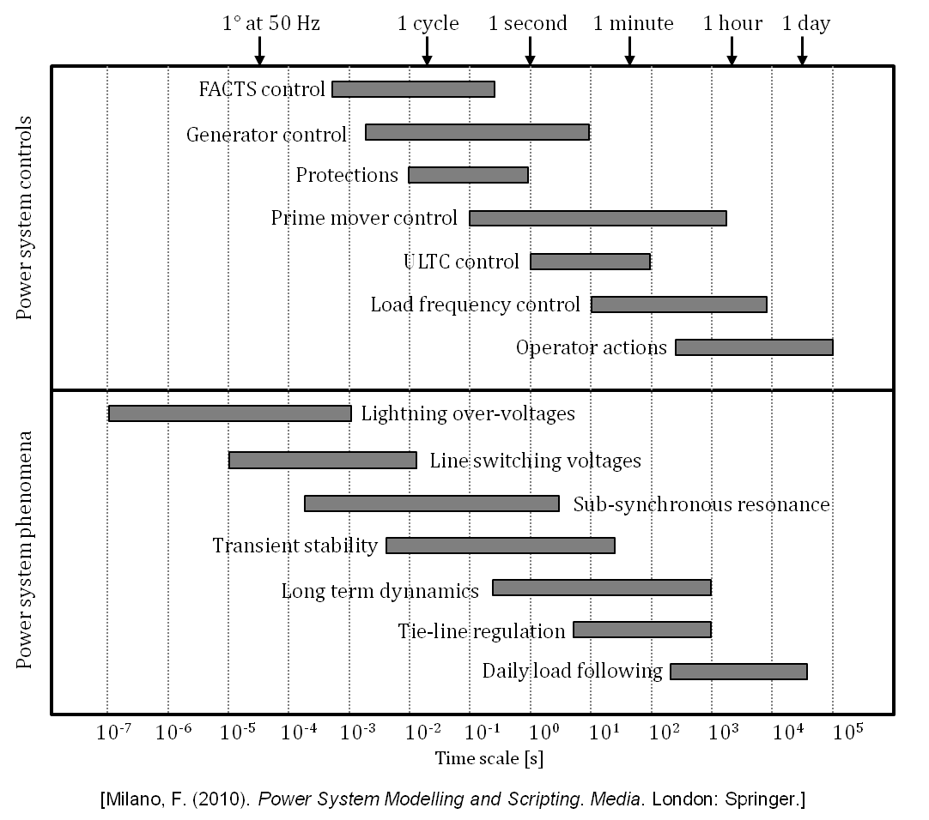
Figure 2: Time scales of power system dynamics

Observation types
In addition, each of the model classes presented above can be used to analyze different types of observation. That is, we can create categorize different observations as well. Table 1 shows different observation categories (Transients, Dynamics, etc…) and the modeling classes that are applicable for each of the observation categories.

Table 1: Observation types (simulation types? Phenomenon types?) and applicable model representations
 | Transients | Dynamics | Short-Circuit | Quasi Steady-State | Steady-State
Partial Differential Equation | X | X | X
Ordinary Differential Equation | X | X | X
Stationary Load Flow |  |  | X | X | X
Time Series |  |  |  |  | X
Probability Density Function |  |  |  |  | X

Issues

Issue categories:
- Protection and Safety
- Voltage Regulation
- Islanding and Grounding
- Design, Planning, and Economics
- Power Quality (Difference to B?)
- Green Energy (share of green power)

Modeling Capabilities

Software (Tool) capabilities:
- Line Coupling: Transmission line models that account for electromagnetic coupling between phases and that allow explicit modeling of each wire of an n-wire line.
- Zero-sequence: Representation of a full-sequence network possible (positive, negative, and zero sequence). Zero-sequence parameters determine the current flow through a ground path.
- Time-Current Characteristic Curve: Time-Current Characteristics (TCCs) of protection devices (relays and fuses) can be simulated.
- Storage Elements: Model representations of batteries and other storage devices.
- Controlled Switches: Ideal and/or non-ideal switches that are time-controlled or controlled by logic.
- Non-Linear Elements: Non-linear elements are available. Examples for non-linear elements are arresters and saturable transformers.
- Voltage Regulators: Substation Load-Tap Changer (LTC), line regulators, and capacitor banks can be represented. Tab changes and switching actions of the regulators can be monitored.
- Frequency Scan: A frequency scan that scans the system behavior in response to current and voltages that vary over a range of frequencies can be performed. Frequency scans are commonly employed to determine at which frequencies resonance conditions exist
- Logic Trigger: Logical operations can be performed during the simulation run. An example for a logical operation is a switch operation that is triggered if a voltage exceeds a predefined threshold.
- Control: The dynamic behavior of the system can be simulated by a customer-specifiable control block diagram, which represents a transfer function. The transfer function relates the input and output of the system with each other. Examples for elements that can be represented as a transfer function are analog and digital filters.

Business Domains
Domains from NIST NIST Framework and Roadmap for Smart Grid Interoperability Standards :
- Bulk Generation
- Transmission
- Distribution
- Customer
- Market
- Operations
- Service Provider

Formats
- Matlab (MAT)
- CSV
- CIM (Topology)

Morphological Box

Scale | Scale Domain | Representation | Power System Controls | Power System Phenomena (vs Issue!?) | Phenomena Types | Issue | Model Capabilities | Component (from survey) | BusIness Domains | Format | Dataset | Tool category
1 μs | Time Domain | Partial Differential Equation | FACTS control | Lightning over-voltages | Transients | Protection and Safety | Line Coupling | DER | Bulk Generation | MAT | Load profiles | Spreadsheet
1 ms | Frequency Domain | Ordinary Differential Equation | Generator control | Line switching voltages | Dynamics | Voltage Regulation | Zero Sequence | Thermal power plants | Transmission | CSV | Vehicle usage behavior | Power flow analysis
1 s |  | Stationary Load Flow | Protections | Sub-synchronous resonance | Short-Circuit | Islanding and Grounding | Time-Current Characteristics | Transmission grid | Distribution | CIM | Sun irradiation | Simulation framework
1 minute |  | Time Series | Prime mover control | Transient stability | Quasi Steady-State | Design, Planning, Economics | Storages | Distribution grid | Customer | Plaintext (custom) | Wind speed | Matlab like
1 hour |  | Probability Density Function | ULTC control | Long term dynamics | Steady State | Power Quality | Controllable Switches | Residential load | Market | Tool specific | Grid topology | Agent framework
1 day |  |  | Load frequency control | Tie-line regulation |  | Green Energy | Non-Linear Elements | Commercial load | Operations |  | GIS data | Solver
1 week |  |  | Operator actions | Daily load following |  |  | Voltage Regulators | Industrial load | Service Provider |  |  | Statistic package
1 month |  |  |  |  |  |  | Frequency Scan | FACTS
1 year |  |  |  |  |  |  | Logic Triggers | AC/DC
 |  |  |  |  |  |  | Control

Please add more categories/attributes,… here, e.g. radio communication related stuff…
Metrics

Function based, ontological representation
Inspired by the works of [GSA12], a possible way to arrange the gathered categories shown in the morphological box (in the last section 3.3) is shown in Figure 4. It is based on the basic structure shown in Figure 3.

Requirement
Function
Provider
requires
offers
Sub-Function
Sub -Requirement
Sub-Provider
Attribute
Attribute
Attribute
Figure 3: Function based separation of requirements and implementations (provider)
The model shown in Figure 4 is by no means complete or fixed. Is is a first basis for discussion. The different columns from the morphological box can be used in three ways: As sublcasses for a base class (e.g. see the Tool class), as attribute values (e.g. scale attribute of research question) or as instances for a class (e.g. instances of ModelCapability class could represent the different model capabilities in the morphological box). The choice is subject to discussion and strongly problem domain specific. Thus, there is no fixed method for choosing the representation variant.
Requirement
Function
Provider
requires
offers
Model Capability
Research Question
Spreadsheet
Component
Power Flow Tool
Simulation Framework
Matlab like
Agent Framework
Solver
Statistic Package
Tool
Data
Format
Content
DER
Thermal Plant
Grid
Load
Scale
Issue /Power System Phenomena
Representation
Model
of
Scenario
Figure 4: First draft for a metamodel of the problem domain (oval=classes, rectangular=class attributes, dashed lines=references, solid lines=inheritance)

Figure 5 shows an example of how to use the metamodel defined in Figure 4 using the example of the analysis of different research questions (“ecological performance” and “grid performance”) for different EV charging strategies. The fact that it is related to EV charging strategies is not captured, yet. We would need some kind of “Research Question group” that bundles different questions. Metrics for measuring the performance of the algorithm could be defined as well (TBD). The general benefit of this approach will be the definition of a set of scenarios and/or research objectives and associated elements (models, etc…) and metrics for achieving the research objectives.

Ecological performance
Research Question
Issue: Green Energy
Scale: 1 Minute
Grid performance
Issue: Voltage Stability
Scale: 1 Minute
Requirement
EV Model
Representation:Time Series
LV Grid Model
Representation:Stationary
Function
Component
Provider
Simulation Framework
Tool
Model
Scenario
Scenario A
SimPy
EVSim
PyPower
GridSim
Figure 5: Example for the application of the domain metamodel
Obviously a graphical representation as shown here is not the best solution. Therefore we would want to use a standardized ontological format such as OWL (http://www.w3.org/TR/owl2-overview/) and freely available tools such as Protégé (http://protege.stanford.edu/) for editing the ontology.

Tasks
This section enumerates different tasks that simulationists in the SmartGrid domain are confronted with. For each task, a description introduces the task in a very high-level and general way. Then, different variations are given, each of which providing concrete details of the requirements and how this use case has been implemented for these requirements. Finally, for each variation the desired/missing requirements are stated.
Short: Each variation corresponds to one state-of-the-art implementation of the described task for the variations requirements.
Rationale: This structure has been chosen, as it is likely to have different solutions for a single task. This way we can gather the different implementation possibilities and can condense the redundancies and requirements in a later step.

<Task Name>
Description
What is the use case that is to be simulated.

Variation - <author/contact name>
Requirements
What where the requirements for this variation?
Required models?
Required data?
State-of-the-Art Implementation
How has the simulation been implemented (please indicate the use of readily available tools and own implementations).
Derived Requirement
How would an ideal simulation concept look like (regardless of technical constraints)?
What are the identified requirements to bridge the gap between state-of-the-art and ideal simulation concept?

Evaluation of EV charging strategies
Description
Different charging strategies for electric vehicles shall be tested, evaluated and compared.

Variation – OFFIS, S.Schütte
Requirements
- Evaluation with respect to the charging strategies’ potential of using local PV feed-in.
- Strategies used for home charging only
- Observation of effects on the lv-grid (using static powerflow analysis only)
- Integration of existing implementations of the charging strategies
- Simulation of different scenarios (grid topology, EV share/parameters, PV share, charging at work)
- All simulation have a resolution of 15 minutes
- Use of a free power flow analysis tools
- Use of CIM-compliant grid topologies
Required models: EV, PV, private Consumer, Grid (static power flow analysis)
Required data: Grid topologies, vehicle usage behavior
State-of-the-Art Implementation
For the photovoltaic and the private consumers, existing models from previous projects were available as complex Matlab model and CSV-Data respectively.
For the simulation of the electric vehicles, a new simulation model has been implemented using the SimPy (see 7.1) simulation framework. The data for modeling the vehicle behavior has been purchased from the German Federal Ministry of Transport, Building and Urban Development.
The power flow analysis has been implemented using open-source components for Python. A missing component for integrating the CIM-based grid topologies has been added to form the final tool-chain as described in section 6.1.1.

Derived Requirements / Ideal simulation
- Integration of different, heterogeneous simulation models
- Simple and compact definition of different scenarios that are to be simulated
- Automatic composition and simulation of the different scenarios using the integrated models
- Ensuring semantic validity based on semantic description of the integrated models

Variation – Ghent University - IBBT, K. Mets, C. Develder
Requirements
- Evaluation of residential EV charging strategies in the context of peak shaving.
- Evaluation of multiple algorithms with different assumptions and requirements, e.g. with or without communication between the different households.
- Observations of the effects on the low voltage distribution grid.
- Simulation of different scenario's (grid topology, EV share/parameters, charging locations).
- Simulations have a resolution of 5 or 15 minutes.
Required models: EV, private consumer, power grid (static power flow).
Required data: Grid topologies, vehicle usage behavior.
State-of-the-Art implementation
The peak shaving scenario has been implemented in OMNeT++ (see 6.1), a discrete event simulation framework for network and distributed systems simulations. (For an overview of the simulation framework, see [Camad2011].)
Synthetic load profiles provided by regulatory instances (e.g. Flemish Regulator of the Electricity and Gas market (VREG) [VREG]) and load profiles obtained from measurements in Belgian households have been used to model energy consumption of private consumers. The data is made available in the form of CSV or Excel data. The electric vehicle behavior model is implemented as a MATLAB model [Ca08], and the model output is exported as CSV-data.
The EV charging strategies model the EV charging problem as a quadratic programming model that is solved using CPLEX.
The power flow analysis has been implemented in MATLAB and a C++ library was created using the MATLAB Compiler. The C++ library is used in the OMNeT++ based smart grid simulation framework.
(Initial case studies are described in [NOMS10, ICC11, SGMS11].)

Modeling & Simulation requirements
“[..]There is a large installed base of mature power system simulation tools that have evolved over decades and have the trust of the energy service providers who must rely on them. New tools are certainly required but I would argue that just as important is the need to provide guidance on how the existing tool base should be used to address smart grid applications not previously modeled extensively using these tools. In particular, best practices on how to use multiple tools to address applications where a multi-discipline, multi-domain, systems-of-systems engineering focus is required. Modeling guidelines and "glueware" linking these tools to evaluate the impact of communications and control systems is particularly needed.” [Erich W. Gunther, mail to the Sims WG, 08. March 2011]

Overview
A Smart Grid simulation study may involve elements of different types, as shown in Figure 6. The power grid is, of course, a major element but is not necessarily a part of every study. Simple load based calculations (demand-supply matching) ma not consider the power grid. Next, the different resources connected to the power grid are to be simulated. This element category may range from simple time-series based load models up to detailed models of renewable energies, combined heat and power plants (may be including a thermal model) or any kind of storages (chemical, thermal, hydro). Common to elements of this category is a connection to the power grid and, in case of controllable devices, some kind of communication interface. The communication interface is used by some kind of controller that has to communicate with these interfaces via some communication channel. All these elements are exposed to the environment. The environment may impact elements of the power grid (e.g. through a storm damage), the resources (e.g. by changing power production of PV systems or the thermal demand of CHPs), the communication channels, e.g. by a changed wireless connection quality or destroyed wires and the controllers have to be aware of the weather in order to keep the Smart Grid in a stable state (e.g. influencing controllable resources to keep the supply demand equilibrium).
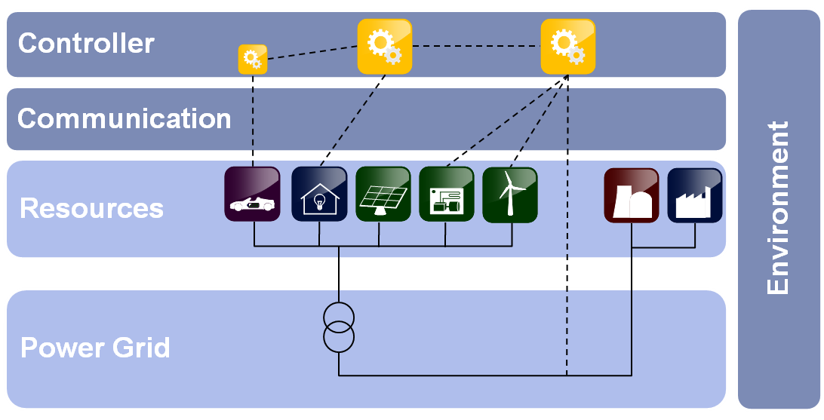
Figure 6: Categories of simulated objects [based on Sc11a]

In [NIST10, p.128] the interfaces between these elements (there called Actors) are “[..]either electrical connections or communications connections.” For the M&S case, however, we can distinguish 4 different types of connections can be identified, as shown in Figure 7.
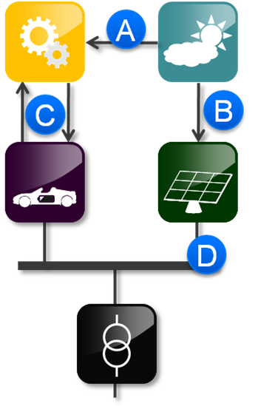
Figure 7: Connection types
First, two basic categories “Physical” (A, B, D) and “Informational” (C) can be identified. The physical flows can be power flows (D) or any other energy flow, such as heat or sun irradiation (A, B). Further we can distinguish these flows from a temporal point of view. A weather simulation (upper right of Figure 7) may provide actual (B) or future values (A). Informational flows occur at distinct points in time (e.g. packet arrival) whereas physical flows are of continuous nature. Table 2 shows these conclusions neatly arranged (*SCNR*).
Table 2: Connection types and characteristics
 | Type | Meaning | Time | Simulation mechanism
A | Physical | Weather | Forecast | Discrete
B | Physical | Weather | Actual | Continuous/Discrete
C | Informational | Control | Forecast / Actual | Discrete
D | Physical | Power | Actual | Continuous/Discrete

Table 3 shows the two simulation mechanisms and how these can be represented/used. It also shows a non-exhaustive list of frameworks/standards to couple simulators that use this presentation.
Table 3: Simulation mechanisms
Continuous | Discrete
Time-Stepped |  | Event-based
Variable-Step | Fixed-Step
- FMI | - FMI  - mosaik | - HLA

Approach
For the different issues presented in the tasks chapter (and Jens’ Excel-Table), we could try to define the participating elements in more detail as indicated in Figure 8. This way we get a number of infrastructure “templates” that each can be used to investigate a bunch of issues. E.g. for investigating wireless control signal quality template xyz can be used as a starting point. For investigating cloud transients template abc can be used (e.g. providing resolution in seconds with time-stepped coupling). Note: Currently I’m not satisfied with the presentation here. It does not make clear how we should describe the issues in detail. I think we can also use the ontological representation I added in document version 0.15 in chapter 3.4. However, it is still not 100% clear to me so we have to discuss anyway. As usual, any ideas are welcome

Static view:
What objects are required for investigating issue xyz and what data do they exchange? What kind of simulator glue is needed?
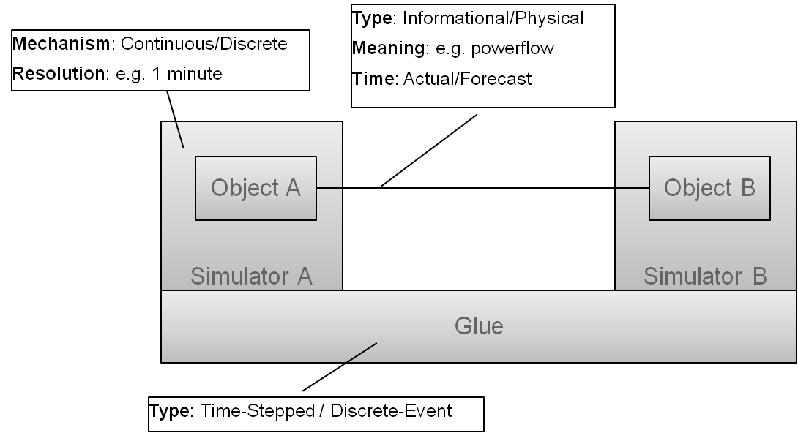
Figure 8: Static view on simulator coupling

Dynamic view:
E.g. simulate coverage for wireless communication channels first and then perform simulation by following the protocol...

State-of-the-Art

Static Power Flow Analysis

CIM-Compliant tool chain for Python – OFFIS, S.Schütte
To perform a static load flow analysis in Python, three different open-source modules can be used.
- PyCIM (http://pycim.org) can be used to import the grid topology available as CIM-XML/RDF file
- The CIM2BusBranch (https://bitbucket.org/ssc/cim2busbranch) component is used to convert the CIM topology (node breaker topology) into a less complex bus branch representation suitable for the load flow analysis
- The load flow analysis can be done using PyPOWER (http://pypower.org) , a Matpower clone implemented in Python.

Co-Simulation

Agent-based Coordination & Power Systems
[Ba10] describes an approach for coupling power simulation tools with agent based modeling frameworks. The project is available at http://sourceforge.net/projects/gridiq/ and is demonstrated by an example using PSAT as power simulator and JADE as agent framework.

Communication Networks & Power Systems
See [Go10], [La11], [Li11]

Tools

Simulation frameworks
Tool | Available | License
SimPy | http://simpy.sourceforge.net/ | Free
OMNeT++ | http://omnetpp.org/ | Academic Public Licence

Power System Simulation
Tool | Available | License
PSAT | http://www.uclm.es/area/gsee/web/Federico/psat.htm | Free
Alternative Transients Program (ATP) | http://www.emtp.org/ | ?
Electromagnetic Transients Program (EMTP-RV) | http://www.emtp.com/ | ?
PSCAD | http://www.pscad.com/ | ?
DigSilent | http://www.digsilent.de/ | $$
PSSE | http://www.energy.siemens.com/hq/en/services/power-transmission-distribution/power-technologies-international/software-solutions/pss-e.htm | ?
NETOMAC | http://www.energy.siemens.com/hq/en/services/power-transmission-distribution/power-technologies-international/software-solutions/pss-netomac.htm | ?
GE PSLF | http://www.gepower.com/prod_s | ?
ASPEN Oneliner | http://www.aspeninc.com/aspen/index.php | ?
OpenDSS | http://sourceforge.net/projects/electricdss/ | Open-Source
GridLab-D | http://www.gridlabd.org/ | Open-Source
Matlab/SimPower
SynerGEE
DEW
CYMEDIST
SKM-Dapper
PowerWorld
ASPEN-OneLiner
WindMill
FeederAll
EMRP-RV
TELVENT
ATP
SuperHarm
T2000
CymHarmo
Distriview
SINCAL

Agent based modeling (ABM)
Tool | Available | License
JADE | http://jade.tilab.com/ | Open-Source

Comprehensive lists of ABM software can be found here:
http://193.62.125.70/Complex/ABMS/
http://en.wikipedia.org/wiki/Comparison_of_agent-based_modeling_software

Literature

[Ba05] Banks, J. et al. 2005. Discrete-Event System Simulation. Pearson
[Ba10] Bankier, J. GridIQ – A Test bed for Smart Grid Agents. Bachelor Thesis, University of Queensland, 2010. Available: http://gridiq.sourceforge.net/GridIQThesis.pdf
[Ca08] E. D. Caluwe, “Potentieel van demand side management, piekvermogen ´en netondersteunende diensten geleverd door Plug-in Hybride Elektrische Voertuigen op basis van een beschikbaarheidsanalyse.” Master’s thesis, Katholieke Universiteit Leuven, 2007–2008.
[Go10] Godfrey, T.; Sara, M.; Dugan, R. C.; Rodine, C.; Griffith, D. W.; Golmie, N. T. Modeling Smart Grid Applications with Co-Simulation. In: The 1st IEEE International Conference on Smart Grid Communications (SmartGridComm 2010). Available: http://www.nist.gov/customcf/get_pdf.cfm?pub_id=905684
[ICC11] K. Mets, T. Verschueren, F. De Turck, and C. Develder, “Evaluation of Multiple Design Options for Smart Charging Algorithms”, Proc. 2nd IEEE ICC Int. Workshop on Smart Grid Commun., Kyoto, Japan, Jun. 2011
[GSA12] González V., José M.;Sauer, Jürgen;Appelrath, H.-Jürgen, “METHODS TO MANAGE INFORMATION SOURCES FOR SOFTWARE PRODUCT MANAGERS IN THE ENERGY MARKET”, Business & Information Systems Engineering (The International Journal of WIRTSCHAFTSINFORMATIK).
[La11] Liberatore, V.; Al-Hammouri, A. Smart Grid Communication and Co-Simulation. 2011. Available: http://vorlon.case.edu/~vxl11/NetBots/energy-tech.pdf
[Li11] Lin, H.; Sambamoorthy, S.; Thorp, J.;Mili, L. Power System and Communication Network Co-Simulation for Smart Grid Applications. In: Innovative Smart Grid Technologies (ISGT) 2011. Available: http://ieeexplore.ieee.org/xpls/abs_all.jsp?arnumber=5759166&tag=1
[NIST10] NIST. 2010. NIST Framework and Roadmap for Smart Grid Interoperability Standards, Release 1.0. Nist Special Publication.
[NOMS10] K. Mets, T. Verschueren, W. Haerick, C. Develder, and F. De Turck, “Optimizing smart energy control strategies for plug-in hybrid electric vehicle charging,” Proc. 1st IFIP/IEEE Int. Workshop on Management of Smart Grids, at 2010 IEEE/IFIP Netw. Operations and Management Symp. (NOMS 2010), Osaka, Japan, 19–23 Apr. 2010, pp. 293–299.
[Ro08] Robinson S. "Conceptual modelling for simulation part I: Definition and requirements". Journal of the Operational Re- search Society, 2008, 59:278-290.
[SGMS11] K. Mets, T. Verschueren, F. De Turck, and C. Develder, “Exploiting V2G to Optimize Residential Energy Consumption with Electrical Vehicle (Dis)Charging”, Proc. 1st Int. Workshop Smart Grid Modeling and Simulation (SGMS 2011) at IEEE SmartGridComm 2011, Brussels, Belgium, 17 Oct. 2011
[Sc11a] Schütte, Steffen. A domain-speciﬁc language for simulation composition. In Burczynski, T., Kolodziej, J., Byrski, A., and Carvalho, M., editors, 25th European Conference on Modelling and Simulation, pages 146–152, Krakow.
[VREG] Flemish Regulator of the Electricity and Gas market (VREG), “Verbruiksprofielen”, Available: http://www.vreg.be/verbruiksprofielen-0
[WTW09] Wang, Wenguang, Tolk, A., & Wang, Weiping. (2009). The Levels of Conceptual Interoperability Model: Applying Systems Engineering Principles to M & S. Spring Simulation Multiconference (SpringSimʼ09). San Diego.

i.e. new types of electrical equipment or new control mechanisms
NIST. (2010). NIST Framework and Roadmap for Smart Grid Interoperability Standards, Release 1.0. Nist Special Publication.
http://www.modelisar.com/fmi.html
http://mosaik.offis.de
http://en.wikipedia.org/wiki/High-level_architecture_(simulation)

