Smart Grid Standards Assessment and Recommendations for Adoption and Development

Prepared for the California Energy Commission by

Erich W. Gunther
Aaron Snyder
Grant Gilchrist
Darren Reece Highfill

EnerNex Corporation

February 2009
Draft 0.83

Executive Summary
This paper addresses four fundamental questions related to standards and technology for building a Smart Grid for California:
- What new and emerging technologies are on the horizon that impact the Smart Grid of the future;
- How to avoid incompatible systems being fielded that result in costly replacements ahead of projections;
- How to help foster open access, competition and commercial growth of new and exciting technologies that offer energy consumers new ways to meet their energy needs while at the same time saving them money; and
- Where government can help and where government should stay out.
A key factor in addressing the Smart Grid problem is a decomposition of the power system and underlying standards and technologies into coherent parts that allow targeted research to be applied, while exposing the problems that have precluded solution development.
First, a high-level overview of available and developing standards and technology will juxtapose the demands of standards development and interoperable systems. The differences between standards developing organizations and technology alliances are used to explore why standardization does not always result in interoperability. Included in this overview is a discussion of how policy and regulation, jurisdictional scope and the roles of the standards and technology developers shape Smart Grid solutions.
Following this, the Smart Grid problem is decomposed into four key areas: Generation, Transmission, Distribution, and Consumer. This will clearly delineate the areas of impact as well as expose the seams between systems where more investment is needed to develop the standards and best practices necessary to link up Smart Grid technologies. Cross cutting decompositions of the communications infrastructure necessary to link the components in the four utility infrastructure zones noted above are also evaluated including Home Area Networks (HAN), Field Area Networks (FAN), Substation Area Networks (SAN), Wide Area Networks (WAN), utility Local Area Networks (LAN), and Enterprise integration.
Next, an inventory of specific existing or developing standards, best practices, legislation, and regulations in these key areas will be presented that are relevant to smart grid deployment in California. Particular attention is paid to how these standards come into play over time according to the California Smart Grid Roadmap.
Finally, solutions are proffered that address the four questions from the standpoint of what standards and technologies should be recommended, required, or researched to meet the goals of a modern Smart Grid.
One of the key findings of this paper is that there are many mature standards and best practices already available that can be readily deployed to facilitate smart grid deployment. The main problem with adoption seems to be a lack of awareness of those standards by those involved in designing smart grid systems at a high level and a lack of clear best practices and regulatory guidelines for applying them.

Key recommendations include:
- Policy makers should utilize the DOE ‘GridWise Architecture Interoperability Checklist’ to evaluate utility proposals for projects involving rate recovery.
- Regulations should be developed that encourage utilities and product vendors to support standards-based technologies over proprietary solutions.
- Regulations should avoid mandating specific standards or technologies where possible in favor of specifying desired outcomes and important characteristics of the standards to be employed.
- Research should be conducted to accelerate the development of standards that fill existing gaps including those for security, smart grid network and device management, information privacy management, and field area network interoperability.

Introduction to Standards and Technology
Standards development organizations (SDOs) operate under similar rules worldwide. In general terms, the members of the committees doing the actual development work are limited by anti-trust rules or laws from engaging in anti-competitive behavior such as market division, pricing discussions and the like. Also, intellectual property is treated as a potential source for standards language, and requires disclosure by the holder. For balloting, strict control of the candidate voters with respect to balanced interest is performed to provide a measure of fairness and balance. As an example, the American National Standards Institute (ANSI) has three categories, producer, user and general interest, and for balloting groups no single category can exceed forty (40) percent of eligible voters.
Standards usually begin as de facto standards; i.e., enough commonality among enough producers to call the product/approach/protocol “standard.” Beyond this, SDOs actually author de jure standards; i.e., those that are codified in a manner similar to laws. Given the careful attention to balloting balance, open rules and open participation, standards may be adopted in place of laws in certain jurisdictions.
In North America, the following are relevant SDOs for the utility industry:
ANSI – American National Standards Institute (www.ansi.org)
DIN – Deutsches Institut für Normung, German Standards Institute (www.din.de)
IEC – International Electrotechnical Commission (www.iec.ch)
IEEE – Institute of Electrical and Electronics Engineers (www.ieee.org)
ISO – International Organization for Standardization (www.iso.org)
ITU – International Telecommunication Union (www.itu.int)
One of the examples is the German Standards Institute, which would seem to be out of place in this candidate list. However, there are areas such as electricity metering where the DIN standards are influential.
Distinct from SDOs are what are known as “alliances.” These are entities and individuals that recognize the value of a particular technology, and form an interest group to promote for example the codification of design and marketing of that technology. The difference between an alliance and a standards group lies with both the rules and the work products. Since any number of interested parties can form an alliance, the rules under which they operate vary widely. An example is the ZigBee Alliance, which has a fifteen (15) member board (“Promoters”) made up of technology vendors and two other classes of membership, “Participant” and “Adopter”. The work products of the ZigBee Alliance are known as “profiles”, or agreed-upon specifications. Since an alliance is not required to have a balanced membership or in some cases to follow certain anti-trust regulations, the work products must be submitted to a SDO in order to become true de jure standards.
The following organizations are well-known alliances related to the utility industry in the Home Area Network (HAN) market space:
HomePlug Powerline Alliance (www.homeplug.org)
Z-Wave Alliance (www.z-wavealliance.org)
ZigBee Alliance (www.zigbee.org)
Each alliance combines different participants across the industry to meet their stated goals. Often, the alliance promotes specifications as standards, before they are officially codified in a manner similar to the formal SDOs. Also, one of the primary goals of most alliance efforts is product interoperability, with some sort of certification program followed to demonstrate that capability. In August of 2008, the ZigBee and HomePlug alliances announced a joint effort to provide some harmonization to their efforts. Examples of this from the computing industry include the Wi-Fi Alliance and the USB (Universal Serial Bus) Implementers Forum.

How to go beyond standardization
Standards meet the goal of creating a common basic understanding of a technology. Unless the scope of a standard includes interoperability tests or guidelines, at best a technology would be in compliance with the standard. In electronic and power technology, unlike physical technology (sizes), interoperability is at best an aspiration of the community that developed the standard. This highlights the need for a dedicated user’s community tasked to identify interoperability challenges (requirements), write tests to validate products, and certify those results.
In addition to SDO’s and alliances, a third important entity is a “user’s group”. A differentiator between users groups, standardization organizations and alliances is that user’s groups’ rules often permit more free discussion between those actually using standards and specifications than those of the developing organizations. An example of the relationship is shown by the IEC 61850 standards developing committee (Technical Committee 57, Working Group 10) and the UCA International User’s Group (UCAIug) IEC 61850 committee. The IEC technical committee is made up of national experts, nominated and accepted by the IEC. Each committee follows a prescriptive process for producing IEC standards, in this case the IEC 61850 suite of standards. Part 10 of that suite is interoperability tests. The UCAIug IEC 61850 committee is composed of experts that meet on a semi-annual basis to discuss how the compliance of products to IEC 61850 is demonstrated. This is accomplished by that committee validating that the standard tests are applied in a consistent, transparent and fair manner, and thereby conforming products meet the goals of the standard. Also within the UCAIug are task forces such as OpenHAN (HAN – Home Area Network) and AMI-SEC (Advanced Metering Infrastructure SECurity) which have published system requirements specifications. These specifications allow the customer and vendor communities to communicate with each other through a common document and to understand the complexities of what is needed to meet business objectives. The specifications are also written in a manner that facilitates work by standards groups to develop de jure standards that lead to products that meet the desired requirements.
Another group laying the foundation for true interoperability is the GridWise Architecture (GWAC). In a partnership with NIST (National Institute of Standards and Technology), the GWAC sponsors the Grid-Interop conference, which has the goals of achieving system-to-system interoperability, business process interoperation, preparing for a sustainable electricity system, developing policies for integrated smart energy and a holistic view of generation to consumption.
One method to move beyond standards and technology driven by customers and vendors is to use rules and regulations from governments and governmental agencies. The best of these are targets or guidelines with appropriate incentives and penalties without too much prescription. An example from another industry is the corporate average fuel economy (CAFE) standard for automobile manufacturers codified in the United States Code. This is a target for the entire production, without specifying which particular models. The market of vehicles then signals to the manufacturers which vehicle and what volumes are needed, allowing them to develop technologies (engines, combustion techniques, etc.) to meet the government standard measurement.
Finally, to move beyond standards that are regional in scope, there are pacts in place to allow co-publication of standards between the IEC and IEEE, ANSI and IEEE, and others. This is the first step toward true harmonization, whereby a standard is in place for a broader market.

Methodology

Power System Infrastructure
For analysis, the utility power system is broken into three parts along traditional lines of generation, transmission, and distribution. All of the different load classes, industrial, commercial and residential are grouped into the “Customer” category.

Generation
For the purposes of discussion, Generation means high-capacity (250 MVA and up) central plants connected through a transmission network and distribution system to the Customers. This may include wind farms whose total capacity exceeds this minimum threshold when treated as a single generating station for analytical purposes.
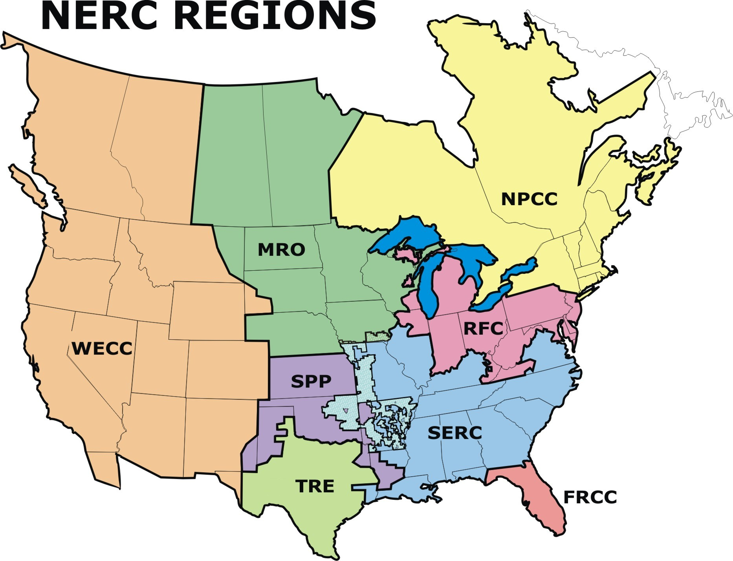
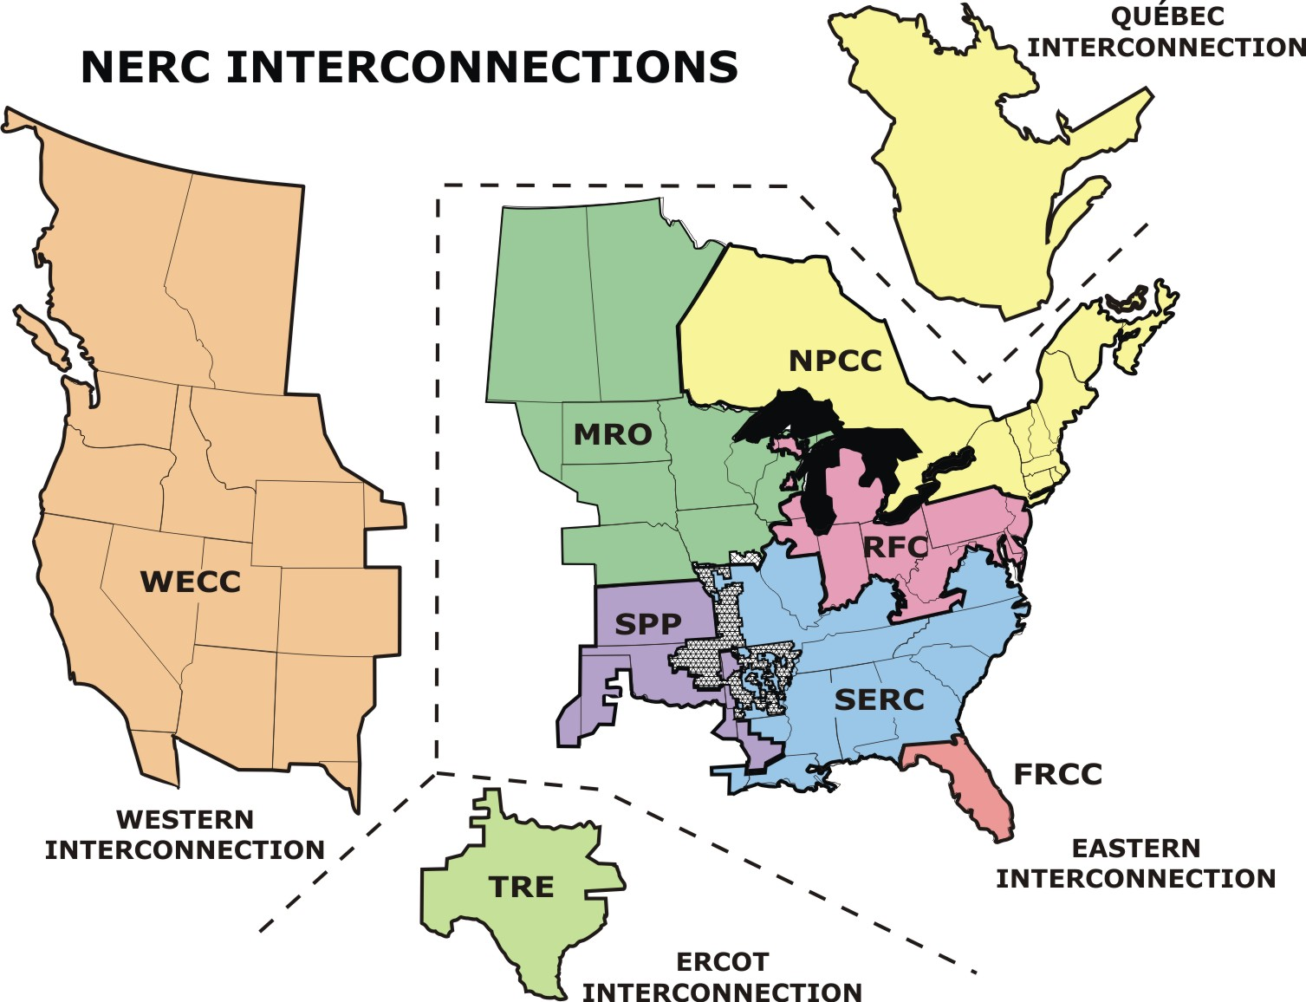
Figure 1a: NERC Interconnections Figure 1b: NERC Regions

Transmission
The transmission network, along with the distribution system, is sometimes also referred to as the “bulk power” system. This network in North America is broken into four coherent, synchronous areas: the Québec Interconnection, the Eastern Interconnection, the Western Interconnection (also known as the Western Electricity Coordinating Council, or WECC)and the Electric Reliability Council of Texas Interconnection (also known as ERCOT and the Texas Regional entity, or TRE), as shown in Figure 1a. The Eastern Interconnection includes the following regional entities: Florida Reliability Coordinating Council (FRCC), Midwest Reliability Organization (MRO), Northeast Power Coordinating Council (NPCC), ReliabilityFirst Corporation (RFC), SERC Reliability Corporation (SERC), and the Southwest Power Pool (SPP). By “coherent, synchronous area”, this defines how the generation supply of that area is coordinated to meet the load. It also defines catastrophic problem boundaries for problems such as blackouts. The transmission system operates at the highest voltage level, typically 138 – 1000 kV.

Distribution
The distribution system is the most equipment and maintenance-intensive portion of the bulk power system. The design of the distribution system is not a true “grid”; i.e., multiple power delivery paths for a single load. Rather, each load can be clearly paired with a transmission-level source, typically a substation delivery point. Some industrial sites have multiple feeds with switchover equipment to provide a higher degree of reliability. It is also possible to connect generation on the distribution system, known as distributed generation, or distributed resources. The power provided by this generation ranges from 5 to 500 MVA, and includes wind turbines, solar arrays, solar thermal, small hydroelectric plants, fuel cells, microturbines. When considering the definition of distributed resources, technologies such as battery energy storage, superconducting magnetic energy storage, as well as many others are added to the generation mix.
The operations and maintenance needed to support the distribution system is revealed through the quantity of devices required to support its function: for every 250,000 customers there are up to 60,000 secondary or service transformers, up to 227 feeders and 45 substations. Each feeder may also have a power transformer at the substation to convert from the transmission or sub-transmission voltage to the distribution voltage. The distribution system typically operates at 13.8-138 kV, though some system operators consider 34.5-138 kV to be the “subtransmission” system, and the distribution system to include 240V-34.5 kV.

Customer
The customer was once only treated as a pure revenue source for the utility, but will in the near future (and in some cases today) be treated as a “partner”. Once a ubiquitous communication system is in place linking customers to the utility, monitoring and control of each load will be simplified. Customers will be encouraged through rate programs and incentives to moderate their consumption of energy (and demand) to allow the utility to avoid the need to purchase power during peak consumption periods. These so-called “demand response” programs then enable the utility to defer investment in infrastructure, with its long litany of complaints, and instead invest in continual efficiency improvements.
One vision for demand response does include some investment in infrastructure; however, the investment is in communications infrastructure, which is considerably easier to deploy that power lines. Advanced devices such as two-way communicating meters, communicating thermostats, and home automation devices such as programmable and communicating outlet controllers will assist energy customers in managing their demand for energy. For commercial and industrial customers, one possibility is installing an energy management system linked to a system of internal sensors and controllers that leverages the continual load and rate structures to allow both demand response operations and demand bidding operations.

Communications Infrastructure
A smart grid is achieved by overlaying the power systems infrastructure with communications infrastructure. Benefits are derived by delineating the communications infrastructure along functions that are not quite tied on a one-to-one basis with the power system infrastructure.

Home Area Networks (HAN)
Sometimes referred to as a Premise Area Network (PAN) or a Building Area Network (BAN), this zone includes devices with a single premise (industrial site, commercial business or home) communicating over one or more networks. Electric utilities are looking to leverage these networks to provide relief during high demand periods (demand response) by communicating through some type of home gateway bridging utility and home networks.

Field Area Networks (FAN)
This zone includes devices communicating over one or more networks between the individual service connections and backhaul points leading to the utility (see WAN below). This network is primarily supported by an Advanced Metering Infrastructure deployment, as this is the most widespread communications network a utility can install. Included in a FAN are distribution automation and control (DAC) devices.

Substation Area Networks (SAN)
This zone includes devices communicating over one or more networks inside of a single electric substation. These typically are capacitor banks, relays and other substation automation equipment. This network is often the most remote zone of operation of a SCADA (supervisory control and data acquisition) system. One group is working to extend a SAN standard (IEC 61850) to include more than one substation (substation-to-substation communications).

Wide Area Networks (WAN)
This zone is the bridge between FANs and SANs and the utility LAN and back office. This includes communications from control centers to the substations. This is commonly referred to as ‘backhaul’ communications.

Local Area Networks (LAN)
This zone identifies a “close” set of devices in communication, as the name implies, in a local configuration. Often each floor of a building may be on its own LAN, or a single server room may be a LAN. HANs, FANs and SANs are types of local area networks.
Figure 2 provides a high-level overview of the smart grid landscape. Ideally, each of the domains, members and technologies would interact in a manner that empowered all actors (utilities, customers, etc.) to participate in meeting any of the business, technology and societal goals. From the HAN, where consumers would be able to purchase and install monitors and controls, through the utility network formed of communications and power system infrastructure to the enterprise applications, data would be transformed into useful information wherever and whenever necessary. In reality, each of the horizontal domains represents a zone of interoperation where there may be competing and complementary standards and technology, often focused on a specific technology or partner technologies, and developed without consideration for the requirements of any other domains.
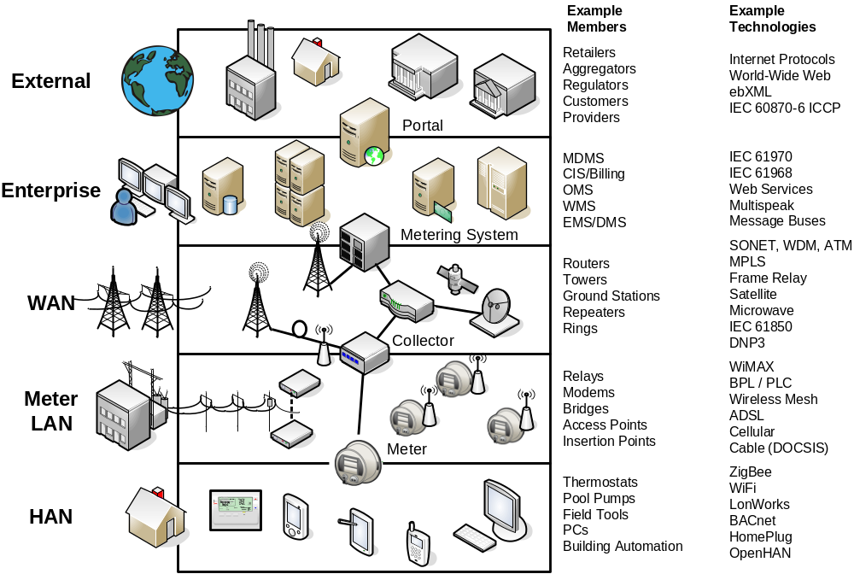

Figure 2: Smart Grid High Level Overview

Enterprise Integration
Enterprise Integration identifies the connection of disparate applications needed to drive the utility business needs. This typically includes applications with “system” in their name such as outage management systems (OMS), graphical information systems (GIS), distribution management systems (DMS), energy management systems (EMS), customer information systems (CIS), meter data management systems (MDMS), or even an enterprise resource planning (ERP) system. Common practice is for each of these systems to be supplied by a different vendor, leading to difficulties in managing the data needed to run the utility business. The industry is moving toward common information model (CIM) development and away from proprietary integration development.

A Deeper View of the Problem
Figure 3 is a pictorial representation of the different networks mentioned here with some example devices, systems and actors. One can easily trace from the HAN, through a LAN and WAN, and into the Utility Enterprise. Beyond this dimension, there are seven layers represented, following the OSI (open systems interconnection) model: Application, Presentation, Session, Transport, Network, Data Link and Physical. This is a more accurate representation of the hurdles to true interoperability of devices and systems. To be properly integrated, two devices/systems must agree on standards and protocols for each of the seven layers.
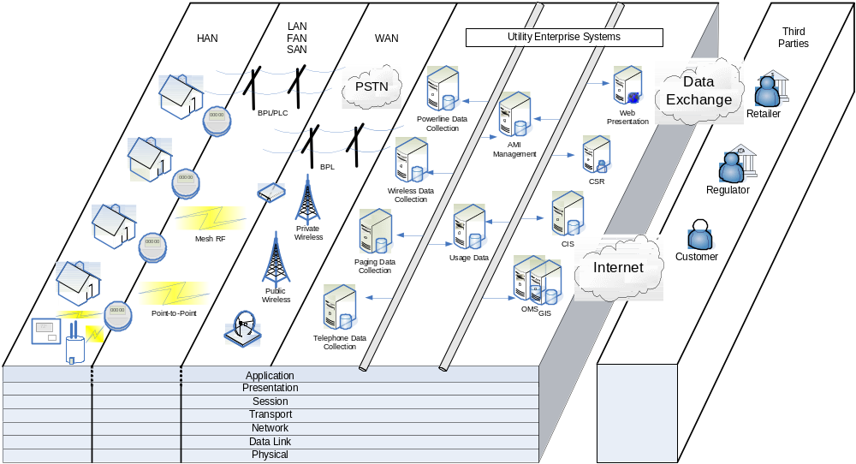

Figure 3: Enterprise Systems, Communications and Layers
The physical layer is the media by which bits are exchanged. The data link layer (e.g., media access control or MAC) is where the exchange of frames (many bits) is performed. The network layer is the level where paths are determined and logical addressing is applied for packets (many frames). End-to-end connections are formed at the transport layer and segments (many packets) are exchanged. The session layer deals with interhost communication. The presentation layer deals with data representation and encryption. Finally, the application layer is the level at which interaction with a user is attained.
Sometimes technologies will use a different model from the seven layers of the OSI stack. These models may only reference three or four layers, however the functionality of all seven OSI layers is typically bundled in to the model regardless. The OSI model is generally accepted as the most detailed practical representation of communication functionality.

Smart Grid Gap Identification and Decomposition
With the plethora of standards available in the utility space in each “networked” zone as well as through the layers, it is often beneficial to juxtapose existing standards against actual requirements, resulting in a “gap” analysis. A gap analysis is facilitated by preparing annotated requirements against which technologies may be vetted. An approach that derives requirements from use cases is one of the best methods to develop requirements list(s).

Generation
For power equipment, this is a well-defined space, with mature standards and regulations. For communications between utility operations applications and equipment, the same is true. However, technology will always evolve and new standards will always be developed.

Transmission
For power equipment, this is a well-defined space, with mature standards and regulations. For communications between utility operations applications and equipment, the same is generally true. Technology will always evolve and new standards will always be developed. Representative standards, specifications and technologies are categorized by application domain in Table 1.
Domain | Standard/Specification/Technology
Control Centers | IEC 61970 Common Information Model (CIM)
Control Centers | IEC 60870-6 Inter-Control Center Protocol (ICCP)
Control Centers | NRECA MultiSpeak
Substations | IEEE C37.1 SCADA and Automation Systems
Substations | IEEE C37.2 Device Function Numbers
Substations | IEC 61850 Protocols, Configuration, Information Models
Substations | IEEE 1646 Communications Performance
Substations | Distributed Network Protocol (DNP3)
Substations | Modbus
Substations | IEEE C37.111-1999 – COMTRADE
Substations | IEEE 1159.3 PQDIF
Outside the Substation | IEEE C37.118 Phasor Measurement
Outside the Substation | IEC 61850-90 (in development)
Outside the Substation | IEEE 1588 Precision Time Protocol
Outside the Substation | Network Time Protocol
Security | IEEE 1686 IED Security
Security | IEC 62351 Utility Communications Security
Security | NERC Critical Infrastructure Protection (CIP) Standards
Hardening / Codes | IEEE 1613 Substation Hardening for Gateways
Hardening / Codes | IEC 61000-4 Electromagnetic Compatibility
Hardening / Codes | IEC 60870-2 Telecontrol Operating Conditions
Hardening / Codes | IEC 61850-3 General Requirements
Table 1: Transmission Standards and Technologies

Distribution
For typical central generation supply and typical substation designs, this is a well-defined space, with mature standards and regulations. For legacy utility communications, the same is true. However, this is one of the areas where much of the innovation is expected to occur.
Moving away from the central generation supply model, it is the distribution portion of the grid to which distributed resources (generation and storage) will be connected. Two standards bodies, IEEE SCC21 (standards coordinating committee) and IEC TC8 (technical committee), have groups focused on the technical standard aspects of attaching generation and storage to distribution systems on both the primary (higher voltage, up to 34.5kV) side and secondary (lower voltage, down to 240V) side. Examples of these standards are IEEE 1547, the IEC 61400 series for wind turbines, IEC 60364-7-712 for a building solar power supply and the IEC 62257 series for small renewable energy and hybrid systems for rural installations.
For treatment of applications of those technologies, much work has been performed defining information exchange standards with the goals of permitting model exchanges, load flow calculation exchanges, and driving toward operation and control data exchanges. Collectively, this work is known as the Common Information Model, or CIM, standards. On the standard side, the IEC has several suites of publications in the 61970, 61968 and 61850 series. The first is known as the Generic Interfaces Definition (GID) and the CIM, the second contains the CIM for business-to-business exchanges of information, while the third is for substation equipment monitoring, operation and control.
Other examples of protocols in this domain include the Distributed Network Protocol (known as DNP3) and Modbus for what is known as distribution automation products, and ANSI C12.19 (table-based data model) and ANSI C12.22 (networked communications) for electricity metering products. A series of standards produced by the IEC in the 62056 series provides a competing set of metering protocols.

Consumer
For the consumer, equipment standards are generally driven by product safety codes and regulations, especially for electricity-consuming products. Underwriters Laboratories (UL) and the Canadian Standards Association (CSA) are the main bodies that develop safety standards, with the National Fire Protection Agency (NFPA) responsible for the National Electric Code (NFPA 70), a version of which is used to judge installations. Another safety-oriented standard is IEEE C2, known as the National Electric Safety Code, or NESC. For communications signals and interference, the Federal Communications Commission (FCC) has jurisdiction over products according to Code of Federal Regulations (CFR) Title 47 Part 15. Most consumer devices are tested and certified to accept any incoming interfering signals and continue operations, and to not generate any interfering signals in a certain frequency band.
Communications standards and specifications have historically failed to gain widespread application (and product adoption) due to the variety of products in this market space at all levels. Industry-facing efforts include the specifications developed by the ZigBee and HomePlug Alliance alliances, standards such as BACnet (building automation and control network communication protocol), LONWorks, and X-10. In certain cases, an alliance will coalesce around a standard to deal with the certification and marketing of products conforming to the standard. An example of this is the Wi-Fi (short for wireless fidelity) Alliance, formed to address the market needs of products conforming to the IEEE 802.11 series of standards.
For energy consuming products, the EnergyStar is a US government-sponsored program that quantifies the efficiency of those products, allowing consumers to use that efficiency as one of their means of selection and purchase. The program is also applicable to entire homes as well as home improvements and commercial and industrial buildings. The Leadership in Energy and Environmental Design (LEED) is a program by the U.S. Green Building Council focused on a rating and certification program for high performance green buildings.
Other examples of industry and governmental groups include the OpenHAN (home area network) task force, part of the Open Smart Grid subcommittee within the UCAIug. This cross-industry group formed of utility, vendor and third-party representatives developed an OpenHAN System Requirements Specification, intended to facilitate a viable, robust and competitive home area network market. As is indicated by the title, the specification contains the minimum system requirements that are deemed necessary for systems being developed for use by customers and utilities in the home area network space. On the commercial applications side, research performed by the Lawrence Berkeley National Laboratory on the “…feasibility of developing of developing a low cost communications infrastructure to improve the reliability, repeatability, robustness, and cost-effectiveness of demand response (DR) in commercial buildings” is being published as a set of standards known as Open Automated Demand Response Communication Standards, OpenADR or Open Auto-DR. These standards outline communications using Web Services to send demand response signals to end-use customer systems.
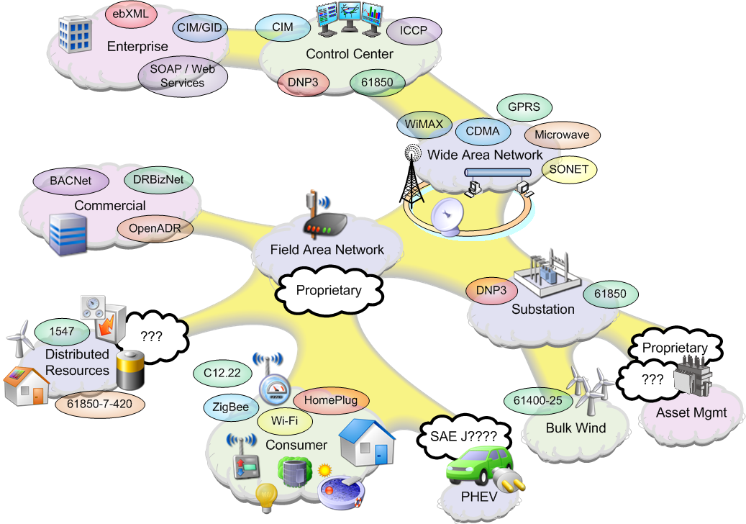
Figure 4: Domain Decomposition

Cross-cutting Decompositions

Figure 4 shows the utility landscape decomposed into discrete domains, not intending to be all-inclusive. Those domains include the Enterprise (Integration), Control Center (Local Area Network), Wide Area Network, Substation (Area Network), Field Area Network, Consumer (Home area Network) and Distributed Resources. Most of the existing systems that utilities use for their business have been designed, tendered, installed and operated for a single application. The most common application that may cross operational and communications domains is a supervisory control and data acquisition (SCADA) system, which is used by a control center to operate elements in the substation domain across a wide area network. Despite this internal stratification, a significant amount of utility research and development effort has been devoted to advanced applications, usually with the presumption of some sort of high-speed communications network being available. Examples of these applications are a broadly deployed power quality monitoring and control system or a phasor measurement monitoring system. The former often requires feature-rich monitoring devices (large quantities of data, to the oscillographic level) and extremely high-speed communications to leverage the system under operational conditions (sub-second to minutes). The latter may represent fewer data elements, but still necessitates high-speed communications with low total elapsed time (latency) for its most useful applications of system protections (a few seconds) to system state calculation (a few minutes).

As much as the utility business is still composed of internal silos of operation, the product domain exhibits the same characteristics. It is rare for companies to have a broad portfolio of solutions for more than two of the domains. Even if one abstracts the problem further, one finds the standards and user communities also typically focus their efforts on one domain, one integrated solution, or one particular product or suite of products.

AMI communication technologies
Vendors are currently building “last mile” AMI communications solutions around five technologies: wireless star, wireless mesh, power line carrier (PLC), broadband over power line (BPL), and fiber optics. Wireless star technologies are available in both licensed (200 MHz, 900MHz) and unlicensed spectra (900 MHz, 2.4GHz). Advantages of licensed technology include greater allowable transmission power (2 Watts vs. 1 Watt) and blocking of interference sources. The principal disadvantage is the need to obtain a jurisdiction-by-jurisdiction license to operate. The desired frequency may also have been already allocated. Advantages of unlicensed technology are elimination of licensing requirements due to the use of the “free” spectra and more choices in which set of frequencies to use within the spectral bands. These two aspects often offset the potential interference and lower allowable transmission power.
For wired technologies, the principal hurdle is propagation of the signal across power system equipment such as transformers. Transformers act as natural filters to the radio frequency signal. Another difficulty is maximizing the the bi-directional communication rate. For BPL technologies, the communications rate is solved by choice of the frequency band; however, power line communications equipment often interferes with other wireless communication technologies (amateur radio).
None of the above limitations apply to fiber optic technologies. However, it is often difficult to cost justify “fiber to the home” for a single purpose use (such as advanced metering). Smaller utilities such as municipalities have sometimes successfully invested in this medium as they may then be able to offer cable television, phone service, and internet service first (depending on competitive legal issues) with enough bandwidth still remaining for their utility operations.
The major disadvantage of wired technologies is that they are often incompatible with water and gas meters due to their use of the electrical distribution wires as the transmission media. A wireless technology is needed to reach any device not receiving electric service. Sometimes utilities will adopt a hybrid approach, utilizing different technologies to accomplish heterogeneous functional objectives.

NERC CIP Standards
The North American Electric Reliability Corporation (NERC) Critical Infrastructure Protection (CIP) Standards received the force of law in 2008 when the Federal Energy Regulatory Commission (FERC) approved their use. These standards dictate measures utilities must take in identifying and protecting Critical Cyber Assets. However, jurisdictional issues complicate the matter for distribution-oriented smart grid technologies such as AMI.
The primary point of contention over whether or not the CIP Standards should apply to AMI has to do with one of the criteria explicitly delineated as requiring consideration for designation as a Critical Asset. CIP 002 states that utilities shall give consideration to “systems and facilities critical to automatic load shedding under a common control system capable of shedding 300 MW or more.” If an AMI deployment includes integrated disconnects in the meters, this threshold is easily surpassed by distribution networks even in the 100,000 home range. For larger deployments with significant demand response program enrollment, it is possible this threshold may even be surpassed without disconnects in the equation.
The take-away point here is that significant smart grid technology deployments such as distribution automation or advanced metering have the ability to dramatically affect load if compromised and used improperly or for malicious intent. Further, the automation capabilities of these systems may provide the ability to drop load suddenly or rapidly enough to impact overall system stability, including causing problems for transmission and generation, and possibly even causing a cascading blackout. This is a case of technological development having simply outpaced the relevant regulatory structures.
By law, NERC has jurisdiction over generation and transmission as they frequently involve interstate commerce. On the other hand, most distribution technologies including AMI do not involve interstate commerce, and therefore fall under the purview of individual state utility commissions. As of this writing, the NERC CIP Standards do not apply to AMI or any other smart grid technology deployed in the distribution domain.

Technology Enumeration
A non-exhaustive list of technologies that straddle the identified decomposition is enumerated below.
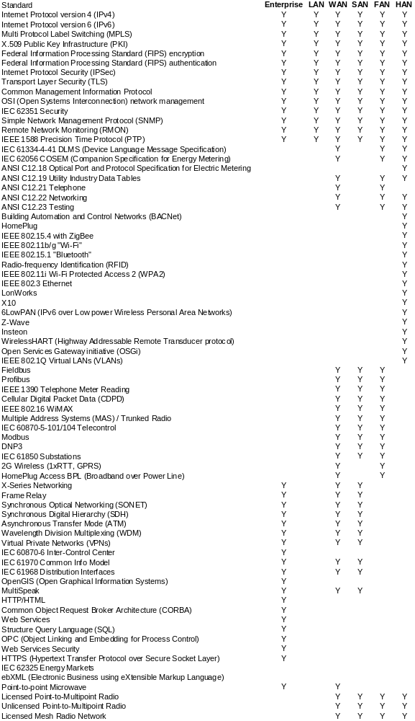

Issues
The electrical utility industry must overcome the following challenges to make the Smart Grid a reality:
- Deployment of technologies still under development. Although most of the technologies necessary to build the Smart Grid already exist, most of them have not been mapped into the electric power domain. Products for cost-effectively applying some of these technologies in the power system have only become available in the past few years. Due to the nascent state of product availability and pressures to deploy Smart Grid technologies, utilities right now often need to work in partnership with vendors to define requirements, provide design feedback and evaluate prototypes. After downsizing and deregulation, many utilities do not have the research and development resources available to make this happen.
The pressures of rapidly deploying smart grid technologies and being first-to-market also generate particular concerns for security – both in the short and long term. Knowledge of how to develop secure embedded technology is a scarce and expensive commodity, and neither of these attributes mesh well with a high-pressure, get-it-done-now approach. As a result, many technologies are being deployed with numerous flaws that stem from a hurried and immature process.
Building the necessary controls for strong security into the production process takes time for the vendor and pressure from utility customers. The AMI-SEC Task Force has only recently finalized the first version of the AMI System Security Requirements document. Even once vendors start building product to the AMI-SEC guidance, it will take several months for this product to make it to the field and likely several more for the industry to work out any issues with interpretation of the guidance. In the meantime vendors are still making products and putting them into the field, setting up a potential need for a significant replacement effort at some point in the future to remove points of vulnerability.
- Lack of market power for smaller utilities. Deploying advanced technology is easier for bigger utilities for two reasons: firstly, they simply have more internal resources to apply to the project; and secondly, they must deploy to a larger number of sites and therefore can offer bigger incentives to vendors to implement the features they need. Smaller utilities do not have economies of scale, cannot offer large incentives and therefore must often take off-the-shelf technology. This may mean their Smart Grid projects are “not as smart”, or must be deferred because they are not yet cost-effective.
- Interoperability weak spots. Several of the key Smart Grid communications standards, notably ANSI C12, IEC 61850, and IEC 61968/61970 follow a similar pattern:
  - Committees have developed them over a long time, perhaps a decade or more, and the standards therefore represent heroic efforts on the part of multiple vendors to compromise. The fact that some of them exist at all is remarkable.
  - Nevertheless, the process in which they were developed means the standards contain options for most of the possible ways that vendors have implemented these utility applications over the years.
  - The standards therefore contain many implementation choices with few mandatory items, and implementations are difficult for utilities to specify without significant internal expertise.
  - Utilities use these standards in areas that have traditionally been dominated by single-vendor implementations, and for economic reasons unfortunately continue to be so dominated despite the use of the standards. Therefore, significant multi-vendor interoperability testing in real-world situations is slow to arrive and sometimes painful when it does.
  - In some cases, such as ANSI C12, no organization exists even to provide certification testing. Although it is less effective than true interoperability testing, certification would at least represent a major step toward interoperability.
  - Devices implementing the standard typically can establish basic communications and exchange simple information very easily. However, when trying to deploy more advanced functions, utilities discover that vendors follow differences in philosophy that cause them to not work well together. The GridWise Interoperability Framework [reference] would identify these philosophical differences as a lack of interoperability at the level of Semantic Understanding, Business Context, or Business Procedures.
The traditional solution for these problems is to let more time pass and let the standard mature. Implementers discover the weak spots in the standard and utility users eventually begin to demand more mandatory items. The industry eventually develops guidelines for implementation that restrict the number of ways a vendor can implement the standard to a minimum set. IEC 61850, for instance, is about to release a second edition closing many of the “holes” in the first specification, three years after the first edition.
However, the regulatory and economic realities of Smart Grid deployment mean that some utilities do not have the time to wait for the standards to mature. It may be necessary for groups of utilities to step in and impose guidelines for interoperability. Nevertheless, to do so assumes that someone knows what the best guidelines should be!
- Enterprise application integration. This area represents a particular interoperability weak spot because the current state of the art is an extremely manual, labor-intensive process that is very dependent on the utility’s existing information infrastructure and the utility’s business practices.
The two major standards players in this area, the IEC 61968/61970 CIM standards and MultiSpeak, approach these problems from different directions.
The CIM standards do not attempt to provide plug-and-play interoperability, but instead define a “tool kit” that can be used to develop a set of essentially new protocols. An analogy for this process is that CIM defines a common set of words, but utilities must create their own rules for creating sentences from these words. One utility’s implementation cannot talk to that of another utility if they have not worked together from the start of the project to define the same rules.
MultiSpeak, developed for and by smaller co-op utilities with no resources to develop their own protocols, takes the opposite approach. It rigidly defines an interface in a very clear manner but this interface does not take into account the possible variations of information infrastructure at the utility. Although it provides interoperability between vendors very quickly, its feature set is limited and not easy to expand.
The solution to these problems of course lies somewhere between these two extremes, and both technologies will likely migrate in that direction. However, the problem again is time.
- Lack of standard distribution LANs, especially wireless mesh and BPL. The distribution automation domain, also known as “access” or “last mile to the home”, is dominated by proprietary solutions to a classic engineering problem: deploying millions of endpoints requires an extremely low cost solution, but the area to be covered is huge with great variations in terrain that must be overcome. Furthermore, new distribution applications such as auto-restoration and remote downloading of firmware are demanding lower latency and higher bandwidth.
Dozens of vendors have applied themselves to this problem space, producing a variety of solutions, each hoping to be the “better mousetrap” technology that takes the industry by storm. Unfortunately, none has (yet) emerged as a clear leader. As long as this is the situation, there is little incentive for vendors to work together to develop a common standard.
Standards do exist in this domain, and many of them are promising. ADSL and television cable are already deployed to a large number of premises, and a great variety of cellular phone technologies are available. The new wireless technology WiMAX is an open standard and seems particularly promising. However, utilities remain skeptical about these technologies. This reluctance to deploy standards in the last mile occurs for a variety of reasons: they may not provide sufficient reliability, sufficient bandwidth, or sufficient coverage. The most important barrier, however, is the cost of deploying thousands or millions of endpoints. These endpoints can be extraordinarily problematic as well, as utilities sometimes find themselves in the situation that the last 2% of the customer base represents 20% (or more) of the cost to deploy working technology under the obligation-to-serve paradigm. Utilities may deploy these open standards to the neighborhood or collector level, but the last mile typically remains proprietary.
In addition to creating interoperability issues, proprietary protocols also are a security concern. In the security realm, technology is never known to be unbreakable. The best one can hope for is that the security holds up long enough to support a useful life for the technology. Use of proprietary protocols often fosters a false sense of security when the developers of the security scheme are the only ones who have had significant exposure and interaction with the protocol. This is also called “security by obscurity,” and is widely recognized as one of the weakest mechanisms for protecting valuable assets. The harsh realities of humanity mean that everyone is prone to mistakes and the limits of their own perspective. We are better off leveraging the benefit of scrutiny and analysis by numerous industry experts early and often in the development lifecycle. This kind of exposure only takes place in open standards based work.
The typical communications solution to a variety of proprietary physical layers is to use a common network layer or application layer to “bridge across” between technologies as illustrated in Figure 1. The clear leader in this area is the Internet Protocol suite, which has been doing just this type of bridging for several decades now. However, most of the existing proprietary last-mile technologies were designed for applications with low messaging requirements and have traded off bandwidth for low cost. They are not capable of dealing with either the extra bandwidth required by an IP-based solution, or with the underlying philosophy of the Internet technologies that permits any device to acquire bandwidth as needed at any time.
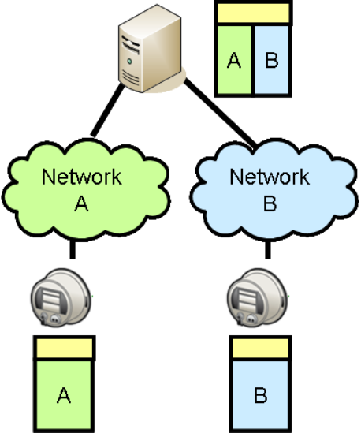
Figure 1 – Using a Common Upper Layer to Bridge Proprietary Networks
With this in mind, some vendors are offering Field LANs with an open standard application layer, namely ANSI C12.22 (including ANSI C12.19 data models). In theory, this would permit a Metering System using ANSI C12.22 to communicate over IP or variety of Field LANs with any device that also supports ANSI C12.22. Unfortunately, in practice, no such multi-vendor Metering System exists. The ANSI C12.22 standard permits so much flexibility in implementation that even Metering Systems that support ANSI C12.22 typically only support meters from the same vendor. Furthermore, using a metering standard, ANSI C12.22, as the only means of interoperability means that there are few non-meter devices that can use these networks.
So the solution needed in the last-mile domain is more bandwidth at lower cost. This will permit the deployment of standard IP-based protocols to the customer premise, and as an added benefit, to the pole-top. There are some signs that a few vendors will soon be able to meet these requirements.
- Too many HAN standards. In attempting to deploy Smart Grid applications such as AMI and DR to the home, utilities have necessarily entered the volatile home and building automation markets. These industries have implemented a huge variety of networking technologies, open and proprietary, wired and wireless. The leaders in this area include BACnet, HomePlug 6LowPAN and ZigBee, plus semi-proprietary solutions like LONtalk, Insteon, and Z-Wave; more traditional (but costly and power-hungry) open standards like Ethernet and Wi-Fi; and popular legacy protocols such as X10. Such diversity and lack of interoperability has presented difficulties to the vendors in these markets previously, but the problem has been exacerbated by the deployment of AMI and other Smart Grid applications. Utilities would prefer to implement a single networking technology across every premise in their service area, a possibility that was previously very unlikely in this market.
There are a few promising efforts in this area. First among these is the OpenHAN working group, which has defined a set of common requirements for HANs intended to be used by utilities. The next step in the OpenHAN process will be a common information model that could be carried over a variety of networking technologies. Second was the swift creation of the “Smart Energy” profile, an object model dedicated to electric utility functions, by the ZigBee Alliance. Another promising sign is the agreement between the ZigBee Alliance and HomePlug PowerLine Alliance to develop a common application layer across their respective wireless and broadband-over-power line technologies. All these efforts are being coordinated though the UtilityAMI organization.
However, any standards effort takes time. Utilities that must deploy customer-oriented Smart Grid applications right now are being forced to either commit to a particular technology, provide services only to customers who already have Internet access, or defer applications that require the use of a HAN until some future release. In the latter case, they may be faced with higher upgrade costs later.
- Gateway definition between utility and premise. Although EPRI and others have been studying the idea of a “consumer portal” for several years now, the technological shape of the gateway between the utility and each customer has never been well-defined. For instance, consider a system using ANSI C12 over the WAN and distribution LAN, and the ZigBee Smart Energy profile on customer premises. There is no specification that clearly defines how the functions of these two technologies should be mapped to one another. For instance, which object or message on the HAN implements a demand response event expressed in ANSI C12?
- Common information model. The lack of a gateway mapping definition is a special case of the lack of a common information model that reaches across all Smart Grid domains. For instance, a CIM message to generate an energy price event, transmitted in the enterprise domain, must be translated to an equivalent ANSI C12 message to travel across the WAN and Field LAN and then translated again to a corresponding ZigBee SE message before it reaches a thermostat in a consumer’s home. Such translation is necessary because there is typically no common network layer used across all domains, and generally not enough bandwidth to carry an enterprise message verbatim down to the thermostat even if there was. There is even less agreement on how such a message might be translated and sent to a pole-top distribution automation device using, for example, DNP3.
At the moment, each of these translation steps is completely ad hoc and vendor-specific because there is no agreement on a common object model that works in all domains. The CIM, as a data model specific to the enterprise domain, is a good starting point; and various parts of UtilityAMI are beginning the first steps of harmonizing it with other technologies, but there is much work to be done.
- Legacy transmission and distribution automation. Utilities that attempt to deploy Smart Grid applications universally across their service area must first deal with the automation they have already deployed. Most utilities have several “islands of automation” in place, developed on a project-by-project basis over the years. Automation projects have tended to be “spotty” and incomplete due to a lack of a business case, especially in the distribution environment. Now that the business environment for widespread automation is improved, system engineers must find ways to incorporate these legacy systems into the new Smart Grid.
An important factor is that many of the technologies used in these legacy systems are becoming obsolete and are no longer supported. The “technology time warp” in the power industry is such that many technologies considered “advanced” by utilities are already considered to be aging and on the way out in general computing environments. Examples of such technologies are SONET, Frame Relay, 10Mbit Ethernet, trunked radio and even leased telephone lines. Many older technologies, such as Bell 202 modems, are now essentially only found in utility automation. Smart Grid deployments must find a way to either integrate or replace these systems.
- Poor business cases in isolation, high initial investment when integrated. In the metering and distribution automation environments, basic Smart Grid functions tend to have poor business cases by themselves. Examples of such functions are simple automatic meter reading, or feeder fault location and auto-restoration. While nobody can deny their intrinsic value, these functions typically do not provide enough return on investment to justify building the communications networks needed to deploy them over a wide area.
Many early adopters of Smart Grid philosophy have discovered, however, that when several Smart Grid applications are deployed together, the integrated business case becomes viable. For instance, when basic meter reading is combined with meter-aided outage management, theft detection, and prepayment and/or real-time-pricing, it is easier to justify an AMI deployment. Similarly, when fault location is combined with phasor measurement and real-time state estimation, the business case for transmission or distribution automation becomes clearer.
Nevertheless, these more advanced features require bigger up-front investment. The higher initial investment of integrating advanced Smart Grid applications may present a challenge to many utilities.
- Merging organizations. One of the biggest challenges facing utilities wishing to implement Smart Grid automation is that these applications force previously isolated organizations to communicate with each other, and perhaps merge. Some examples include:
  - Merging SCADA and protection. For several years now, it has become apparent that substation automation using intelligent devices and modern LAN technology requires the integration of substation functions. Protection devices must be capable of control and monitoring, and SCADA devices must take some part in protection. Similarly, the parent organizations of these devices must learn to communicate with each other.
  - Merging IT and operations. As utilities deploy enterprise bus technologies, the traditional separation between corporate IT and utility operations organizations must narrow, especially to address security issues.
  - Merging metering and distribution automation. These two systems previously had nothing to do with each other although they shared a common geographic area of responsibility. Soon they will likely make use of a common, ubiquitous distribution communications network. Similarly, their respective organizations must now integrate operating procedures to realize some of the advantages of an integrated Smart Grid, such as advanced outage management.
  - Merging power and industry. As more customer-centric applications like real-time pricing, distributed generation and micro-grids are deployed; utilities must take more of an interest in the industrial automation world. What was previously a one-way relationship must become a partnership as customers become active contributors to the operation of the power system.
- Applying holistic security. Even if they applied to distribution-oriented Smart Grid technologies, the NERC Critical Infrastructure Protection (CIP) standards clearly specify that utilities must integrate information system security into all aspects of their automation systems: not just devices, computer systems and technologies but also policies, procedures, and training. This is sound practice and utilities would be well advised to follow this guidance even if the force of law does not apply. In order to be effective, utilities must apply these measures consistently and in an integrated fashion across their entire organization.
The Smart Grid vision of information flowing automatically throughout the utility provides great opportunities for efficiency, reliability and cost-effectiveness. However, it also provides many more opportunities for attackers. The challenge for most utilities will be to build their Smart Grid systems in an evolutionary fashion, integrating security, network management and data management into each Smart Grid application as it is deployed.

Best Practices
Within the scope of an AMI deployment, most utilities have re-discovered the value of a system engineering approach. Bringing together personnel from various groups impacted by the different aspects of metering (meters, communications, information technology, system planning, system operation, customer interface, maintenance, reliability, and business operations, to name a few) to discuss on an abstract level the use of such a system and capturing the responses via a “Use Case” is the first step. From these use cases, it is possible to eliminate spurious actors and requirements (both functional and non-functional) through the documentation step. Functional requirements and non-functional requirements are then enumerated. Further discussion with utility personnel allows them to target high-impact (low-hanging) returns, making for a solid business case. Applying a ranking system to the requirements provides the utility personnel a tool with which to evaluate the relative maturity of any technology with respect to the cross-paired requirements and business goals. The vendors are then given a clear signal against which to develop (or modify) candidate elements and systems to meet the utility needs.
While a laborious process, both sides (utility and vendor) derive considerable benefit. The utility has several points along the process against which to test both their system and goals and candidate technology. The vendors have a relatively static target that facilitates development investment and this static target also creates “vendor tension” – that is, competition – which the utility can leverage in either a performance or financial manner (or sometimes both).
The “Smart Grid” deployment will be a bit less concrete for many utilities than an AMI deployment. However, the same process will facilitate success in both grid operation and financial goals.

Legislation and Regulations
One area that is difficult to navigate is legislation and regulations. The utility space is rife with conflicting constraints, including obligation to serve, monopoly franchising, right-of-way obtention and defense, primary fuel source considerations, environmental, legal, rate of return, and many others. An example of this is provided by the attempt to mandate programmable, controllable thermostats (PCTs) in all new construction in California. These PCTs would enable the customer to determine a program that met their comfort and financial (and in some cases, environmental) goals, while providing utilities a touch point to limit peak demand (among other capabilities). Clearly non-discriminatory in application (all new houses were required to have one), however the perceived discrimination in operation (temperature and wind speed variance across a service territory might lead to a certain population “suffering” whilst another did not) provided a means to eliminate this law and regulation. One of the root causes of such vehement opposition is the flat consumption rate/tariff that is in place for the majority of electricity consumers. The fear of changing to another pricing model adds the potential for every single consumer to increase their cost of consumption. This is particularly unpalatable if one perceives others to be benefitting at one’s expense, no matter what the “greater good” might dictate.
Clearly there was no lack of vision in this example. Rather, the legislation was defeated by good counter-marketing press. As demand response, smart grids, and even AMI are difficult concepts for the general public to grasp, fear of change drives efforts to understand, accept and agree. A suggestion for strategy in the legislative and regulatory environment would be one of continual engagement with the general public at every stage. Communities of experts, such as those found collaborating in organizations such as GridWise Architecture Council and regulators in those such as the Mid-Atlantic Demand Response Initiative provide models for public engagement and leveraging the expertise in the industry.
As mentioned previously, cyber security also poses a particular challenge for legislation and regulation. While a uniform cyber security vision and strategy across the system may make sense from a technical standpoint, we face a hurdle in the way that our government is fundamentally structured. States still hold the trump card when it comes to legislation, and from a regulatory standpoint we operate more like 50 separate markets – each with their own rules and procedures. As long as state regulatory commissions determine how rates are figured, this issue is not likely to go away.

Solutions

The following annotated recommendations are offered to assist in crafting the smart grid standards landscape.
Standard Field LANs – Especially where “internet” technology is deployed, standard field LANs leverage existing network management tools and applications, allowing for reduced learning curves and minimizing special training. This would also allow utilities to create “vendor tension” to drive innovation.
Modems for Field LANs – Whether wired or wireless, some locations will require a connection not limited by the existing communications architecture (e.g., wireless mesh, wireless star, Ethernet) and application(s) and dedicated for the “smart grid” purpose; this is also a reasonable backup to a primary communications technology.
More field bandwidth – Single-purpose networks (e.g., AMI, SCADA, PMU monitoring) often are constrained where even a second application is precluded. It is rare that the realm of applications is known when hardware is deployed and this modest investment would allow innovation to flourish.
CIM Design Framework – The IEC 61968 or CIM standards are a loosely-defined semantic model for application-to-application integration. To date, only power system model exchanges have been tested for compatibility and interoperability. One of the challenges with this suite of standards is the choice of semantics is made by the user, within the limits of the standard. As such, only the fact that the messages conform to the semantic model can be verified. If different applications have employed different, yet compliant, choices, they may still be incompatible. The industry needs to be encouraged to tighten the allowable choices and offer an implementation guide. This would allow users to better develop interoperable applications.
CIM Application Security – The CIM standards are useless without applications and an integration layer across which information is exchanged. As such, there are no native security elements present. Instead, the native security of the applications and integration layer are used. Despite this, the standard’s developers need to be encouraged to develop guidelines for verifiable CIM application security.
CIM/61850 Harmonization – A gap analysis was performed and set of recommendations for harmonization between the CIM and IEC 61850 has been developed. The users group or other certified entity should be encouraged to develop the recommendations presented in the latest investigation.
IEC 61850 Outside Substation – This protocol standard suite offers a compliance test and a users group committed to mediating and validating compliance and interoperability for substation communications equipment. The IEC working group has begun to extend the standard to communications outside of the substation (e.g., hydroelectric plants in 61850-7-410 and DER devices in 61850-7-420) and to work on substation-to-substation communications.
ANSI C12 Guidelines – The ANSI metering protocol standards suffer from a lack of compliance tests as well as any means to demonstrate interoperable products, and this simply must change. Utilities should demand that the vendors in this market develop and demonstrate compliant and interoperable products.
Support of UtiliSec - The UtiliSEC Working Group of the Open Smart Grid Subcommittee of the UCAIug is charged with developing security guidelines, recommendations, and best practices for the Smart Grid. The AMI-SEC Task Force has produced an AMI Risk Assessment and System Security Requirements document, with a Component Catalog being populated and the AMI-SEC Implementation Guide in final revisions. Ultimately these documents will provide additional assurance not previously available within the utility industry. While not directly measurable, the working group provides a focal point for industry discussions on security as it relates to the Smart Grid where the interchange of information and lessons learned between utilities on security-related issues is vital to the overall growth of the community.
Asset Management – Already a key business element for many utilities, deployment of advanced communications infrastructure and smart grid devices will cause this problem to outgrow existing tools and management systems. However, that same infrastructure and smart devices will facilitate new systems in their efforts to perform true cradle-to-grave asset management. Whether certifying as-delivered functionality, monitoring the KPIs of the equipment during its operational life, or tracking maintenance and end-of-life information, this functionality is expected to greatly assist utility managers with minimizing operational and maintenance costs over the lifetime of utility assets.
Distributed Energy Resources – Existing distribution systems are designed with a source-to-sink power flow in mind. Protection equipment and schemes, voltage support equipment and schemes and other technical aspects assume a one-way power flow. Distributed energy resources, including generation and storage, require re-thinking and re-design of both power equipment and analytical software applications as they contain energy supply or what some would consider “reverse” power flow. Standards are in the works for modeling, operation and control of these devices, as well as protocols for defining them, but much of this may be revised once there is widespread deployment and integration of DER devices.
Plug-in Hybrid Electric Vehicles – Another area of concern are PHEVs. This is one technology which completely shatters the central generation to end-consumer power system model that is in operation today. Most aspects of these load and storage devices (in technical terms) are yet defined. Policies and regulations are also not quite complete and certainly business models for energy accounting are sorely lacking. There are several cross-industry groups assessing these gaps and proposing solutions. Utilities are attempting to prepare by obtaining advanced metering devices which are able to perform bi-directional energy accounting, by developing strategies around home area networks and information models, and investigating financial accounting strategies, but much of this work is incomplete.

Strategies
Three overarching strategies will prove useful when addressing the standards and technology. The first is a commitment to drive stakeholders from use of open standards to demonstrations of interoperability. Stagnation at the standards developer level can ruin a good standard (see IEEE 802.11.n and P1901). If compliance tests are not defined and moderated, the standards themselves are both too strict and too interpretable for each implementer. If interoperability tests are not defined and moderated, it is nearly impossible to provide any assurance of field compatibility.
A holistic approach (technical, communications, environment, regulation, security) is difficult but feasible. Clearly defined requirements in all of the areas allow system designers and integrators to develop, test and deploy solutions that have a chance for success.
Finally, simple single-entity rate of return is a poor measure of project value. Both positive and negative business cases exist for AMI-only projects. Few are indeed positive, unless there is also some other hidden benefit that favors the project such as a jump from all human-read to fully automatic reading, a significant existing communications infrastructure, or favorable population density or terrain. The systems engineering approach assists a utility with finding multiple benefit streams for a project deployment, and helps to eliminate the siloed or “my project” syndromes that plague many large projects in many industries. Third-party metrics such as the GridWise Architecture Interoperability Checklist provide an independent means for project teams to self-evaluate, leading to more transparent benefit derivation.

Requirements
For large systems such as AMI and “smart grid” deployment, it is not longer the case that a “boutique” approach is viable: purchasing the latest and “greatest” components and stitching them together to construct a system. The process is reasonable clear for determining and acting upon requirements:
- Legislation and regulations (and markets) will determine targets for Utilities
- Utilities will use specifications and standards (and proprietary information) to procure and deploy equipment from vendors, within the legislative and regulatory constraints
- Vendors will use specifications and standards (and utility information) to develop equipment
None of this approach is unknown; however, the final steps are not always followed:
- Appropriate parties should construct compliance tests (e.g., vendors and third parties)
- Appropriate parties should construct acceptance tests (e.g., utilities and vendors)
- Appropriate parties should construct interoperability tests (e.g., vendors, third parties and utilities)
- Appropriate parties should construct security tests (e.g., independent third parties and utilities)
Standards groups are ill-equipped to partake in these efforts as often the scope of the group or its ground rules preclude the open communication necessary to properly expose issues with technology as it is measured against the standard. However, the vendors participating in those groups are, with proper moderation and oversight, well-equipped to perform exactly these tasks. The other parties need to resist the “single vendor, end-to-end is better” which, while true initially, leads (and has lead) to incompatible products, poorly defined systems, and widespread buyer’s remorse in the utility industry.

Research
Research should be conducted to accelerate the development of standards that fill existing gaps including those for security, smart grid network and device management, information privacy management, and field area network interoperability. Appropriate private and public sector funding and organizations are needed to address these needs. Security, network and device management and field interoperability touch on both technology and policy, in that order. It is not enough to develop secure, manageable and interoperable technology if policies, rules and regulations inhibit its use in the power system.
Information privacy management also touches both policy and technology, though likely policy first. Best practices on developing policies are most likely not centered on the “terms of use” model from websites: long, legalese-filled missives that often inhibit understanding by the casual user. For example, this is an area where some discomfort may be found in the answer where the end-consumer is the owner of the data collected and permits the utility, and only that utility, to use that data to provide the service. Permission is not granted to release the information to any entity, regardless of situation. This is not the current model nor is this a proposed solution, rather an example of an issue regarding information privacy management. This particular subject area requires legal research as well, to examine what liability limits each party owns.

Conclusions and Recommendations
One of the key findings of this paper is that there are many mature standards and best practices already available that can be readily deployed to facilitate smart grid deployment. The main problem with adoption seems to be a lack of awareness of those standards by those involved in designing smart grid systems at a high level and a lack of clear best practices and regulatory guidelines for applying them. Of particular concern is an over-reliance on using standards as the “final” request to meet requirements. Often products conforming to standards fail to meet the hidden requirement of being truly interoperable in the context of a greater system.
Key recommendations include:
- Policy makers should utilize the DOE GridWise Architecture Interoperability Checklist to evaluate utility proposals for projects involving rate recovery.
- Regulations should be developed that encourage utilities and product vendors to support standards based technologies over proprietary solutions.
- Regulations should avoid mandating specific standards or technologies where possible in favor of specifying desired outcomes and important characteristics of the standards to be employed.
- Research should be conducted to accelerate the development of standards that fill existing gaps including those for security, smart grid network and device management, information privacy management, and field area network interoperability.

References and Recommended Reading
EPRI Technical Report: Integration of Advanced Automation and Enterprise Information Infrastructures: Harmonization of IEC 61850 and IEC 61970/61968 Models, EPRI, Palo Alto, CA 2006. Product ID 1013802.
G. R. Gray, “AMI Enterprise, A Framework For Standard Interface Development”, [Online]. Available: (link).
GridWise Architecture Council (http://www.gridwiseac.org/) Interoperability Checklist, [Online]. Available: http://www.gridwiseac.org/pdfs/gwac_decisionmakerchecklist.pdf
L. Philipson and H. L. Willis, Understanding Electric Utilities and De-Regulation, 2nd ed. Boca Raton: CRC Press, 2006.
H. L. Willis, Power Distribution Planning Reference Book, 2nd ed. Boca Raton: CRC Press, 2004.
NERC Copyright Policy. [Online]. http://www.nerc.com/%5Cfileuploads%5Cfile%5Caboutnerc%5CCopyright_notice.pdf
Journalist’s Guide to the Federal Courts Glossary, [Online}. http://www.uscourts.gov/journalistguide/glossary.html

Glossary
ADSL Asymmetric Digital Subscriber Line
ATM Asynchronous Transfer Mode
BACnet Building Automation and Control Networks data communication protocol
BAN Building Area Network – synonym for HAN
BPL Broadband over Power Line
CDMA Code Division Multiple Access
CIM Common Information Model
CIS Customer Information System
DMS Distribution Management System
DNP Distributed Network Protocol
DOCSIS Data Over Cable Service Interface Specification
DRbizNet Demand Response Business Network
ebXML Electronic Business using eXtensible Markup Language
EMS Energy Management System
FAN Field Area Network
GID Generic Interface Definition
GPRS General Packet Radio Service
HAN Home Area Network
ICCP Inter Control Center Protocol
LAN Local Area Network
MPLS Multiprotocol Label Switching
OMS Outage Management System
PAN Premise Area Network – synonym for HAN
PC Personal Computer
PHEV Plug-in Hybrid Electric Vehicle
PLC Powerline Carrier
SAE Society of Automotive Engineers
SAN Substation Area Network
SCADA Supervisory Control and Data Acquisition
SOAP Simple Object Access Protocol
SONET Synchronous Optical Networking
WAN Wide Area Network
WDM Wave-division Multiplexing
WiMAX Worldwide Interoperability for Microwave Access
WMS Work Management System

Journalist’s Guide to the Federal Courts: “Something that exists in fact but not as a matter of law.”
Journalist’s Guide to the Federal Courts: “Something that exists by operation of law.”
“Utilities ZigBee and HomePlug join forces to create wired HAN Standard,” http://zigbee.org/imwp/idms/popups/pop_download.asp?contentID=13867
http://www.wi-fi.org/
http://www.usb.org/
[Online]. Available: www.grid-interop.com/2008/
49 U.S.C., Subtitle VI, Part C, Chapter 329, §32902, 32904
MVA: Mega Volt Amperes
Used with permission. [Online]. http://www.nerc.com/fileUploads/File/AboutNERC/maps/NERC_Interconnections_color.jpg
Used with permission. [Online]. http://www.nerc.com/fileUploads/File/AboutNERC/maps/NERC_Regions_color.jpg
[Online]. Available: www.nerc.com
kV: kilo Volts
Willis, p. 11, Table 1.3.
Example: IEC 61970 and IEC 61868 suites of standards.
Wikipedia, “OSI model”
Adopted from Gray, “AMI Enterprise, A Framework For Standard Interface Development”
{Online}. Available: http://grouper.ieee.org/groups/scc21/
[Online]. Available: http://www.iec.ch/dyn/www/f?p=102:17:0::::FSP_SEARCH_TC:8
Environmental Protection Agency and the Department of Energy
http://osgug.ucaiug.org/default.aspx
http://drrc.lbl.gov/openadr/
EPRI 1013802, Chapter 5.

