SG Network System Requirements Specification
Interim Release 3

5/17/2010

Table of Contents

Document History - 3 -
Revision History - 3 -
Preface - 4 -
Authors - 6 -
Acknowledgements - 7 -
Acronyms and Abbreviations - 8 -
Definitions - 11 -
SG-Network Requirements Gathering process - 15 -
Listing of pertinent use cases - 16 -
Identification of Actors within Use Cases - 17 -
Gap analysis by mapping actors to use cases - 18 -
Defining Functional Requirements - 19 -
Smart Grid Domain, Actor, Interface Reference Model - 21 -
Diagram 1 – Baseline Diagram Without Cross Domain & Network DataFlows - 22 -
Diagram 2 – Baseline Diagram With Cross Domain & Network flows - 23 -
Table 1 – Smart Grid Functional & Volumetric Business Requirements - 24 -
Diagram 3 – Customer Information / Messaging Use Case - 25 -
Diagram 4 – Distribution Automation Use Case - 26 -
Diagram 5 – Meter Read Use Case - 27 -
Diagram 6 – PHEV Use Case - 28 -
Diagram 7 – PrePay Use Case - 29 -
Diagram 8 – Service Switch - 30 -
Diagram 9 – Utility CIS <-> Meter Communication Path Scenarios - 31 -
Diagram 10 – IPD & Cust. EMS <-> Meter Communication Path Scenarios - 32 -
Diagram 11 – Web Portal <-> ODS Communication Path Scenarios - 33 -
Diagram 12 – Utility CIS <-> IPD Communication Path Scenarios - 34 -
Diagram 13 – REP CIS <-> IPD Communication Path Scenarios - 35 -
Diagram 14 – DMS <-> DA Feeder Devices Communication Path Scenarios - 36 -
Diagram 15 – DMS <-> DA Substation Devices Communication Path Scenarios - 37 -

Document History

Revision History

Revision Number | Revision Date | Revision  By | Summary of Changes | Changes marked
1.01 |  |  | Documented shell created | N
1.02 | 2/16/10 | MKG | Result from 2/16/10 conference call | N
1.03 | 2/16/10 | Armes/MKG | Cleaned up definitions and acronyms | N
1.04 | 2/16/10 | MKG | Added TOC and Draft Preface | N
1.05 | 2/22/10 | MKG | Added Requirements specification info | N
1.06 | 2/22/10 | MKG | Clerical updates to links to work | N
2 | 2/22/10 | MKG | Updated version number for release | N
3 rc1 | 4/17/10 | MKG/RTC | Updated Use case flow charts and diagrams | N
3 rc3 | 4/17/10 | RTC | Added links to documentation instructions | Y
3 rc5 | 4/18/10 | MKG | Added acknowledgements and minor edits. Made images/illustrations portrait versus landscape | N

Preface
This document has been created to support NIST Smart Grid Interoperability Priority Action Plans (PAP) 1 & 2 and provide Utilities, Vendors and Standard Development Organizations a system requirements specification for Smart Grid Communication.

For PAP 1 the tasks assigned to UCAiug (SG-Network) are as follows:

Task 1: Develop a set of requirements for different Smart Grid applications

For PAP 2 the tasks assigned to UCAiug (SG Network) are as follows:

Task 1: Segment the smart grid and wireless environments into a minimal set of categories for which individual wireless requirements can be identified.

Task 3: Compile & communicate use cases and develop requirements for all smart grid domains in terms that all parties can understand.

Task 4: Compile and communicate a list of capabilities, performance metrics, etc. in a way that all parties can understand. - Not quantifying any standard, just defining the set of metrics.

To accomplish these assignments, the UCAiug Open Smart Grid (OpenSG) has assigned these tasks to a task force within the SG Communications working group called SG Network to formally work on these tasks.

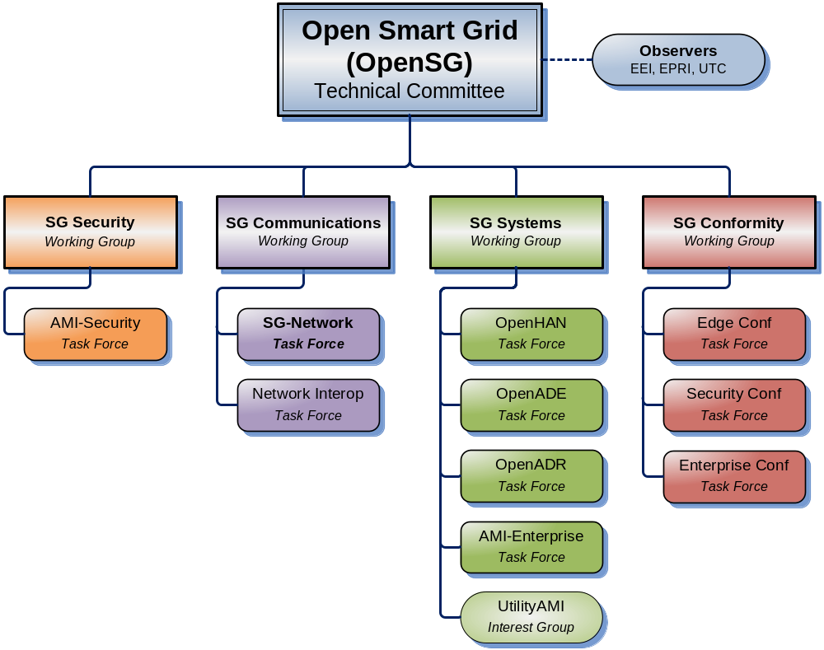

Authors
The following individuals and their companies are members of the OpenSG SG-Network Task Force Core Development Team and contributed substantially to the drafting of the SG-Network System Requirement Specification:

Ron Cunningham, American Electric Power
Matt Gillmore, Consumers Energy
Bill Godwin, Progress Energy
Michael Northern, Deloitte Consulting LLP
Don Sturek, Pacific Gas & Electric
Vincent Bemmel, Trilliant
Paul Duffy, Cisco
Claudio Lima, Sonoma Innovations
Bill Leslie, Longboard Technologies
Jerry Armes, Micronet Communications
Gary Stuebing, Duke Energy
George Cosio, Florida Power & Light
David Pilon, Detroit Edison
Kelly Flowers, Detroit Edison
John Buffington, Itron

Acknowledgements
The content delivered by the SG-Network task force would not be possible without feedback and consensus from the overall industry. Listed below are individuals who have provided substantial feedback and guidance to SG-Network.

Nada Golmie, NIST
David Cypher, NIST
David Su, NIST
Erich Gunther, Enernex
Mark Kleerer, Qualcomm
Pat Kinney, Kinney Consulting
Bruce Kraemer, Marvell
Wayne Longcore, Consumers Energy
Geoff Mulligan, IPSO Alliance
Robby Simpson, GE Energy
Phil Slack, Florida Power & Light

Acronyms and Abbreviations

AC | Alternating Current
AMI | Advanced Metering Infrastructure
AMS | Asset management system
ASAP-SG | Advanced Security Acceleration Project-Smart Grid
B2B | Business to Business
BAN | Business Area Network
CIM | Common Information Model.
CIP | Critical Infrastructure Protection
CSWG | Cyber Security Working Group
DA | Distribution Automation
DAP | Data Aggregation Point
DER | Distributed Energy Resources
DHS | Department of Homeland Security
DMS | Distribution Management System
DNP | Distributed Network Protocol
DOE | Department of Energy
DOMA | Distribution Operations Model and Analysis
DR | Demand Response
DSDR | Distribution Systems Demand Response
DSM | Demand Side Management
EMS | Energy Management System
EPRI | Electric Power Research Institute
ES | Electric Storage
ESB | Enterprise Service Bus
ESI | Energy Services Interface
ET | Electric Transportation
EUMD | End Use Measurement Device
EV/PHEV | Electric Vehicle/Plug-in Hybrid Electric Vehicles
EVSE | Electric Vehicle Service Element
FAN | Field Area Network
FEP | Front End Processor
FERC | Federal Energy Regulatory Commission
FIPS | Federal Information Processing Standard Document
FLIR | Fault Location, Isolation, Restoration
G&T | Generations and Transmission
GAPP | Generally Accepted Privacy Principles.
GIS | Geographic Information System
GPRS | General Packet Radio Service
HAN | Home Area Network
HMI | Human-Machine Interface
HVAC | Heating, Ventilating, and air conditioning (shown in figure)
I2G | Industry to Grid
IEC | International Electrotechnical Commission
IED | Intelligent Electronic Device
IHD | In-home Display
ISA | International Society of Automation
ISO | Independent System Operator
ISO/IEC27001 | International Organization for Standardization/International Electrotechnical Commission Standard 27001.
IT | Information Technology
LAN | Local Area Network
LMS | Load management system
LMS/DRMS | Load Management System/ Distribution Resource Management System
LV | Low voltage (in definition)
MDMS | Meter Data Management System
MFR | Multi-Feeder Reconnection
MSW | Meter service switch
MV | Medium voltage (in definition)
NAN | Neighborhood Area Network
NERC | North American Electric Reliability Corporation
NIPP | National Infrastructure Protection Plan
NIST | National Institute of Standards and Technology
NISTIR | NIST Interagency Report
NMS | Network Management system
OMS | Outage Management System
OWASP | Open Web Application Security Project
PAP | Priority Action Plan
PCT | Programmable Communicating Thermostat
PEV | Plug-In Electric Vehicle
PI | Process Information
PIA | Privacy Impact Assessment. .
PII | Personally Identifying Information
R&D | Research and Development
RTO | Regional Transmission Operator
RTU | Remote Terminal Unit
SCADA | Supervisory Control and Data Acquisition
SCE | Southern California Edison
SGIP | Smart Grid Interoperability Panel
SGIP-CSWG | SGIP – Cyber Security Working Group
SP | Special Publication
SSP | Sector-Specific Plans
T/FLA | Three/Four Letter Acronym
VAR | Volt-Amperes Reactive
VVWS | Volt-VAR-Watt System
WAMS | Wide-Area Measurement System
WAN | Wide Area Network
WASA | Wide Area Situational Awareness
WLAN | Wireless Local Area Network
WMS | Work Management System

Definitions

Actor | A generic name for devices, systems, or programs that make decisions and exchange information necessary for performing applications: smart meters, solar generators, and control systems represent examples of devices and systems.
Anonymize | A process of transformation or elimination of PII for purposes of sharing data
Aggregation | Practice of summarizing certain data and presenting it as a total without any PII identifiers
Aggregator | SEE FERC OPERATION MODEL
Applications | Tasks performed by one or more actors within a domain.
Asset Management System | A system(s) of record for assets managed in the Smart Grid. Management context may change(e.g. financial, network)
Capacitor Bank | This is a device used to add capacitance as needed at strategic points in a distribution grid to better control and manage VARs and thus the Power Factor and they will also affect voltage levels.
Common Information Model | A structured set of definitions that allows different Smart Grid domain representatives to communicate important concepts and exchange information easily and effectively.
Common Web Portal | Web interface for Regional Transmission Operator, customers, retail electric providers and transmission distribution service provider to function as a clearing house for energy information. Commonly used in deregulated markets.
Data Collector | See Substation Controller
Data Aggregation Point | This device is a logical actor that represents a transition in most AMI networks between Wide Area Networks and Neighborhood Area Networks. (e.g. Collector, Cell Relay, Base Station, Access Point, etc)
De-identify | A form of anonymization that does not attempt to control the data once it has had PII identifiers removed, so it is at risk of re-identification.
Demand Side Management | A system that co-ordinates demand response / load shedding messages indirectly to devices (e.g. Set point adjustment)
Distribution Management System | A system that monitors, manages and controls the electric distribution system.
Distribution Systems Demand Response | A system used to reduce load during peak demand. Strictly used for Distribution systems only.
Electric Vehicle/Plug-in Hybrid Electric Vehicles | Cars or other vehicles that draw electricity from batteries to power an electric motor. PHEVs also contain an internal combustion engine.
Energy Services Interface | Provides security and, often, coordination functions that enable secure interactions between relevant Home Area Network Devices and the Utility. Permits applications such as remote load control, monitoring and control of distributed generation, in-home display of customer usage, reading of non-energy meters, and integration with building management systems. Also provides auditing/logging functions that record transactions to and from Home Area Networking Devices.
Enterprise Service Bus | The Enterprise Service Bus consists of a software architecture used to construct integration services for complex event-driven and standards-based messaging to exchange meter or grid data. The ESB is not limited to a specific tool set rather it is a defined set of integration services.
Fault Detector | A device used to sense a fault condition and can be used to provide an indication of the fault.
Field Force | Employee working in the service territory that may be working with Smart Grid devices.
GAPP | Generally Accepted Privacy Principles. Privacy principles and criteria developed and updated by the AICPA and Canadian Institute of Chartered Accountants to assist organizations in the design and implementation of sound privacy practices and policies.
Home Area Network | A network of energy management devices, digital consumer electronics, signal-controlled or enabled appliances, and applications within a home environment that is on the home side of the electric meter.
Intelligent Fault Detector | A device that can sense a fault and can provide more detailed information on the nature of the fault, such as capturing an oscillography trace.
ISO/IEC27001 | An auditable international standard that specifies the requirements for establishing, implementing, operating, monitoring, reviewing, maintaining and improving a documented Information Security Management System within the context of the organization's overall business risks. It uses a process approach for protection of critical information
Last Gasp | Concept of an energized device within the Smart Grid detecting power loss and sending a broadcast message of the event.
Load Management System | System that controls load by sending messages directly to device (e.g. On/Off)
Low Voltage Sensor | A device used to measure and report electrical properties (such as voltage, current, phase angle or power factor, etc.) at a low voltage customer delivery point.
Medium Voltage Sensor | A device used to measure and report electrical properties (such as voltage, current, phase angle or power factor, etc.) on a medium voltage distribution line.
Motorized Switch | A device under remote control that can be used to open or close a circuit.
Neighborhood Area Network | A network comprised of all communicating components within a distribution domain.
Network Management System | A system that manages Fault, Configuration, Auditing/Accounting, Performance and Security of the communication. This system is exclusive from the electrical network.
Outage Management System | A system that receives out power system outage notifications and correlates where the power outage occurred
Personal Information | Information that reveals details, either explicitly or implicitly, about a specific individual’s household dwelling or other type of premises. This is expanded beyond the normal "individual" component because there are serious privacy impacts for all individuals living in one dwelling or premise. This can include items such as energy use patterns or other types of activities. The pattern can become unique to a household or premises just as a fingerprint or DNA is unique to an individual.
Phase Measuring Unit | A device capable of measuring the phase of the voltage or current waveform relative to a reference.
Power Factor | A dimensionless quantity that relates to efficiency of the electrical delivery system for delivering real power to the load. Numerically, it is the Cosine of the phase angle between the voltage and current waveforms. The closer the power factor is to unity the better the inductive and capacitive elements of the circuit are balanced and the more efficient the system is for delivering real power to the load(s).
Privacy Impact Assessment | A process used to evaluate the possible privacy risks to personal information, in all forms, collected, transmitted, shared, stored, disposed of, and accessed in any other way, along with the mitigation of those risks at the beginning of and throughout the life cycle of the associated process, program or system
Programmable Communicating Thermostat | A device within the premise that has communication capabilities and controls heating, ventilation and cooling systems.
Recloser (non-Team) | A device used to sense fault conditions on a distribution line and trip open to provide protection. It is typically programmed to automatically close (re-close) after a period of time to test if the fault has cleared. After several attempts of reclosing it can be programmed to trip open and stop trying to reclose until reset either locally or under remote control.
Recloser (Team) | A device that can sense fault conditions on a distribution line and to communicate with other related reclosers (the team) to sectionalize the fault and provide a coordinated open/close arrangement to minimize the effect of the fault.
Regional Transmission Operator | A Regional Transmission Organization (RTO) is an organization that is established with the purpose of promoting efficiency and reliability in the operation and planning of the electric transmission grid and ensuring non-discrimination in the provision of electric transmission services based on the following required/demonstrable characteristics and functions.
Remote Terminal Unit | Aggregator of multiple serialized devices to a common communications interface
Sub Meter | Premise based meter used for Distributed Energy Resources and PHEV. This device may be revenue grade.
Substation Controller | Distributed processing device that has supervisory control or coordinates information exchanges from devices within a substation from a head end system.
Transformer (MV-to-LV) | A standard point of delivery transformer. In the Smart Grid context is it assumed there will be a need to measure some electrical or physical characteristics of this transformer such as voltage (high and/or low side) current, MV load, temperature, etc.
Use Case | Use cases are a systems engineering tool for defining a system’s behavior from the perspective of users. In effect, a use case is a story told in structure and detailed steps—scenarios for specifying required usages of a system, including how a component, subsystem, or system should respond to a request that originates elsewhere.
Voltage Regulator | This device is in effect an adjustable ratio transformer sitioned at strategic points in a distribution grid and is utilized to better manage and control the voltage as it changes along the distribution feeder.
VAR – Volt-Amperes Reactive; | In an AC power system the voltage and current measured at a point along the delivery system will often be out of phase with each other as a result the combined effects of the resistive and reactive (i.e. the capacitance and inductive) characteristics of the delivery system components and the load. The phase angle difference at a point along the delivery system is an indication of how well the inductive and capacitive effects are balanced at that point. The real power passing that point is the product of the magnitude of the Voltage and Current and the Cosine of the angle between the two. The VAR parameter is the product of the magnitude of the Voltage and Current and the Sine of the angle between the two. The magnitude of the VAR parameter is an indication of the phase imbalance between the voltage and current waveforms.
Web Portal | Interface between energy customers and the system provider. Could be the utility or third party

SG-Network Requirements Gathering process

The SG-Network task force derived functional requirements from the following process:
- Listing of pertinent use cases
- Identification of Actors within use cases
- Gap analysis by mapping actors to use cases
- Defining Functional Requirements
  - Requirement actor to actor
  - Estimated payload
  - Expected latency
  - Expected Reliability
  - Security Requirements
    - Low, Medium, High per NISTIR 7628
  - Implications of failure

- Smart Grid Domain, Actor, Interface reference diagram
  - Illustrative diagram of requirements

Listing of pertinent use cases

In order to create a list of functional requirements for the Smart Grid, an exercise was performed to list all pertinent use cases that involve network communication. Sources for this information include the Southern California Edison Use Cases, Grid Wise Architectural Console use cases, EPRI and others. Use cases from all of these sources were selected based upon a network requirements basis. From this research the following high level use cases have been identified.
Smart Grid Use Case | Requirements Derived | Requirements included in release 3.0
Meter Read | Yes | Yes
Direct load control | In progress | No
Service Switch | Yes | Yes
PHEV | Yes | Yes
System updates | In progress | No
Distributed GEN | In progress | No
Distributed Storage | Draft | No
Outage Events | Yes | Yes
Tamper Events | Draft | No
Meter Events | Draft | No
Demand Response | Draft | No
Pre-Pay Metering | Yes | Yes
Field Force tools | Not started | No
Distribution automation support | Yes | Yes
Transmission automation support | Not started | No
Pricing TOU / RTP/ CPP | in progress | No
Configuration mgmt | in progress | No
Accounting Mgmt | in progress | No
Performance Mgmt | in progress | No
Security mgmt | in progress | No
Fault mgmt | in progress | No
Volt/VAR Management | Yes | Yes

The “Requirements Derived” Column of the above table shows that requirements have been produced for the use case. However the requirements will not be submitted for wider audiences until they have been fully vetted. Requirements that are fully vetted have a “Yes” in the “Requirements Fully Vetted” column.

Identification of Actors within Use Cases

After the use cases were identified. Members of SG Network reviewed the existing use cases from the industry and defined the actors. While doing this exercise the actors were also added to architectural domains:

Actor | Domain
Meter Data Management System | Operations
Asset Management System | Operations
Energy Management System | Operations
Demand Side Management System | Operations
Event / OMS System | Operations
Distribution Management System | Operations
Load Management System | Operations
Supervisory Control and Data Acquisition System | Operations
Geospatial Information System | Operations
Network Management System | Operations
Head End System | Operations
Capacitor Bank | Distribution
Voltage Regulator | Distribution
Meduim Voltage Sensor | Distribution
Recloser Teamed | Distribution
Recloser Not Teamed | Distribution
Phase Measuring Unit | Distribution
Fault Detector | Distribution
Data Aggregation Point | Transmission and Distribution
Smart Meter | Customer
Energy Services Interface | Customer
In Home Display | Customer
Customer Information System | Service Provider
Customer Information System 3rd Party | Service Provider

Gap analysis by mapping actors to use cases
Having collected a list of actors and use cases, the gab analysis was conducted by mapping actors to use cases. The exercise involved a review of each selected use case and mapping which actors apply. Below is an example of this process for Meter Reading.

Actor | Domain | Use Case: Meter Reading
Meter Data Management System | Operations | Yes
Asset Management System | Operations | No
Energy Management System | Operations | No
Demand Side Management System | Operations | No
Event / OMS System | Operations | No
Distribution Management System | Operations | No
Load Management System | Operations | No
Supervisory Control and Data Acquisition System | Operations | No
Geospatial Information System | Operations | No
Network Management System | Operations | No
Head End System | Operations | Yes
Capacitor Bank | Distribution | No
Voltage Regulator | Distribution | No
Medium Voltage Sensor | Distribution | No
Recloser Teamed | Distribution | No
Recloser Not Teamed | Distribution | No
Phase Measuring Unit | Distribution | No
Fault Detector | Distribution | No
Data Aggregation Point | Transmission and Distribution | Yes
Smart Meter | Customer | Yes
Energy Services Interface | Customer | Yes
In Home Display | Customer | Yes
Customer Information System | Service Provider | Yes
Customer Information System 3rd Party | Service Provider | Yes

Defining Functional Requirements
The process of requirements gathering has been evolutionary in nature. The SG Network task force has defined over 800 functional requirements while reviewing the use cases identified previously. The group intends to release versions of requirements over time in order to keep scope and focus attainable yet giving consumers of this information something to work with and provide feed back.

The requirements have been captured in a spreadsheet that matches the version of this document. A partial description of the spreadsheet and its columns are below. For a more complete description, refer to the latest version of the “Requirements Documentation Instructions” located in the SG-Network Task Force webpage folder

http://osgug.ucaiug.org/UtiliComm/Shared%20Documents/Interium_Release_3/

Rqmt Ref – This column is a reference to the original worksheet line number the requirement originally defined

Data-Flow Ref – This column is a reference to the architectural reference models lines between actors shown illustratively in this document and attached to this work as a separate file

Data Flow From Actor – This column indicates the actor that is considered the sender of information noted in the Requirements Column

Data Flow to Actor – This column indicates the actor that is considered the desired recipient of the information noted in the Requirements Column

Requirements – This column is the actual application requirement. Words like “shall” in this column are to be considered required, while words like “may” should be considered optional

Payload Name – This column explains the scenario type of the requirement derived from the use case. (e.g. Bulk, On Demand for meter reading)

Candidate NIST LIC – Derived and mapped to the NISTIR document 7628

Security Confidentiality – Derived and mapped to the NISTIR document 7628

Security Integrity – Derived and mapped to the NISTIR document 7628

Security Availability – Derived and mapped to the NISTIR document 7628

Latency - Summation of the node processing time and network time from the originating payload actor to the consuming actor

Reliability - The probability that an operation will complete without failure over a specific period or amount of time.

Payload Size Type – This column indicates whether the payload is native (encoded in a compact format), intgrt (encoded in an API or web service format) or Display (encoded in a format for a user interface)

App Payload Size – This column is an estimation of how many bytes are needed for the requirement as actual payload.

Implications – This column is an attempt to explain the impacts of the requirements not being met for the operator of the system.

Smart Grid Domain, Actor, Interface Reference Model
In these section a few illustrative diagrams are included to help the reader of this document to understand the content. These files are also available for reference at the following location:

The reference model diagrams locations are in the SG-Network TF webpage folder:
http://osgug.ucaiug.org/UtiliComm/Shared%20Documents/Interium_Release_3/Diagrams

The SG-Network functional requirements table location is:

http://osgug.ucaiug.org/UtiliComm/Shared%20Documents/Interium_Release_3/SG-Net_TF_%20funct-volumteric-reqs_v3.xls

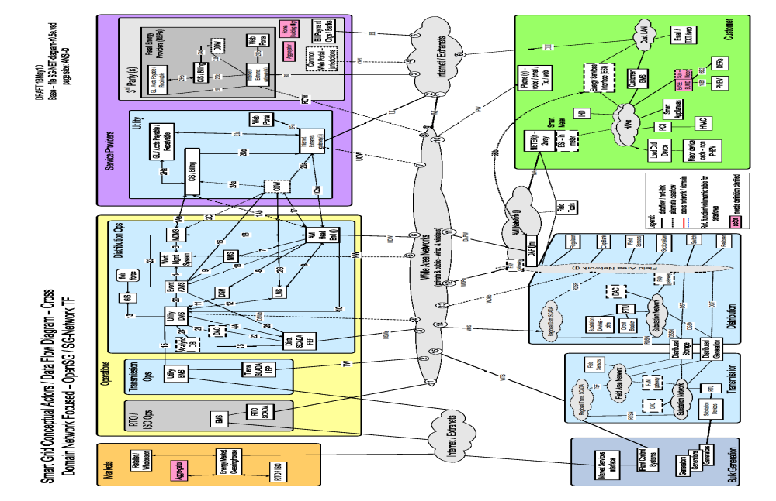

Diagram 1 – Baseline Diagram Without Cross Domain & Network

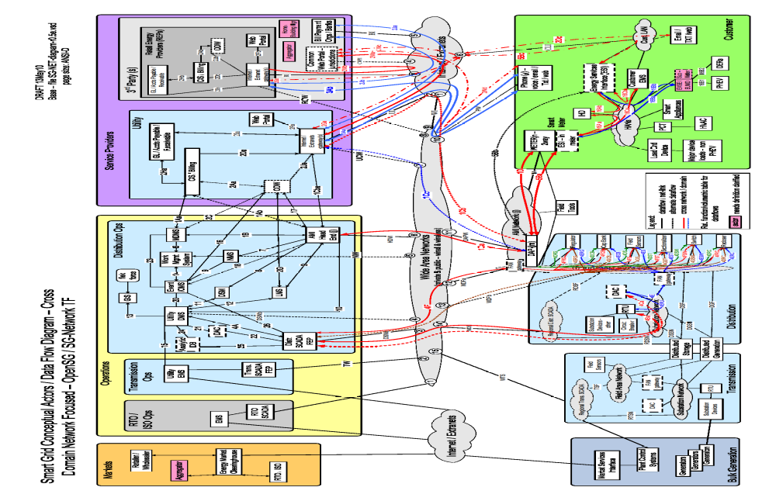

Diagram 2 – Baseline Diagram With Cross Domain & Network flows
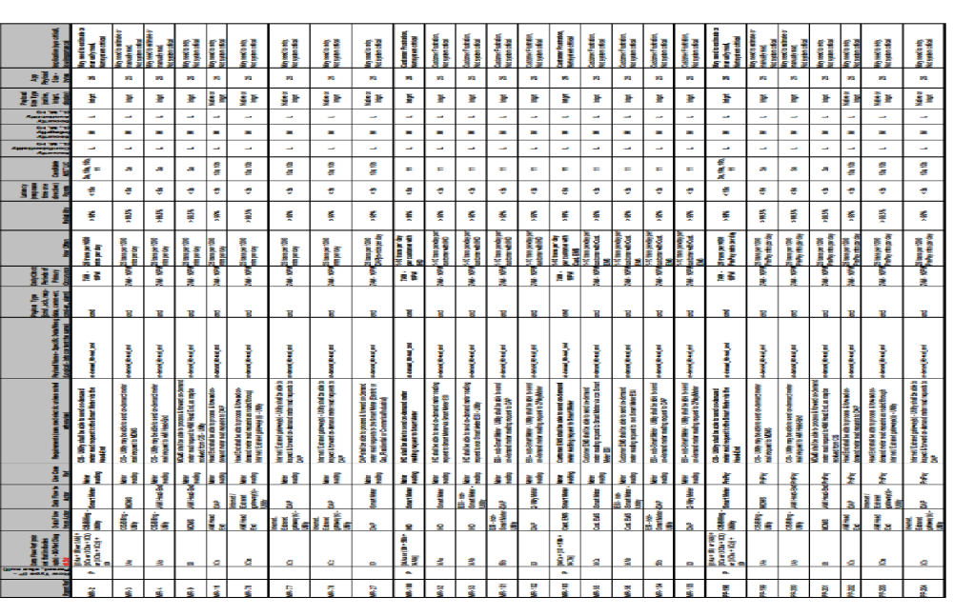

Table 1 – Smart Grid Functional & Volumetric Business Requirements
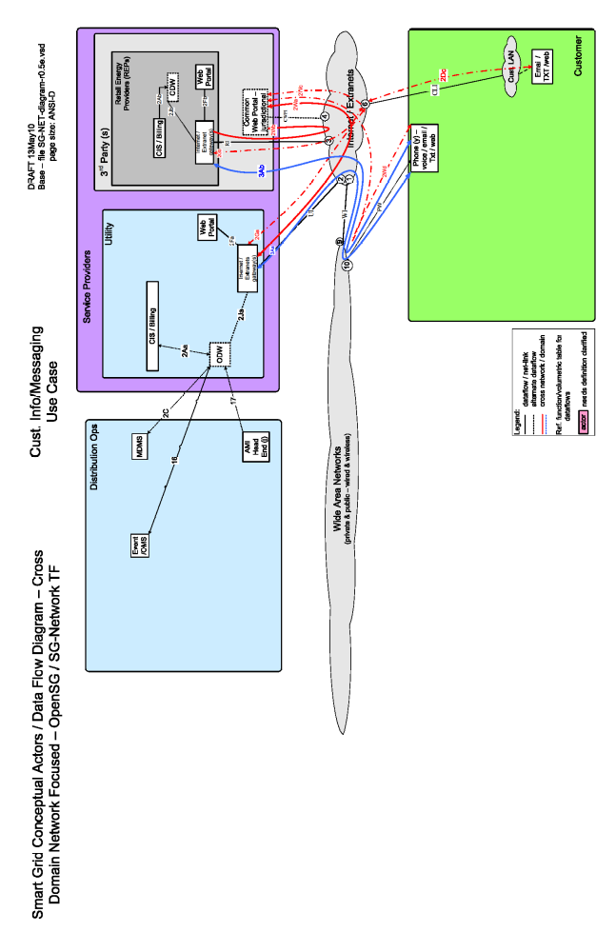

Diagram 3 – Customer Information / Messaging Use Case

Diagram 4 – Distribution Automation Use Case
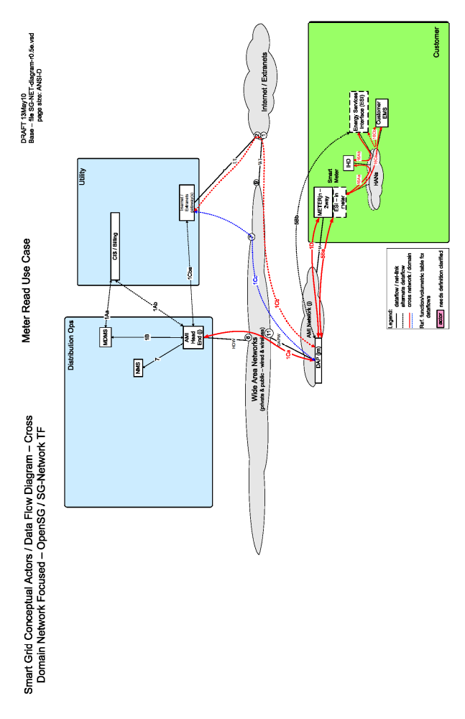

Diagram 5 – Meter Read Use Case
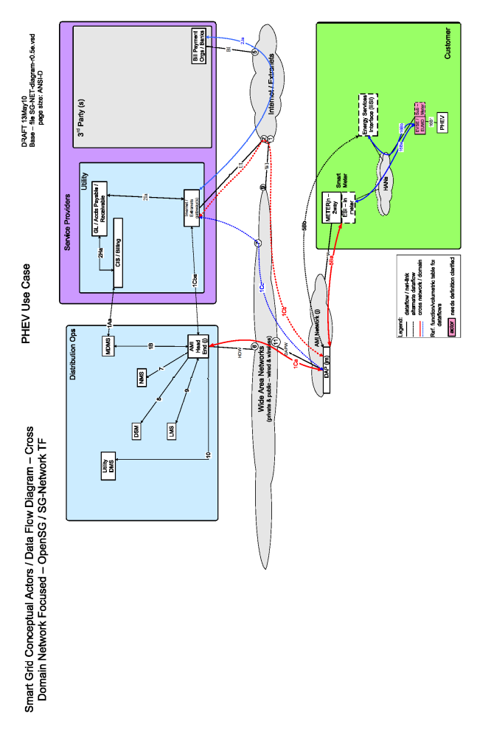

Diagram 6 – PHEV Use Case
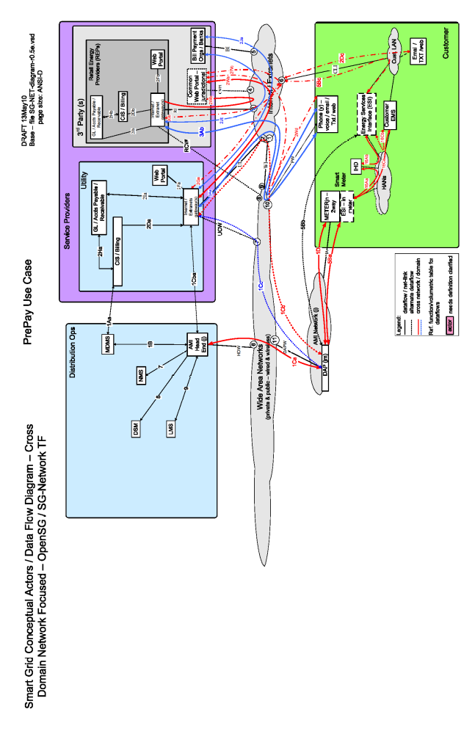

Diagram 7 – PrePay Use Case
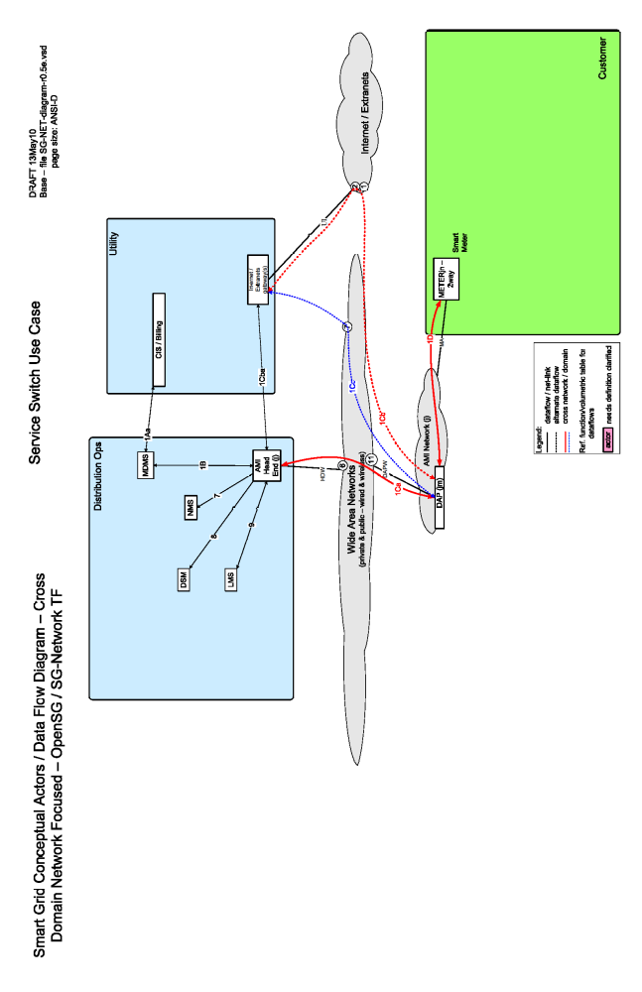

Diagram 8 – Service Switch
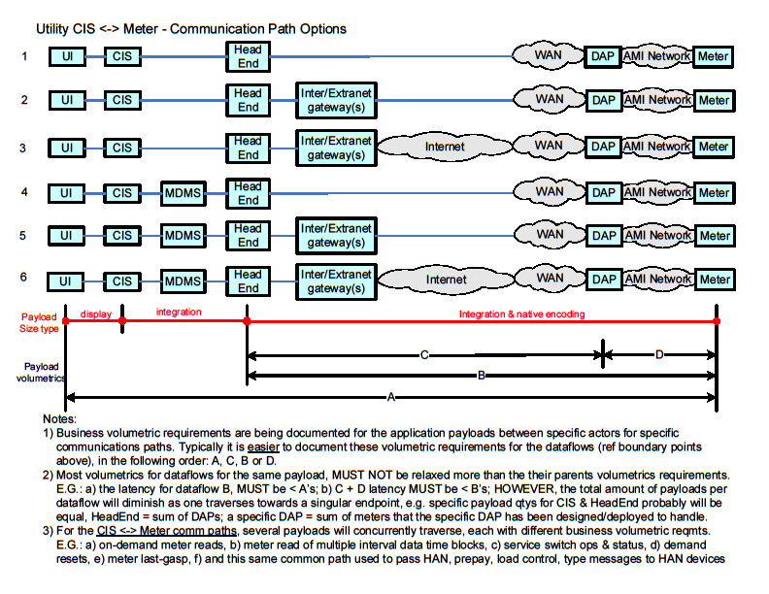

Diagram 9 – Utility CIS <-> Meter Communication Path Scenarios
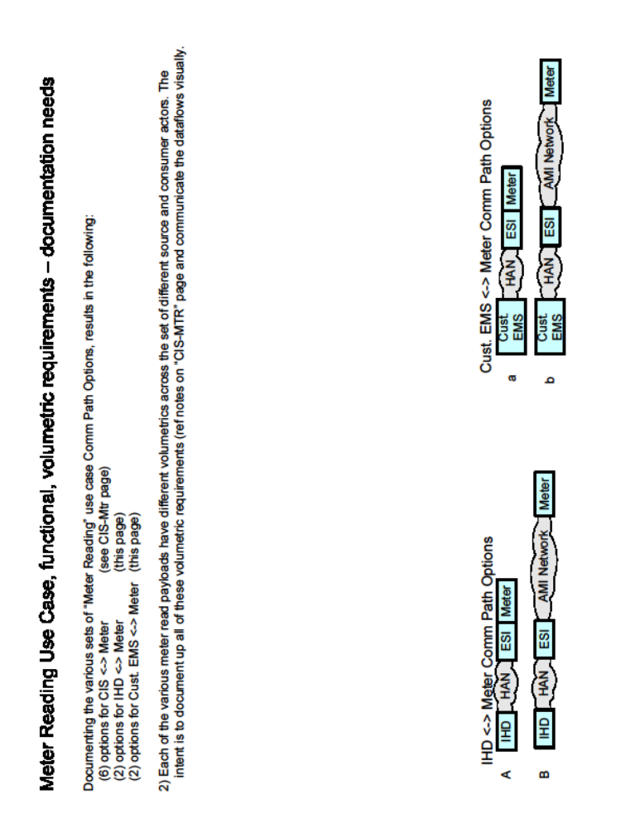

Diagram 10 – IPD & Cust. EMS <-> Meter Communication Path Scenarios
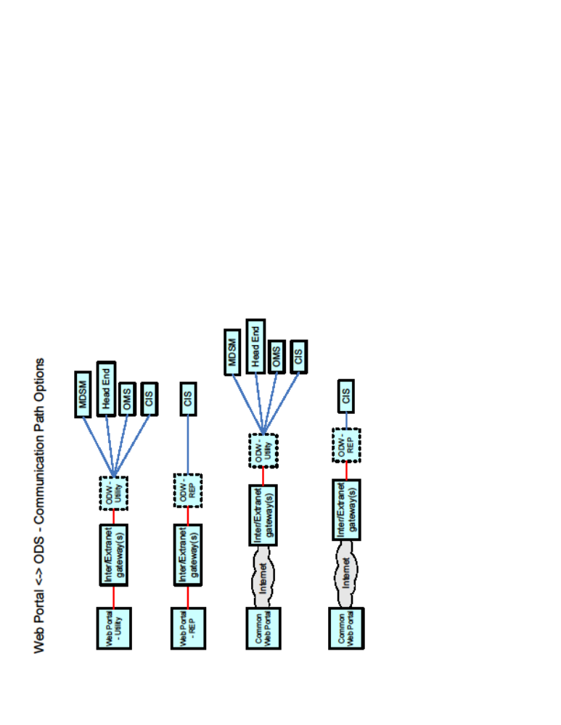

Diagram 11 – Web Portal <-> ODS Communication Path Scenarios
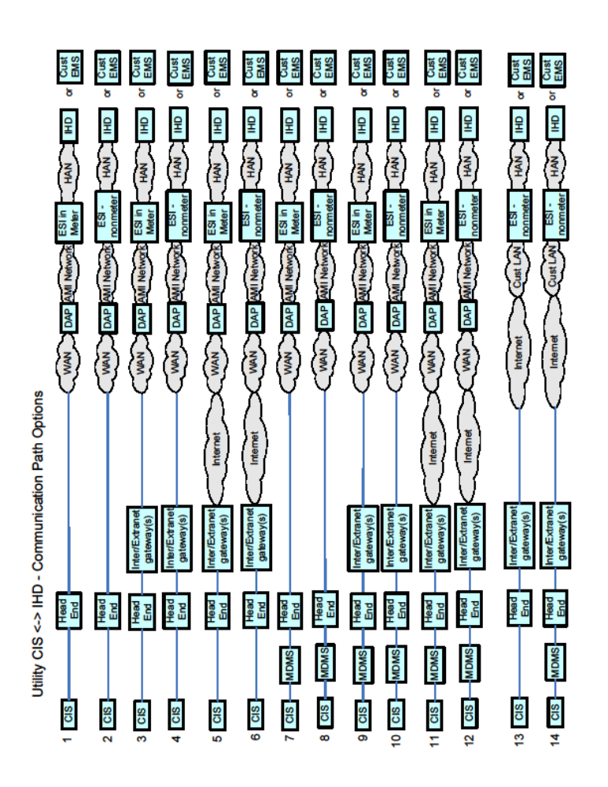

Diagram 12 – Utility CIS <-> IPD Communication Path Scenarios
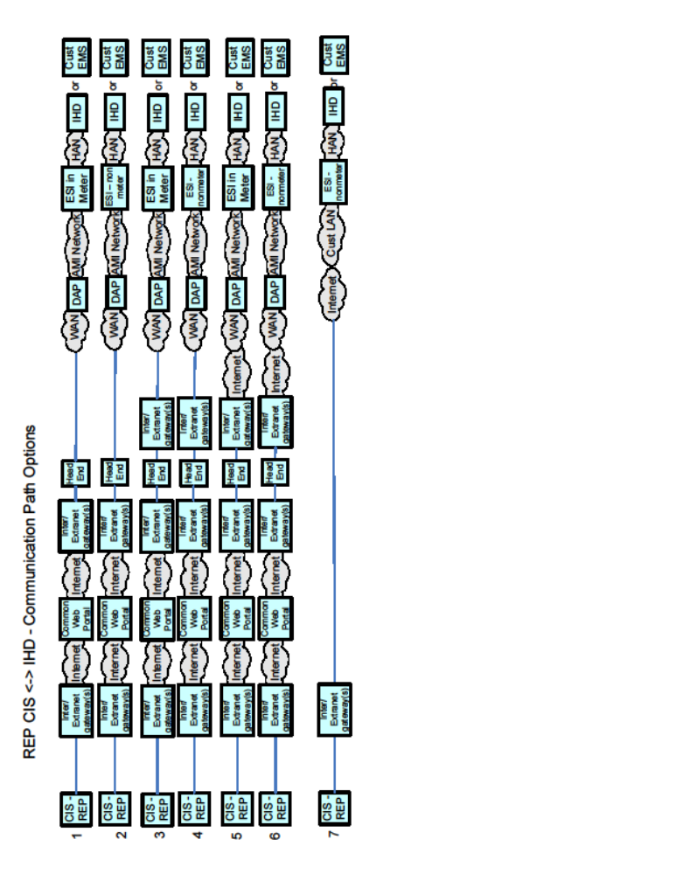

Diagram 13 – REP CIS <-> IPD Communication Path Scenarios
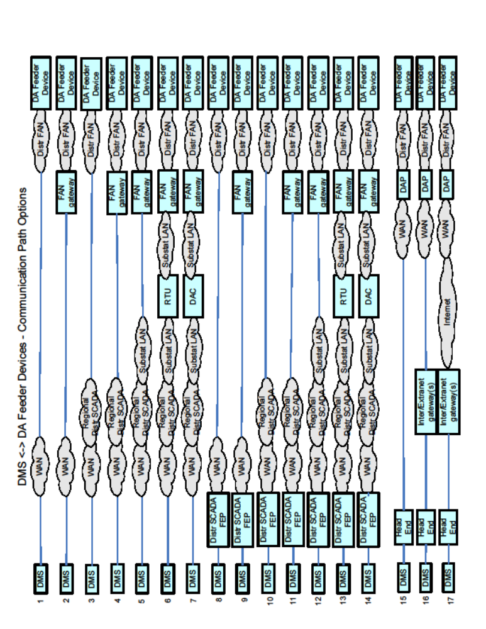

Diagram 14 – DMS <-> DA Feeder Devices Communication Path Scenarios

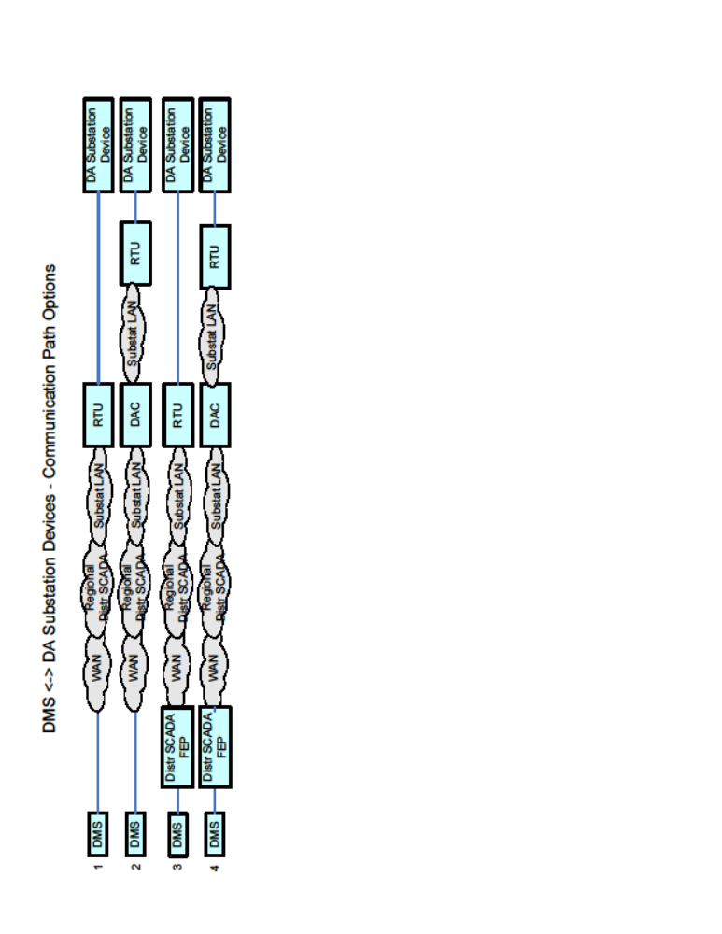

Diagram 15 – DMS <-> DA Substation Devices Communication Path Scenarios

