SG-Networks Database Tables and Software Module Documentation

Version V4-d6

Jerry Armes
Micronet Communications, Inc.

July 27, 2010

Introduction

The SG-Net Database provides a vehicle for organizing and documenting a high level of detail in Use Case records generated by the SG-Net Task Force within the Open SG Users Group. The version number on this release, Version V4-d6, simply indicates that the corresponding database is current with Version 4 draft 6 of the System Requirements spreadsheet.

Details of individual message payloads traveling across the Smart Grid network are well documented in an Excel-based system requirements spreadsheet file. The Data Flow Reference summarizes alternative paths, shown on the System Diagram, as to how a given message may travel across the network.

Parent rows contain a comprehensive description of the Application level connections between a Source Actor and a Target Actor for the delivery of a specific payload message.

A Data Flow Reference column documents the requirements of each message, including the alternative paths that can be used in message delivery. The data flow reference includes “+” and OR statements to describe both the primary and alternative paths.

Parsing software in the database breaks down the Data Flow Reference column into each of the alternative paths that can carry a given message across the Smart Grid, and places them in a separate table, where each record is indexed to its parent record. The details of the parsing process are discussed in Appendix A.

Under normal usage, there is no requirement for a user to run any software. This is strictly provided to support the input of new data into the database from a system requirements spreadsheet.

Child rows in the spreadsheet contain each of the individual Actor-Actor connections required to implement parent row (Application Level) connections.

The working tables that support these processes are shown in the next section.

Database Organization

The database is organized to allow the contents of a System Requirements Excel file to be pasted into an input table, where internal software can process the information, move to other tables, support queries, etc. The primary working tables are shown here.

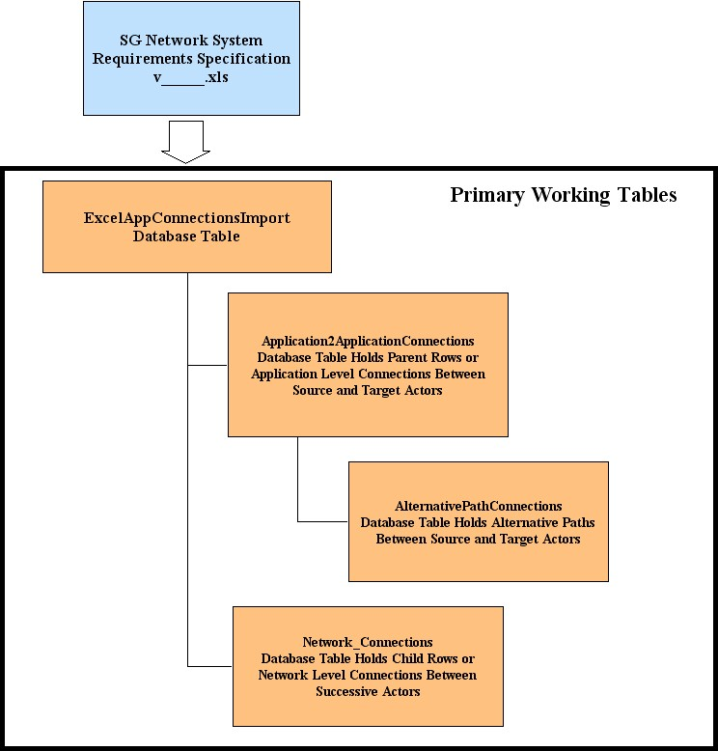

The Structure of the Database

A schema diagram shows the input table at the lower left, along with the Application2ApplicationConnections table holding the parent rows. Note that both the Network_Connections and AlternativePathConnections tables are indexed back to the Application2ApplicationConnections parent table. In addition, tables exist for tracking Use Case descriptions, Actors, Payloads and Payload Types. The tables also support tracking the origins of the work being done with linkages back to the original NIST actors and domains.

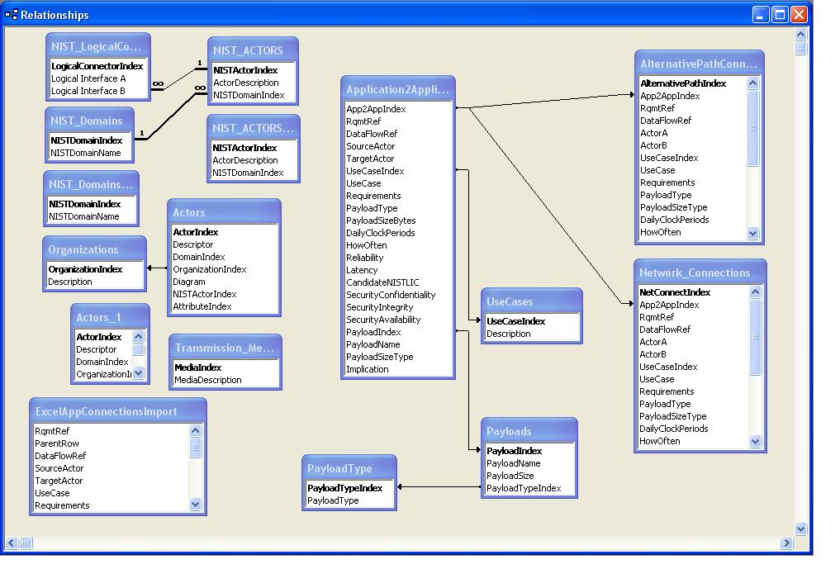

Queries
An initial form query has been structured to support multiple Actors and Use Cases, providing those records in the specified use cases that contain the specified actors.
A screen image is provided here as an example.
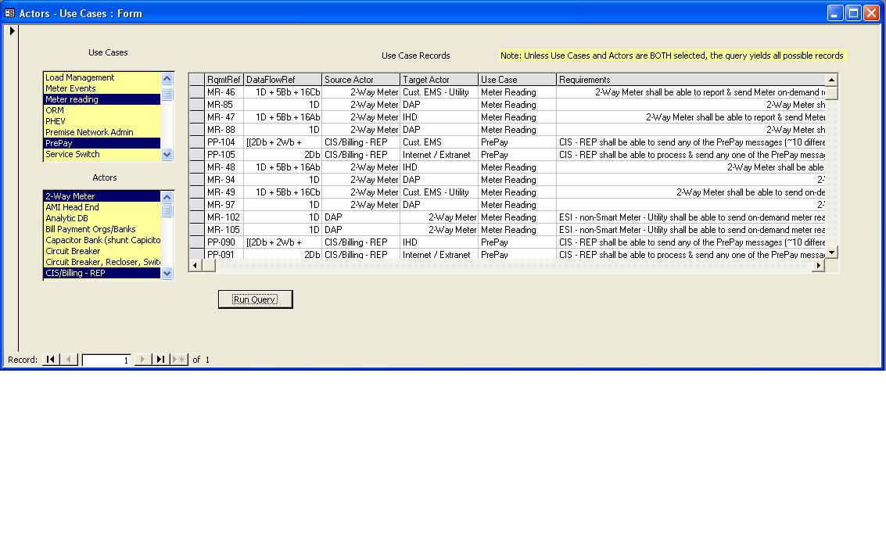

Summary
This work is ongoing, and there will no doubt be numerous queries, forms, and reports added as the work progresses.

Appendix A: Data Parsing Documentation
A number of tables and related software routines have been developed to support this effort. The starting point is a table named ExcelAppConnectionsImport. This table should be initially cleared by erasing all rows of data in it. Then the rows of the Excel Spreadsheet making up the current version of the SG Network System Requirements Specification Excel spreadsheet file can be copied and pasted into the ExcelAppConnectionsImport table. It is worth noting that while ExcelAppConnectionsImport table is not an indexed table, all other tables in the database are auto-indexed for data integrity.

Upon successful completion of this paste operation, it is necessary to scan this table for Null Fields as there will be empty cells in the SG Network System Requirements Specification Excel spreadsheet file. Running the Module named ScanForNull, examines each field in the ExcelAppConnectionsImport table and inserts “tbd” into any Null fields.

The next routine to be run is called Table Mapper. This routine searches the ExcelAppConnectionsImport table, and maps both the Parent and Child Rows to two additional tables. Parent rows are placed in the Application2ApplicationConnections table while Child rows are placed in the Network_Connections table.

In both of these tables, the exact bracket nomenclature from the SG Network System Requirements Specification Excel spreadsheet file are maintained.

For further analysis of the Parent Rows, an additional working table is provided named Application2ApplicationWithBracketHierarchy.

Mapping into this table from the ExcelAppConnectionsImport table is done with a Module named TableMapperWHierarchy. To ensure data consistency across various authors, a routine named ReBracket is used to standardize the brackets for various levels in accordance with the following table.

Bracket Level | Bracket Type
Level 1 | [ ]
Level 2 | { }
Level 3 | ( )
Level 4 | <>

Data Parsing

Since the parent rows describing application–to–application connections often contain alternative routing, it is desirable to break these down into the alternative specific routes the message may travel. This is done using a routine called DFR_Parser.

This routine has to accomplish two things. First, a parsing operation is done to extract each of the data segments and isolate them for later use in building alternative routes. However, to support the reconstruction process, their bracket levels, aggregations (+) and OR statements must be carefully logged.

The second operation is the construction of the individual alternative routes and mapping of them to the AlternativePathConnections table.

Finally the records in the AlternativePathConnections table represent alternative paths as first recorded in the SG Network System Requirements Specification Excel spreadsheet file and mapped to the Application2ApplicationConnections table.

However, they were generated by analysis of the Application2ApplicationWithBracketHierarchy table and consequently are indexed to that table.

Since queries and reports will need to maintain the original bracket formatting of the Application2ApplicationConnections table, it is essential that the indexes of the records in the AlternativePathConnections table reflect the parent record in the Application2ApplicationConnections table and not the Application2ApplicationWithBracketHierarchy table.

A module to accomplish this task has been written and named RePoint.

Software License
Each software routine in the database includes the following license statement.
Copyright (C)Micronet Communications, Inc., 2010, Author: Jerry Armes (jarmes@micronetcom.com) 'This program is free software; you can redistribute it and/or modify it under the terms of the 'GNU General Public License as published by the Free Software Foundation; 'either version 2 of the License, or any later version.
'This program is distributed in the hope that it will be useful, but WITHOUT ANY WARRANTY; 'without even the implied warranty of MERCHANTABILITY or FITNESS FOR A PARTICULAR PURPOSE. 'See the GNU General Public License for more details. 'You should have received a copy of the GNU General Public License along with this program; 'if not, write to the Free Software Foundation, Inc., 59 Temple Place, Suite 330, 'Boston, MA 02111-1307 USA

