NIST Priority Action Plan 2
Wireless standards for Smart Grid

<Insert cool NIST / SGIP Graphic here>

Table of Contents

Revision History iv
Preface - 1 -
Authors - 2 -
1 Overview of the Process - 3 -
2 Acronyms and Definitions - 4 -
2.1 Acronyms - 4 -
2.2 Definitions - 7 -
3 Smart Grid Conceptual Model and Business Functional Requirements - 11 -
3.1 Smart Grid Conceptual Reference Diagrams - 11 -
3.2 List of Actors - 14 -
3.3 Smart Grid Use Cases - 16 -
3.4 Smart Grid Business Functional and Volumetric Requirements - 17 -
3.5 Smart Grid User Applications’ Quantitative Requirements - 19 -
3.6 Aggregation of requirements per actor to actor - 19 -
4 Wireless Technology - 27 -
4.1 Technology Descriptor Headings - 27 -
4.2 Technology Descriptor Details - 27 -
4.2.1 Descriptions of Groups 1-7 Submissions - 27 -
4.2.1.1 Group 1: Link Availability - 28 -
4.2.1.2 Group 2: Data/Media Type Supported - 29 -
4.2.1.3 Group 3: Coverage Area - 29 -
4.2.1.4 Group 4: Mobility - 29 -
4.2.1.5 Group 5: Data Rates - 29 -
4.2.1.6 Group 6: RF Utilization - 30 -
4.2.1.7 Descriptions of Groups 1-7 Submissions - 31 -
4.2.2 Descriptions of Groups 8-12 Submissions - 31 -
4.2.2.1 Group 8: Link Quality Optimization - 31 -
4.2.2.2 Group 9: Radio Performance Measurement & Management - 32 -
4.2.2.3 Group 10: Power Management - 32 -
4.2.2.4 Group 11: Connection Topologies - 32 -
4.2.2.5 Group 12: Connection Management - 32 -
4.2.3 Descriptions of Groups 13-20 Submissions - 32 -
4.2.3.1 Group 13: QoS and Traffic Prioritization - 33 -
4.2.3.2 Group 14: Location characterization - 33 -
4.2.3.3 Group 15: Security and Security Management - 34 -
4.2.3.4 Group 16: Radio Environment - 34 -
4.2.3.5 Group 17: Intra-technology Coexistence - 34 -
4.2.3.6 Group 18: Inter-technology Coexistence - 34 -
4.2.3.7 Group 19: Unique Device Identification - 34 -
4.2.3.8 Group 20: Technology Specification Source - 34 -
4.2.4 Descriptions of Group 21 Submission - 34 -
4.2.4.1 Group 21 Description - 35 -
4.3 Technology Submission Titles - 35 -
4.4 Technology Submissions - 35 -
5 Modeling and Evaluation Approach - 36 -
5.1 Modeling Framework - 37 -
5.1.1 Channel Models - 38 -
5.1.1.1 Indoor-indoor environments - 39 -
5.1.1.2 Outdoor-outdoor environments - 39 -
5.1.1.3 Outdoor-indoor environments - 40 -
5.1.2 Coverage analysis model - 40 -
5.1.3 PHY sublayer - 41 -
5.1.4 MAC sublayer - 41 -
5.2 An Example - 42 -
5.2.1 Applications modeling - 43 -
5.2.1.1 Conversion Procedure - 43 -
5.2.1.2 Example - 43 -
5.2.2 PHY layer modeling - 44 -
5.2.2.1 Channel Model - 45 -
5.2.2.2 Computing the Conditional Probability of Failure - 45 -
5.2.3 Coverage Analysis - 46 -
5.2.3.1 Nominal Received SNR - 47 -
5.2.3.2 Calculating Outage Probability - 47 -
5.2.3.3 Example - 48 -
5.2.4 MAC layer modeling - 49 -
5.2.5 Combining Components - 53 -
5.2.6 Example results - 54 -
6 Findings / Results - 56 -
7 Conclusions - 56 -
8 References - 57 -
9 Bibliography - 57 -

Revision History

Revision Number | Revision Date | Revision  By | Summary of Changes | Changes marked
.01 | 3/31/2010 | Matt Gillmore | Initial take on the outline, TOC, ,authors, definitions, acronyms, reference architecture | No
.02 | 4/28/2010 | David Cypher | Added outline numbering for cross reference purposes, added text for 1, 3.3 and 5 | No
.03 | 5/3/2010 | David Cypher | Edits and additional material for 3.2, 5 and 6 | No
.04 | 5/4/2010 | Nada Golmie | Edits to section 5 | No
.05 | 7/28/2010 | NIST & PAP2 Team | Updated most of the document | No

Preface
Wireless technologies for technical and business communications have been available for over a century and are widely used for many popular applications. The use of wireless technologies in the power system is also not new. Its use for system monitoring, metering and data gathering goes back several decades. However, the advanced applications and widespread use now foreseen for the Smart Grid require highly reliable, secure, well designed and managed communication networks.

The decision to apply wireless technologies for any given set of applications is a local decision that must take into account several important elements including both technical and business considerations. Smart Grid applications requirements must be defined with enough specificity to quantitatively define communications traffic loads, levels of performance and quality of service. Applications requirements must be combined with as complete a set of management and security requirements for the life-cycle of the system. These requirements can then used to assess the suitability of various wireless technologies to meet the requirements in the particular applications environment.

This report is a draft of key tools to assist Smart Grid system designers in making informed decisions about existing and emerging wireless technologies. An initial set of quantified requirements have been brought together for advanced metering infrastructure (AMI) and initial Distribution Automation communications. These two areas present technological challenges due to their scope and scale. These systems will span widely diverse geographic areas and operating environments and population densities ranging from urban to rural.

The wireless technologies presented here encompass different technologies that range in capabilities, cost, and ability to meet different requirements for advanced power systems applications. System designers are be further assisted by the presentation of a set of wireless capability characteristics matrices for existing and emerging standards based wireless technologies. Details of the capabilities are presented in this report as a way for designers to initially sort through the available wireless technology options.

To further assist decision making, the document presents a set of tools in the form of models that can be used for parametric analyses of the various wireless technologies.

This document represents an initial set of guidelines to assist Smart Grid designers and developers in their independent evaluation of candidate wireless technologies. While wireless holds many promises for the future it is not without limitations. In addition wireless technology continues to evolve. Priority Action Plan 2 is fundamentally cuts across the entire landscape of the Smart Grid. Wireless is one of several communications options for the Smart Grid that must be approached with technical rigor to ensure communication systems investments are well suited to meet the needs of the Smart Grid both today as well as in the future.

Follow-on reports under Priority Action Plan 2 will include further requirements development for advanced distribution automation, transmission wide area measurement and control and advancements in customer communications. These requirements will be drawn from power industry sources and significant projects underway such as the North American Synchrophasor Initiative and work taking place now within other Priority Action Plans and Smart Grid Interoperability Panel (SGIP) committees.

The scope and scale of wireless technology will represent a significant capital investment. In addition the Smart Grid will be supporting a wide diversity of applications including several functions that represent critical infrastructure for the operation of the Nations electric and energy services delivery systems.

Feedback and critical review of this document are welcome. Individuals interested in directly participating in follow on work are encouraged to join in assisting with tasks defined within PAP 2 on the SGIP twiki page at http://collaborate.nist.gov/twiki-sggrid/bin/view/SmartGrid/PAP02Wireless.

Authors

Provide feedback and edits to this document to get your name here!

Matthew Gillmore – Consumers Energy
Ron Cunningham – American Electric Power
Bill Godwin – Progress Energy
Bruce Kraemer – Marvell
Mark Klerer – Qualcomm
Joe Hugues - EPRI
David Cypher – NIST
David Griffith – NIST
Michael Souryal – NIST
Camillo Gentile – NIST
Nada Golmie - NIST

- Overview of the Process

The process by which this document was generated is based on the six tasks for Priority Action Plan 2 (PAP#2).
- http://collaborate.nist.gov/twiki-sggrid/bin/view/SmartGrid/PAP02Wireless

Task 1: Segment the smart grid and wireless environments into a minimal set of categories for which individual wireless requirements can be identified. This was accomplished by the creation of a template (app_matrix_pap.xls) for input to application communication requirements. This template contained two main sheets one for characterizing the user application and the other for characterizing the physical devices that would be used for the user applications. With this template as a basis OpenSG submitted a subset of user application quantitative information (SG Network System Requirements Specification v4.0.xls). See section .

Task 2: Develop Terminology and definitions. This was accomplished by combining the terms and definitions from the various input documents to other tasks of PAP#2, as well as using those from the base Smart Grid documents (Second DRAFT NIST IR 7628 Smart Grid Cyber Security Strategy and Requirements and NIST Framework and Roadmap for Smart Grid Interoperability Standards, Release 1.0). For Acronyms see 2.1 and definitions see 2.2.

Task 3: Compile and communicate use cases and develop requirements for all smart grid domains in terms that all parties can understand. This task is in progress and has been partially completed for the submitted user applications (see 3.3) and the smart grid domains that are applicable to the user requirements.

Task 4: Compile and communicate a list of capabilities, performance metrics, etc. in a way that all parties can understand. - Not quantifying any standard, just defining the set of metrics. This was accomplished by default with the submission for Task 5.

Task 5: Create an inventory of wireless standards and their associated characteristics (defined in task 4) for the environments identified in task 1. The Wireless Functionality and Characteristics Matrix for the identification of Smart grid domain application (Consolidated_NIST_Wireless_Characteristics_Matrix-V4.xls.) excel spread sheet captures a list of wireless standards and their associated characteristics. (See Error: Reference source not found)

Task 6: Perform the mapping and conduct an evaluation of the wireless technologies based on the criteria and metrics developed in task 4. This is the subject of Sections 5–7 of this document (Modeling and Evaluation Approach (5) Findings / Results (6), and Conclusions (7)).
- Acronyms and Definitions

The acronyms and definitions provided are used in this document and in its referenced supporting documentation.

  - Acronyms

AC | Alternating Current
AICPA | American Institute of Certified Public Accountants
AMI | Advanced Metering Infrastructure
AMS | Asset Management System
ASAP-SG | Advanced Security Acceleration Project-Smart Grid
B2B | Business to Business
BAN | Business Area Network
CIM | Common Information Model
CIP | Critical Infrastructure Protection
CPP | Critical Peak Pricing
CSWG | Cyber Security Working Group
DA | Distribution Automation
DAC | Distributed Application Controller
DAP | Data Aggregation Point
DER | Distributed Energy Resources
DHS | Department of Homeland Security
DMS | Distribution Management System
DNP | Distributed Network Protocol
DOE | Department of Energy
DOMA | Distribution Operations Model and Analysis
DR | Demand Response
DRMS | Distribution Resource Management System
DSDR | Distribution Systems Demand Response
DSM | Demand Side Management
EMS | Energy Management System
EPRI | Electric Power Research Institute
ES | Electric Storage
ESB | Enterprise Service Bus
ESI | Energy Services Interface
ET | Electric Transportation
EUMD | End Use Measurement Device
EV/PHEV | Electric Vehicle/Plug-in Hybrid Electric Vehicles
EVSE | Electric Vehicle Service Element
FAN | Field Area Network
FEP | Front End Processor
FERC | Federal Energy Regulatory Commission
FIPS | Federal Information Processing Standard Document
FLIR | Fault Location, Isolation, Restoration
G&T | Generations and Transmission
GAPP | Generally Accepted Privacy Principles
GIS | Geographic Information System
GL | General Ledger
GPRS | General Packet Radio Service
HAN | Home Area Network
HMI | Human-Machine Interface
HVAC | Heating, Ventilating, and Air Conditioning
I2G | Industry to Grid
IEC | International Electrotechnical Commission
IED | Intelligent Electronic Device
IHD | In-home Display
ISA | International Society of Automation
ISO | Independent System Operator
ISO | International Organization for Standardization
IT | Information Technology
LAN | Local Area Network
LMS | Load management System
LMS/DRMS | Load Management System/ Distribution Resource Management System
LV | Low voltage (in definition)
MAC | Medium Access Control
MDMS | Meter Data Management System
MFR | Multi-Feeder Reconnection
MSW | Meter Service Switch
MV | Medium Voltage
NAN | Neighborhood Area Network
NERC | North American Electric Reliability Corporation
NIPP | National Infrastructure Protection Plan
NISTIR | NIST Interagency Report
NMS | Network Management System
ODW | Operational Data Warehouse
OMS | Outage Management System
OWASP | Open Web Application Security Project
PAP | Priority Action Plan
PCT | Programmable Communicating Thermostat
PEV | Plug-In Electric Vehicle
PHEV | Plug-in Hybrid Electric Vehicle
PI | Process Information
PIA | Privacy Impact Assessment
PII | Personally Identifying Information
R&D | Research and Development
REP | Retail Electric Provider
RTO | Regional Transmission Operator
RTP | Real Time Pricing
RTU | Remote Terminal Unit
SCADA | Supervisory Control and Data Acquisition
SCE | Southern California Edison
SDO | Standards Development Organization
SGIP | Smart Grid Interoperability Panel
SGIP-CSWG | SGIP – Cyber Security Working Group
SM | Smart Meter
SP | Special Publication
SSP | Sector-Specific Plans
T/FLA | Three/Four Letter Acronym
TOU | Time Of Use
VAR | Volt-Amperes Reactive
VVWS | Volt-VAR-Watt System
WAMS | Wide-Area Measurement System
WAN | Wide Area Network
WASA | Wide Area Situational Awareness
WLAN | Wireless Local Area Network
WMS | Work Management System

  - Definitions

Actor | A generic name for devices, systems, or programs that make decisions and exchange information necessary for performing applications: smart meters, solar generators, and control systems represent examples of devices and systems.
Anonymize | A process of transformation or elimination of PII for purposes of sharing data
Aggregation | Practice of summarizing certain data and presenting it as a total without any PII identifiers
Aggregator | SEE FERC OPERATION MODEL
Applications | Tasks performed by one or more actors within a domain.
Asset Management System | A system(s) of record for assets managed in the Smart Grid. Management context may change (e.g. financial, network).
Capacitor Bank | This is a device used to add capacitance as needed at strategic points in a distribution grid to better control and manage VARs and thus the Power Factor and they will also affect voltage levels.
Common Information Model | A structured set of definitions that allows different Smart Grid domain representatives to communicate important concepts and exchange information easily and effectively.
Common Web Portal | Web interface for Regional Transmission Operator, customers, retail electric providers and transmission distribution service provider to function as a clearing house for energy information. Commonly used in deregulated markets.
Data Collector | See Substation Controller
Data Aggregation Point | This device is a logical actor that represents a transition in most AMI networks between Wide Area Networks and Neighborhood Area Networks. (e.g. Collector, Cell Relay, Base Station, Access Point, etc)
De-identify | A form of anonymization that does not attempt to control the data once it has had PII identifiers removed, so it is at risk of re-identification.
Demand Side Management | A system that co-ordinates demand response / load shedding messages indirectly to devices (e.g. Set point adjustment)
Distribution Management System | A system that monitors, manages and controls the electric distribution system.
Distribution Systems Demand Response | A system used to reduce load during peak demand. Strictly used for Distribution systems only.
Electric Vehicle/Plug-in Hybrid Electric Vehicles | Cars or other vehicles that draw electricity from batteries to power an electric motor. PHEVs also contain an internal combustion engine.
Energy Services Interface | Provides the communications interface to the utility. It provides security and, often, coordination functions that enable secure interactions between relevant Home Area Network Devices and the Utility. Permits applications such as remote load control, monitoring and control of distributed generation, in-home display of customer usage, reading of non-energy meters, and integration with building management systems. Also provides auditing/logging functions that record transactions to and from Home Area Networking Devices.
Enterprise Service Bus | The Enterprise Service Bus consists of a software architecture used to construct integration services for complex event-driven and standards-based messaging to exchange meter or grid data. The ESB is not limited to a specific tool set rather it is a defined set of integration services.
Fault Detector | A device used to sense a fault condition and can be used to provide an indication of the fault.
Field Force | Employee working in the service territory that may be working with Smart Grid devices.
Generally Accepted Privacy Principles | Privacy principles and criteria developed and updated by the AICPA and Canadian Institute of Chartered Accountants to assist organizations in the design and implementation of sound privacy practices and policies.
Home Area Network | A network of energy management devices, digital consumer electronics, signal-controlled or enabled appliances, and applications within a home environment that is on the home side of the electric meter.
Intelligent Fault Detector | A device that can sense a fault and can provide more detailed information on the nature of the fault, such as capturing an oscillography trace.
ISO/IEC27001 | Provides an auditable international standard that specifies the requirements for establishing, implementing, operating, monitoring, reviewing, maintaining and improving a documented Information Security Management System within the context of the organization's overall business risks. It uses a process approach for protection of critical information
Last Gasp | Refers to the capability of a device to emit one last message when it loses power. Concept of an energized device within the Smart Grid detecting power loss and sending a broadcast message of the event
Load Management System | A system that controls load by sending messages directly to device (e.g. On/Off)
Low Voltage Sensor | A device used to measure and report electrical properties (such as voltage, current, phase angle or power factor, etc.) at a low voltage customer delivery point.
Medium Voltage Sensor | A device used to measure and report electrical properties (such as voltage, current, phase angle or power factor, etc.) on a medium voltage distribution line.
Motorized Switch | A device under remote control that can be used to open or close a circuit.
Neighborhood Area Network | A network comprised of all communicating components within a distribution domain.
Network Management System | A system that manages Fault, Configuration, Auditing/Accounting, Performance and Security of the communication. This system is exclusive from the electrical network.
Outage Management System | A system that receives out power system outage notifications and correlates where the power outage occurred
Personal Information | Information that reveals details, either explicitly or implicitly, about a specific individual’s household dwelling or other type of premises. This is expanded beyond the normal "individual" component because there are serious privacy impacts for all individuals living in one dwelling or premise. This can include items such as energy use patterns or other types of activities. The pattern can become unique to a household or premises just as a fingerprint or DNA is unique to an individual.
Phase Measuring Unit | A device capable of measuring the phase of the voltage or current waveform relative to a reference.
Power Factor | A dimensionless quantity that relates to efficiency of the electrical delivery system for delivering real power to the load. Numerically, it is the Cosine of the phase angle between the voltage and current waveforms. The closer the power factor is to unity the better the inductive and capacitive elements of the circuit are balanced and the more efficient the system is for delivering real power to the load(s).
Privacy Impact Assessment | A process used to evaluate the possible privacy risks to personal information, in all forms, collected, transmitted, shared, stored, disposed of, and accessed in any other way, along with the mitigation of those risks at the beginning of and throughout the life cycle of the associated process, program or system
Programmable Communicating Thermostat | A device within the premise that has communication capabilities and controls heating, ventilation and cooling systems.
Recloser (non-Team) | A device used to sense fault conditions on a distribution line and trip open to provide protection. It is typically programmed to automatically close (re-close) after a period of time to test if the fault has cleared. After several attempts of reclosing it can be programmed to trip open and stop trying to reclose until reset either locally or under remote control.
Recloser (Team) | A device that can sense fault conditions on a distribution line and to communicate with other related reclosers (the team) to sectionalize the fault and provide a coordinated open/close arrangement to minimize the effect of the fault.
Regional Transmission Operator | An organization that is established with the purpose of promoting efficiency and reliability in the operation and planning of the electric transmission grid and ensuring non-discrimination in the provision of electric transmission services based on the following required/demonstrable characteristics and functions.
Remote Terminal Unit | Aggregator of multiple serialized devices to a common communications interface
Sub Meter | Premise based meter used for Distributed Energy Resources and PHEV. This device may be revenue grade.
Substation Controller | Distributed processing device that has supervisory control or coordinates information exchanges from devices within a substation from a head end system.
Transformer (MV-to-LV) | A standard point of delivery transformer. In the Smart Grid context it is assumed there will be a need to measure some electrical or physical characteristics of this transformer such as voltage (high and/or low side) current, MV load, temperature, etc.
Use Case | A systems engineering tool for defining a system’s behavior from the perspective of users. In effect, a use case is a story told in structure and detailed steps—scenarios for specifying required usages of a system, including how a component, subsystem, or system should respond to a request that originates elsewhere.
Voltage Regulator | This device is in effect an adjustable ratio transformer positioned at strategic points in a distribution grid and is utilized to better manage and control the voltage as it changes along the distribution feeder.
VAR – Volt-Amperes Reactive; | In an AC power system the voltage and current measured at a point along the delivery system will often be out of phase with each other as a result the combined effects of the resistive and reactive (i.e. the capacitance and inductive) characteristics of the delivery system components and the load. The phase angle difference at a point along the delivery system is an indication of how well the inductive and capacitive effects are balanced at that point. The real power passing that point is the product of the magnitude of the Voltage and Current and the Cosine of the angle between the two. The VAR parameter is the product of the magnitude of the Voltage and Current and the Sine of the angle between the two. The magnitude of the VAR parameter is an indication of the phase imbalance between the voltage and current waveforms.
Web Portal | Interface between energy customers and the system provider. Could be the utility or a third party.
Link Budget | Accounts for the attenuation of the transmitted signal due to antenna gains, propagation, and miscellaneous losses.
Packet | A formatted unit of data sent across a network.
Header | The portion of a packet, before the data field that typically contains source and destination addresses , control fields and error check fields.
Goodput | Goodput is the application level throughput, i.e. the number of useful bits per unit of time forwarded by the network from a certain source address to a certain destination, excluding protocol overhead, and excluding retransmitted data packets.
Throughput | The number of bits (regardless of purpose) moving over a communications link per unit of time. Throughput is most commonly expressed in bits per second.
Rate Adaptation | The mechanism by which a modem adjusts its modulation scheme, encoding and/or speed in order to reliably transfer data across channel exhibiting different SNR characteristics.

- Smart Grid Conceptual Model and Business Functional Requirements

This section provides an overview of the primary sets of information that UCAiug – OpenSG – SG Communications – SG Network Task Force (SG Network TF), prepared to address Task 3 of PAP 2, plus an explaination of how this information is intended to be interpreted and an example of how to consume the information as an input into other analysis tools e.g. network traffic modeling.

  - Smart Grid Conceptual Reference Diagrams

SG Network TF expanded upon the Smart Grid conceptual reference diagram that was introduced in version 1.0 of the NIST Smart Grid Interoperability Framework and other reference diagrams included in NISTIR 7628. The Smart Grid conceptual reference diagram is included below, along with two views of SG Network TF’s conceptual reference diagrams, one without and one with cross domain data flows. Alternative (optional) interfaces between actors and communication paths to amongst actors are also contained in the diagrams. These reference diagrams are further explained in Smart Grid use case documentation and detailed business functional and volumetric requirements in the sections that follow.

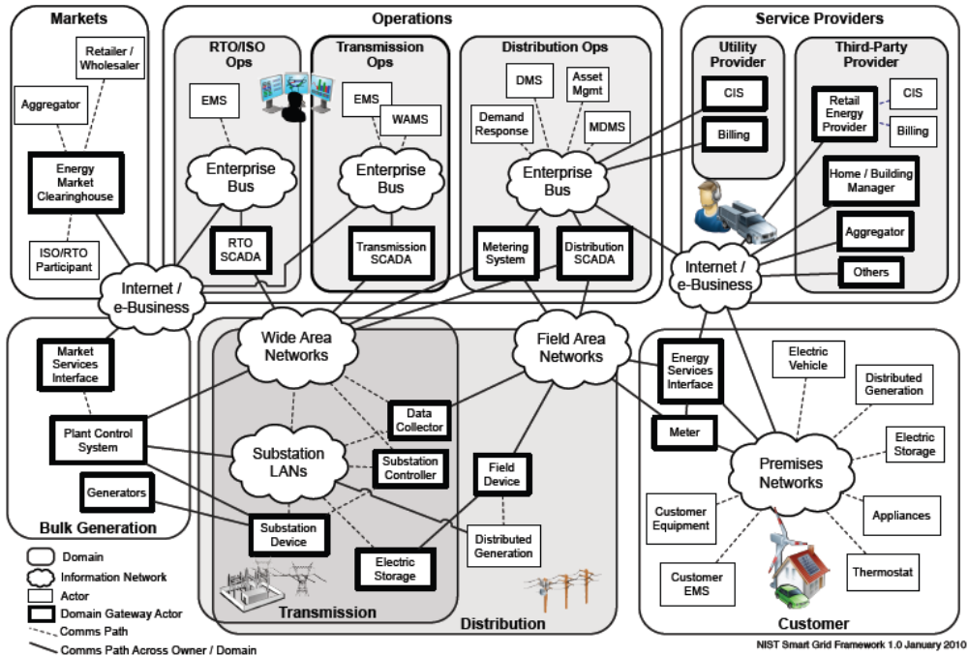

Figure 1 - Smart Grid Conceptual Reference Diagram
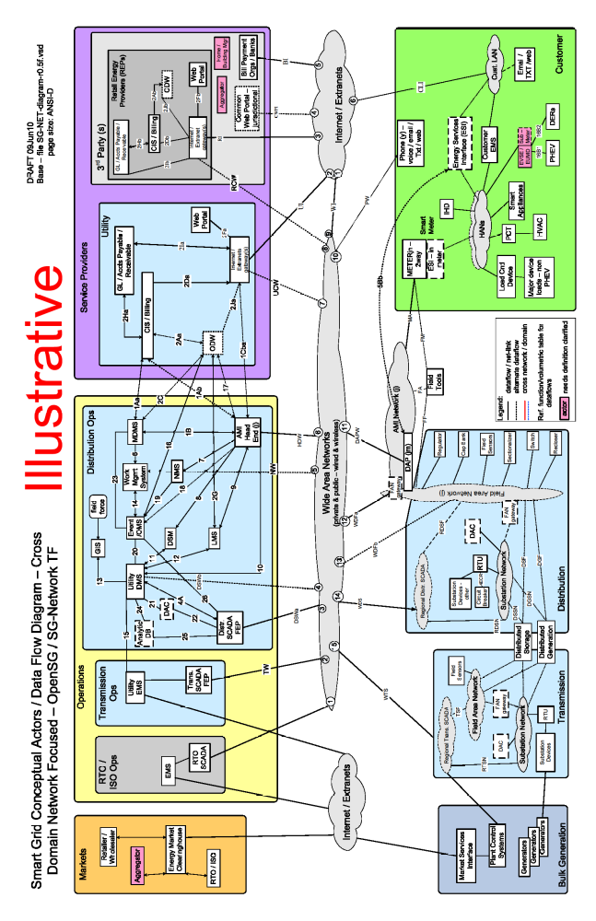
Figure 2 - OpenSG_SG Network TF Smart Grid Conceptual Reference Diagram
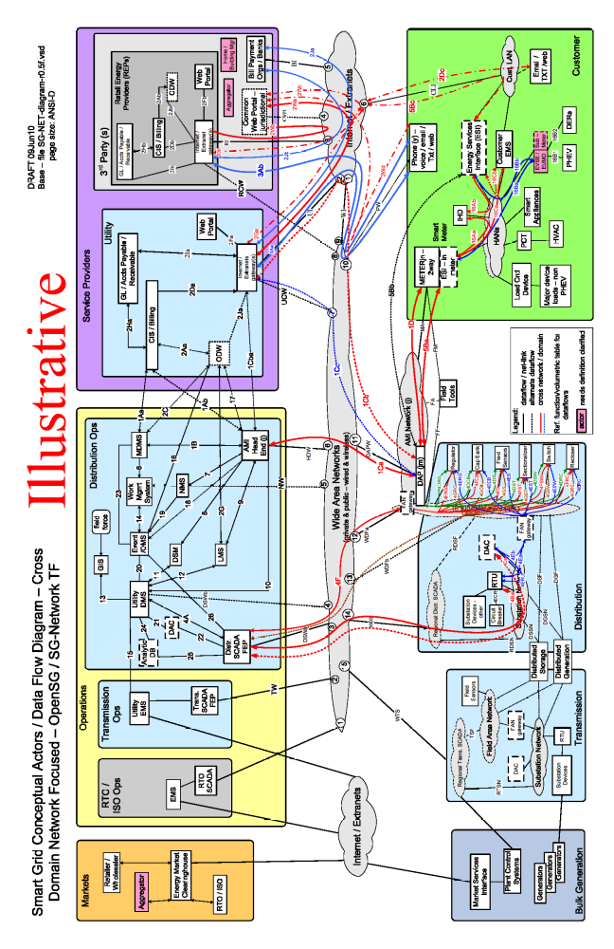
Figure 3 - OpenSG_SG Network TF Smart Grid Conceptual Reference Diagram with Cross Domain Data Flows
The latest set of SG Network TF reference diagrams are located at
- http://osgug.ucaiug.org/UtiliComm/Shared%20Documents/Latest_Release_Deliverables/Diagrams/

  - List of Actors
The Table 1table below maps the actors included in the SG NetworkeTF Smart Grid Conceptual Reference Diagram (Figure ) and the NIST smart grid conceptual reference diagram (). The SG NetworceTF high level list of actors are further qualified by domain and sub-domain as used in documenting the Smart Grid business functional and volumetric requirements.

Table 1: Mapping of actors to domain names
SG Network TF Reference Diagram Descriptor (Actor) | SG Network TF Ref Diagram Domain Name | Related NIST Diagram Descriptor (Actor)
Field Tools
Generators | Bulk Generation | Generators
Market Services Interface | Bulk Generation | Market Services Interface
Plant Control Systems | Bulk Generation | Plant Control Systems
 | Customer | Electric Storage
Customer EMS | Customer | Customer EMS
DERs (Solar, Wind, premise generation sources) | Customer | Distributed Generation
ESI (Broadband) | Customer | Energy Services Interface
ESI (In Meter) | Customer | Energy Services Interface
EVSE / EUMD | Customer | Customer Equipment
HVAC | Customer | Customer Equipment
IHD (In Home Device) | Customer | Customer Equipment
Load Control Device | Customer | Customer Equipment
PCT | Customer | Thermostat
PHEV | Customer | Electric Vehicle
Phone/Email/Text/Web | Customer | Customer Equipment
Smart Appliances | Customer | Appliances
Smart Meter | Customer | Meter
Sub-Meter | Customer | Customer Equipment
Two Way Meter | Customer | Meter
Capacitor Bank | Distribution | Field Device
Circuit Breaker | Distribution | Field Device
Recloser | Distribution | Field Device
Sectionalizer | Distribution | Field Device
Switch | Distribution | Field Device
Voltage Regulator | Distribution | Field Device
Distributed Application Controller (DAC) | Distribution / Transmission | Substation Controller
Distributed Generation | Distribution / Transmission | Distributed Generation
Distributed Storage (Substation to 4-6 residential customer per size) | Distribution / Transmission | Storage System
FAN Gateway | Distribution / Transmission
Field Sensors | Distribution / Transmission | Field Device
RTU | Distribution / Transmission | Data Collector
Substation Devices | Distribution / Transmission | Substation Device
Energy Market Clearinghouse | Markets | Energy Market Clearinghouse
Retailer/Wholesaler | Markets | Aggregator/Retail Energy Provider
RTO/ISO | Markets | RTO/ISO
Aggregator | Markets / Service Providers | Aggregator
 | Operations | Asset Mgmt
 | Operations | WAMS
AMI Head-End | Operations | Metering System
Analytic Database | Operations
Distr. SCADA FEP | Operations | Distr. SCADA
DSM | Operations | Demand Response
EMS | Operations | Utility EMS
Event/OMS | Operations
GIS | Operations
GL / Accounts Payable / Receivable | Operations
LMS | Operations
MDMS | Operations | MDMS
NMS | Operations
RTO SCADA | Operations | RTO SCADA
Trans. SCADA FEP | Operations | Trans. SCADA FEP
Utility DMS | Operations | DMS
Utility EMS | Operations | EMS
Work Management System | Operations
Bill Payment Orgs/Banks | Service Provider | Other
Common Web Portal-Jurisdictional | Service Provider | Other
Home/Building Manager | Service Provider | Home/Building Manager
Internet/Extranet Gateway | Service Provider
ODW | Service Provider
REP CIS/Billing | Service Provider | Retail Energy Providers Billing
REP CIS/Billing | Service Provider | Retail Energy Providers CIS
Utility CIS/Billing | Service Provider | Utility CIS
Utility CIS/Billing | Service Provider | Utility Billing
Web Portal | Service Provider

  - Smart Grid Use Cases
From the Interoperability Knowledge Base (IKB),
- http://collaborate.nist.gov/twikisggrid/in/view/SmartGrid/InteroperabilityKnowledgeBase#Use_Cases
use cases come in many shapes and sizes. With respect to the IKB, fairly comprehensive use case descriptions are used to expose functional requirements for applications of the Smart Grid. In order to provide this depth, these use cases contain the following:
- Narrative: a description in prose of the application represented including all important details and participants described in the context of their activities
- Actors: identification of all the persons, devices, subsystems, software applications that collaborate to make the use case work
- Information Objects: defines the specific aggregates of information exchanged between Actors to implement the use case
- Activities/Services: description of the activities and services this use case relies on or implements
- Contracts/Regulations: what contractual or regulatory constraints govern this use case
- Steps: the step by step sequence of activities and messaging exchanges required to implement the use case

For use cases following this description, see:
- http://collaborate.nist.gov/twiki-sggrid/bin/view/SmartGrid/IKBUseCases

SG-Network TF performed an exercise to research and to identify all pertinent use cases that involve network communication to help satisfy the OpenSG input requirements into the NIST PAP 2 tasks. Use cases from several sources (Southern California Edison, Grid Wise Architectural Console, EPRI and others) were researched. Table 2 summarizes the use cases SG-NetworkeTF has currently in scope for this work effort.

Table 2: OpenSG_SG Network TF Use Cases and Status
Smart Grid Use Case | Requirements in Release 4.0 of the Requirements Table, or planned for later release(s)
Accounting Management | Yes
Configuration Management | Yes
Direct Load Control | Yes
Distributed Storage | Yes
DSDR - Centralized Control | Yes
Fault Clear Isolation Reconfigure | Yes
Fault Management | Yes
Meter Events | Yes
Meter Read | Yes
Pre-Pay Metering | Yes
Service Switch | Yes
Customer Information / Messaging | Partial
Demand Response | Partial
Distribution automation support | Partial
Outage Restoration Management | Partial
PHEV | Partial
Premise Network Administration | Partial
Security Management | Partial
System Updates | Partial
Volt/VAR Management | Partial
Distributed Generation | Planned
Field Force Tools | Planned
Performance Management | Planned
Pricing TOU / RTP/ CPP | Planned
Transmission automation support | Planned

Documenting and describing the in-scope Smart Grid use cases by SG Network TF is contained in the System Requirements Specification (SRS) document. The SG Network TF objective for the SRS is to provide sufficient information for the reader to understand the overall business requirements for a smart grid implementation and to summarize the the business volumetric requirements at a use case payload level as focused on the communications networking requirements, without documenting the use cases to the full level of documentation detail as described by the IKB.

The scope of the SRS focuses on explaining: the objectives, approach to documenting the use cases; inclusion of summarization of the network and volumetric requirements and necessary definition of terms; and guidance upon how to interprete and consume the business functional and volumetric requirements. The latest released version of the SRS is located at
- http://osgug.ucaiug.org/UtiliComm/Shared%20Documents/Latest_Release_Deliverables/
with a file name syntax of “SG Network System Requirements Specification vN.doc”.

Smart Grid Business Functional and Volumetric Requirements
There are many smart grid user applications (use cases) collections of documentation. Many have text describing the user applications (see IKB), but few contain quantitative business requirements, which are necessary: to design communications protocols; assess; and/or plan communication networks. OpenSG_SG Communications_SG Network TF took on the task to document the Smart Grid business functional and volumetric requirements for input into the NIST PAP 2 tasks and to help fill this requirements documentation void. The current SG-Network business functional and volumetric requirements are located at
- http://osgug.ucaiug.org/UtiliComm/Shared%20Documents/Latest_Release_Deliverables/
with a file name syntax of “SG Network System Requirements Specification vN.N.xls”. This spreadsheet is referred to below as the Requirements Table.

Instructions for how to document the business functional and volumetric requirements was prepared for the requirement authors, but also can be used by the consumer of the Requirements Table to better understand what is and is not included, and how to interpret the requirement data. The requirements documentation instructions are located at:
- http://osgug.ucaiug.org/UtiliComm/Shared%20Documents/Latest_Release_Deliverables/
with a file name syntax of “rqmts-documentation-instructions-rN.N.doc”.

The Requirements Table consists of several major sets of information for each use case e.g.:
- Business functional requirement statements are documented as individual information flows (e.g., specific application payload requirement sets). This is comparable to what many use case tools capture as information flows and/or illustrated in sequence diagram flows.
- To the baseline business requirements are added the:
  - volumetric attributes (the when, how often, with what availability, latency, application payload size). Take note that the SG Network TF Requirements Table definition for some terms e.g. “Latency” is different than the classic use latency across a network link. Refer to the SG Network TF Requirements Documentation Instructions for that detailed definition.
  - an assignment of the security confidentiality, integrity, and availability low-medium-high risk values for that application payload
- Payload requirement sets are grouped rows in the table that contain all the detailed actor to actor passing of the same application payloads in a sequence that follows the main data flow from that payload’s originating actor to primary consuming actor(s) across possible multiple communication paths that a deployment might use. The payload requirements’ sets will always contain a parent (main) actor to actor row and most will contain child (detailed) rows for that requirement set.
- Payload communication path (information or data flow) alternatives that a given smart grid deployment might use.

The process of requirements gathering and documentation has been evolutionary in nature as various combinations of: additional attributes are documented; use cases added; payload requirement sets added; and alternative communication paths documented. The SG Network TF has defined over 1400 (as of release 4.0) functional and volumetric detailed requirements rows in the Requirements Table representing 165 different payloads for 18 use cases.

SG Network TF intends to continue this incremental version release approach to manage the scope and focus on documenting the requirements for specific use cases and payloads, yet giving consumers of this information something to work with and provide feedback for consideration in the next incremental releases. It is expected that the number of requirements rows in the Requirements Table will more than double if not triple from the current size when completed.

To effectively use the business functional and volumetric requirements, the consumer of the Requirements Table must:
- select which use cases and payloads are to be included
- select which communication path scenario (alternative) is to be used for each of the main information/data flows from originating actor to target consuming actor
- specify the size (quantity and type of devices) of the smart grid deployment
- perform other tweaks to the payload volumetrics to match that smart grid deployment’s needs

The current Requirements Table as a spreadsheet is not very conducive to performing these tasks. SG-Network TF is building a database that is synchronized with the latest release of the Requirements Table (spreadsheet). SG Network TF will be adding capabilities to the database to: solicit answers to the questions summaried above; query the database; and return the results. The current SG-Network TF Requirements Database and related use documentation are located at
- http://osgug.ucaiug.org/UtiliComm/Shared%20Documents/Latest_Release_Deliverables/ Rqmts_Database/

Use of

  - Smart Grid User Applications’ Quantitative Requirements for PAP 2 Tasks
An earlier release of the Requirements Table (i.e., “SG Network System Requirements Specification v2.1” (March 12, 2010) contained sufficient data for consideration as a partial list of Smart Grid user applications’ quantitative requirements to PAP 2. This version contained three user applications (use cases): meter reading, PHEV, and service switching along with their quantitative (volumetric attributes) requirements.

Subsequent releases of the Requirements Table from SG-Network have also been made available to PAP 2 for their use. Release 4.0 of the Requirements Table contains 18 use cases. As SG Network TF continues to provide incremental Requirement Table releases and eventually completes that effort, that availability of quantified business functional and volumetric data will provide PAP 2 and the reader of this document with a more complete set of smart grid business functional and volumetric requirement data for assessment of any given network standard and technology against. This is not a do it once and it’s done type of task.

  - Adapt SG Network TF’s Requirements Table Data for Use in Network Modeling Tools
When examining the detailed records of the Requirements Table and as noted in section 3.4, there are several decisions and selections the consumer of the Requirements Table must make. This section identifies a method for making those decisions and selections, and how to adapt the detailed quantified requirements into a form that can be loaded into the wireless mode in section 5.1 or into any other traffic modeling or assessment tool.

Method:
Step 1 - Determine which use cases (applications) to use
Step 2 - Select which actor to actor interface is to be investigated:
- which communication path
- which network link

Step 3 - Identify the applications` events (payloads) that are to be used
Step 4 - Select one value for metrics where ranges are provided.
Step 5 - Assume (and document) values for missing information.
Step 6 - Select which type of data analysis method is to be used:
- aggregation of data volumetrics based on values per a specified time period for input into a static system model
- simulation of multiple discrete transactions (payloads) retaining each events unique data volumetrics and profiles
Step 7 – Finalize the data preparation tasks based on the selections and assumptions from steps 1-6.

As of April 12, 2010 there were three user applications provided (meter reading, PHEV, and service switching) in the SG Network System Requirements Specification v2.1. The remainder of this section provides an EXAMPLE of using the steps above for a very limitied and focused amount of requirements from the Requirements Table. The user of the Requirements Table and this method needs to perform the steps specific to the objectives and scope of their assessment.

Example use of the method
Step 1 - Determine which use cases (applications) to use
.
The spreadsheet filter feature can be used on the “Use Case Ref” column to identify and select which uses cases are of interest. For this EXAMPLE exercising of the steps, all three of the available use cases will be used e.g. Meter reading, PHEV, and Service Switch.

Step 2 - Select which actor to actor interface is to be investigated:
- which communication path
Using the filtered view of the Requirements Table for the three selected applications and reviewing the distinct 2-way communications between the “From” and “To” actors indicates there are 32 unique one directional primary “From-To” actor pairings, excluding all the intermediary actor to actor pairings.

Let’s focus on the DAP from/to Smart Meter actor to actor pairing.

- which network link
In reviewing the SG Network TF Reference Diagrams (reference Figure 2 and 3), indicates that there is one network interface “MA” between the DAP and the Smart Meter (that includes the ESI – in meter module) or to the 2-way meter (that excludes the ESI module). There are two data flows that identified between the DAP to the Smart Meter: “1D’” which is intended to deal with that traffic terminating with the meter metrology, and “5Ba” which is terminating with the ESI module in meters that have ESI modules. Without getting too technology specific, many technologies for communicating with 2-way meters use one network interface module that “MA” interfaces to. Consequently, both the “1D” and “5Ba” data flows would tranverse across the “MA” interface.

The vast majority of the communication interfaces included in the Requirements Table are documented as data flows, which can be further decomposed to specific network actor to actor or actor to network or network to network links. If the modeling effort is intended to focus on ALL traffic that passes across a network link e.g. “MA”, then regardless of the payloads or use cases, the all business requirements in the Requirements Table that have data flows that traverse that inferface MUST be used in selecting the requirements data for analysis.

For this simple example, let’s focus on just the payloads that are targeted to the Smart Meter metrology from the DAP “1D” and NOT the traffic with the ESI –in meter module via “5Ba”.

Step 3 – Identify the applications` events (payloads) that are to be used
Using the Requirements Table filter capabilities, using any two of the following three column filters:
- “Data Flow Ref” contains “1D”
- “Data Flow from Actor” equals “DAP”
- “Data Flow to Actor” equals “Smart Meter”

five events are present in the DAP to Smart Meter direction
- 2 for the meter reading application,
  - multiple interval meter reading request and
  - on-demand meter read requests.
- 3 for Service Switch application
  - cancel service switch operate request,
  - service switch operate request, and
  - service switch state request.
- 0 for all other applications

and after resetting the filters immediately prior, using any two of the following three column filters:
- “Data Flow Ref” contains “1D”
- “Data Flow from Actor” equals “Smart Meter”
- “Data Flow to Actor” equals “DAP”

ten events are present in the Smart Meter to DAP direction
- 6 for meter reading application,
  - multiple interval meter read data
    - Commercial / Industrial Gas smart meters,
    - Commercial / Industrial Electric meters,
    - Residential gas smart meters, and
    - Residential electric smart meters.
  - on-demand read request app errors, and
  - on-demand meter read data.
- 4 for Service Switch application
  - send service switch operate acknowledgment,
  - send service switch operate failure,
  - send metrology information after a successful service switch operate, and
  - send service switch state data.
- 0 for all other applications

Step 4 - Select one value for metrics where ranges are provided.
Use the information from these events (and perhaps others) to calculate the individual contribution of each event in terms of its frequency (Requirements Table “How Often” values), and its application payload size. Please note that the Requirements Table “Daily Clock Periods” values directly impacts the frequency calculations when the frequency is taken down from say a daily value to an hourly value for specific time blocks in the day, referr to the hourly columns in tables 3 and 4 below. Also if the hour of consideration is shifted to an evening hour, the values may or may not change depending upon the “Daily Clock Periods” for that payload (event).

These metrics have either ranges of values or scalar values. An example of a range of values is the multiple interval meter read data (Commercial / Industrial Gas smart meters) where the frequency is 1 – 6 transactions per day and the size of the data is 1600 bytes – 2400 bytes. An example of a scalar value is the send service switch operate failure to DAP where the frequency is 1 trans per 1000 switch operate per day. Since this is an error based on the original number of switch operate commands, we must obtain that event’s frequency information, which is 1 - 50 transactions per 1000 meters per day.

For each of the possible range of values select a value that is meaningful to your particular deployment scenario. The following tables contain EXAMPLE selections of values.

Table 3: Selected values for DAP to Smart meter direction
Event | How often  (events/SM/day) | How often (events/SM/mid-day hour) | Size  (bytes)
multiple interval meter reading request | 25 events /1000 SMs/day | Daily value/11 | 25
on-demand meter read requests | 25/1000 | Daily value/15 | 25
cancel service switch operate request | 2/1000 | Daily value/8 | 25
service switch operate request | 50/1000 | Daily value/8 | 25
service switch state request | 50/1000 | Daily value/8 | 25

Table 4: Selected values for Smart meter to DAP direction
Event | How often (events/SM/day) | How often (events/SM/mid-day hour) | Size  (bytes)
multiple interval meter read data  (Commercial / Industrial Gas smart meters) | 6 events/SM/day | If randomized then daily value/24, otherwise depends on fixed hourly periods | 1600
multiple interval meter read data (Commercial / Industrial Electric meters) | 12 | If randomized then daily value/24, otherwise depends on fixed hourly periods | 1600
multiple interval meter read data (Residential gas smart meters) | 6 | If randomized then daily value/24, otherwise depends on fixed hourly periods | 1600
multiple interval meter read data (Residential electric smart meters) | 6 | If randomized then daily value/24, otherwise depends on fixed hourly periods | 1600
on-demand read request app errors | (25/1000+10)/1000 | Daily value/15 | 50
on-demand meter read data | 25/1000 | Daily value/15 | 100
send service switch operate acknowledgment | 2/1000 | Daily value/8 | 25
send service switch operate failure | 1/1000 * 50/1000 | Daily value/8 | 50
send metrology information after a successful service switch operate | 2/1000 | Daily value/8 | 100
send service switch state data | 50/1000 | Daily value/8 | 100

Step 5 - Assume (and document) values for missing information.
There is still some information not available from the user applications matrix. For example to calculate the aggregate traffic from a single smart meter to a DAP, the type of smart meter is needed; also the number of smart meters that will be sending their data to a single DAP is needed.
- How many Smart Meters?
  - What proportion of types (deployment classifications using the same network technology) of smart meters?
    - Commercial / Industrial Gas smart meters,
    - Commercial / Industrial Electric meters, and
    - Commercial / Industrial Water meters, and
    - Residential gas smart meters, and
    - Residential electric smart meters, and
    - Residential water smart meters.

  - Assume the following proportions of types of smart meters using scenario 1 in Table 5:

Table 5: Example 2-way meter deployment classifications and example apportionments
2-Way Meter Deployment Classifications | Scenario 1 – meter %s | Scenario 2 – meter %s | Scenario 3 – meter %s
Commercial / Industrial Gas smart meters | 6.5 |  | 2.5
Commercial / Industrial Electric meters | 17.4 | 10 | 5.0
Commercial / Industrial Water meters |  |  | 2.5
Residential gas smart meters | 6.5 |  | 20
Residential electric smart meters | 69.6 | 90 | 45
Residential water smart meters |  |  | 25
Total | 100 | 100 | 100

- Quantity of endpoints (meters) per the same technology DAP in a specific deployment geographic area.

Some current technology DAPs have design maximum number of endpoints per DAP that typically range from 1,000 – 50,000. Actual deployment quantity of endpoints per DAP will be less than the technology’s maximums based on:
  - the endpoint density
  - design limits thresholds imposed by the network designers to address application latency requirements and providing headroom in the network.

For endpoint deployments of 100,000, multiple DAPs will be required, with the actual quantity of endpoints per DAP varying significantly across that 100,000 deployment. When the assessment is focused on the ability of a technology to handle the deployment, two areas of concern jump out e.g. the high density urban areas and the low endpoint density rural areas. One is focused on the handing all the traffic and the other is being able to extend the reach of the DAP technology to still provide acceptable application latency and reliability at acceptable cost points.

For example purposes only, let’s assume a 1000 endpoints (smart meters) per DAP assessment.

Step 6 – Select which type of data analysis method is to be used:
There are at least two common approaches to data analysis that deal with events that occurs in time displaying deterministic timings and those with probabilistic distributions:
a) aggregation of data volumetrics based on values per a specified time period for input into a static system model
b) simulation of multiple discrete transactions (payloads) retaining each events unique data volumetrics and profiles
The aggregation of data volumes based on values per specified time periods will be discussed in this section. The simulation approach is further discussed in section 5.

Aggregation of data volumes based on values per specified time periods, carries with it no indication of when those events occur during the time period. Many readers may make the assumption that the events occur evenly across the time period, but it’s just that, an assumption. All that can be stated is that during that time period the events are expected to occur at the stated quantity per total period.

When using the “Daily Clock Periods” a better understanding of the quantity of events occurring in that shorter time period is possible, though as in illustrated in Tables 3 & 4 above, interpolating that value to an hourly value for a specific hour of the day is possible, but carries the same limits to that usage as mentioned above.

Alternatives to just these simple “How Often” values is to consider what those values would be for different operating modes that a smart grid deployment might encounter. This might be represented as three different values to account for: normal; medium; and high periods of event occurrence. For the Meter Reading, Service Switch use cases, this might entail:
- after new rate structures have been imposed
- high energy usage billing periods
- college move ins move outs or entry or exodux of customers
- storm events

Whether or not SG Network TF adds this additional level of detail to the Requirements Table, the user of the Requirements Table can modify the requirement data themselves to match their analysis needs and assumptions.

For simplicity, let’s disregard the “Daily Clock Periods” and keep the frequency (How Often) based on a 24 hour period, daily values.

Step 7 – Finalize the data preparation tasks based on the selections and assumptions from steps 1-6.

Using the selected values from step 4 and the assumed values from step 5, and assuming that a data analysis method is based on the aggregation of data volumetrics to simple per period metrics, the aggregate traffic for each direction is calculated in Table 6 and Table 7 below.

Table 6: DAP to Smart Meter direction
Event | How often (events/SM/day) | Size (bytes/event) | Avg. Traffic Load (bytes/SM/day)
multiple interval meter reading request | 25/1000 | 25 | 0.625
on-demand meter read requests | 25/1000 | 25 | 0.625
cancel service switch operate request | 2/1000 | 25 | 0.05
service switch operate request | 50/1000 | 25 | 1.25
service switch state request | 50/1000 | 25 | 1.25
Total | 0.152 | N/A | 3.8

Mean message size (bytes) per event = 3.8 / 0.152 = 25 bytes/event
Number of events per meter per second = 0.152 / 86400 = 1.76 x 10⁻⁶ events/SM/s

Table 7: Smart Meter to DAP direction
Event | How often (events/SM/day) | proportion | Size (bytes/event) | Avg. Traffic Load (bytes/ SM/day)
multiple interval meter read data  (Commercial / Industrial Gas smart meters) | 6 | 0.065 | 2400 | 936
multiple interval meter read data (Commercial / Industrial Electric meters) | 24 | 0.174 | 1600 | 6681.6
multiple interval meter read data (Residential gas smart meters) | 6 | 0.065 | 2400 | 936
multiple interval meter read data (Residential electric smart meters) | 6 | 0.696 | 2400 | 10022.4
Subtotal | Frequency * proportion = | 9.132 events/ SM/day | Frequency * Size * proportion = | 18576 bytes/ SM/day
on-demand read request app errors | (25/1000+10)/1000 |  | 50 | 0.50125
on-demand meter read data | 25/1000 |  | 100 | 2.5
send service switch operate acknowledgment | 2/1000 |  | 25 | 0.05
send service switch operate failure | 1/1000 * 50/1000 |  | 50 | 0.0025
send metrology information after a successful service switch operate | 2/1000 |  | 100 | 0.2
send service switch state data | 50/1000 |  | 100 | 5
Total | 9.221075 events/SM/day |  | N/A | 18584.25 bytes/ SM/day

Mean message size (bytes) per event = 18584.25 / 9.221075 = 2015.411 bytes/event
Number of events per meter per second = 9.221075 / 86400 = 1.07 x 10⁻⁴ events/SM/s

- Wireless Technology

  - Technology Descriptor Headings

To be able to describe wireless technology a set of characteristics were identified and organized into logical groups. The group titles are listed below.

- 1. Link Availability
- 2. Data/Media Type Supported
- 3. Coverage Area
- 4. Mobility
- 5. Data Rates
- 6. RF Utilization
- 7. Data Frames & Packets
- 8. Link Quality Optimization
- 9. Radio Performance Measurement & Management
- 10. Power Management
- 11. Connection Topologies
- 12. Connection Management
- 13. QoS & Traffic Prioritization
- 14. Location Characterization
- 15. Security & Security Management
- 16. Radio Environment
- 17. Intra-technology Coexistence
- 18. Inter-technology Coexistence
- 19. Unique Device Identification
- 20. Technology Specification Source
- 21. Deployment Domain Characterization
- 22. Exclusions

  - Technology Descriptor Details
Each of these groups was composed of individual descriptive components for which an entry for each technology was requested. The rows are described in more detail below.

    - Descriptions of Groups 1-7 Submissions

Wireless Functionality and Characteristics Matrix for the Identification of Smart Grid Domain Application
Functionallity/Characteristic |  | Measurement Unit
Group 1: Link Availability
a: | Ability to reliably establish an appropriate device link | % of time
b: | Ability to maintain an appropriate connection | failure rate per 1000 sessions
Group 2: Data/Media Type Supported
a: | Voice
b: | Data | Max user data rate per user in Mb/s
c: | Video | Max resolution in pixels @  x fps
Group 3: Coverage Area
a: | Geographic coverage area | km²
b: | Link budget | dB
Group 4: Mobility
a: | Maximum relative movement rate | m/s
b: | Maximum Doppler | Hz
Group 5: Data Rates
a: | Peak over the air uplink data rate | Mb/s
b: | Peak over the air downlink data rate | Mb/s
c: | Peak goodput uplink data rate | Mb/s
d: | Peak goodput downlink data rate | Mb/s
Group 6: RF Utilization
a: | Public radio standard operating in unlicensed bands | GHz L/UL
b: | Public radio standard operating in licensed bands | GHz L/UL
c: | Private radio standard operating in licensed bands | GHz L/UL
d: | Duplex method | TDD/FDD
e: | Bandwidth | kHz
f: | Channel separation | kHz
g; | Number of non overlapping channels in band of operation
h: | Spectral Efficiency | bits/s/Hz
i: | Cell Spectral Efficiency | bits/s/Hz/cell
Group 7: Data Frames and Packets
a: | Frame duration | ms
b: | Maximum packet size | bytes
c: | Segmentation support | Yes/No

      - Group 1: Link Availability
The desire is to be able to use the radio link whenever it is needed by the application. There is an expectation that the radio link will not be continuously maintained and that some devices will be “put to sleep” for periods of time and then, upon “wake up” be required to connect to another device on the network to transfer control information or data. Since there is no absolute certainty that a link will be fully operational there is a probability associated with the connection. The technology “Operating Point” chosen is presumably chosen recognizing that a high % availability is desired.

During the period when a radio link is active there is, again, no guarantee that the link will be flawlessly maintained. The failure source is not defined but is presumed to be associated with the failure of the radio to decode properly the radio symbols causing a packet error. Failure could also be caused by interference from other radio sources or perhaps deep fading due to shadowing, but these effects are not explicitly included in the failure calculations. Rate is another way to represent the statistical nature of a radio link. The technology “Operating Point” chosen is presumably chosen recognizing that achieving a low failure rate is desirable.

      - Group 2: Data/Media Type Supported
Information transferred within the Smart Grid is usually associated with data. However, it was noted that there would be value in transferring both voice and video information.
Voice: There is no specification of the codec being used but the assumption was that some form of packetized voice processing would be used and the connection would be two-way.
Data: is a generic term for information being transferred from machine to machine and can include information being displayed to a person for interpretation and further action.

Video: Especially in cases where there is an outage and the situation in the field needs to be displayed to others remote from the outage site, video is desirable. Video could be still pictures or motion pictures. The request is that the best case capabilities be reported.

      - Group 3: Coverage Area
Wireless systems are designed to service a wide variety of application scenarios. The intent of this group is to capture the expected coverage area in a typical deployment. Some systems are optimized for very short ranges, perhaps 10 meters or less, while others are intended for longer ranges, perhaps on the order of 30 km.
The intent of this group is to capture the expected coverage area in a typical deployment.

      - Group 4: Mobility
Some Smart Grid applications might require relative movement between a transmitter and receiver during the operation of the radio link. The inability of the radio link to operate successfully in situations of movement is due to Doppler shift.
This metric is intended to display the mobility capability of the radio technology in one or both of the two ways commonly used:
- Maximum relative movement rate (expressed in meters/second)
- The maximum tolerated Doppler shift (expressed in Hertz)

      - Group 5: Data Rates
Data rates are a very frequently used metric of radio link capability. The data rates for wireless technologies can span 6 decades of range starting at a few kilo bits per second up to several giga bits per second. However, data rate can be considered to be an ambiguous term unless the terms of use are fully described. An additional complication comes from the fact that the data payload of interest is “surrounded” with additional bits used to provide error correction, error detection, address information and a variety of pieces of control information. Because of these added bits the data payload may be a small portion of the total number of bits transmitted and received. The metrics used for this group are therefore in two subsets.
Peak over the air data rates are intended to display the data rates of the PHY when sending bits through the air from transmitter to receiver.
Goodput is intended to display the rate at which “application data” is being transferred. Goodput rate calculations remove such items as PHY and MAC preamble, address and error correction from the calculation. A Goodput data rate will always be less than the over the air rate used to send data.

Additionally, some radio systems are designed with uplink and downlink data rates that are equal in both directions, as well as others that allow asymmetric rates. Downlink (see terms and definitions) represents the data transmission from the “central” transmitter to the client device receiver. Uplink (see terms and definitions) represents the data transmission from the client device transmitter to the “central” receiver. Typically the asymmetry is designed to provide a higher downlink rate than uplink. This allows a “central” station or base station to take advantage of antenna height and transmit power not available on the client device.

      - Group 6: RF Utilization
This group asks for display of information on radio spectrum use.
- Public Radio standard operating in unlicensed band
- Public Radio standard operating in licensed band
- Private Radio standard operating in licensed band
Some radio spectrum is available without license fees and is shared among a wide variety of devices. An example of this would be the 2.4GHz ISM band which is generally available anywhere in the world but shared among diverse radio technologies, such as cordless phones, 802.11 Wireless LANs, 802.15 Personal Area Networks and Bluetooth devices, to name a few.

Some spectrum is sold and licensed to individual entities, such as a mobile phone service provider, and the designated spectrum (at least on a regional basis) is not expected to be used by any other radio type.
- Duplex method - It is also generally assumed that Smart Grid radios will be both transmitting and receiving information. One method used to accomplish bi-directional transfer is time division duplexing (TDD) where uplink and down link packets are alternated in time. Another method is frequency division multiplexing (FDD) where uplink and downlink packets are carried on different frequencies.
- Channel Bandwidth - As with data rates, some radios use a very small amount of radio spectrum for their channel bandwidths (perhaps a few kilohertz) while others may use a very large swath (perhaps several GHz).
- Channel Separation - This metric is intended to report the separation between channels.
- Non-overlapping channels in the band
To use an example, some 802.11 radios operate in the 2.4GHz unlicensed ISM band. Within the US there is 83.5MHz of spectrum available; however, there are restrictions on “out of band emissions”. (Described in FCC Title 47). 802.11 initially chose to use a spread spectrum technology that occupied 20MHz of channel bandwidth. When the FCC rules and the technology choices are combined, the result is a technology that has 11 operating channels defined with center carrier frequencies separated by 5 MHz. Hence, in the 2.4 GHz band, 802.11 technology would be described as having 11 operating channels, separated by 5 MHz and 3 non-overlapping channels.
- Spectral efficiency (bits/second/Hz) - This is a measure of the efficiency of use of the spectrum. It is highly dependent on the modulation scheme being used. Although the differences between over-the-air and usable data described under “Group 4 - data rate” could be repeated here, the intent for this study is only to represent over-the air information. As an example, a radio system operates at a nominal 1800 MHz with a signal that uses 10 kHz of spectrum (Channel bandwidth) to transfer 10 kb/s of signal information, plus has a spectral efficiency of 1 bit per second per Hertz.
- Spectral efficiency (bits/second/Hz/cell) - By default a simple monopole antenna generates an isotropic pattern with equal transmit and receive gain equal in all directions. Some systems employ narrow band antenna technology to allow the otherwise circular coverage area to be subdivided into “sectors”. Each sector then services its own group of radios independently. Although the “central” station requires a separate antenna for each sector the scheme allows for a greater number of client devices per area of coverage.

      - Descriptions of Groups 1-7 Submissions
Group 7: Data Frames and Packets
This group asks for display of information on packetization process.
- What is the maximum frame duration?
- What is the maximum packet size that can be sent in one radio frame?
- Does the radio system support segmentation when the payload size exceeds the capacity of one radio frame?

    - Descriptions of Groups 8-12 Submissions

Group 8: Link Quality Optimization
a: | Diversity technique | antenna, polarization, space, time
b: | Beam steering | Yes/No
c: | Retransmission | ARQ/HARQ/-
d: | Error correction technique
e: | Interference cancellation
Group 9: Radio Performance Measurement & Management
a: | RF frequency of operation
b: | Retries
c: | RSSI
d: | Lost packets
Group 10: Power Management
a: | Mechanisms to reduce power consumption
b: | Low power state support
Group 11: Connection Topologies
a: | Point to point
b: | Point to Multipoint
c: | Broadcast
d: | MESH
Group 12: Connection Management
a: | Handover
b: | Media Access Method
c: | Discovery
d: | Association

      - Group 8: Link Quality Optimization
Radio systems can use a variety of techniques to improve the likelihood a transmitted packet will be successfully received. The most fundamental technique is to have the receiving radio send an acknowledgement (ACK) back to the transmitting station. If the ACK is not received then the transmitter will try again (up to some limit of retries). Other techniques seek to improve the signal to noise ratio (SNR) at the receiver. The techniques include polarization, beam steering, etc. The intent here is to capture the techniques employed by the candidate systems.

      - Group 9: Radio Performance Measurement & Management
This group is used to indicate what the radio technology provides to an administrator to assist in link assessment. Most radio systems dynamically and autonomously assess their environment and adjust to optimize performance. Sometimes it is useful for an network administrator to monitor behavior to determine if problems exist that are impeding performance or perhaps make manual selections that might indeed improve radio performance beyond what might be achieved autonomously.

      - Group 10: Power Management
Radio devices may not be directly powered by mains power supply and may be required to run off a battery that is seldom, if ever, recharged. The intent is to capture information on techniques the radio technology has defined that can be used to reduce power consumption.

      - Group 11: Connection Topologies
Radio systems may be designed to use one or more connection topology. One form that is often used is the star topology.

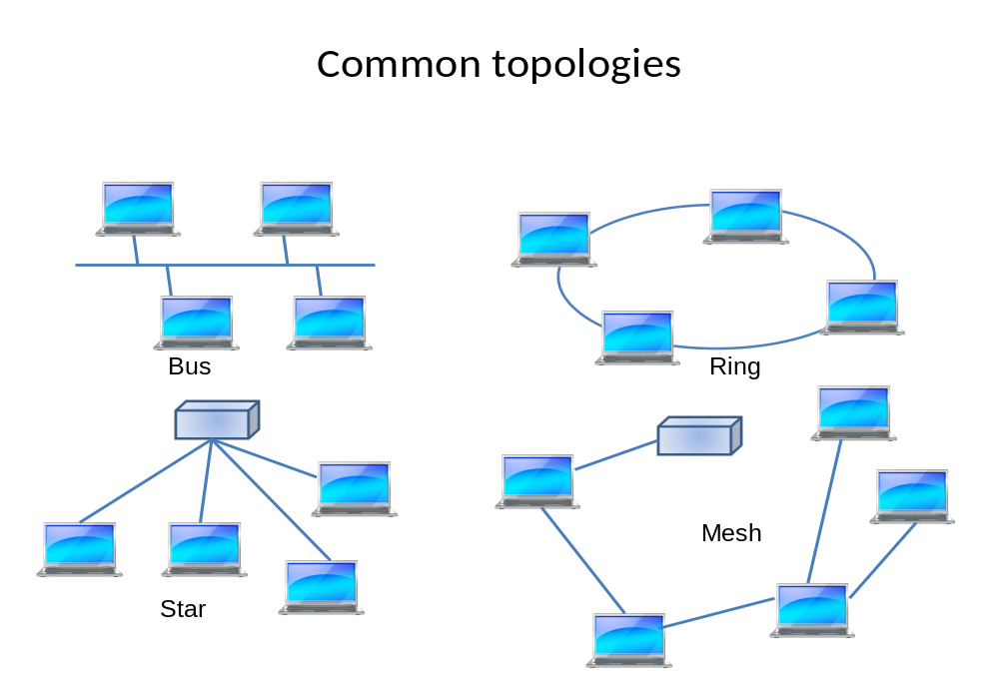

      - Group 12: Connection Management
This group is intended to capture the capabilities provided to initiate and maintain radio connectivity.

    - Descriptions of Groups 13-20 Submissions

Group 13: QoS and Traffic Prioritization
a: | Traffic priority | diffserv, resserv
b: | Pass-thru Data Tagging
c: | Radio queue priority
Group 14: Location characterization
a: | Location awareness (x,y,z coordinates)
b: | Ranging (distance reporting)
Group 15: Security and Security Management
a: | Encryption | Algorithms supported
b: | Authentication
c: | Replay protection
d: | Key exchange | Protocols supported
e: | Rogue node detection
Group 16: Radio Environment
 | Channel model
 | Interference sources
Group 17: Intra-technology Coexistence
a: | Co-channel interference
b: | Adjacent channel interference
c: | Alternate channel interference
d: | Collision avoidance
e: | Protection mechanisms
Group 18: Inter-technology Coexistence
a: | Sensitivity to other interfering radio technologies
b: | Degree of interference caused to other radio technologies
c: | Sensitivity to power line RF emissions
Group 19: Unique Device Identification
a: | MAC address
b: | SIM card
c: | Other identity
d: | Rogue detection
Group 20: Technology Specification Source
a: | Base Standard SDO | SDO name
b: | Profiling and Application Organizations | Association / Forum Name

      - Group 13: QoS and Traffic Prioritization
Quality of service can be viewed as and end-to-end requirement, but some radio systems assist in the process by providing QoS between radio nodes. This group is used to capture information regarding the capabilities to manage traffic priority.
- Traffic priority refers to the ability of radio systems to use high level priority schemes such as diffserv (defined by IETF RFCs 2472 & 2475) & intserv (defined by IETF RFCs 1633 & 2205).
- Pass-thru Data tagging refers to the ability to transfer successfully packets that use a class of service priority tags, such as those defined by IEEE 802.1p
- Radio queue priority refers to the ability of radio nodes to prioritize packets that are queued for transmission.

      - Group 14: Location characterization
Radio systems that provide information about their location can be helpful. One common form of location information would provide 3-dimensional information regarding position, such as that provided via GPS coordinates. An alternate form would provide range information such that when the absolute location of every node is not known, if the location of one radio device was known, then at least the distance between the nodes could be provided.

      - Group 15: Security and Security Management
Ensuring that Smart Grid data is transferred securely is a high priority. As with other such as QoS there are options to apply security at multiple different layers in the OSI model. This group focuses on options provided and by the radio system at layer 1 and layer 2.

      - Group 16: Radio Environment

      - Group 17: Intra-technology Coexistence
Some radio technologies provide mechanisms for avoiding or detecting interference cause by other radios of the same type within receiving range. The intent is to determine if a system has such capabilities that can be used to reduce detrimental interference and thereby improve SNR, and thus will allow the radio to maintain a low error rate link.

      - Group 18: Inter-technology Coexistence
As with the previous group, some radio technologies provide mechanisms for avoiding or detecting interference cause by other radios of a different type that are operating in the same spectrum and are within receiving range. The intent is to determine if a system has such capabilities that can be used to reduce detrimental interference and thereby improve SNR, and thus will allow the radio to maintain a low error rate link.

      - Group 19: Unique Device Identification
It was desired that each radio node be directly identifiable and addressable. This requires that each device have a unique identification scheme. There is more than one way to accomplish this. The information provided will identify the unique identification scheme offered.

      - Group 20: Technology Specification Source
The intent is to provide information about the SDO that developed and maintains the radio technology, plus identify who provided the information for the matrix. Also, in some cases the base standard source is assisted by a compatriot organization that provides additional support including specifications or applications that operate above Layer 2. The support organizations may also provide certification of specification compliance, interoperability and performance.

    - Descriptions of Group 21 Submission

Wireless Functionality NOT directly specified by a standard that is needed in quantifying operating metrics
 | Rx sensitivity | dBm
 | Tx Power peak | dBm
 | Antenna gain | dBi
 | Noise floor | dBm
 | Modulation | GFSK, OFDM, BPSK, GMSK
 | Forward error Coding | Coding rate

      - Group 21 Description
Although these items are vital components of a radio technology description, they do not directly affect the suitability of a technology to a Smart Grid application.

They are a few additional characteristics that are needed to characterize the operation of the radio for the chosen operating point.

- Rx sensitivity - Receiver sensitivity may be specified as a minimum capability required by the SDO in the technology specification. Technology implementations may provide much greater sensitivity than the minimum, so the intent is to capture a typical value that is used for the operating point calculations.
- Tx Power peak – Transmission Peak power is needed for the calculations as well. Some technologies specify only a regulatory limit or allow for a wide variety of options. The Tx power of the devices under consideration for the operating point calculations needs to be specified.
- Antenna gain - Antenna gain is rarely part of a technical radio standard but is a critical component of link budget calculations.
- Noise floor - Noise floor is much like receiver sensitivity. There might be a minimal specification for noise floor required by the SDO in the technology specification. Technology implementations may provide a much lower noise floor than the minimum, so the intent is to capture a typical value that is used for the operating point calculations.
- Modulation - The modulation scheme is not directly part of any calculation but needs to be indentified to aid in other technologists verifying the operating point calculations were correct.
- Forward Error Coding - The methods used by the technology are not of direct interest but the coding rate is when trying to understand the difference between over-the-air data rates and Goodput rates.

  - Technology Submission Titles
Responses have currently been received for the following technologies:
- Cdma2000 1x and cdma2000 HRPD
- Cdma2000 xHRDP
- GMR-1 3G
- IPOS/DVB-S2
- RSM-A
- IEEE 802.16 e,m
- IEEE 802.11
- IEEE 802.15
- Inmarsat BGAN
- LTE
- HSPA+
- UMTS
- EDGE

  - Technology Submissions
The matrix of entries is too large to conveniently show in this document. The complete matrix is contained in the embedded file.

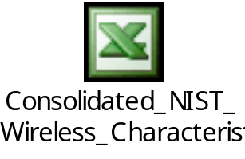

- Modeling and Evaluation Approach
Determining an assessment method for evaluating whether a wireless technology can satisfy the smart grid user applications’ requirements is a daunting task, especially given that there are many possible physical deployment options for smart grid devices and facilities, many wireless technology standards, and uncertainty in planning for future needs.

Some wireless technologies are a part of a larger system, while others are complete communication networks. For example, wireless technologies developed by the IEEE 802 working group consider mostly the Media Access Control (MAC) sublayer and Physical Layer (PHY), while the Universal Mobile Telecommunications System (UMTS) is a complete mobile (and wireless) network system. This makes comparing wireless technologies impractical. For this reason, PAP 2 assesses each wireless technology on whether it can satisfy the smart grid user applications requirements; PAP 2 will not rank the various wireless technologies relative to each other.

Assessment of Wireless Technologies Against Smart Grid Business Application Requirements
The assessment approach described below should be considered as an approach, not the approach that must be used. Options are discussed on how the assessment can be refined with one method further described an detailed in the section 5 sub-sections. The two main tasks includes:
- Perform an initial screening the wireless technologies against the Smart Grid Business Functional and Volumetric Requirements
- Perform refinements to the initial screening using one or a combination of the following:
  - Mathematical models
  - Simulation models
  - Testbeds (lab and in the field)

The initial assessment (technology screening) is based on the smart grid user applications’ requirements in Section and the wireless functionality and characteristics matrix in Section Error: Reference source not found. For example, a user application’s requirement for reliability should be related to the wireless technology’s link availability (i.e. the ability to reliably establish an appropriate device link and the ability to maintain an appropriate connection). One can use the results from the initial assessment to determine whether a given wireless technology should be further considered for use with a particular application in a particular deployment.

After the initial assessment, the next step is to refine the assessment using other methods (i.e., mathematical models, simulations models, or testbeds).
Mathematical Models
These types of models requires creating mathematical model representations that approzimate the characteristics of the system in question e.g. the Smart Grid. These models can be simplistic in that event data volumetrics are aggregated to singular values, or events are treated as individual inputs into the models, or data volumetrics represented and input based on probabilities. Mathematical models usually take less time to produce results than simulation models. There are some limitations to what some of the simpler mathematical models can adequately model.

The concept of aggregating the data to different time intervals (or in this case to a common time interval) has an underlying issue with how the temporal or time distribution of these data requirement is to be treated. There will be a mixture of probabilistic modes involved rather than simple steady state, static values. While it is interesting and simpler to specify the data requirement for an end device in terms of its average data requirements, the reality is that the data flow will not be uniformly spread over the time period of the average. The reality is there will be burst of data, and more likely than not, it be large burst of data to/from the end devices with some high degree of correlation in time. Thus, while some of the data flows may exhibit the classical exponential or Poisson or some other distribution, this will represent only a small portion of the data flow requirements. The greater majority of the data will follow a more deterministic distribution and/or a highly concentrated distribution over a short period of time.

For example, every four hours there may be a request by the head end system to query all the DAPs. So every four hours there will be a burst of data exchanged with the DAPs. In the DA world, there will be a background distribution of data based on normal operation (poll/response, poll/response, etc.) which is usually somewhat deterministic in and of itself. However, as significant events occur on the electrical grid, or the electrical generation side, or load side, there will be burst of data associated with that event, that end up being highly correlated in time.

As long as the reader, user of the mathematical models and especially how input data e.g the smart grid business functional volumetric data has been input into the model, mathematical models are still of value. Section 3.6 illustrates how an aggregation of the business volumetric requirements can be adapted for this approach.

Simulation Models
These type of models, attempt to account for more of the event occurrence variability as noted in the mathematical model discussion above. Simulation models can provide more realistic results than mathematical models, which often require simplifying assumptions to make them tractable.

Testbeds
Usually, neither mathematical or simulation model types are able to capture all the details of a proposed network deployment (e.g., accurate channel models are difficult to obtain without direct measurement of the deployment environment). Using testbeds (in the lab and preferably actual in the field), can provide very accurate results; however, this method requires the most time and effort to produce results.

The key for network design is to understand and define the networks system design goals. Designing a network system to support the average data requirements is one design concept, which tends to result in under designed and built networks. Another concept is to design network system that can handle the absolute worst case imaginable, which tends to result in over designed and built networks. Again the key is to establish a goal of the network and of the individual elements and threads of that network so that it will handle the heaviest expected (combined) burst rates with an acceptable level of failure. For example, in the old telephone trunk design days, one would specify the number of voice trunks necessary to carry the “busy hour” traffic with an acceptable level of failure (2% failure, 5% failure, etc.).

This then leads to two questions that the network designers and implementers need to address, but are not answered in this guideline:
- What is this highest level of traffic that must be accommodated over the burst period(s)? The methods for determining this will be highly dependent on the individual utility operational modes and the aggregated data that will flow through a particular network link or thread. As you can imagine, this will vary greatly from utility to utility and with the topology/technology used to construct the network threads.
- What is an acceptable level of overloading these threads that will result in failure to deliver the data within the required latency and fidelity constraints? This will depend on multiple factors, including the latency and fidelity requirements of the system or application, buffering capabilities to buffer overflow traffic, and how error recover is accomplished.

The Utilities will need to implement systems that will satisfy the needs of that specific utility. Translation – one size does not fit all. So the network designers need to find a way to project and predict the real temporal (and spatial) requirements of the data flows (for the utility, application, or operating mode in question) and to then select and implement technologies and topologies that will provide the needed capacity, reliability, security, cost effectiveness, etc.

For illustrative purposes, a general mathematical modeling framework is developed and described in detail in the section that follows. EXAMPLES are also provided to show how the modeling framework can be used.

  - Modeling Framework

This subsection describes the modeling framework that was developed by the PAP2 working group. The goal of the development process was to produce an analytical structure that was flexible so that it allows users to employ a variety of modeling techniques, and it can be used with virtually any proposed wireless technology. The framework’s main components are a MAC sublayer model, a PHY sublayer model, a module that performs coverage analysis, and a channel propagation model. The overall design of the model is shown in Figure 4. This subsection discusses each of these components and explains how they interact with each other and operate within the larger analytical framework.
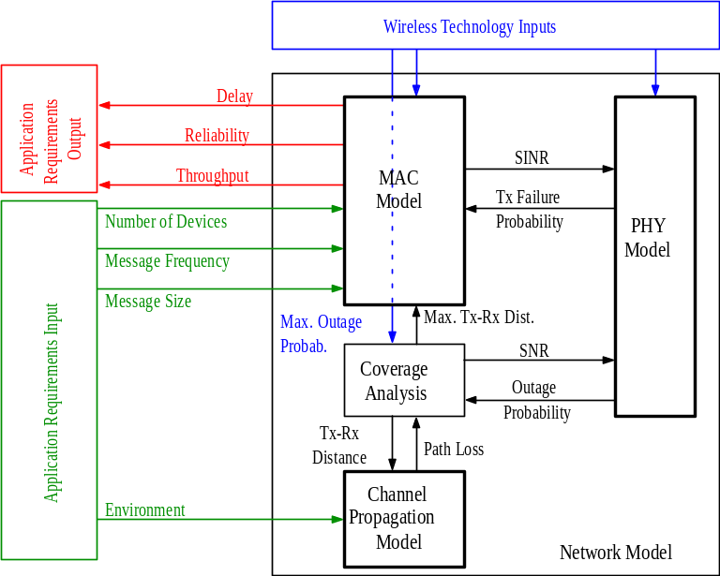
Figure 4 – Modeling Framework Building Blocks

    - Channel Models

Channel models represent the physical wireless characteristics that are expected to be experienced by the communicating signals between a transmitter and a receiver. Here the major problem is identifying the factors that have the greatest impact on the communicating signals between a transmitter and a receiver.

This section gathers channel propagation models for a host of environments. The model parameters were extracted from the data collected in a series of measurement campaigns conducted by the Radio Frequency (RF) Fields Group in the Electronics and Electrical Engineering Laboratory at NIST. The results cited below concentrate on the 2.4 GHz and 5 GHz unlicensed bands common to many technologies.

The environments considered are categorized according to the placement of the transmitter-receiver pair as indoor-indoor, outdoor-outdoor, and outdoor-indoor. The channel propagation path between the pair is characterized by the dual-slope path loss model, which is more flexible than the single-slope model and so can reflect a wider range of environments. The deterministic component of the path loss, PL (dB), is a function of the distance, d (m), between the transmitter and receiver and is defined as follows:

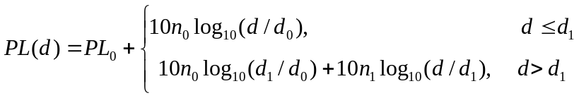

where PL₀ (dB) is the reference path loss at d₀ = 1 m and d₁ (m) is the breakpoint where the path loss exponent adjusts from n₀ to n₁.

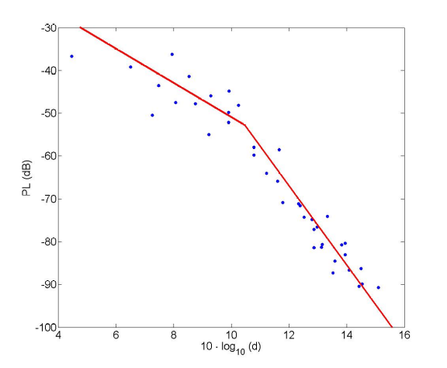
Figure 5: The dual-slope path loss model in an indoor-indoor residential environment at f_{c} = 5 GHz

The path loss model with shadowing PL_{S} (dB) includes the stochastic shadowing parameter S (dB) which varies according to a zero-mean Normal distribution with standard deviation σ:

Figure 5 shows the extraction procedure of the model from the data points. The PL in red is fit to the blue data points collected in an indoor-indoor residential environment at f_{c} = 5 GHz. The deviation of the data points from the line represents the shadowing effect.

      - Indoor-indoor environments
We have gathered indoor-indoor data for residential, office, industrial, and cinder block environments. The details of the measurement system, procedure, and campaign are described in [1,2]. The five model parameters are listed in Table 8. Each environment is further differentiated into line-of-sight (LOS) and non-line-of-sight (NLOS) conditions. Note that in some environments the dual-slope model simply collapses to the single-slope model by setting n₁ = n₀ and choosing d₁ = d₀. Note also that the path loss exponents are stated relative to the free space path loss, so that a reported value of 0.5 for n₀ or n₁ means that the actual loss exponent is 2.5.

Table 8: Indoor-indoor environments
environment |  | f_{c} = 2.4 GHz |  |  |  |  | f_{c} = 5 GHz
 |  | PL₀ | n₀ | d₁ | n₁ | σ | PL₀ | n₀ | d₁ | n₁ | σ
LOS | residential | 16.3 | 2.2 | 1 | 2.2 | 2.4 | 17.9 | 1.7 | 1 | 1.7 | 1.5
LOS | office | 22.8 | 1.2 | 1 | 1.2 | 1.7 | 17.5 | 1.9 | 1 | 1.9 | 1.1
LOS | industrial | 22.4 | 1.1 | 1 | 1.1 | 2.1 | 15.2 | 1.8 | 1 | 1.8 | 1.2
LOS | cinder block | 24.2 | 1.5 | 1 | 1.5 | 2.8 | 12.7 | 2.5 | 1 | 2.5 | 1.6
NLOS | residential | 12.5 | 2.2 | 11 | 5.6 | 3.0 | 20.2 | 2.4 | 11 | 5.4 | 3.3
NLOS | office | 26.8 | 2.2 | 10 | 6.7 | 3.7 | 26.0 | 2.3 | 10 | 8.1 | 4.0
NLOS | industrial | 29.4 | 1.4 | 1 | 1.4 | 6.3 | 27.5 | 1.7 | 1 | 1.7 | 6.7
NLOS | cinder block | 9.1 | 4.9 | 1 | 4.9 | 6.7 | 7.8 | 5.3 | 1 | 5.3 | 7.7

      - Outdoor-outdoor environments
We also gathered outdoor-outdoor data for oil refinery and urban-canyon environments. The details of the measurement system, procedure, and campaign are described in [3,4]. The model parameters are listed in Table 9. In the oil refinery environment, the propagation paths before the breakpoint were in LOS, while those after the breakpoint traversed dense metal piping. This explains the large discrepancy between n₀ and n₁ there, versus the small discrepancy in the urban canyon environment for both LOS and NLOS.

Table 9: Outdoor-outdoor environments
environment | f_{c} = 2.4 GHz |  |  |  |  | f_{c} = 5 GHz
environment | PL₀ | n₀ | d₁ | n₁ | σ | PL₀ | n₀ | d₁ | n₁ | σ
urban-canyon / LOS | 6.9 | 1.7 | 1 | 1.7 | 2.4 | 15.2 | 1.6 | 1 | 1.6 | 2.7
urban-canyon / NLOS | 21.3 | 1.6 | 1 | 1.6 | 7.4 | 20.7 | 2.1 | 1 | 2.1 | 7.5
oil refinery | 16.8 | 0.4 | 87 | 12.2 | 2.3 | 3.0 | 1.3 | 87 | 12.9 | 3.3

      - Outdoor-indoor environments
Finally, we gathered outdoor-indoor data for office, high-rise building, convention center, and the Greathouse mine tunnel environments. The details of the measurement system, procedure, and campaign are described in [13]. The model parameters are listed in Table 10. Because of the nature of the outdoor-indoor environment, all parameters are for non-line-of-sight conditions. In the office environment, measurements were not available at 5 GHz. Also, since no data points were collected there before d₁ = 70 m, we assumed free space (n₀ = 2.0) for distances before the breakpoint. This seems reasonable given the nearly free-space conditions that we observed in the high-rise environment. In the mine-tunnel environment, the propagation paths before the breakpoint were in LOS, while those after were in NLOS where penetration is difficult given the thickness and density of the mine walls. This explains the very large discrepancy between n₀ and n₁ there.

Alternatively, an outdoor-indoor environment can be composed from an indoor-indoor segment, an outdoor-outdoor segment, and a fixed penetration loss to account for the transition through the building material. Reference [5] provides an extensive list of penetration losses at a number of center frequencies.

Table 10: Outdoor-indoor environments
environment | f_{c} = 2.4 GHz |  |  |  |  | f_{c} = 5 GHz
environment | PL₀ | n₀ | d₁ | n₁ | σ | PL₀ | n₀ | d₁ | n₁ | σ
office | 0.2 | 2.0 | 70 | 4.2 | 3.3 | NA | NA | NA | NA | NA
high-rise | 8.8 | 2.2 | 1 | 2.2 | 5.6 | 9.2 | 3.3 | 1 | 3.3 | 4.8
convention center | 4.2 | 0.6 | 100 | 3.7 | 4.6 | 15.5 | 0.8 | 100 | 7.6 | 3.6
mine tunnel | 5.7 | 0.7 | 70 | 18.3 | 5.8 | 1.3 | 0.2 | 70 | 23.4 | 4.3

    - Coverage analysis model
The purpose of the coverage analysis is to predict the maximum range of a wireless technology for a given outage probability and a specified set of operating parameters. The range of a wireless technology can help to determine its suitability for linking a particular pair of actors and its coverage area in a point-to-multipoint arrangement.

The outage criterion is the probability that the wireless transmitter-receiver link is not operational. It is expressed in terms of a probability because of the unpredictable behavior of RF propagation, which is often modeled as a stochastic process when accounting for the possible losses due to obstructions (shadowing) and reflections (multipath fading).

In the context of a point-to-multipoint wireless technology, coverage is often analyzed in terms of the maximum cell radius that a base station (BS) or access point (AP) can support. Within the cell, the outage probability varies, generally increasing as a terminal approaches the cell edge. In the analysis below, the outage criterion is expressed in terms of the average outage probability, averaged over all locations in the coverage area. Thus, a reported outage probability of 1%, for example, means that a terminal located at a random point in the cell has a 1% chance of being in outage.

We define the outage probability as the probability that the received signal-to-noise-ratio (SNR) is below the required SNR to operate the link. The required SNR depends on the wireless technology under consideration and serves as an input to the analysis. The received SNR is modeled as a deterministic component, based on transmitter-receiver separation distance, attenuated by random components due to shadowing and fading. For the distance-based component, we assume a dual slope model of path loss with distance as described in Section 5.1.1. For the shadowing, we assume a lognormal distribution (i.e. normal in the log domain), and for the fading, we assume a Nakagami distribution of the fading envelope.

    - PHY sublayer
Next, we discuss the PHY sublayer model. This model exchanges information with the MAC sublayer model and the coverage analysis model. The MAC model supplies a signal-to-interference ratio (SIR), which is based on collision events if the MAC layer uses a shared medium and contention-based protocol and is based on interference statistics for stations at other base stations that use the same frequency as the station of interest. The PHY model also receives signal-to-noise ratio (SNR) information from the coverage analysis model. It combines the inputs to determine the signal-to-interference-and-noise ratio (SINR) at the receiving station. The PHY model combines the SINR with information about the various transmit and receive stages that contribute to the link budget. These stages can include (but are not limited to) the following:
- transmit/receive antennas, which contribute gain
- transmit/receive amplifiers, which also contribute gain
- equalization, which can reduce the effect of inter-symbol interference
- interleaving, which mitigates the effect of long sequences of errors (burst errors)
- modulation scheme (e.g. QPSK or QAM)
- coding scheme, which provides an effective gain by correcting errors
- spread spectrum techniques, which reduce the effect of additive noise and interference

The effects of all of the modeled processing elements are combined to produce a bit error rate (BER), which can be used to compute a frame error rate (FER) by accounting for the effect of higher layer error detection and correction measures such as cyclic redundancy checks (CRCs). The frame error rate is passed to the MAC layer, which can it to compute performance metrics such as the probability that frame retransmissions are required. The PHY model also uses the BER to compute a transmission outage probability, which it sends to the coverage analysis model. The coverage model uses the outage probability to determine the outage criterion, as described in Section 5.1.2.

    - MAC sublayer
Finally, we discuss the MAC sublayer model. This model can be either analytical or simulation-based, and its complexity is determined by the preferences and needs of the user. The MAC sublayer model receives inputs based on the application requirements and the wireless (or wired) technology that is being used to carry the data; the model interacts with both the PHY sublayer and the coverage analysis models.

The MAC sublayer model is responsible for returning values for the following performance metrics for the communications system:
- Reliability
- Mean packet delay
- Throughput
We define the reliability, R, to be the probability that a packet originating from a sending node’s MAC layer is correctly received by the corresponding MAC layer at the receiving node. Thus the reliability is defined with respect to a single link, rather than on an end-to-end or edge-to-edge basis. For MAC layers with a shared channel, where there is contention for resources, the reliability is the probability that the packet does not collide with any packets that are transmitted by other senders and that the packet is not corrupted by channel errors. If the channel is dedicated to the sender (no contention), then the reliability is simply the probability that the packet does not experience any channel errors.

The mean packet delay, D, is the average time from the passage of the packet to the sender’s MAC layer from the protocol layer immediately above to the delivery of the packet by the receiver’s MAC layer to the protocol layer immediately above it. The mean packet delay includes the following:
- The time that the packet spends in the sender’s MAC layer’s transmission buffer
- The processing time at the sender’s MAC layer
- The time required to transmit the packet, which is the packet length in bits divided by the PHY layer channel rate in bits/s
- The time spent waiting to retransmit the packet if it encounters collisions (in the case of a contention-based MAC protocol) or channel errors
- The propagation delay between the sender and the receiver
- The processing time at the receiver’s MAC layer

The throughput, S, is a measure of how efficiently the channel is being used, and it is measured in units of application bits per second. The model computes two types of throughput. The first type is the average throughput, which is the product of the offered load at the application layer, λ, and the packet reliability, R. Note that this means that the ratio of the throughput to the offered load is always a number between 0 and 1. The second type of throughput measured by the model is the instantaneous throughput, which is the ratio of the mean number of application data bits per packet to the mean packet delay. This gives the effective channel rate experienced by a packet that is ultimately successfully sent across the link, even if it requires retransmissions.

The major external inputs that do not depend on the particular MAC technology are the number of devices accessing the channel, the mean packet generation rate of each device, and the mean packet size. The mean packet generation rate is typically given in units of packets per second; the actual packet generation process is arbitrary. Packets can arrive according to a deterministic process, in which case the mean generation rate is simply the actual generation rate, or they can arrive according to a random process, e.g. a Poisson arrival process. The size of the packet typically includes the size of the application data as well as the combined size of all headers, including the MAC and PHY layer headers. The packet size can be deterministic or random, depending on the applications that are being modeled.

There are additional inputs that are unique to the MAC technology that is being modeled. In the case of a contention-based MAC technology, these parameters can include the number of times the MAC layer will attempt to transmit a packet before giving up and dropping it, rules for handling packet collisions, such as the amount of time that the MAC layer must wait to retransmit a packet after it has collided with a packet from another transmitter, and the amount of time the sending MAC layer must wait for an acknowledgement of a transmitted packet before taking further action. Non-contention MAC technologies will use different parameter sets.

The PHY sublayer model exports the probability of transmission failure (P_{fail}) to the MAC sublayer model, which uses it to help compute the output metrics. For instance, if we were modeling a very simple MAC layer that uses dedicated resources (so no contention) and no retransmissions, we would find that the reliability is equal to (1 − P_{fail}), and the mean delay of successfully received packets is the sum of the propagation delay and the transmission time.

The coverage analysis model exports the maximum Tx-Rx distance to the MAC sublayer model. If we have only a user population density, we can use the maximum Tx-Rx distance to compute the size of the user population.

  - An Example
In this subsection we use the methodology that we described in the previous subsections to demonstrate how one can begin with a set of traffic characteristics, a physical channel description, and a MAC layer protocol of interest, and arrive at output metrics that quantify the performance of the system. For this example, we consider a hypothetical channel between a population of smart meters and a DAP. The link is loaded with traffic from applications associated with the following three use cases: meter reading, service switch, and PHEV. The link uses IEEE 802.11 in this example, and features losses due to fading, shadowing, and interference. We begin by considering the input from the application requirements.

    - Applications modeling
Using the application requirements that cover the various Smart Grid domains, this section describes a procedure to convert these requirements into link traffic data for telecommunications modeling and provides an example.

      - Conversion Procedure
Given a Smart Grid network link topology, the application requirements can be converted to link requirements in order to analyze the traffic flow on each link. A link (j,k) is denoted by the downlink message flow from actor j to actor k; in general, the links are asymmetric and so let link (k,j) denote the uplink flow from k to j. The traffic flow on each link is quantified by the aggregate link message rate 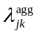 and the average link message size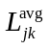, after accounting for all the relevant applications specified in the requirements matrix. Assuming application traffic generated by different sources is modeled as independent Poisson processes with respective generation rates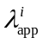 and message sizes 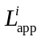, the conversion can be performed as follows: for each of the applications indexed 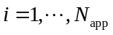,where 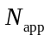is the total number of applications, assign the Boolean value 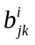 to be 1 if the traffic from application i flows on link (j,k) and 0 otherwise. Then the probability 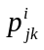 that a message on link (j, k) originates from application i is [8]
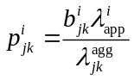,
where the aggregate message rate on link (j,k) can be expressed as
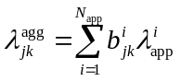
Then the average message size on link (j,k) follows as
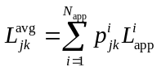
      - Example
Out of the many high level application use cases identified to date, few have been quantified enough to be evaluated. We consider three use cases defined in [9]: Service Switch (SS),
Meter Reading (MR), and Plug in Hybrid Electric Vehicle (PHEV). Considering all the applications of these use cases in the requirements matrix, we examine the aggregate flow on a single link in the network, between the AMI Headend and the DAP, as an example. Nine applications send traffic across this link. The nine message generation rates and application message sizes appear in Figure 6. They are used to compute the aggregate link arrival rate and the average link message size through Eqs. and as 6.7×10⁻⁵ events per electric smart meter (emeter) per second and 197.1 bytes, respectively. We can repeat this process for all the links between the actors in the example link topology shown in Figure 7, resulting in the link requirements matrix shown in Table 11. Each link corresponds to a row in the matrix. Note that the matrix distinguishes between downlink and uplink flows.

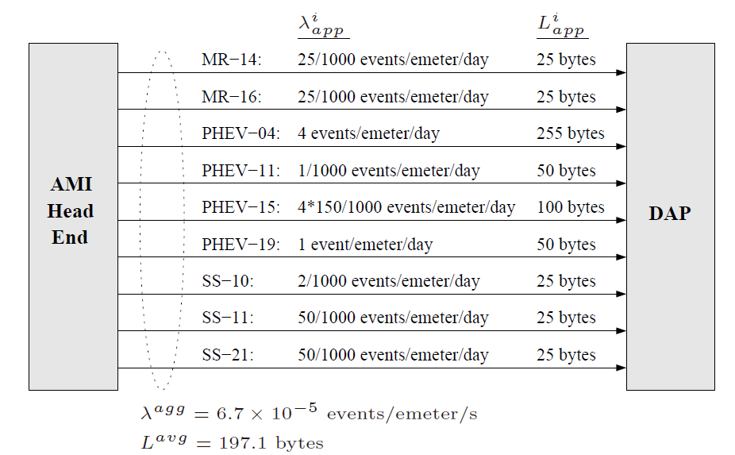
Figure 6 Application flows from AMI Head End to DAP

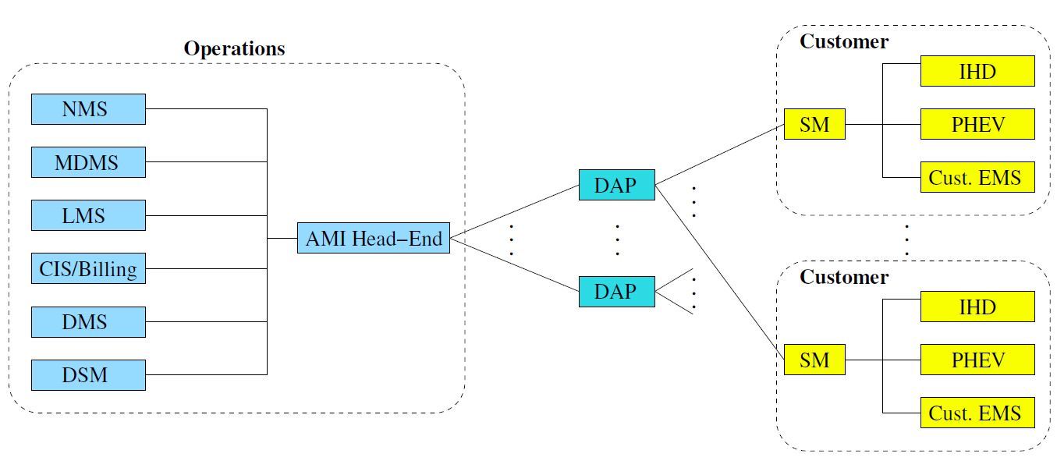
Figure 7: Example link topology

Table 11: Resulting link requirements matrix
Uplink l_{kj} | 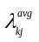 (messages per second) | 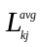 (bytes) | Downlink l_{jk} | 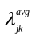 (messages per second) | 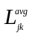 (bytes)
Cust. EMS → SM | 1.2 × 10⁻⁴ | 25 | SM → Cust. EMS | 1.2 × 10⁻⁷ per meter | 50
PHEV → ESI-SM | 2.4 × 10⁻⁴ per PHEV | 97.6 | ESI-SM → PHEV | 9.3 × 10⁻⁵ | 177.5
IHD → SM | 1.2 × 10⁻⁴ | 25 | SM → IHD | 1.2 × 10⁻⁷ | 50
SM → DAP | 1.1 × 10⁻⁴ per meter | 2017.4 | DAP → SM | 1.8 × 10⁻⁶ | 25
DAP → AMI Headend | 1.3 × 10⁻⁴ per meter | 842.5 | AMI Headend → DAP | 6.7 × 10⁻⁵ per meter | 197.1
AMI Headend → CIS/Billing | 6.3 × 10⁻⁷ per meter | 96.1 | CIS/Billing → AMI Headend | 1.5 × 10⁻⁶ per meter | 25
AMI Headend → LMS | 1.4 × 10⁻⁵ per meter | 99.9 | LMS → AMI Headend | 6.9 × 10⁻⁶ per PHEV | 255
AMI Headend → MDMS | 1.3 × 10⁻⁵ per meter | 107.0 | MDMS → AMI Headend | 1.3 × 10⁻⁵ per meter | 25
AMI Headend → NMS | 4.4 × 10⁻⁷ | 50
AMI Headend → DMS | 4.6 × 10⁻⁸ per PHEV | 50
AMI Headend → DSM | 6.3 × 10⁻⁷ per PHEV | 96.3

    - PHY layer modeling
The probability of failure of a transmission attempt is modeled as the probability that the received signal-to-interference and-noise ratio (SINR) is less than a threshold. The received SINR is modeled as random due to channel attenuation (fading, shadowing, path loss) and interference, both of which are treated as random processes. The SINR threshold model for transmission success/failure is based on the observation that for block transmissions, especially those with strong error correction codes, the block error probability in the absence of fading and shadowing is a steep function of the SINR. The model approximates this function as a step function at a threshold value of SINR, which we shall refer to as SINRreq. According to this model, when the actual received SINR—after accounting for fading, shadowing, and the instantaneous interference power—is less than this threshold, the transmission is deemed a failure; otherwise, it is deemed successful. The probability of failure jointly accounts for loss due to a weak received signal, failure due to collision with other stations, and the possibility of capture in the presence of interfering transmissions.

The SINR is expressed as
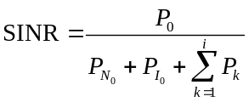
where P₀ is the received power from the station of interest, P_{k}; k = 1,…,i, are the received powers from co-channel transmitters, 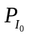 is the power of background interference, and 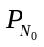is the receiver’s thermal noise power. Then, the probability of failure, conditioned on the number of additional concurrent transmissions, i, is approximated as
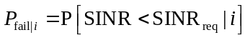

In the denominator of Eq. , we account for two sources of interference, in addition to the noise term . The summation over P_{k}, k = 1,…,i, accounts for the i other stations that are concurrently attempting a transmission to the AP. The term accounts for additional sources of interference (e.g., a jammer, other networks, etc.) and is treated as a constant in what follows.

The received power, P_{k}, from station k, k = 0,…,i, including the station of interest, is a function of the transmitted power, antenna gains, channel attenuation, and other losses. It is modeled (in decibels referenced to 1 mW) as
where P_{t,k,dBm} is the conducted power to the transmit antenna (dBm), G_{t,dBi} and G_{r,dBi} are the transmit and receive antenna gains (dBi), respectively, L_{c,dB} is the loss due to channel propagation, and L_{s,dB} accounts for other system losses like cabling.

      - Channel Model
The channel propagation loss is composed of losses due to distance, fading, and shadowing. We assume a dual-slope model of path loss with distance, Nakagami frequency-flat small-scale fading, and lognormal shadowing. The overall channel propagation loss can then be expressed as
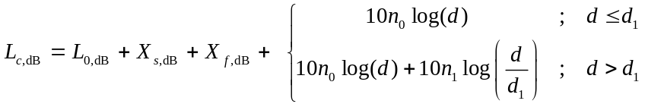
where X_{f;dB} = 10 log(X_{f} ) and X_{f} is a unit-mean gamma-distributed random variable with variance 1/m (and where m is the Nakagami fading parameter); X_{s} dB is a zero mean Gaussian random variable with standard deviation σ_{s}, and all logarithms are base 10. We assume that the fading and shadowing are constant during the transmission of a frame, are mutually independent, and are independent of those on other links.

      - Computing the Conditional Probability of Failure
In the special case of no competing transmissions (i = 0), Eq. is relatively straightforward to compute analytically. For a given station-to-AP distance, r₀, this probability of failure, P_{fail | i = 0}(r₀), can be expressed in terms of the cumulative distribution function of the combined fading/shadowing channel attenuation. To analyze the performance of an average station, we assume that a station’s location is random and uniformly distributed in a circular coverage area of radius R centered at the AP. Under this assumption, it is easily shown that the probability density function of the station-to-AP distance is given by f(r) = 2r/R²; 0 < r < R, so that the average conditional probability of failure is
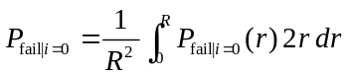
which can be evaluated numerically. In the more general case of more than one concurrent transmission (i.e., i > 0), evaluating Eq. and accounting for the random distances of all i + 1 transmitting stations as well as their respective fading and shadowing attenuations is not trivial. Certain special cases can be evaluated analytically. One such case is when the thermal noise and background interference can be ignored and the fading is Rayleigh [10]. Another approach which allows more general fading distributions is to treat the interference as resulting from a Poisson field of emitters on an infinite two-dimensional plane, in which case the total interference power has an α-stable distribution. However, a closed-form expression for this distribution only arises for a single-slope path loss model with exponent n = 4. To accommodate more general scenarios, we resort to a Monte Carlo approximation of Eq. obtained by sampling the random variables on which Eq. depends and calculating the ratio of the number of samples for which SINR < SINR_{req} to the total number of samples. A comparison of numerical results obtained using 10⁶ samples with those available analytically [10]—for the special case of Rayleigh fading (m = 1), no background noise, and path loss exponent 4—demonstrates an accuracy on the order of 10⁻⁴.

    - Coverage Analysis
The purpose of the coverage analysis is to predict the maximum range of a wireless technology for a given outage probability and a specified set of operating parameters. The range of a wireless technology can help to determine its suitability for linking a particular pair of actors, the number of actors it can support in a point-to-multipoint arrangement, and the resulting network topology.

The outage criterion is the probability that the wireless transmitter-receiver link is not operational. It is expressed in terms of a probability because of the unpredictable behavior of RF propagation, which is often modeled as a stochastic process when accounting for the possible losses due to obstructions (shadowing) and reflections (multipath fading).

In the context of a point-to-multipoint wireless technology, coverage is often analyzed in terms of the maximum cell radius that a base station (BS) or access point (AP) can support. Within the cell, the outage probability varies, generally increasing as a terminal approaches the cell edge. In the analysis below, the outage criterion is expressed in terms of the average outage probability, averaged over all locations in the coverage area. Thus, a reported outage probability of 1 %, for example, means that a terminal located at a random point in the cell has a 1 % chance of being in outage.

We define the outage probability as the probability that the received signal-to-noise-ratio (SNR) is below the required SNR to operate the link. The required SNR depends on the wireless technology under consideration and serves as an input to the analysis. The received SNR is modeled as having a deterministic component, based on transmitter-receiver separation distance, and random components due to shadowing and fading. For the distance-based deterministic component, we assume a dual-slope model of path loss versus distance. For the shadowing, we assume a lognormal distribution, and for the fading, we assume a Nakagami distribution of the fading envelope [10].

      - Nominal Received SNR
The deterministic component of the received SNR, or the nominal SNR at some transmitter-receiver distance d in the absence of fading and shadowing, can be evaluated using a link budget approach. In terms of the commonly used E_{b}/N₀, the ratio of the received energy per bit to the power spectral density of the noise, it is modeled in decibels as
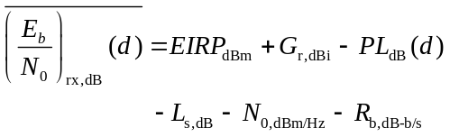
where EIRP_{dBm} is the effective isotropic radiated power from the transmitter (dBm), G_{r,dBi} is the receiver antenna gain (dBi), PL_{dB}(d) is the path loss in dB at distance d, L_{s,dB} is the cumulative system loss due to cabling or other implementation losses (dB), N_{0,dBm/Hz} is the power spectral density of the noise (dBm/Hz) (computed as 30 + log₁₀(kT₀F) where k is Boltzmann's constant (J/K), T₀ is the temperature (K), and F is the receiver's noise figure) and R_{b,dB-b/s} is the physical layer information data rate (dB-b/s).

Using the dual-slope path loss model, the term for path loss with distance in Eq. is calculated as

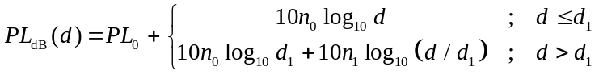

where n₀ and n₁ are the path loss exponents of the dual-slope model, d₁ is the breakpoint distance (m) from path loss exponent n₀ to n₁, and PL₀ is the reference path loss at 1 m. Table 12 lists values for these parameters that were extracted from measurements made at 2.4 GHz in various environments [11]—[14].

Table 12: Path loss parameters at 2.4 GHz for several environments
Environment | PL₀ (dB) | n₀ | d₁ (m) | n₁ | σ (dB)
Indoor residential LOS | 16.3 | 4.2 | N/A | N/A | 2.4
Indoor residential NLOS | 12.5 | 4.2 | 11 | 7.6 | 3.0
Indoor industrial NLOS | 29.4 | 3.4 | N/A | N/A | 6.3
Outdoor urban-canyon NLOS | 21.3 | 3.6 | N/A | N/A | 7.4
Indoor-outdoor convention center NLOS | 4.2 | 2.6 | 100 | 5.7 | 4.6

      - Calculating Outage Probability
The outage probability at distance d is the probability that the received SNR, (E_{b}/N₀)_{rx}(d), is less than the required SNR, (E_{b}/N₀)_{req}:
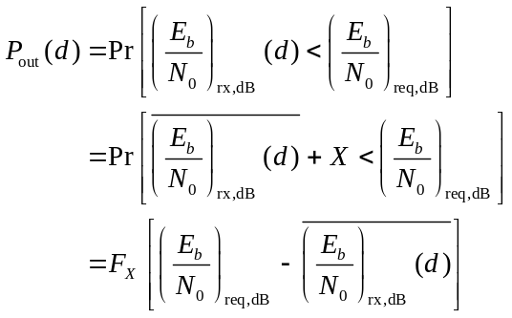
where X = X_{s,dB} + X_{f,dB} is the combined random attenuation due to shadowing and fading, and F_{X}(x) is the cumulative distribution function (cdf) of the random variable X.

Based on the assumption of lognormal shadowing, the shadowing attenuation X_{s,dB} is modeled as a zero-mean Gaussian random variable with standard deviation σ. (Table~\ref{tbl:channelModels} lists values of σ obtained by measurement in various environments.) In the presence of shadowing alone (i.e., X = X_{s,dB}), the cdf of X is
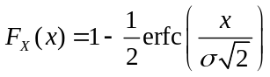
where erfc(x) is the complementary error function.

Based on the assumption of Nakagami-m fading, the fading attenuation X_{f} is modeled as a unit-mean Gamma-distributed random variable. In the presence of fading alone (i.e., X = X_{f,dB} = 10log₁₀ X_{f}), the cdf of X is
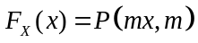
where 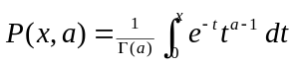 is the incomplete gamma function (lower regularized).

In the presence of combined lognormal shadowing and Nakagami fading (X = X_{s,dB} + X_{f,dB}), the cdf of X can be evaluated numerically as
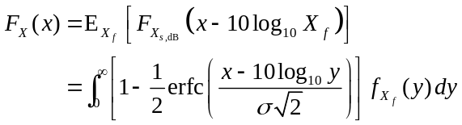
where the probability density function of X_{f} is
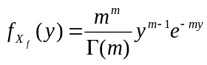
and Γ(·) is the Gamma function.

Finally, to obtain the average outage probability over the entire coverage area, we must average Eq. over the area of the cell. For uniformly distributed terminal locations in a cell bounded by radii R_{min} and R_{max}, it can be shown that this average is given by [10]
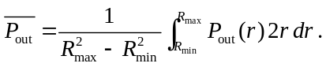

      - Example
Figure 8 plots sample results for the average outage probability from Eq. as a function of the maximum coverage radius, R_{max}, and for R_{min} = 10 m. Outage curves for three cases are shown, all at 2.4 GHz: (i) the indoor residential non-line-of-sight (NLOS) environment (row 2 of Table 12) at typical transmit power, (ii) the outdoor urban NLOS environment (row 4 of Table 12) at typical transmit power, and (iii) the same outdoor environment but operating at the maximum permitted EIRP for the unlicensed 2.4 GHz band. In each case, the fading is Rayleigh (i.e., Nakagami fading parameter m = 1). The values for the remaining technology-specific parameters used in this example are listed in Table 13 and generally correspond to the IEEE 802.11 standard operating at 1 Mb/s.

Table 13: PHY parameter values used for Figure 8
PHY Model Parameter | Symbol | Value
PHY data rate | R_{b} | 1 Mb/s
Required E_{b}/N₀ | (E_{b}/N₀)_{req,dB} | 10.4 dB
Receiver noise figure | F | 5 dB
Temperature | T₀ | 293 K
System losses | L_{s,dB} | 1.5 dB

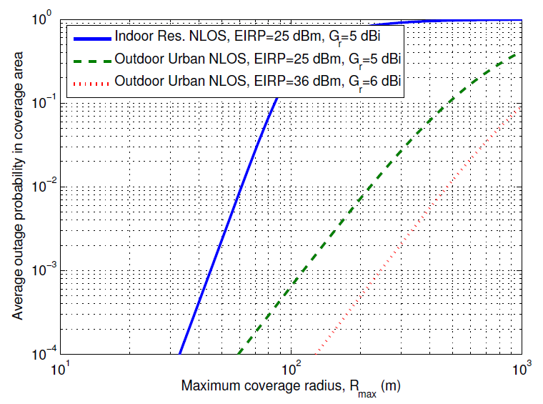
Figure 8: Sample outage results at 2.4 GHz

Figure 8 shows that, for this example, the outdoor coverage radius corresponding to a 1 % outage probability is 220 m at moderate transmission power and nearly 500 m at maximum transmission power. Furthermore, the indoor range is clearly sufficient for most indoor residential environments.

    - MAC layer modeling
By combining elements of the Bianchi and Zhai models [3],[4] while incorporating the threshold-based physical layer model that we described in Section~\ref{sec:model:PHY}, we produced an extended MAC layer model for the half-duplex channel. This model contains novel elements that allow us to more accurately predict the performance of lightly loaded wireless networks that feature symmetric traffic patterns on their links. This section describes the principal features of the model.

We show the Markov chain for an IEEE 802.11 station that supports finite retransmissions in Figure 9. The figure is derived from Fig. 3 from [4]. The (i,j)th state in the diagram denotes the station's being on the (i − 1)th transmission attempt, with the backoff counter at j; when the counter reaches j = 0, the station attempts to transmit its frame. Stations are allowed up to α retransmissions of a frame if the first attempt fails. If a transmission attempt fails, which occurs with probability P_{fail}, the station chooses a random backoff if it has retransmission attempts remaining. If, after α + 1 attempts, the station fails to send the frame, it drops the frame.

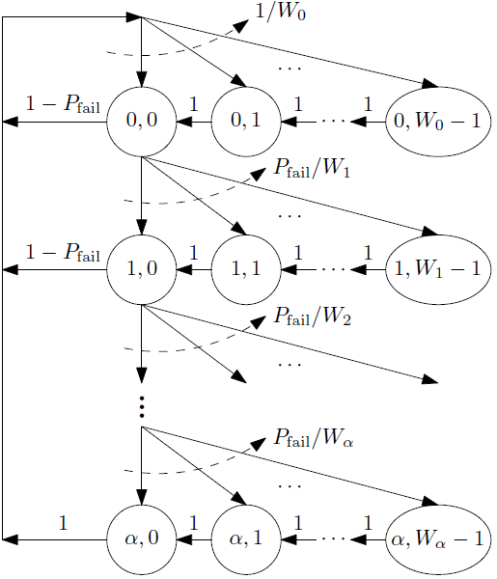
Figure 9: Markov chain for IEEE 802.11 backoff counter with maximum of α retransmissions

The maximum number of backoff slots that an IEEE 802.11 transmitter can use during the ith attempted retransmission of a frame is
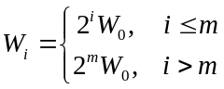
where W_{m} is the maximum backoff window size. Using the Markov chain analysis from [3], we get expressions for τ_{ST}, the probability that a given station is transmitting a frame, and τ_{AP}, the probability that the AP is transmitting a frame. Both expressions have the form shown below, where X ∈ {ST,AP}:
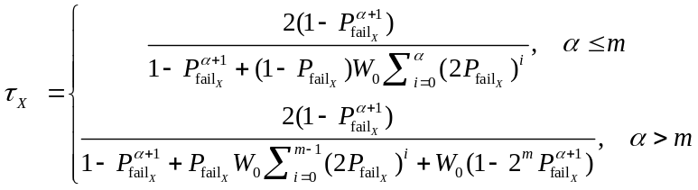

We can obtain expressions for 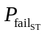and 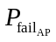, which are the probability that a station's frame transmission attempt fails and the probability that the AP's frame transmission attempt fails, respectively. In the case of the station, we condition the probability of transmission failure on the number of other stations that are transmitting at the same time. Since the stations transmit independently, the probability of i stations transmitting follows a binomial distribution. Given that i other stations are transmitting, the conditional probability of failure for the station of interest is further conditioned on whether the AP is transmitting. If the AP is transmitting, the transmission attempt will fail because the AP cannot receive anything while it is transmitting. If the AP is not transmitting, the probability of transmission failure is 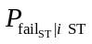, which we obtain by using the threshold-based physical layer model in Section~\ref{sec:model:PHY}. Thus the probability that a given station's transmission attempt fails is
where 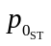is the probability that the station is idle, i.e. that it has no frames to send, and 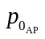is the probability that the AP is idle.

To get the AP's probability of frame transmission failure, we condition on the number of stations that send frames when the AP is transmitting. For each case where i stations are transmitting, we also condition on whether one of the i stations is the destination for the AP's transmission. We assume that the probability that a given station is the AP's destination is 1/N. The AP's destination will therefore be transmitting, causing the AP's transmission to fail, with probability i/N. Otherwise, with probability (N − i)/N, the destination is not transmitting, and the AP's conditional failure probability is 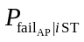, which we obtain from the threshold-based physical layer model. Putting everything together, we get
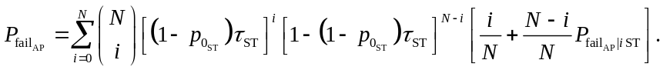

Together, Eqs. , , and comprise a system of nonlinear equations in the variables τ_{ST} and τ_{AP}, and and . We use a simple grid search technique to find τ_{ST} and τ_{AP}, given values of and , since each variable is restricted to the interval [0,1]. We use the values of τ_{ST} and τ_{AP} to get new values for and . From these values, we perform a queueing analysis to get new values for and , which we use to solve Eq. again. We continue this iterative process until the values of τ_{ST}, τ_{AP}, and , and converge, and we are able to get the performance metrics for the stations and the AP.

Using the PGF-based technique from [4], we can find the mean MAC processing time, which is the mean time from the beginning of the first frame transmission attempt to either the frame's successful reception or its dropping by the sender because the allowed number of transmission attempts has been used, without success. The mean MAC-layer frame processing time for the stations and the AP is:
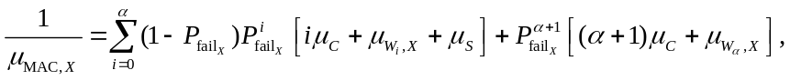
where X ∈ {ST,AP}. This expression follows from evaluating the PGF of the MAC processing time, using the assumptions that consecutive frame transmission attempts are independent and that the number of transmission attempts follows a truncated geometric distribution. The independence assumption is reasonable in a fast fading environment, where channel conditions will vary between transmission attempts. Given that i retransmission attempts are required, the average time required to successfully send the frame is the sum of μ_{S} = E{S_{t}}, the expected duration of a successful frame transmission cycle, iμ_{C}, the expected duration of i unsuccessful frame transmission cycles where μ_{C} = E{C_{t}}, and 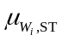 or 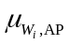, which are respectively the expected time that a station or the AP spends in the 0th to ith backoff stages. They are both given by
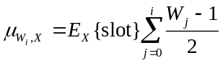
where E_{X}{slot} is the mean time between backoff counter decrements, and X ∈ {ST,AP}. The additional term in Eq. is associated with the event where all α + 1 attempts fail.

The length of time that a station or AP must wait to decrement its backoff counter depends on the level of activity on the channel while it is waiting. If the backed off entity does not sense any transmissions on the channel during the slot interval σ, it will automatically decrement its counter. If there is activity on the channel, the backed off entity will wait until the channel is idle for a slot duration, at which time it will decrement its counter. The amount of time that the backed off entity must wait depends on the outcome of the transmission attempt. If it is successful, and we are using the basic access scheme, the delay is (from Eq. (13) in [4]):
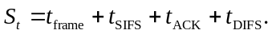
In this expression, t_{frame} and t_{ACK} are the times associated with transmitting the frame and the ACK message, respectively. t_{SIFS} and t_{DIFS} are the durations of the Short InterFrame Space (SIFS) and the Distributed Coordination Function (DCF) InterFrame Space (DIFS), respectively. The DIFS and SIFS are related by t_{DIFS} = t_{SIFS} + 2σ [15]. We assume that the frames are a fixed length, so that S_{t} is deterministic. Likewise, from Eq. (12) in [4], the duration of an unsuccessful transmission attempt is
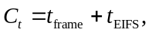
where t_{EIFS} is the Extended Interframe Space (EIFS) duration, and t_{EIFS} = t_{SIFS} + t_{ACK} + t_{DIFS} [15].

In [4], the authors used PGFs to obtain an expression for the mean time between counter decrements. The extension to the half-duplex channel case is straightforward, giving
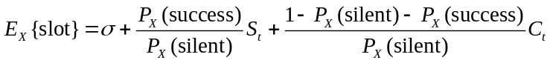
for the stations and the AP.

The probability that a backed off station detects an idle slot, P_{ST}(silent), is the probability that neither the AP nor any of the other N − 1 stations attempts transmission in that slot. Likewise P_{AP}(silent), the probability that the AP detects an idle slot while in backoff, is the probability that none of the N stations attempts a transmission. Since the transmission probabilities in a given slot for a station and the AP are (1 − )τ_{ST} and (1 − )τ_{AP}, we have
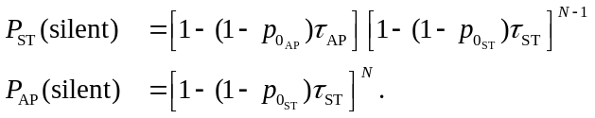

Figure 10(a) and Figure 10(b) show the transmissions and interference that affect both uplink and downlink transmissions. In Figure 10(a), the station indicated by the red triangle will be able to successfully transmit to the AP (the blue square), if the Signal-to-Interference-and-Noise Ratio (SINR) in Eq. is greater than some threshold, SINR_{req}.
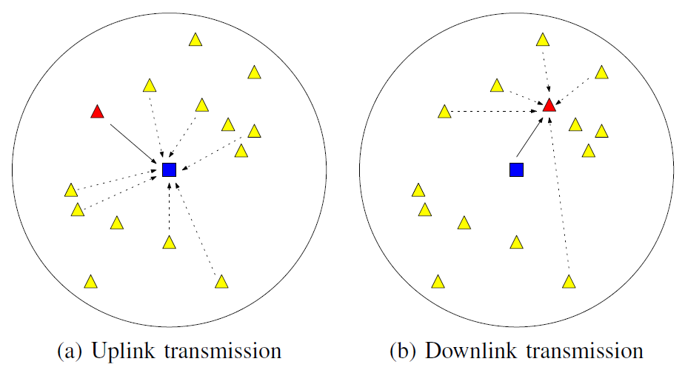
Figure 10: Transmitters and interferers on the uplink and downlink in an
IEEE 802.11 network consisting of a single AP and multiple stations

We get the probability that a station in backoff detects a successful transmission by conditioning on whether the AP is transmitting. If the AP is transmitting, it is impossible for a station to successfully send a frame to the AP. For the case where the AP is not transmitting, we need to condition on the number of stations that are transmitting and then use the physical layer model to get the probability that one of the i stations has a SINR that is above the recovery threshold while the remaining transmitting stations do not. The resulting expression for P_{ST}(success) is
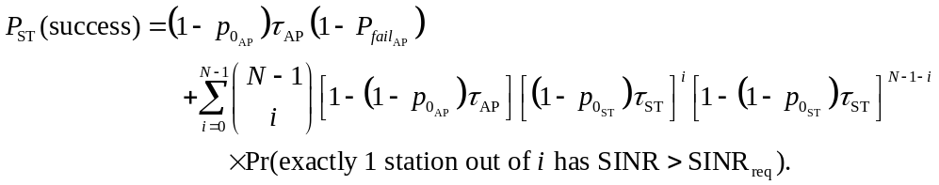

We get the probability that a backed-off AP receives a successful transmission from one of the stations by conditioning on the number of stations that are transmitting. We assume that the AP is in receive mode while it is backed off. We get
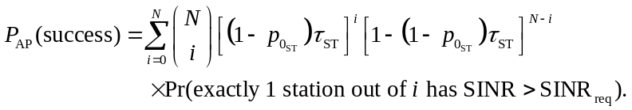

Once we have the mean MAC service times for both the stations and the AP, we use an M/M/1/K queue model to get the performance metrics for the network. Each station has a capacity of K frames, including a frame buffer that can hold up to K − 1 frames. We say that a station is in state n if it is holding n frames, 0  n  K, with one being transmitted and max(0,n − 1) queued in the buffer. The probability that a station is in state n is
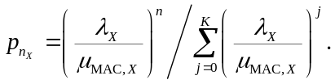
With the queue state probabilities in hand for the stations and the AP, we can get our metrics, again using the placeholder X ∈ {ST,AP}. For instance, the queue blocking probability is the probability that the station is in state K:
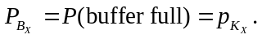
The mean system occupancy is the average number of frames at a station or at the AP:
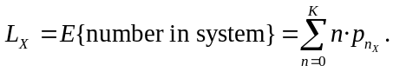
Using Little's Law [16] it follows that the mean frame delay, i.e. the mean time from a frame's insertion into the tail of the MAC buffer to its successful reception, is
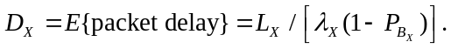
The station's frame reliability is the probability that a frame is neither dropped because the buffer is full nor discarded after α + 1 unsuccessful transmission attempts:
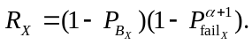
The mean throughput in frames per second is the frame arrival rate multiplied by the fraction of frames that successfully reach their destination, i.e. the reliability:
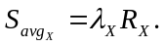

    - Combining Components
The MAC sublayer model takes input from the PHY sublayer model to determine the probability that a transmitted frame is lost. Previous versions of Bianchi-type models either ignored frame losses due to channel effects or they treated collisions with other frames and losses due to channel effects as independent events. More recently, the work by Daneshgaran et al. has modeled the effect of channel capture, but has treated losses due to bit errors as separate, independent events. In our model, we use a threshold-based system that jointly accounts for both collisions and channel errors to determine whether a transmitted frame reaches its destination.

    - Example results
Consider again the example logical link topology of the Smart Grid network illustrated in Figure 7. The actors are grouped into Operations and Customer domains connected through Data Aggregation Points (DAP). The AMI Headend has a link with multiple DAPs, each of which in turn has a link with multiple smart meters (SM). The offered load on each link is listed in Table 11.

For illustrative purposes only, we analyzed the logical link between a DAP and the smart meters assuming the use of an intervening layer of relays. The relays aggregate traffic from smart meters and they send the aggregated traffic to the DAP over an 802.11 wireless multiple access network. Using the physical layer parameter values of Table 13 along with the channel parameters for the outdoor urban NLOS environment in Table 12, our 802.11 analysis tool processed the traffic parameters of the DAP-relay link and returned its mean delay, reliability, and throughput. The number of relays communicating with the DAP was set to 40 in this example, and the smart meters were assumed to be evenly allocated to the relays.

Figure 11 plots the throughput and Figure 12 plots the delay on the DAP-relay link as a function of the number of smart meters served by each relay. The relay-DAP uplink saturates first, because of its higher traffic load, but not until 4000 smart meters per relay. Recalling the coverage analysis of Figure 8, the coverage radius at maximum power and 1% outage probability is about 0.5 km. Assuming comparable DAP and relay coverage radii, and an urban meter density of 2000 electric meters per square kilometer, the DAP would only have about 6000 smart meters within its two-hop coverage area, or about 150 smart meters per relay, far below the link’s capacity limit of 4000 smart meters per relay. Thus, considering all factors—geographic coverage, traffic load, and link performance—we observe that the SM relay-DAP link in this example is coverage-limited, not bandwidth-limited, and therefore has excess network capacity.

The traffic load used in this example is derived from the three use cases that have been quantified thus far [12]. Naturally, additional application traffic will cause the network to saturate at a lower number of meters.

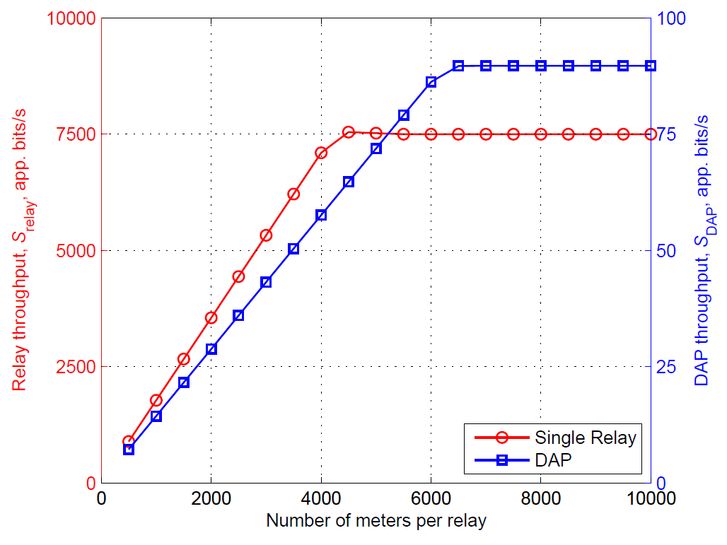
Figure 11: Relay throughput, versus number of SMs aggregated per DAP

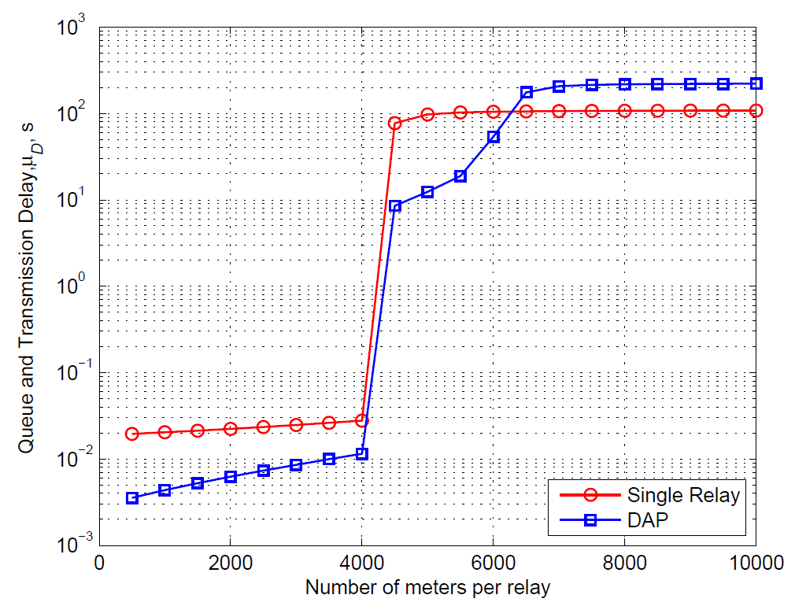
Figure 12: Mean delay of relay and DAP, versus number of SMs aggregated per DAP

- Findings / Results

Does wireless technology X meet SG-Network requirements
Performance Metrics
Reliability
Latency
Scalability
meets throughput needs
handles the number of devices needed
range
interference immunity

By actor to actor / Link by link which is the best to use

How does its work in urban, sub-urban, rural
How well does it propagate (e.g. walls, basements, vaults, clutter, hills)
scalability over a quantity of end points

Equipment required to operate
Include processing time between actor to actor

- Conclusions
- Smart Grid Standards are Smart Business
- Standards are great, everyone has one
- Don’t touch downed power lines

- References

ISO/IEC27001 - International Organization for Standardization/International Electrotechnical Commission Standard 27001 –Information technology -- Security techniques -- Information security management systems -- Requirements

NIST Special Publication 1108 - NIST Framework and Roadmap for Smart Grid Interoperability Standards, Release 1.0∗, January 2010

Second DRAFT NIST IR 7628 Smart Grid Cyber Security Strategy and Requirements

http://osgug.ucaiug.org/UtiliComm/Shared%20Documents/Forms/AllItems.aspx?RootFolder=http%3a%2f%2fosgug%2eucaiug%2eorg%2fUtiliComm%2fShared%20Documents%2fInterium%5fRelease%5f2&FolderCTID=0x012000D61E6400383B0E4DA3A3454503972C5A

- Bibliography

- M. Zorzi and R. R. Rao, “Capture and retransmission control in mobile radio,” IEEE J. Select. Areas Commun., vol. 12, no. 8, pp. 1289–1298, Oct. 1994.

- M. R. Souryal, B. R. Vojcic, and R. L. Pickholtz, “Interference model for ad hoc DS/CDMA packet radio networks with variable coherent modulation,” in Proc. MILCOM, Oct. 2003.

- Bianchi, G., “Performance analysis of the IEEE 802.11 distributed coordination function,” IEEE IEEE J. Select. Areas Commun., vol. 18, no. 3, pp. 535–547, 2000.

- Zhai, H.Q., Kwon, Y.G., and Fang, Y.G., “Performance analysis of IEEE 802.11 MAC protocols in wireless LANs,” Wireless Communications and Mobile Computing, vol. 4, no. 8, pp. 917–931, 2004.

- Daneshgaran, F., Laddomada, M., Mesiti, F., and Mondin, M., “Unsaturated throughput analysis of IEEE 802.11 in presence of non ideal transmission channel and capture effects,” IEEE Transactions on Wireless Communications, vol. 7, no. 4, pp. 1276–1286, April 2008.

- Jin, H., Jung, B.C., Hwang, H.Y., and Sung, D.K., “A throughput balancing problem between uplink and downlink in multi-user MIMObased WLAN systems,” in Proc. IEEE WCNC, pp. 17951800, April 2009.

- Griffith, D., Souryal, M., Gentile, C., and Golmie, N., “An integrated PHY and MAC layer model for half-duplex IEEE 802.11 networks”, to be presented at IEEE Military Communications Conf. (MILCOM), December 2010.

- A. Papoulis, Probability, Random Variables, and Stochastic Processes, McGraw-Hill, Inc., Third Edition, 1991.

- SG Network Systems Requirements Specification, v. 2.1, Mar. 12, 2010. Available online at http://osgug.ucaiug.org/UtiliComm/Shared%20Documents/Interium_Release_2/.

- T. S. Rappaport, Wireless Communications: Principles and Practice. Upper Saddle River, New Jersey: Prentice Hall PTR, 1996.

- C. Gentile, S. M. Lopez, and A. Kik, “A comprehensive spatial-temporal channel propagation model for the ultra-wideband spectrum 2-8 GHz,” in Proc. IEEE Global Telecommunications Conf., Dec. 2009.

- NIST UWB-MIMO Channel Propagation Measurements in the 2-8 GHz Spectrum. Available online at http://www-x.antd.nist.gov/uwb.

- W. F. Young, K. A. Remley, J. Ladbury, C. L. Holloway, C. Grosvenor, G. Koepke, D. Camell, S. Floris, W. Numan, and A. Garuti, “Measurements to support public safety communications: Attenuation and variability of 750 MHz radio wave signals in four large building structures,” Natl. Inst. Stand. Technol. Note 1552, Aug. 2009.

- D. W. Matolak, K. A. Remley, C. Gentile, C. L. Holloway, Q. Wu, and Q. Zhang, “Ground-based urban channel characteristics for two public safety bands,” submitted to IEEE Trans. on Antennas and Propagation, Dec. 2009.

- “IEEE 802.11-2007, Wireless LAN Medium Access Control (MAC) and Physical Layer (PHY) Specifications,” June 2007.

- Gross, D. and Harris, C.M., Fundamentals of Queueing Theory, Wiley Series in Probability and Mathematical Statistics, 1985.

The full description of the procedures used in this document requires the identification of certain commercial products and their suppliers. The inclusion of such information should in no way be construed as indicating that such products or suppliers are endorsed by NIST or are recommended by NIST or that they are necessarily the best materials, instruments, software or suppliers for the purposes described.
AICPA, 1211 Avenue of the Americas, New York, NY 10036; www.aicpa.org
Department of Homeland Security – www.dhs.gov
Electric Power Research Institute, Inc. (EPRI) 3420 Hillview Avenue, Palo Alto, California 94304
Federal Energy Regulatory Commission - www.ferc.gov
International Electrotechnical Commission – www.iec.ch
ISA, 67 Alexander Drive, Research Triangle Park, NC 27709 USA - www.isa.org
www.nerc.com
www.sce.com

