Documenting Functional & Volumetric Requirements
Instructions

A SG-Network use case functional and volumetric requirements, is a collection of application payload requirement sets that describe the interaction from the originating source of a specific application payload, across intermediary actors, to the consuming actor(s), with primary focus on domain gateway actors and the electronic communication paths.

Each application payload requirement-set consists of multiple functional & volumetric table rows, where:
- requirements must be stated from a business perspective and not specific to what any technology or standard or protocol might theoretically operate
- payloads stated as one directional, with any expected results documented as a separate named application payload, unless specifically stated otherwise e.g. negotiation communication threads
- the sequence of the entered rows flow from the originating source actor, through any intermediary actors to the consuming actor(s).
- 1st row of a payload requirement set is the application payload parent for that requirement set, that identifies the actor originating the payload and the actor(s) that consume the payload. The parent row is to use bold text.
- the remaining rows (children rows), for that specific parent’s from and to actors, are entered in sequence as one traverses from the originating source actor through the any alternative intermediary actor communication or interface paths, ending with row(s) for the from to actor pair for the consuming actor(s).
- Notes:
- if there are no intermediary actors or alternative communication paths or interfaces, then only one requirement row is required, and it is treated as a parent
- no child row shall have any embedded intermediary actors for that childs from to actor pairing.
- application payload parent volumetric requirements must mathematically be satisfied by the application payloads' children rows that are entered below the parent for top down data flows.

Version Control will be applied to the requirements table with these major points:
- each release of the table will contain all the past and current documented requirements
- when changes or additional payload requirement-sets are added to previously issued tables, the release number will increment in as in 2.0 to 2.1, 2.2
- when “new” use case requirements are added (no previous requirements for a named use case existed), the release number will increment by a whole number e.g. 2.2 to 3.0. This release may also include change s (adds, deletes, edits) to previously released payload requirement-sets.
- changes from one release to the next, will use some form of formatting indicating what data has changed, e.g. shading (light blue or light green, something that does not make entered text hard to read), of table cells or specific text in a cell e.g. red text. Any flagged changes (version change text formatting above) from previous releases, will be removed e.g. no cell shading and black text.

A description and data entry syntax of the requirements table and its columns follows.

Rqmt Ref – This column is a unique fixed reference to a given application payload's actor to actor pairing functional and volumetric requirements row. Syntax and redaction:
- [short acronym (upper case) based on “Use Case” name | “- “ | zero left filled numeric] applied after all of the use case's payload sets have been entered and the “normal” use case rows sorting applied:
- new requirement rows are manually inserted where appropriate (in the normal table sort sequence), with the next available use case “Rqmt Ref” sequence number
- Notes:
  - this reference number is not to be changed from one release of the requirements table to the next, and no significance is to be applied to the “Rqmt Ref” value other than it will remain with the requirement row regardless of what edits are made to that row, and.
  - retired/deleted rows will be physically removed from the requirements table and will result in voids in the “Rqmt Ref” sequencing. If there is a need to retain these retired/deleted rows for possible future reuse, then the physical delete step must be changed to mark the row for deletion e.g. text strike-through, resulting in no anticipated voids in the use case “Rqmt Ref” numeric portion of the label.

Row Type – This column is used to indicate that the row is a “parent” row for the specific payload source actor and the consuming actor, and is of primary use in data load to the Requirements Data Base. Syntax: [ P (if parent) | else null ]

Data-Flow Ref – This column is a reference to the reference diagram lines(interfaces) between actors shown illustratively in the release requirement text. Syntax:
- for the parent row includes the complete set of data flows or comm paths from originating actor to consuming actor(s) including alternatives e.g. “[(ref1 or ref2-alternative)] |+| ref10 |+|(ref20 or (ref25 + ref26))]”
- for children requirement rows:
  - originating actor to 1st intermediary actor e.g. “[ref1 or ref2]” or “ref9”
  - intermediary actor to intermediary actor e.g. “ref30”
  - intermediary actor to consuming actor e.g. “[ref40 or ref42]” or “ref45”
- no data flow shall encompass more than 2 actors

Data Flow From Actor – This column indicates the actor that is considered the sender of information (application payload) noted in the Requirements & Payload Name columns. Syntax:
- actor must be included in the Actors table and have the same spelling as that Actor table entry

Data Flow to Actor – This column indicates the actor that receives the information (application payload) as noted in the Requirements & Payload Name columns. Syntax:
- actor must be included in the Actors table and have the same spelling as that Actor table entry

Requirements – This column is the actual application requirement. Words like “shall” in this column are to be considered required, while words like “may” should be considered optional. Syntax:
- statement starts with the name of the “Data Flow From Actor”
- with action verbs that indicates:
  - originating source actor sends
  - intermediary “data flow from actor” [processing (if any reformatting of the application payload) & forwarding | forwarding ] the information (fully qualified)
- statement ends with the name of the “Data Flow to Actor”

Payload Name – This column is a unique payload label used for any requirement rows or use cases that specify the exact same application payload as described in the “requirements” column excluding any specific references to the specific originating and consuming actors. Application Payload label is the concatenation of the “Requirements” application key words. Syntax:
- [ keyword1_ | keyword2_ | keywordn_ | payload type ]

Payload Type – This column specifies the payload type and unique to each payload , and generally denote one directional flows. Syntax (acceptable values):
- ack – acknowledgement to a received command (request)
- alarm – message that orginates from any actor indicating an condition that warrants immediate attention
- cmd – command (request) to perform a specific action by the target (consuming) actor
- cmd-err – command execution or processing error by the target (consuming) actor
- comm-err – communications error in sending or forwarding the payload between actor pairs
- rpns-data – response data to a command (request)
- negot-thread – negotiation thread – used as shorthand to account for a variable number of passing different (but cyclical) payloads between the originating and consuming actor to reach agreement on the operating parameters or options for the two actors.
Daily Clock Periods – This column indicates the primary times during the day that the payloads are sent or forwarded. Syntax:
- [ start hour – end hour (1st period using 12 hour format) | + | start hour – end hour ( 2nd period using 12 hour format) ]

How Often – This column attempts to describe the quantity and frequency of the specific application payload as it moves between the stated actors across the interface (data flow) that this requirement row addresses. Syntax (also refer to the Communications Path Options Discussion Diagram):
- structure the quantity to be driven by every 1000 e.g. meters or targeted measurable points so that by taking a total quantity of measurable points for a specific deployment, the total quantity of application payloads can be calculated
- where appropriate state the frequency in units per day
- for application payloads that are used in several use cases, make sure there are NO duplication of quantities across those use cases for that specific application payload
- make sure that mathematically the children rows “How Often” are consistent with the parent's “How Often”
- “How Often” is also specific to the use case and payload actor pairings e.g. DAP to Smart Meter, the measure needs to qualified to just the meters a specific DAP communicates with and not the entire population of deployed meters for example “1-2 trans per 1000 DAPjm-PrePay meters per day”.

Reliability – The probability that an operation will complete without failure over a specific period or amount of time. Syntax (also refer to the Communications Path Options Discussion Diagram):
- the parent's value can be in the range from less than the highest children’s reliability value and greater than the lowest children's reliability value
- date center actor to actor are generally higher values than those in field actor to actor interfaces

Latency – Summation of actor (including network nodes) processing time and network transport time measured from an actor sending or forwarding a payload to an actor, and that actor processing (or consuming) the payload. Syntax (also refer to the Communications Path Options Discussion Diagram), the parent's value must be equal or greater than:
- any communication path scenarios for the parent's stated from actor and to actor
- and must be mathematically consistent with the accumulation of children latencies specific to each communication path scenarios

Candidate NIST LIC – Logical Interface Category derived and mapped to the NISTIR 7628 2nd draft document “Table 2.2 – 2.7 Logical Interfaces by Logical Interface Category” Syntax:
- [ numeric-alpha value 1 | , | numeric-alpha value 2 | , | numeric-alpha value n ] after mapping the “Data Flow Ref” to the appropriate “Table 2.2 – 2.7 Logical Interfaces by Logical Interface Category” “Logical Interface” or the “Logical Interface Category” values

Security Confidentiality – Impact levels derived from the NISTIR 7628 2nd draft document “Table 3.2 Impact Levels Definitions” specific to the application payload. Syntax (acceptable values):
- L – low
- M – moderate
- H - high
as determined from the “Confidentiality” row values in “Table 3.2 Impact Levels Definitions”

Security Integrity – Impact levels derived from the NISTIR 7628 2nd draft document “Table 3.2 Impact Levels Definitions” specific to the application payload. Syntax (acceptable values):
- L – low
- M – moderate
- H - high
as determined from the “Integrity” row values in “Table 3.2 Impact Levels Definitions”

Security Availability – Impact levels derived from the NISTIR 7628 2nd draft document “Table 3.2 Impact Levels Definitions” specific to the application payload. Syntax (acceptable values):
- L – low
- M – moderate
- H - high
as determined from the “Availability” row values in “Table 3.2 Impact Levels Definitions”

Payload Size Type – This column indicates one of the following values:
- native – (encoded in a compact format),
- intgrt – integration (encoded in an API or web service format)
- display – (encoded in a format for a user interface)

App Payload Size – This column is an estimation of how many bytes are needed for the requirement application payload without any other overheads included.

Implications – This column is an attempt to explain the impacts of the requirements not being met for the operator of the system. Syntax:
- identify any alternative business process that may need to be invoked
- state any IT or communication network or electrical grid system impacts including the level of severity.

Getting Started – Suggested Approach
- Select one of the “new” use case application payload to prepare a functional & volumetric requirement payload set.
- Make a copy of the current requirements table, and at the bottom, create the payload requirement set, starting with the parent row for that selected application payload
  - Identify the various communication path scenarios the parent row might take, then select either the longest path e.g. number of actors because it should make creating the other scenarios easier, or pick the scenario you are most familiar with
  - Decompose the parent into the individual children rows traversing through one of the end-to-end communication paths, actor by actor
  - Note, if the diagram data flows and correct communication paths have not already been identified in the current master diagram, continue on without that information. Once the use case payload requirement sets are drafted, then share that with the maintainers of the master diagram and the needed data flows references and other communication paths can be created and added to the master, diagram and then entered into the payload documentation sets.
- Create the response payload requirement set (if the one selected in (1) was a “cmd” payload type, using the same steps identified in step 2a & 2b. Should make traversing backward through the communication paths and actors easier since you just finished the forward traverse in step 2a & 2b.
- With these two initial payload requirement sets completed, go into each one and incrementally and manually insert the alternative communication paths children for each payload.
- Continue this process for the remaining payloads for that use case. If there are payloads that have already been created in the current release that traverse the same originating actor to consuming actor, copy paste that into this new use case, change the payload names and requirements as appropriate along with all the other volumetric data as appropriate to that use case and payload. At least the majority of the number of children and the references to the data flow references hopefully will still apply.

Remember to take advantage of the table filtering capability to help focus on the specific payload of interest or using custom filters to selection two similar payload requirement sets as reference in creating or modifying new payload requirement sets.
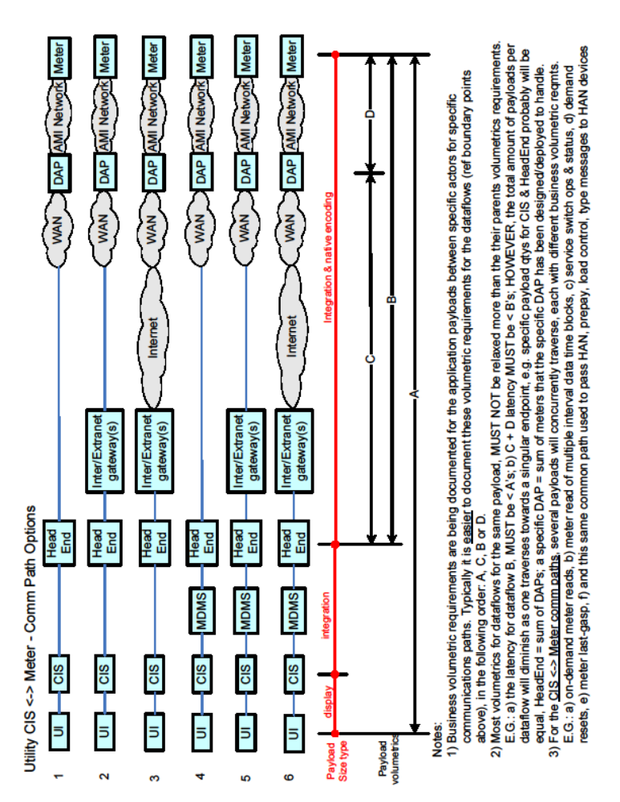

Communications Path Options Discussion Diagram

