SG Network System Requirements Specification

UCAiug
Mm/dd/yyyy

Revision information/change log

Preface

Authors

Acronyms

T/FLA | Value
T/FLA | Three/Four Letter Acronym
DMS | Distribution management system
EMS | Energy management system
DSM | Demand Side Management
LMS | Load management system
NMS | Network management system
OMS | Outage management system
MSW | Meter service switch
ESI | Energy Services Interface
AMS | Asset management system
DSDR | Distribution Systems Demand Response
MDMS | Meter Data Management System
Aggregation | Practice of summarizing certain data and presenting it as a total without any PII identifiers
AICPA | American Institute of Certified Public Accountants. The national, professional organization for all Certified Public Accountants.
AMI | Advanced Metering Infrastructure
Anonymize | A process of transformation or elimination of PII for purposes of sharing data
ASAP-SG | Advanced Security Acceleration Project-Smart Grid
B2B | Business to Business
BAN | Business Area Network
CIM | Common Information Model. A structured set of definitions that allow different Smart Grid domain representatives to communicate important concepts and exchange information easily and effectively.
CIP | Critical Infrastructure Protection
CSWG | Cyber Security Working Group
DA | Distribution Automation
De-identify | A form of anonymization that does not attempt to control the data once it has had PII identifiers removed, so it is at risk of re-identification.
DER | Distributed Energy Resources
DHS | Department of Homeland Security
DMS | Distribution Management System
DNP | Distributed Network Protocol
DOE | Department of Energy
DOMA | Distribution Operations Model and Analysis
DR | Demand Response
EMS | Energy Management System
EPRI | Electric Power Research Institute
ES | Electric Storage
ESI | Energy Services Interface
ET | Electric Transportation
EUMD | End Use Measurement Device
EV/PHEV | Electric Vehicle/Plug-in Hybrid Electric Vehicles. Cars or other vehicles that draw electricity from batteries to power an electric motor. PHEVs also contain an internal combustion engine.
EVSE | Electric Vehicle Service Element
FERC | Federal Energy Regulatory Commission
FIPS | Federal Information Processing Standard Document
FLIR | Fault Location, Isolation, Restoration
G&T | Generations and Transmission
GAPP | Generally Accepted Privacy Principles. Privacy principles and criteria developed and updated by the AICPA and Canadian Institute of Chartered Accountants to assist organizations in the design and implementation of sound privacy practices and policies.
GIS | Geographic Information System
GRPS | General Packet Radio Service
HAN | Home Area Network. A network of energy management devices, digital consumer electronics, signal-controlled or enabled appliances, and applications within a home environment that is on the home side of the electric meter.
HMI | Human-Machine Interface
I2G | Industry to Grid
IEC | International Electrotechnical Commission
IED | Intelligent Electronic Device
ISA | International Society of Automation
ISO | Independent System Operator
ISO/IEC27001 | International Organization for Standardization/International Electrotechnical Commission Standard 27001. A auditable international standard that specifies the requirements for establishing, implementing, operating, monitoring, reviewing, maintaining and improving a documented Information Security Management System within the context of the organization's overall business risks. It uses a process approach for protection of critical information.
IT | Information Technology
LAN | Local Area Network
LMS/DRMS | Load Management System/ Distribution Resource Management System
MDMS | Meter Data Management System
MFR | Multi-Feeder Reconnection
NERC | North American Electric Reliability Corporation
NIPP | National Infrastructure Protection Plan
NIST | National Institute of Standards and Technology
NISTIR | NIST Interagency Report
OECD | Organisation for Economic Cooperation and Development. A global governmental forum of 30+ market democracies for comparison of policy experiences, good practices, and coordination of domestic and international policies. It is one of the world’s largest and most reliable sources of comparable statistical, economic and social data.
OMS | Outage Management System
OWASP | Open Web Application Security Project
PAP | Priority Action Plan
Personal Information | Information that reveals details, either explicitly or implicitly, about a specific individual’s household dwelling or other type of premises. This is expanded beyond the normal "individual" component because there are serious privacy impacts for all individuals living in one dwelling or premise. This can include items such as energy use patterns or other types of activities. The pattern can become unique to a household or premises just as a fingerprint or DNA is unique to an individual.
PEV | Plug-In Electric Vehicle
PI | Process Information
PIA | Privacy Impact Assessment. A process used to evaluate the possible privacy risks to personal information, in all forms, collected, transmitted, shared, stored, disposed of, and accessed in any other way, along with the mitigation of those risks at the beginning of and throughout the life cycle of the associated process, program or system.
PII | Personally Identifying Information
R&D | Research and Development
RTO | Regional Transmission Operator
RTU | Remote Terminal Unit
SCADA | Supervisory Control and Data Acquisition
SCE | Southern California Edison
SGIP | Smart Grid Interoperability Panel
SGIP-CSWG | SGIP – Cyber Security Working Group
SP | Special Publication
SSP | Sector-specific Plans
VVWS | Volt-Var-Watt
WAMS | Wide-Area Measurement System
WAN | Wide Area Network
WASA | Wide Area Situational Awareness
WLAN | Wireless Local Area Network
WMS | Work Management System

MDMS | AMS | EMS | DSM | Event / OMS | DMS | LMS | SCADA | GIS | NMS | Head End | CIS | CIS |  |  |  |  |  |  |  | DAP | Meter Meter | Meter NIC | ESI | Meter SW

Glossary

Definitions

Asset Management System – A system(s) of record for assets managed in the Smart Grid. Management context may change(e.g. financial, network)

Capacitor Bank – This is a device used to add capacitance as needed at strategic points in a distribution grid to better control and manage VARs and thus the Power Factor and they will also affect voltage levels.
Distribution Systems Demand Response – A system used to reduce load during peak demand. Strictly used for Distribution systems only.

Data Aggregation Point – This device is a logical actor that represents a transition in most AMI networks between Wide Area Networks and Neighborhood Area Networks. (e.g. Collector, Cell Relay, Base Station, Access Point, etc)

Distribution Management System – A system that monitors, manages and controls the electric distribution system.

Demand Side Mangement – A system that co-ordinates demand response / load shedding messages indirectly to devices (e.g. Set point adjustment) _Harmonize with openHAN

Field Force – Employee working in the service territory that may working Smart Grid devices.

Energy Services Interface – Use Open HAN

Voltage Regulator – This device is in effect an adjustable ratio transformer positioned at strategic points in a distribution grid and is utilized to better manage and control the voltage as it changes along the distribution feeder.

Medium Voltage Sensor – A device used to measure and report electrical properties (such as voltage, current, phase angle or power factor, etc.) on a medium voltage distribution line.

Last Gasp – Concept of an energized device within the Smart Grid detecting power loss and sending a broadcast message of the event.

Load Management System – System that controls load by sending messages directly to device (e.g. On/Off) Harmonize wth openHAN

Low Voltage Sensor – A device used to measure and report electrical properties (such as voltage, current, phase angle or power factor, etc.) at a low voltage customer delivery point.

Network Management System – A system that manages Fault, Configuration, Auditing/Accounting, Performance and Security of the communication. This system is exclusive from the electrical network.

Recloser (non-Team) – A device used to sense fault conditions on a distribution line and trip open to provide protection. It is typically programmed to automatically close (re-close) after a period of time to test if the fault has cleared. After several attempts of reclosing it can be programmed to trip open and stop trying to reclose until reset either locally or under remote control.

Recloser (Team) – A device that can sense fault conditions on a distribution line and to communicate with other related reclosers (the team) to sectionalize the fault and provide a coordinated open/close arrangement to minimize the effect of the fault.

Motorized Switch – A device under remote control that can be used to open or close a circuit.

Fault Detector – A device used to sense a fault condition and can be used to provide in indication of the fault.

Intelligent Fault Detector – A device that can sense a fault and can provide more detailed information on the nature of the fault, such as capturing an oscillography trace.

Phase Measuring Unit – A device capable of measuring the phase of the voltage waveform relative to a reference.

Outage Management System – A system that receives out power system outage notifications and corilates where the power outage occurred

Regional Transmission Operator – RON

Transformer (MV-to-LV) – A standard point of delivery transformer. In the Smart Grid context is it assumed there will be a need to measure some electrical or physical characteristics of this transformer such as voltage (high and/or low side) current, MV load, temperature,

Common Web Portal – Web interface for Regional Transmission Operator, customers, retail electric providers and transmission distribution service provider to function as a clearing house for energy information. Common used in deregulated markets.

Web Portal – Interface between energy customers and the system provider. Could be the utility or third party

Aggregator – SEE FERC OPERATION MODEL

Sub Meter – Premise based meter used for Distributed Energy Resources and PHEV. This device may be revenue grade.

Programable Communicating Thermostat – A device within the premise that has communication capabilities and controls heating, ventilation and cooling systems.

Substation Controller – Distributed processing device that has supervisory control or coordinates information exchanges from devices within a substation from a head end system.

Data Collector – See Substation Controller

Neighborhood Area Network – Also called FAN. A network comprised of all communicating components within a distribution domain.

Enterprise Service Bus – TBD

Remote Terminal Unit – Aggregator of multiple serialized devices to a common communications interface

Architecture Reference Model

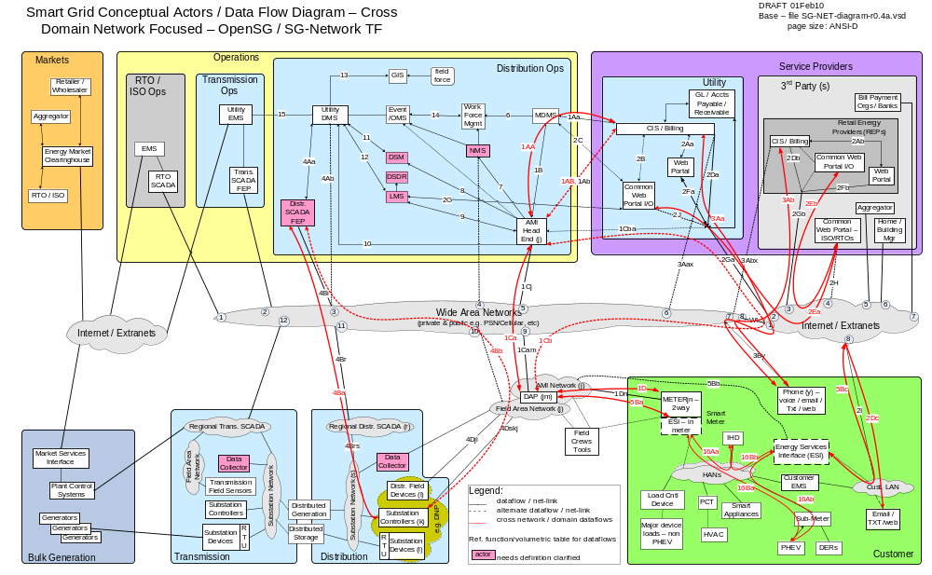
Use Cases

Meter Reading
PHEV

Requirements

References

