UCAIug: SG Net SRS
Smart Grid Networks System Requirements Specification
Release Candidate 3 revision *
DRAFT
Table of Contents
Document History 6
1 Overview 7
1.1 Executive Summary 7
1.1.1 Background - Energy Independence and Security Act of 2007 7
1.1.2 Goals and Objective - Matt 7
1.1.3 Priority Action Plans 7
1.1.4 Deliverables 8
1.1.5 Authors 9
1.1.6 Acknowledgements 10
1.2 Approach 10
1.2.1 SG-Network Requirements Gathering Process 10
1.2.2 System Requirement Specifications 15
1.2.3 Network and Systems Management 15
1.3 Terms and Definitions 15
2 Architecture Overview 15
3 Use Cases and Communications Requirements 31
3.1 Overview and Context 31
3.2 Payload Reference – PLACEHOLDER 31
3.3 Wide Area Situational Awareness - Cosio 31
3.3.1 Objective 31
3.4 Demand Response and Consumer Energy Efficiency – Matt 31
3.4.1 Demand Response 31
3.4.2 Direct Load Control 32
3.5 Energy Storage - Ron 33
3.5.1 Objectives 33
3.5.2 Actors 33
3.5.3 Latency Requirements 33
3.5.4 Process Flow 33
3.5.5 Included Processes 33
3.6 Electric Transportation 33
3.6.1 PHEV Use Cases (Vincent/Ron/Jerry) 33
3.7 System Security – Vincent / Matt 34
3.7.1 Overview – Cosio 34
3.7.2 CIA 34
3.7.3 Use Cases 34
3.7.4 Security Event (Kelly) 34
3.7.5 Audit Event (Kelly) 35
3.8 Network Communications – 36
3.8.1 Overview 36
3.8.2 Configuration Event (Ron) 36
3.8.3 Fault Error Alarm Event (Kelly) 38
3.9 Meter Reading Use Cases 39
3.9.1 Overview 39
3.9.2 Actors 40
3.9.3 Scenarios 41
3.10 Distribution Grid Management (all) 45
3.10.1 Overview of Business Processes 45
3.10.2 Business Process Definitions 45
3.10.3 Actors 46
3.10.4 Automated Feeder / Re-closer Switching 46
3.10.5 Voltage Regulator 49
3.10.6 Capacitor Bank Control 51
3.10.7 Fault Current Indicator 53
3.10.8 Transformer Monitoring 54
3.10.9 Voltage and Current Sensors 55
3.10.10 Network Protection Monitoring 57
3.10.11 Throw Over Switch Monitoring 58
3.10.12 Health Checks 59
3.10.13 Power Quality Event (Kelly) 60
Distribution Automation Network Design and Provisioning - (Move to appendix) 62

List of Tables
Table 1- Pertinent Use Cases 11
Table 2 - Actors 12
Table 3 - Actor Domain Mapping 13
Table 4 - Smart Grid Functional & Volumetric Business Requirements 18
Table 5 - Actors 32
Table 6 - Actors 32
Table 7 - Actors 33
Table 8 - Actors 34
Table 9 - Metering Audit Event Actors 35
Table 10 - Metering Security Event Actors 36
Table 11 - Latency Requirements 36
Table 12 - Metering Configuration Event Actors 37
Table 13 - Latency Requirements 37
Table 14 - Metering Fault Alarm Actors 38
Table 15 - Latency Requirements 38
Table 16 – Meter Reading Actors Error! Bookmark not defined.
Table 17 - Latency Requirements Error! Bookmark not defined.
Table 18 – Outage Notification Actors 44
Table 19 - Latency Requirements 44
Table 20 – Electric Service Prepayment Actors 45
Table 21 - Latency Requirements 45
Table 22 - Distribution Automation Actor Descriptions 47
Table 23 - Actors Automated Feeder Switching 48
Table 24 - Applicable Distribution Applications 48
Table 25 - Latency requirements AFS operation 48
Table 26 - Latency requirements Automated Feeder Switch Telemetry 48
Table 27 - Actors Voltage Regulator Operation 50
Table 28 - Applicable Distribution Applications 51
Table 29 - Latency requirements Voltage Regulator Operation 51
Table 30 - Latency requirements Voltage Regulator Telemetry 51
Table 31 - Actors Capacitor Banks 52
Table 32 - Applicable Distribution Applications 53
Table 33 - Latency requirements Capacitor Bank Operation 53
Table 34 - Actors Fault Current Indicator 54
Table 35 - Applicable Distribution Applications 54
Table 36 - Latency requirements Fault Current Indicator 55
Table 37 - Actors Transformer Monitoring 55
Table 38 - Applicable Distribution Applications 56
Table 39 – Latency requirements Transformer Monitoring 56
Table 40 - Actors Voltage and Current Sensors 56
Table 41 - Applicable Distribution Applications 57
Table 42 -Latency requirements Amp / voltage sensor 57
Table 43 - Actors Network Protector Monitoring 58
Table 44 - Applicable Distribution Applications 58
Table 45 - Latency Requirements Network Protector Monitoring 59
Table 46 - Actors Throw Over Switch Monitoring 59
Table 47 - Applicable Distribution Applications 60
Table 48 - Latency Requirements Throw Over Switch Monitoring 60
Table 49 – Actors Device Health Check 61
Table 50 - Latency Requirements Device Health Check 61
Table 51 - Metering Power Quality Actors 62
Table 52 - Latency Requirements 62
Table 54 - Actors Distribution Logical Network Design 64

List of Figures
Figure 1 - Open SG structure 9
Figure 2 - Baseline Diagram Without Cross Domain & Network 16
Figure 3 - Baseline Diagram with Cross Domain & Network flows 17
Figure 4 - Customer Information / Messaging Use Case 19
Figure 5 - Distribution Automation Use Case 20
Figure 6 - Meter Read Use Case 21
Figure 7 - PHEV Use Case 21
Figure 8– PrePay Use Case 22
Figure 9 - Service Switch 23
Figure 10 – Utility CIS <-> Meter Communication Path Scenarios 24
Figure 11– IPD & Customer. EMS <-> Meter Communication Path Scenarios 25
Figure 12 - Web Portal <-> ODS Communication Path Scenarios 26
Figure 13 – Utility CIS <-> IPD Communication Path Scenarios 27
Figure 14 – REP CIS <-> IPD Communication Path Scenarios 28
Figure 15 – DMS <-> DA Feeder Devices Communication Path Scenarios 29
Figure 16– DMS <-> DA Substation Devices Communication Path Scenarios 30
Figure 17 - Process Flow 36
Figure 18 - Process Flow 37
Figure 19 - Process Flow 38
Figure 20 - Information flow AFS automated operation 49
Figure 21 - Information flow AFS Manual Switch Operation 49
Figure 22 - Information flow AFS monitoring and diagnostics 49
Figure 23 - Information flow AFS manual DNP configuration change 50
Figure 24 - Information flow manual switch operation and DNP configuration change 50
Figure 25 - Information flow Voltage Regulator operation 52
Figure 26 - Information flow Capacitor Bank Control 53
Figure 27 - Information flow Capacitor Bank Monitoring 54
Figure 28 - Information flow Fault current Indicator 55
Figure 29 - Information flow Transformer Monitor 56
Figure 30 - Information flow Amp / Voltage Sensor 57
Figure 31 - Information flow Network Protector 59
Figure 32 - Information flow Throw Over Switch 60
Figure 33 - Information flow Health check 61
Figure 34 - Process Flow 62
Figure 35 - Process flow Distribution Logical Network Design 63

Document History
Revision History

Revision Number | Revision Date | Revision  By | Summary of Changes | Changes marked
1.01 |  |  | Documented shell created | N
1.02 | 2/16/10 | MKG | Result from 2/16/10 conference call | N
1.03 | 2/16/10 | Armes/MKG | Cleaned up definitions and acronyms | N
1.04 | 2/16/10 | MKG | Added TOC and Draft Preface | N
1.05 | 2/22/10 | MKG | Added Requirements specification info | N
1.06 | 2/22/10 | MKG | Clerical updates to links to work | N
2 | 2/22/10 | MKG | Updated version number for release | N
3 rc1 | 4/17/10 | MKG/RTC | Updated Use case flow charts and diagrams | N
3 rc3 | 4/17/10 | RTC | Added links to documentation instructions | Y
3 rc5 | 4/18/10 | MKG | Added acknowledgements and minor edits. Made images/illustrations portrait versus landscape | N
3rc6 | 6/1/2010 | GC | Harmonized use case document with original RC3 | N
3RCx | 6/7/10 | GC | Updating Use Case descriptions and nomenclature | N

Overview

Executive Summary

Background - Energy Independence and Security Act of 2007
Under the Energy Independence and Security Act (EISA) of 2007, the National Institute of Standards and Technology (NIST) is assigned “primary responsibility to coordinate development of a framework that includes protocols and model standards for information management to achieve interoperability of Smart Grid devices and systems…” [EISA Title XIII, Section 1305]. There is an urgent need to establish these standards. Deployment of various Smart Grid elements, such as smart meters, is already underway and will be accelerated as a result of Department of Energy (DOE) Investment Grants. Without standards, there is the potential for these investments to become prematurely obsolete or to be implemented without necessary measures to ensure security.

Recognizing the urgency, NIST developed a three-phase plan to accelerate the identification of standards while establishing a robust framework for the longer-term evolution of the standards and establishment of testing and certification procedures.

Goals and Objective - Matt
What trying to accomplish with the document.

Priority Action Plans
PAPs arise from the analysis of the applicability of Standards to the Use Cases of the Smart Grid. PAPs include identified experts in relative SDOs, known as the PAP Working Group Management Team.
Specifically, a PAP addresses either:
A gap where a standard or standard extension is needed:
- The need for meter image-download requirements is an example of a non-existing standard needed to fill an identified gap.
An overlap where two complementary standards address some information that is in common but different for the same scope of an Application:
- An example of this is metering information where CIM, 61850, ANSI C12.19, SEP 1&2 all have non-equivalent methods of representing revenue meter readings.

Deliverables
This document has been created to support NIST Smart Grid Interoperability Priority Action Plans (PAP) 1 & 2 and provide Utilities, Vendors and Standard Development Organizations a system requirements specification for Smart Grid Communication.

For PAP 1 the tasks assigned to UCAiug (SG-Network) are as follows:

Task 1: Develop a set of requirements for different Smart Grid applications

For PAP 2 the tasks assigned to UCAiug (SG Network) are as follows:

Task 1: Segment the smart grid and wireless environments into a minimal set of categories for which individual wireless requirements can be identified.

Task 3: Compile & communicate use cases and develop requirements for all smart grid domains in terms that all parties can understand.

Task 4: Compile and communicate a list of capabilities, performance metrics, etc. in a way that all parties can understand. - Not quantifying any standard, just defining the set of metrics.

To accomplish these assignments, the UCAiug Open Smart Grid (OpenSG) has assigned these tasks to a task force within the SG Communications working group called SG Network to formally work on these tasks.

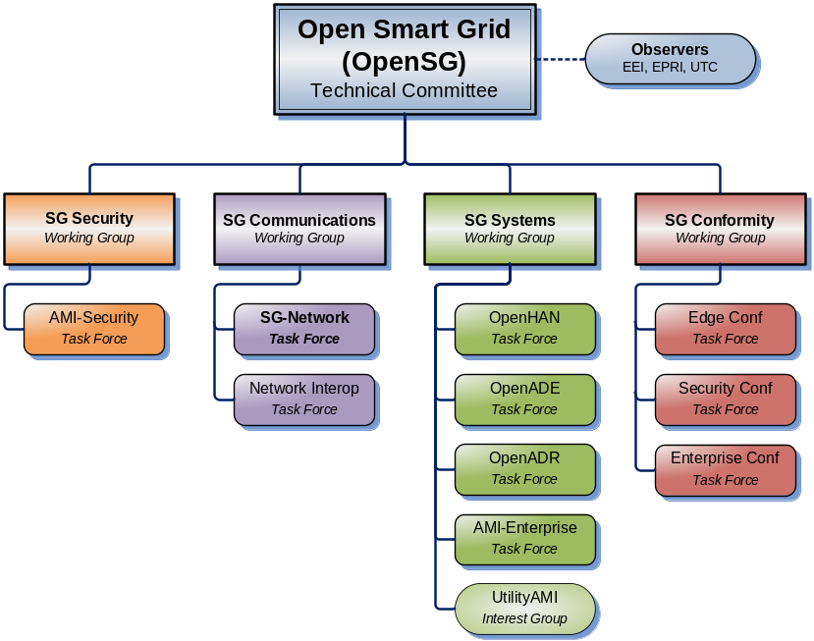
Figure 1 - Open SG structure

Authors
The following individuals and their companies are members of the OpenSG SG-Network Task Force Core Development Team and contributed substantially to the drafting of the SG-Network System Requirement Specification:

Jerry Armes, Micronet Communications
Vincent Bemmel, Trilliant
John Buffington, Itron
George Cosio, Florida Power & Light, Co.
Ron Cunningham, American Electric Power
Paul Duffy, Cisco Systems
Kelly Flowers, Detroit Edison
Matt Gillmore, Consumers Energy
Bill Godwin, Progress Energy
Bill Leslie, Longboard Technologies
Claudio Lima, Sonoma Innovations
Michael Northern, Deloitte Consulting LLP
David Pilon, Detroit Edison
Gary Stuebing, Duke Energy
Don Sturek, Pacific Gas & Electric

Acknowledgements
The content delivered by the SG-Network task force would not be possible without feedback and consensus from the overall industry. Listed below are individuals who have provided substantial feedback and guidance to SG-Network.

David Cypher, NIST
Nada Golmie, NIST
Erich Gunther, Enernex
Pat Kinney, Kinney Consulting
Mark Kleerer, Qualcomm
Bruce Kraemer, Marvell
Wayne Longcore, Consumers Energy
Geoff Mulligan, IPSO Alliance
Robby Simpson, GE Energy
Phil Slack, Florida Power & Light, Co.
David Su, NIST

Approach

SG-Network Requirements Gathering Process
The SG-Network task force derived functional requirements from the following process:
- Listing of pertinent use cases
- Identification of Actors within use cases
- Gap analysis by mapping actors to use cases
- Defining Business Functional and Volumetric Requirements
  - Requirement actor to actor
  - Estimated payload
  - Expected latency
  - Expected Reliability
  - Security Requirements
    - Low, Medium, High per NISTIR 7628
  - Implications of failure

- Smart Grid Domain, Actor, Interface reference diagram
  - Illustrative diagram of requirements

Listing of pertinent use cases
In order to create a list of functional requirements for the Smart Grid, an exercise was performed to list all pertinent use cases that involve network communication. Sources for this information include the Southern California Edison Use Cases, Grid Wise Architectural Console use cases, EPRI and others. Use cases from all of these sources were selected based upon a network requirements basis. From this research the following high level use cases have been identified.

Smart Grid Use Case | Requirements Derived | Requirements included in release 4.0 and later
Meter Read | Yes | Yes
Direct load control | In progress | No
Service Switch | Yes | Yes
PHEV | Yes | Yes
System updates | In progress | No
Distributed GEN | In progress | No
Distributed Storage | Draft | No
Outage Events | Yes | Yes
Tamper Events | Draft | No
Meter Events | Draft | No
Demand Response | Draft | No
Pre-Pay Metering | Yes | Yes
Field Force tools | Not started | No
Distribution automation support | Yes | Yes
Transmission automation support | Not started | No
Pricing TOU / RTP/ CPP | in progress | No
Configuration mgmt | in progress | No
Accounting Mgmt | in progress | No
Performance Mgmt | in progress | No
Security mgmt | in progress | No
Fault mgmt | in progress | No
Volt/VAR Management | Yes | Yes
Table 1- Pertinent Use Cases
The “Requirements Derived” Column of the above table shows that requirements have been produced for the use case. However the requirements will not be submitted for wider audiences until they have been fully vetted. Requirements that are fully vetted have a “Yes” in the “Requirements Fully Vetted” column.

Identification of Actors within Use Cases

After the use cases were identified. Members of SG Network reviewed the existing use cases from the industry and defined the actors. While doing this exercise the actors were also added to architectural domains:

Actor | Domain
Meter Data Management System | Operations
Asset Management System | Operations
Energy Management System | Operations
Demand Side Management System | Operations
Event / OMS System | Operations
Distribution Management System | Operations
Load Management System | Operations
Supervisory Control and Data Acquisition System | Operations
Geospatial Information System | Operations
Network Management System | Operations
Head End System | Operations
Capacitor Bank | Distribution
Voltage Regulator | Distribution
Meduim Voltage Sensor | Distribution
Recloser Teamed | Distribution
Recloser Not Teamed | Distribution
Phase Measuring Unit | Distribution
Fault Detector | Distribution
Data Aggregation Point | Transmission and Distribution
Smart Meter | Customer
Energy Services Interface | Customer
In Home Display | Customer
Customer Information System | Service Provider
Customer Information System 3rd Party | Service Provider
Table 2 - Actors

Gap analysis by mapping actors to use cases
Having collected a list of actors and use cases, the gab analysis was conducted by mapping actors to use cases. The exercise involved a review of each selected use case and mapping which actors apply. Below is an example of this process for Meter Reading.

Actor | Domain | Use Case: Meter Reading
Meter Data Management System | Operations | Yes
Asset Management System | Operations | No
Energy Management System | Operations | No
Demand Side Management System | Operations | No
Event / OMS System | Operations | No
Distribution Management System | Operations | No
Load Management System | Operations | No
Supervisory Control and Data Acquisition System | Operations | No
Geospatial Information System | Operations | No
Network Management System | Operations | No
Head End System | Operations | Yes
Capacitor Bank | Distribution | No
Voltage Regulator | Distribution | No
Medium Voltage Sensor | Distribution | No
Recloser Teamed | Distribution | No
Recloser Not Teamed | Distribution | No
Phase Measuring Unit | Distribution | No
Fault Detector | Distribution | No
Data Aggregation Point | Transmission and Distribution | Yes
Smart Meter | Customer | Yes
Energy Services Interface | Customer | Yes
In Home Display | Customer | Yes
Customer Information System | Service Provider | Yes
Customer Information System 3rd Party | Service Provider | Yes
Table 3 - Actor Domain Mapping

Defining Business Functional and Volumetric Requirements
The process of requirements gathering has been evolutionary in nature. The SG Network task force has defined over 1400 (as of release 4.0) functional requirements while reviewing the use cases identified previously. The group intends to release versions of requirements over time in order to keep scope and focus attainable yet giving consumers of this information something to work with and provide feed back.

The requirements have been captured in a spreadsheet that matches the version of this document. A partial description of the spreadsheet and its columns are below. For a more complete description, refer to the latest version of the “Requirements Documentation Instructions” located in the SG-Network Task Force webpage folder.

Spreadsheet Column Descriptions
- Rqmt Ref – This column is a reference to the original worksheet line number the requirement originally defined

- Data-Flow Ref – This column is a reference to the architectural reference models lines between actors shown illustratively in this document and attached to this work as a separate file

- Data Flow From Actor – This column indicates the actor that is considered the sender of information noted in the Requirements Column

- Data Flow to Actor – This column indicates the actor that is considered the desired recipient of the information noted in the Requirements Column

- Requirements – This column is the actual application requirement. Words like “shall” in this column are to be considered required, while words like “may” should be considered optional

- Payload Name – This column explains the scenario type of the requirement derived from the use case. (e.g. Bulk, On Demand for meter reading)

- Candidate NIST LIC – NISTIR 7628 document values used in establishing values

- Security Confidentiality – NISTIR 7628 document values used in establishing values

- Security Integrity – NISTIR 7628 document values used in establishing values

- Security Availability – NISTIR 7628 document values used in establishing values

- Latency - Summation of the node processing time and network time for a specific pairing of actors from the “from” actor to the “to” actor, excluding communications and protocol or security overheads.

- Reliability - The probability that an operation will complete without failure over a specific period or amount of time.

- Payload Size Type – This column indicates whether the payload is native (encoded in a compact format), intgrt (encoded in an API or web service format) or Display (encoded in a format for a user interface)

- App Payload Size – This column is an estimation of how many bytes are needed for the requirement as actual payload.

- Implications – This column is an attempt to explain the impacts of the requirements not being met for the operator of the system.

System Requirement Specifications

Network and Systems Management
In the development of Smart Grid related requirements and standards, it became evident that a model for managing very large communication networks did not exist. As part of the SG Network Systems Requirements Specification the SG Network WG developed a set of common network management requirements based on the FCAPS model of network management.
FCAPS is the ISO Telecommunications Management Network model and framework for network management. FCAPS is an acronym for Fault, Configuration, Accounting, Performance, Security, the management categories into which the ISO model defines network management tasks.

Terms and Definitions
The use of a common vocabulary has been of critical important in the development of this and other Smart Grid related work products. All pertinent terms and definitions utilized in this document are listed in the appendix of this document.

Architecture Overview
In these section a few illustrative diagrams are included to help the reader of this document to understand the content. These files are also available for reference at the following locations:

The reference model diagrams locations are in the SG-Network TF webpage folder:
http://osgug.ucaiug.org/UtiliComm/Shared%20Documents/Interium_Release_3/Diagrams

The SG-Network functional requirements table location is:

http://osgug.ucaiug.org/UtiliComm/Shared%20Documents/Interium_Release_3/SG-Net_TF_%20funct-volumteric-reqs_v3.xls

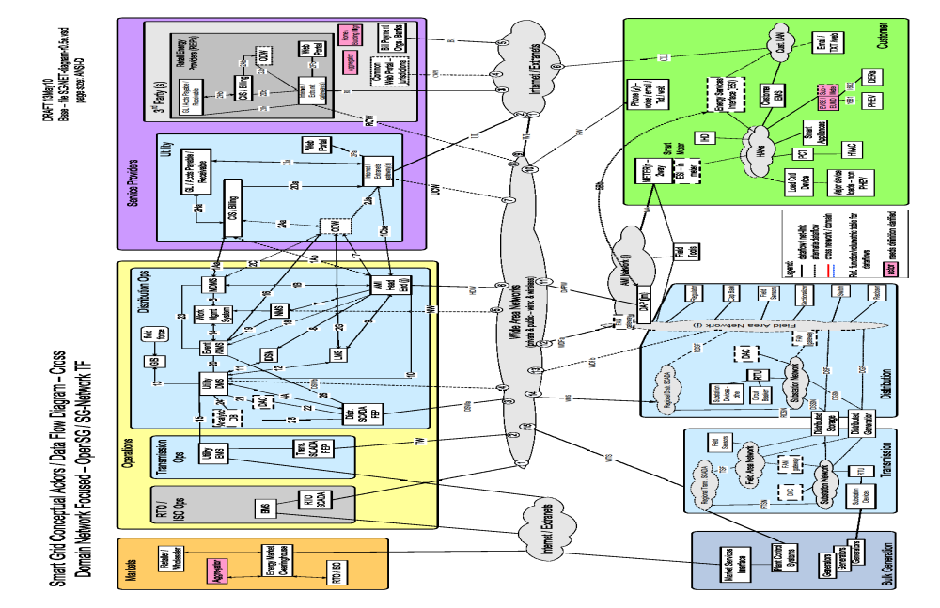
Figure 2 - Baseline Diagram Without Cross Domain & Network

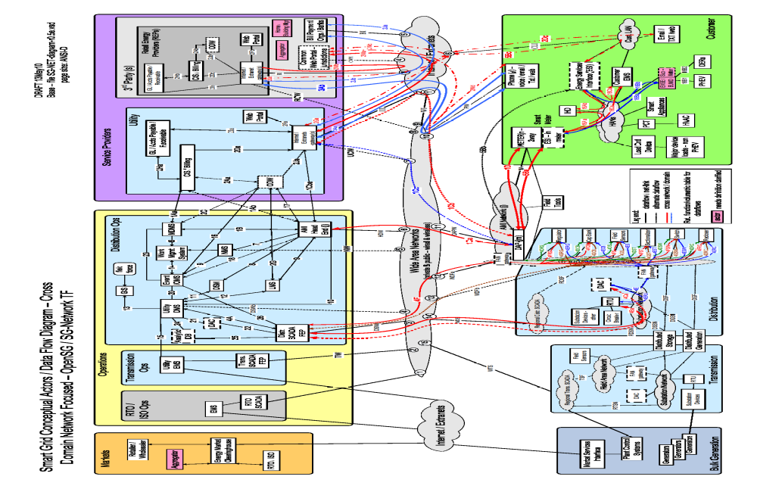
Figure 3 - Baseline Diagram with Cross Domain & Network flows

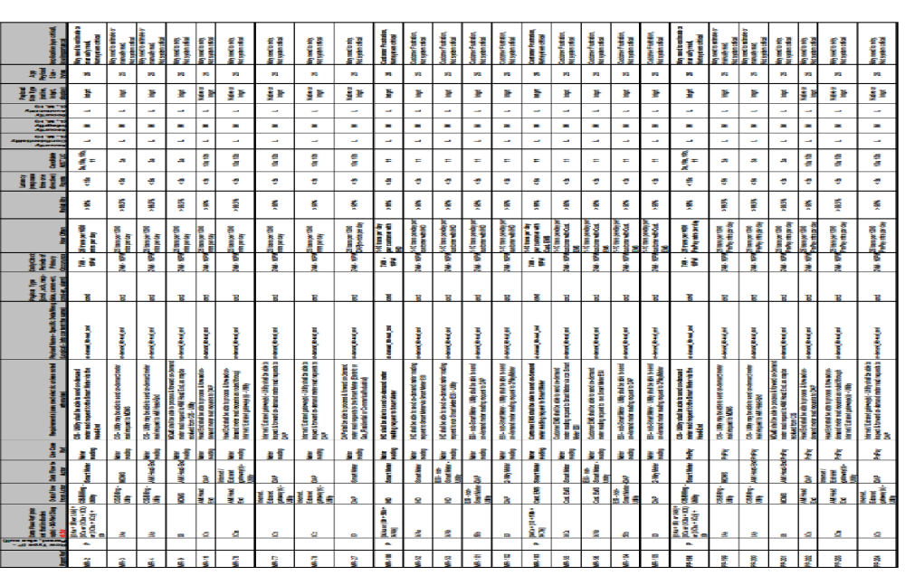
Table 4 - Smart Grid Functional & Volumetric Business Requirements
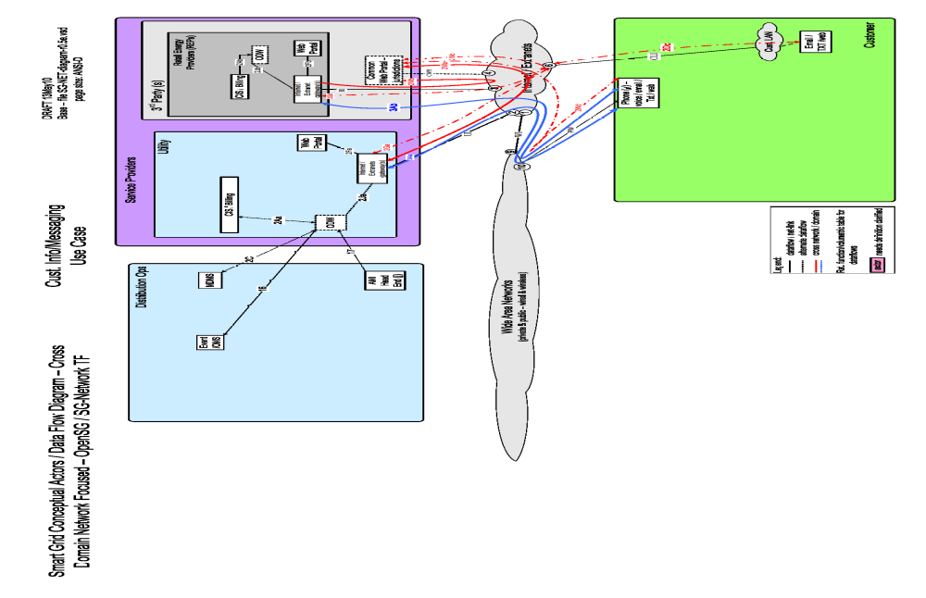
Figure 4 - Customer Information / Messaging Use Case
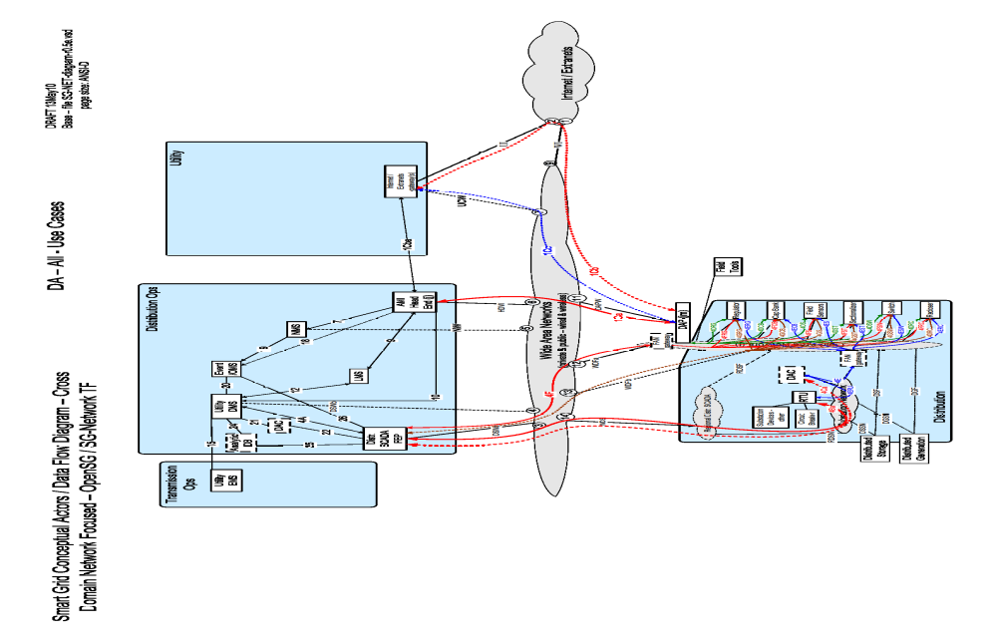
Figure 5 - Distribution Automation Use Case

Figure 6 - Meter Read Use Case
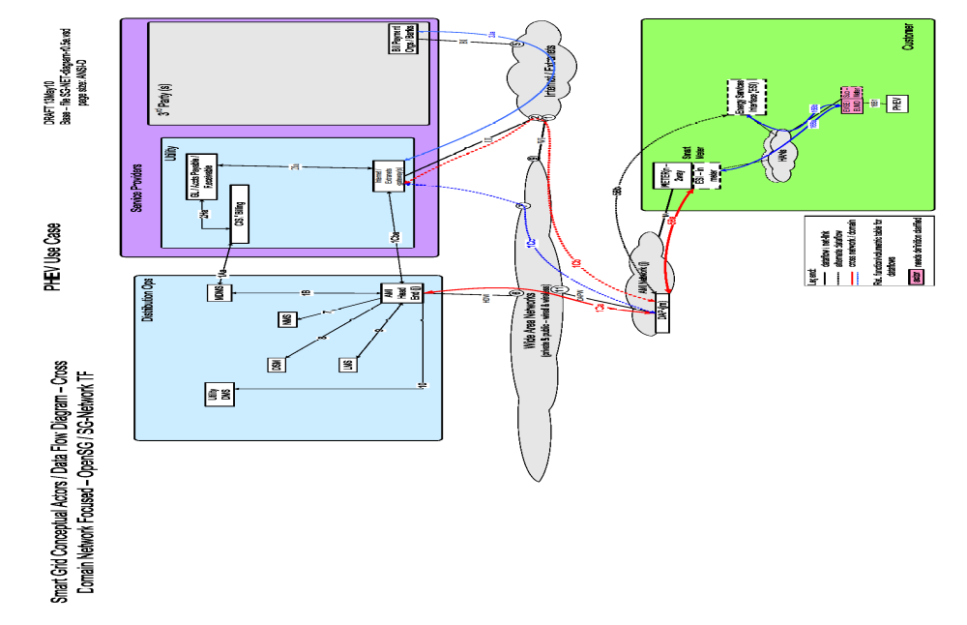
Figure 7 - PHEV Use Case
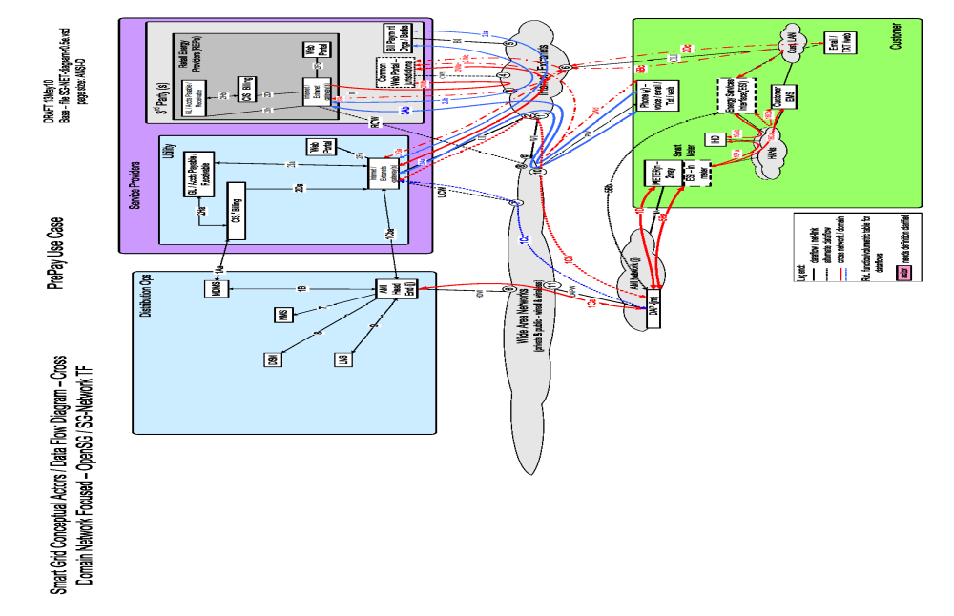
Figure 8– PrePay Use Case
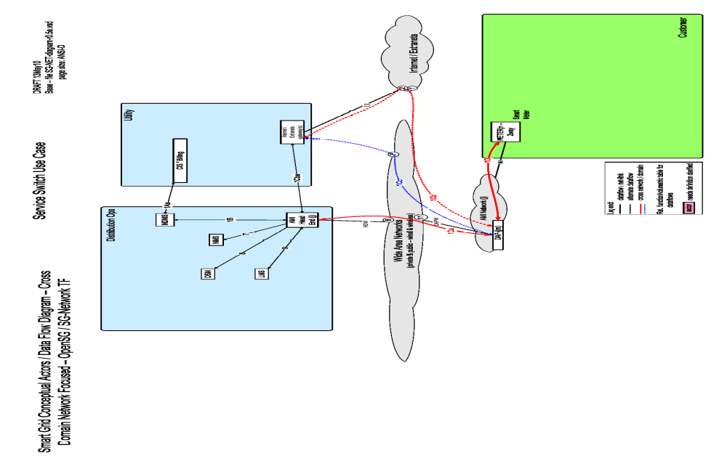
Figure 9 - Service Switch
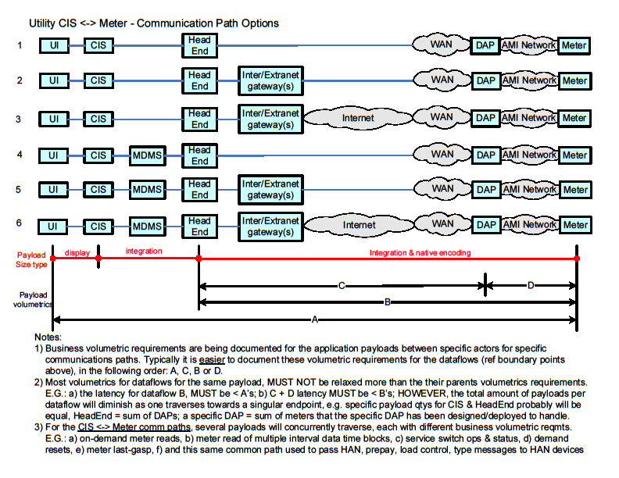
Figure 10 – Utility CIS <-> Meter Communication Path Scenarios
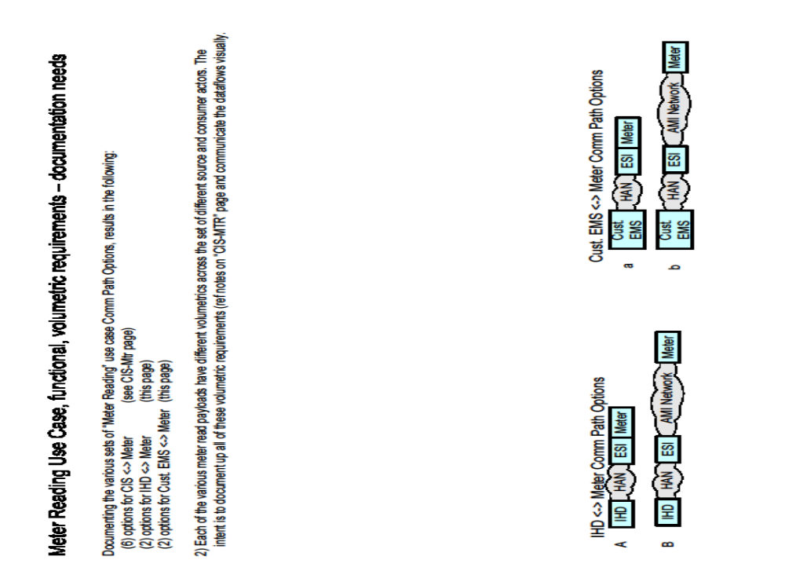
Figure 11– IPD & Customer. EMS <-> Meter Communication Path Scenarios
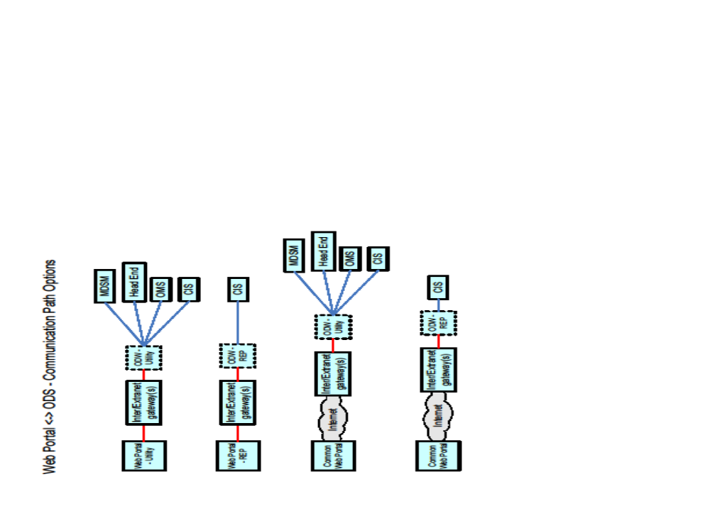
Figure 12 - Web Portal <-> ODS Communication Path Scenarios
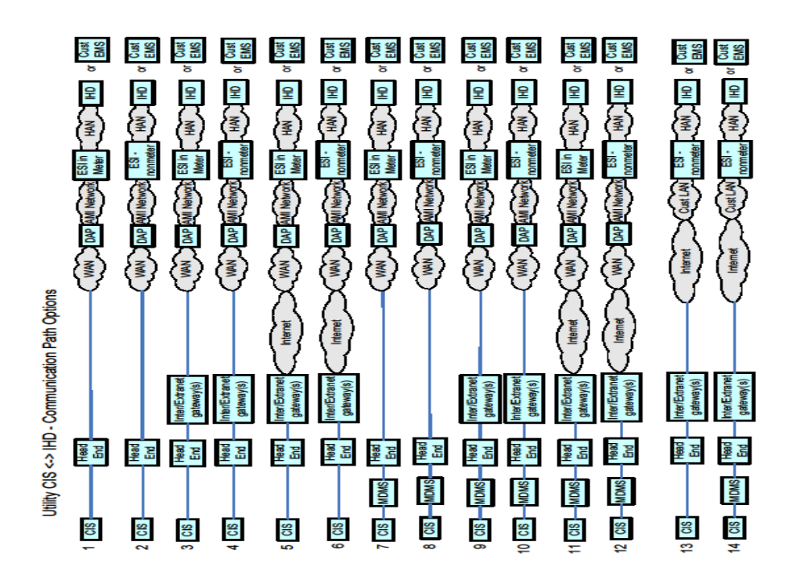
Figure 13 – Utility CIS <-> IPD Communication Path Scenarios
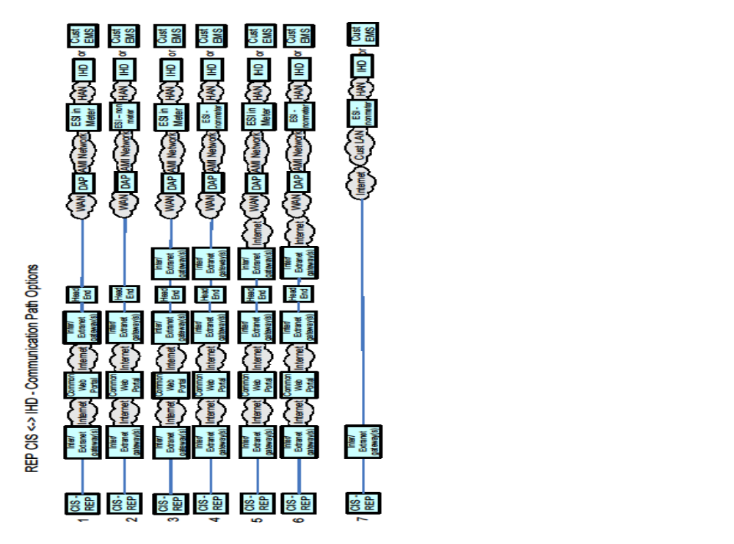
Figure 14 – REP CIS <-> IPD Communication Path Scenarios
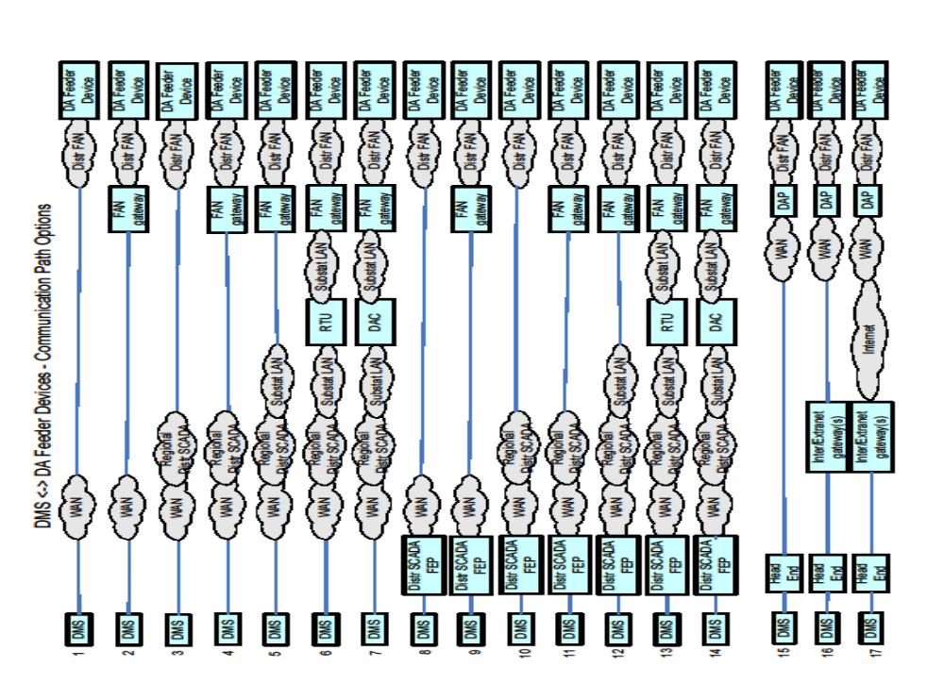
Figure 15 – DMS <-> DA Feeder Devices Communication Path Scenarios
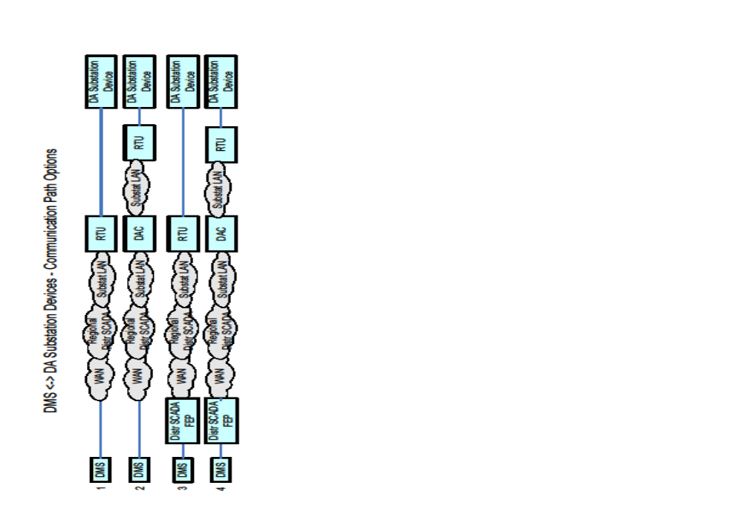
Figure 16– DMS <-> DA Substation Devices Communication Path Scenarios

Use Cases and Communications Requirements

Overview and Context
The use cases listed in this section are intended to provide a summarization of the various use cases reviewed and analyzed by the SG Network WG. The corresponding use case requirements listed in this document represent the most conservative requirements gathered from the utilities that participated in the SG Network WG and illustrated as reference for the worst case scenario. In actual practice readers should establish requirements that best address the objectives of their company’s specific business case and operational requirements.
For purposes of organization, the use cases are represented in the context of the eight priority areas outlined by NIST in the “NIST Framework and Roadmap for Smart Grid Interoperability Standards, Release 1.0”. The authors have chosen to organize the use case summaries in a manner as to provide traceability between the NIST priority areas and the contents of this document.
Wherever possible the use cases have been summarized in order to provide a concise account of the process, actors and requirements. Additional information relating to the use cases is available at the SG Network Share point.

Payload Reference – PLACEHOLDER
What is the best approach for addressing this comment from Ron? Should we place a master payload reference for all use cases, list them with each relevant use case or simply reference them from the appendix?

Wide Area Situational Awareness - Cosio

Objective
Place holder at this time - tbd

Demand Response and Consumer Energy Efficiency – Matt

Demand Response

Objective

Actors
Actor | Description | Role
Table 5 - Actors

Latency Requirements

Process Flow

Included Processes

Direct Load Control

Objective

Actors
Actor | Description | Role
Table 6 - Actors

Latency Requirements

Process Flow

Included Processes

Energy Storage - Ron

Objectives

Actors
Actor | Description | Role
Table 7 - Actors

Latency Requirements

Process Flow

Included Processes

Electric Transportation

PHEV Use Cases (Vincent/Ron/Jerry)

Objectives (Matt)

Actors

Actor | Description | Role
Table 8 - Actors

Latency Requirements

Process Flow

Included Processes

System Security – Vincent / Matt

Overview – Cosio
The following section identifies network requirements for enabling and processing security events and use cases associated with the Smart Grid. This document does not address, establish or recommend any security requirements or supporting architectures needed for the Smart Grid. Smart Grid security is being addressed in detail by other functioning task forces with in the OpenSG and the UCAIUG. The intent is to establish a straw man set of requirements to be incorporated into the overall Smart Grid network design for addressing security communication requirements.

CIA
The team has identified the CIA values for the specific network transactions associated with the network security events and use cases. The CIA designations are based on the types of transactions and payloads being transmitted by the respective actors. The CIA designations are included in the accompanying databases and spreadsheets that compromise the SRS.

Use Cases

Security Event (Kelly)

Objective

Actors
Actor | Description | Role
Customer Information System | The application responsible for the collection and retrieval of all relevant customer information for purposes of billing and facilitating interaction.
Meter Data Management System | The MDMS is the application responsible for coordinating the billing of AMI data. MDMS often interact with CIS, as well as other systems, to automate customer and billing functions with the Smart Grid.
Enterprise Service Bus | This is an integration bus utilized for integrating disparate applications. The ESB is also used as a translation engine that can translate and harmonize messages and transactions between systems.
AMI Head End | The AMI head end is responsible for the operation and coordination of AMI system components. It represents the central nervous system of the AMI system.
Network Management System | A system or series of systems that are utilized to operate and manage utility assets that interact on any given network. These assets are comprised of both hardware and software components that require ongoing monitoring and management.
Internet / Extranet Gateways | These are gateways used to connect internal utility networks with external networks.
Data Aggregation Point | This is the Data Aggregation Point on the NAN. It is essentially the point of convergence for all communication between SG devices and utility back office systems. In this specific use case it provides a communication conduit for AMI Smart Meters.
Repeater | A repeater is used in radio frequency networks as a means of extending the each of the network.
Smart Meter – AMI Interface | This is the interface utilized to communicate directly between the Smart Meter and the AMI system. This interface is used to allow utilities and third parties to communicate with the meter via the AMI system.
Smart Meter – Energy Services Interface | This is the interface utilized to communicate directly between the Smart Meter and the Customer HAN or EMS system. This interface is used to allow utilities and third parties to communicate with the customer via the AMI system.
Table 9 - Metering Audit Event Actors

Latency Requirements

Process Flow

Included Processes

Audit Event (Kelly)

Objective
The objective is to collect events from the meter that occur when there is a failure or exception in the execution of a request or an internal application function. Audit events are considered to be time based or on demand. The time based events could be driven by the validation the registers within the meter are still valid. Application events can be caused by a running application not performing as designed and reporting an error or a running application on the meter causing a threshold to be reached and triggering an event.

Actors
Actor | Description | Role
Meter Data Management System | The MDMS is the application responsible for coordinating the billing of AMI data. MDMS often interact with CIS, as well as other systems, to automate customer and billing functions with the Smart Grid.
AMI Head End | The AMI head end is responsible for the operation and coordination of AMI system components. It represents the central nervous system of the AMI system.
Data Aggregation Point | This is the Data Aggregation Point on the NAN. It is essentially the point of convergence for all communication between SG devices and utility back office systems. In this specific use case it provides a communication conduit for AMI Smart Meters.
Smart Meter – AMI Interface | This is the interface utilized to communicate directly between the Smart Meter and the AMI system. This interface is used to allow utilities and third parties to communicate with the meter via the AMI system.
Table 10 - Metering Security Event Actors

Latency Requirements
Source | Destination | Frequency | Response Time | Priority
Smart Meter | DAP | Event Driven | <1 min | Medium
DAP | AMI Head End | Event Driven | <1 min | Medium
AMI Head End | MDMS | Event Driven | <1 min | Medium
Table 11 - Latency Requirements

Process Flow
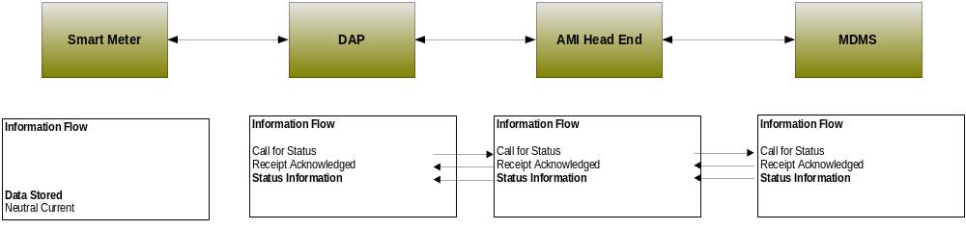
Figure 17 - Process Flow

Included Processes

Network Communications –

Overview

Configuration Event (Ron)

Objective
The objective is to collect events from the meter that occur when there is a out of state condition with the configuration on the meter. The configuration events are focused on maintaining metrics that define the meters operating state. Unlike other events that have a high and low limit thresholds the configuration events are thought to not any thresholds. The event would be trigged on the meter by a state outside of a defined metric for configuration.

Actors
Actor | Description | Role
Meter Data Management System | The MDMS is the application responsible for coordinating the billing of AMI data. MDMS often interact with CIS, as well as other systems, to automate customer and billing functions with the Smart Grid.
AMI Head End | The AMI head end is responsible for the operation and coordination of AMI system components. It represents the central nervous system of the AMI system.
Data Aggregation Point | This is the Data Aggregation Point on the NAN. It is essentially the point of convergence for all communication between SG devices and utility back office systems. In this specific use case it provides a communication conduit for AMI Smart Meters.
Smart Meter – AMI Interface | This is the interface utilized to communicate directly between the Smart Meter and the AMI system. This interface is used to allow utilities and third parties to communicate with the meter via the AMI system.

Table 12 - Metering Configuration Event Actors

Latency Requirements
Source | Destination | Frequency | Response Time | Priority
Smart Meter | DAP | Event Driven | <30 sec | High
DAP | AMI Head End | Event Driven | <30 sec | High
AMI Head End | MDMS | Event Driven | <30 sec | High
Table 13 - Latency Requirements

Process Flow
Figure 18 - Process Flow

Included Processes

Fault Error Alarm Event (Kelly)

Objective
The objective is to collect alarms from the meter that occur when there is an out of state or passed a threshold condition on the meter. The communication of the event information is triggered locally on the meter in response to reaching a pre defined condition. The metric to judge the state or condition are locally store on the meter device.

Actors
Actor | Description | Role
Meter Data Management System | The MDMS is the application responsible for coordinating the billing of AMI data. MDMS often interact with CIS, as well as other systems, to automate customer and billing functions with the Smart Grid.
AMI Head End | The AMI head end is responsible for the operation and coordination of AMI system components. It represents the central nervous system of the AMI system.
Data Aggregation Point | This is the Data Aggregation Point on the NAN. It is essentially the point of convergence for all communication between SG devices and utility back office systems. In this specific use case it provides a communication conduit for AMI Smart Meters.
Smart Meter – AMI Interface | This is the interface utilized to communicate directly between the Smart Meter and the AMI system. This interface is used to allow utilities and third parties to communicate with the meter via the AMI system.
Table 14 - Metering Fault Alarm Actors

Latency Requirements
Source | Destination | Frequency | Response Time | Priority
MDMS | Smart Meter | Event Driven | <15 sec | Medium
Smart Meter | MDMS | Event Driven | <15 sec | Medium
Table 15 - Latency Requirements

Process Flow
Figure 19 - Process Flow

Included Processes

Meter Reading Use Cases

Overview
The Meter Reading use cases described in this body of work include the following scenarios. For each scenario the primary command, response and failure payloads are described
- On Demand Meter read
- Interval data read

Below is an example architecture showing the Domains, Actors and Interfaces used in this use case.

Below is an illustration of the possible communication paths that may be implemented in this use case.
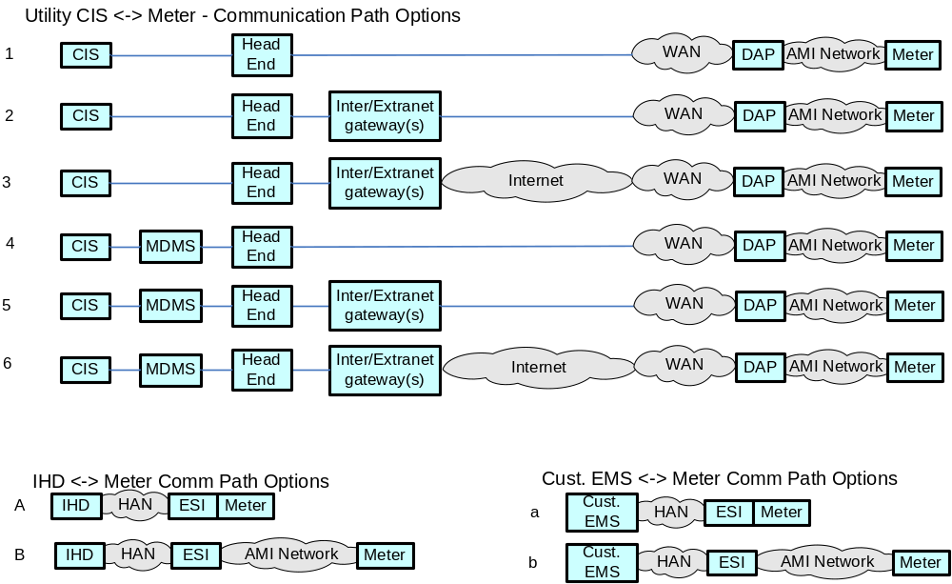

Actors
Name | Description
Customer Information System | The application responsible for the collection and retrieval of all relevant customer information for purposes of billing and facilitating interaction.
Meter Data Management System | The MDMS is the application responsible for coordinating the billing of AMI data. MDMS often interact with CIS, as well as other systems, to automate customer and billing functions with the Smart Grid.
Enterprise Service Bus | This is an integration bus utilized for integrating disparate applications. The ESB is also used as a translation engine that can translate and harmonize messages and transactions between systems.
AMI Head End | The AMI head end is responsible for the operation and coordination of AMI system components. It represents the central nervous system of the AMI system.
Network Management System | A system or series of systems that are utilized to operate and manage utility assets that interact on any given network. These assets are comprised of both hardware and software components that require ongoing monitoring and management.
Internet / Extranet Gateways | These are gateways used to connect internal utility networks with external networks.
Data Aggregation Point | This is the Data Aggregation Point on the NAN. It is essentially the point of convergence for all communication between SG devices and utility back office systems. In this specific use case it provides a communication conduit for AMI Smart Meters.
Repeater | A repeater is used in radio frequency networks as a means of extending the each of the network.
Smart Meter – AMI Interface | This is the interface utilized to communicate directly between the Smart Meter and the AMI system. This interface is used to allow utilities and third parties to communicate with the meter via the AMI system.
Smart Meter – Energy Services Interface | This is the interface utilized to communicate directly between the Smart Meter and the Customer HAN or EMS system. This interface is used to allow utilities and third parties to communicate with the customer via the AMI system.

Scenarios

Scenario: On-Demand Meter Reading

Narrative
Electric meters are anticipated to have on-demand meter reading capability. In this scenario, the request may originate from the CIS or the MDMS. In any case, we expect the head end to receive on demand meter read request and forward the request to the Smart Meter via the DAP. Smart meters may be read on demand for purposes of backfilling missing information, customer interaction or move in and move out scenarios.

Business Objectives

Originating Actor | Desination Actor | Latency | Reliability | Payload Size | Payload Name
MDMS | Smart Meter | < 15 seconds | 98% | 25 bytes | on-demand_Mtr-read_cmd
Smart Meter | MDMS | < 15 seconds | 98% | 200-400 bytes | On-demand_Mtr-read_rspns
Totals |  | < 30 seconds | 96%

Implications and Rationale
Functional Domain | Expected Potential Impact | Rationale
Bulk Generation
Customer | X | Cannot access recent usage information.
Distribution
Markets
Operation | X | Systems will have to retry communications
Service Providers | X | Cannot acquire specific recent meter usage information.
Transmission

Scenario On-Demand Read Failure

Narrative
Electric meters are anticipated to have on-demand meter reading failure. In this scenario, the request may originate from the CIS or the MDMS. In any case, we expect the Smart Meter on demand read request to fail and at each step of the process, if a failure occurs, the upstream devices shall send a notification of failure.

Business Objectives

Originating Actor | Desination Actor | Latency | Reliability | Payload Size | Payload Name
MDMS | Smart Meter | < 15 seconds | 98% | 25 bytes | on-demand_Mtr-read_cmd_comm_err
Smart Meter | MDMS | < 15 seconds | 98% | 25 bytes | on-demand_Mtr-read_cmd_err

Outage Notification (Matt)

Overview

Actors
Actor | Description
Customer Information System | The application responsible for the collection and retrieval of all relevant customer information for purposes of billing and facilitating interaction.
Meter Data Management System | The MDMS is the application responsible for coordinating the billing of AMI data. MDMS often interact with CIS, as well as other systems, to automate customer and billing functions with the Smart Grid.
Enterprise Service Bus | This is an integration bus utilized for integrating disparate applications. The ESB is also used as a translation engine that can translate and harmonize messages and transactions between systems.
AMI Head End | The AMI head end is responsible for the operation and coordination of AMI system components. It represents the central nervous system of the AMI system.
Network Management System | A system or series of systems that are utilized to operate and manage utility assets that interact on any given network. These assets are comprised of both hardware and software components that require ongoing monitoring and management.
Internet / Extranet Gateways | These are gateways used to connect internal utility networks with external networks.
Data Aggregation Point | This is the Data Aggregation Point on the NAN. It is essentially the point of convergence for all communication between SG devices and utility back office systems. In this specific use case it provides a communication conduit for AMI Smart Meters.
Repeater | A repeater is used in radio frequency networks as a means of extending the each of the network.
Smart Meter – AMI Interface | This is the interface utilized to communicate directly between the Smart Meter and the AMI system. This interface is used to allow utilities and third parties to communicate with the meter via the AMI system.
Smart Meter – Energy Services Interface | This is the interface utilized to communicate directly between the Smart Meter and the Customer HAN or EMS system. This interface is used to allow utilities and third parties to communicate with the customer via the AMI system.
Table 16 – Outage Notification Actors

Scenarios

Scenario: On-Demand Meter Reading

Narrative

Business Objectives

Originating Actor | Desination Actor | Latency | Reliability | Payload Size | Payload Name
Totals

Implications and Rationale
Functional Domain | Expected Potential Impact | Rationale

Electric Service Prepayment (Ron)

Overview

Actors
Actor | Description
Customer Information System | The application responsible for the collection and retrieval of all relevant customer information for purposes of billing and facilitating interaction.
Meter Data Management System | The MDMS is the application responsible for coordinating the billing of AMI data. MDMS often interact with CIS, as well as other systems, to automate customer and billing functions with the Smart Grid.
Enterprise Service Bus | This is an integration bus utilized for integrating disparate applications. The ESB is also used as a translation engine that can translate and harmonize messages and transactions between systems.
AMI Head End | The AMI head end is responsible for the operation and coordination of AMI system components. It represents the central nervous system of the AMI system.
Network Management System | A system or series of systems that are utilized to operate and manage utility assets that interact on any given network. These assets are comprised of both hardware and software components that require ongoing monitoring and management.
Internet / Extranet Gateways | These are gateways used to connect internal utility networks with external networks.
Data Aggregation Point | This is the Data Aggregation Point on the NAN. It is essentially the point of convergence for all communication between SG devices and utility back office systems. In this specific use case it provides a communication conduit for AMI Smart Meters.
Repeater | A repeater is used in radio frequency networks as a means of extending the each of the network.
Smart Meter – AMI Interface | This is the interface utilized to communicate directly between the Smart Meter and the AMI system. This interface is used to allow utilities and third parties to communicate with the meter via the AMI system.
Smart Meter – Energy Services Interface | This is the interface utilized to communicate directly between the Smart Meter and the Customer HAN or EMS system. This interface is used to allow utilities and third parties to communicate with the customer via the AMI system.
Table 17 – Outage Notification Actors

Scenarios

Scenario: On-Demand Meter Reading

Narrative

Business Objectives

Originating Actor | Desination Actor | Latency | Reliability | Payload Size | Payload Name
Totals

Implications and Rationale
Functional Domain | Expected Potential Impact | Rationale

Distribution Grid Management (all)

Overview of Business Processes
The following sections outline business use cases for distribution automation. Distribution Automation represents a fairly complex set of use cases and requirements. The implementations of these use cases, and their accompanying requirements, will vary from utility to utility. In addition, the implementation of distribution automation assets is not uniform across utilities.
The association of devices to specific use cases will vary across different distribution monitoring and control devices. The author’s intent is to capture the numerous use case requirements across these monitoring and control devices. The intent is to reflect which use cases can be applied to different distribution automation devices.
Since utility’s Distribution Automation implementations vary, the authors wished to provide a menu of different devices and use cases that could be customized to specific utility needs.
Initially we define the use cases by their respective business process. Since Distribution Automation is a complex application, encumbering numerous applications that can be implemented in a number of ways, we have attempted to map the Distribution Automation business processes to specific distribution devices in an effort to provide an accurate depiction of the roles and uses relating different devices in a distribution network.

Business Process Definitions

Maintenance

Voltage and Var Monitoring

Distribution System Demand Response DSDR
Distribution System Demand Response is an operational mode that reduced the voltage on the Distribution Grid to reduce demand (load) during periods of peak demand – with the goal of not violating any low voltage limits anywhere on the grid.

Line Segmentation
Line segmentation is the concept of dynamically reconfiguring loop feeders to restore the maximum number of customers after a fault has caused a section of the gird (i.e. a feeder segment) to be out of service.

Distributed Energy Resources
Distributed Energy Resources, also called on-site generation, dispersed generation, embedded generation, decentralized generation, decentralized energy or distributed generation, generates electricity from many small energy sources.

Actors
Actor | Description
Automated Feeder Switches | These devices are deployed at critical points with in the Distribution network for purposes of isolating electric faults and providing system telemetry regarding the performance of the electric system.
Slave | This device provides the radio communication to the Automated Feeder switch.
Master | This device provides radio communication between the Front End Processor, DMS and the automated feeder switch.
Front End Processor | This device serves as the primary conduit for issuing commands from DMS/SCADA and receiving information from field devices deployed with in the Distribution network.
Distribution Management System and SCADA | Application responsible for collection of distributed information and issuance of Distribution Automation commands.
Automated Feeder Switches | These devices are deployed at critical points with in the Distribution network for purposes of isolating electric faults and providing system telemetry regarding the performance of the electric system.
Voltage Regulators | These devices are deployed at critical points with in the Distribution network for purposes of regulating voltage and providing system telemetry regarding the performance of the electric system.
Capacitor Bank | An Intelligent Electronic Device that provides electronic analog performance information, status and fault information. In addition, the device can be remotely controlled in order to increase voltage on a given segment of the Distribution network.
Fault Current Indicator | An Intelligent Electronic Device that provides electronic analog performance information, status and fault information.
Transformer Monitor | An Intelligent Electronic Device that provides electronic analog performance information, status and fault information.
Voltage and Current sensor | An Intelligent Electronic Device that provides electronic analog performance information, status and fault information.
Network Protector | An Intelligent Electronic Device that provides electronic analog performance information, status and fault information.
Throw Over Switch | A device that provides electronic analog status and fault information.
Table 18 - Distribution Automation Actor Descriptions

Automated Feeder / Re-closer Switching

Objective
The process involves the automatic isolation and notification of faults with in the Distribution electric system. The process requires close orchestration between the DMS system and automated feeder / re-closer switching devices deployed with in the Distribution network.

Actors
Actor | Role
Automated Feeder Switches | Primary and Secondary
Slave | Secondary
Master | Secondary
Front End Processor | Primary
Distribution Management System and SCADA | Primary
Table 19 - Actors Automated Feeder Switching

Applicable Distribution Applications
Source | Destination | Transaction | Acknowledged or replied | Distribution application
 |  |  |  | Maintenance | Voltage &Var Monitoring | DSDR | Line Seg | Distributed Energy Resources
DMS | Recloser | Status Request | Y | Y |  |  | Y
DMS | Recloser | Sensor Data request | Y | Y |  |  | Y
DMS | Recloser | Command – Step UP | Y |  |  |  | Y
DMS | Recloser | Command – Step Down | Y |  |  |  | Y
DMS | Recloser | New Config | Y |  | Y |  | Y
Recloser | DMS | Status Change | Optional | Y
Recloser | DMS | Deviation Alert | Optional | Y
Recloser | DMS | Alarm Condition | Optional | Y
Recloser | DMS | Device Failure | Optional | Y
Table 20 - Applicable Distribution Applications

Latency Requirements - Switching
Source | Destination | Frequency | Response Time | Priority
AF Switch 1 | AF Switch 2 | Event Driven | 2 Seconds | HIGH
AF Switch 2 | AF Switch 1 | Event Driven | 2 Seconds | HIGH
AF Switch 1 | Master | Event Driven | 2 Seconds | HIGH
AF Switch 2 | Master | Event Driven | 2 Seconds | HIGH
Master | AF Switch 1 | Event Driven | 2 Seconds | HIGH
Master | AF Switch 2 | Event Driven | 2 Seconds | HIGH
DMS | AF Switch 1 | Event Driven | ~5 Seconds | HIGH
DMS | AF Switch 2 | Event Driven | ~5 Seconds | HIGH
AF Switch 1 | DMS | Event Driven | ~5 Seconds | HIGH
AF Switch 2 | DMS | Event Driven | ~5 Seconds | HIGH
Table 21 - Latency requirements AFS operation

Latency Requirements - Telemetry
Source | Destination | Frequency | Response Time | Priority
DMS | AF Switch 1 | 5 Second Interval | ~5 Seconds | HIGH
DMS | AF Switch 2 | 5 Second Interval | ~5 Seconds | HIGH
Table 22 - Latency requirements Automated Feeder Switch Telemetry

Process Flow
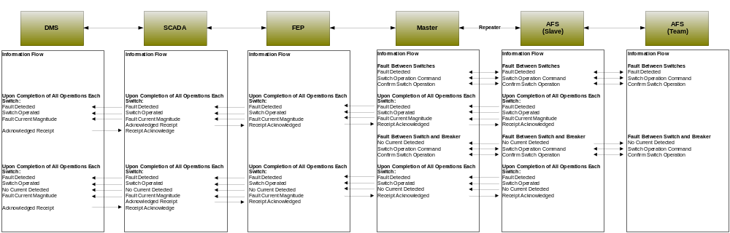
Figure 20 - Information flow AFS automated operation

Included Processes

Manual Switch Operation

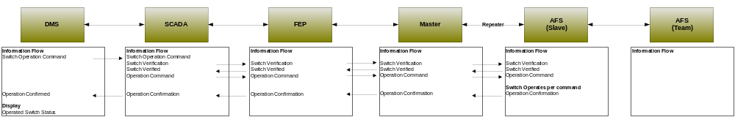
Figure 21 - Information flow AFS Manual Switch Operation

Switch Monitoring and Diagnostics

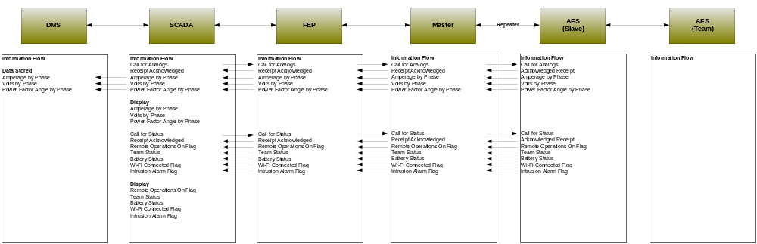
Figure 22 - Information flow AFS monitoring and diagnostics

Switch Configuration Change

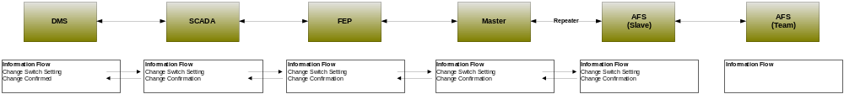
Figure 23 - Information flow AFS manual DNP configuration change

Switch Operation and Configuration Change

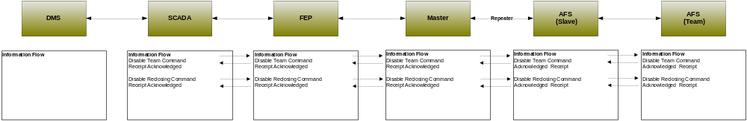
Figure 24 - Information flow manual switch operation and DNP configuration change

Switch to Switch Fault Detection
This process involves notification and interaction with devices in the event a fault is identified to have occurred in between deployed DA switches.

Switch to Breaker Fault Detection
This process involves notification and interaction with devices in the event a fault is identified to have occurred in between a deployed DA switch and the substation.

Voltage Regulator

Objective
The process involves the automatic and manual operation of voltage regulators to improve the voltage characteristics of any particular segment of the distribution network. The process requires close orchestration between the DMS system and voltage regulation devices deployed with in the Distribution network.

Actors
Actor | Role
Voltage Regulators | Primary
Slave | Secondary
Master | Secondary
Front End Processor | Primary
Distribution Management System and SCADA | Primary
Table 23 - Actors Voltage Regulator Operation

Applicable Distribution Applications
Source | Destination | Transaction | Acknowledged or replied | Distribution application
 |  |  |  | Maintenance | Voltage &Var Monitoring | DSDR | Line Seg | Distributed Energy Resources
DMS | Voltage Regulator | Status Request | Y | Y
DMS | Voltage Regulator | Sensor Data request | Y | Y |  | Y
DMS | Voltage Regulator | Command – Step UP | Y |  | Y | Y | Y | Y
DMS | Voltage Regulator | Command – Step Down | Y |  | Y | Y | Y | Y
DMS | Voltage Regulator | New Config | Y |  | Y | Y | Y | Y
Voltage Regulator | DMS | Status Change | Optional | Y
Voltage Regulator | DMS | Deviation Alert | Optional | Y
Voltage Regulator | DMS | Alarm Condition | Optional | Y
Voltage Regulator | DMS | Device Failure | Optional | Y
Table 24 - Applicable Distribution Applications

Latency Requirements - Operation
Source | Destination | Frequency | Response Time | Priority
DMS | Voltage Regulator | Event Driven | 5 Seconds | High
Voltage Regulator | DMS | Event Driven | 5 Seconds | High
Master | Voltage Regulator | Event Driven | 2 Seconds | High
Voltage Regulator | Master | Event Driven | 2 Seconds | High
Table 25 - Latency requirements Voltage Regulator Operation

Latency Requirements - Telemetry
Source | Destination | Frequency | Response Time | Priority
DMS | Voltage Regulator | 5 Second Interval | ~5 Seconds | HIGH
Table 26 - Latency requirements Voltage Regulator Telemetry

Process Flow
Figure 25 - Information flow Voltage Regulator operation

Included Processes

Alerts and Alarms

Status Change and System Conditions

Capacitor Bank Control

Objective
The objective is to remotely operate and poll capacitor banks for purposes of modifying the voltage and power quality on a particular segment of distribution. The intent of this use case is to document the process for automated and manual operation of capacitor banks.

Actors
Actor | Role
Dispatch Operator | Primary
Distribution Management System and SCADA | Primary
Front End Processor | Secondary
Master | Secondary
Repeaters | Secondary
Slave | Secondary
Capacitor Bank | Primary
Table 27 - Actors Capacitor Banks

Applicable Distribution Applications
Source | Destination | Transaction | Acknowledged or replied | Distribution application
 |  |  |  | Maintenance | Voltage &Var Monitoring | DSDR | Line Seg | Distributed Energy Resources
DMS | Capacitor Bank | Status Request | Y | Y
DMS | Capacitor Bank | Sensor Data request | Y | Y |  | Y
DMS | Capacitor Bank | Command – Step UP | Y |  | Y | Y | Y | Y
DMS | Capacitor Bank | Command – Step Down | Y |  | Y | Y | Y | Y
DMS | Capacitor Bank | New Config | Y |  | Y | Y | Y | Y
Capacitor Bank | DMS | Status Change | Optional | Y
Capacitor Bank | DMS | Deviation Alert | Optional | Y
Capacitor Bank | DMS | Alarm Condition | Optional | Y
Capacitor Bank | DMS | Device Failure | Optional | Y
Table 28 - Applicable Distribution Applications

Latency Requirements
Source | Destination | Frequency | Response Time | Priority
DMS | Capacitor Bank | Event Driven | 5 Seconds | High
Capacitor Bank | DMS | Event Driven | 5 Seconds | High
Master | Capacitor Bank | Event Driven | 2 Seconds | High
Capacitor Bank | Master | Event Driven | 2 Seconds | High
Table 29 - Latency requirements Capacitor Bank Operation

Process Flow
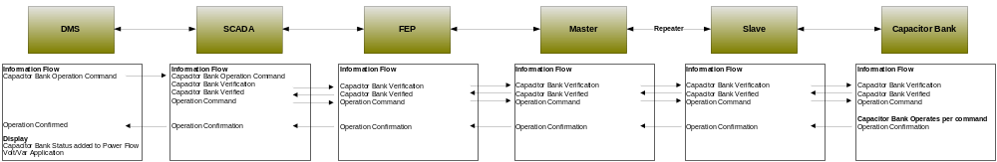
Figure 26 - Information flow Capacitor Bank Control

Included Processes

Alerts and Alarms

Status Change and System Conditions

Capacitor Bank Monitoring

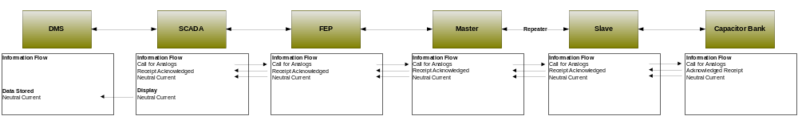
Figure 27 - Information flow Capacitor Bank Monitoring

Fault Current Indicator

Objective
The objective is to remotely poll and collect information from fault current indicators on a particular segment of distribution. The intent of this use case is to document the process for automated and manual operation of fault current indicators.

Actors
Actor | Role
Dispatch Operator | Primary
Distribution Management System and SCADA | Primary
Front End Processor | Secondary
Master | Secondary
Repeaters | Secondary
Slave | Secondary
Fault Current Indicator | Primary
Table 30 - Actors Fault Current Indicator

Applicable Distribution Applications
Source | Destination | Transaction | Acknowledged or replied | Distribution application
 |  |  |  | Maintenance | Voltage &Var Monitoring | DSDR | Line Seg | Distributed Energy Resources
DMS | Fault Current Indicator | Status Request | Y |  |  |  | Y
DMS | Fault Current Indicator | Sensor Data request | Y |  |  |  | Y
DMS | Fault Current Indicator | New Config | Y |  |  |  | Y
Fault Current Indicator | DMS | Deviation Alert | Optional | Y |  |  | Y
Fault Current Indicator | DMS | Alarm Condition | Optional | Y |  |  | Y
Table 31 - Applicable Distribution Applications

Latency Requirements
Source | Destination | Frequency | Response Time | Priority
DMS | Slave | Event Driven | 5 Seconds | High
Slave | DMS | Event Driven | 5 Seconds | High
Master | Slave | Event Driven | 2 Seconds | High
Slave | Master | Event Driven | 2 Seconds | High
Table 32 - Latency requirements Fault Current Indicator

Process Flow
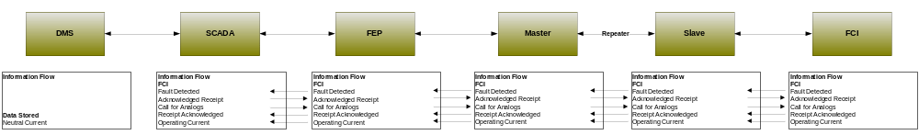
Figure 28 - Information flow Fault current Indicator

Included Processes

Alerts and Alarms

Status Change and System Conditions

Transformer Monitoring

Objective
The objective is to remotely poll and collect information from transformer monitors on a particular segment of distribution. The intent of this use case is to document the process for automated and manual operation of transformer monitors.

Actors
Actor | Role
Dispatch Operator | Primary
Distribution Management System and SCADA | Primary
Front End Processor | Secondary
Master | Secondary
Repeaters | Secondary
Slave | Secondary
Transformer Monitor | Primary
Table 33 - Actors Transformer Monitoring

Applicable Distribution Applications
Source | Destination | Transaction | Acknowledged or replied | Distribution application
 |  |  |  | Maintenance | Voltage &Var Monitoring | DSDR | Line Seg | Distributed Energy Resources
DMS | Transformer Monitor | Status Request | Y | Y
DMS | Transformer Monitor | Sensor Data request | Y | Y |  | Y
DMS | Transformer Monitor | New Config | Y |  | Y | Y | Y | Y
Transformer Monitor | DMS | Status Change | Optional | Y
Transformer Monitor | DMS | Deviation Alert | Optional | Y
Transformer Monitor | DMS | Alarm Condition | Optional | Y
Table 34 - Applicable Distribution Applications

Latency Requirements
Source | Destination | Frequency | Response Time | Priority
DMS | Slave | 15 Minute Interval | 10 Seconds | Medium
Slave | DMS | NA | 10 Seconds | Medium
Master | Slave | NA | 5 Seconds | Medium
Slave | Master | NA | 5 Seconds | Medium
Table 35 – Latency requirements Transformer Monitoring

Process Flow
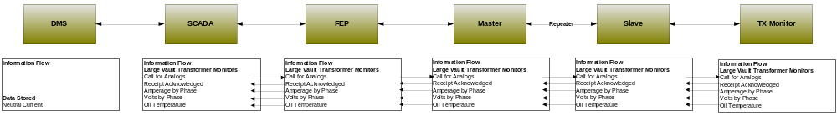
Figure 29 - Information flow Transformer Monitor

Included Processes

Alerts and Alarms

Status Change and System Conditions

Voltage and Current Sensors

Objective
The objective is to remotely poll and collect information from voltage and current sensors on a particular segment of distribution. The intent of this use case is to document the process for automated and manual operation of voltage and current sensors.

Actors
Actor | Role
Dispatch Operator | Primary
Distribution Management System and SCADA | Primary
Front End Processor | Secondary
Master | Secondary
Repeaters | Secondary
Slave | Secondary
Voltage and Current sensor | Primary
Table 36 - Actors Voltage and Current Sensors

Applicable Distribution Applications
Source | Destination | Transaction | Acknowledged or replied | Distribution application
 |  |  |  | Maintenance | Voltage &Var Monitoring | DSDR | Line Seg | Distributed Energy Resources
DMS | Sensor | Status Request | Y | Y
DMS | Sensor | Sensor Data request | Y | Y |  | Y
DMS | Sensor | New Config | Y |  | Y | Y | Y | Y
Sensor | DMS | Status Change | Optional | Y
Sensor | DMS | Deviation Alert | Optional | Y
Sensor | DMS | Alarm Condition | Optional | Y
Table 37 - Applicable Distribution Applications

Latency Requirements
Source | Destination | Frequency | Response Time | Priority
DMS | Slave | 5 Second Interval | 10 Seconds | Medium
Slave | DMS | NA | 10 Seconds | Medium
Master | Slave | NA | 5 Seconds | Medium
Slave | Master | NA | 5 Seconds | Medium
Table 38 -Latency requirements Amp / voltage sensor

Process Flow
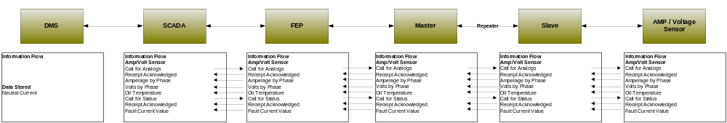
Figure 30 - Information flow Amp / Voltage Sensor

Included Processes

Alerts and Alarms

Status Change and System Conditions

Network Protection Monitoring

Objective
The objective is to remotely poll and collect information from network protection monitors on a particular segment of distribution. The intent of this use case is to document the process for automated and manual operation of network protection monitors.

Actors
Actor | Role
Dispatch Operator | Primary
Distribution Management System and SCADA | Primary
Front End Processor | Secondary
Master | Secondary
Repeaters | Secondary
Slave | Secondary
Network Protector | Primary
Table 39 - Actors Network Protector Monitoring

Applicable Distribution Applications
Source | Destination | Transaction | Acknowledged or replied | Distribution application
 |  |  |  | Maintenance | Voltage &Var Monitoring | DSDR | Line Seg | Distributed Energy Resources
DMS | Switch | Status Request | Y | Y |  |  | Y
DMS | Switch | Sensor Data request | Y | Y |  | Y | Y
DMS | Switch | Command – Step UP | Y |  | Y | Y | Y | Y
DMS | Switch | Command – Step Down | Y |  | Y | Y | Y | Y
DMS | Switch | New Config | Y |  |  |  | Y
Switch | DMS | Status Change | Optional | Y |  |  | Y
Switch | DMS | Deviation Alert | Optional | Y |  |  | Y
Switch | DMS | Alarm Condition | Optional | Y |  |  | Y
Switch | DMS | Device Failure | Optional | Y |  |  | Y
Table 40 - Applicable Distribution Applications

Latency Requirements
Source | Destination | Frequency | Response Time | Priority
DMS | Slave | Event Driven | 10 Seconds | Medium
Slave | DMS | Event Driven | 10 Seconds | Medium
Master | Slave | Event Driven | 5 Seconds | Medium
Slave | Master | Event Driven | 5 Seconds | Medium
Table 41 - Latency Requirements Network Protector Monitoring

Process Flow
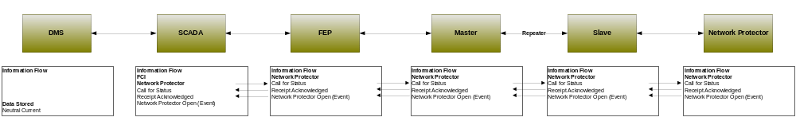
Figure 31 - Information flow Network Protector

Included Processes

Alerts and Alarms

Status Change and System Conditions

Throw Over Switch Monitoring

Objective
The objective is to remotely poll and collect information from throw over switch monitors on a particular segment of distribution. The intent of this use case is to document the process for monitoring throw over switches.

Actors
Actor | Role
Dispatch Operator | Primary
Distribution Management System and SCADA | Primary
Front End Processor | Secondary
Master | Secondary
Repeaters | Secondary
Slave | Secondary
Throw Over Switch | Primary
Table 42 - Actors Throw Over Switch Monitoring

Applicable Distribution Applications
Source | Destination | Transaction | Acknowledged or replied | Distribution application
 |  |  |  | Maintenance | Voltage &Var Monitoring | DSDR | Line Seg | Distributed Energy Resources
DMS | Switch Sensor | Status Request | Y | Y
DMS | Switch Sensor | Sensor Data request | Y | Y |  | Y
DMS | Switch Sensor | New Config | Y |  | Y | Y | Y | Y
Switch Sensor | DMS | Status Change | Optional | Y
Switch Sensor | DMS | Deviation Alert | Optional | Y
Switch Sensor | DMS | Alarm Condition | Optional | Y
Table 43 - Applicable Distribution Applications

Latency Requirements
Source | Destination | Frequency | Response Time | Priority
DMS | Slave | 5 Minute Interval | 10 Seconds | Medium
Slave | DMS | Event Driven | 10 Seconds | Medium
Master | Slave | Event Driven | 5 Seconds | Medium
Slave | Master | Event Driven | 5 Seconds | Medium
Table 44 - Latency Requirements Throw Over Switch Monitoring

Process Flow
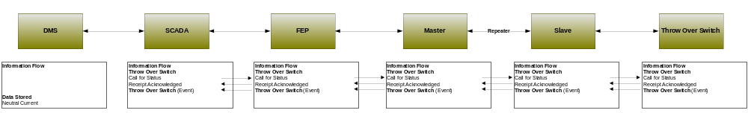
Figure 32 - Information flow Throw Over Switch

Included Processes

Alerts and Alarms

Status Change and System Conditions

Health Checks

Objective
The objective is to remotely poll and collect information health information from distribution equipment on a particular segment of distribution.

Actors
Actor | Role
Dispatch Operator | Primary
Distribution Management System and SCADA | Primary
Front End Processor | Secondary
Master | Secondary
Repeaters | Secondary
Slave | Secondary
RTU | Primary
Table 45 – Actors Device Health Check

Latency Requirements
Source | Destination | Frequency | Response Time | Priority
DMS | Slave | 5 Minute Interval | 10 Seconds | Medium
Slave | DMS | Event Driven | 10 Seconds | Medium
Master | Slave | Event Driven | 5 Seconds | Medium
Slave | Master | Event Driven | 5 Seconds | Medium
Table 46 - Latency Requirements Device Health Check

Process Flow
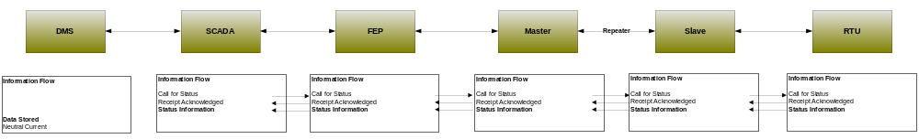
Figure 33 - Information flow Health check

Power Quality Event (Kelly)

Objective
The objective is to collect alarms from the meter that occur when there is a out of state or passed a threshold condition on the meter. Power quality event are disturbance oriented by nature, leading / lagging power. In most cases the events will be as result of excessive steady state voltage variation, unbalance in energy flow, harmonics on the line, sags, swells, oscillatory.

Actors
Actor | Description | Role
Meter Data Management System | The MDMS is the application responsible for coordinating the billing of AMI data. MDMS often interact with CIS, as well as other systems, to automate customer and billing functions with the Smart Grid.
AMI Head End | The AMI head end is responsible for the operation and coordination of AMI system components. It represents the central nervous system of the AMI system.
Data Aggregation Point | This is the Data Aggregation Point on the NAN. It is essentially the point of convergence for all communication between SG devices and utility back office systems. In this specific use case it provides a communication conduit for AMI Smart Meters.
Smart Meter – AMI Interface | This is the interface utilized to communicate directly between the Smart Meter and the AMI system. This interface is used to allow utilities and third parties to communicate with the meter via the AMI system.
Table 47 - Metering Power Quality Actors

Latency Requirements
Source | Destination | Frequency | Response Time | Priority
Smart Meter | DAP | Event Driven | <30 sec | High
DAP | AMI Head End | Event Driven | <30 sec | High
AMI Head End | MDMS | Event Driven | <30 sec | High
Table 48 - Latency Requirements

Process Flow
Figure 34 - Process Flow

Included Processes

Appendix
Notes from the Authors

Distribution Automation Network Design and Provisioning - (Move to appendix)
The following use cases are intended to be informational in nature. Their inclusion in this document is to highlight the importance of some of the network management specific requirements highlighted in this document. In the end, these use cases provide a small representation of the complex nature of Smart Grid deployments.

Distribution Communications Network Design

Objective
In order to facilitate communication between DMS, SCADA, the FEP and DA devices, each component of the solution will require the assignment of a at least one unique network address. The address is a unique identifier for the DMS application needed to identify each device for purposes of passing control messages. The primary goal of this process is the allocation and design of the address scheme for each logical network and all associated distribution field devices. The result schematic will be referred to as the Distribution Logical Network Design. Once completed the Distribution Logical Network Design serve as the reference configuration for DMS, SCADA and all other pertinent DA components.

Process Flow
The following diagram provides a sample process flow for development of a Distribution Logical Network Design. The Distribution Logical Network Design involves close synchronization between Distribution devices, systems, asset management, network management and various operational systems.
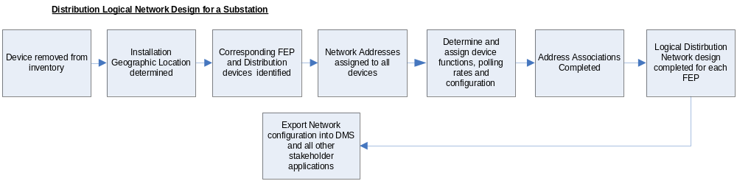
Figure 35 - Process flow Distribution Logical Network Design

Actors
Actor | Description | Role
Network Administrator | This is an individual responsible for operation, management and engineering of network communication infrastructure. In this process this roll will be critical in configuring the DA communication components. | Secondary
Distribution Engineer | The Distribution Engineer is an individual operating in a supporting role. In this process the DE provides requirements information that the Network Administrator will input into their network design for deployed communication devices. The design provided should reflect the physical and logical association between distribution assets and their respective substation. In this process the DE should develop DNP mapping tables for every device associated with a given substation. The intent is to develop the mapping of all devices with in DMS. | Primary
Network Management System | This application is responsible for configuring and management of network assets assigned to support DA. In this case NMS will be responsible for distributing DNP mapping tables and pertinent configuration information to all DA network components. | Primary
Data Aggregation Point | This is the Data Aggregation Point on the NAN. It is essentially the point of convergence for all communication between SG devices and utility back office systems. This device serves as the gateway between the DA communication devices, DMS / SCADA and NMS. | Secondary
Repeaters | These devices are the common communication infrastructure used for extending radio frequency coverage of a specific network. These devices may not be applicable to all DA communications architectures. | Secondary
Master | This device provides radio communication between the Front End Processor, DMS and the Distribution field device. These devices along with its Slave counterparts must be provisioned with DNP mapping tables that reflects the DNP configuration of all associated distribution field devices. | Secondary
Slave | These devices serve as the primary communications for DA field devices and must reflect the same DNP configuration as its attached RTU device. | Secondary
WAN | Data Aggregation Point link that provides communication between field devices and the data center. | Secondary
Receive Transmit Units | These are the physical DA devices attached to the Slaves. These devices along with their Master and Slave counterparts must be provisioned with DNP mapping tables. | Secondary
Table 49 - Actors Distribution Logical Network Design

Included Processes

Documenting Geographic Location
This process involves the creation of a data file containing all relevant electronic configuration and installation location information for a given distribution automation field device. The intent of this file is to document location specific information relating to the devices deployed in the field. In addition, this file may serve as a reference for updating asset information in any applicable AMS.

Device Input into Asset Management System
This process involves updating utility asset management information in AMS as components are drawn from inventory and devices are deployed in the field.

Substation Distribution Logical Network and Device Input into Distribution Management System
This process involves updating device configuration information into DMS and SCADA as devices are deployed in the field. Ideally the DMS updates should occur once a substation’s Distribution Logical Network Design is completed. The Distribution Logical Network Design must include all assigned mapping tables for all given devices associated with a given substation. This process is intended to reflect device updates to DMS and SCADA that occur prior to the device being installed.

Substation Distribution Logical Network and Device Input into SCADA
This process involves updating device configuration information into SCADA as devices are deployed in the field. Ideally the SCADA updates should occur once a substation’s DNP Logical Network Design is completed. This process is intended to reflect device updates to DMS and SCADA that occur after the device has been installed.

Substation Distribution Logical Network and Device Input into NMS
This process involves updating device communications configuration information in NMS as devices are deployed in the field. Ideally the NMS updates should occur as soon as the Distribution Logical Network Design is completed. The Distribution Logical Network Design must include all assigned device mapping tables for all given devices associated with a given substation. In addition, the information must provide an accurate mapping between the device mapping tables, device addresses, their respective Master communications devices, Slave communication devices and their respective substation network.

Acronyms and Abbreviations

AC | Alternating Current
AMI | Advanced Metering Infrastructure
AMS | Asset management system
ASAP-SG | Advanced Security Acceleration Project-Smart Grid
B2B | Business to Business
BAN | Business Area Network
CIM | Common Information Model.
CIP | Critical Infrastructure Protection
CSWG | Cyber Security Working Group
DA | Distribution Automation
DAP | Data Aggregation Point
DER | Distributed Energy Resources
DHS | Department of Homeland Security
DMS | Distribution Management System
DNP | Distributed Network Protocol
DOE | Department of Energy
DOMA | Distribution Operations Model and Analysis
DR | Demand Response
DSDR | Distribution Systems Demand Response
DSM | Demand Side Management
EMS | Energy Management System
EPRI | Electric Power Research Institute
ES | Electric Storage
ESB | Enterprise Service Bus
ESI | Energy Services Interface
ET | Electric Transportation
EUMD | End Use Measurement Device
EV/PHEV | Electric Vehicle/Plug-in Hybrid Electric Vehicles
EVSE | Electric Vehicle Service Element
FAN | Field Area Network
FEP | Front End Processor
FERC | Federal Energy Regulatory Commission
FIPS | Federal Information Processing Standard Document
FLIR | Fault Location, Isolation, Restoration
G&T | Generations and Transmission
GAPP | Generally Accepted Privacy Principles.
GIS | Geographic Information System
GPRS | General Packet Radio Service
HAN | Home Area Network
HMI | Human-Machine Interface
HVAC | Heating, Ventilating, and air conditioning (shown in figure)
I2G | Industry to Grid
IEC | International Electrotechnical Commission
IED | Intelligent Electronic Device
IHD | In-home Display
ISA | International Society of Automation
ISO | Independent System Operator
ISO/IEC27001 | International Organization for Standardization/International Electrotechnical Commission Standard 27001.
IT | Information Technology
LAN | Local Area Network
LMS | Load management system
LMS/DRMS | Load Management System/ Distribution Resource Management System
LV | Low voltage (in definition)
MDMS | Meter Data Management System
MFR | Multi-Feeder Reconnection
MSW | Meter service switch
MV | Medium voltage (in definition)
NAN | Neighborhood Area Network
NERC | North American Electric Reliability Corporation
NIPP | National Infrastructure Protection Plan
NIST | National Institute of Standards and Technology
NISTIR | NIST Interagency Report
NMS | Network Management system
OMS | Outage Management System
OWASP | Open Web Application Security Project
PAP | Priority Action Plan
PCT | Programmable Communicating Thermostat
PEV | Plug-In Electric Vehicle
PI | Process Information
PIA | Privacy Impact Assessment. .
PII | Personally Identifying Information
R&D | Research and Development
RTO | Regional Transmission Operator
RTU | Remote Terminal Unit
SCADA | Supervisory Control and Data Acquisition
SCE | Southern California Edison
SGIP | Smart Grid Interoperability Panel
SGIP-CSWG | SGIP – Cyber Security Working Group
SP | Special Publication
SSP | Sector-Specific Plans
T/FLA | Three/Four Letter Acronym
VAR | Volt-Amperes Reactive
VVWS | Volt-VAR-Watt System
WAMS | Wide-Area Measurement System
WAN | Wide Area Network
WASA | Wide Area Situational Awareness
WLAN | Wireless Local Area Network
WMS | Work Management System

Definitions

Actor | A generic name for devices, systems, or programs that make decisions and exchange information necessary for performing applications: smart meters, solar generators, and control systems represent examples of devices and systems.
Anonymize | A process of transformation or elimination of PII for purposes of sharing data
Aggregation | Practice of summarizing certain data and presenting it as a total without any PII identifiers
Aggregator | SEE FERC OPERATION MODEL
Applications | Tasks performed by one or more actors within a domain.
Asset Management System | A system(s) of record for assets managed in the Smart Grid. Management context may change(e.g. financial, network)
Capacitor Bank | This is a device used to add capacitance as needed at strategic points in a distribution grid to better control and manage VARs and thus the Power Factor and they will also affect voltage levels.
Common Information Model | A structured set of definitions that allows different Smart Grid domain representatives to communicate important concepts and exchange information easily and effectively.
Common Web Portal | Web interface for Regional Transmission Operator, customers, retail electric providers and transmission distribution service provider to function as a clearing house for energy information. Commonly used in deregulated markets.
Data Collector | See Substation Controller
Data Aggregation Point | This device is a logical actor that represents a transition in most AMI networks between Wide Area Networks and Neighborhood Area Networks. (e.g. Collector, Cell Relay, Base Station, Access Point, etc)
De-identify | A form of anonymization that does not attempt to control the data once it has had PII identifiers removed, so it is at risk of re-identification.
Demand Side Management | A system that co-ordinates demand response / load shedding messages indirectly to devices (e.g. Set point adjustment)
Distribution Management System | A system that monitors, manages and controls the electric distribution system.
Distribution Systems Demand Response | A system used to reduce load during peak demand. Strictly used for Distribution systems only.
Electric Vehicle/Plug-in Hybrid Electric Vehicles | Cars or other vehicles that draw electricity from batteries to power an electric motor. PHEVs also contain an internal combustion engine.
Energy Services Interface | Provides security and, often, coordination functions that enable secure interactions between relevant Home Area Network Devices and the Utility. Permits applications such as remote load control, monitoring and control of distributed generation, in-home display of customer usage, reading of non-energy meters, and integration with building management systems. Also provides auditing/logging functions that record transactions to and from Home Area Networking Devices.
Enterprise Service Bus | The Enterprise Service Bus consists of a software architecture used to construct integration services for complex event-driven and standards-based messaging to exchange meter or grid data. The ESB is not limited to a specific tool set rather it is a defined set of integration services.
Fault Detector | A device used to sense a fault condition and can be used to provide an indication of the fault.
Field Force | Employee working in the service territory that may be working with Smart Grid devices.
GAPP | Generally Accepted Privacy Principles. Privacy principles and criteria developed and updated by the AICPA and Canadian Institute of Chartered Accountants to assist organizations in the design and implementation of sound privacy practices and policies.
Home Area Network | A network of energy management devices, digital consumer electronics, signal-controlled or enabled appliances, and applications within a home environment that is on the home side of the electric meter.
Intelligent Fault Detector | A device that can sense a fault and can provide more detailed information on the nature of the fault, such as capturing an oscillography trace.
ISO/IEC27001 | An auditable international standard that specifies the requirements for establishing, implementing, operating, monitoring, reviewing, maintaining and improving a documented Information Security Management System within the context of the organization's overall business risks. It uses a process approach for protection of critical information
Last Gasp | Concept of an energized device within the Smart Grid detecting power loss and sending a broadcast message of the event.
Load Management System | System that controls load by sending messages directly to device (e.g. On/Off)
Low Voltage Sensor | A device used to measure and report electrical properties (such as voltage, current, phase angle or power factor, etc.) at a low voltage customer delivery point.
Medium Voltage Sensor | A device used to measure and report electrical properties (such as voltage, current, phase angle or power factor, etc.) on a medium voltage distribution line.
Motorized Switch | A device under remote control that can be used to open or close a circuit.
Neighborhood Area Network | A network comprised of all communicating components within a distribution domain.
Network Management System | A system that manages Fault, Configuration, Auditing/Accounting, Performance and Security of the communication. This system is exclusive from the electrical network.
Outage Management System | A system that receives out power system outage notifications and correlates where the power outage occurred
Personal Information | Information that reveals details, either explicitly or implicitly, about a specific individual’s household dwelling or other type of premises. This is expanded beyond the normal "individual" component because there are serious privacy impacts for all individuals living in one dwelling or premise. This can include items such as energy use patterns or other types of activities. The pattern can become unique to a household or premises just as a fingerprint or DNA is unique to an individual.
Phase Measuring Unit | A device capable of measuring the phase of the voltage or current waveform relative to a reference.
Power Factor | A dimensionless quantity that relates to efficiency of the electrical delivery system for delivering real power to the load. Numerically, it is the Cosine of the phase angle between the voltage and current waveforms. The closer the power factor is to unity the better the inductive and capacitive elements of the circuit are balanced and the more efficient the system is for delivering real power to the load(s).
Privacy Impact Assessment | A process used to evaluate the possible privacy risks to personal information, in all forms, collected, transmitted, shared, stored, disposed of, and accessed in any other way, along with the mitigation of those risks at the beginning of and throughout the life cycle of the associated process, program or system
Programmable Communicating Thermostat | A device within the premise that has communication capabilities and controls heating, ventilation and cooling systems.
Recloser (non-Team) | A device used to sense fault conditions on a distribution line and trip open to provide protection. It is typically programmed to automatically close (re-close) after a period of time to test if the fault has cleared. After several attempts of reclosing it can be programmed to trip open and stop trying to reclose until reset either locally or under remote control.
Recloser (Team) | A device that can sense fault conditions on a distribution line and to communicate with other related reclosers (the team) to sectionalize the fault and provide a coordinated open/close arrangement to minimize the effect of the fault.
Regional Transmission Operator | A Regional Transmission Organization (RTO) is an organization that is established with the purpose of promoting efficiency and reliability in the operation and planning of the electric transmission grid and ensuring non-discrimination in the provision of electric transmission services based on the following required/demonstrable characteristics and functions.
Remote Terminal Unit | Aggregator of multiple serialized devices to a common communications interface
Sub Meter | Premise based meter used for Distributed Energy Resources and PHEV. This device may be revenue grade.
Substation Controller | Distributed processing device that has supervisory control or coordinates information exchanges from devices within a substation from a head end system.
Transformer (MV-to-LV) | A standard point of delivery transformer. In the Smart Grid context is it assumed there will be a need to measure some electrical or physical characteristics of this transformer such as voltage (high and/or low side) current, MV load, temperature, etc.
Use Case | Use cases are a systems engineering tool for defining a system’s behavior from the perspective of users. In effect, a use case is a story told in structure and detailed steps—scenarios for specifying required usages of a system, including how a component, subsystem, or system should respond to a request that originates elsewhere.
Voltage Regulator | This device is in effect an adjustable ratio transformer sitioned at strategic points in a distribution grid and is utilized to better manage and control the voltage as it changes along the distribution feeder.
VAR – Volt-Amperes Reactive; | In an AC power system the voltage and current measured at a point along the delivery system will often be out of phase with each other as a result the combined effects of the resistive and reactive (i.e. the capacitance and inductive) characteristics of the delivery system components and the load. The phase angle difference at a point along the delivery system is an indication of how well the inductive and capacitive effects are balanced at that point. The real power passing that point is the product of the magnitude of the Voltage and Current and the Cosine of the angle between the two. The VAR parameter is the product of the magnitude of the Voltage and Current and the Sine of the angle between the two. The magnitude of the VAR parameter is an indication of the phase imbalance between the voltage and current waveforms.
Web Portal | Interface between energy customers and the system provider. Could be the utility or third party

For additional information regarding EISA 2007, please visit http://energy.senate.gov/public/_files/RL342941.pdf
SOURCE: NIST Smart Grid Twiki, http://collaborate.nist.gov/twiki-sggrid/bin/view/SmartGrid/PriorityActionPlans
http://osgug.ucaiug.org/UtiliComm/Shared%20Documents/Interium_Release_3/
SOURCE: “NIST Framework and Roadmap for Smart Grid Interoperability Standards, Release 1.0”, page 20
http://osgug.ucaiug.org/UtiliComm/Shared%20Documents/Forms/AllItems.aspx

