UCAIug: SG Net SRS
Smart Grid Networks System Requirements Specification
Release Candidate 3 revision *
DRAFT
Table of Contents
Document History 6
1 Authors 7
1.1 Acknowledgements Error! Bookmark not defined.
2 Overview 7
2.1 Executive Summary 7
2.1.1 Background - Energy Independence and Security Act of 2007 Error! Bookmark not defined.
2.1.2 Goals and Objective Error! Bookmark not defined.
2.1.3 Priority Action Plans Error! Bookmark not defined.
2.1.4 Deliverables Error! Bookmark not defined.
2.2 Approach 7
2.2.1 SG-Network Requirements Gathering Process 7
2.3 Terms and Definitions 13
3 Illustrative Reference Architecture Overview 14
3.1.1 Alternative Paths 17
4 Use Cases and Communications Requirements 18
4.1 Overview and Context 18
4.2 Payload Reference – PLACEHOLDER Error! Bookmark not defined.
4.3 Wide Area Situational Awareness - Cosio Error! Bookmark not defined.
4.3.1 Objective Error! Bookmark not defined.
4.4 Demand Response and Consumer Energy Efficiency – Matt Error! Bookmark not defined.
4.4.1 Demand Response Error! Bookmark not defined.
4.4.2 Direct Load Control Error! Bookmark not defined.
4.5 Energy Storage Error! Bookmark not defined.
4.5.1 Objectives Error! Bookmark not defined.
4.5.2 Actors Error! Bookmark not defined.
4.5.3 Latency Requirements Error! Bookmark not defined.
4.5.4 Process Flow Error! Bookmark not defined.
4.5.5 Included Processes Error! Bookmark not defined.
4.6 Electric Transportation Error! Bookmark not defined.
4.6.1 PHEV Use Cases (Vincent/Ron/Jerry) Error! Bookmark not defined.
4.7 System Security – Vincent / Matt Error! Bookmark not defined.
4.7.1 Overview – Cosio Error! Bookmark not defined.
4.7.2 CIA Error! Bookmark not defined.
4.7.3 Use Cases Error! Bookmark not defined.
4.7.4 Security Event (Kelly) Error! Bookmark not defined.
4.7.5 Audit Event (Kelly) Error! Bookmark not defined.
4.8 Network Communications – Error! Bookmark not defined.
4.8.1 Overview Error! Bookmark not defined.
4.8.2 Configuration Event (Ron) Error! Bookmark not defined.
4.8.3 Fault Error Alarm Event (Kelly) Error! Bookmark not defined.
4.9 Meter Reading Use Cases Error! Bookmark not defined.
4.9.1 Overview Error! Bookmark not defined.
4.9.2 Actors Error! Bookmark not defined.
4.9.3 Scenarios Error! Bookmark not defined.
Mtr-read_multi-interval-data_resp-data Error! Bookmark not defined.
4.10 Outage Notification Error! Bookmark not defined.
4.10.1 Overview Error! Bookmark not defined.
4.10.2 Actors Error! Bookmark not defined.
4.10.3 Scenarios Error! Bookmark not defined.
4.11 Electric Service Prepayment Error! Bookmark not defined.
4.11.1 Overview Error! Bookmark not defined.
4.11.2 Actors Error! Bookmark not defined.
4.11.3 Scenarios Error! Bookmark not defined.
4.12 Distribution Grid Management Error! Bookmark not defined.
4.12.1 Overview of Business Processes Error! Bookmark not defined.
4.12.2 Business Process Definitions Error! Bookmark not defined.
4.12.3 Actors Error! Bookmark not defined.
4.12.4 Automated Feeder / Re-closer Switching Error! Bookmark not defined.
4.12.5 Voltage Regulator Error! Bookmark not defined.
4.12.6 Capacitor Bank Control Error! Bookmark not defined.
4.12.7 Fault Current Indicator Error! Bookmark not defined.
4.12.8 Transformer Monitoring Error! Bookmark not defined.
4.12.9 Voltage and Current Sensors Error! Bookmark not defined.
4.12.10 Network Protection Monitoring Error! Bookmark not defined.
4.12.11 Throw Over Switch Monitoring Error! Bookmark not defined.
4.12.12 Health Checks Error! Bookmark not defined.
4.12.13 Power Quality Event (Kelly) Error! Bookmark not defined.
5 Appendix 18
5.1 Distribution Automation Network Design and Provisioning - (Move to appendix) 18
5.2 Acronyms and Abbreviations 18
5.3 Definitions 18
5.4 Alternative / Multiple Communication Paths 18
5.5 Application Payloads 18

List of Tables
Table 1- Pertinent Use Cases Error! Bookmark not defined.
Table 2 - Actors Error! Bookmark not defined.
Table 3 - Actor Domain Mapping Error! Bookmark not defined.
Table 4 - Smart Grid Functional & Volumetric Business Requirements Error! Bookmark not defined.
Table 5 - Actors Error! Bookmark not defined.
Table 6 - Actors Error! Bookmark not defined.
Table 7 - Actors Error! Bookmark not defined.
Table 8 - Actors Error! Bookmark not defined.
Table 9 - Metering Audit Event Actors Error! Bookmark not defined.
Table 10 - Metering Security Event Actors Error! Bookmark not defined.
Table 11 - Latency Requirements Error! Bookmark not defined.
Table 12 - Metering Configuration Event Actors Error! Bookmark not defined.
Table 13 - Latency Requirements Error! Bookmark not defined.
Table 14 - Metering Fault Alarm Actors Error! Bookmark not defined.
Table 15 - Latency Requirements Error! Bookmark not defined.
Table 16 – Outage Notification Actors Error! Bookmark not defined.
Table 17 – Outage Notification Actors Error! Bookmark not defined.
Table 18 - Distribution Automation Actor Descriptions Error! Bookmark not defined.
Table 19 - Actors Automated Feeder Switching Error! Bookmark not defined.
Table 20 - Applicable Distribution Applications Error! Bookmark not defined.
Table 21 - Latency requirements AFS operation Error! Bookmark not defined.
Table 22 - Latency requirements Automated Feeder Switch Telemetry Error! Bookmark not defined.
Table 23 - Actors Voltage Regulator Operation Error! Bookmark not defined.
Table 24 - Applicable Distribution Applications Error! Bookmark not defined.
Table 25 - Latency requirements Voltage Regulator Operation Error! Bookmark not defined.
Table 26 - Latency requirements Voltage Regulator Telemetry Error! Bookmark not defined.
Table 27 - Actors Capacitor Banks Error! Bookmark not defined.
Table 28 - Applicable Distribution Applications Error! Bookmark not defined.
Table 29 - Latency requirements Capacitor Bank Operation Error! Bookmark not defined.
Table 30 - Actors Fault Current Indicator Error! Bookmark not defined.
Table 31 - Applicable Distribution Applications Error! Bookmark not defined.
Table 32 - Latency requirements Fault Current Indicator Error! Bookmark not defined.
Table 33 - Actors Transformer Monitoring Error! Bookmark not defined.
Table 34 - Applicable Distribution Applications Error! Bookmark not defined.
Table 35 – Latency requirements Transformer Monitoring Error! Bookmark not defined.
Table 36 - Actors Voltage and Current Sensors Error! Bookmark not defined.
Table 37 - Applicable Distribution Applications Error! Bookmark not defined.
Table 38 -Latency requirements Amp / voltage sensor Error! Bookmark not defined.
Table 39 - Actors Network Protector Monitoring Error! Bookmark not defined.
Table 40 - Applicable Distribution Applications Error! Bookmark not defined.
Table 41 - Latency Requirements Network Protector Monitoring Error! Bookmark not defined.
Table 42 - Actors Throw Over Switch Monitoring Error! Bookmark not defined.
Table 43 - Applicable Distribution Applications Error! Bookmark not defined.
Table 44 - Latency Requirements Throw Over Switch Monitoring Error! Bookmark not defined.
Table 45 – Actors Device Health Check Error! Bookmark not defined.
Table 46 - Latency Requirements Device Health Check Error! Bookmark not defined.
Table 47 - Metering Power Quality Actors Error! Bookmark not defined.
Table 48 - Latency Requirements Error! Bookmark not defined.
Table 49 - Actors Distribution Logical Network Design Error! Bookmark not defined.

List of Figures
Figure 1 - Open SG structure Error! Bookmark not defined.
Figure 2 - Baseline Diagram Without Cross Domain & Network 15
Figure 3 - Baseline Diagram with Cross Domain & Network flows 16
Figure 4 - Customer Information / Messaging Use Case Error! Bookmark not defined.
Figure 5 - Distribution Automation Use Case Error! Bookmark not defined.
Figure 6 - Meter Read Use Case Error! Bookmark not defined.
Figure 7 - PHEV Use Case Error! Bookmark not defined.
Figure 8– PrePay Use Case Error! Bookmark not defined.
Figure 9 - Service Switch Error! Bookmark not defined.
Figure 10 – Utility CIS <-> Meter Communication Path Scenarios 17
Figure 11– IPD & Customer. EMS <-> Meter Communication Path Scenarios Error! Bookmark not defined.
Figure 12 - Web Portal <-> ODS Communication Path Scenarios Error! Bookmark not defined.
Figure 13 – Utility CIS <-> IPD Communication Path Scenarios Error! Bookmark not defined.
Figure 14 – REP CIS <-> IPD Communication Path Scenarios Error! Bookmark not defined.
Figure 15 – DMS <-> DA Feeder Devices Communication Path Scenarios Error! Bookmark not defined.
Figure 16– DMS <-> DA Substation Devices Communication Path Scenarios Error! Bookmark not defined.
Figure 17 - Process Flow Error! Bookmark not defined.
Figure 18 - Process Flow Error! Bookmark not defined.
Figure 19 - Process Flow Error! Bookmark not defined.
Figure 20 - Information flow AFS automated operation Error! Bookmark not defined.
Figure 21 - Information flow AFS Manual Switch Operation Error! Bookmark not defined.
Figure 22 - Information flow AFS monitoring and diagnostics Error! Bookmark not defined.
Figure 23 - Information flow AFS manual DNP configuration change Error! Bookmark not defined.
Figure 24 - Information flow manual switch operation and DNP configuration change Error! Bookmark not defined.
Figure 25 - Information flow Voltage Regulator operation Error! Bookmark not defined.
Figure 26 - Information flow Capacitor Bank Control Error! Bookmark not defined.
Figure 27 - Information flow Capacitor Bank Monitoring Error! Bookmark not defined.
Figure 28 - Information flow Fault current Indicator Error! Bookmark not defined.
Figure 29 - Information flow Transformer Monitor Error! Bookmark not defined.
Figure 30 - Information flow Amp / Voltage Sensor Error! Bookmark not defined.
Figure 31 - Information flow Network Protector Error! Bookmark not defined.
Figure 32 - Information flow Throw Over Switch Error! Bookmark not defined.
Figure 33 - Information flow Health check Error! Bookmark not defined.
Figure 34 - Process Flow Error! Bookmark not defined.
Figure 35 - Process flow Distribution Logical Network Design Error! Bookmark not defined.

Document History
Revision History

Authors

Overview

Executive Summary

Approach

SG-Network Requirements Gathering Process

Listing of pertinent use cases

Identification of Actors within Use Cases

Identification of pertinent application payloads

Gap analysis by mapping actors to use cases

Defining Business Functional and non-Funtional (Volumetric) Requirements
There are many smart grid user applications (use cases) collections of documentation. Many have text describing the user applications (see IKB), but few contain quantitative business functional and volumetric requirements, which are necessary to design communications protocols, to assess, or to plan communication networks. Documenting the detailed actor to actor payloads and volumetric requirements allows for:
- aggregation of the details to various levels (e.g., specific interface or network link, a specific network or actor and have the supporting details versus making assumptions about those details) and
- allows the consumer of the Requirements Table to scope and customize the smart grid deployment specific to their needs (e.g., which set of use cases, payloads, actors, communication path deployments).

OpenSG_SG Communications_SG Network TF took on the task to document the Smart Grid business functional and volumetric requirements for input into the NIST PAP 2 tasks and to help fill this requirements documentation void. The current SG-Network business functional and volumetric requirements are located at
- http://osgug.ucaiug.org/UtiliComm/Shared%20Documents/Latest_Release_Deliverables/
with a file name syntax of “SG Network System Requirements Specification vN.R.xls”, where N represents the version number and R represents the revision number. This spreadsheet is referred to below as the Requirements Table (see the following illustrative example view).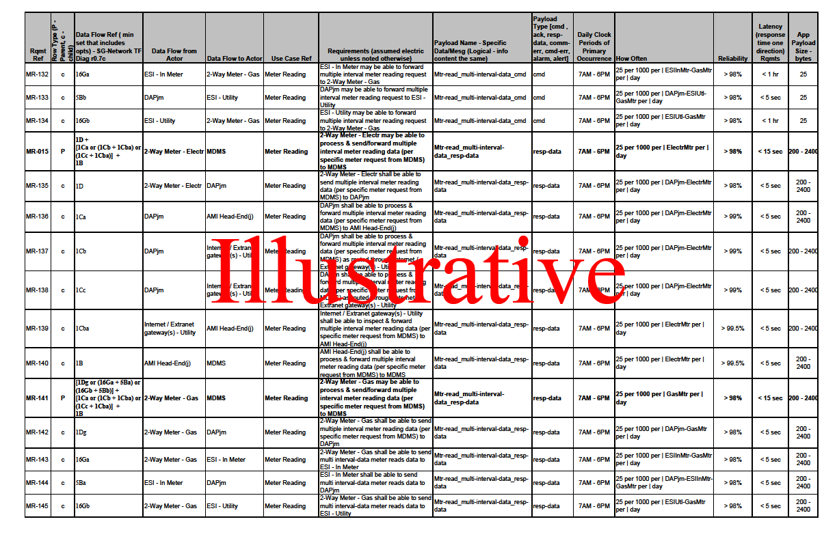Table 1 - Smart Grid Functional & Volumetric Business Requirements

Instructions for how to document the business functional and volumetric requirements was prepared for the requirement authors, but also can be used by the consumer of the Requirements Table to better understand what is and is not included, and how to interpret the requirement data. The requirements documentation instructions are located at:
- http://osgug.ucaiug.org/UtiliComm/Shared%20Documents/Latest_Release_Deliverables/
with a file name syntax of “rqmts-documentation-instructions-rN.R.doc”, where N represents the version number and R represents the revision number.

The Requirements Table consists of several major sets of information for each use case: For example:
- Business functional requirement statements are documented as individual information flows (e.g., specific application payload requirement sets). This is comparable to what many use case tools capture as information flows and/or illustrated in sequence diagram flows.
- To the baseline business requirements are added the:
  - volumetric attributes (the when, how often, with what availability, latency, application payload size). Take note that the SG Network TF Requirements Table definition for some terms (e.g. latency) is different than the classic “network link latency” usage. Please refer to the SG Network TF Requirements Documentation Instructions or section Requirements Table Column Descriptionsfor the detailed definitions for clarification.
  - further payload details e.g. description, attributes, NISTIR 7628 security Logical Interface Category mapping, an assignment of the security confidentiality, integrity, and availability low-medium-high risk values, and business impacts of the payload being compromised as assessed against the security confidentiality, integrity, availability values for that application payload.
- Payload requirement sets are grouped by rows in the table that contains all the detailed actor to actor passing of the same application payloads in a sequence that follows the main data flow from that payload’s originating actor to primary consuming actor(s) across possible multiple communication paths that a deployment might use. The payload requirements’ sets will always contain a parent (main) actor to actor row and most will contain child (detailed) rows for that requirement set.
- Payload communication path (information or data flow) alternatives that a given smart grid deployment might use.

The process of requirements gathering and documentation has been evolutionary in nature as various combinations of additional attributes are documented; use cases added; payload requirement sets added; and alternative communication paths documented. The SG Network TF has defined ~7875 (as of release 5.0) functional and volumetric detailed requirements rows in the Requirements Table representing 204 different payloads for 19 use cases.

SG Network TF intends to continue this incremental version release approach to manage the scope and focus on documenting the requirements for specific use cases and payloads, yet giving consumers of this information something to work with and provide feedback for consideration in the next incremental releases. We expect that the number of requirements rows in the Requirements Table will increase over time.

For background information, the following link is provided for more information on how requirements are derived:
http://osgug.ucaiug.org/UtiliComm/Shared%20Documents/Latest_Release_Deliverables/rqmts-documentation-instructions-r1.3.pdf

To effectively use the business functional and volumetric requirements, the consumer of the Requirements Table must:
- select which use cases and payloads are to be included
- select which communication path scenario (alternative) is to be used for each of the main information/data flows from originating actor to target consuming actor
- specify the size (quantity and type of devices) of the smart grid deployment
- perform other tweaks to the payload volumetrics to match that smart grid deployment’s needs e.g. specifying variables not specifically quantified or ranges are provided

The current Requirements Table as a spreadsheet is not very conducive to performing these tasks. SG-Network TF is building a database that is synchronized with the latest release of the Requirements Table (spread sheet). SG Network TF will be adding capabilities to the database to:
- solicit answers to the questions summarized above;
- query the database; and
- format and aggregate the query results for either reporting or exporting for use by other tools.

The current SG-Network TF Requirements Database and related use documentation are located at
- http://osgug.ucaiug.org/UtiliComm/Shared%20Documents/Latest_Release_Deliverables/ Rqmts_Database/

Requirements Table Column Descriptions
The Requirements Table spreadsheet contains several worksheets, two of which contain the bulk of the documented requirements: “Reqmts-Combined”; “Payload_attrib_LIC-CIA-rtnl”. The columns of data for each of these two worksheets are described as follows.

Reqmts-Combined Worsksheet (tab)
- Rqmt Ref – is a reference to the original worksheet line number the requirement originally defined

- Row Type – indicates whether the requirement row is the parent row for the specific payload or a child requirement row of that specific payload requirement set

- Data-Flow Ref – is a reference to the architectural reference models lines (data flows or interfaces) between actors shown illustratively in this document and attached to this work as a separate file

- Data Flow From Actor – indicates the actor that is considered the sender of information noted in the Requirements Column

- Data Flow to Actor – indicates the actor that is considered the desired recipient of the information noted in the Requirements Column

- Requirements – is the actual application requirement. Words like “shall” in this column are to be considered required, while words like “may” should be considered optional

- Payload Name – explains the scenario type of the requirement derived from the use case. (e.g. Bulk, On Demand for meter reading)

- Payload Type – indicates the category of the application payload

- Daily Clock Periods of Primary Occurrence – one or multiple periods of the day that the majority of the specific payload occurs

- How Often - describes the quantity and frequency of the specific application payload as it moves between the stated actors across the interface (data flow) that this requirement row addresses

- Reliability - the probability that an operation will complete without failure over a specific period or amount of time.

- Latency - Summation of actor (including network nodes) processing time and network transport time measured from an actor sending or forwarding a payload to an actor, and that actor processing (or consuming) the payload.

- App Payload Size – is an estimation of how many bytes are needed for the requirement as actual application payload exclusive of any added security, or network, or protocol overheads.

Payload_attrib_LIC_CIA_rtnl Worsheet (tab)
- Payload Name – this syncs with the Payload Name in the Reqmts-Combined worksheet

- Payload Type – this syncs with the Payload Type in the Reqmts-Combined worksheet

- Payload Description - explanation of what is the application payload use and intent

- Payload Attributes - the data elements that are included in the application payload. This excludes any additional security and/or telecommunication protocol(s) added data elements around the application payload.

- Security LICs - NISTIR 7628 – Logical Interface Category (LIC) derived and mapped (as closely as possible to typically no more than 2-3 LICs) from the NISTIR 7628 document volume 1, section 2.3 “Table 2.2 Logical Interfaces by Category” and remaining sections 2.3.x to the application payload

- Payload C-I-A Risk Values– Confidentiality, Integrity, Availability security risk levels as described in NISTIR 7628 document volume 1, section 3.2 “Table 3-1 Impact Levels Definitions” and assigned based on the application payload’s description, attributes, C-I-A rationale excluding other security or telecomm network protocol(s) overhead data elements

- Security C-I-A Risk Values Rationale– documents the business impacts of the payload being compromised as assessed against the security confidentiality, integrity, availability areas

Adaptation of the Requirements Table Data for Use in Network Modeling
To correctly interpret, select, scale, and specify the requirements contained in the Requirements Table, refer to Appendix Method for Adaptation of the Requirements Table Data to Specific Analysis Needs.

Terms and Definitions

Illustrative Reference Architecture Overview
This section provides an overview of the primary sets of information that SG Network TF prepared to address task 3 of PAP 2.

Smart Grid Conceptual Reference Diagrams
SG Network TF expanded upon the smart grid conceptual reference diagram that was introduced in NIST Special Publication 1108 - NIST Framework and Roadmap for Smart Grid Interoperability Standards, Release 1.0 and other reference diagrams included in NISTIR 7628 - Guidelines for Smart Grid Cyber Security. The smart grid conceptual reference diagram is included below, along with two views of SG Network TF’s conceptual reference diagrams, one without and one with cross domain data flows. Alternative (optional) interfaces between actors and communication paths amongst actors are also contained in the diagrams. In these figures the customer domain focus is not intended to be just the residential customer.

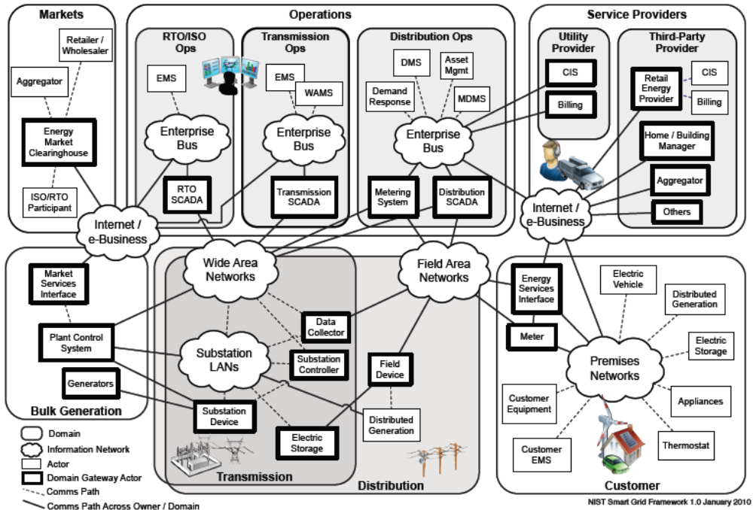
Figure x – Smart Grid Conceptual Reference Diagram

The SG Network TF reference model diagrams are located in the SG-Network TF webpage folder:
http://osgug.ucaiug.org/UtiliComm/Shared%20Documents/Latest_Release_Deliverables/Diagrams
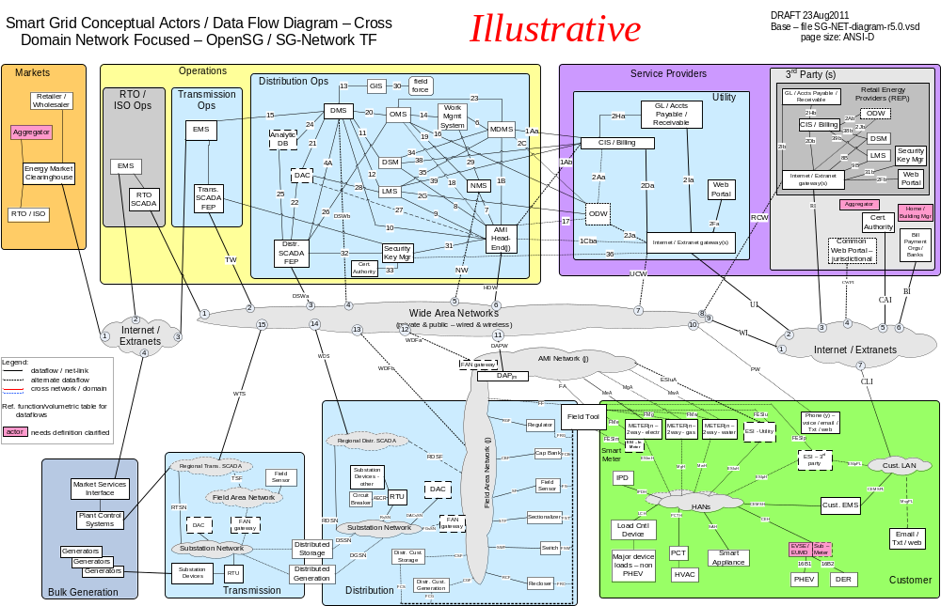
Figure 1 - Baseline Diagram Without Cross Domain & Network

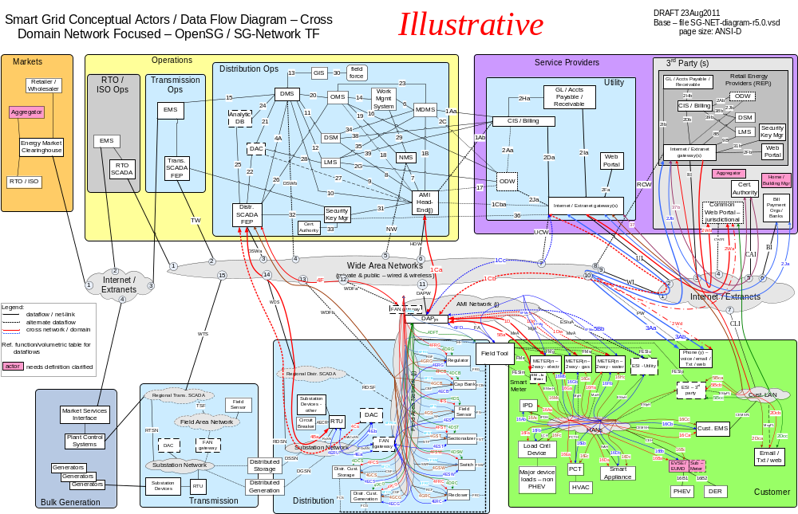
Figure 2 - Baseline Diagram with Cross Domain & Network flows

Alternative Paths
The reference architecture developed by the SG-Network task force was intentionally created to model multiple variations in smart grid implementations, due to the variations from one utility to another utilities’: service territory, architectural and system design principles and topologies. The diagram that follows is an example of illustrating the multiple communication paths an application payload might take. See the Appendix section Alternative / Multiple Communication Paths for more information.

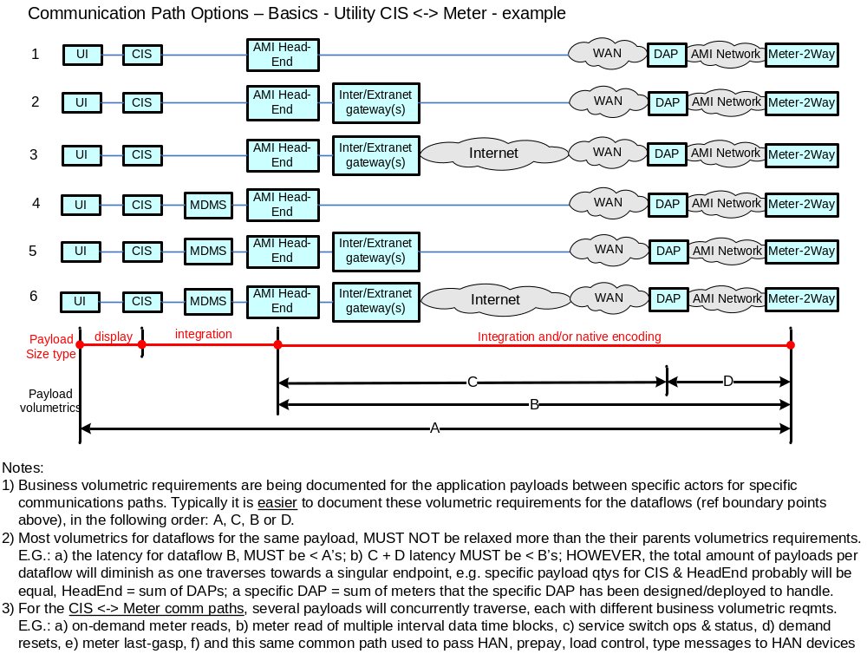
Figure 3 – Utility CIS <-> Meter Communication Path Scenarios

Use Cases and Communications Requirements

Overview and Context

Appendix
Notes from the Authors

Distribution Automation Network Design and Provisioning - (Move to appendix)

Acronyms and Abbreviations

Definitions

Alternative / Multiple Communication Paths

Application Payloads

Method for Adaptation of the Requirements Table Data to Specific Analysis Needs
When examining the detailed records of the Requirements Table and as noted in section 2.2.1.5 there are several decisions and selections the consumer of the Requirements Table must make. This section identifies a method for making most of those decisions and selections, and how to adapt the detailed quantified requirements into a form that can be extracted for input into telecommunication traffic models or assessment tool.

Method:
Step 1 - Determine which use cases (applications) to use.
Step 2 - Select which actor to actor interface is to be investigated:
- which communication path
- which network link(s).
Step 3 - Identify the applications’ events (payloads) that are to be used.
Step 4 - Select one value for metrics where ranges are provided.
Step 5 - Specify (and document) values for missing information.
Step 6 - Select which type of data analysis method is to be used:
- aggregation of data volumetrics based on values per a specified time period for input into a static system model
- simulation of multiple discrete transactions (payloads) retaining each events unique data volumetrics and profiles
Step 7 – Finalize the data preparation tasks based on the selections and assumptions from steps 1-6.

The remainder of this section provides an example of using the steps above on the 5.0 release of the Requirements Table. As the seven steps are exercised, a very limited and focused amount of requirements from the Requirements Table will be selected for analysis.. The user of the Requirements Table and this method needs to perform the steps as driven by the specific objectives and scope of their assessment.

Example use of the method
Step 1 - Determine which use cases (applications) to use
The spreadsheet filter feature can be used on the “Use Case Ref” column to identify and select which uses cases are of interest. For this example exercising the steps above, two applications (Meter Reading and Service Switch) of the available use cases will be used.

Step 2 - Select which actor to actor interface is to be investigated:
- which communication path
Using a combination of “pivot tables or data pilots” and additional queries of the Requirements Table for the two selected applications and reviewing the distinct 2-way communications between the “From” and “To” actors indicates that there are 41 unique actor to actor pairings.

Let us focus on the Data Aggregation Point (DAPjm) from/to Meter-2Way actor to actor pairing.

- which network link
SG Network TF Reference Diagrams (Figure x and Figure y), indicates that there are three network interfaces “MeA”, “MgA”, :MwA” between the DAP and the Meter-2Ways. Note the term Smart Meter includes both the Meter-2Way and the ESI – InMtr components. There are two independent data flows identified between the DAP to the electric Smart Meter: “1D’” which is intended to deal with that traffic terminating with the meter metrology, and “5Ba” which is directed to the ESI module in meters that have ESI modules, plus “1Dg” and “1Dw” for the other two 2Way Meters. Without getting too technology specific, many technologies for communicating with 2Way meters use one network interface module that “MeA” interfaces to. Consequently, both the “1D” and “5Ba” data flows would traverse across the “MeA” interface, as an example.

The vast majority of the communication interfaces included in the Requirements Table are documented as data flows, which are further decomposed to specific network actor to actor across network links, or direct actor to actor interfaces (no network cloud called out, e.g. back office LANs). If the modeling effort is intended to focus on all traffic that passes across a network link (e.g. “MeA”), for a specific smart grid deployment, then all business requirements in the Requirements Table that have data flows that traverse this interface for the specific selection of use cases, payloads, and communication paths (deployment topologies), must be used in selecting the requirements data for analysis.

For this simple example, let us focus on just the Meter Read and Service Switch application payloads that use the Meter–2Way Electric actor metrology to/from the DAP (i.e. “1D”) data flow and not the traffic with the ESI–InMtr component via “5Ba” or the gas “1Dg” or water “1Dw” data flows.

Step 3 – Identify the applications` events (payloads) that are to be used
Using the Requirements Table (v5.0) filter capabilities against the previous 2 application filters and applying the following two column filters:
- “Data Flow Ref” contains “1D”
- “Row Type” equals “P”
- “Data Flow from Actor” does not contain “Gas” and does not contain “Water”
- “Data Flow to Actor” does not contain “Gas” and does not contain “Water”
would include those payloads coming from five actors:
  - CIS/Billing – Utility
  - MDMS
  - IPD if the communications path “1D + 5Bb + 16Ab” or it’s inverse, via ESI–Utility actor is selected
  - Cust. EMS if the communications path “1D + 5Bb + 16Cb” or it’s inverse, via ESI–Utility actor is selected
  - 2Way Meter – Electr (non qualified, “C/I”, “Resdnt”)

The first four actors are sending payloads to the 2Way Meter, and the last one is the 2Way Meter sending payloads to other actors.

Need to review and revise rest of this appendix from this point on.

For this example let us restrict the events to those only coming from the CIS/Billing – Utility actor, which results in five events present in the DAP to 2-Way Meter – Electric metrology direction
- 2 for the meter reading application,
  - multiple interval meter reading request and
  - on-demand meter read requests
- 3 for Service Switch application
  - cancel service switch operate request,
  - service switch operate request, and
  - service switch state request.

After resetting the previous filters and applying the following two column filters:
• “Data Flow Ref” contains “1D”
• “Data Flow to Actor” equals “DAP”
would include those events going to 3 actors:
    - CIS/Billing – Utility
    - IHD if the communications option via ESI –Utility actor “16Ab + 5Bb + 1D” is selected
    - Cust. EMS if the communications option – ESI – Utility actor “16Cb + 5Bb + 1D” is selected .
For this example let us restrict the events to those only going to the CIS/Billing – Utility actor, which results in 8 events present in the 2-Way Meter –Electric metrology to DAP direction
- 4 for meter reading application,
  - multiple interval meter read data
    - Commercial / Industrial Electric meters,
    - Residential electric smart meters.
  - on-demand read request app errors, and
  - on-demand meter read data.
- 4 for Service Switch application
  - send service switch operate acknowledgment,
  - send service switch operate failure,
  - send metrology information after a successful service switch operate, and
  - send service switch state data.

Step 4 – Select one value for metrics where ranges are provided.
Use the information from these events (and perhaps others) to calculate the individual contribution of each event in terms of its frequency (Requirements Table: “How Often” values) and its application payload size. Please note that the Requirements Table “Daily Clock Periods” values directly impacts the frequency calculations when the frequency is taken down from say a daily value to an hourly value for specific time blocks in the day, refer to the hourly columns in Table and Table below. Also if the hour of consideration is shifted to an evening hour, the values may or may not change depending upon the “Daily Clock Periods” for that payload (event).

These metrics have either ranges of values or scalar values. An example of a range of values is the multiple interval meter read data (Commercial / Industrial Electric smart meters) where the frequency is 12 - 24 transactions per day and the size of the data is 200 bytes – 1600 bytes. An example of a scalar value is the send service switch operate failure to DAP where the frequency is 1 trans per 1000 switch operate per day. Since this is an error based on the original number of switch operate commands, we must obtain that event’s frequency information, which is 1 - 50 transactions per 1000 meters per day.

For each of the possible range of values select a value that is meaningful to your particular deployment scenario. The following tables contain example selections of values.

Table 1: Selected values for DAP to Smart meter direction
Event | How often  (events/Mtr/day) | How often (events/Mtr/midday hour) | Size  (bytes)
multiple interval meter reading request | 25 events / 1000 Mtrs / day | Daily value/11 | 25
on-demand meter read requests | 25/1000 | Daily value/15 | 25
cancel service switch operate request | 2/1000 | Daily value/8 | 25
service switch operate request | 50/1000 | Daily value/8 | 25
service switch state request | 50/1000 | Daily value/8 | 25

Table 2: Selected values for Smart meter to DAP direction
Event | How often (events/Mtr/day) | How often (events/Mtr/midday hour) | Size  (bytes)
multiple interval meter read data (Commercial / Industrial Electric meters) | 24 | If randomized then daily value/24, otherwise depends on fixed hourly periods | 1600
multiple interval meter read data (Residential electric smart meters) | 6 | If randomized then daily value/24, otherwise depends on fixed hourly periods | 2400
on-demand read request app errors | 25/1000*1/1000 | Daily value/15 | 50
on-demand meter read data | 25/1000 | Daily value/15 | 100
send service switch operate acknowledgment | 2/1000 | Daily value/8 | 25
send service switch operate failure | 1/1000 * 50/1000 | Daily value/8 | 50
send metrology information after a successful service switch operate | 2/1000 | Daily value/8 | 100
send service switch state data | 50/1000 | Daily value/8 | 100

Step 5 - Assume (and document) values for missing information.
There is still some information not available from the user applications matrix. For example to calculate the aggregate traffic from a single 2_way meter to a DAP, the type of 2-way meter is needed; also the number of 2-way meters that will be sending their data to a single DAP is needed.
- How many 2-Way Meters?
  - What proportion of types (deployment classifications using the same network technology) of smart meters?
    - Commercial / Industrial Gas smart meters,
    - Commercial / Industrial Electric meters,
    - Commercial / Industrial Water meters,
    - Residential gas smart meters,
    - Residential electric smart meters, and
    - Residential water smart meters.

Assume the following proportions of types of 2-way meters using scenario 2 in Table as this example has been filtered to just the electric meters:

Table 3: Example 2-way meter deployment classifications and example apportionments
2-Way Meter Deployment Classifications | Scenario 1 – meter (%) | Scenario 2 – meter (%) | Scenario 3 – meter (%)
Commercial / Industrial Gas smart meters | 6.5 |  | 2.5
Commercial / Industrial Electric meters | 17.4 | 10 | 5.0
Commercial / Industrial Water meters |  |  | 2.5
Residential gas smart meters | 6.5 |  | 20
Residential electric smart meters | 69.6 | 90 | 45
Residential water smart meters |  |  | 25
Total | 100 | 100 | 100

- Quantity of endpoints (meters) per the same technology DAP in a specific deployment geographic area.

AMI Networks have design maximum number of endpoints per DAP that typically range from 1,000 – 50,000. Actual deployment quantity of endpoints per DAP will be less than the technology’s maximums based on:
- the endpoint density
- design limits’ thresholds imposed by the network designers to address application latency requirements and providing “headroom” in the network.

For deployments of 100,000 endpoints, multiple DAPs will be required, with the actual quantity of endpoints (e.g. meters) per DAP varying significantly across that 100,000 deployment. When the assessment is focused on the ability of a technology to handle the deployment, two areas of concern arise (i.e., the high density urban areas and the low endpoint density rural areas). One is focused on the handling of all the traffic and the other is being able to extend the reach between the DAP and the endpoints and still provide acceptable application latency and reliability at acceptable cost points.

For example purposes only, let us assume a 1000 endpoints per DAP assessment.

Step 6 - Select which type of data analysis method is to be used:
There are at least two common approaches to data analysis that deal with events that occur in time displaying deterministic timings and those with probabilistic distributions:
- aggregation of data volumetrics based on values per a specified time period for input into a static system model
- simulation of multiple discrete transactions (payloads) retaining each events unique data volumetrics and profiles
The aggregation of data volumes based on values per specified time periods will be discussed in this step. The simulation approach is further discussed in section Error: Reference source not found.

Aggregation of data volumes based on values per specified time periods, carries with it no indication of when those events occur during the time period. Many readers may make the assumption that the events occur evenly across the time period, but it is just that, an assumption. All that can be stated is that during that time period the events are expected to occur at the stated quantity per total period.

When using the “Daily Clock Periods” a better understanding of the quantity of events occurring in that shorter time period is possible, though as in illustrated in Table and Table above, interpolating that value to an hourly value for a specific hour of the day is possible, but carries the same limits to that usage as mentioned above.

An alternative to just these simple “How Often” values is to consider what those values would be for different operating modes that a smart grid deployment might encounter. This might be represented as three different values to account for: normal; medium; and high periods of event occurrence. For the Meter Reading, Service Switch use cases, this might entail:
- after new rate structures have been imposed
- high energy usage billing periods
- college move ins / move outs or entry or exodus of customers
- storm events

Whether or not SG Network TF adds this additional level of detail to the Requirements Table, the user of the Requirements Table can modify the requirement data themselves to match their analysis needs and assumptions, but it must be documented.

For simplicity, let us disregard the “Daily Clock Periods” and keep the frequency (How Often) based on a 24 hour period, daily values.

Step 7 – Finalize the data preparation tasks based on the selections and assumptions from steps 1-6.

Using the selected values from step 4 and the assumed values from step 5, and assuming that a data analysis method is selected using the aggregation of data volumetrics to simple per period metrics, the aggregate traffic for each direction is calculated in Table and Table below.

Table 4: DAP to Smart Meter direction
Event | How often (events/Mtr/day) | Size (bytes/event) | Avg. Traffic Load (bytes/Mtr/day)
multiple interval meter reading request | 25/1000 | 25 | 0.625
on-demand meter read requests | 25/1000 | 25 | 0.625
cancel service switch operate request | 2/1000 | 25 | 0.05
service switch operate request | 50/1000 | 25 | 1.25
service switch state request | 50/1000 | 25 | 1.25
Total | 0.152 | N/A | 3.8

Mean message size (bytes) per event = 3.8 / 0.152 = 25 bytes/event
Number of events per meter per second = 0.152 / 86400 = 1.76 x 10⁻⁶ events/mtr/s

Table 5: Smart Meter to DAP direction
Event | How often (events/Mtr/day) | proportion | Size (bytes/event) | Avg. Traffic Load (bytes/ Mtr/day)
multiple interval meter read data (Commercial / Industrial Electric meters) | 24 | 0.174 | 1600 | 6681.6
multiple interval meter read data (Residential electric smart meters) | 6 | 0.696 | 2400 | 10022.4
Subtotal | Frequency * proportion = | 8.352 events/ Mtr/day | Frequency * Size * proportion = | 16704 bytes/ Mtr/day
on-demand read request app errors | 25/1000*1/1000 |  | 50 | 0.00125
on-demand meter read data | 25/1000 |  | 100 | 2.5
send service switch operate acknowledgment | 2/1000 |  | 25 | 0.05
send service switch operate failure | 1/1000 * 50/1000 |  | 50 | 0.0025
send metrology information after a successful service switch operate | 2/1000 |  | 100 | 0.2
send service switch state data | 50/1000 |  | 100 | 5
Subtotal | 0.079 |  | N/A | 7.754
Total | 8.43 events/Mtr/day |  | N/A | 16712 bytes/ Mtr/day

Mean message size (bytes) per event = 16712 / 8.43 = 1982 bytes/event
Number of events per meter per second = 8.43 / 86400 = 9.76x 10⁻⁵ events/Mtr/s

http://osgug.ucaiug.org/UtiliComm/Shared%20Documents/Interium_Release_3/
- Smart Grid architectures include the use of AMI technologies which specifies telecommunication capabilities with the meters as being 2-way. Consequently this excludes 1-way meters and meters without any remote communication capabilities. If the user of the Requirements Table wants to include 1-way meters into their analysis, then the requirements specific to those 1-way meters will need to be created by the user specify to their needs.
- There is an inverse relationship between one value of the “How Often” range to that of some of the associated “Payload Size” range values. The intended interpretation of the stated payload size of 1600 is associated with a “How Often” value of 12 which ties with 15 minute interval data and 20 data points per interval. This misinterpretation of the Requirements Table should not take away from the example of using the method and steps. SG Network TF will address how to better document the intended interpretation and use of these range of values in the next release of the Requirements Table.

