Smart Grid Networks System Requirements Specification
Release Candidate 5 revision *
DRAFT
Table of Contents
Document History 6
1 Authors 7
1.1 Acknowledgements 7
2 Overview 8
2.1 Executive Summary 8
2.1.1 Background - Energy Independence and Security Act of 2007 8
2.1.2 Goals and Objective 9
2.1.3 Priority Action Plans 10
2.1.4 Deliverables 10
2.2 Approach 12
2.2.1 SG-Network Requirements Gathering Process 12
2.3 Terms and Definitions 22
3 Illustrative Reference Architecture Overview 22
3.1.1 Alternative Paths 29
4 Use Cases and Communications Requirements 31
4.1 Overview and Context 31
4.2 Demand Response and Consumer Energy Efficiency – Matt 31
4.2.1 Demand Response 31
4.2.2 Direct Load Control 32
4.3 Energy Storage 32
4.3.1 Objectives 32
4.3.2 Actors 32
4.3.3 Latency Requirements 33
4.3.4 Process Flow 33
4.3.5 Included Processes 33
4.4 Electric Transportation 33
4.4.1 PHEV Use Cases (Vincent/Ron/Jerry) 33
4.5 System Security – Vincent / Matt 34
4.5.1 Overview – Cosio 34
4.5.2 CIA 34
4.5.3 Use Cases 34
4.5.4 Security Event (Kelly) 34
4.5.5 Audit Event (Kelly) 35
4.6 Network Communications – 36
4.6.1 Overview 36
4.6.2 Configuration Event (Ron) 36
4.6.3 Fault Error Alarm Event (Kelly) 37
4.7 Meter Reading Use Cases 39
4.7.1 Overview 39
4.7.2 Actors 41
4.7.3 Scenarios 42
Mtr-read_multi-interval-data_resp-data 44
4.8 Outage Notification 45
4.8.1 Overview 45
4.8.2 Actors 45
4.8.3 Scenarios 46
4.9 Electric Service Prepayment 46
4.9.1 Overview 46
4.9.2 Actors 46
4.9.3 Scenarios 47
4.10 Distribution Grid Management 48
4.10.1 Overview of Business Processes 48
4.10.2 Business Process Definitions 48
4.10.3 Actors 67
4.10.4 Automated Feeder / Re-closer Switching 68
4.10.5 Voltage Regulator 71
4.10.6 Capacitor Bank Control 73
4.10.7 Fault Current Indicator 74
4.10.8 Transformer Monitoring 76
4.10.9 Voltage and Current Sensors 77
4.10.10 Network Protection Monitoring 78
4.10.11 Throw Over Switch Monitoring 80
4.10.12 Health Checks 81
4.10.13 Power Quality Event (Kelly) 82
5 Appendix 84
5.1 Distribution Automation Network Design and Provisioning - (Move to appendix) 84
5.2 Acronyms and Abbreviations 87
5.3 Definitions 90
5.4 Alternative / Multiple Communication Paths 94
5.5 Application Payloads 102

List of Tables
Table 1- Pertinent Use Cases 12
Table 2 - Actors 15
Table 3 - Actor Domain Mapping 17
Table 4 - Smart Grid Functional & Volumetric Business Requirements 25
Table 5 - Actors 29
Table 6 - Actors 29
Table 7 - Actors 30
Table 8 - Actors 30
Table 9 - Metering Audit Event Actors 32
Table 10 - Metering Security Event Actors 33
Table 11 - Latency Requirements 33
Table 12 - Metering Configuration Event Actors 34
Table 13 - Latency Requirements 34
Table 14 - Metering Fault Alarm Actors 35
Table 15 - Latency Requirements 35
Table 16 – Outage Notification Actors 43
Table 17 – Outage Notification Actors 44
Table 18 - Distribution Automation Actor Descriptions 65
Table 19 - Actors Automated Feeder Switching 65
Table 20 - Applicable Distribution Applications 66
Table 21 - Latency requirements AFS operation 66
Table 22 - Latency requirements Automated Feeder Switch Telemetry 66
Table 23 - Actors Voltage Regulator Operation 68
Table 24 - Applicable Distribution Applications 69
Table 25 - Latency requirements Voltage Regulator Operation 69
Table 26 - Latency requirements Voltage Regulator Telemetry 69
Table 27 - Actors Capacitor Banks 70
Table 28 - Applicable Distribution Applications 70
Table 29 - Latency requirements Capacitor Bank Operation 71
Table 30 - Actors Fault Current Indicator 72
Table 31 - Applicable Distribution Applications 72
Table 32 - Latency requirements Fault Current Indicator 72
Table 33 - Actors Transformer Monitoring 73
Table 34 - Applicable Distribution Applications 73
Table 35 – Latency requirements Transformer Monitoring 73
Table 36 - Actors Voltage and Current Sensors 74
Table 37 - Applicable Distribution Applications 75
Table 38 -Latency requirements Amp / voltage sensor 75
Table 39 - Actors Network Protector Monitoring 76
Table 40 - Applicable Distribution Applications 76
Table 41 - Latency Requirements Network Protector Monitoring 76
Table 42 - Actors Throw Over Switch Monitoring 77
Table 43 - Applicable Distribution Applications 78
Table 44 - Latency Requirements Throw Over Switch Monitoring 78
Table 45 – Actors Device Health Check 79
Table 46 - Latency Requirements Device Health Check 79
Table 47 - Metering Power Quality Actors 79
Table 48 - Latency Requirements 80
Table 49 - Actors Distribution Logical Network Design 82

List of Figures
Figure 2 Application Payload 16
Figure 3 - Baseline Diagram Without Cross Domain & Network 24
Figure 4 - Baseline Diagram with Cross Domain & Network flows 25
Figure 5 – Utility CIS <-> Meter Communication Path Scenarios 29
Figure 6 - Process Flow 36
Figure 7 - Process Flow 37
Figure 8 - Process Flow 38
Figure 9 - Information flow AFS automated operation 69
Figure 10 - Information flow AFS Manual Switch Operation 70
Figure 11 - Information flow AFS monitoring and diagnostics 70
Figure 12 - Information flow AFS manual DNP configuration change 70
Figure 13 - Information flow manual switch operation and DNP configuration change 71
Figure 14 - Information flow Voltage Regulator operation 72
Figure 15 - Information flow Capacitor Bank Control 74
Figure 16 - Information flow Capacitor Bank Monitoring 74
Figure 17 - Information flow Fault current Indicator 75
Figure 18 - Information flow Transformer Monitor 77
Figure 19 - Information flow Amp / Voltage Sensor 78
Figure 20 - Information flow Network Protector 80
Figure 21 - Information flow Throw Over Switch 81
Figure 22 - Information flow Health check 82
Figure 23 - Process Flow 83
Figure 24 - Process flow Distribution Logical Network Design 84

Document History
Revision History

Revision Number | Revision Date | Revision  By | Summary of Changes | Changes marked
1.01 |  |  | Documented shell created | N
1.02 | 2/16/10 | MKG | Result from 2/16/10 conference call | N
1.03 | 2/16/10 | Armes/MKG | Cleaned up definitions and acronyms | N
1.04 | 2/16/10 | MKG | Added TOC and Draft Preface | N
1.05 | 2/22/10 | MKG | Added Requirements specification info | N
1.06 | 2/22/10 | MKG | Clerical updates to links to work | N
2 | 2/22/10 | MKG | Updated version number for release | N
3 rc1 | 4/17/10 | MKG/RTC | Updated Use case flow charts and diagrams | N
3 rc3 | 4/17/10 | RTC | Added links to documentation instructions | Y
3 rc5 | 4/18/10 | MKG | Added acknowledgements and minor edits. Made images/illustrations portrait versus landscape | N
3rc6 | 6/1/2010 | GC | Harmonized use case document with original RC3 | N
3RCx | 6/7/10 | GC | Updating Use Case descriptions and nomenclature | N

Authors
The following individuals and their companies are members of the OpenSG SG-Network Task Force Core Development Team and contributed substantially to the drafting of the SG-Network System Requirement Specification:

Jerry Armes, Micronet Communications
Vincent Bemmel, Trilliant
Andrew Bordine, Consumers Energy
John Buffington, Itron
George Cosio, Florida Power & Light, Co.
Ron Cunningham, American Electric Power
Paul Duffy, Cisco Systems
Kelly Flowers, Detroit Edison
Matt Gillmore, Consumers Energy
Bill Godwin, Progress Energy
Bill Leslie, Longboard Technologies
Claudio Lima, Sonoma Innovations
Michael Northern, Deloitte Consulting LLP
David Pilon, Detroit Edison
Gary Stuebing, Duke Energy
Don Sturek, Pacific Gas & Electric
David De Yagher – BC Hydro
Cheong Siew – BC Hydro
Ed Eckert - Itron
Klaus Bender - UTC
Kory Fifield – Sensus
Mike Rodgers - Capgemini

Acknowledgements
The content delivered by the SG-Network task force would not be possible without feedback and consensus from the overall industry. Listed below are individuals who have provided substantial feedback and guidance to SG-Network.

David Cypher, NIST
Nada Golmie, NIST
Erich Gunther, Enernex
Pat Kinney, Kinney Consulting
Mark Kleerer, Qualcomm
Bruce Kraemer, Marvell
Wayne Longcore, Consumers Energy
Geoff Mulligan, IPSO Alliance
Robby Simpson, GE Energy
Phil Slack, Florida Power & Light, Co.
David Su, NIST

Overview

Executive Summary

Background - Energy Independence and Security Act of 2007
Under the Energy Independence and Security Act (EISA) of 2007, the National Institute of Standards and Technology (NIST) is assigned “primary responsibility to coordinate development of a framework that includes protocols and model standards for information management to achieve interoperability of Smart Grid devices and systems…” [EISA Title XIII, Section 1305]. There is an urgent need to establish these standards. Deployment of various Smart Grid elements, such as smart meters, is already underway and will be accelerated as a result of Department of Energy (DOE) Investment Grants. Without standards, there is the potential for these investments to become prematurely obsolete or to be implemented without necessary measures to ensure security.

Recognizing the urgency, NIST developed a three-phase plan to accelerate the identification of standards while establishing a robust framework for the longer-term evolution of the standards and establishment of testing and certification procedures.

Goals and Objective
The SG-Network Task force had originally started from a group called AMI-Net within the UCAiug in 2008. With the formation of the SGIP’s Priority Action Plan process, the AMI-Net task force acquired a variety of responsibilities.
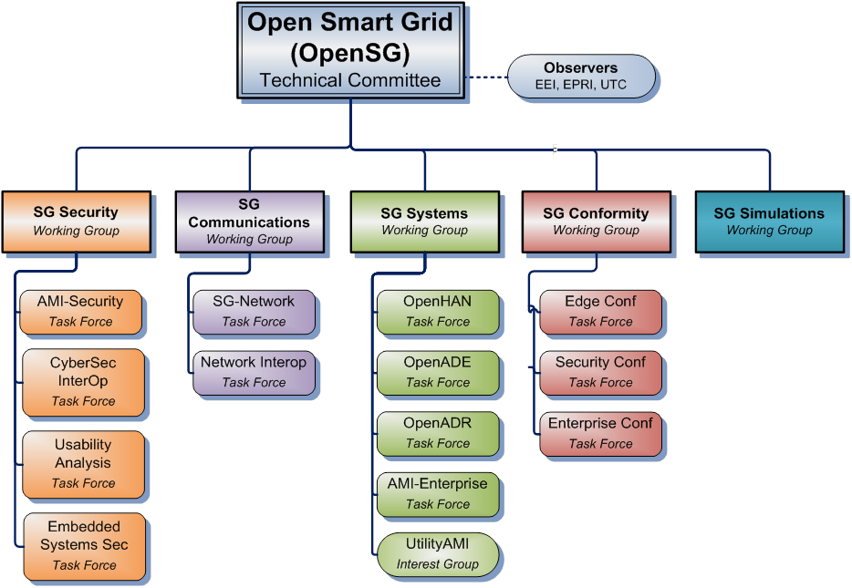
The scope of these responsibilities quickly showed a change was required in the scope and charter of the AMI-Net task force. With these changes, the task force changed their name to SG-Network and has the following charter.

“The SG-Network task force is charged with defining functional system requirements for Management of AMI Communication systems. The goal of this work is to identify common needs of Utilities procuring products in this space. We anticipate utilities, academia, government and vendors to find this topic of interest and participate in this process. This task force anticipates pulling knowledge and experience from other industries with knowledge of operating large scale networks.”

The Scope of SG-Network is as follows:

  - NIST PAP 2 (Wireless standards for the Smart Grid)
    - Supply functional requirements for Smart Grid Networks from a utility perspective
    - Define functional domains within the Smart Grid
  - Create a System Requirements Specification
  - Create a comprehensive set of non functional and functional requirements
  - Create a common reference architecture
  - Provide information to SDO’s (e.g., IEEE P2030, Zigbee Alliance, Wi-Fi, etc)

The SG-Network has endeavored to perform these tasks with the goal of having a common set of requirements, reference architecture, and having an appropriate amount of information to allow the Smart Grid Industry to build, standardize and achieve economies of scale with the products and services that they provide.

Priority Action Plans
PAPs arise from the analysis of the applicability of Standards to the Use Cases of the Smart Grid. PAPs include identified experts in relative SDOs, known as the PAP Working Group Management Team.
Specifically, a PAP addresses either:
A gap where a standard or standard extension is needed:
- The need for meter image-download requirements is an example of a non-existing standard needed to fill an identified gap.
An overlap where two complementary standards address some information that is in common but different for the same scope of an Application:
- An example of this is metering information where CIM, 61850, ANSI C12.19, SEP 1&2 all have non-equivalent methods of representing revenue meter readings.

Deliverables
This document has been created to support NIST Smart Grid Interoperability Priority Action Plans (PAP) 1 & 2 and provide Utilities, Vendors and Standard Development Organizations a system requirements specification for Smart Grid Communication.

For PAP 1 the tasks assigned to UCAiug (SG-Network) are as follows:

Task 1: Develop a set of requirements for different Smart Grid applications

For PAP 2 the tasks assigned to UCAiug (SG Network) are as follows:

Task 1: Segment the smart grid and wireless environments into a minimal set of categories for which individual wireless requirements can be identified.

Task 3: Compile & communicate use cases and develop requirements for all smart grid domains in terms that all parties can understand.

Task 4: Compile and communicate a list of capabilities, performance metrics, etc. in a way that all parties can understand. - Not quantifying any standard, just defining the set of metrics.

To accomplish these assignments, the UCAiug Open Smart Grid (OpenSG) has assigned these tasks to a task force within the SG Communications working group called SG Network to formally work on these tasks.

The following artifacts have been created to address the tasks described above
- System Requirements Specification (this document), including Reference Diagram and use case subsets, and Payload Attributes and Security Characteristics <MKG> add brief narrative </MKG>

- Requirements Table <MKG> add brief narrative </MKG>

- Requirements Database <MKG> add brief narrative </MKG>

Approach

SG-Network Requirements Gathering Process
The SG-Network task force derived functional requirements from the following process:
- Listing of pertinent use cases
- Identification of Actors within use cases
- Identification of pertinent payloads
- Gap analysis by mapping actors to use cases
- Defining Business Functional and Volumetric Requirements
  - Requirement actor to actor
  - Estimated payload
  - Expected latency
  - Expected Reliability
  - Security Requirements
    - Low, Medium, High per NISTIR 7628
  - Implications of failure

- Smart Grid Domain, Actor, Interface reference diagram
  - Illustrative diagram of requirements

Listing of pertinent use cases
In order to create a list of functional requirements for the Smart Grid, an exercise was performed to list all pertinent use cases that involve network communication. Sources for this information include the Southern California Edison Use Cases, Grid Wise Architectural Console use cases, EPRI and others. Use cases from all of these sources were selected based upon a network requirements basis. From this research the following high level use cases have been identified.

Smart Grid Use Case | Requirements included in release 5.0
Customer Info / Messaging | Yes
Dispatch Distributed Customer Storage | Yes
Demand Response | Yes
Direct load control | Yes
Distribution System Demand Response – Centralized Control | Yes
Distribution System Demand Response – De-Centralized Control | No
Fault Clear Isolate – Distribution DAC | Yes
Fault Clear Isolate – Distribution Management System | Yes
Fault Clear Isolate – Regional Distribution DAC | Yes
Field Distribution Automation Maintenance – Centralized Control | Yes
Firmware / Program Update | Yes
Islanded Distribution Customer Storage | Yes
Meter Events | Yes
Meter Reading | Yes
Outage & Restoration Management | Yes
Performance Management | No
PHEV | Yes
Premises Network Administration | Yes
Pre-Pay Metering | Yes
Pricing TOU / RTP/ CPP | Yes
Security Management | No
Service Switch | Yes
Transmission Automation | No
Volt/VAR Management –Centralized | Yes
Table 1- Pertinent Use Cases
The “Requirements Derived” Column of the above table shows that requirements have been produced for the use case. However the requirements will not be submitted for wider audiences until they have been fully vetted. Requirements that are fully vetted have a “Yes” in the “Requirements Fully Vetted” column.

Identification of Actors within Use Cases

After the use cases were identified, members of SG Network reviewed the existing use cases and reference diagrams from the industry and defined the following actors. While doing this exercise the actors were also added to architectural domains as mapped against the SG Network TF Reference Diagram r5.0 and the Related NIST Framework and Roadmap for Interoperability Standards, Release 1.0 January 2010 – Figure 3-2 Conceptual Reference Diagram :

SG Network TF Reference Diagram Descriptor (Actor Actor | [sub Domain]) | SG Network TF Ref Diagram Primary Domain Name | Related NIST Diagram Descriptor (Actor | [sub Domain])
Generators | Bulk Generation | Generators
Market Services Interface | Bulk Generation | Market Services Interface
Plant Control Systems | Bulk Generation | Plant Control Systems
DER | Customer | Electric Storage
Customer EMS | Customer | Customer EMS
DER | Customer | Distributed Generation
Email/Text/Web | Customer | Customer Equipment
ESI (3rd party) | Customer | Energy Services Interface
ESI (Utility) | Customer | Energy Services Interface
ESI (In meter) | Customer | Energy Services Interface
EVSE / EUMD | Customer | Customer Equipment
HVAC | Customer | Customer Equipment
IPD | Customer | Customer Equipment
Load Control Device | Customer | Customer Equipment
PCT | Customer | Thermostat
PHEV | Customer | Electric Vehicle
Phone/Email/Text/Web | Customer | Customer Equipment
Smart Appliance | Customer | Appliances
Smart Meter | Customer | Meter
Sub-Meter | Customer | Customer Equipment
Meter 2Way – Electric | Customer | Meter
Meter 2Way - Gas | Customer | Meter
Meter 2Way – Water | Customer | Meter
DAP | Customer / Distribution
Field Tool | Customer / Distribution
Capacitor Bank | Distribution | Field Device
Circuit Breaker | Distribution | Field Device
Recloser | Distribution | Field Device
Distributed Customer Generation | Distribution | Distribution Generation
Distributed Customer Storage | Distribution | Storage System
Sectionalizer | Distribution | Field Device
Switch | Distribution | Field Device
Regulator | Distribution | Field Device
DAC | Distribution / Transmission | Substation Controller
Distributed Generation | Distribution / Transmission | Distributed Generation
Distributed Storage | Distribution / Transmission | Storage System
FAN Gateway | Distribution / Transmission
Field Sensor | Distribution / Transmission | Field Device
RTU | Distribution / Transmission | Data Collector
Substation Devices | Distribution / Transmission | Substation Device
Energy Market Clearinghouse | Markets | Energy Market Clearinghouse
Retailer/Wholesaler | Markets | Aggregator/Retail Energy Provider
RTO/ISO | Markets | RTO/ISO
Aggregator | Markets / Service Providers | Aggregator
 | Operations | Asset Mgmt
 | Operations | WAMS
AMI Head-End | Operations | Metering System
Analytic Database | Operations
Distribution SCADA FEP | Operations | Distribution SCADA
DMS | Operations | DMS
EMS [RTO/ISO Ops] | Operations | EMS [RTO/ISO Ops]
EMS [Transmission Ops] | Operations | EMS [Transmission Ops]
GIS | Operations
GL / Accounts Payable / Receivable | Operations
MDMS | Operations | MDMS
NMS | Operations
OMS | Operations
RTO SCADA | Operations | RTO SCADA
Transmission SCADA FEP | Operations | Transmission SCADA
Work Management System | Operations
Certificate Authority | Operations / Service Provider
DSM [Distribution Ops / REP] | Operations / Service Provider | Demand Response
LMS [Distribition Ops / REP] | Operations / Service Provider
Security Key Manager [Distribution Ops / REP] | Operations / Service Provider
Bill Payment Orgs/Banks | Service Provider | Other
CIS/Billing [REP] | Service Provider | Billing [Retail Energy Provider]
CIS/Billing [REP] | Service Provider | CIS [Retail Energy Provider]
CIS/Billing [Utility] | Service Provider | CIS [Utility]
CIS/Billing [Utility] | Service Provider | Billing [Utility]
Common Web Portal-Jurisdictional | Service Provider | Other
Home/Building Manager | Service Provider | Home/Building Manager
Internet/Extranet Gateway [REP] | Service Provider
ODW [REP] | Service Provider
Web Portal [REP] | Service Provider
Web Portal [Utility] | Service Provider

Table 2 - Actors

Identification of pertinent application payloads
While creating requirements the SG-Network team also documented the payloads’ general characteristics as the analysis was performed. For each payload the following data was identified: payload name and type; general description, primary attributes, mapping to NISTIR 7628 v1.0 Logical Interface Categories (LICs); and security confidentiality, integrity, availability (CIA) risk values along with rationale for those CIA values from an operational and business perspective. For more information see the Application Payloads section in the Appendix 5.5. The figure that follows is illustrates the contents of that appendix.
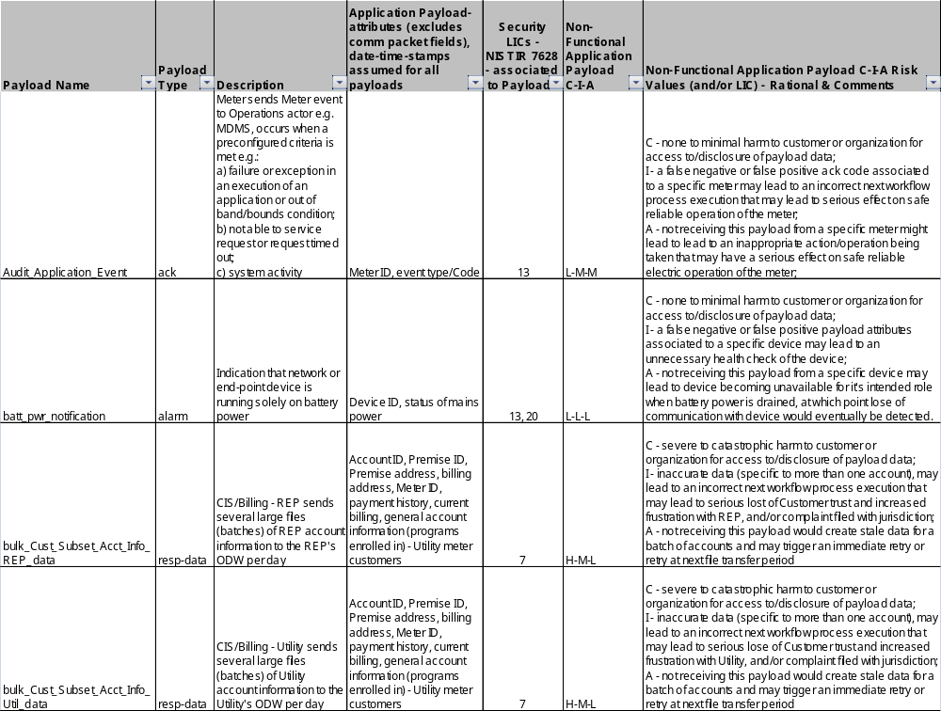
Figure 1 Application Payload

Defining Business Functional and non-Functional (Volumetric) Requirements
There are many smart grid user applications (use cases) collections of documentation. Many have text describing the user applications (see IKB), but few contain quantitative business functional and volumetric requirements, which are necessary to design communications protocols, to assess, or to plan communication networks. Documenting the detailed actor to actor payloads and volumetric requirements allows for:
- aggregation of the details to various levels (e.g., specific interface or network link, a specific network or actor and have the supporting details versus making assumptions about those details) and
- allows the consumer of the Requirements Table to scope and customize the smart grid deployment specific to their needs (e.g., which set of use cases, payloads, actors, communication path deployments).

OpenSG_SG Communications_SG Network TF took on the task to document the Smart Grid business functional and volumetric requirements for input into the NIST PAP 2 tasks and to help fill this requirements documentation void. The current SG-Network business functional and volumetric requirements are located at
- http://osgug.ucaiug.org/UtiliComm/Shared%20Documents/Latest_Release_Deliverables/
with a file name syntax of “SG Network System Requirements Specification vN.R.xls”, where N represents the version number and R represents the revision number. This spreadsheet is referred to below as the Requirements Table.

Instructions for how to document the business functional and volumetric requirements was prepared for the requirement authors, but also can be used by the consumer of the Requirements Table to better understand what is and is not included, and how to interpret the requirement data. The requirements documentation instructions are located at:
- http://osgug.ucaiug.org/UtiliComm/Shared%20Documents/Latest_Release_Deliverables/
with a file name syntax of “rqmts-documentation-instructions-rN.R.doc”, where N represents the version number and R represents the revision number.

The Requirements Table consists of several major sets of information for each use case: For example:
- Business functional requirement statements are documented as individual information flows (e.g., specific application payload requirement sets). This is comparable to what many use case tools capture as information flows and/or illustrated in sequence diagram flows.
- To the baseline business requirements are added the:
  - volumetric attributes (the when, how often, with what availability, latency, application payload size). Take note that the SG Network TF Requirements Table definition for some terms (e.g. latency) is different than the classic “network link latency” usage. Please refer to the SG Network TF Requirements Documentation Instructions or section Requirements Table Column Descriptions for the detailed definitions for clarification.
  - further payload details e.g. description, attributes, NISTIR 7628 security Logical Interface Category mapping, an assignment of the security confidentiality, integrity, and availability low-medium-high risk values, and business impacts of the payload being compromised as assessed against the security confidentiality, integrity, availability values for that application payload.
- Payload requirement sets are grouped by rows in the table that contains all the detailed actor to actor passing of the same application payloads in a sequence that follows the main data flow from that payload’s originating actor to primary consuming actor(s) across possible multiple communication paths that a deployment might use. The payload requirements’ sets will always contain a parent (main) actor to actor row and most will contain child (detailed) rows for that requirement set.
- Payload communication path (information or data flow) alternatives that a given smart grid deployment might use.

The process of requirements gathering and documentation has been evolutionary in nature as various combinations of additional attributes are documented; use cases added; payload requirement sets added; and alternative communication paths documented. The SG Network TF has defined ~7875 (as of release 5.0) functional and volumetric detailed requirements rows in the Requirements Table representing 204 different payloads for 19 use cases.

SG Network TF intends to continue this incremental version release approach to manage the scope and focus on documenting the requirements for specific use cases and payloads, yet giving consumers of this information something to work with and provide feedback for consideration in the next incremental releases. We expect that the number of requirements rows in the Requirements Table will increase over time.

For background information, the following link is provided for more information on how requirements are derived:
http://osgug.ucaiug.org/UtiliComm/Shared%20Documents/Latest_Release_Deliverables/rqmts-documentation-instructions-r1.3.pdf

To effectively use the business functional and volumetric requirements, the consumer of the Requirements Table must:
- select which use cases and payloads are to be included
- select which communication path scenario (alternative) is to be used for each of the main information/data flows from originating actor to target consuming actor
- specify the size (quantity and type of devices) of the smart grid deployment
- perform other tweaks to the payload volumetrics to match that smart grid deployment’s needs e.g. specifying variables not specifically quantified or ranges are provided

The current Requirements Table as a spreadsheet is not very conducive to performing these tasks. SG-Network TF is building a database that is synchronized with the latest release of the Requirements Table (spread sheet). SG Network TF will be adding capabilities to the database to:
- solicit answers to the questions summarized above;
- query the database; and
- format and aggregate the query results for either reporting or exporting for use by other tools.

The current SG-Network TF Requirements Database and related use documentation are located at
- http://osgug.ucaiug.org/UtiliComm/Shared%20Documents/Latest_Release_Deliverables/ Rqmts_Database/

Requirements Table Column Descriptions
The Requirements Table spreadsheet contains several worksheets, two of which contain the bulk of the documented requirements: “Reqmts-Combined”; “Payload_attrib_LIC-CIA-rtnl”. The columns of data for each of these two worksheets are described as follows.

Reqmts-Combined Worsksheet (tab)
- Rqmt Ref – is a reference to the original worksheet line number the requirement originally defined

- Row Type – indicates whether the requirement row is the parent row for the specific payload or a child requirement row of that specific payload requirement set

- Data-Flow Ref – is a reference to the architectural reference models lines (data flows or interfaces) between actors shown illustratively in this document and attached to this work as a separate file

- Data Flow From Actor – indicates the actor that is considered the sender of information noted in the Requirements Column

- Data Flow to Actor – indicates the actor that is considered the desired recipient of the information noted in the Requirements Column

- Requirements – is the actual application requirement. Words like “shall” in this column are to be considered required, while words like “may” should be considered optional

- Payload Name – explains the scenario type of the requirement derived from the use case. (e.g. Bulk, On Demand for meter reading)

- Payload Type – indicates the category of the application payload

- Daily Clock Periods of Primary Occurrence – one or multiple periods of the day that the majority of the specific payload occurs

- How Often - describes the quantity and frequency of the specific application payload as it moves between the stated actors across the interface (data flow) that this requirement row addresses

- Reliability - the probability that an operation will complete without failure over a specific period or amount of time.

- Latency - Summation of actor (including network nodes) processing time and network transport time measured from an actor sending or forwarding a payload to an actor, and that actor processing (or consuming) the payload.

- App Payload Size – is an estimation of how many bytes are needed for the requirement as actual application payload exclusive of any added security, or network, or protocol overheads.

Payload_attrib_LIC_CIA_rtnl Worsheet (tab)
- Payload Name – this syncs with the Payload Name in the Reqmts-Combined worksheet

- Payload Type – this syncs with the Payload Type in the Reqmts-Combined worksheet

- Payload Description - explanation of what is the application payload use and intent

- Payload Attributes - the data elements that are included in the application payload. This excludes any additional security and/or telecommunication protocol(s) added data elements around the application payload.

- Security LICs - NISTIR 7628 – Logical Interface Category (LIC) derived and mapped (as closely as possible to typically no more than 2-3 LICs) from the NISTIR 7628 document volume 1, section 2.3 “Table 2.2 Logical Interfaces by Category” and remaining sections 2.3.x to the application payload

- Payload C-I-A Risk Values– Confidentiality, Integrity, Availability security risk levels as described in NISTIR 7628 document volume 1, section 3.2 “Table 3-1 Impact Levels Definitions” and assigned based on the application payload’s description, attributes, C-I-A rationale excluding other security or telecomm network protocol(s) overhead data elements

- Security C-I-A Risk Values Rationale– documents the business impacts of the payload being compromised as assessed against the security confidentiality, integrity, availability areas

Terms and Definitions
The use of a common vocabulary has been of critical important in the development of this and other Smart Grid related work products. All pertinent terms and definitions utilized in this document are listed in the appendix section of this document.

Illustrative Reference Architecture Overview
In these section a few illustrative diagrams are included to help the reader of this document to understand the content. These files are also available for reference at the following locations:

The reference model diagrams locations are in the SG-Network TF webpage folder:
http://osgug.ucaiug.org/UtiliComm/Shared%20Documents/Latest_Release_Deliverables/Diagrams

The SG-Network functional requirements table location is:
http://osgug.ucaiug.org/UtiliComm/Shared%20Documents/Latest_Release_Deliverables
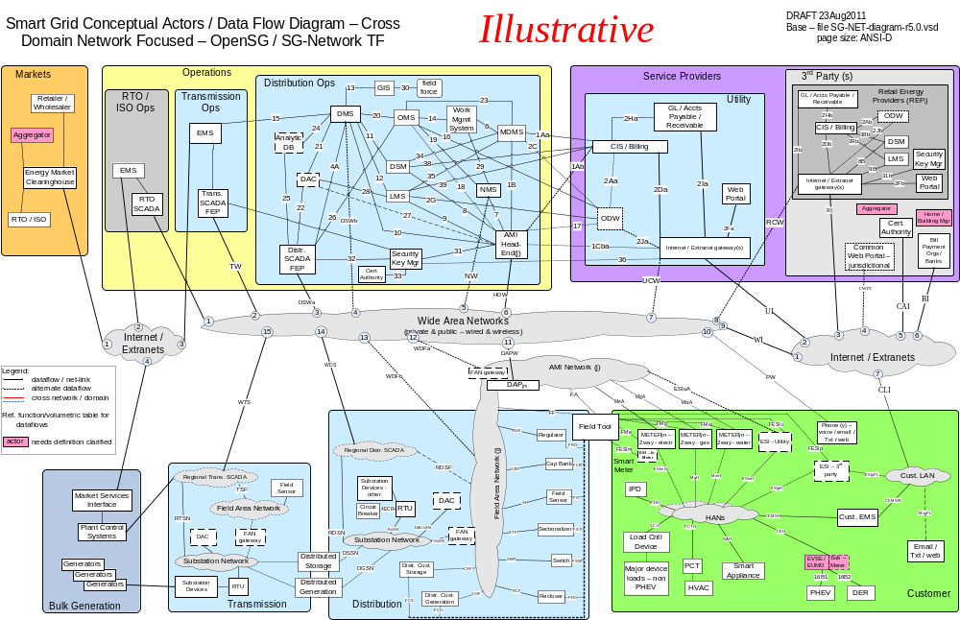

Figure 2 - Baseline Diagram Without Cross Domain & Network

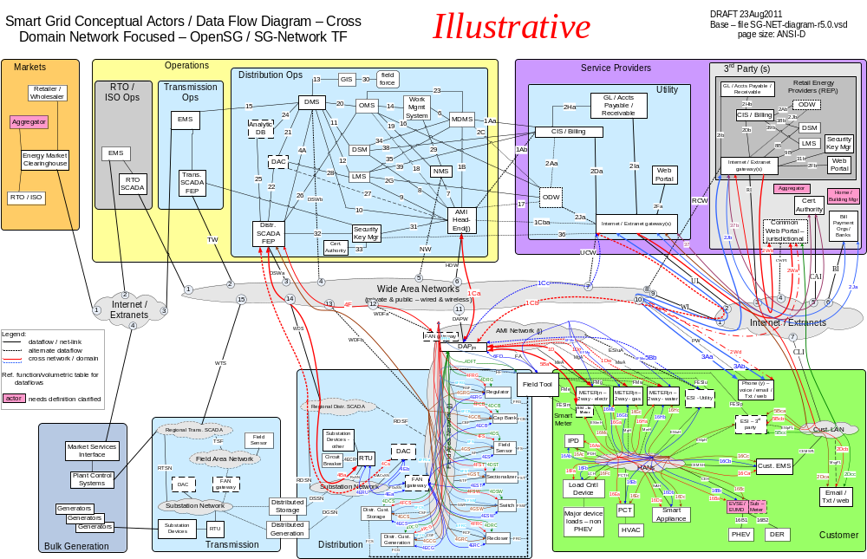
Figure 3 - Baseline Diagram with Cross Domain & Network flows

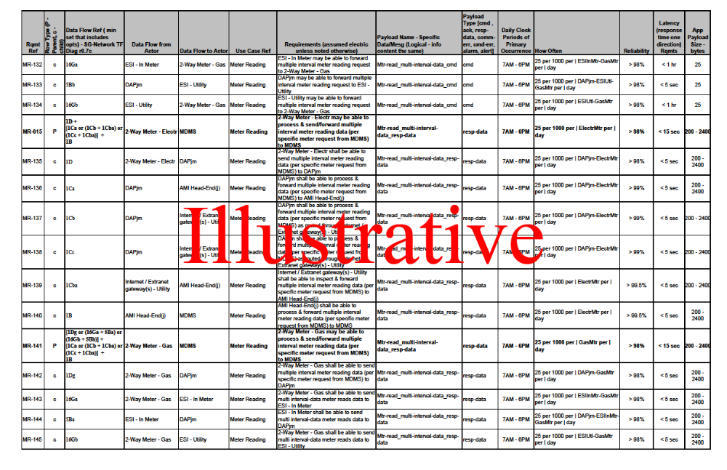
Table 3 - Smart Grid Functional & Volumetric Business Requirements

Alternative Paths
The reference architecture developed by the SG-Network task force was intentionally created to model multiple variations of implementations. Due to the variations in utility service territory, architectural principles and topologies, multiple paths of communication will be used. The diagram in figure 10 is an example of multiple paths communications will take. See the Appendix section Alternatives Paths for more information.

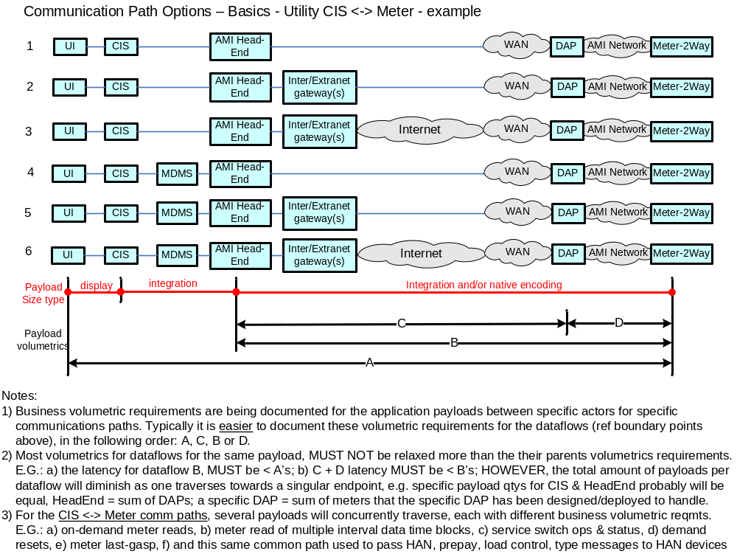
Figure 4 – Utility CIS <-> Meter Communication Path Scenarios

Use Cases and Communications Requirements

Overview and Context
The use cases listed in this section are intended to provide a summarization of the various use cases reviewed and analyzed by the SG Network WG. The corresponding use case requirements listed in this document represent the most conservative requirements gathered from the utilities that participated in the SG Network WG and illustrated as reference for the worst case scenario. In actual practice readers should establish requirements that best address the objectives of their company’s specific business case and operational requirements.
For purposes of organization, the use cases are represented in the context of the eight priority areas outlined by NIST in the “NIST Framework and Roadmap for Smart Grid Interoperability Standards, Release 1.0”. The authors have chosen to organize the use case summaries in a manner as to provide traceability between the NIST priority areas and the contents of this document.
Wherever possible the use cases have been summarized in order to provide a concise account of the process, actors and requirements. Additional information relating to the use cases is available at the SG Network Share point.

Customer Information & Messaging

Overview
In order to provide a customer access to their account information, information needs to be sent to the appropriate operational data warehouse and web portal. This information may be served from a utility, third party Retail Energy Producer (REP) or a political jurisdiction.

Reference Architecture with Domains, Actors and Interfaces
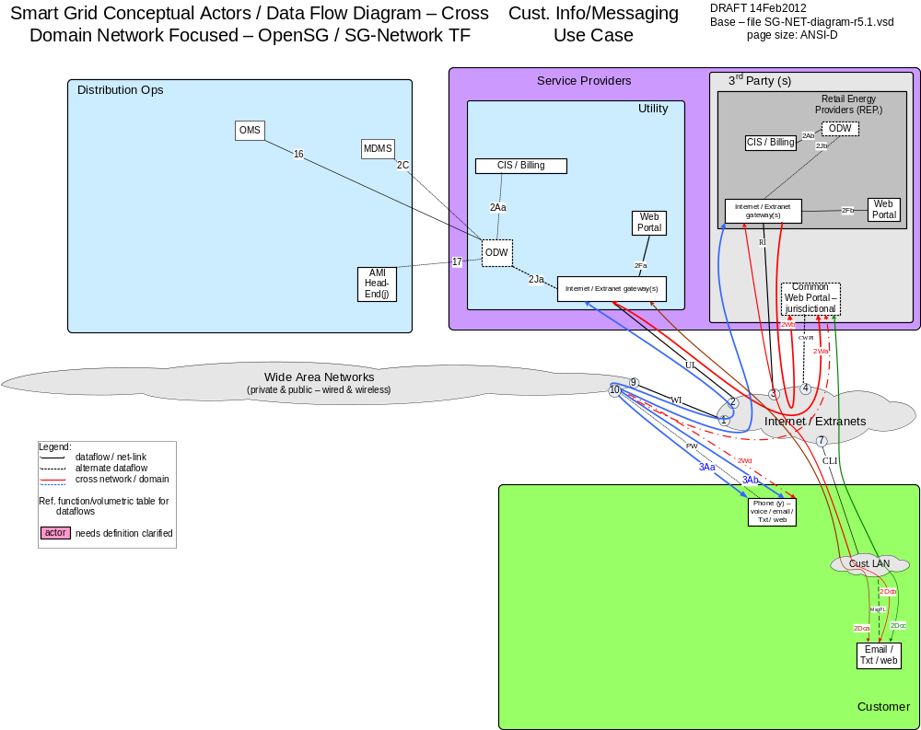

Possible communication paths
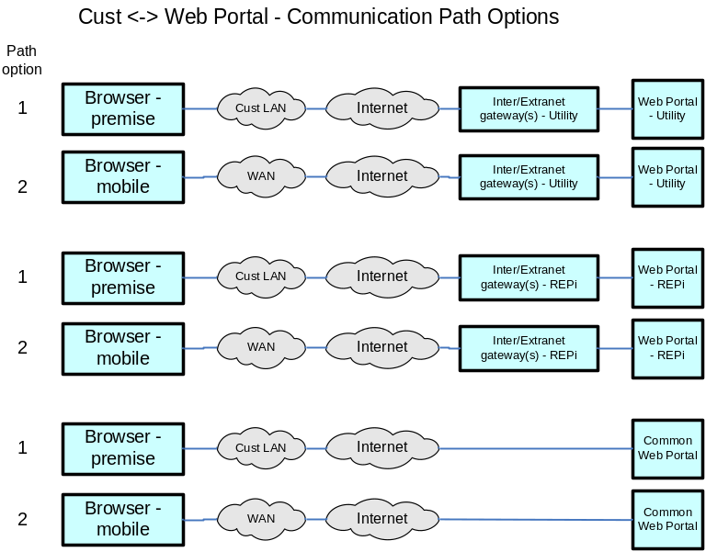

Actors
Common Web Portal | Web interface for Regional Transmission Operator, customers, retail electric providers and transmission/distribution service provider to function as a clearing house for energy information.
Cust. Browser - Mobile | A mobile device World Wide Web compliant internet browser (e.g. Internet Explorer, Google Chrome, Safari, Mozila Firefox) used by a customer.
Cust. Browser - Premise | A World Wide Web compliant internet browser (e.g. Internet Explorer, Google Chrome, Safari, Mozila Firefox) used within a customers premises.
Internet / Extranet gateway(s) - REPi | These are gateways used to connect internal utility networks with external networks.
Internet / Extranet gateway(s) - Utility | These are gateways used to connect internal utility networks with external networks.
ODW - REPi | Operational Data Warehouse
ODW - Utility | Operational Data Warehouse
Web Portal – REPi | Web interface for Regional Transmission Operator, customers, retail electric providers and transmission/distribution service provider to function as a clearing house for energy information. Commonly used in deregulated markets.
Web Portal – Utility | Web interface for Regional Transmission Operator, customers, retail electric providers and transmission/distribution service provider to function as a clearing house for energy information. Commonly used in deregulated markets.

Scenarios

Scenario: Utility shall be able to process, extract, send bulk Customers subset of Account information to ODW - Utility

Narrative
Utility periodically sends in bulk transactions Customer Account Information to the Operation Data Warehouse. This transaction contains information from the Utilities Head End, MDMS, OMS and CIS.

Business Objectives

Originating Actor | Desination Actor | Latency | Reliability | Payload Size | Payload Name
CIS/Billing – Utility | ODW - Utility | < 1 hr | > 99.5% | xMB | bulk_Cust_Subset_Acct_Info_Util_data
OMS | ODW - Utility | < 1 hr | > 99.5% | xMB | bulk_Cust_Subset_meter_outage_Info_Util_data
MDMS | ODW - Utility | < 1 hr | > 99.5% | xMB | bulk_Cust_Subset_meter_Info_Util_data
AMI Head-End(j) | ODW - Utility | < 1 hr | > 99.5% | xMB | bulk_Cust_Subset_meter_comm_Info_Util_data
CIS/Billing - REPi | ODW - REPi | < 1 hr | > 99.5% | xMB | bulk_Cust_Subset_Acct_Info_REP_data
Totals |  | N/A | N/A | N/A

Implications and Rationale
Functional Domain | Expected Potential Impact | Rationale
Bulk Generation
Customer
Distribution
Markets
Operation | X
Service Providers | X
Transmission

Scenario: Customer request account information from Utility or REP

Narrative
The customer logs onto a jurisdictional, utility or REP (retail energy provider) web portal and requests information about their account from a personal computer or a mobile device.

Business Objectives
Personal computer used to access the jurisdictional common web portal.
Originating Actor | Desination Actor | Latency | Reliability | Payload Size | Payload Name
Cust. Browser - Premise | Common Web Portal | < 15 sec | > 99% | 50 | Cust_Acct_Info_cmd
Common Web Portal | Cust. Browser - Premise | < 15 sec | > 99% | 200 | Cust_Acct_Info_resp-data
Totals |  | < 30 sec | >98% | 250
Mobile Device used to access the jurisdictional common web portal
Originating Actor | Desination Actor | Latency | Reliability | Payload Size | Payload Name
Cust. Browser - Mobile | Common Web Portal | < 15 sec | > 99% | 50 | Cust_Acct_Info_cmd
Common Web Portal | Cust. Browser - Mobile | < 15 sec | > 99% | 200 | Cust_Acct_Info_resp-data
Totals |  | < 30 sec | >98% | 250

Personal computer used to access the utility portal.
Originating Actor | Desination Actor | Latency | Reliability | Payload Size | Payload Name
Cust. Browser - Premise | Web Portal - Utility | < 15 sec | > 99% | 50 | Cust_Acct_Info_cmd
Web Portal - Utility | Cust. Browser - Premise | < 15 sec | > 99% | 200 | Cust_Acct_Info_resp-data
Totals |  | < 30 sec | >98% | 250
Mobile Device used to access the utility portal
Originating Actor | Desination Actor | Latency | Reliability | Payload Size | Payload Name
Cust. Browser - Mobile | Web Portal - Utility | < 15 sec | > 99% | 50 | Cust_Acct_Info_cmd
Web Portal - Utility | Cust. Browser - Mobile | < 15 sec | > 99% | 200 | Cust_Acct_Info_resp-data
Totals |  | < 30 sec | >98% | 250

Personal computer used to access the REP portal.
Originating Actor | Desination Actor | Latency | Reliability | Payload Size | Payload Name
Cust. Browser - Premise | Web Portal - REPi | < 15 sec | > 99% | 50 | Cust_Acct_Info_cmd
Web Portal - REPi | Cust. Browser - Premise | < 15 sec | > 99% | 200 | Cust_Acct_Info_resp-data
Totals |  | < 30 sec | >98% | 250
Mobile Device used to access the REP portal
Originating Actor | Desination Actor | Latency | Reliability | Payload Size | Payload Name
Cust. Browser - Premise | Web Portal - REPi | < 15 sec | > 99% | 50 | Cust_Acct_Info_cmd
Web Portal - REPi | Cust. Browser - Premise | < 15 sec | > 99% | 200 | Cust_Acct_Info_resp-data
Totals |  | < 30 sec | >98% | 250

Implications and Rationale
Functional Domain | Expected Potential Impact | Rationale
Bulk Generation
Customer | X
Distribution
Markets
Operation
Service Providers | X
Transmission

Scenario: Operational Data Warehouse sends appropriate customer information to the web portal.

Narrative
The ODW needs to keep jurisdictional, utility and REP web portals up to date with the most recent customer information. This information may contain customer usage, outages, etc.
Business Objectives

Originating Actor | Desination Actor | Latency | Reliability | Payload Size | Payload Name
ODW - Utility | Web Portal - Utility | < 1 hr | > 99.5% | xMB | bulk_Cust_Subset_Acct_Premise_Info_Util_data
ODW - Utility | Common Web Portal | < 1 hr | > 99.5% | xMB | bulk_Cust_Subset_Acct_Premise_Info_Util_data
ODW - REPi | Web Portal - REPi | < 1 hr | > 99.5% | xMB | bulk_Cust_Subset_Acct_Premise_Info_REP_data
ODW - REPi | Common Web Portal | < 1 hr | > 99.5% | xMB | bulk_Cust_Subset_Acct_Premise_Info_REP_data
Totals |  | N/A | N/A | N/A

Implications and Rationale
Functional Domain | Expected Potential Impact | Rationale
Bulk Generation
Customer
Distribution
Markets
Operation | X
Service Providers | X
Transmission

Dispatched Distributed Customer Storage

Overview
circuit-brk_device_status_cmd
circuit-brk_status_resp-data
distr_cust_storage_charge-rate_cmd
distr_cust_storage_charge-rate_cmd_ack
distr_cust_storage_discharge_cmd
distr_cust_storage_discharge_cmd_ack

Reference Architecture with Domains, Actors and Interfaces
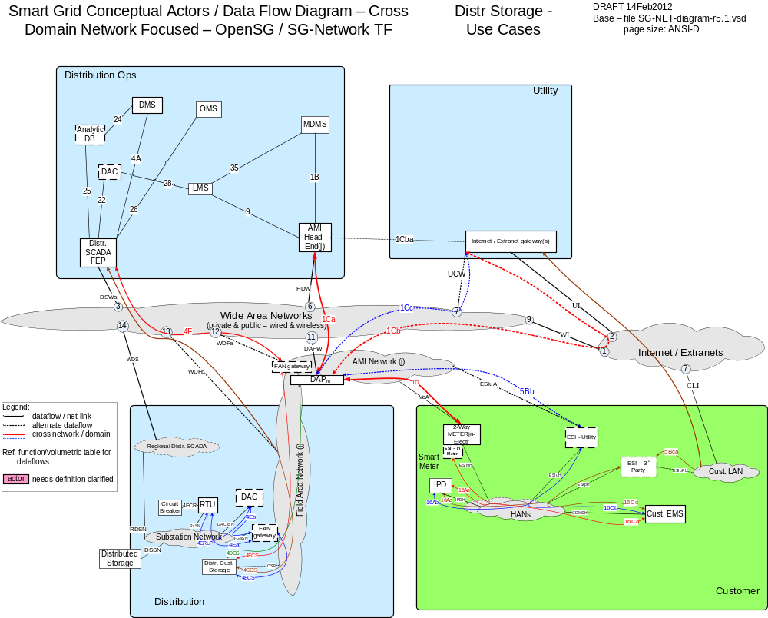

Possible communication paths
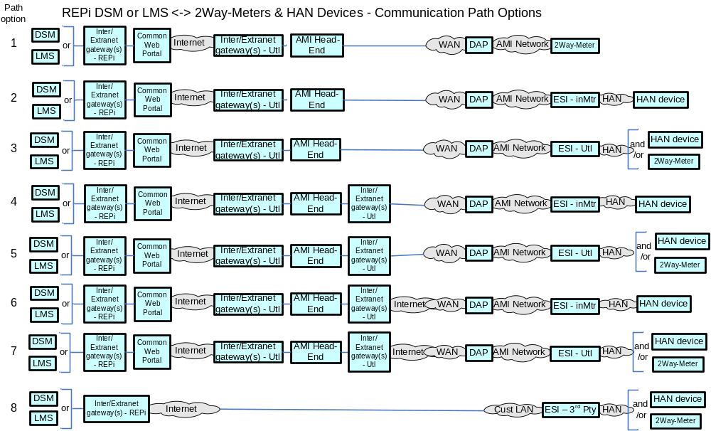

Actors
DAC - Ops/Regnl | Distribution Application Control system hosted in either the Utilities Operations or Regional Data Centers to run a specific Distrbution application
DAC – sub | Distribution Application Control system hosted in a Distribution Substation to run a specific Distrbution application
Distr. Cust. Storage | Distributed Customer Storage is a storage device sized to meet typical distribution substation circuit loads and is typically located at or near a distribution substation or in smaller capacities out in customer/premise neighborhoods
Distr. SCADA FEP | Distribution Supervisory Control and Data Acquisition Front End Processor
DMS | Distribution Management System - A system that monitors, manages and controls the electric distribution system.
FAN gateway - sub | Field Area Network gateway device located in the substation, that provides the interface between the Feeder Line device communication modules and the Substation network connection.
Feeder Circuit Breaker | A device used in the substation that is used per a specific configuration to protect distribution equipment.
RTU | Remote Terminal Unit - Aggregator of multiple serialized devices to a common communications interface

Scenarios

Scenario: X

Narrative

Business Objectives

Originating Actor | Desination Actor | Latency | Reliability | Payload Size | Payload Name
Totals

Implications and Rationale
Functional Domain | Expected Potential Impact | Rationale
Bulk Generation
Customer
Distribution
Markets
Operation
Service Providers
Transmission

Demand Response

Overview
The Demand Response and Load Control use cases described in this body of work include the following scenarios. For each scenario the primary command, response and failure payloads are described.

- Load Management Requests
- Load Management Requests Acknowledgements
- Load Management Request Opt Outs
- Voluntary Load Management Requests
- Voluntary Load Management Requests Acknowledgements

Reference Architecture with Domains, Actors, and Interfaces
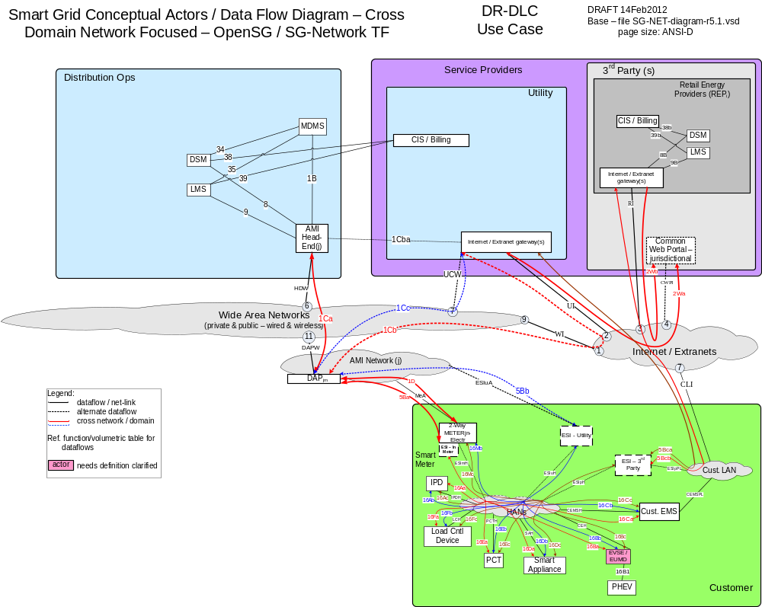

Possible Communications Paths

Actors
2-Way Meter – Electr | A bi-directional communication device used to perform measurement of electrical energy usage for residential use.
AMI Head-End(j) | The AMI head end is responsible for the operation and coordination of AMI system components. It represents the central nervous system of the AMI system.
Common Web Portal | Web interface for Regional Transmission Operator, customers, retail electric providers and transmission/distribution service provider to function as a clearing house for energy information.
Cust. EMS | A customer owned energy management system used to manage energy with a premises.
DAPjm | This is the Data Aggregation Point on the NAN. It is essentially the point of convergence for all communication between SG devices and utility back office systems. In this specific use case it provides a communication conduit for AMI Smart Meters.The su
DSM – REPi | Demand Side Management - Retail Energy Provider; A system that co-ordinates demand response / load shedding messages indirectly to devices (e.g. Set point adjustment)
DSM – Utility | Demand Side Management - Utility; A system that co-ordinates demand response / load shedding messages indirectly to devices (e.g. Set point adjustment)
ESI - 3rd Party | An ESI, owned by the Customer and not provided by the Utility, which enables secure interactions between HAN Devices Registered on its network and the service provider e.g. REP. The 3rd Party ESI functionality may reside in the Customer EMS or customer's
ESI - In Meter | An ESI, owned by the Utility and resides in the Utility meter, which enables secure interactions between HAN Devices Registered on its network and the Utility AMI.
ESI – Utility | An ESI, owned by the Utility, which enables secure interactions between HAN Devices Registered on its network and the Utility AMI. The Utility ESI functionality may reside in the Customer EMS or customer broadband router.
EVSE / EUMD | Electric Vehicle Supply Equipment / End Use Metering Device
Internet / Extranet gateway(s) - REPi | These are gateways used to connect internal utility networks with external networks.
Internet / Extranet gateway(s) - Utility | These are gateways used to connect internal utility networks with external networks.
IPD | In Premise Display
LMS – REPi | Load management system
LMS – Utility | Load management system - System that controls load by sending messages directly to device (e.g. On/Off)
Load Cntl Device | A device used within the customer domain for load management (e.g. Air conditioning, etc)
PCT | A device within the premise that has communication capabilities and controls heating, ventilation and cooling systems.
PHEV | Plug-in Hybrid Electric Vehicles - Cars or other vehicles that draw electricity from batteries to power an electric motor for vehicle propulsion. PHEVs also contain an internal combustion engine.
Smart Appliance | A white good or household appliance, that has HAN communication capability and is capable of receiving signals from authorized parties (e.g. Utility, Service Provider, EMS, Consumer, etc.) and of adjusting its operational mode based on Consumer preference

Scenarios

Scenario: Load Shed Request

Narrative

In this scenario, the event originates at the Load Management System or Demand Side Management system where it is transferred to the AMI head-end for transmission to the ESI. This message may be unicast, multicast or broadcast depending upon the given capabilities of a specific system and the needed load reduction.

Transmission to the ESI can occur through the DAP via the AMI network, or alternatively, through the Internet/Extranet gateway via the Internet/Extranets.
From the ESI, the message is forwarded to the appropriate HAN device (IHD, PCT, Appliance, PHEV, etc). The HAN device will acknowledge the receipt of the information and initiate the appropriate action, e.g., adjust its load based on the current price tier.

The acknowledgement typically follows the reverse path to the LMS or DSM, i.e. via the AMI network through the DAP to the AMI Headend, or alternatively, via the Internet/Extranets through the Internet/Extranet gateway DAP to the AMI Headend, from where the message is then forwarded to LMS or DSM. Some utilities require acknowledgement of receipt of the load management request. Acknowledgement may come from the device automatically or from a user interface.

Business Objectives

Originating Actor | Desination Actor | Latency | Reliability | Payload Size | Payload Name
LMS - Utility or DSM -Utility  Or  LMS – REPi  or DSM - REPi | 2-Way Meter - Electr, IPD, Cust. EMS, PCT, PHEV, Smart Appliance, Load Cntl Device | < 1 minute | >98% | 100 bytes | Load_mgm_reqst  Load_mgm_reqst_mltcst  Load_mgm_reqst_brdcst
2-Way Meter - Electr, IPD, Cust. EMS, PCT, PHEV, Smart Appliance, Load Cntl Device | LMS - Utility or DSM -Utility  Or  LMS – REPi  or DSM - REPi | < 4 hr (expected window of data delivery) | 90% success every 4-6 hr,  98% success over 1 day,  > 99.5% over 2 day | 25 bytes | Load_mgm_req_ack
Totals |  | N/A | N/A

Implications and Rationale
Functional Domain | Expected Potential Impact | Rationale
Bulk Generation
Customer | X | Cannot participate in load control programs
Distribution
Markets
Operation | X | Systems will have to retry communications, Cannot shed desired load
Service Providers
Transmission

Scenario: Voluntary Load Shed Event Notification

Narrative
Voluntary Load Shed Requests are used to communicate voluntary energy management requests to the end use consumer devices to manage load on the distribution network.
In this scenario, the request originates at the Load Management System or Demand Side Management system where it is transferred to the AMI head-end for transmission to the ESI.
Transmission from the AMI head-end to the ESI can occur in several ways:
- Via the WAN, through the DAP, via the AMI network
- through the Internet/Extranet gateway(s), via the Internet/Extranets and WAN, through the DAP via the AMI network
- through the Internet/Extranet gateway(s), via the Internet/Extranets and Customer LAN
From the ESI, the message is forwarded to the appropriate HAN device (Appliance, PHEV, Load control Device). The HAN device will acknowledge the receipt of the information and initiate the appropriate action.
The acknowledgement typically follows the reverse path to the LMS or DSM, i.e. via the AMI network through the DAP to the AMI Headend, or alternatively, via the Internet/Extranets through the Internet/Extranet gateway DAP to the AMI Headend, from where the message is then forwarded to LMS or DSM. Some utilities require acknowledgement of receipt of the voluntary load management request. Acknowledgement may come from the device automatically or from a user interface.

Business Objectives
Originating Actor | Desination Actor | Latency | Reliability | Payload Size | Payload Name
LMS - Utility or DSM -Utility  Or  LMS – REPi  or DSM - REPi | IPD, Cust. EMS, PCT, PHEV, Smart Appliance, Load Cntl Device | < 1 minute | >98% | 100 bytes | Vol_load_shed_reqst  Vol_load_shed_reqst_brdcst  Vol_load_shed_reqst_mltcst
IPD, Cust. EMS, PCT, PHEV, Smart Appliance, Load Cntl Device | LMS - Utility or DSM -Utility  Or  LMS – REPi  or DSM - REPi | < 4 hr (expected window of data delivery) | 90% success every 4-6 hr,  98% success over 1 day,  > 99.5% over 2 day | 25 bytes | Vol_load_shed_req_ack
Totals |  | N/A | N/A

Implications and Rationale
Functional Domain | Expected Potential Impact | Rationale
Bulk Generation
Customer | X | Cannot receive Voluntary Load Shed event
Distribution
Markets
Operation | X | Systems will have to retry communications or cannot achieve savings
Service Providers
Transmission

Scenario: Customer Opts out of load control event

Narrative
In this scenario, the customer elects to not participate in a load control event. When this happens, a message gets sent back to the utility or third party service provider(e.g. REP, ISO, etc) indicating the opt out.

Business Objectives

Originating Actor | Desination Actor | Latency | Reliability | Payload Size | Payload Name
2-Way Meter - Electr, IPD, Cust. EMS, PCT, PHEV, Smart Appliance, Load Cntl Device | LMS - Utility or DSM -Utility  Or  LMS – REPi  or DSM - REPi | < 1 minute | > 98% | 25 bytes | Load_mgm_opt_out
Totals |  | N/A | N/A

Implications and Rationale
Functional Domain | Expected Potential Impact | Rationale
Bulk Generation
Customer | X | Customer cannot notify utility or third party service provider that they opted out.
Distribution
Markets
Operation | X | Operations is not aware of the customer opting out and may not realize the desired load shed.
Service Providers
Transmission

Firmware / Program Update

Overview
DAP_firmware_update_cmd
DAP_firmware_update_confirmation
DAP_program_update_cmd
DAP_program_update_confirmation
ESI_firmware_update_cmd
ESI_firmware_update_confirmation
ESI-In-Utility_firmware_update_broadcast_cmd
ESI-In-Utility_firmware_update_cmd
ESI-In-Utility_firmware_update_confirmation
ESI-In-Utility_firmware_update_multicast_cmd
FAN-GtWay_firmware_update_cmd
FAN-GtWay_firmware_update_confirmation
FAN-GtWay_program_update_cmd
FAN-GtWay_program_update_confirmation
Fdr-dev-cntl_firmware_update_cmd
Fdr-dev-cntl_firmware_update_confirmation
Fdr-dev-cntl_program_update_cmd
Fdr-dev-cntl_program_update_confirmation
metrology_firmware_update_broadcast_cmd
metrology_firmware_update_cmd
metrology_firmware_update_confirmation
metrology_firmware_update_multicast_cmd
metrology_program_update_broadcast_cmd
metrology_program_update_cmd
metrology_program_update_confirmation
metrology_program_update_multicast_cmd
NIC_firmware_update_broadcast_cmd
NIC_firmware_update_cmd
NIC_firmware_update_confirmation
NIC_firmware_update_multicast_cmd
NIC_program_update_broadcast_cmd
NIC_program_update_cmd
NIC_program_update_confirmation

Reference Architecture with Domains, Actors and Interfaces
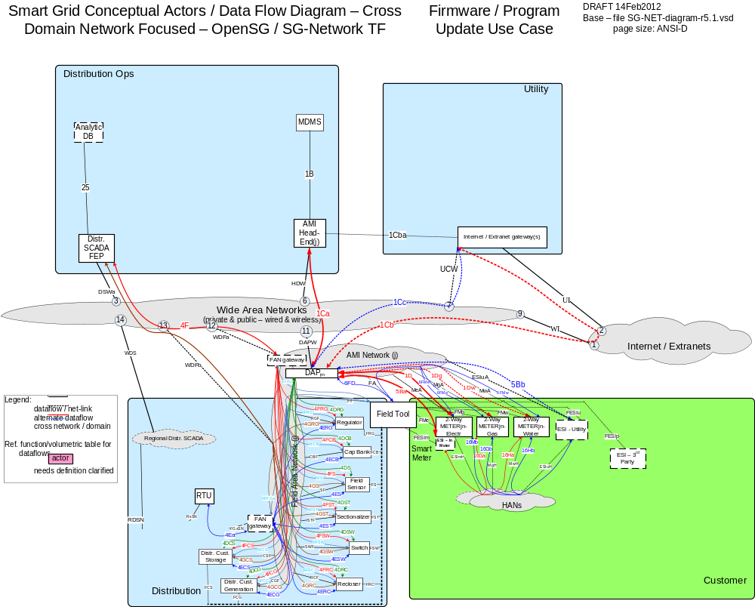

Possible communication paths
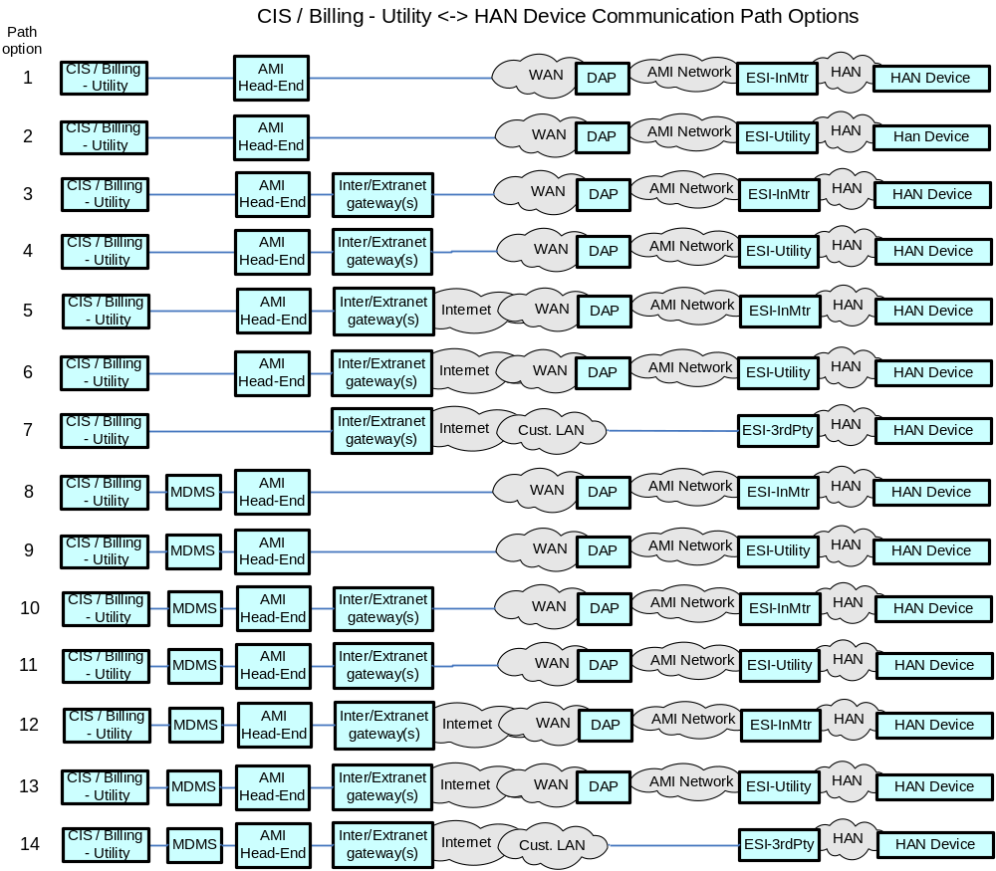
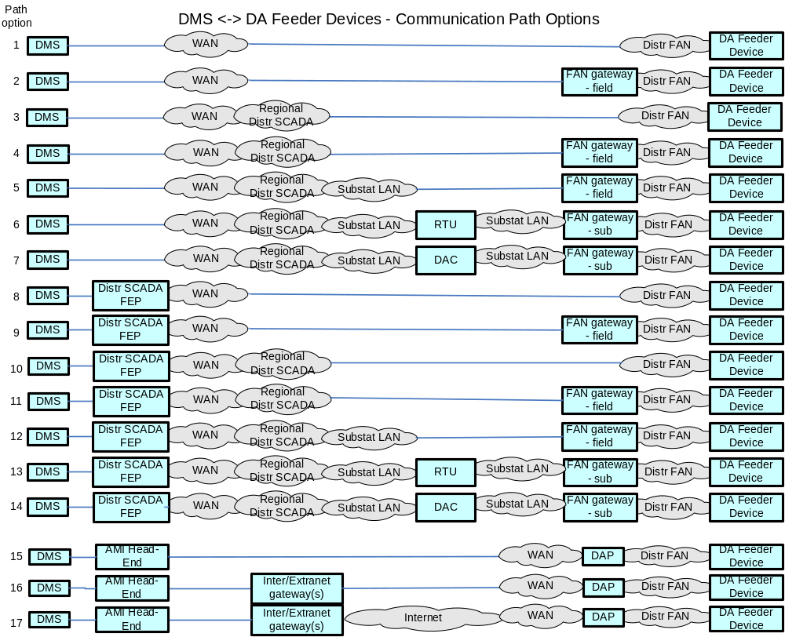

Actors
2-Way Meter - Electr | A bi-directional communication device used to perform measurement of electrical energy usage for residential use.
2-Way Meter - Gas | A bi-directional communication device used to perform measurement of gas consumption for residential use.
2-Way Meter - Water | A bi-directional communication device used to perform measurement of water consumption for residential use.
AMI Head-End(j) | The AMI head end is responsible for the operation and coordination of AMI system components. It represents the central nervous system of the AMI system.
DAPjm | This is the Data Aggregation Point on the NAN. It is essentially the point of convergence for all communication between SG devices and utility back office systems. In this specific use case it provides a communication conduit for AMI Smart Meters.The su
Distr. Cust. Generation | Distributed Customer Generation is a generation source sized to meet typical distribution substation circuit loads and is typically located at or near a distribution substation
Distr. Cust. Storage | Distributed Customer Storage is a storage device sized to meet typical distribution substation circuit loads and is typically located at or near a distribution substation or in smaller capacities out in customer/premise neighborhoods
Distr. SCADA FEP | Distribution Supervisory Control and Data Acquisition Front End Processor
ESI - 3rd Party | An ESI, owned by the Customer and not provided by the Utility, which enables secure interactions between HAN Devices Registered on its network and the service provider e.g. REP. The 3rd Party ESI functionality may reside in the Customer EMS or customer's
ESI - In Meter | An ESI, owned by the Utility and resides in the Utility meter, which enables secure interactions between HAN Devices Registered on its network and the Utility AMI.
ESI - In Meter, ESI - Utility | A combination of ESI - In Meter and ESI - Utility for determining the exact quantity of payloads to be associated to a DAPjm
ESI - In Meter, ESI - Utility, ESI - 3rd Party | A combination of ESI - In Meter and ESI - Utility and ESI - 3rd Party for determining the exact quantity of payloads to be associated to a DAPjm
ESI – Utility | An ESI, owned by the Utility, which enables secure interactions between HAN Devices Registered on its network and the Utility AMI. The Utility ESI functionality may reside in the Customer EMS or customer broadband router.
FAN gateway – field | Field Area Network gateway device located in the field, that provides the interface between the Feeder Line device communication modules and the Wide Area Network connection.
FAN gateway - field, FAN gateway - sub | A combination of FAN gateway - field and FAN gateway - sub for determining the exact quantify of payloads to the Feeder Line devices
FAN gateway – sub | Field Area Network gateway device located in the substation, that provides the interface between the Feeder Line device communication modules and the Substation network connection.
Feeder Cap Bank | This is a device used to add capacitance as needed at strategic points in a distribution grid to better control and manage VARs and thus the Power Factor and they will also affect voltage levels.
Feeder Recloser | A device used to sense fault conditions on a distribution line and trip open to provide protection. It is typically programmed to automatically close (re-close) after a period of time to test if the fault has cleared. After several attempts of reclosing
Feeder Regulator | This device is in effect an adjustable ratio transformer positioned at strategic points in a distribution grid and is utilized to better manage and control the voltage as it changes along the distribution feeder.
Feeder Sensor | A device used to measure and report electrical properties (such as voltage, current, phase angle or power factor, etc.) at a low voltage customer delivery point.
Feeder Switch | These devices are deployed at critical points within the Distribution network for purposes of isolating electric faults and providing system telemetry regarding the performance of the electric system
Field Tool | A device used in the distribution operations and customer domain to perform configuration and maintenance of devices.
Internet / Extranet gateway(s) - Utility | These are gateways used to connect internal utility networks with external networks.
MDMS | The application responsible for the collection and retrieval of all relevant customer information for purposes of billing and facilitating interaction.
RTU | Remote Terminal Unit - Aggregator of multiple serialized devices to a common communications interface

Scenarios

Scenario: X

Narrative

Business Objectives

Originating Actor | Desination Actor | Latency | Reliability | Payload Size | Payload Name
Totals

Implications and Rationale
Functional Domain | Expected Potential Impact | Rationale
Bulk Generation
Customer
Distribution
Markets
Operation
Service Providers
Transmission

Electric Transportation

Overview
The use case of Electric Transportation was considered to show communications requirements for transactions that occur while charging electric vehicles. The following scenarios are considered in this use case.
- Negotiation of Price
- Negotiation of Charging rate (e.g. Level 1, Level 2, etc)
- Electric Vehicle sends VIN to Energy Supply agent
- Electric Vehicle sends charge state to Energy Supply agent

Reference Architecture with Domains, Actors and Interfaces
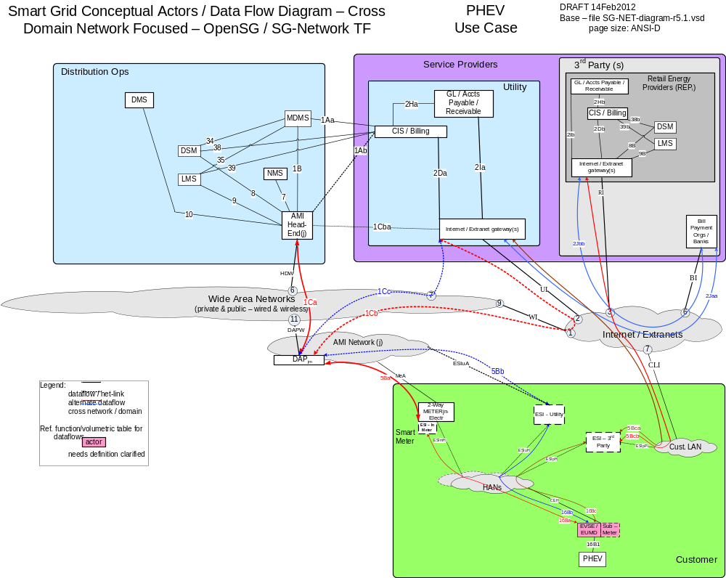

Possible communication paths
Note: HAN device in this figure is refers to Plugin Hybrid Electric Vehicle and/or Electric Vehicle Supply Equipment

Actors
FIXME

Scenarios

Scenario: Price Negotiation Scenario

Narrative
Communication of price and rate from energy provider to PHEV to inform vehicle charging decision
Business Objectives

Originating Actor | Desination Actor | Latency | Reliability | Payload Size | Payload Name
LMS – Utility | PHEV | < 15 sec | > 98% | 255 | PHEV_price_rate_cmd
(ESI - Utility)  OR  (ESI - In Meter)  OR  (ESI - 3rd Party) | LMS - Utility, NMS, DMS, DSM – Utility | < 15 sec | > 98% for Utility or meter,  > 99% for 3rd Party | 50 | PHEV_price_rate_comm_err
Totals |  | n/a | n/a | n/a

Implications and Rationale
Functional Domain | Expected Potential Impact | Rationale
Bulk Generation
Customer | X | Customer would be unable to make informed decision on if/when to charge vehicle
Distribution
Markets
Operation | X | Operations does not know current agreement on pricing with PHEV.
Service Providers | X | 3rd party service provider would be unaware of a failure to communicate price/rate
Transmission

Scenario: Negotiation of Power Charging Rate between Utility and PHEV

Narrative
Utility and PHEV can exchange information to negotiate rate for charging. This negotiation is bi-directional and may occur multiple times.
Business Objectives

Originating Actor | Desination Actor | Latency | Reliability | Payload Size | Payload Name
LMS – Utility | PHEV | < 15 sec | > 98% | 100 | PHEV_pwr_chrg_rate_negot-thrd
PHEV | LMS – Utility | < 15 sec | > 98% | 100 | PHEV_pwr_chrg_rate_negot-thrd
AMI Head-End(j) | PHEV, NMS | < 15 sec | > 98% | 50 | PHEV_pwr_chrg_rate_comm_err
AMI Head-End(j) | LMS - Utility, NMS | < 10 sec | > 99% | 50 | PHEV_pwr_chrg_rate_comm_err
Totals |  | n/a | n/a | n/a

Implications and Rationale
Functional Domain | Expected Potential Impact | Rationale
Bulk Generation
Customer | X | Customer could be unable or unwilling to charge vehicle without negotiated price. Customer frustration.
Distribution
Markets
Operation | X | Loss of revenue from missed opportunity for charging a vehicle
Service Providers
Transmission

Scenario: PHEV sends vehicle identification number to MDMS

Narrative
The VIN may be used to associate a specific vehicle with a specific user account in the MDMS to enable special tariffs for EV charging.
Business Objectives

Originating Actor | Desination Actor | Latency | Reliability | Payload Size | Payload Name
PHEV | MDMS | < 15 sec | > 98% | 50 | PHEV_Vin_data_cmd
PHEV | MDMS | < 10 sec | > 99.5% | 50 | PHEV_Vin_data_comm_err
Totals |  | n/a | n/a | n/a

Implications and Rationale
Functional Domain | Expected Potential Impact | Rationale
Bulk Generation
Customer | X | Customer might not receive benefits of special rates or plans for the PHEV
Distribution
Markets
Operation | X | Incorrect rates applied to PHEV charging transaction; manual corrections necessary at a later time.
Service Providers
Transmission

Scenario: PHEV sends charge status data to LMS_Utility

Narrative
The charge status information is used by the utility to inform of the total amount of energy needed to complete the charging of the vehicle.
Business Objectives

Originating Actor | Desination Actor | Latency | Reliability | Payload Size | Payload Name
PHEV | LMS – Utility | < 15 sec | > 98% | 100 | PHEV_pwr_chrg_status_resp-data
Totals |  | < 15 sec | > 98% | 100

Implications and Rationale
Functional Domain | Expected Potential Impact | Rationale
Bulk Generation
Customer
Distribution | X | LMS would be unable to function correctly, potentially causing excess load on distribution circuits
Markets
Operation | X | LMS would be unable to function correctly
Service Providers
Transmission

Meter Reading Use Cases

Overview
The Meter Reading use cases described in this body of work include the following scenarios. For each scenario the primary command, response and failure payloads are described

- On Demand Meter read
- On Demand Meter read failure
- On Demand Meter interval period read
- Normal Meter Reading Operations
- Bulk Meter Interval data read

Reference Architecture with Domains, Actors and Interfaces
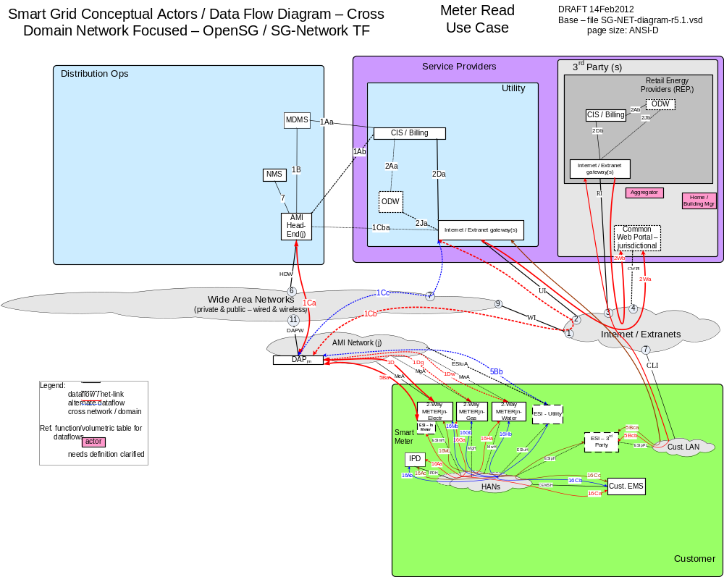

Possible communications paths
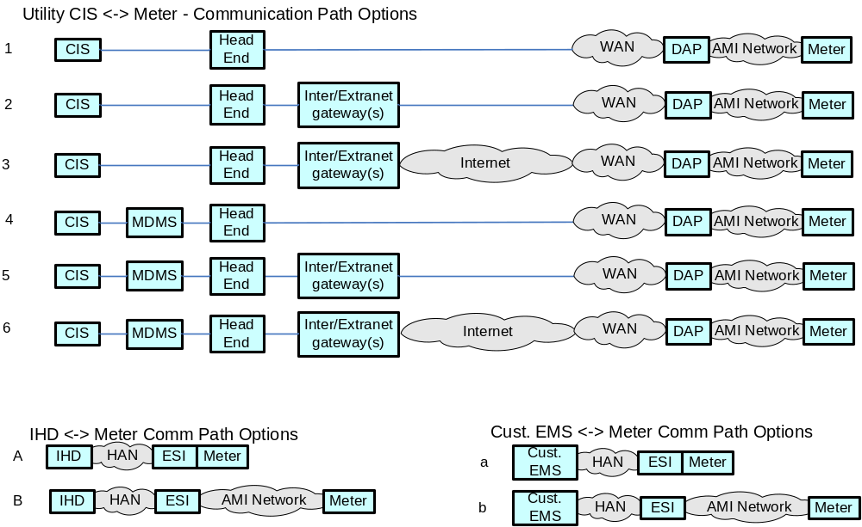

Actors
2-Way Meter - Electr | A bi-directional communication device used to perform measurement of electrical energy usage for residential use.
2-Way Meter - Gas | A bi-directional communication device used to perform measurement of gas consumption for residential use.
2-Way Meter - Water | A bi-directional communication device used to perform measurement of water consumption for residential use.
AMI Head-End(j) | The AMI head end is responsible for the operation and coordination of AMI system components. It represents the central nervous system of the AMI system.
CIS/Billing - Utility | A utility billing system used for reconcilling customer payments for electricity usage. This system may also be used for manageing vendors of electricity generation.
Cust. EMS | A customer owned energy management system used to manage energy with a premises.
DAPjm | This is the Data Aggregation Point on the NAN. It is essentially the point of convergence for all communication between SG devices and utility back office systems. In this specific use case it provides a communication conduit for AMI Smart Meters.The su
ESI - 3rd Party | An ESI, owned by the Customer and not provided by the Utility, which enables secure interactions between HAN Devices Registered on its network and the service provider e.g. REP. The 3rd Party ESI functionality may reside in the Customer EMS or customer's
ESI - In Meter | An ESI, owned by the Utility and resides in the Utility meter, which enables secure interactions between HAN Devices Registered on its network and the Utility AMI.
ESI - Utility | An ESI, owned by the Utility, which enables secure interactions between HAN Devices Registered on its network and the Utility AMI. The Utility ESI functionality may reside in the Customer EMS or customer broadband router.
Internet / Extranet gateway(s) - Utility | These are gateways used to connect internal utility networks with external networks.
IPD | In Premise Display
MDMS | The application responsible for the collection and retrieval of all relevant customer information for purposes of billing and facilitating interaction.
NMS | A system or series of systems that are utilized to operate and manage utility assets that interact on any given network. These assets are comprised of both hardware and software components that require ongoing monitoring and management.

Scenarios

Scenario: On-Demand Meter Reading

Narrative
Meters, whether they are Electric, Gas or Water, are anticipated to have on-demand meter reading capability. In this scenario, the request may originate from the CIS or the MDMS but can also originate from devices within the HAN. In any case, we expect the head end to receive on demand meter read request and forward the request to the Smart Meter via the DAP. Smart meters may be read on demand for purposes of backfilling missing information, customer interaction or move in and move out scenarios.

Business Objectives

Originating Actor | Desination Actor | Latency | Reliability | Payload Size | Payload Name
CIS/Billing - Utility, MDMS, NMS,  Cust. EMS,  IPD | 2-Way Meter – Electr  Or  2-Way Meter - Gas  Or  2-Way Meter – Water | < 15 seconds | 98% | 25 bytes | on-demand_Mtr-read_cmd
2-Way Meter – Electr  Or  2-Way Meter - Gas  Or  2-Way Meter – Water | CIS/Billing - Utility, MDMS, NMS,  Cust. EMS,  IPD | < 15 seconds | 98% | 200-400 bytes | On-demand_Mtr-read_rspns_data
Totals |  | < 30 seconds | 96%

Implications and Rationale
Functional Domain | Expected Potential Impact | Rationale
Bulk Generation
Customer | X | Cannot access recent usage information.
Distribution
Markets
Operation | X | Systems will have to retry communications
Service Providers | X | Cannot acquire specific recent meter usage information.
Transmission

Scenario On-Demand Read Failure

Narrative
Meters, whether they are Electric, Gas or Water, are anticipated to have on-demand meter reading failures. In this scenario, the request may originate from the CIS or the MDMS. In any case, we expect the Meter on demand read request to fail and at each step of the process, if a failure occurs, the upstream devices shall send a notification of failure. Failure in this case can be defined as failure to communicate (on-demand_Mtr-read_cmd_comm_err) or an failure to read the actual meter (on-demand_Mtr-read_cmd_err).

Business Objectives

Originating Actor | Desination Actor | Latency | Reliability | Payload Size | Payload Name
2-Way Meter – Electr  Or  2-Way Meter - Gas  Or  2-Way Meter – Water | CIS/Billing - Utility, MDMS, NMS,  Cust. EMS,  IPD | < 15 seconds | 98% | 25 bytes | on-demand_Mtr-read_cmd_comm_err
2-Way Meter – Electr  Or  2-Way Meter - Gas  Or  2-Way Meter - Water | CIS/Billing - Utility, MDMS, NMS,  Cust. EMS,  IPD | < 15 seconds | 98% | 25 bytes | on-demand_Mtr-read_cmd_err

Implications and Rationale
Functional Domain | Expected Potential Impact | Rationale
Bulk Generation
Customer | X | Cannot access recent usage information.
Distribution
Markets
Operation | X | Systems will have to retry communications
Service Providers | X | Cannot acquire specific recent meter usage information.
Transmission

Scenario: Scheduled Meter Register read

Narrative
Electric, Gas, Water utilities wish to obtain electric, gas or water consumption at least one time a day. This operation shall respond with a snap shot of the meters register taken at a time configured by the owner of the device.

Business Objectives

Originating Actor | Desination Actor | Latency | Reliability | Payload Size | Payload Name
2-Way Meter – Electr  Or  2-Way Meter - Gas  Or  2-Way Meter – Water | CIS/Billing - Utility, MDMS, NMS,  Cust. EMS,  IPD | < 3 hour | 98% | 200-1600 bytes | Mtr-read_data_resp-data
Totals |  | < 3 hour | 98%

Implications and Rationale
Functional Domain | Expected Potential Impact | Rationale
Bulk Generation
Customer | X | Cannot access recent usage information.
Distribution
Markets
Operation | X | Systems will have to retry communications
Service Providers | X | Cannot acquire specific recent meter usage information.
Transmission

Scenario: Scheduled Meter interval read

Narrative
Electric, Gas, Water utilities wish to obtain electric, gas or water consumption data four to six times a day. During these four to six operations per day, the operation shall obtain interval usage information varying from 15 minutes to 1 hour in duration since the last successful bulk read operation.

Business Objectives

Originating Actor | Desination Actor | Latency | Reliability | Payload Size | Payload Name
2-Way Meter – Electr  Or  2-Way Meter - Gas  Or  2-Way Meter – Water | CIS/Billing - Utility, MDMS, NMS,  Cust. EMS,  IPD | < 3 hour | 98% | 200-1600 bytes | Mtr-read_multi-interval-data_resp-data
Totals |  | < 3 hour | 98%

Implications and Rationale
Functional Domain | Expected Potential Impact | Rationale
Bulk Generation
Customer | X | Cannot access recent usage information.
Distribution
Markets
Operation | X | Systems will have to retry communications
Service Providers | X | Cannot acquire specific recent meter usage information.
Transmission

Scenario: Bulk Meter Reading Information Transfer

Narrative
Depending on how the Meter reading system is architected. A large bulk meter request will be made from the CIS/Billing-Utility actor or MDMS within an Utility Enterprise. The response will include Meter Reading information from Scheduled Meter Register Reads, Scheduled Meter Interval Reads or information from On-Demand read requests.

Business Objectives

Originating Actor | Desination Actor | Latency | Reliability | Payload Size | Payload Name
CIS/Billing - Utility  Or  MDMS | AMI Head-End(j) | < 1 hour | 99.5% | 200-1600 bytes | bulk_Mtr-read_cmd
AMI Head-End(j) | CIS/Billing - Utility  Or  MDMS | < 1 hour | 99.5% | xMB | bulk_Mtr-read_resp-data
Totals |  | < 2 hour | 99%

Implications and Rationale
Functional Domain | Expected Potential Impact | Rationale
Bulk Generation
Customer | X | Cannot access recent usage information.
Distribution
Markets
Operation | X | Systems will have to retry communications
Service Providers | X | Cannot acquire specific recent meter usage information.
Transmission

Outage and Restoration Management

Overview of Business Processes
The following sections outline business use cases for Outage and Restoral Management. This management pertains to many forms of information that is exchanged between the communication actors.
The implementations of these use cases, and their accompanying requirements, will vary from utility to utility. Some examples of factors that will cause variations are:
Environmental (Earthquake/creep, Weather, Seasonal, Topography, etc)
Demographic (Residential, Industrial, etc)
The author’s intent is to capture the numerous use case requirements across the communication actors in the scope of the management of this information. The intent is to reflect which use cases can be applied to different aspects of the Utility/Customer.
batt_pwr_notification
otg_ntf_evnt_data
svc_rst_ntf_evnt_data

Reference Architecture with Domains, Actors and Interfaces
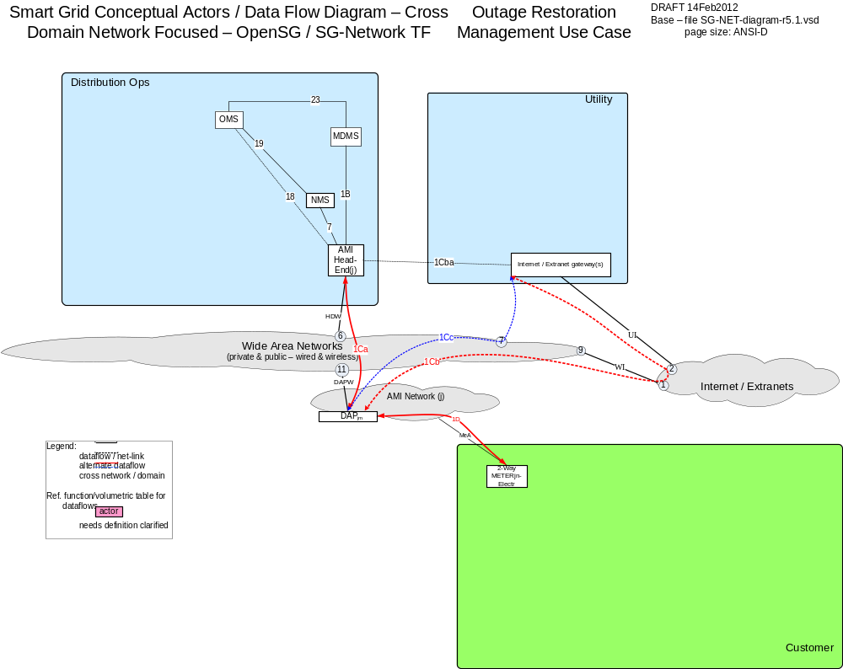

Possible communication paths
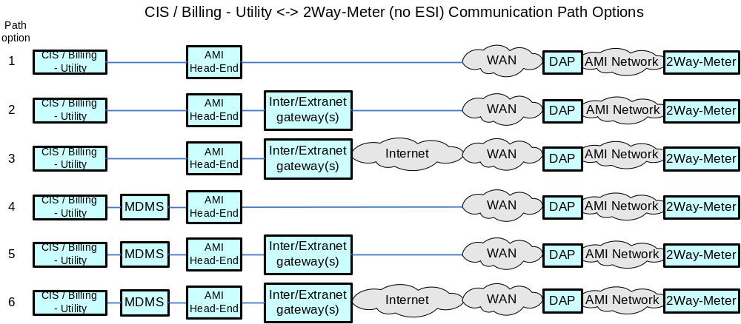

Actors
AMI Head-End(j) | The AMI head end is responsible for the operation and coordination of AMI system components. It represents the central nervous system of the AMI system.
DAPjm | This is the Data Aggregation Point on the NAN. It is essentially the point of convergence for all communication between SG devices and utility back office systems. In this specific use case it provides a communication conduit for AMI Smart Meters.The su
Internet / Extranet gateway(s) - Utility | These are gateways used to connect internal utility networks with external networks.
MDMS | The application responsible for the collection and retrieval of all relevant customer information for purposes of billing and facilitating interaction.
NMS | A system or series of systems that are utilized to operate and manage utility assets that interact on any given network. These assets are comprised of both hardware and software components that require ongoing monitoring and management.
OMS | A system that receives power system outage notifications and correlates the geographic location of the power outage

Scenarios – Off AC Power
All communication actors run of some form of power system. The failure of the AC power source can affect many aspects of the service and business.

Business Objectives

Originating Actor | Desination Actor | Latency | Reliability | Payload Size | Payload Name
Smart Meter | DAP | < 20 seconds | > 30% large outage, > xx% small outage | 25 bytes | otg_ntf_evnt_data
Totals |  | < 20 seconds

Implications and Rationale
Functional Domain | Expected Potential Impact | Rationale
Bulk Generation
Customer | X | Cannot access recent usage information.
Distribution | X | Potential Infrastructure is offline.
Markets
Operation | X | Utility may need to roll personnel.
Service Providers | X | Cannot acquire specific recent meter usage information.
Transmission

Scenarios – Battery Backup State
When main power source is lost and the actor is running off a backup power source, an important alarm is the state of the backup system. The assumption is the meter is still functional.
Business Objectives

Originating Actor | Desination Actor | Latency | Reliability | Payload Size | Payload Name
Smart Meter | DAP | < 5 seconds | > 99% | 25 bytes | btry_pwr_notification
Totals |  | < 5 seconds

Implications and Rationale
Functional Domain | Expected Potential Impact | Rationale
Bulk Generation
Customer
Distribution
Markets
Operation | X | Utility may need to roll personnel
Service Providers
Transmission

Scenarios – Electric Power Restoration
When the power source of the actor is restored, there is an alert to notify the destination that the originating actor is back online.

Business Objectives

Originating Actor | Desination Actor | Latency | Reliability | Payload Size | Payload Name
Smart Meter | DAP | < 20 seconds | > 98% | 25 bytes | svc_rst_ntf_evnt_data
Totals |  | < 20 seconds

Implications and Rationale
Functional Domain | Expected Potential Impact | Rationale
Bulk Generation
Customer | X | Can now read recent usage information.
Distribution
Markets
Operation | X | Utility may be able to stop roll of personnel
Service Providers | X | Can now acquire specific recent meter usage information.

Meter System Events

Overview
Audit_Application_Event
Configuration_Event
Fault_Error_Alarm_Event
Power_Quality_Event
Security_Event

The following section identifies network requirements for enabling and processing system events and use cases associated with the Smart Grid. This document does not address, establish or recommend any security requirements or supporting architectures needed for the Smart Grid. Smart Grid security is being addressed in detail by other functioning task forces within the OpenSG and the UCAIUG. The intent is to establish a straw man set of requirements to be incorporated into the overall Smart Grid network design for addressing security communication requirements.
Below is an example architecture showing the Domains, Actors, and Interfaces used in this use case.

Reference Architecture with Domains, Actors and Interfaces
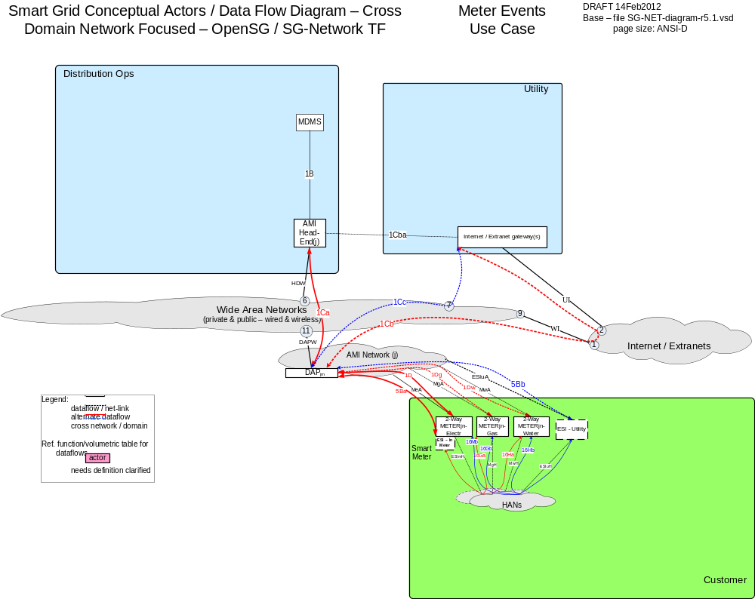

Possible Communications Paths

Actors
AMI Head-End(j) | The AMI head end is responsible for the operation and coordination of AMI system components. It represents the central nervous system of the AMI system.
CIS/Billing - Utility | A utility billing system used for reconcilling customer payments for electricity usage. This system may also be used for manageing vendors of electricity generation.
DAPjm | This is the Data Aggregation Point on the NAN. It is essentially the point of convergence for all communication between SG devices and utility back office systems. In this specific use case it provides a communication conduit for AMI Smart Meters.The su
ESI - In Meter | An ESI, owned by the Utility and resides in the Utility meter, which enables secure interactions between HAN Devices Registered on its network and the Utility AMI.
ESI - Utility | An ESI, owned by the Utility, which enables secure interactions between HAN Devices Registered on its network and the Utility AMI. The Utility ESI functionality may reside in the Customer EMS or customer broadband router.
Internet / Extranet gateway(s) - Utility | These are gateways used to connect internal utility networks with external networks.
MDMS | The application responsible for the collection and retrieval of all relevant customer information for purposes of billing and facilitating interaction.

Configuration Event

Objective
The objective is to collect events from the meter that occur when there is a out of state condition with the configuration on the meter. The configuration events are focused on maintaining metrics that define the meters operating state. Unlike other events that have a high and low limit thresholds the configuration events are thought to not any thresholds. The event would be trigged on the meter by a state outside of a defined metric for configuration.

Actors
Actor | Description | Role
Meter Data Management System | The MDMS is the application responsible for coordinating the billing of AMI data. MDMS often interact with CIS, as well as other systems, to automate customer and billing functions with the Smart Grid.
AMI Head End | The AMI head end is responsible for the operation and coordination of AMI system components. It represents the central nervous system of the AMI system.
Data Aggregation Point | This is the Data Aggregation Point on the NAN. It is essentially the point of convergence for all communication between SG devices and utility back office systems. In this specific use case it provides a communication conduit for AMI Smart Meters.
Smart Meter – AMI Interface | This is the interface utilized to communicate directly between the Smart Meter and the AMI system. This interface is used to allow utilities and third parties to communicate with the meter via the AMI system.

Table 4 - Metering Configuration Event Actors

Latency Requirements
Source | Destination | Frequency | Response Time | Priority
Smart Meter | DAP | Event Driven | <30 sec | High
DAP | AMI Head End | Event Driven | <30 sec | High
AMI Head End | MDMS | Event Driven | <30 sec | High
Table 5 - Latency Requirements

Process Flow
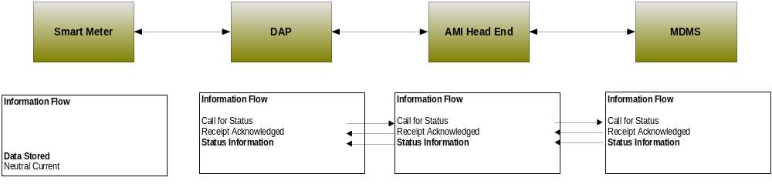
Figure 5 - Process Flow

Included Processes

Audit Event

Objective
The objective is to collect events from the meter that occur when there is a failure or exception in the execution of a request or an internal application function. Audit events are considered to be time based or on demand. The time based events could be driven by the validation the registers within the meter are still valid. Application events can be caused by a running application not performing as designed and reporting an error or a running application on the meter causing a threshold to be reached and triggering an event.

Actors
Actor | Description | Role
Meter Data Management System | The MDMS is the application responsible for coordinating the billing of AMI data. MDMS often interact with CIS, as well as other systems, to automate customer and billing functions with the Smart Grid.
AMI Head End | The AMI head end is responsible for the operation and coordination of AMI system components. It represents the central nervous system of the AMI system.
Data Aggregation Point | This is the Data Aggregation Point on the NAN. It is essentially the point of convergence for all communication between SG devices and utility back office systems. In this specific use case it provides a communication conduit for AMI Smart Meters.
Smart Meter – AMI Interface | This is the interface utilized to communicate directly between the Smart Meter and the AMI system. This interface is used to allow utilities and third parties to communicate with the meter via the AMI system.
Table 6 - Metering Security Event Actors

Latency Requirements
Source | Destination | Frequency | Response Time | Priority
Smart Meter | DAP | Event Driven | <1 min | Medium
DAP | AMI Head End | Event Driven | <1 min | Medium
AMI Head End | MDMS | Event Driven | <1 min | Medium
Table 7 - Latency Requirements

Process Flow
Figure 6 - Process Flow

Included Processes

Fault Error Alarm Event

Objective
The objective is to collect alarms from the meter that occur when there is an out of state or passed a threshold condition on the meter. The communication of the event information is triggered locally on the meter in response to reaching a pre defined condition. The metric to judge the state or condition are locally store on the meter device.

Actors
Actor | Description | Role
Meter Data Management System | The MDMS is the application responsible for coordinating the billing of AMI data. MDMS often interact with CIS, as well as other systems, to automate customer and billing functions with the Smart Grid.
AMI Head End | The AMI head end is responsible for the operation and coordination of AMI system components. It represents the central nervous system of the AMI system.
Data Aggregation Point | This is the Data Aggregation Point on the NAN. It is essentially the point of convergence for all communication between SG devices and utility back office systems. In this specific use case it provides a communication conduit for AMI Smart Meters.
Smart Meter – AMI Interface | This is the interface utilized to communicate directly between the Smart Meter and the AMI system. This interface is used to allow utilities and third parties to communicate with the meter via the AMI system.
Table 8 - Metering Fault Alarm Actors

Latency Requirements
Source | Destination | Frequency | Response Time | Priority
MDMS | Smart Meter | Event Driven | <15 sec | Medium
Smart Meter | MDMS | Event Driven | <15 sec | Medium
Table 9 - Latency Requirements

Process Flow
Figure 7 - Process Flow

Included Processes

Power Quality Event

Objective
The objective is to collect alarms from the meter that occur when there is a out of state or passed a threshold condition on the meter. Power quality event are disturbance oriented by nature, leading / lagging power. In most cases the events will be as result of excessive steady state voltage variation, unbalance in energy flow, harmonics on the line, sags, swells, oscillatory.

Actors
Actor | Description | Role
Meter Data Management System | The MDMS is the application responsible for coordinating the billing of AMI data. MDMS often interact with CIS, as well as other systems, to automate customer and billing functions with the Smart Grid.
AMI Head End | The AMI head end is responsible for the operation and coordination of AMI system components. It represents the central nervous system of the AMI system.
Data Aggregation Point | This is the Data Aggregation Point on the NAN. It is essentially the point of convergence for all communication between SG devices and utility back office systems. In this specific use case it provides a communication conduit for AMI Smart Meters.
Smart Meter – AMI Interface | This is the interface utilized to communicate directly between the Smart Meter and the AMI system. This interface is used to allow utilities and third parties to communicate with the meter via the AMI system.
Table 10 - Metering Power Quality Actors

Latency Requirements
Source | Destination | Frequency | Response Time | Priority
Smart Meter | DAP | Event Driven | <30 sec | High
DAP | AMI Head End | Event Driven | <30 sec | High
AMI Head End | MDMS | Event Driven | <30 sec | High
Table 11 - Latency Requirements

Process Flow
Figure 8 - Process Flow

Included Processes

Security Event

Scenario:Security Event
Narrative
The objective is to collect alarms from the meter that occur when a meter is driven to an out of state condition. The communication of the event information is triggered locally on the meter in response to pre defined condition. The metric to judge the state or condition are locally store on the meter device.

Business Objectives
Originating Actor | Desination Actor | Latency | Reliability | Payload Size | Payload Name
Smart Meter | MDMS | <2 min | >98% | 25-278 bytes | Security_Event
Totals |  | <2 min | >98%

Implications and Rationale
Functional Domain | Expected Potential Impact | Rationale
Bulk Generation
Customer | X | Customer's service could be affected.
Distribution
Markets
Operation | X | Smart Meter could require maintenance.
Service Providers
Transmission

Scenario: Audit Event
Narrative
The objective is to collect events from the meter that occur when there is a failure or exception in the execution of a request or an internal application function. Audit events are considered to be time based or on demand. The time based events could be driven by the validation the registers within the meter are still valid. Application events can be caused by a running application not performing as designed and reporting an error or a running application on the meter causing a threshold to be reached and triggering an event.

Business Objectives
Originating Actor | Desination Actor | Latency | Reliability | Payload Size | Payload Name
Smart Meter | MDMS | <4 min | >98% | 25-278 bytes | Audit_Application_Event
Totals |  | <4 min | >98%

Implications and Rationale
Functional Domain | Expected Potential Impact | Rationale
Bulk Generation
Customer | X | Customer's service could be affected.
Distribution
Markets
Operation | X | Smart Meter could require maintenance.
Service Providers
Transmission

Scenario: Configuration Event
Narrative
The objective is to collect events from the meter that occur when there is a out of state condition with the configuration on the meter. The configuration events are focused on maintaining metrics that define the meters operating state. Unlike other events that have a high and low limit thresholds the configuration events are thought to not any thresholds. The event would be trigged on the meter by a state outside of a defined metric for configuration.

Business Objectives
Originating Actor | Desination Actor | Latency | Reliability | Payload Size | Payload Name
Smart Meter | MDMS | <2 min | >98% | 25-278 bytes | Configuration_Event
Totals |  | <2 min | >98%

Implications and Rationale
Functional Domain | Expected Potential Impact | Rationale
Bulk Generation
Customer | X | Customer's service could be affected.
Distribution
Markets
Operation | X | Smart Meter could require maintenance.
Service Providers
Transmission

Scenario: Fault Error Alarm Event
Narrative
The objective is to collect alarms from the meter that occur when there is an out of state or passed a threshold condition on the meter. The communication of the event information is triggered locally on the meter in response to reaching a pre defined condition. The metric to judge the state or condition are locally store on the meter device.

Business Objectives
Originating Actor | Desination Actor | Latency | Reliability | Payload Size | Payload Name
Smart Meter | MDMS | <2 min | >98% | 25-278 bytes | Fault_Error_Alarm_Event
Totals |  | <2 min | >98%

Implications and Rationale
Functional Domain | Expected Potential Impact | Rationale
Bulk Generation
Customer | X | Customer's service could be affected.
Distribution
Markets
Operation | X | Smart Meter could require maintenance.
Service Providers
Transmission

Scenario: Power Quality Event
Narrative
The objective is to collect alarms from the meter that occur when there is a out of state or passed a threshold condition on the meter. Power quality event are disturbance oriented by nature, leading / lagging power. In most cases the events will be as result of excessive steady state voltage variation, unbalance in energy flow, harmonics on the line, sags, swells, oscillatory.

Business Objectives
Originating Actor | Desination Actor | Latency | Reliability | Payload Size | Payload Name
Smart Meter | MDMS | <2 min | >98% | 25-278 bytes | Power_Quality_Event
Totals |  | <2 min | >98%

Implications and Rationale
Functional Domain | Expected Potential Impact | Rationale
Bulk Generation
Customer | X | Customer's service could be affected.
Distribution
Markets
Operation | X | Smart Meter could require maintenance.
Service Providers
Transmission

System Security Events

Overview
The following section identifies network requirements for enabling and processing security events and use cases associated with the Smart Grid. This document does not address, establish or recommend any security requirements or supporting architectures needed for the Smart Grid. Smart Grid security is being addressed in detail by other functioning task forces with in the OpenSG and the UCAIUG. The intent is to establish a straw man set of requirements to be incorporated into the overall Smart Grid network design for addressing security communication requirements.

CIA
The team has identified the CIA values for the specific network transactions associated with the network security events and use cases. The CIA designations are based on the types of transactions and payloads being transmitted by the respective actors. The CIA designations are included in the accompanying databases and spreadsheets that compromise the SRS.

Reference Architecture with Domains, Actors and Interfaces

Possible communication paths

Actors
Actor | Description | Role
Customer Information System | The application responsible for the collection and retrieval of all relevant customer information for purposes of billing and facilitating interaction.
Meter Data Management System | The MDMS is the application responsible for coordinating the billing of AMI data. MDMS often interact with CIS, as well as other systems, to automate customer and billing functions with the Smart Grid.
Enterprise Service Bus | This is an integration bus utilized for integrating disparate applications. The ESB is also used as a translation engine that can translate and harmonize messages and transactions between systems.
AMI Head End | The AMI head end is responsible for the operation and coordination of AMI system components. It represents the central nervous system of the AMI system.
Network Management System | A system or series of systems that are utilized to operate and manage utility assets that interact on any given network. These assets are comprised of both hardware and software components that require ongoing monitoring and management.
Internet / Extranet Gateways | These are gateways used to connect internal utility networks with external networks.
Data Aggregation Point | This is the Data Aggregation Point on the NAN. It is essentially the point of convergence for all communication between SG devices and utility back office systems. In this specific use case it provides a communication conduit for AMI Smart Meters.
Repeater | A repeater is used in radio frequency networks as a means of extending the each of the network.
Smart Meter – AMI Interface | This is the interface utilized to communicate directly between the Smart Meter and the AMI system. This interface is used to allow utilities and third parties to communicate with the meter via the AMI system.
Smart Meter – Energy Services Interface | This is the interface utilized to communicate directly between the Smart Meter and the Customer HAN or EMS system. This interface is used to allow utilities and third parties to communicate with the customer via the AMI system.
Table 12 - Metering Audit Event Actors

Premises Network Administration

Overview
Premises/Home Area Network Administration consists of the following scenarios. Note the acronym HAN and PAN are used interchangeably.
- Joining new devices to the network
- Removing devices from the network
han_dev_join_ack
han_dev_join_cmd
han_dev_join_cmd_err
han_dev_un_join_ack
han_dev_un_join_cmd
han_dev_un-join_cmd_err

Reference Architecture with Domains, Actors and Interfaces
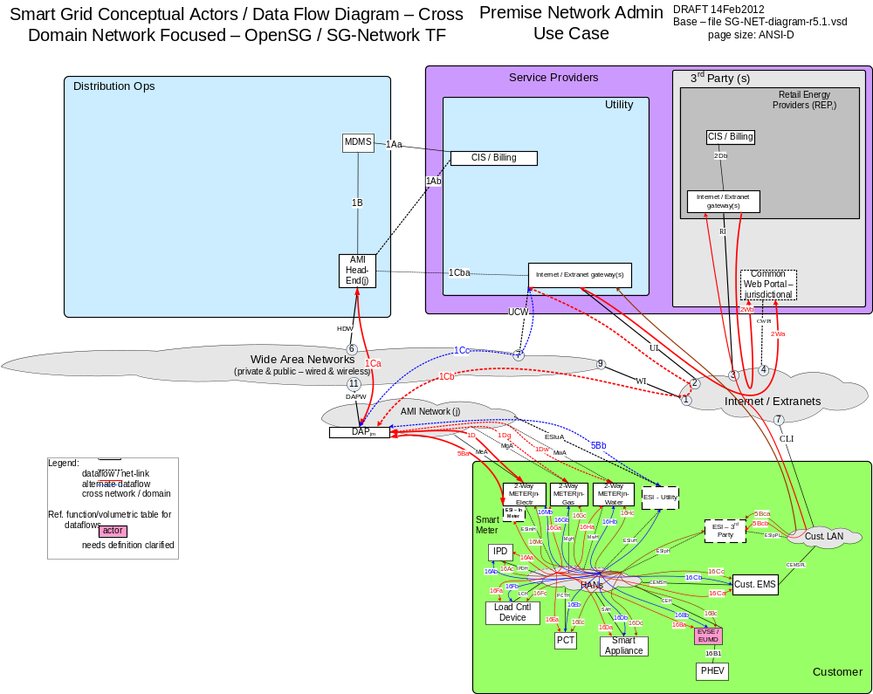

Possible communication paths

Actors
2-Way Meter – Electr | A bi-directional communication device used to perform measurement of electrical energy usage for residential use.
2-Way Meter – Gas | A bi-directional communication device used to perform measurement of gas consumption for residential use.
2-Way Meter – Water | A bi-directional communication device used to perform measurement of water consumption for residential use.
AMI Head-End(j) | The AMI head end is responsible for the operation and coordination of AMI system components. It represents the central nervous system of the AMI system.
CIS/Billing – REPi | A third party billing system used for reconcilling customer payments for electricity usage. This system may also be used for manageing vendors of electricity generation.
CIS/Billing – Utility | A utility billing system used for reconcilling customer payments for electricity usage. This system may also be used for manageing vendors of electricity generation.
Common Web Portal | Web interface for Regional Transmission Operator, customers, retail electric providers and transmission/distribution service provider to function as a clearing house for energy information.
Cust. EMS | A customer owned energy management system used to manage energy with a premises.
DAPjm | This is the Data Aggregation Point on the NAN. It is essentially the point of convergence for all communication between SG devices and utility back office systems. In this specific use case it provides a communication conduit for AMI Smart Meters.The su
ESI - 3rd Party | An ESI, owned by the Customer and not provided by the Utility, which enables secure interactions between HAN Devices Registered on its network and the service provider e.g. REP. The 3rd Party ESI functionality may reside in the Customer EMS or customer's
ESI - In Meter | An ESI, owned by the Utility and resides in the Utility meter, which enables secure interactions between HAN Devices Registered on its network and the Utility AMI.
ESI – Utility | An ESI, owned by the Utility, which enables secure interactions between HAN Devices Registered on its network and the Utility AMI. The Utility ESI functionality may reside in the Customer EMS or customer broadband router.
EVSE / EUMD | Electric Vehicle Supply Equipment / End Use Metering Device
Internet / Extranet gateway(s) – REPi | These are gateways used to connect internal utility networks with external networks.
Internet / Extranet gateway(s) – Utility | These are gateways used to connect internal utility networks with external networks.
IPD | In Premise Display
Load Cntl Device | A device used within the customer domain for load management (e.g. Air conditioning, etc)
MDMS | The application responsible for the collection and retrieval of all relevant customer information for purposes of billing and facilitating interaction.
NMS | A system or series of systems that are utilized to operate and manage utility assets that interact on any given network. These assets are comprised of both hardware and software components that require ongoing monitoring and management.
PCT | A device within the premise that has communication capabilities and controls heating, ventilation and cooling systems.
PHEV | Plug-in Hybrid Electric Vehicles - Cars or other vehicles that draw electricity from batteries to power an electric motor for vehicle propulsion. PHEVs also contain an internal combustion engine.
Smart Appliance | A white good or household appliance, that has HAN communication capability and is capable of receiving signals from authorized parties (e.g. Utility, Service Provider, EMS, Consumer, etc.) and of adjusting its operational mode based on Consumer preference

Scenarios

Scenario: Device Joins the Network

Narrative
A consumer/customer wishes to connect a Premises / Home Area Network device to the network. The customer from the IVR, Web Portal, etc submits a device ID and network key for the device to join the network. When successful, the device or 2-way meter sends an acknowledgement of the successful command.
Business Objectives

Originating Actor | Destination Actor | Latency | Reliability | Payload Size | Payload Name
CIS | 2-way electric meter | < 20s | 98% | 25 | Han_dev_join_cmd
2-way electric meter | CIS | < 20s | 98% | 25 | Han_dev_join_ack
Totals |  |  | 96% | 50

Implications and Rationale
Functional Domain | Expected Potential Impact | Rationale
Bulk Generation
Customer | X | Customer cannot connect a device to the network.
Distribution | X | Device may not be able to participate in demand response programs.
Markets
Operation | X | Utility may need to roll personnel.
Service Providers
Transmission

Scenario: Device fails to Join the Network

Narrative
A consumer/customer wishes to connect a Premises / Home Area Network device to the network. The customer from the IVR, Web Portal, etc submits a device ID and network key for the device to join the network. When successful, the device or 2-way meter sends an acknowledgement of the successful command.
Business Objectives

Originating Actor | Destination Actor | Latency | Reliability | Payload Size | Payload Name
CIS | 2-way electric meter | < 20s | 98% | 25 | Han_dev_join_cmd
2-way electric meter | CIS | < 20s | 98% | 25 | Han_dev_join_cmd_err
Totals |  |  | 96% | 50

Implications and Rationale
Functional Domain | Expected Potential Impact | Rationale
Bulk Generation
Customer | X | Customer cannot connect a device to the network.
Distribution | X | Device may not be able to participate in demand response programs.
Markets
Operation | X | Utility may need to roll personnel.
Service Providers
Transmission

Scenario: Device Un-Joins the Network

Narrative
A consumer/customer wishes to remove a Premises / Home Area Network device from the network. The customer from the IVR, Web Portal, etc selects the device ID for the device to be removed from the network. When successful, the device or 2-way meter sends an acknowledgement of the successful device removal command.
Business Objectives

Originating Actor | Destination Actor | Latency | Reliability | Payload Size | Payload Name
CIS | 2-way electric meter | < 20s | 98% | 25 | Han_dev_un_join_cmd
2-way electric meter | CIS | < 20s | 98% | 25 | Han_dev_un_join_ack
Totals |  |  | 96% | 50

Implications and Rationale
Functional Domain | Expected Potential Impact | Rationale
Bulk Generation
Customer | X | Customer cannot connect a device to the network.
Distribution | X | Device may not be able to participate in demand response programs.
Markets
Operation | X | Utility may need to roll personnel.
Service Providers
Transmission

Scenario: Device Fails To Un-Join the Network

Narrative
A consumer/customer wishes to remove a Premises / Home Area Network device from the network. The customer from the IVR, Web Portal, etc selects the device ID for the device to be removed from the network. If this commands fails, the device or 2-way meter sends a message of the failure of the device removal command.
Business Objectives

Originating Actor | Destination Actor | Latency | Reliability | Payload Size | Payload Name
CIS | 2-way electric meter | < 20s | 98% | 25 | Han_dev_un_join_cmd
2-way electric meter | CIS | < 20s | 98% | 25 | Han_dev_un_join_cmd_err
Totals |  |  | 96% | 50

Implications and Rationale
Functional Domain | Expected Potential Impact | Rationale
Bulk Generation
Customer | X | Customer cannot connect a device to the network.
Distribution | X | Device may not be able to participate in demand response programs.
Markets
Operation | X | Utility may need to roll personnel.
Service Providers
Transmission

Electric Service Prepayment

Overview
The Electric Service Prepayment use cases described in this body of work include the following scenarios. For each scenario the primary command, response and failure payloads are described
- Customer Enroll or Un Enroll and Meter Configuration
- On-Demand Meter Read
- On-Demand Meter Read Errors
- PrePay Messaging to Customer
- Customer Payments
- Service Switch Operation
- Service Switch Operation Errors
on-demand_Mtr-read_cmd
on-demand_Mtr-read_cmd_comm_err
on-demand_Mtr-read_cmd_err
on-demand_Mtr-read_resp-data
prepay_cust_enroll_cmd
prepay_cust_unenroll_cmd
prepay_meter_config_cmd
prepay_msg_[1of10]_resp-data
SW_opr_cancel_cmd
SW_opr_cmd
SW_opr_cmd_ack
SW_opr_cmd_comm-err
SW_opr_fail_cmd-err
SW_post-oper-info_resp-data
SW_state_cmd
SW_state_cmd_resp-data
valve_opr_cancel_cmd
valve_opr_cmd
valve_opr_cmd_ack
valve_opr_cmd_comm-err
valve_opr_fail_cmd-err
valve_post-oper-info_resp-data
valve_state_cmd
valve_state_cmd_resp-data

Reference Architecture with Domains, Actors and Interfaces

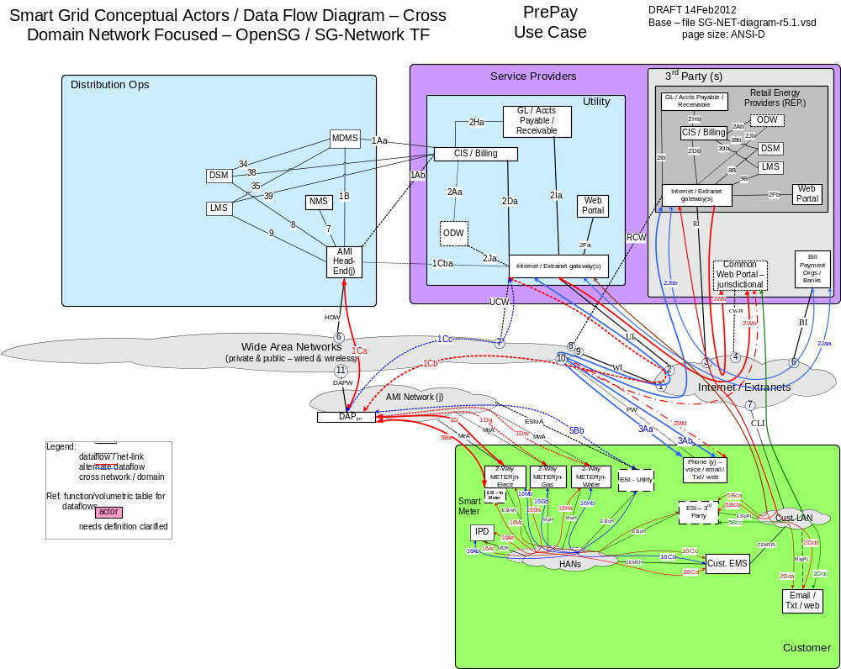

Possible communications paths
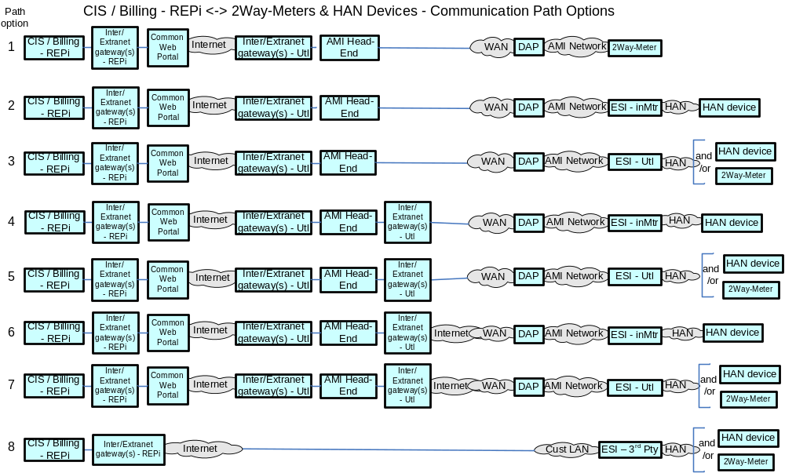

Actors
2-Way Meter - Electr | A bi-directional communication device used to perform measurement of electrical energy usage for residential use.
2-Way Meter - Gas | A bi-directional communication device used to perform measurement of gas consumption for residential use.
2-Way Meter - Water | A bi-directional communication device used to perform measurement of water consumption for residential use.
AMI Head-End(j) | The AMI head end is responsible for the operation and coordination of AMI system components. It represents the central nervous system of the AMI system.
CIS/Billing - REPi | A third party billing system used for reconcilling customer payments for electricity usage. This system may also be used for manageing vendors of electricity generation.
CIS/Billing - Utility | A utility billing system used for reconcilling customer payments for electricity usage. This system may also be used for manageing vendors of electricity generation.
Common Web Portal | Web interface for Regional Transmission Operator, customers, retail electric providers and transmission/distribution service provider to function as a clearing house for energy information.
Cust. EMS | A customer owned energy management system used to manage energy with a premises.
DAPjm | This is the Data Aggregation Point on the NAN. It is essentially the point of convergence for all communication between SG devices and utility back office systems. In this specific use case it provides a communication conduit for AMI Smart Meters.The su
ESI - 3rd Party | An ESI, owned by the Customer and not provided by the Utility, which enables secure interactions between HAN Devices Registered on its network and the service provider e.g. REP. The 3rd Party ESI functionality may reside in the Customer EMS or customer's
ESI - In Meter | An ESI, owned by the Utility and resides in the Utility meter, which enables secure interactions between HAN Devices Registered on its network and the Utility AMI.
ESI - Utility | An ESI, owned by the Utility, which enables secure interactions between HAN Devices Registered on its network and the Utility AMI. The Utility ESI functionality may reside in the Customer EMS or customer broadband router.
Internet / Extranet gateway(s) - REPi | These are gateways used to connect internal utility networks with external networks.
Internet / Extranet gateway(s) - Utility | These are gateways used to connect internal utility networks with external networks.
IPD | In Premise Display
MDMS | The application responsible for the collection and retrieval of all relevant customer information for purposes of billing and facilitating interaction.
NMS | A system or series of systems that are utilized to operate and manage utility assets that interact on any given network. These assets are comprised of both hardware and software components that require ongoing monitoring and management.
Web Portal - REPi | Web interface for Regional Transmission Operator, customers, retail electric providers and transmission/distribution service provider to function as a clearing house for energy information. Commonly used in deregulated markets.
Web Portal - Utility | Web interface for Regional Transmission Operator, customers, retail electric providers and transmission/distribution service provider to function as a clearing house for energy information. Commonly used in deregulated markets.

Scenarios

Customer Enroll or Un-Enroll and Meter Configuration

Narrative
Electric meters may be enrolled in prepayment programs through the use of customer requests to the CIS infrastructure. There are several sources of the enroll request that can be collapsed into two basic types, one from browsers at the customer premise and one from the customer mobile browser. Specified here are two collapsed un-enroll use cases for premise and mobile browser requests.
Business Objectives

Customer Enroll Mobile Browser

Originating Actor | Desination Actor | Latency | Reliability | Payload Size | Payload Name
Cust. Browser - Mobile | CIS | < 30s | >99% | 100 | prepay_cust_enroll_cmd
CIS/Billing - Utility | Meter | < 1m | >98% | 25 | prepay_meter_config_cmd
Smart Meter | CIS/Billing - Utility,  MDMS | < 1m | >98% | 25 | SW_opr_cmd_ack
Totals |  | < 2:30m | >95% | 150

Customer Enroll Premise Browser

Originating Actor | Desination Actor | Latency | Reliability | Payload Size | Payload Name
Cust. Browser - Premis | CIS | < 15s | >99% | 100 | prepay_cust_enroll_cmd
CIS/Billing - Utility | Meter | < 1m | >98% | 25 | prepay_meter_config_cmd
Smart Meter | CIS/Billing - Utility,  MDMS | < 1m | >98% | 25 | SW_opr_cmd_ack
Totals |  | < 2:15m | >95% | 150

Customer Un-Enroll Mobile Browser

Originating Actor | Desination Actor | Latency | Reliability | Payload Size | Payload Name
Cust. Browser - Mobile | CIS | < 30s | >99% | 100 | prepay_cust_unenroll_cmd
CIS/Billing - Utility | Meter | < 1m | >98% | 25 | prepay_meter_config_cmd
Smart Meter | CIS/Billing - Utility,  MDMS | < 1m | >98% | 25 | SW_opr_cmd_ack
Totals |  | < 2:30m | >95% | 150

Customer Enroll Premise Browser

Originating Actor | Desination Actor | Latency | Reliability | Payload Size | Payload Name
Cust. Browser - Premis | CIS | < 15s | >99% | 100 | prepay_cust_unenroll_cmd
CIS/Billing - Utility | Meter | < 1m | >98% | 25 | prepay_meter_config_cmd
Smart Meter | CIS/Billing - Utility,  MDMS | < 1m | >98% | 25 | SW_opr_cmd_ack
Totals |  | < 2:15m | >95% | 150

Implications and Rationale

Functional Domain | Expected Potential Impact | Rationale
Bulk Generation
Customer | X | Cannot enroll or un-enroll prepay services
Distribution
Markets
Operation | X | Systems will have to retry communications
Service Providers
Transmission

On-Demand Meter Read

See Section X.X.X.X On-Demand Meter Read

On-Demand Meter Read Errors

See Section X.X.X.X On-Demand Meter Read Errors

PrePay Messaging to Customer

Narrative
The CIS actors may need to send messages to PrePay customers from time to time to inform customers on items like price, available credit, or general broadcast messages. The CIS actor can send messages to different actors which are the IHD, the Customer EMS. The communication characteristics can be collapsed for simplification to one use case shown below.
Business Objectives

Originating Actor | Desination Actor | Latency | Reliability | Payload Size | Payload Name
CIS | Cust. EMS  Or  IHD | < 30s | >99.5% | 50 -100 | prepay_msg_[1of10]_resp-data
Cust. EMS  Or  IHD | CIS | ? | ? | ? | ?????_resp_data_ack
Totals

Implications and Rationale

Functional Domain | Expected Potential Impact | Rationale
Bulk Generation
Customer | X | Cannot enroll or un-enroll prepay services
Distribution
Markets
Operation | X | Systems will have to retry communications
Service Providers
Transmission

Customer Payments

Narrative
Customers must make payments in order to continue to receive electric service. Non-payment will ultimately result in a meter disconnection of service. It is assumed that the payment and credit activities are out of scope from this document. Customer account levels and the display of that information on the IHD are in scope.
The use cases described above for PrePay Messaging to Customers is assumed to cover this use case.

Service Switch Operation

Narrative
Service Switch Operations are used within these use cases for the purpose of shutting off electric service to those PrePay customers who have not paid for service and have run out of funds in their accounts. The process for determining account funding are out of scope for this document. This use case will begin with the need of the CIS actors to operate the service swith on or off.
It is assumed that there are other use cases describing service switch operation.
Business Objectives

Service Switch Operation – Turn Off – Response from Meter state is OFF

Originating Actor | Desination Actor | Latency | Reliability | Payload Size | Payload Name
CIS/Billing - Utility | Smart Meter | < 1m | > 98% | 25 | SW_state_cmd
Smart Meter | CIS/Billing - Utility,  MDMS,  LMS,  DSM | < 1m | > 98% | 100 | SW_state_cmd_resp-data
Totals

Service Switch Operation – Turn Off – Response from Meter state is ON – no comm. errors

Originating Actor | Desination Actor | Latency | Reliability | Payload Size | Payload Name
CIS/Billing - Utility | Smart Meter | < 1m | > 98% | 25 | SW_state_cmd
Smart Meter | CIS/Billing - Utility,  MDMS,  LMS,  DSM | < 1m | > 98% | 100 | SW_state_cmd_resp-data
CIS/Billing - Utility | Smart Meter | < 1m | > 98% | 25 | SW_opr_cmd
Smart Meter | CIS/Billing - Utility,  MDMS | < 3m | > 98% | 25 | SW_opr_cmd_ack
Totals

Service Switch Operation – Turn Off – Response from Meter state is ON – With comm. errors

Sequence | Originating Actor | Desination Actor | Latency | Reliability | Payload Size | Payload Name
1 | CIS/Billing - Utility | Smart Meter | < 1m | > 98% | 25 | SW_state_cmd
2 | Smart Meter | CIS/Billing - Utility,  MDMS,  LMS,  DSM | < 1m | > 98% | 100 | SW_state_cmd_resp-data
3 | CIS/Billing - Utility | Smart Meter | < 1m | > 98% | 25 | SW_opr_cmd
4 | Smart Meter | CIS/Billing - Utility,  MDMS | < 3m | > 98% | 50 | SW_opr_fail_cmd-err
4 | DAP | CIS/Billing - Utility,  MDMS,  NMS | < 1m | > 99% | 50 | SW_opr_cmd_comm-err
4 | Smart Meter | CIS/Billing - Utility,  MDMS | < 3m | > 98% | 50 | SW_opr_fail_cmd-err
 | Totals

Implications and Rationale
Functional Domain | Expected Potential Impact | Rationale

Service Switch Operation Errors

Narrative

Business Objectives

Originating Actor | Desination Actor | Latency | Reliability | Payload Size | Payload Name
Totals

Implications and Rationale
Functional Domain | Expected Potential Impact | Rationale

Distribution Grid Management

Overview of Business Processes
The following sections outline business use cases for distribution automation. Distribution Automation represents a fairly complex set of use cases and requirements. The implementations of these use cases, and their accompanying requirements, will vary from utility to utility. In addition, the implementation of distribution automation assets is not uniform across utilities.
The association of devices to specific use cases will vary across different distribution monitoring and control devices. The author’s intent is to capture the numerous use case requirements across these monitoring and control devices. The intent is to reflect which use cases can be applied to different distribution automation devices.
Since utility’s Distribution Automation implementations vary, the authors wished to provide a menu of different devices and use cases that could be customized to specific utility needs.
Initially we define the use cases by their respective business process. Since Distribution Automation is a complex application, encumbering numerous applications that can be implemented in a number of ways, we have attempted to map the Distribution Automation business processes to specific distribution devices in an effort to provide an accurate depiction of the roles and uses relating different devices in a distribution network.

Reference Architecture with Domains, Actors and Interfaces
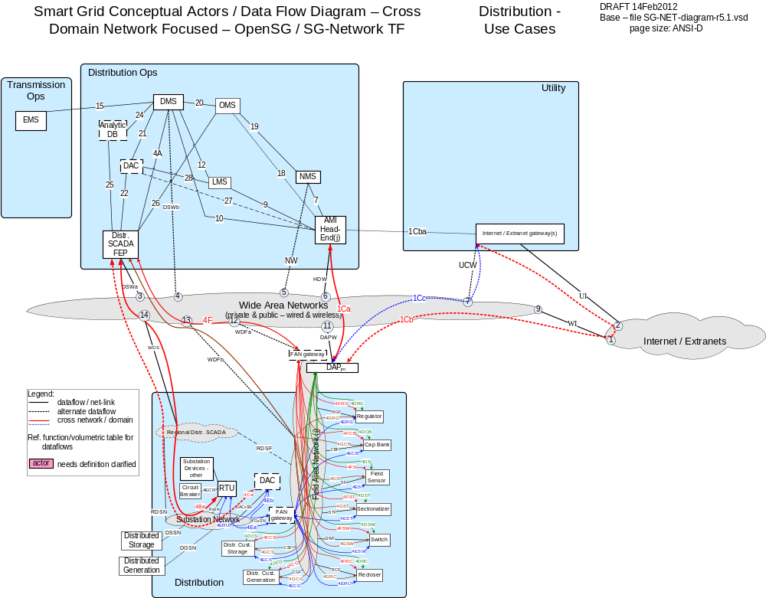

Possible communication paths

Business Process Definitions

Maintenance

Overview
Physical distribution devices require maintenance procedures to make sure that the equipment is functioning properly. These procedures can include self checks on equipment, poling equipment at scheduled intervals, and reading sensor data to monitor equipment conditions. There are several devices that fall into this category. The term Feeder Line Device is used to represent any of the following in this maintenance use case:
- Capacitor Bank Controller (CBC)
- Fault Detector
- Recloser
- Line Sensor
- Switch
- Voltage Regulator

Scenario: Feeder Line Device Alarm

Narrative
The Feeder Line Device sends an alarm to SCADA that is operating improperly.

Business Objectives
Originating Actor | Destination Actor | Latency | Reliability | Payload Size | Payload Name
Feeder Line Device | SCADA | < 5 seconds | 99.5% | 50 | FeederCBC_alarm  FeederFault_Detector_alarm  FeederRecloser_alarm  FeederSensor_alarm  FeederSwitch_alarm  FeederVR_alarm
Totals |  | < 5 seconds | 99.5%

Implications and Rationale
Functional Domain | Expected Potential Impact | Rationale
Bulk Generation
Customer | X | Customer voltage and VAR flow negatively impacted
Distribution | X | Circuit feeder efficiency reduced
Markets
Operation | X | Loss of system communication or improper operation
Service Providers
Transmission | X | Device groupings not functional for mass operation.

Scenario: Feeder Line Device Deviation Alert

Narrative
The Feeder Line Device sends an alarm to SCADA that is operating outside of its normal boundaries. An example of this would be the system voltage drops under a predetermined level.

Business Objectives
Originating Actor | Destination Actor | Latency | Reliability | Payload Size | Payload Name
Feeder Line Device | SCADA | < 5 seconds | 99.5% | 50 | FeederCBC_deviation_alert  FeederFault_Detector_deviation_alert  FeederRecloser_deviation_alert  FeederSensor_deviation_alert  FeederSwitch_deviation_alert  FeederVR_deviation_alert
Totals |  | < 5 seconds | 99.5%

Implications and Rationale
Functional Domain | Expected Potential Impact | Rationale
Bulk Generation
Customer | X | Customer voltage and VAR flow negatively impacted
Distribution | X | Circuit feeder efficiency reduced
Markets
Operation | X | Loss of system communication or improper operation
Service Providers
Transmission | X | CBC groupings not functional for mass operation.

Scenario: Feeder Line Device Operate Failure

Narrative
The Feeder Line Device sends an alarm to SCADA that is has failed to operate. An example would be that the unit tries to open or close and is unable to do so because of a physical malfunction of the control linkage.
Business Objectives
Originating Actor | Destination Actor | Latency | Reliability | Payload Size | Payload Name
Feeder Line Device | SCADA | < 5 seconds | 99.5% | 50 | FeederCBC_Operate_failure  FeederRecloser_Operate_failure  FeederSwitch_Operate_failure  FeederVR_Operate_failure
Totals |  | < 5 seconds | 99.5%

Implications and Rationale
Functional Domain | Expected Potential Impact | Rationale
Bulk Generation
Customer | X | Customer voltage and VAR flow negatively impacted
Distribution | X | Circuit feeder efficiency reduced
Markets
Operation | X | Loss of system communication or improper operation
Service Providers
Transmission | X | Device groupings not functional for mass operation.

Scenario: Feeder Line Device Sensor Data Maintenance

Narrative
SCADA sends a command to the Feeder Line Device to issue a retrieval of the sensor data. This can be used to determine physical conditions of the unit.

Business Objectives
Originating Actor | Destination Actor | Latency | Reliability | Payload Size | Payload Name
SCADA | Feeder Line Device | < 5 seconds | 99.5% | 50 | FeederCBC_sensor_data_command  FeederFault_Detector_sensor_data_cmd  FeederRecloser_sensor_data_cmd  FeederSensor_sensor_data_cmd  FeederSwitch_sensor_data_cmd  FeederVR_sensor_data_cmd
Feeder Line Device | SCADA | < 5 seconds | 99.5% | 100 | FeederCBC_sensor_data_resp-data  FeederFault_Detector_sensor_data_resp-data  FeederRecloser_sensor_data_resp-data  FeederSensor_sensor_data_resp-data  FeederSwitch_sensor_data_resp-data  FeederVR_sensor_data_resp-data
Totals |  | < 5 seconds | 99.5%

Implications and Rationale
Functional Domain | Expected Potential Impact | Rationale
Bulk Generation
Customer | X | Customer voltage and VAR flow negatively impacted
Distribution | X | Circuit feeder efficiency reduced
Markets
Operation | X | Loss of system communication or improper operation
Service Providers
Transmission | X | Device groupings not functional for mass operation.

Scenario: Feeder Line Device Status Change Alert

Narrative
The Feeder Line Device sends a message to SCADA notifying the system that there has been a status change that’s either intentional or caused by a failure.
Business Objectives
Originating Actor | Destination Actor | Latency | Reliability | Payload Size | Payload Name
Feeder Line Device | SCADA | < 5 seconds | 99.5% | 50 | FeederCBC_status_change_alert  FeederFault_Detector_status_change_alert  FeederRecloser_status_change_alert  FeederSensor_status_change_alert  FeederSwitch_status_change_alert  FeederVR_status_change_alert
Totals |  | < 5 seconds | 99.5%

Implications and Rationale
Functional Domain | Expected Potential Impact | Rationale
Bulk Generation
Customer | X | Customer voltage and VAR flow negatively impacted
Distribution | X | Circuit feeder efficiency reduced
Markets
Operation | X | Loss of system communication or improper operation
Service Providers
Transmission | X | Device groupings not functional for mass operation.

Scenario: Feeder Line Device Sensor Data Maintenance

Narrative
SCADA sends a command to the Feeder Line Device to issue a retrieval of the status. An example would be the present state (open/close) or active/deactive/functioning properly.

Business Objectives
Originating Actor | Designation Actor | Latency | Reliability | Payload Size | Payload Name
SCADA | Feeder Line Device | < 5 seconds | 99.5% | 50 | FeederCBC_status_cmd  FeederFault_Detector_status_cmd  FeederRecloser_status_cmd  FeederSensor_status_cmd  FeederSwitch_status_cmd  FeederVR_status_cmd
Feeder Line Device | SCADA | < 5 seconds | 99.5% | 100 | FeederCBC_status_resp-data  FeederFault_Detector_status_resp-data  FeederRecloser_status_resp-data  FeederSensor_status_resp-data  FeederSwitch_status_resp-data  FeederVR_status_resp-data
Totals |  | < 5 seconds | 99.5%

Implications and Rationale
Functional Domain | Expected Potential Impact | Rationale
Bulk Generation
Customer | X | Customer voltage and VAR flow negatively impacted
Distribution | X | Circuit feeder efficiency reduced
Markets
Operation | X | Loss of system communication or improper operation
Service Providers
Transmission | X | Device groupings not functional for mass operation.

Voltage and VAR Monitoring

Overview: Voltage and VAR Management can reduce load while respecting given voltage tolerance (normal and emergency), conserve energy, reduce or eliminate overload in transmission lines, reduce or eliminate voltage violations on transmission lines, provide reactive power support for transmission/distribution bus, provide spinning reserve support, and/or minimize cost of energy. For the distribution system, communications required for Voltage and VAR Management include monitoring of feeder line devices by polling or self-read at scheduled intervals, configuration or control of some of these feeder line devices, and can also include device deviations for operation outside of desired range. Voltage and VAR Management can be Centralized with the most requirements for communications, or Distributed with the ability to coordinate between feeder line devices dependent on the amount of peer-to-peer communications.

- Substation Sensor (on feeder circuit breaker or feeder bus)
- Capacitor Bank Controller (CBC)
- Recloser
- Line Sensor
- Switch
- Voltage Regulator
- Customer Meter

Scenario: Device Deviation Alert

Narrative
The device sends an alarm to SCADA that is operating outside of its normal boundaries. An example of this would be the system voltage drops under a predetermined level.

Business Objectives
Originating Actor | Destination Actor | Latency | Reliability | Payload Size | Payload Name
Device | SCADA | < 5 seconds | 99.5% | 50 | FeederCBC_deviation_alert  FeederRecloser_deviation_alert  FeederSensor_deviation_alert  FeederSwitch_deviation_alert  FeederVR_deviation_alert
Totals |  | < 5 seconds | 99.5%

Implications and Rationale
Functional Domain | Expected Potential Impact | Rationale
Bulk Generation
Customer | X | Customer voltage and VAR flow negatively impacted
Distribution | X | Circuit feeder efficiency reduced
Markets
Operation | X | Loss of system communication or improper operation
Service Providers
Transmission | X | CBC groupings not functional for mass operation.

Scenario: Device Sensor Data- Poll

Narrative
SCADA sends a command to the device to issue a retrieval of the sensor data at scheduled intervals.

Business Objectives
Originating Actor | Destination Actor | Latency | Reliability | Payload Size | Payload Name
SCADA | Device | < 5 seconds | 99.5% | 50 | FeederCBC_sensor_data_command  FeederRecloser_sensor_data_cmd  FeederSensor_sensor_data_cmd  FeederSwitch_sensor_data_cmd  FeederVR_sensor_data_cmd
Device | SCADA | < 5 seconds | 99.5% | 100 | FeederCBC_sensor_data_resp-data  FeederRecloser_sensor_data_resp-data  FeederSensor_sensor_data_resp-data  FeederSwitch_sensor_data_resp-data  FeederVR_sensor_data_resp-data
Totals |  | < 5 seconds | 99.5%

Implications and Rationale
Functional Domain | Expected Potential Impact | Rationale
Bulk Generation
Customer | X | Customer voltage and VAR flow negatively impacted
Distribution | X | Circuit feeder efficiency reduced
Markets
Operation | X | Loss of system communication or improper operation
Service Providers
Transmission | X | Device groupings not functional for mass operation.

Scenario: Device Sensor Data- Push

Narrative
Self-read of sensor data at scheduled intervals.

Business Objectives
Originating Actor | Destination Actor | Latency | Reliability | Payload Size | Payload Name
Device | SCADA | < 5 seconds | 99.5% | 100 | FeederCBC_sensor_data_resp-data  FeederRecloser_sensor_data_resp-data  FeederSensor_sensor_data_resp-data  FeederSwitch_sensor_data_resp-data  FeederVR_sensor_data_resp-data
Totals |  | < 5 seconds | 99.5%

Implications and Rationale
Functional Domain | Expected Potential Impact | Rationale
Bulk Generation
Customer | X | Customer voltage and VAR flow negatively impacted
Distribution | X | Circuit feeder efficiency reduced
Markets
Operation | X | Loss of system communication or improper operation
Service Providers
Transmission | X | Device groupings not functional for mass operation.

Scenario: Device Status Change Alert

Narrative
The device sends a message to SCADA notifying the system that there has been a status change that’s intentional.
Business Objectives
Originating Actor | Destination Actor | Latency | Reliability | Payload Size | Payload Name
Device | SCADA | < 5 seconds | 99.5% | 50 | FeederCBC_status_change_alert  FeederRecloser_status_change_alert  FeederSensor_status_change_alert  FeederSwitch_status_change_alert  FeederVR_status_change_alert
Totals |  | < 5 seconds | 99.5%

Implications and Rationale
Functional Domain | Expected Potential Impact | Rationale
Bulk Generation
Customer | X | Customer voltage and VAR flow negatively impacted
Distribution | X | Circuit feeder efficiency reduced
Markets
Operation | X | Loss of system communication or improper operation
Service Providers
Transmission | X | Device groupings not functional for mass operation.

Distribution System Demand Response DSDR

Overview: Distribution System Demand Response is an operational mode that reduces the voltage on the Distribution Grid to help manage system load during periods of peak demand. The parallel goal is to avoid violating any low voltage limits on the grid.

This use case encompasses four types of distribution feeder devices that operate within the parameters of demand response. These devices include:
- Capacitor Banks
- Line Sensors
- Automated Feeder Switches
- Voltage Regulators
Below is an example architecture layout showing the Domain, Actors and Interfaces used in this use case.
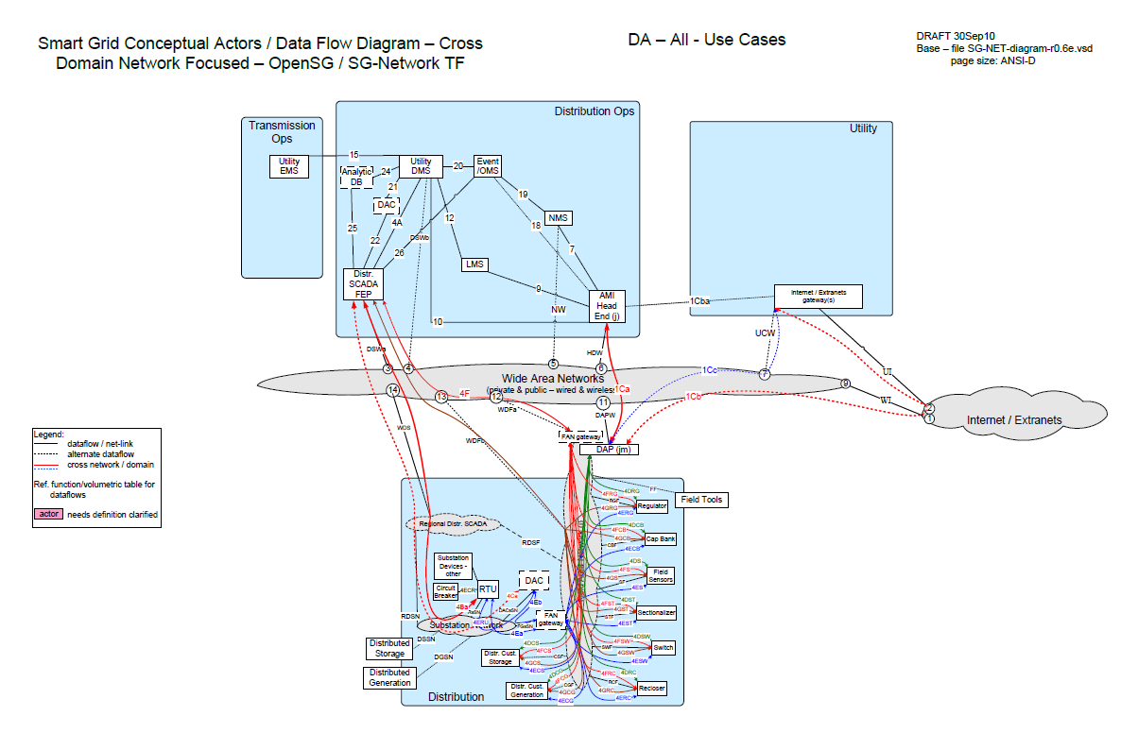
Flow Diagram Figure XX

Communication: The following examples show the communication paths that are implemented with the distribution devices above (shown as a field device in the diagram). It is important to note that the communication strategy varies based upon the network that is chosen for back haul:

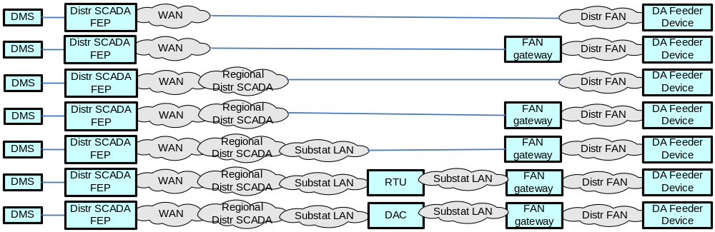
Communication Options Figure XX

Actors
Name | Description
Automated Feeder Switches | These devices are deployed at critical points within the Distribution network for purposes of isolating electric faults and providing system telemetry regarding the performance of the electric system.
Slave | This device provides the radio communication to the field device.
Master | This device provides radio communication between the Front End Processor, DMS and the field device.
Front End Processor | This device serves as the primary conduit for issuing commands from DMS/SCADA and receiving information from field devices deployed with in the Distribution network.
Distribution Management System and SCADA | Application responsible for collection of distributed information and issuance of Distribution Automation commands.
Voltage Regulators | These devices are deployed at critical points within the Distribution network for purposes of regulating voltage and providing system telemetry regarding the performance of the electric system.
Capacitor Bank | An Intelligent Electronic Device that provides electronic analog performance information, status and fault information. In addition, the device can be remotely controlled in order to increase voltage on a given segment of the Distribution network.
Line Sensor | A device capable of providing data on distribution and secondary line systems to show current, voltage, fault indication, loading or phase conditions.
Transformer Monitor | An Intelligent Electronic Device that provides electronic analog performance information, status and fault information.

Scenarios

Scenario: CBC Configuration

Narrative
The Capacitor Bank Controller may need to be configured remotely to allow it to function in different operating modes. Some examples of these changes include adjusting time schedules for automatic turn on, voltage thresholds, and IP settings. The communication would take place from DMS/SCADA though the network path to the end device.

Business Objectives
Originating Actor | Destination Actor | Latency | Reliability | Payload Size | Payload Name
DMS | CBC | < 5 seconds | 99.5% | 500 | FeederCBC_new_config_cmd
CBC | DMS | < 5 seconds | 99.5% | 25 | FeederCBC_new_config_ack
Totals |  | < 10 seconds | 99%

Implications and Rationale
Functional Domain | Expected Potential Impact | Rationale
Bulk Generation
Customer | X | Customer voltage and VAR flow negatively impacted
Distribution | X | Circuit feeder efficiency reduced
Markets
Operation | X | Loss of system communication or improper operation
Service Providers
Transmission | X | CBC groupings not functional for mass operation.

Scenario: CBC Operation (Open/Close)

Narrative
The CBC controls the capacitors by opening and closing breakers that feed onto the line system. This is the primary function of the unit when it operates. The operation is controlled by the control unit and can be directly operated from OMS based upon system conditions or other predefined requirements.

Business Objectives
Originating Actor | Destination Actor | Latency | Reliability | Payload Size | Payload Name
DMS | CBC | < 5 seconds | 99.5% | 150 | FeederCBC_open_cmd  FeederCBC_close_cmd
CBC | DMS | < 5 seconds | 99.5% | 25 | FeederCBC_open_ack  FeederCBC_close_ack
Totals |  | < 10 seconds | 99%

Implications and Rationale
Functional Domain | Expected Potential Impact | Rationale
Bulk Generation
Customer | X | Customer voltage and VAR flow negatively impacted
Distribution | X | Circuit feeder efficiency reduced
Markets
Operation | X | Loss of system communication or improper operation
Service Providers
Transmission | X | CBC groupings not functional for mass operation.

Scenario: CBC Data Read/Respond

Narrative
The CBC sends back data points related to both the device itself (housing temperature and breaker status), and line conditions (voltage, current, phase). These data groupings are used to monitor the status of the device and also check for line conditions that may be used for analysis in the DMS as an additional node point. The retrieval is initiated from DMS/SCADA and can be set for required intervals.

Business Objectives
Originating Actor | Destination Actor | Latency | Reliability | Payload Size | Payload Name
DMS | CBC | < 2 seconds | 99.5% | 50 | FeederCBC_sensor_data_cmd
CBC | DMS | < 2 seconds | 99.5% | 100 | FeederCBC_sensor_data_resp-data
Totals |  | < 4 seconds | 99%

Implications and Rationale
Functional Domain | Expected Potential Impact | Rationale
Bulk Generation
Customer
Distribution | X | Circuit feeder efficiency reduced
Markets
Operation | X | Loss of data causing DMS and other systems to analyze line conditions off of inaccurate or reduced information. Affects power flow studies.
Service Providers
Transmission

Scenario: Sensor Configuration

Narrative
Line sensors that bring back data can be configured based upon the type of device and its role. The configurations include network changes, rate of reads, and alarm thresholds for notification. The changes are issued from DMS or a third party provider if the sensor operates on a proprietary network.
Business Objectives
Originating Actor | Destination Actor | Latency | Reliability | Payload Size | Payload Name
DMS | Sensor | < 5 seconds | 99.5% | 500 | FeederSensor_new_config_cmd
Sensor | DMS | < 5 seconds | 99.5% | 25 | FeederSensor_new_config_ack
Totals |  | < 10 seconds | 99%

Implications and Rationale
Functional Domain | Expected Potential Impact | Rationale
Bulk Generation
Customer | X | Outage restoration time increased
Distribution | X | Circuit feeder status inaccurate
Markets
Operation | X | Outage and fault location time increased
Service Providers
Transmission

Scenario: Sensor Data Read/Respond

Narrative
Line sensors fall into two operational modes. The first is exception based reporting where the device senses an event and initiates a message back to DMS. The second mode is normal operation where some devices can be commanded to send interval data back on primary and secondary line conditions.
Business Objectives
Originating Actor | Destination Actor | Latency | Reliability | Payload Size | Payload Name
DMS | Sensor | < 2 seconds | 99.5% | 150 | FeederSensor_sensor_data_cmd
Sensor | DMS | < 2 seconds | 99.5% | 250 | FeederSensor_sensor_data_resp-data
Totals |  | < 4 seconds | 99%

Implications and Rationale
Functional Domain | Expected Potential Impact | Rationale
Bulk Generation
Customer | X | Outage restoration time increased
Distribution | X | Circuit feeder status inaccurate
Markets
Operation | X | Outage and fault location time increased
Service Providers
Transmission

Scenario: Switch Configuration

Narrative
Motor operated switch gear can be configured for several roles. These units operate based upon a direct command from the system or in a team of switches that is set for automatic reconfiguration of a system based upon defined parameters.

Business Objectives
Originating Actor | Destination Actor | Latency | Reliability | Payload Size | Payload Name
DMS | Switch | < 5 seconds | 99.5% | 500 | FeederSwitch_new_config_cmd
Switch | DMS | < 5 seconds | 99.5% | 25 | FeederSwitch_new_config_ack
Totals |  | < 10 seconds | 99%
Implications and Rationale
Functional Domain | Expected Potential Impact | Rationale
Bulk Generation
Customer | X | May experience unnecessary or lengthened outages
Distribution | X | Circuit remains in wrong configuration
Markets
Operation | X | Switch not set for optimal operation
Service Providers
Transmission

Scenario: Switch Operation (Open/Close)

Narrative
DMS/SCADA issues a command to the switch to open or close because of a needed grid system change. This can be used to help sectionalize a fault for circuit restoration or allow for a line reconfiguration off of a looped feed or neighboring circuit.
Business Objectives
Originating Actor | Destination Actor | Latency | Reliability | Payload Size | Payload Name
DMS | Switch | < 5 seconds | 99.5% | 150 | FeederSwitch_open_cmd  FeederSwitch_close_cmd
Switch | DMS | < 5 seconds | 99.5% | 25 | FeederSwitch_open_ack  FeederSwitch_close_ack
Totals |  | < 10 seconds | 99%

Implications and Rationale
Functional Domain | Expected Potential Impact | Rationale
Bulk Generation
Customer | X | May experience unnecessary or lengthened outages
Distribution | X | Switch remains in wrong position causing loss of power or added load on a circuit
Markets
Operation | X | Operation Failure
Service Providers
Transmission

Scenario: Switch Data Read/Respond

Narrative
Motor operated switches are capable of sending information including device status, breaker position, temperature, and voltage information. The data package can include information about the switch or the line itself (with installed sensors). This information is used in DMS to determine circuit configurations and line conditions.
Business Objectives
Originating Actor | Destination Actor | Latency | Reliability | Payload Size | Payload Name
DMS | Switch | < 2 seconds | 99.5% | 50 | FeederSwitch_sensor_data_cmd
Switch | DMS | < 2 seconds | 99.5% | 100 | FeederSwitch_sensor_data_resp-data
Totals |  | < 4 seconds | 99%

Implications and Rationale
Functional Domain | Expected Potential Impact | Rationale
Bulk Generation
Customer
Distribution | X | Failure to communicate and know switch status
Markets
Operation | X | Unable to make decisions based upon real time information
Service Providers
Transmission

Scenario: Voltage Regulator Configuration

Narrative
Voltage regulators can be configured to operate and raise or lower levels based upon set thresholds on the device. The device can be set to operate independently or by direct control from DMS.

Business Objectives
Originating Actor | Destination Actor | Latency | Reliability | Payload Size | Payload Name
DMS | Voltage Regulator | < 5 seconds | 99.5% | 500 | FeederVR_new_config_cmd
Voltage Regulator | DMS | < 5 seconds | 99.5% | 25 | FeederVR_new_config_ack
Totals |  | < 10 seconds | 96%

Implications and Rationale
Functional Domain | Expected Potential Impact | Rationale
Bulk Generation
Customer | X | Negative impact on secondary voltage levels
Distribution | X | Line not conditioned properly to meet 120v base
Markets
Operation
Service Providers
Transmission

Scenario: Voltage Regulator Step Operation

Narrative
The Voltage Regulator has a series of steps that can be raised and lowered to change the output voltage on the primary line system. These devices are used to help keep the voltage within the operating guidelines of the system.
Business Objectives
Originating Actor | Destination Actor | Latency | Reliability | Payload Size | Payload Name
DMS | Voltage Regulator | < 2 seconds | 99.5% | 250 | FeederVR_step_up_cmd  FeederVR_step_down_cmd
Voltage Regulator | DMS | < 2 seconds | 99.5% | 25 | FeederVR_step_up_ack  FeederVR_step_down_ack
Totals |  | < 4 seconds | 99%

Implications and Rationale
Functional Domain | Expected Potential Impact | Rationale
Bulk Generation
Customer | X | Negative impact on secondary voltage levels
Distribution | X | Line not conditioned properly to meet 120v base
Markets
Operation
Service Providers
Transmission

Scenario: Voltage Regulator Data read/Respond

Narrative
The voltage regulator can have sensors built into the device that act as another node point on the line for retrieving feeder data. This data can be used with other devices to make a clear picture of the grid system to an operator or an automatic DMS setup.

Business Objectives
Originating Actor | Destination Actor | Latency | Reliability | Payload Size | Payload Name
DMS | Voltage Regulator | < 2 seconds | 99.5% | 150 | FeederVR_sensor_data_cmd
Voltage Regulator | DMS | < 2 seconds | 99.5% | 1000 | FeederVR_sensor_data_resp-data
Totals |  | < 4 seconds | 99%

Implications and Rationale
Functional Domain | Expected Potential Impact | Rationale
Bulk Generation
Customer
Distribution | X | System voltage levels are not maintained properly.
Markets
Operation | X | System does not receive real time updates of line conditions
Service Providers
Transmission

Scenario: Distributed Device Operations

Narrative
Each of the devices above (except sensors) can operate in a distributed mode if programmed to do so by the utility. The device will respond to DMS with an indication of the action that has been performed remotely.

Business Objectives
Originating Actor | Destination Actor | Latency | Reliability | Payload Size | Payload Name
CBC | DMS | < 5 seconds | 99.5% | 25 | FeederCBC_open_ack
CBC | DMS | < 5 seconds | 99.5% | 25 | FeederCBC_close_ack
Voltage Regulator | DMS | < 5 seconds | 99.5% | 25 | FeederVR_step_up_ack
Voltage Regulator | DMS | < 5 seconds | 99.5% | 25 | FeederVR_step_down_ack
Switch | DMS | < 5 seconds | 99.5% | 25 | FeederSwitch_open_ack
Switch | DMS | < 5 seconds | 99.5% | 25 | FeederSwitch_close_ack

Implications and Rationale
Functional Domain | Expected Potential Impact | Rationale
Bulk Generation
Customer
Distribution | X | Decision analysis would be performed on inaccurate data and improper line configurations
Markets
Operation | X | System is not aware of the actual status and configuration on the circuits.
Service Providers
Transmission

Line Segmentation
Line segmentation is the concept of dynamically reconfiguring loop feeders to restore the maximum number of customers after a fault has caused a section of the gird (i.e. a feeder segment) to be out of service.

Distributed Energy Resources
Distributed Energy Resources, also called on-site generation, dispersed generation, embedded generation, decentralized generation, decentralized energy or distributed generation, generates electricity from many small energy sources.

Actors
Actor | Description
Automated Feeder Switches | These devices are deployed at critical points with in the Distribution network for purposes of isolating electric faults and providing system telemetry regarding the performance of the electric system.
Slave | This device provides the radio communication to the Automated Feeder switch.
Master | This device provides radio communication between the Front End Processor, DMS and the automated feeder switch.
Front End Processor | This device serves as the primary conduit for issuing commands from DMS/SCADA and receiving information from field devices deployed with in the Distribution network.
Distribution Management System and SCADA | Application responsible for collection of distributed information and issuance of Distribution Automation commands.
Automated Feeder Switches | These devices are deployed at critical points within the Distribution network for purposes of isolating electric faults and providing system telemetry regarding the performance of the electric system.
Voltage Regulators | These devices are deployed at critical points within the Distribution network for purposes of regulating voltage and providing system telemetry regarding the performance of the electric system.
Capacitor Bank | An Intelligent Electronic Device that provides electronic analog performance information, status and fault information. In addition, the device can be remotely controlled in order to increase voltage on a given segment of the Distribution network.
Fault Current Indicator | An Intelligent Electronic Device that provides electronic analog performance information, status and fault information.
Transformer Monitor | An Intelligent Electronic Device that provides electronic analog performance information, status and fault information.
Voltage and Current sensor | An Intelligent Electronic Device that provides electronic analog performance information, status and fault information.
Network Protector | An Intelligent Electronic Device that provides electronic analog performance information, status and fault information.
Throw Over Switch | A device that provides electronic analog status and fault information.
Table 13 - Distribution Automation Actor Descriptions

Distribution System Demand Response
FeederCapBank_close_ack
FeederCapBank_close_cmd
FeederCapBank_new_config_ack
FeederCapBank_new_config_cmd
FeederCapBank_open_ack
FeederCapBank_open_cmd
FeederCapBank_sensor_data_cmd
FeederCapBank_sensor_data_resp-data
FeederRegulator_new_config_ack
FeederRegulator_new_config_cmd
FeederRegulator_sensor_data_cmd
FeederRegulator_sensor_data_resp-data
FeederRegulator_step_down_ack
FeederRegulator_step_down_cmd
FeederRegulator_step_up_ack
FeederRegulator_step_up_cmd
FeederSensor_new_config_ack
FeederSensor_new_config_cmd
FeederSensor_sensor_data_cmd
FeederSensor_sensor_data_resp-data
FeederSwitch_close_ack
FeederSwitch_close_cmd
FeederSwitch_new_config_ack
FeederSwitch_new_config_cmd
FeederSwitch_open_ack
FeederSwitch_open_cmd
FeederSwitch_sensor_data_cmd
FeederSwitch_sensor_data_resp-data

Energy Storage

Islanded Distribution Customer Storage

Overview

Reference Architecture with Domains, Actors and Interfaces

Possible communication paths

Actors
2-Way Meter – Electr | A bi-directional communication device used to perform measurement of electrical energy usage for residential use.
AMI Head-End(j) | The AMI head end is responsible for the operation and coordination of AMI system components. It represents the central nervous system of the AMI system.
Cust. EMS | A customer owned energy management system used to manage energy with a premises.
DAC - Ops/Regnl | Distribution Application Control system hosted in either the Utilities Operations or Regional Data Centers to run a specific Distrbution application
DAC – sub | Distribution Application Control system hosted in a Distribution Substation to run a specific Distrbution application
DAPjm | This is the Data Aggregation Point on the NAN. It is essentially the point of convergence for all communication between SG devices and utility back office systems. In this specific use case it provides a communication conduit for AMI Smart Meters.The su
Distr. SCADA FEP | Distribution Supervisory Control and Data Acquisition Front End Processor
DMS | Distribution Management System - A system that monitors, manages and controls the electric distribution system.
ESI - 3rd Party | An ESI, owned by the Customer and not provided by the Utility, which enables secure interactions between HAN Devices Registered on its network and the service provider e.g. REP. The 3rd Party ESI functionality may reside in the Customer EMS or customer's
ESI – Utility | An ESI, owned by the Utility, which enables secure interactions between HAN Devices Registered on its network and the Utility AMI. The Utility ESI functionality may reside in the Customer EMS or customer broadband router.
FAN gateway – field | Field Area Network gateway device located in the field, that provides the interface between the Feeder Line device communication modules and the Wide Area Network connection.
FAN gateway – sub | Field Area Network gateway device located in the substation, that provides the interface between the Feeder Line device communication modules and the Substation network connection.
Internet / Extranet gateway(s) - Utility | These are gateways used to connect internal utility networks with external networks.
IPD | In Premise Display
LMS – Utility | Load management system - System that controls load by sending messages directly to device (e.g. On/Off)
MDMS | The application responsible for the collection and retrieval of all relevant customer information for purposes of billing and facilitating interaction.
OMS | A system that receives power system outage notifications and correlates the geographic location of the power outage
RTU | Remote Terminal Unit - Aggregator of multiple serialized devices to a common communications interface

Scenarios

Scenario: X

Narrative

Business Objectives

Originating Actor | Desination Actor | Latency | Reliability | Payload Size | Payload Name
Totals

Implications and Rationale
Functional Domain | Expected Potential Impact | Rationale

Fault Clear Isolate
circuit_device_oper_cmd
circuit_device_oper_cmd_ack
circuit_device_self-init_status_resp-data
circuit_device_status_cmd
circuit_device_status_resp-data
fault_lock_out_alarm

Fault Clear Isolate
Includes – Distribution DAC, Distribution Management System, Regional Distribution DAC

Overview

Reference Architecture with Domains, Actors and Interfaces

Possible communication paths

Actors
DAC - sub | Distribution Application Control system hosted in a Distribution Substation to run a specific Distrbution application
Distr. SCADA FEP | Distribution Supervisory Control and Data Acquisition Front End Processor
DMS | Distribution Management System - A system that monitors, manages and controls the electric distribution system.
FAN gateway - sub | Field Area Network gateway device located in the substation, that provides the interface between the Feeder Line device communication modules and the Substation network connection.
Feeder Circuit Breaker | A device used in the substation that is used per a specific configuration to protect distribution equipment.
Feeder Recloser | A device used to sense fault conditions on a distribution line and trip open to provide protection. It is typically programmed to automatically close (re-close) after a period of time to test if the fault has cleared. After several attempts of reclosing
Feeder Switch | These devices are deployed at critical points within the Distribution network for purposes of isolating electric faults and providing system telemetry regarding the performance of the electric system
OMS | A system that receives power system outage notifications and correlates the geographic location of the power outage
RTU | Remote Terminal Unit - Aggregator of multiple serialized devices to a common communications interface

Scenarios

Scenario: X

Narrative

Business Objectives

Originating Actor | Desination Actor | Latency | Reliability | Payload Size | Payload Name
Totals

Implications and Rationale
Functional Domain | Expected Potential Impact | Rationale

Maintenance

Voltage / Var Control

Automated Feeder / Re-closer Switching

Objective
The process involves the automatic isolation and notification of faults with in the Distribution electric system. The process requires close orchestration between the DMS system and automated feeder / re-closer switching devices deployed with in the Distribution network.

Actors
Actor | Role
Automated Feeder Switches | Primary and Secondary
Slave | Secondary
Master | Secondary
Front End Processor | Primary
Distribution Management System and SCADA | Primary
Table 14 - Actors Automated Feeder Switching

Applicable Distribution Applications
Source | Destination | Payload | Acknowledged or replied | Distribution application
 |  |  |  | Maintenance | Voltage &Var Monitoring | DSDR | Line Seg | Distributed Energy Resources
DMS | Recloser | Status Request | Y | Y |  |  | Y
DMS | Recloser | Sensor Data request | Y | Y |  |  | Y
DMS | Recloser | Command – Step UP | Y |  |  |  | Y
DMS | Recloser | Command – Step Down | Y |  |  |  | Y
DMS | Recloser | New Config | Y |  | Y |  | Y
Recloser | DMS | Status Change | Optional | Y
Recloser | DMS | Deviation Alert | Optional | Y
Recloser | DMS | Alarm Condition | Optional | Y
Recloser | DMS | Device Failure | Optional | Y
Table 15 - Applicable Distribution Applications

Latency Requirements - Switching
Source | Destination | Frequency | Response Time | Priority
AF Switch 1 | AF Switch 2 | Event Driven | 2 Seconds | HIGH
AF Switch 2 | AF Switch 1 | Event Driven | 2 Seconds | HIGH
AF Switch 1 | Master | Event Driven | 2 Seconds | HIGH
AF Switch 2 | Master | Event Driven | 2 Seconds | HIGH
Master | AF Switch 1 | Event Driven | 2 Seconds | HIGH
Master | AF Switch 2 | Event Driven | 2 Seconds | HIGH
DMS | AF Switch 1 | Event Driven | ~5 Seconds | HIGH
DMS | AF Switch 2 | Event Driven | ~5 Seconds | HIGH
AF Switch 1 | DMS | Event Driven | ~5 Seconds | HIGH
AF Switch 2 | DMS | Event Driven | ~5 Seconds | HIGH
Table 16 - Latency requirements AFS operation

Latency Requirements - Telemetry
Source | Destination | Frequency | Response Time | Priority
DMS | AF Switch 1 | 5 Second Interval | ~5 Seconds | HIGH
DMS | AF Switch 2 | 5 Second Interval | ~5 Seconds | HIGH
Table 17 - Latency requirements Automated Feeder Switch Telemetry

Process Flow
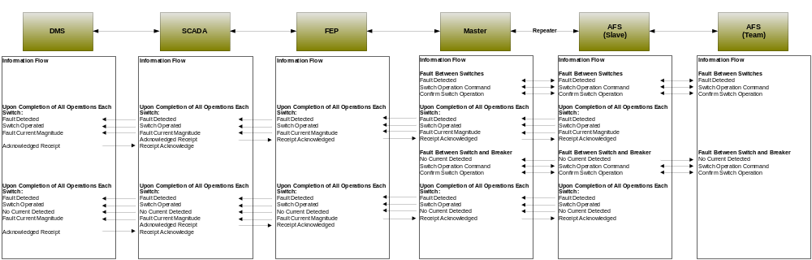
Figure 9 - Information flow AFS automated operation

Included Processes

Manual Switch Operation

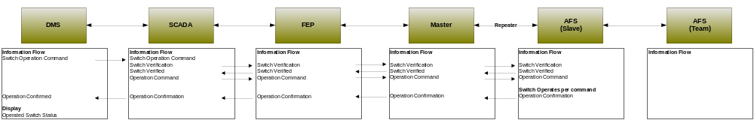
Figure 10 - Information flow AFS Manual Switch Operation

Switch Monitoring and Diagnostics

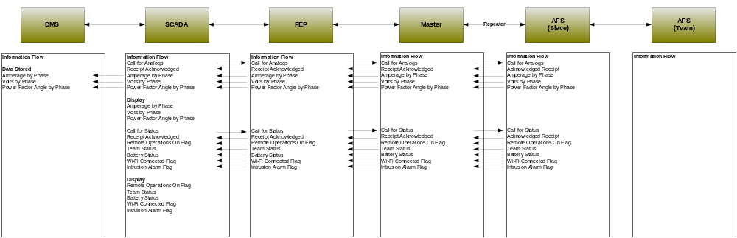
Figure 11 - Information flow AFS monitoring and diagnostics

Switch Configuration Change

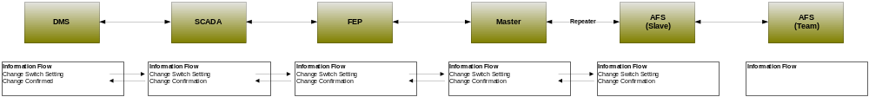
Figure 12 - Information flow AFS manual DNP configuration change

Switch Operation and Configuration Change

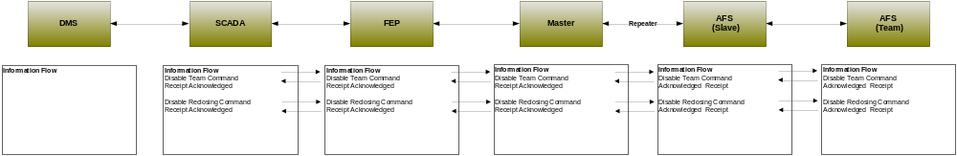
Figure 13 - Information flow manual switch operation and DNP configuration change

Switch to Switch Fault Detection
This process involves notification and interaction with devices in the event a fault is identified to have occurred in between deployed DA switches.

Switch to Breaker Fault Detection
This process involves notification and interaction with devices in the event a fault is identified to have occurred in between a deployed DA switch and the substation.

Voltage Regulator

Objective
The process involves the automatic and manual operation of voltage regulators to improve the voltage characteristics of any particular segment of the distribution network. The process requires close orchestration between the DMS system and voltage regulation devices deployed with in the Distribution network.

Actors
Actor | Role
Voltage Regulators | Primary
Slave | Secondary
Master | Secondary
Front End Processor | Primary
Distribution Management System and SCADA | Primary
Table 18 - Actors Voltage Regulator Operation

Applicable Distribution Applications
Source | Destination | Transaction | Acknowledged or replied | Distribution application
 |  |  |  | Maintenance | Voltage &Var Monitoring | DSDR | Line Seg | Distributed Energy Resources
DMS | Voltage Regulator | Status Request | Y | Y
DMS | Voltage Regulator | Sensor Data request | Y | Y |  | Y
DMS | Voltage Regulator | Command – Step UP | Y |  | Y | Y | Y | Y
DMS | Voltage Regulator | Command – Step Down | Y |  | Y | Y | Y | Y
DMS | Voltage Regulator | New Config | Y |  | Y | Y | Y | Y
Voltage Regulator | DMS | Status Change | Optional | Y
Voltage Regulator | DMS | Deviation Alert | Optional | Y
Voltage Regulator | DMS | Alarm Condition | Optional | Y
Voltage Regulator | DMS | Device Failure | Optional | Y
Table 19 - Applicable Distribution Applications

Latency Requirements - Operation
Source | Destination | Frequency | Response Time | Priority
DMS | Voltage Regulator | Event Driven | 5 Seconds | High
Voltage Regulator | DMS | Event Driven | 5 Seconds | High
Master | Voltage Regulator | Event Driven | 2 Seconds | High
Voltage Regulator | Master | Event Driven | 2 Seconds | High
Table 20 - Latency requirements Voltage Regulator Operation

Latency Requirements - Telemetry
Source | Destination | Frequency | Response Time | Priority
DMS | Voltage Regulator | 5 Second Interval | ~5 Seconds | HIGH
Table 21 - Latency requirements Voltage Regulator Telemetry

Process Flow
Figure 14 - Information flow Voltage Regulator operation

Included Processes

Alerts and Alarms

Status Change and System Conditions

Capacitor Bank Control

Objective
The objective is to remotely operate and poll capacitor banks for purposes of modifying the voltage and power quality on a particular segment of distribution. The intent of this use case is to document the process for automated and manual operation of capacitor banks.

Actors
Actor | Role
Dispatch Operator | Primary
Distribution Management System and SCADA | Primary
Front End Processor | Secondary
Master | Secondary
Repeaters | Secondary
Slave | Secondary
Capacitor Bank | Primary
Table 22 - Actors Capacitor Banks

Applicable Distribution Applications
Source | Destination | Transaction | Acknowledged or replied | Distribution application
 |  |  |  | Maintenance | Voltage &Var Monitoring | DSDR | Line Seg | Distributed Energy Resources
DMS | Capacitor Bank | Status Request | Y | Y
DMS | Capacitor Bank | Sensor Data request | Y | Y |  | Y
DMS | Capacitor Bank | Command – Step UP | Y |  | Y | Y | Y | Y
DMS | Capacitor Bank | Command – Step Down | Y |  | Y | Y | Y | Y
DMS | Capacitor Bank | New Config | Y |  | Y | Y | Y | Y
Capacitor Bank | DMS | Status Change | Optional | Y
Capacitor Bank | DMS | Deviation Alert | Optional | Y
Capacitor Bank | DMS | Alarm Condition | Optional | Y
Capacitor Bank | DMS | Device Failure | Optional | Y
Table 23 - Applicable Distribution Applications

Latency Requirements
Source | Destination | Frequency | Response Time | Priority
DMS | Capacitor Bank | Event Driven | 5 Seconds | High
Capacitor Bank | DMS | Event Driven | 5 Seconds | High
Master | Capacitor Bank | Event Driven | 2 Seconds | High
Capacitor Bank | Master | Event Driven | 2 Seconds | High
Table 24 - Latency requirements Capacitor Bank Operation

Process Flow
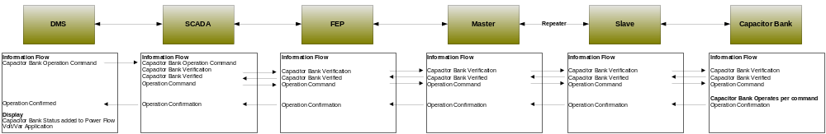
Figure 15 - Information flow Capacitor Bank Control

Included Processes

Alerts and Alarms

Status Change and System Conditions

Capacitor Bank Monitoring

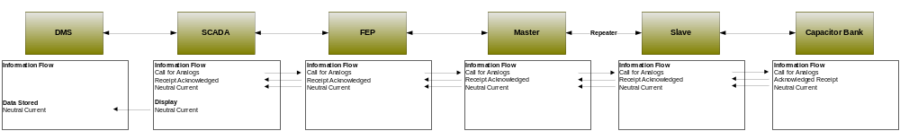
Figure 16 - Information flow Capacitor Bank Monitoring

Fault Current Indicator

Objective
The objective is to remotely poll and collect information from fault current indicators on a particular segment of distribution. The intent of this use case is to document the process for automated and manual operation of fault current indicators.

Actors
Actor | Role
Dispatch Operator | Primary
Distribution Management System and SCADA | Primary
Front End Processor | Secondary
Master | Secondary
Repeaters | Secondary
Slave | Secondary
Fault Current Indicator | Primary
Table 25 - Actors Fault Current Indicator

Applicable Distribution Applications
Source | Destination | Transaction | Acknowledged or replied | Distribution application
 |  |  |  | Maintenance | Voltage &Var Monitoring | DSDR | Line Seg | Distributed Energy Resources
DMS | Fault Current Indicator | Status Request | Y |  |  |  | Y
DMS | Fault Current Indicator | Sensor Data request | Y |  |  |  | Y
DMS | Fault Current Indicator | New Config | Y |  |  |  | Y
Fault Current Indicator | DMS | Deviation Alert | Optional | Y |  |  | Y
Fault Current Indicator | DMS | Alarm Condition | Optional | Y |  |  | Y
Table 26 - Applicable Distribution Applications

Latency Requirements
Source | Destination | Frequency | Response Time | Priority
DMS | Slave | Event Driven | 5 Seconds | High
Slave | DMS | Event Driven | 5 Seconds | High
Master | Slave | Event Driven | 2 Seconds | High
Slave | Master | Event Driven | 2 Seconds | High
Table 27 - Latency requirements Fault Current Indicator

Process Flow
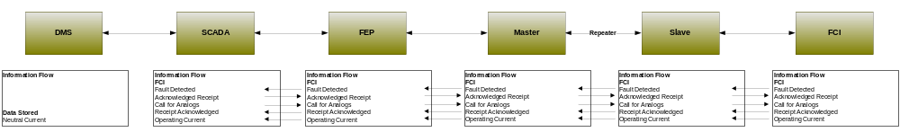
Figure 17 - Information flow Fault current Indicator

Included Processes

Alerts and Alarms

Status Change and System Conditions

Transformer Monitoring

Objective
The objective is to remotely poll and collect information from transformer monitors on a particular segment of distribution. The intent of this use case is to document the process for automated and manual operation of transformer monitors.

Actors
Actor | Role
Dispatch Operator | Primary
Distribution Management System and SCADA | Primary
Front End Processor | Secondary
Master | Secondary
Repeaters | Secondary
Slave | Secondary
Transformer Monitor | Primary
Table 28 - Actors Transformer Monitoring

Applicable Distribution Applications
Source | Destination | Transaction | Acknowledged or replied | Distribution application
 |  |  |  | Maintenance | Voltage &Var Monitoring | DSDR | Line Seg | Distributed Energy Resources
DMS | Transformer Monitor | Status Request | Y | Y
DMS | Transformer Monitor | Sensor Data request | Y | Y |  | Y
DMS | Transformer Monitor | New Config | Y |  | Y | Y | Y | Y
Transformer Monitor | DMS | Status Change | Optional | Y
Transformer Monitor | DMS | Deviation Alert | Optional | Y
Transformer Monitor | DMS | Alarm Condition | Optional | Y
Table 29 - Applicable Distribution Applications

Latency Requirements
Source | Destination | Frequency | Response Time | Priority
DMS | Slave | 15 Minute Interval | 10 Seconds | Medium
Slave | DMS | NA | 10 Seconds | Medium
Master | Slave | NA | 5 Seconds | Medium
Slave | Master | NA | 5 Seconds | Medium
Table 30 – Latency requirements Transformer Monitoring

Process Flow
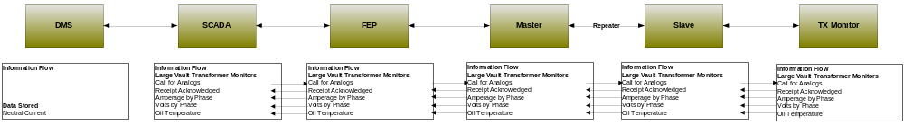
Figure 18 - Information flow Transformer Monitor

Included Processes

Alerts and Alarms

Status Change and System Conditions

Voltage and Current Sensors

Objective
The objective is to remotely poll and collect information from voltage and current sensors on a particular segment of distribution. The intent of this use case is to document the process for automated and manual operation of voltage and current sensors.

Actors
Actor | Role
Dispatch Operator | Primary
Distribution Management System and SCADA | Primary
Front End Processor | Secondary
Master | Secondary
Repeaters | Secondary
Slave | Secondary
Voltage and Current sensor | Primary
Table 31 - Actors Voltage and Current Sensors

Applicable Distribution Applications
Source | Destination | Transaction | Acknowledged or replied | Distribution application
 |  |  |  | Maintenance | Voltage &Var Monitoring | DSDR | Line Seg | Distributed Energy Resources
DMS | Sensor | Status Request | Y | Y
DMS | Sensor | Sensor Data request | Y | Y |  | Y
DMS | Sensor | New Config | Y |  | Y | Y | Y | Y
Sensor | DMS | Status Change | Optional | Y
Sensor | DMS | Deviation Alert | Optional | Y
Sensor | DMS | Alarm Condition | Optional | Y
Table 32 - Applicable Distribution Applications

Latency Requirements
Source | Destination | Frequency | Response Time | Priority
DMS | Slave | 5 Second Interval | 10 Seconds | Medium
Slave | DMS | NA | 10 Seconds | Medium
Master | Slave | NA | 5 Seconds | Medium
Slave | Master | NA | 5 Seconds | Medium
Table 33 -Latency requirements Amp / voltage sensor

Process Flow
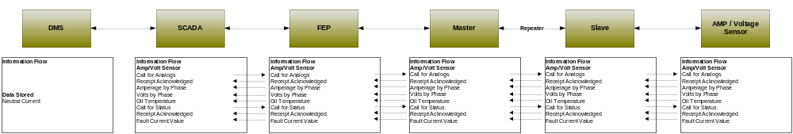
Figure 19 - Information flow Amp / Voltage Sensor

Included Processes

Alerts and Alarms

Status Change and System Conditions

Network Protection Monitoring

Objective
The objective is to remotely poll and collect information from network protection monitors on a particular segment of distribution. The intent of this use case is to document the process for automated and manual operation of network protection monitors.

Actors
Actor | Role
Dispatch Operator | Primary
Distribution Management System and SCADA | Primary
Front End Processor | Secondary
Master | Secondary
Repeaters | Secondary
Slave | Secondary
Network Protector | Primary
Table 34 - Actors Network Protector Monitoring

Applicable Distribution Applications
Source | Destination | Transaction | Acknowledged or replied | Distribution application
 |  |  |  | Maintenance | Voltage &Var Monitoring | DSDR | Line Seg | Distributed Energy Resources
DMS | Switch | Status Request | Y | Y |  |  | Y
DMS | Switch | Sensor Data request | Y | Y |  | Y | Y
DMS | Switch | Command – Step UP | Y |  | Y | Y | Y | Y
DMS | Switch | Command – Step Down | Y |  | Y | Y | Y | Y
DMS | Switch | New Config | Y |  |  |  | Y
Switch | DMS | Status Change | Optional | Y |  |  | Y
Switch | DMS | Deviation Alert | Optional | Y |  |  | Y
Switch | DMS | Alarm Condition | Optional | Y |  |  | Y
Switch | DMS | Device Failure | Optional | Y |  |  | Y
Table 35 - Applicable Distribution Applications

Latency Requirements
Source | Destination | Frequency | Response Time | Priority
DMS | Slave | Event Driven | 10 Seconds | Medium
Slave | DMS | Event Driven | 10 Seconds | Medium
Master | Slave | Event Driven | 5 Seconds | Medium
Slave | Master | Event Driven | 5 Seconds | Medium
Table 36 - Latency Requirements Network Protector Monitoring

Process Flow
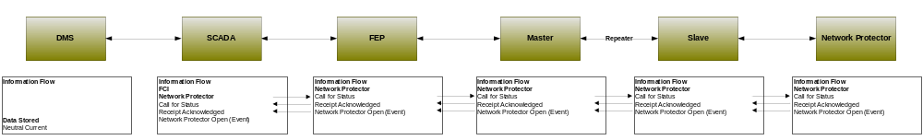
Figure 20 - Information flow Network Protector

Included Processes

Alerts and Alarms

Status Change and System Conditions

Throw Over Switch Monitoring

Objective
The objective is to remotely poll and collect information from throw over switch monitors on a particular segment of distribution. The intent of this use case is to document the process for monitoring throw over switches.

Actors
Actor | Role
Dispatch Operator | Primary
Distribution Management System and SCADA | Primary
Front End Processor | Secondary
Master | Secondary
Repeaters | Secondary
Slave | Secondary
Throw Over Switch | Primary
Table 37 - Actors Throw Over Switch Monitoring

Applicable Distribution Applications
Source | Destination | Transaction | Acknowledged or replied | Distribution application
 |  |  |  | Maintenance | Voltage &Var Monitoring | DSDR | Line Seg | Distributed Energy Resources
DMS | Switch Sensor | Status Request | Y | Y
DMS | Switch Sensor | Sensor Data request | Y | Y |  | Y
DMS | Switch Sensor | New Config | Y |  | Y | Y | Y | Y
Switch Sensor | DMS | Status Change | Optional | Y
Switch Sensor | DMS | Deviation Alert | Optional | Y
Switch Sensor | DMS | Alarm Condition | Optional | Y
Table 38 - Applicable Distribution Applications

Latency Requirements
Source | Destination | Frequency | Response Time | Priority
DMS | Slave | 5 Minute Interval | 10 Seconds | Medium
Slave | DMS | Event Driven | 10 Seconds | Medium
Master | Slave | Event Driven | 5 Seconds | Medium
Slave | Master | Event Driven | 5 Seconds | Medium
Table 39 - Latency Requirements Throw Over Switch Monitoring

Process Flow
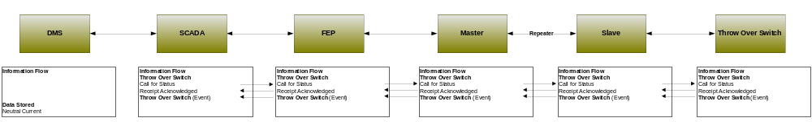
Figure 21 - Information flow Throw Over Switch

Included Processes

Alerts and Alarms

Status Change and System Conditions

Health Checks

Objective
The objective is to remotely poll and collect information health information from distribution equipment on a particular segment of distribution.

Actors
Actor | Role
Dispatch Operator | Primary
Distribution Management System and SCADA | Primary
Front End Processor | Secondary
Master | Secondary
Repeaters | Secondary
Slave | Secondary
RTU | Primary
Table 40 – Actors Device Health Check

Latency Requirements
Source | Destination | Frequency | Response Time | Priority
DMS | Slave | 5 Minute Interval | 10 Seconds | Medium
Slave | DMS | Event Driven | 10 Seconds | Medium
Master | Slave | Event Driven | 5 Seconds | Medium
Slave | Master | Event Driven | 5 Seconds | Medium
Table 41 - Latency Requirements Device Health Check

Process Flow
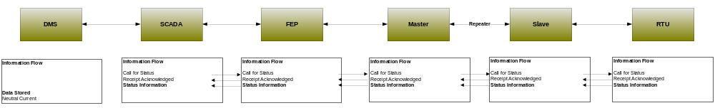
Figure 22 - Information flow Health check

Volt/VAR Management –Centralized

Overview

Reference Architecture with Domains, Actors and Interfaces

Possible communication paths

Actors
AMI Head-End(j) | The AMI head end is responsible for the operation and coordination of AMI system components. It represents the central nervous system of the AMI system.
DAC - sub | Distribution Application Control system hosted in a Distribution Substation to run a specific Distrbution application
DAPjm | This is the Data Aggregation Point on the NAN. It is essentially the point of convergence for all communication between SG devices and utility back office systems. In this specific use case it provides a communication conduit for AMI Smart Meters.The su
Distr. SCADA FEP | Distribution Supervisory Control and Data Acquisition Front End Processor
DMS | Distribution Management System - A system that monitors, manages and controls the electric distribution system.
FAN gateway - field | Field Area Network gateway device located in the field, that provides the interface between the Feeder Line device communication modules and the Wide Area Network connection.
FAN gateway - sub | Field Area Network gateway device located in the substation, that provides the interface between the Feeder Line device communication modules and the Substation network connection.
Feeder Cap Bank | This is a device used to add capacitance as needed at strategic points in a distribution grid to better control and manage VARs and thus the Power Factor and they will also affect voltage levels.
Feeder Recloser | A device used to sense fault conditions on a distribution line and trip open to provide protection. It is typically programmed to automatically close (re-close) after a period of time to test if the fault has cleared. After several attempts of reclosing
Feeder Regulator | This device is in effect an adjustable ratio transformer positioned at strategic points in a distribution grid and is utilized to better manage and control the voltage as it changes along the distribution feeder.
Feeder Sensor | A device used to measure and report electrical properties (such as voltage, current, phase angle or power factor, etc.) at a low voltage customer delivery point.
Feeder Switch | These devices are deployed at critical points within the Distribution network for purposes of isolating electric faults and providing system telemetry regarding the performance of the electric system
Internet / Extranet gateway(s) - Utility | These are gateways used to connect internal utility networks with external networks.
RTU | Remote Terminal Unit - Aggregator of multiple serialized devices to a common communications interface

Scenarios

Scenario: X

Narrative

Business Objectives

Originating Actor | Desination Actor | Latency | Reliability | Payload Size | Payload Name
Totals

Implications and Rationale
Functional Domain | Expected Potential Impact | Rationale

Pricing TOU / RTP/ CPP

Overview
CPP_pricing-data_ack
CPP_pricing-data_brdcst
CPP_pricing-data_cmd
CPP_pricing-data_mltcst
RTP_pricing-data_ack
RTP_pricing-data_brdcst
RTP_pricing-data_cmd
RTP_pricing-data_mltcst
TOU_pricing-data_ack
TOU_pricing-data_brdcst
TOU_pricing-data_cmd
TOU_pricing-data_mltcst

Reference Architecture with Domains, Actors and Interfaces

Possible communication paths

Actors
2-Way Meter - Electr | A bi-directional communication device used to perform measurement of electrical energy usage for residential use.
AMI Head-End(j) | The AMI head end is responsible for the operation and coordination of AMI system components. It represents the central nervous system of the AMI system.
Common Web Portal | Web interface for Regional Transmission Operator, customers, retail electric providers and transmission/distribution service provider to function as a clearing house for energy information.
Cust. EMS | A customer owned energy management system used to manage energy with a premises.
DAPjm | This is the Data Aggregation Point on the NAN. It is essentially the point of convergence for all communication between SG devices and utility back office systems. In this specific use case it provides a communication conduit for AMI Smart Meters.The su
DSM - REPi | Demand Side Management - Retail Energy Provider; A system that co-ordinates demand response / load shedding messages indirectly to devices (e.g. Set point adjustment)
DSM - Utility | Demand Side Management - Utility; A system that co-ordinates demand response / load shedding messages indirectly to devices (e.g. Set point adjustment)
ESI - 3rd Party | An ESI, owned by the Customer and not provided by the Utility, which enables secure interactions between HAN Devices Registered on its network and the service provider e.g. REP. The 3rd Party ESI functionality may reside in the Customer EMS or customer's
ESI - In Meter | An ESI, owned by the Utility and resides in the Utility meter, which enables secure interactions between HAN Devices Registered on its network and the Utility AMI.
ESI - Utility | An ESI, owned by the Utility, which enables secure interactions between HAN Devices Registered on its network and the Utility AMI. The Utility ESI functionality may reside in the Customer EMS or customer broadband router.
EVSE / EUMD | Electric Vehicle Supply Equipment / End Use Metering Device
Internet / Extranet gateway(s) - REPi | These are gateways used to connect internal utility networks with external networks.
Internet / Extranet gateway(s) - Utility | These are gateways used to connect internal utility networks with external networks.
IPD | In Premise Display
LMS - REPi | Load management system
LMS - Utility | Load management system - System that controls load by sending messages directly to device (e.g. On/Off)
Load Cntl Device | A device used within the customer domain for load management (e.g. Air conditioning, etc)
PCT | A device within the premise that has communication capabilities and controls heating, ventilation and cooling systems.
PHEV | Plug-in Hybrid Electric Vehicles - Cars or other vehicles that draw electricity from batteries to power an electric motor for vehicle propulsion. PHEVs also contain an internal combustion engine.
Smart Appliance | A white good or household appliance, that has HAN communication capability and is capable of receiving signals from authorized parties (e.g. Utility, Service Provider, EMS, Consumer, etc.) and of adjusting its operational mode based on Consumer preference

Scenarios

Scenario: X

Narrative

Business Objectives

Originating Actor | Desination Actor | Latency | Reliability | Payload Size | Payload Name
Totals

Implications and Rationale
Functional Domain | Expected Potential Impact | Rationale
Bulk Generation
Customer
Distribution
Markets
Operation
Service Providers
Transmission

Service Switch

Overview
SW_opr_cancel_cmd
SW_opr_cmd
SW_opr_cmd_ack
SW_opr_cmd_comm-err
SW_opr_fail_cmd-err
SW_post-oper-info_resp-data
SW_state_cmd
SW_state_cmd_resp-data
valve_opr_cancel_cmd
valve_opr_cmd
valve_opr_cmd_ack
valve_opr_cmd_comm-err
valve_opr_fail_cmd-err
valve_post-oper-info_resp-data
valve_state_cmd
valve_state_cmd_resp-data

Reference Architecture with Domains, Actors and Interfaces
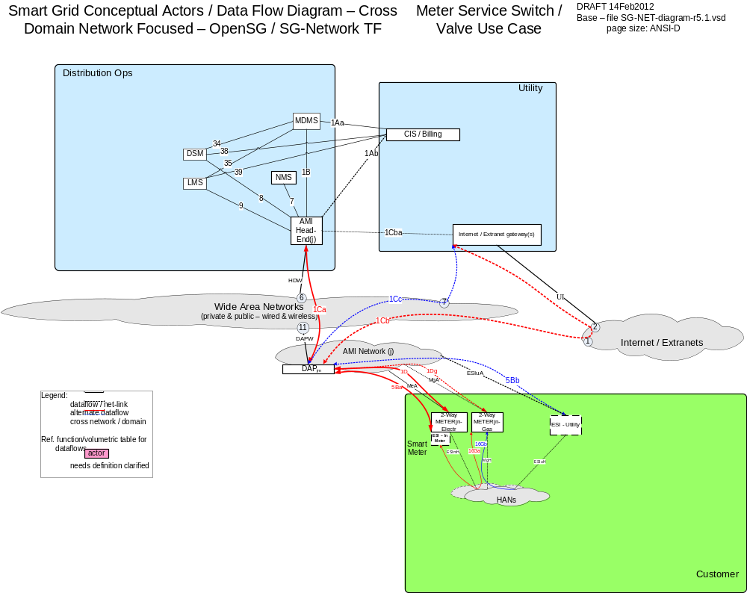

Possible communication paths

Actors
2-Way Meter - Electr | A bi-directional communication device used to perform measurement of electrical energy usage for residential use.
2-Way Meter – Gas | A bi-directional communication device used to perform measurement of gas consumption for residential use.
AMI Head-End(j) | The AMI head end is responsible for the operation and coordination of AMI system components. It represents the central nervous system of the AMI system.
CIS/Billing – Utility | A utility billing system used for reconcilling customer payments for electricity usage. This system may also be used for manageing vendors of electricity generation.
DAPjm | This is the Data Aggregation Point on the NAN. It is essentially the point of convergence for all communication between SG devices and utility back office systems. In this specific use case it provides a communication conduit for AMI Smart Meters.The su
DSM – Utility | Demand Side Management - Utility; A system that co-ordinates demand response / load shedding messages indirectly to devices (e.g. Set point adjustment)
Internet / Extranet gateway(s) - Utility | These are gateways used to connect internal utility networks with external networks.
LMS – Utility | Load management system - System that controls load by sending messages directly to device (e.g. On/Off)
MDMS | The application responsible for the collection and retrieval of all relevant customer information for purposes of billing and facilitating interaction.
NMS | A system or series of systems that are utilized to operate and manage utility assets that interact on any given network. These assets are comprised of both hardware and software components that require ongoing monitoring and management.

Scenarios

Scenario: X

Narrative

Business Objectives

Originating Actor | Desination Actor | Latency | Reliability | Payload Size | Payload Name
Totals

Implications and Rationale
Functional Domain | Expected Potential Impact | Rationale
Bulk Generation
Customer
Distribution
Markets
Operation
Service Providers
Transmission

Appendix

Acronyms and Abbreviations
AC | Alternating Current
AMI | Advanced Metering Infrastructure
AMS | Asset management system
ASAP-SG | Advanced Security Acceleration Project-Smart Grid
B2B | Business to Business
BAN | Business Area Network
CIM | Common Information Model.
CIP | Critical Infrastructure Protection
CIS | Customer Information System
CSWG | Cyber Security Working Group
DA | Distribution Automation
DAC | Distribution Application Controller
DAP | Data Aggregation Point
DC | Direct Current
DER | Distributed Energy Resources e.g. solar, wind, photovoltaic
DHS | Department of Homeland Security
DMS | Distribution Management System
DNP | Distributed Network Protocol
DOE | Department of Energy
DOMA | Distribution Operations Model and Analysis
DR | Demand Response
DSDR | Distribution Systems Demand Response
DSM | Demand Side Management
EMS | Energy Management System
EPRI | Electric Power Research Institute
ES | Electric Storage
ESB | Enterprise Service Bus
ESI | Energy Services Interface
ET | Electric Transportation
EUMD | End Use Measurement Device
EV/PHEV | Electric Vehicle/Plug-in Hybrid Electric Vehicles
EVSE | Electric Vehicle Supply Equipment
FAN | Field Area Network
FCC | Federal Communications Commission
FEP | Front End Processor
FERC | Federal Energy Regulatory Commission
FIPS | Federal Information Processing Standard Document
FLIR | Fault Location, Isolation, Restoration
G&T | Generations and Transmission
GAPP | Generally Accepted Privacy Principles.
GIS | Geographic Information System
GL | General Ledger
GPRS | General Packet Radio Service
HAN | Home Area Network
HMI | Human-Machine Interface
HV | High Voltage (in definition)
HVAC | Heating, Ventilating, and air conditioning (shown in figure)
I2G | Industry to Grid
IEC | International Electrotechnical Commission
IED | Intelligent Electronic Device
IHD | In-home Display
IPD | In Premise Display
ISA | International Society of Automation
ISO | Independent System Operator
ISO/IEC27001 | International Organization for Standardization/International Electrotechnical Commission Standard 27001.
IT | Information Technology
LAN | Local Area Network
LMS | Load management system
LMS/DRMS | Load Management System/ Distribution Resource Management System
LV | Low voltage (in definition)
MDMS | Meter Data Management System
MFR | Multi-Feeder Reconnection
MSW | Meter service switch
MV | Medium voltage (in definition)
NAN | Neighborhood Area Network
NERC | North American Electric Reliability Corporation
NIPP | National Infrastructure Protection Plan
NIST | National Institute of Standards and Technology
NISTIR | NIST Interagency Report
NMS | Network Management system
ODW | Operational Data Warehouse
OMS | Outage Management System
OWASP | Open Web Application Security Project
PAN | Premise Area Network - synonymous for HAN
PAP | Priority Action Plan
PCT | Programmable Communicating Thermostat
PEV | Plug-In Electric Vehicle
PI | Process Information
PIA | Privacy Impact Assessment. .
PII | Personally Identifying Information
R&D | Research and Development
REP | Retail Energy Provider
RTO | Regional Transmission Operator
RTU | Remote Terminal Unit
SCADA | Supervisory Control and Data Acquisition
SCE | Southern California Edison
SGIP | Smart Grid Interoperability Panel
SGIP-CSWG | SGIP – Cyber Security Working Group
SP | Special Publication
SSP | Sector-Specific Plans
T/FLA | Three/Four Letter Acronym
TXT | Text Message or Messaging
VAR | Volt-Amperes Reactive
VVWS | Volt-VAR-Watt System
WAMS | Wide-Area Measurement System
WAN | Wide Area Network
WASA | Wide Area Situational Awareness
WLAN | Wireless Local Area Network
WMS | Work Management System

Definitions
Actor | A generic name for devices, systems, or programs that make decisions and exchange information necessary for performing applications: smart meters, solar generators, and control systems represent examples of devices and systems.
Anonymize | A process of transformation or elimination of PII for purposes of sharing data
Aggregation | Practice of summarizing certain data and presenting it as a total without any PII identifiers
Aggregator | A mechanism for collecting like streams of data or metering for use as a single figures by upstream systems.
Applications | Tasks performed by one or more actors within a domain.
Asset Management System | A system(s) of record for assets managed in the Smart Grid. Management context may change(e.g. financial, network)
Bulk Generation | The generators of electricity in bulk quantities. May also store energy for later distribution (from NIST Smart Grid Framework and Roadmap).
Capacitor Bank | This is a device used to add reactive power as needed at strategic points in a distribution grid to better control and manage VARs and thus the Power Factor and they will also affect voltage levels.
Common Information Model | A structured set of definitions that allows different Smart Grid domain representatives to communicate important concepts and exchange information easily and effectively.
Common Web Portal | Web interface for Regional Transmission Operator, customers, retail electric providers and transmission/distribution service provider to function as a clearing house for energy information. Commonly used in deregulated markets.
Customer | The end users of electricity. May also generate, store, and manage the use of energy. Traditionally, three customer types are discussed, each with its own domain: residential, commercial, and industrial (from NIST Smart Grid Framework and Roadmap).
Data Aggregation Point | This device is a logical actor that represents a transition in most AMI networks between Wide Area Networks and Neighborhood Area Networks. (e.g. Collector, Cell Relay, Base Station, Access Point, etc)
De-identify | A form of anonymization that does not attempt to control the data once it has had PII identifiers removed, so it is at risk of re-identification.
Demand Side Management | A system that co-ordinates demand response / load shedding messages indirectly to devices (e.g. Set point adjustment)
Distribution | The distributors of electricity to and from customers. May also store and generate electricity.
Distribution Management System | A system that monitors, manages and controls the electric distribution system.
Distribution Systems Demand Response | A system used to reduce electric distribution load during peak demand. Strictly used for Distribution systems only.
Domain | A high-level grouping of organizations, buildings, individuals, systems, devices, or other actors with similar objectives and relying on—or participating in— similar types of applications (from NIST Framework and Roadmap)
Electric Vehicle/Plug-in Hybrid Electric Vehicles | Cars or other vehicles that draw electricity from batteries to power an electric motor for vehicle propulsion. PHEVs also contain an internal combustion engine.
Energy Services Interface | Provides security and, often, coordination functions that enable secure interactions between relevant Home Area Network Devices and the Utility. Permits applications such as remote load control, monitoring and control of distributed generation, in-home display of customer usage, reading of non-energy meters, and integration with building management systems. Also provides auditing/logging functions that record transactions to and from Home Area Networking Devices.
Enterprise Service Bus | The Enterprise Service Bus consists of a software architecture used to construct integration services for complex event-driven and standards-based messaging for data exchange. The ESB is not limited to a specific tool set, rather it is a defined set of integration services.
Fault Detector | A device used to sense a fault condition on an electrical circuit and can be used to provide a local and/or remote indication of the fault.
Field Force | Employee working in the service territory that may be working with Smart Grid devices.
GAPP | Generally Accepted Privacy Principles. Privacy principles and criteria developed and updated by the AICPA and Canadian Institute of Chartered Accountants to assist organizations in the design and implementation of sound privacy practices and policies.
Home Area Network | A network of energy management devices, digital consumer electronics, signal-controlled or enabled appliances, and applications within a home environment that is on the premise side of the electric meter. In-premise communication system (OpenHAN 2.0)
ISO/IEC27001 | An auditable international standard that specifies the requirements for establishing, implementing, operating, monitoring, reviewing, maintaining and improving a documented Information Security Management System within the context of the organization's overall business risks. It uses a process approach for protection of critical information
Last Gasp | Concept of an energized device within the Smart Grid detecting power loss and sending a broadcast message of the event prior to complete power loss.
Load Management System | System that controls load by sending messages directly to device (e.g. On/Off)
Low Voltage Sensor | A device used to measure and report electrical properties (such as voltage, current, phase angle or power factor, etc.) at a low voltage customer delivery point.
Markets | The operators and participants in electricity markets (from NIST Smart Grid Framework and Roadmap)
Medium Voltage Sensor | A device used to measure and report electrical properties (such as voltage, current, phase angle or power factor, etc.) on a medium voltage distribution line.
Motorized Switch | A load break device under remote control that can be used to open or close a circuit.
Neighborhood Area Network | A network comprised of all communicating components within a distribution domain.
Network Management System | A system that manages Fault, Configuration, Auditing/Accounting, Performance and Security of the communication network. This system is exclusive from the electrical network.
Operations | The managers of the movement of electricity (from NIST Smart Grid Framework and Roadmap).
Outage Management System | A system that receives out power system outage notifications and correlates the geographic location of the power outage
Personally Identifying Information | (PII) Information that reveals details, either explicitly or implicitly, about a specific individual’s household dwelling or other type of premises. This is expanded beyond the normal "individual" component because there are serious privacy impacts for all individuals living in one dwelling or premise. This can include items such as energy use patterns or other types of activities. The pattern can become unique to a household or premises just as a fingerprint or DNA is unique to an individual.
Phase Measuring Unit | A device capable of measuring the phase of the voltage or current waveform relative to a reference.
Power Factor | A dimensionless quantity that relates to efficiency of the electrical delivery system for delivering real power to the load. Numerically, it is the Cosine of the phase angle between the voltage and current waveforms. The closer the power factor is to unity the better the inductive and capacitive elements of the circuit are balanced and the more efficient the system is for delivering real power to the load(s).
Privacy Impact Assessment | A process used to evaluate the possible privacy risks to Personally Identifying Information, in all forms, collected, transmitted, shared, stored, disposed of, and accessed in any other way, along with the mitigation of those risks at the beginning of and throughout the life cycle of the associated process, program or system
Programmable Communicating Thermostat | A device within the premises that has communication capabilities and controls heating, ventilation and cooling systems.
Recloser (non-Team) | A device used to sense fault conditions on a distribution line and trip open to provide protection. It is typically programmed to automatically close (re-close) after a period of time to test if the fault has cleared. After several attempts of reclosing it can be programmed to trip open and stop trying to reclose until reset either locally or under remote control.
Recloser (Team) | A device that can sense fault conditions on a distribution line and to communicate with other related reclosers (the team) to sectionalize the fault and provide a coordinated open/close arrangement to localize the effect of the fault.
Regional Transmission Operator | A Regional Transmission Organization (RTO) is an organization that is established with the purpose of promoting efficiency and reliability in the operation and planning of the electric transmission grid and ensuring non-discrimination in the provision of electric transmission services based on specific required/demonstrable characteristics and functions.
Remote Terminal Unit | Aggregator of multiple serialized devices to a common communications interface
Service Providers | The organizations providing services to electrical customers and utilities (from NIST Smart Grid Framework and Roadmap).
Sub Meter | Premise based meter used for Distributed Energy Resources and PHEV installed downline from the utility’s meter. This device may be revenue grade.
Substation Controller | Distributed processing device that has supervisory control or coordinates information exchanges from devices within a substation from a head end system.
Transformer (MV-to-LV) | A standard point of delivery transformer. In the Smart Grid context is it assumed there will be a need to measure some electrical or physical characteristics of this transformer such as voltage (high and/or low side) current, MV load, temperature, etc.
Transmission | The carriers of bulk electricity over long distances. May also store and generate electricity.
Use Case | Use cases are a systems engineering tool for defining a system’s behavior from the perspective of users. In effect, a use case is a story told in structure and detailed steps—scenarios for specifying required usages of a system, including how a component, subsystem, or system should respond to a request that originates elsewhere.
Voltage Regulator | This device is in effect an adjustable ratio transformer positioned at strategic points in a distribution grid and is utilized to better manage and control the voltage as it changes along the distribution feeder.
VAR – Volt-Amperes Reactive; | In an AC power system the voltage and current measured at a point along the delivery system will often be out of phase with each other as a result the combined effects of the resistive and reactive (i.e. the capacitance and inductive) characteristics of the delivery system components and the load. The phase angle difference at a point along the delivery system is an indication of how well the inductive and capacitive effects are balanced at that point. The real power passing that point is the product of the magnitude of the Voltage and Current and the Cosine of the angle between the two. The VAR parameter is the product of the magnitude of the Voltage and Current and the Sine of the angle between the two. The magnitude of the VAR parameter is an indication of the phase imbalance between the voltage and current waveforms.
Web Portal | Interface between energy customers and the system provider. Could be the utility or third party

Alternative / Multiple Communication Paths
Appendix – Alternative / Multiple Communication Paths

Referring to the Reference Diagram with multiple data communication paths, how do we select which ones are appropriate and applicable to the deployment being studied or modeled? If one focuses on a very simplistic example of the CIS/Billing – Utility to 2Way-Meter data, two communications path options and one deployment decision need to be made: (refer to following diagram). Note that this example does not contain all of the communication paths possible between the CIS/Billing – Utility to 2Way-Meter. For the full set of communication path options and decisions, refer to Reference Diagram and the decision details later in this appendix.

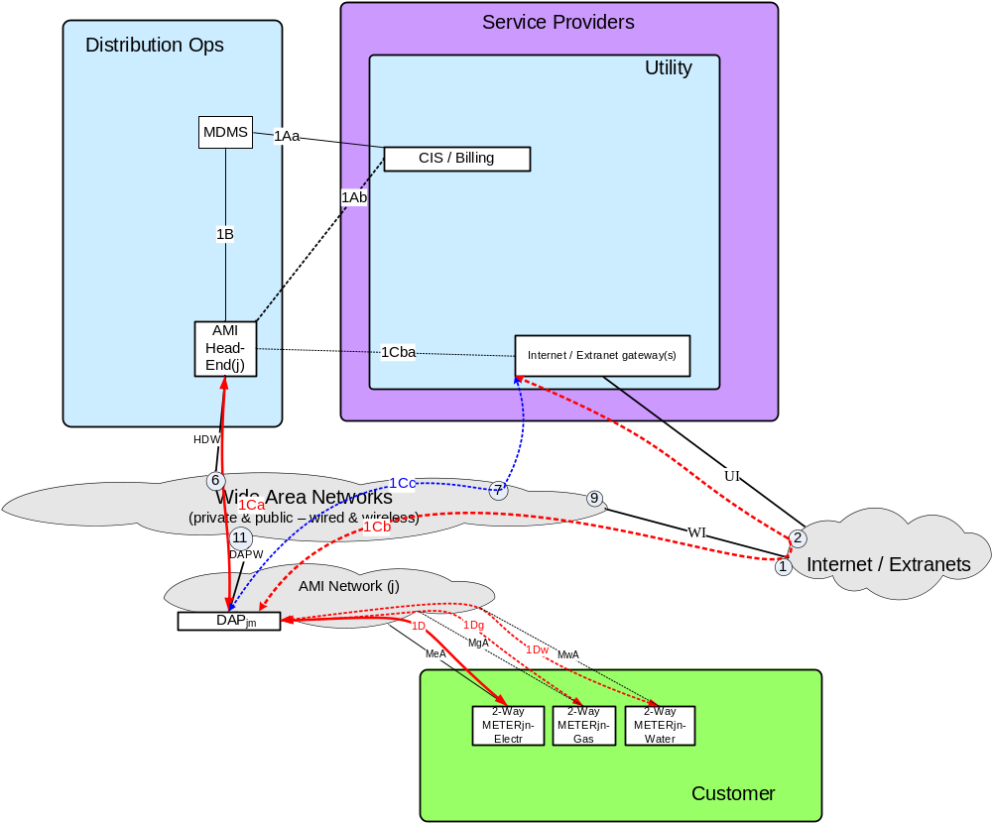
Figure 5.4-1 Alternative / Multiple Communication Paths – Reference Diagram Snippet

Four different ways of documenting these communication path options and deployment decisions are presented in this appendix:
- Graphical Parsing of the Unique From / To Actor Pairing
- Payload Requirement Set Data Flow Ref Pseudo Code
- Communication Path and Deployment Decisions Graphical Pseudo Code
- Deployment Profiles - Unique Deployment Decisions and Selected Comm-Paths

Graphical Parsing of the Unique From / To Actor Pairing

This approach documents all the unique combinations of traversing the available communication paths from one end of a payload requirement set’s from/to actor pairing to the other end point actor, using the Reference Diagram as the baseline. The following figure illustrates this process for a very simplistic example of the CIS / Billing – Utility communications paths with the 2Way-Meter actors, but excludes for brevity purposes, playing out the deployment decision of which 2Way-Meters are in-scope.

Figure 5.4-2 Alternative / Multiple Communication Paths – Options Example

The Path Option pseudo code for this graphic parsing is [1 or 2 or 3 or 4 or 5 or 6].

Payload Requirement Set Data Flow Ref Pseudo Code

The Requirement Table Parent rows’ “Data Flow Ref” column contains pseudo code, specific to that payload requirement set which is another way to document the communication paths and some of the deployment decision points. As an example, to sync up with the Reference Diagram snippet Figure 5.4-1, that contains the electric, gas, and water meters, the “CIS/Billing – Utility” to “2Way-Meter – electr or gas or water”, the Data Flow Ref pseudo code is

[(1Aa + 1B) or 1Ab] +
[1Ca or (1Cba + 1Cb) or (1Cba + 1Cc)] +
[1D or 1Dg or 1Dw]

Communication Path and Deployment Decisions Graphical Pseudo Code

Another approach to documenting the alternative communication paths and deployment decisions is the use of a combined graphic representation and pseudo code. For the “CIS/Billing – Utility” to “2Way-Meter –electr or gas or water”, the communication path decisions include:
- CIS/Billing to AMI Head-End (e.g. is the communications path with or without MDMS)
- AMI Head-End to DAP (across what networks and additional intermediary actors are being used, for which specific set of DAPs e.g. not all DAPs must use the same backhaul communications path to AMI Head-End)

The deployment decision for the “CIS/Billing – Utility” to “2Way-Meter – electr or gas or water”is
- DAP to 2Way-Meter (which meter: electr, gas, water, is driven by the deployment characteristics being studied)

These decisions are illustrated as:
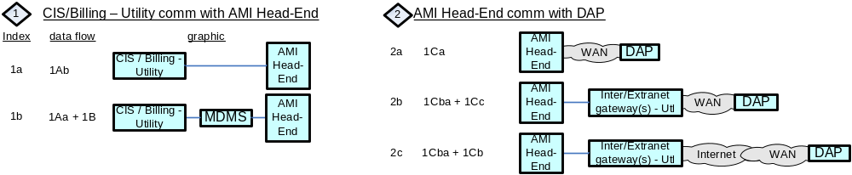
Figure 5.4-3 Alternative / Multiple Communication Paths Decisions – “CIS/Billing – Utility to DAP” Example

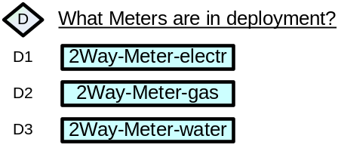
Figure 5.4-4 Deployment Decision – Meter-2way Example

The resultant decisions pseudo code in this example is

 with the resultant pseudo code being (using the decision index values):
[ (1a or 1b) + (2a or 2b or 2c) + (D1 or D2 or D3) ]

Deployment Profiles - Unique Deployment Decisions and Selected Comm-Paths

This method is a tabulation of all the unique combinations of the major deployment decisions and selections of specific communication paths. Those major decisions and selections includes:
- AMI , or DA, or AMI and DA
- REPS (with or without)
- HANs (with or without)
- CIS-Utility comm. with AMI Head-End (direct or via MDMS)
- AMI Head-End comm. with DAP (via WAN direct, or via InternetExtraNetGateway via WAN, or via InternetExtraNetGateway via Internet via WAN)
- Meters (electr and/or gas and/or water and which enrolled in REP programs)
- HAN Devices (which ones and which enrolled in REP programs)
- Distribution Apps (centralized or distributed control)
- Distribution Controller comm. with Feeder Line Devices (via WAN via RTU via substation FAN gateway, or via WAN, or via WAN via field FANgateway, or AMI Head-End to DAP)
- Distribution Endpoints (which ones)
- Use Cases (which ones of the set resulting from previous decisions and selections)

As the Use Case selections are applied, there will be changes as to which Operations and Service Provider Actors, Interfaces, and Data Flows are included in that specific Deployment Profile. For the example “CIS/Billing – Utility” to “2Way-Meter –electr or gas or water” illustrated in Figure 5.4-1, the major deployment decisions and selections of specific communication paths from the bulleted items above results in the following textual string:
AMI, without REPS, without HANs, CIS-Utility comm. with AMI Head-End (direct or via MDMS), AMI Head-End comm. with DAP (via WAN direct, or via InterExtranetGateway via WAN, or via InterExtranetGateway via Internet via WAN), Meters (electr and/or gas and/or water), Use Cases (which ones of the set resulting from previous decisions and selections)

Which is further decomposed in the following table.
Deployment Profile Ref # | AMI or DA | REP | HAN | CIS to AMI Head-End | AMI Head-End to DAP | Which Meters | Which Use Cases
ACdW | AMI | No | No | direct | via WAN | tbd | tbd
ACdIW | AMI | No | No | direct | Via InterExtranetGway via WAN | tbd | tbd
ACdIIW | AMI | No | No | direct | via InterExtranetGway via Internet via WAN | tbd | tbd
ACvW | AMI | No | No | via MDMS | via WAN | tbd | tbd
ACvIW | AMI | No | No | via MDMS | Via InterExtranetGway via WAN | tbd | tbd
ACvIIW | AMI | No | No | via MDMS | via InterExtranetGway via Internet via WAN | tbd | tbd
Table 5.4.1 Deployment Profile – Decisions and Selections - Example

The more complete tabulation of the deployment profiles as represented by the SG Network TF Reference Diagram r5.1, is found in the “Potential-deployment-profiles-r0.2.xls” file located TBD.

This file contains 72 AMI and 12 Distribution Deployment Profiles. The quantity of unique combinations of AMI and Distribution deployment profiles from this tabulation results in 948 unique profiles e.g. 72x12 + 72 + 12. Of those 948 unique deployment profiles, the more predominant or interesting ones includes:

Deployment Profile Ref # | REP | HAN | ESI | CIS to AMI Head-End | AMI Head-End to DAP | Which Meters & HAN Devices | Which endpoints in REP Programs
AHEMCdIW | No | Yes | InMtr | direct | Via InterExtranetGway via WAN | tbd | na
AHEMCvIW | No | Yes | InMtr | via MDMS | Via InterExtranetGway via WAN | tbd | na
AHE3CdIW | No | Yes | 3rdPty | direct | Via InterExtranetGway via WAN | tbd | na
AHE3CvIW | No | Yes | 3rdPty | via MDMS | Via InterExtranetGway via WAN | tbd | na
AHEM3CdIW | No | Yes | InMtr, 3rdPty | direct | Via InterExtranetGway via WAN | tbd | na
AHEM3CvIW | No | Yes | InMtr, 3rdPty | via MDMS | Via InterExtranetGway via WAN | tbd | na
ARHEMCdIW | Yes | Yes | InMtr | direct | Via InterExtranetGway via WAN | tbd | tbd
ARHEMCvIW | Yes | Yes | InMtr | via MDMS | Via InterExtranetGway via WAN | tbd | tbd
ARHE3CdIW | Yes | Yes | 3rdPty | direct | Via InterExtranetGway via WAN | tbd | tbd
ARHE3CvIW | Yes | Yes | 3rdPty | via MDMS | Via InterExtranetGway via WAN | tbd | tbd
ARHEM3CdIW | Yes | Yes | InMtr, 3rdPty | direct | Via InterExtranetGway via WAN | tbd | tbd
ARHEM3CvIW | Yes | Yes | InMtr, 3rdPty | via MDMS | Via InterExtranetGway via WAN | tbd | tbd
Table 5.4.2 Deployment Profile – Decisions and Selections – AMI Examples

Deployment Profile Ref # | Centralized or Decentralized Apps | Using SCADA or AMI networks | Using Independent or AMI Mgt of network gear | DAC/DMS comm. to Fdr Line Devices | Which Fdr Line Devices
DCSIRsF | Centralized | D-SCADA | Independent | Via WAN via RTU via subFANGway | tbd
DCSIW | Centralized | D-SCADA | Independent | Via WAN | tbd
DCSARsF | Centralized | D-SCADA | AMI | Via WAN via RTU via subFANGway & via DAP | tbd
DDIsF | Decentralized | D-SCADA | Independent | Via WAN via DAC via subFANGway | tbd
DDARsF | Decentralized | D-SCADA | AMI | Via WAN via RTU via DAC via subFANGway & DAP | tbd
DDAAD | Decentralized | AMI | AMI | Via subFANGway & DAP | tbd
Table 5.4.3 Deployment Profile – Decisions and Selections – Distribution Examples

Mapping Across the Four Communication Path & Deployment Decision Methods

The relationship (mapping) across these four methods for documenting the communication path options and deployment decisions, provides the ability to translate from one method to another depending upon the readers preference.

Using the “CIS/Billing – Utility” to “2Way-Meter – electr or gas or water” example, the mapping across the three methods illustrate the intended interpretation of extracting the specific payloads as driven by the users specified communication path and deployment decisions.

Graphic Parsing |  | Data Flow |  | Graphic Decisions |  |  | Deployment Profile
[1 or 2 or 3 or 4 or 5 or 6] | = |  |  | [(1a or 1b) + (2a or 2b or 2c) +<D>] | ≈ |  | [ACdW or ACdIW or ACdIIW orACvW or  ACvIW or ACvIIW]
 |  | [(1Aa + 1B) or 1Ab] +  [1Ca or (1Cba + 1Cc) or (1Cba + 1Cb)] +  [1D or 1Dg or 1Dw] | = | [(1a or 1b) + (2a or 2b or 2c) + (D1 or D2 or D3)]
If the right hand side of the parent actor pairing was a specific actor and the same across all thread examples e.g. “Meter-2way-electr”, then all four methods would equate (via the pseudo code) to each other as shown below.
[1 or 2 or 3 or 4 or 5 or 6] | = | [(1Aa + 1B) or 1Ab] +  [1Ca or (1Cba + 1Cc) or (1Cba + 1Cb)] +  1D | = | [(1a or 1b) +  (2a or 2b or 2c) +  D1 | ≈ |  | [ACdW or ACdIW or ACdIIW orACvW or  ACvIW or ACvIIW]
And more specifically, if the communication path decision is (selecting on the Graphic Parsing option 5), the pseudo code results in the following equivalence
5 | = | (1Aa + 1B) + (1Cba + 1Cc) + 1D | = | 1a + 2b + D1 | ≈ | ACvIW
Table 5.4-4 Communications Path & Deployment Decisions Pseudo Code Mapping – Meter-2way Example

These communication path and deployment decisions need to be made, and programmatically applied to the Requirement Table content (preferably as that capability in the Requirements Database), for the correct selection of the application requirements specific to the intended deployment being contemplated and/or studied.

The remainder of this section illustrates and describes in Graphic Decisions pseudo code, most of the communication path and deployment decision points as contained in Requirements Table 5.1.

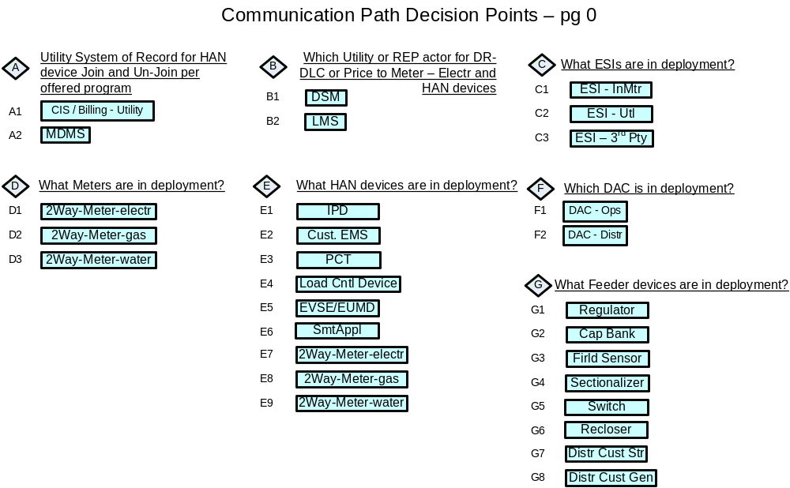
Figure 5.4-5 Deployment Decision – Requirements Table 5.0

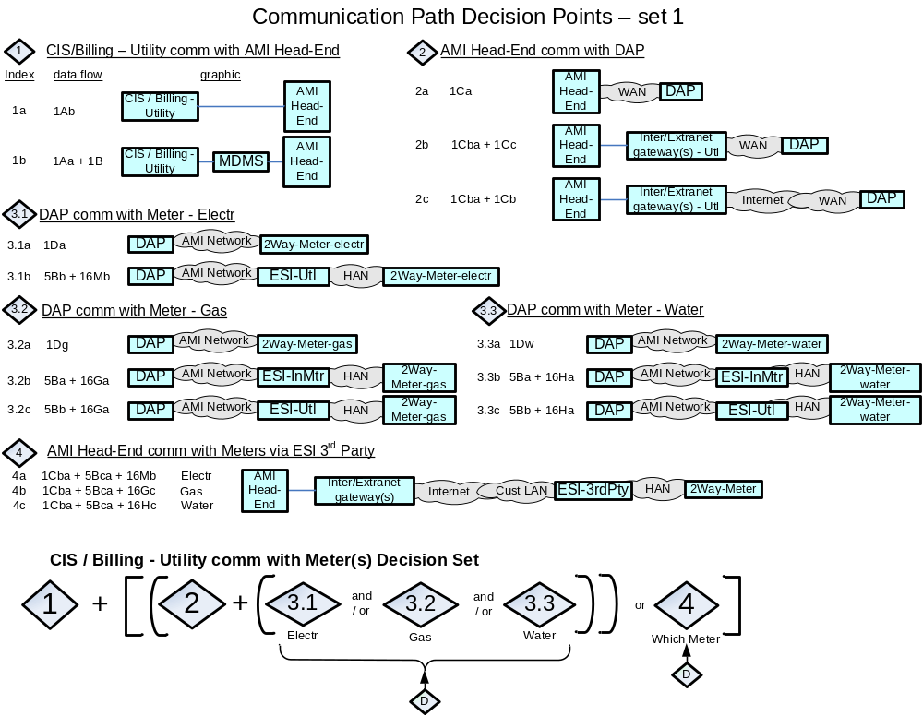
Figure 5.4-6 Communications Path Decision Set 1 – Requirements Table 5.0
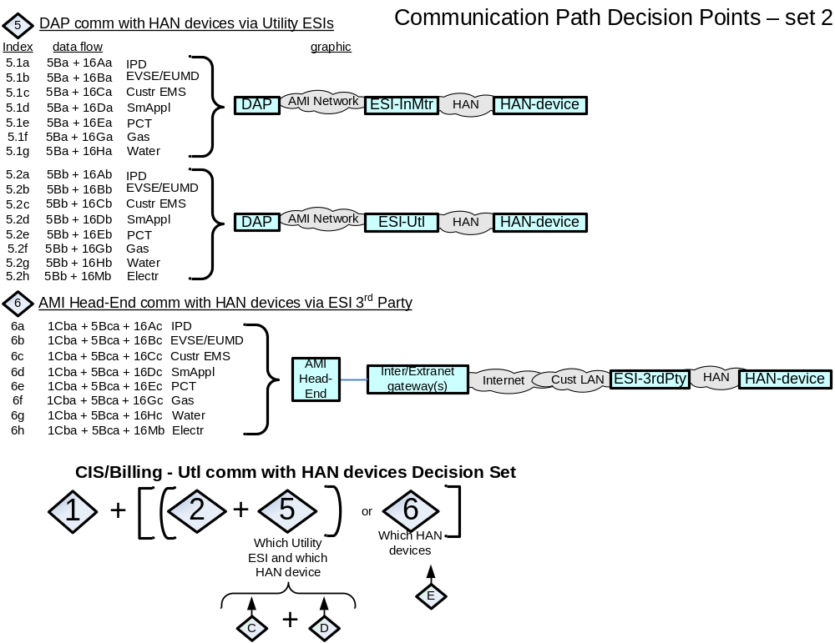
Figure 5.4-7 Communications Path Decision Set 2 – Requirements Table 5.0

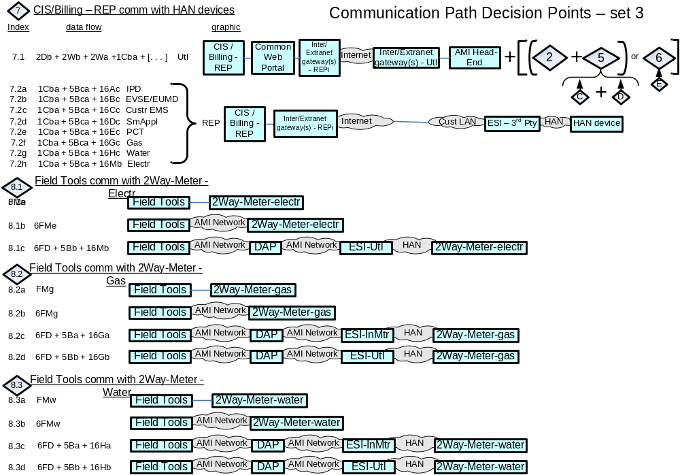
Figure 5.4-8 Communications Path Decision Set 3 – Requirements Table 5.0
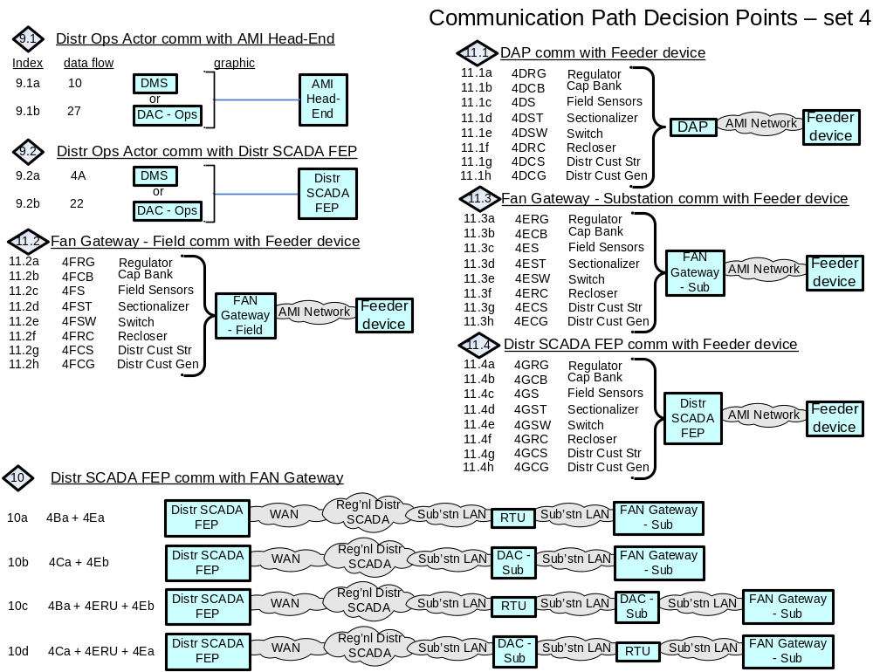
Figure 5.4-9 Communications Path Decision Set 4 – Requirements Table 5.0

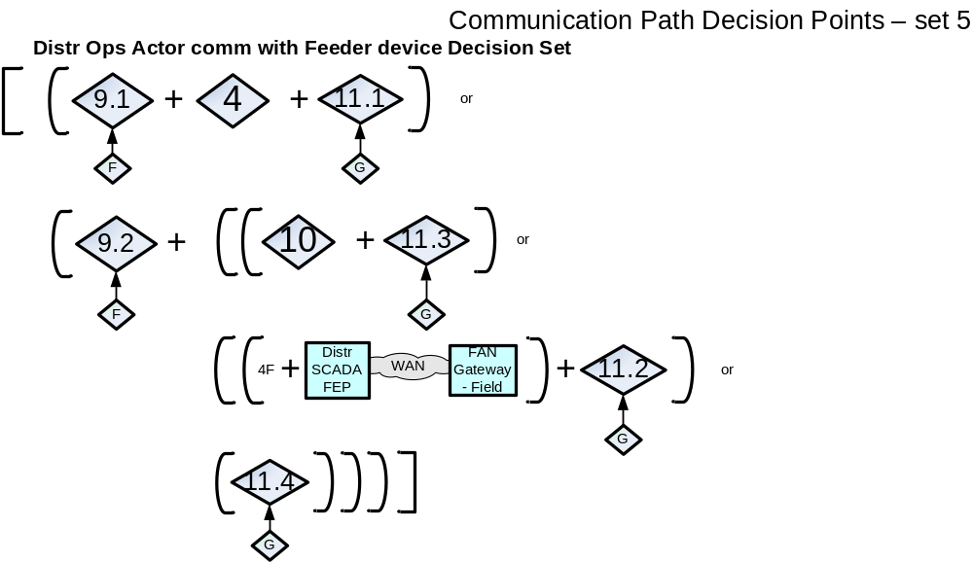
Figure 5.4-10 Communications Path Decision Set 5 – Requirements Table 5.0

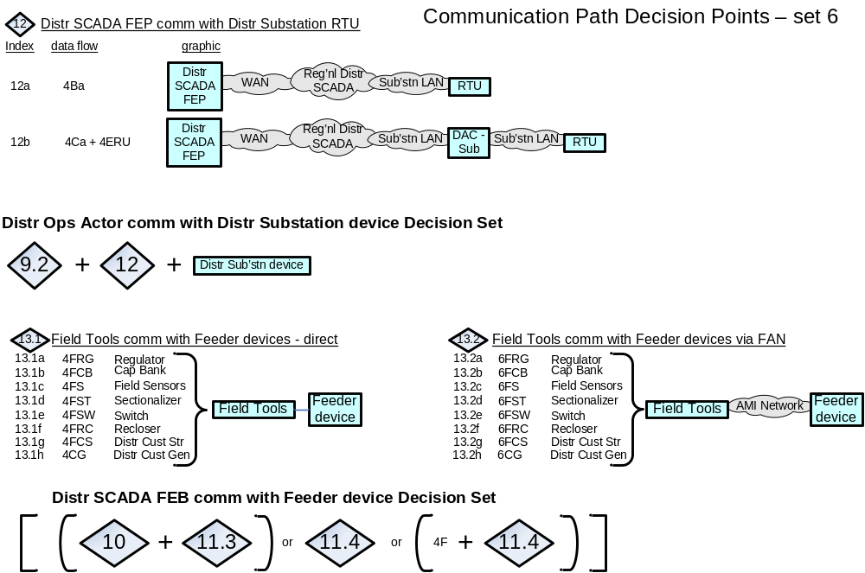
Figure 5.4-11 Communications Path Decision Set 6 – Requirements Table 5.0

Application Payloads
Payload Name | Payload Type | Description | Application Payload-attributes (excludes comm packet fields), date-time-stamps assumed for all payloads | Security LICs - NISTIR 7628 - associated to Payloads | Non-Functional Application Payload  C-I-A | Non-Functional Application Payload C-I-A Risk Values (and/or LIC) - Rational & Comments
Audit_Application_Event | Alert | Meter sends Meter event to Operations actor e.g. MDMS, occurs when a preconfigured criteria is met e.g.:  a) failure or exception in an execution of an application or out of band/bounds condition;  b) not able to service request or request timed out;  c) system activity | Meter ID, event type/Code | 13 | L-M-M | C - none to minimal harm to customer or organization for access to/disclosure of payload data;  I - a false negative or false positive ack code associated to a specific meter may lead to an incorrect next workflow process execution that may lead to serious effect on safe reliable operation of the meter;  A - not receiving this payload from a specific meter might lead to lead to an inappropriate action/operation being taken that may have a serious effect on safe reliable electric operation of the meter;
batt_pwr_notification | Alarm | Indication that network or end-point device is running solely on battery power | Device ID, status of mains power | 13, 20 | L-L-L | C - none to minimal harm to customer or organization for access to/disclosure of payload data;  I - a false negative or false positive payload attributes associated to a specific device may lead to an unnecessary health check of the device;  A - not receiving this payload from a specific device may lead to device becoming unavailable for it's intended role when battery power is drained, at which point lose of communication with device would eventually be detected.
bulk_Cust_Subset_Acct_Info_REP_data | resp-data | CIS/Billing - REP sends several large files (batches) of REP account information to the REP's ODW per day | Account ID, Premise ID, Premise address, billing address, Meter ID, payment history, current billing, general account information (programs enrolled in) - Utility meter customers | 7 | H-M-L | C - severe to catastrophic harm to customer or organization for access to/disclosure of payload data;  I - inaccurate data (specific to more than one account), may lead to an incorrect next workflow process execution that may lead to serious lost of Customer trust and increased frustration with REP, and/or complaint filed with jurisdiction;  A - not receiving this payload would create stale data for a batch of accounts and may trigger an immediate retry or retry at next file transfer period
bulk_Cust_Subset_Acct_Info_Util_data | resp-data | CIS/Billing - Utility sends several large files (batches) of Utility account information to the Utility's ODW per day | Account ID, Premise ID, Premise address, billing address, Meter ID, payment history, current billing, general account information (programs enrolled in) - Utility meter customers | 7 | H-M-L | C - severe to catastrophic harm to customer or organization for access to/disclosure of payload data;  I - inaccurate data (specific to more than one account), may lead to an incorrect next workflow process execution that may lead to serious lose of Customer trust and increased frustration with Utility, and/or complaint filed with jurisdiction;  A - not receiving this payload would create stale data for a batch of accounts and may trigger an immediate retry or retry at next file transfer period
bulk_Cust_Subset_Acct_Premise_Info_REP_data | resp-data | ODW - REP sends 1 large upload of REP customer account info per day to REP's web portal and optional Common Web Portal for access by the REP's customers | Account ID, Premise ID, Meter ID, Premise Address, billing address, payment history, current billing, general account information (programs enrolled in), energy/demand usage history, for REPs energy customers | `7/ 8 | H-M-L | C - severe to catastrophic harm to customer or organization for access to/disclosure of payload data;  I - inaccurate data (specific to more than one account), may lead to serious lose of Customer trust and increased frustration with REP, and/or complaint filed with jurisdiction;  A - not receiving this payload would create stale data for a batch of accounts and may trigger an immediate retry or retry at next file transfer period
bulk_Cust_Subset_Acct_Premise_Info_Util_data | resp-data | ODW - Utility sends 1 large upload of Utility customer account info per day to Utility's web portal and optional Common Web Portal for access by the Utility's customers | Account ID, Premise ID, Meter ID, Premise Address, billing address, payment history, current billing, general account information (programs enrolled in), energy/demand usage history, for Utility's energy customers | `7/ 8 | H-M-L | C - severe to catastrophic harm to customer or organization for access to/disclosure of payload data;  I - inaccurate data (specific to more than one account), may lead to serious lose of Customer trust and increased frustration with Utility, and/or complaint filed with jurisdiction;  A - not receiving this payload would create stale data for a batch of accounts and may trigger an immediate retry or retry at next file transfer period
bulk_Cust_Subset_meter_comm_Info_Util_data | resp-data | AMI Head-End sends several large files (batches) of meter information gathered from the Utility meters appropriate for storage/use in the ODW - Utility | Meter ID, meter read success stats | 7 | L-M-L | C - none to minimal harm to customer or organization for access to/disclosure of payload data;  I - inaccurate payload attributes (specific to more than one meter associated to a specific batch of meters), may lead to an unnecessary health check of the meter or telecomm network or associated applications or inaccurate reporting to jurisdictions;  A - not receiving this payload would create stale data for a batch of meters and may trigger an immediate retry or retry at next file transfer period
bulk_Cust_Subset_meter_Info_Util_data | resp-data | MDMS sends several large files (batches) of Utility meter information to the ODW - Utility | Meter ID, Current meter Readings, meter read history | 7 | M-M-L | C - serious harm to organization for not showing good stewardship (unauthorized access to/disclosure) of large amounts of meter payload data;  I - inaccurate data (specific to more than one account), may lead to an incorrect next workflow process execution that may lead to serious lose of Customer trust and increased frustration with Utility, and/or complaint filed with jurisdiction;  A - not receiving this payload would create stale data for a batch of accounts and may trigger an immediate retry or retry at next file transfer period
bulk_Cust_Subset_meter_outage_Info_Util_data | resp-data | OMS sends several large files (batches) per day of Utility Meter service outage information to ODW - Utility | Meter ID, outage information (reported outage, expected restore date/time, any assigned trouble ticket) | 7 | M-M-L | C - serious harm to organization for not showing good stewardship (unauthorized access to/disclosure) of large amounts of meter payload data;  I - inaccurate payload attributes (specific to more than one meter), associated to a specific batch of meters may lead to an unnecessary health check of the meter or telecomm network or associated applications or inaccurate reporting to jurisdictions;  A - not receiving this payload would create stale data for a batch of meters and may trigger an immediate retry or retry at next file transfer period
bulk_Mtr-read_cmd | Cmd | CIS/Billing - Utility requests several large files (batches) of Utility meter information from MDMS per day | group(cycle)ID, data-elements-groups, data-date | 7 | L-M-M | C - none to minimal harm to customer or organization for access to/disclosure of payload data;  I - inaccurate command parameters associated to a batch of meters may lead to an incorrect next workflow process execution that may lead to a partial rebuild of stored data or a reprocessing (e.g. re-billing) for that batch of meters;  A - not receiving the response payload to this command would create missing data for a batch of meters and would trigger an immediate retry or retry at next file transfer period to satisfy next workflow processing steps (e.g. billing);
bulk_Mtr-read_resp-data | resp-data | MDMS sends several large files (batches) per day of Utility meter information to CIS/Billing - Utility | group(cycle)ID, data-elements-group ID (e.g. Meter ID, Register Readings, Interval Data, program-opt-outs, Voltage), data-date, | 7 | M-M-M | C - serious harm to organization for not showing good stewardship (unauthorized access to/disclosure) of large amounts of meter payload data, with minimal to harm to customer for unauthorized access to/disclosure of payload data;  I - inaccurate positive command parameters associated to a batch of meters may lead to an incorrect next workflow process execution that may lead to a partial rebuild of stored data or a reprocessing (e.g. re-billing) for that batch of meters;  A - not receiving the payload would create missing data for a batch of meters and would trigger an immediate retry or retry at next file transfer period to satisfy next workflow processing steps (e.g. billing);
circuit_device_oper_cmd | Cmd | DMS or DAC sends an operate request to specific zone isolation or circuit restoring devices | device ID, command code | 2, 4 | L-H-H | C - none to minimal harm to customer or organization for access to/disclosure of payload data;  I - incorrect device ID and command code could cause the distribution grid to malfunction in a dangerous manner (operating the wrong device and not completing the necessary zone isolation task) potentially causing the Utility significant financial impact or unsafe conditions to customers on impacted portions of the faulted circuit(s);.  A - latent and un-reliable connections could cause the distribution grid to malfunction in a dangerous manner (operating the wrong device and not completing the necessary zone isolation task) potentially causing the Utility significant financial impact or unsafe conditions to customers on impacted portions of the faulted circuit(s);.
circuit_device_oper_cmd_ack | Ack | specific zone isolation or circuit restoring device sends command receipt/operation acknowledgement to DMS or DAC | device ID, acknowledgement code | 2, 4 | L-H-M | C - none to minimal harm to customer or organization for access to/disclosure of payload data;  I - incorrect device ID and acknowledgement code could cause the inappropriate workflow next step execution, distribution grid to malfunction in a dangerous manner (operating the wrong device and not completing the necessary zone isolation task) potentially causing the Utility significant financial impact (if follow-up device status not implemented) or unsafe conditions to customers on impacted portions of the faulted circuit(s);  A - latent and un-reliable connections could cause the distribution grid to malfunction in a dangerous manner (operating the wrong device and not completing the necessary zone isolation task) potentially causing the Utility financial impact or unsafe conditions to customers on impacted portions of the faulted circuit;.
circuit_device_self-init_status_resp-data | resp-data | specific zone isolation or circuit restoring device sends self initiated device status to DMS or DAC | device ID, response data | 2, 4 | L-H-M | C - none to minimal harm to customer or organization for access to/disclosure of payload data;  I - incorrect device ID and response data could cause incorrect workflow next task execution that may lead to the distribution grid malfunction in a dangerous manner potentially causing significant impact (if follow-up or routine device status requests not implemented) to the Utility and the Customer financials.  A - latent and un-reliable connections could cause the operator of the network to not understand the state of the electric grid.
circuit_device_status_cmd | Cmd | DMS or DAC sends device status request to specific zone isolation or circuit restoring devices | device ID, command code | 2, 4 | L-H-H | C - none to minimal harm to customer or organization for access to/disclosure of payload data;  I - incorrect device ID and command code could cause either the correct device to attempt to perform an inappropriate action or the wrong device to perform an action all of which may lead to unsafe or malfunction operation of the distribution grid that may have severe to catastrophic harm (especially if in-scale) to Utility and/or Customer;  A - latent and un-reliable connections may lead insufficient data for application to determine zone-isolation/circuit-reconfig actions (especially if in-scale), which might lead to significantly more customers being without power than necessary.
circuit_device_status_resp-data | resp-data | specific zone isolation or circuit restoring devices send device status to DMS or DAC | device ID, response data | 2, 4 | L-H-M | C - none to minimal harm to customer or organization for access to/disclosure of payload data;  I - incorrect device ID and response data could cause the distribution grid to malfunction in a dangerous manner potentially causing significant impact (especially if follow-up device status checks not implemented or if in-scale) to the Utility and the Customer financials  A - latent and un-reliable connections may lead insufficient data for application to determine zone-isolation/circuit-reconfig actions, which might lead to more customers being without power than necessary.
circuit-brk_device_status_cmd | Cmd | DAC sends device status request to circuit breaker | device ID, command code | 2, 4 | L-H-M | C - none to minimal harm to customer or organization for access to/disclosure of payload data;  I - incorrect device ID and command code could cause either the correct device to attempt to perform an inappropriate action or the wrong device to perform an action all of which may lead to unsafe or malfunction operation of the distribution grid that may have severe to catastrophic harm to the Utility and/or Customer;  A - latent and un-reliable connections may lead insufficient data for application to determine zone-isolation/circuit-reconfig actions, which might lead to more customers being without power than necessary.
circuit-brk_status_resp-data | resp-data | circuit breaker sends device status to DAC | device ID, response data | 2, 4 | L-H-M | C - none to minimal harm to customer or organization for access to/disclosure of payload data;  I - incorrect device ID and response data could cause the distribution grid to malfunction in a dangerous manner potentially causing significant impact (especially if follow-up device status checks for missing response data not implemented) to the Utility and the Customer financials  A - latent and un-reliable connections may lead insufficient data for application to determine zone-isolation/circuit-reconfig actions, which might lead to more customers being without power than necessary.
Configuration_Event | Alarm | Meter sends message meter indicating configuration has changed for that device e.g. out-of-state condition with configuration; get / set config, config errors | Meter ID, acknowledgement code | 13 | L-H-H | C - none to minimal harm to customer or organization for access to/disclosure of payload data;  I - a false negative or false positive alarm code associated to a specific meter may lead to an incorrect next workflow process execution that may lead to severe or catastrophic impact on safe reliable economic operation of the meter (if in-scale);  A - not receiving this payload from a specific meter might lead to an inappropriate action/operation being taken that may have a severe or catastrophic impact on safe reliable economic operation of the meter (if in-scale);
Cust_Acct_Info_cmd | Cmd | Customer (after a separate authentication to their energy providers web portal), sends a request for Customer's account information | Account ID, query type | 16 | M-M-L | C - minimal to serious harm to customer or organization (if in-scale), for access to/disclosure of Account ID and query type;  I - inaccurate account ID and query type could lead to serious impact (if in-scale) to incorrect customer-to-accountID association e.g. wrong results sent to the wrong customer  A - not receiving this payload could lead to customer frustration and/or complaint being filed with jurisdiction
CPP_pricing-data_ack | ack | HAN device participating in the CPP event sends message to LMS or DSM for either Utility of REP, acknowledging receipt and processing of the CPP command | HAN device ID, acknowledgement code | 13, 15/16 | L-L-L | C - none to minimal harm to customer or organization for access to/disclosure of payload data;  I - minimal harm to customer or organization if a false acknowledgement from the wrong HAN device is sent/received, provided not in-scale.  A - Receipt of these messages need to completed in a reasonable time.
CPP_pricing-data_brdcst | cmd | LMS or DSM for either Utility of REP sends CPP event command to all CPP enrolled HAN devices | HAN device broadcast group ID, CPP price data, CPP effective time period | 13, 15/16 | L-H-L | C - none to minimal harm to customer or organization for access to/disclosure of payload data;  I - These messages need to be properly attributed to the Energy Service Provider that sent them and the content of message.  A - Receipt of these messages need to completed in a reasonable time.
CPP_pricing-data_cmd | cmd | LMS or DSM for either Utility of REP sends CPP event command to specific CPP enrolled HAN device | HAN device ID, CPP effective time period, CPP price data | 13, 15/16 | L-H-L | C - none to minimal harm to customer or organization for access to/disclosure of payload data;  I - These messages need to be properly attributed to the Energy Service Provider that sent them and the content of message.  A - Receipt of these messages need to completed in a reasonable time.
CPP_pricing-data_mltcst | cmd | LMS or DSM for either Utility of REP sends CPP event command to specific groups of CPP enrolled HAN devices | HAN device multicast group ID, CPP price data, CPP effective time period | 13, 15/16 | L-H-L | C - none to minimal harm to customer or organization for access to/disclosure of payload data;  I - These messages need to be properly attributed to the Energy Service Provider that sent them and the content of message.  A - Receipt of these messages need to completed in a reasonable time.
Cust_Acct_Info_resp-data | resp-data | Energy providers Web Portal sends requested Customer's account information to Customer's web interface (after Customer authentication/authorization) | Customer's: Account ID, Premise ID, Meter ID, Premise Address, billing address, payment history, current billing, general account information (programs enrolled in), energy/demand usage history | 16 | H-M-L | C - limited harm to customer (unless name included and associated to account ID) and severe to catastrophic harm to organization especially in-scale, for access to/disclosure of payload data;  I - inaccurate account ID and/or query type could lead to a customers account information sent to the wrong party or correct customer taking inappropriate actions based on the response data;  A - not receiving this payload could lead to customer frustration and/or complaint filed with jurisdiction
DAP_firmware_update_cmd | cmd | AMI Head-End or Field Tool sends command to initiate a firmware update on a DAP. DAP is not a electric grid critical infrastructure component except if it the DAP provides communications to distribution equipment. This payload is not used primarily for disturbance analysis. | device ID, timeout, firmware version number, cut over time or cut over parameters, firmware update | 13/14, 20 | L:-H-L | C - none to minimal harm to customer or organization for access to/disclosure of payload data;  I - serious to severe harm (if used for comm with critical infrastructure or in-scale) if inaccurate Device ID, Firmware could lead to a device loading incorrect firmware, cutover time could lead to a device updating before the system is ready.  A - failed firmware updates commands are assumed to be retried if failed without consequence.
DAP_firmware_update_confirmation | resp-data | DAP sends confirmation of completion of DAP firmware upgrade to AMI Head-End or Field Tool. DAP is not a electric grid critical infrastructure component except if it the DAP provides communications to distribution equipment. This payload is not used primarily for disturbance analysis. | device ID, success or fail notification, firmware revision information | 13/14, 20 | L-M-M | C - none to minimal harm to customer or organization for access to/disclosure of payload data;  I - moderate harm (if in-scale) if inaccurate device ID , success vs fail status and firmware version could lead a utility to believe a system is up to date when incorrect.  A - moderate harm (if in-scale) if failed firmware updates confirmations are assumed to be retried if failed without consequence however confirmation is expected to be guaranteed
DAP_program_update_cmd | cmd | AMI Head-End or Field Tool sends command to initiate a Program/Configuration command to a DAP. DAP is not a electric grid critical infrastructure component except if it the DAP provides communications to distribution equipment. This payload is not used primarily for disturbance analysis. | device group ID, timeout, firmware version number, cut over time or cut over parameters, firmware update | 13/14, 20 | M-H-L | C - moderate harm to customer and utility if an adversary is able to ascertain the configuration/program command with device ID, firmware version number and cut over information.  I - serious to severe operational reliable economic harm (if DAP comm to critical infrastructure or in-scale) if inaccurate Device ID, configuration could lead to a device loading incorrect configuration cutover time could lead to a device updating before the system is ready.  A - failed configuration/program update commands are assumed to be retried if failed without consequence.
DAP_program_update_confirmation | resp-data | DAP sends response that a DAP configuration/program command has been completed to AMI Head-End or Field Tool. DAP is not a electric grid critical infrastructure component except if it the DAP provides communications to distribution equipment. This payload is not used primarily for disturbance analysis. | device ID, acknowledgement code | 13/14, 20 | L-M-M | C - none to minimal harm to customer or organization for access to/disclosure of payload data;ID, acknowledgement code and cut over information.  I - moderate harm if inaccurate device ID , success versus failure status and configuration/program version could lead a utility to believe a system is up to date when incorrect.  A - moderate harm if failed configuration/programming updates confirmations are assumed to be retried if failed without consequence however confirmation is expected to be guaranteed
distr_cust_storage_charge-rate_cmd | cmd | DAC sends specific charge-rate request to Distr Cust Storage device | device ID, command code, charging-rate-value | 2, 4 | L-M-M | C - none to minimal harm to customer or organization for access to/disclosure of payload data;  I - incorrect device ID charging-rate-value and command code could cause the distribution grid to malfunction in a dangerous manner potentially causing serious harm to Utility (if in -scale) and minimum to serious harm to Customer;  A - latent and un-reliable connections could cause the operation requested to seriously harm the electric network
distr_cust_storage_charge-rate_cmd_ack | ack | Distr Cust Storage device sends charge-rate command receipt/command initiation acknowledgement to DAC | device ID, acknowledgement code | 2, 4 | L-M-M | C - none to minimal harm to customer or organization for access to/disclosure of payload data;  I - incorrect device ID and acknowledgement code could cause the distribution grid to be operated in an unsafe/unstable manner potentially causing serious impact (if in-scale) to the Utility and the Customer financials  A - latent and un-reliable connections could cause serious impacts if the operator of the network does not understand the state of the electric grid.
distr_cust_storage_discharge_cmd | cmd | DAC sends specific discharge request to Distr Cust Storage device | device ID, command code | 2, 4 | L-M-M | C - none to minimal harm to customer or organization for access to/disclosure of payload data;  I - incorrect device ID charging-rate-value and command code could cause the distribution grid to malfunction in a dangerous manner potentially causing serious harm to utility (if in -scale) and minimum to serious harm to Customer;  A - latent and un-reliable connections could cause the operation requested to seriously harm (if in-scale) the electric network
distr_cust_storage_discharge_cmd_ack | ack | Distr Cust Storage device sends discharge command receipt/command initiation acknowledgement to DAC | device ID, acknowledgement code | 2, 4 | L-M-M | C - none to minimal harm to customer or organization for access to/disclosure of payload data;  I - incorrect device ID and acknowledgement code could cause the distribution grid to be operated in an unsafe/unstable manner potentially causing serious impact (if in-scale) to the Utility and the Customer financials  A - latent and un-reliable connections could cause serious impacts (if in-scale) if the operator of the network does not understand the state of the electric grid.
distr_cust_storage_in-island-mode_alarm | alarm | Distr Cust Storage device sends in-island-mode and discharging alarm to DAC and is relayed to Operations actors | device ID, alarm code | 2, 4 | L-M-M | C - none to minimal harm to customer or organization for access to/disclosure of payload data;  I - incorrect device ID and alarm code could cause the distribution grid applications to take inappropriate workflow next task executions if the current state of zoned devices not validated, which may lead to unsafe/unstable grid operations, potentially causing serious impact (if in-scale) to the Utility and the Customer financials  A - latent and un-reliable connections could cause serious impact (if in-scale) if the operator of the network does not understand the state of the electric grid.
distr_cust_storage_out-of-island-mode_alert | alert | Distr Cust Storage device sends out-of-island-mode and stop discharging alert to DAC and is relayed to Operations actors | device ID, alert code | 2, 4 | L-M-M | C - none to minimal harm to customer or organization for access to/disclosure of payload data;  I - incorrect device ID and alert code could cause the distribution grid applications to take inappropriate workflow next task executions if the current state of zoned devices not validated, which may lead to unsafe/unstable grid operations, potentially causing serious impact (if in-scale) to the Utility and the Customer financials  A - latent and un-reliable connections could cause serious impact if the operator of the network does not understand the state of the electric grid.
distr_cust_storage_status_cmd | cmd | DAC sends device status request to specific Distr Cust Storage device | device ID, command code | 2, 4 | L-H-M | C - none to minimal harm to customer or organization for access to/disclosure of payload data;  I - incorrect device ID and command code could cause the distribution grid to malfunction in a dangerous manner potentially causing severe impact (if in-scale) to the Utility and the Customer financials  A - latent and un-reliable connections could cause serious impact if the operator of the network does not understand the state of the electric grid.
distr_cust_storage_status_resp-data | resp-data | Distr Cust Storage device sends device status data to DAC and is relayed to Operations actors | device ID, response data | 2, 4 | L-H-M | C - none to minimal harm to customer or organization for access to/disclosure of payload data;  I - incorrect device ID and response data could cause the distribution grid to malfunction in a dangerous manner potentially causing severe impact (if in scale) to the Utility and the Customer financials  A - latent and un-reliable connections could cause serious impact if the operator of the network does not understand the state of the electric grid.
ESI_firmware_update_cmd | cmd | Field Tool sends command to an ESI in the Meter to update the firmware on the device. ESI is not a electric grid critical infrastructure component. This payload is not used primarily for disturbance analysis. | device ID, firmware version number, firmware update | 13, 20, 21 | M-H-L | C - moderate harm to customer and utility if an adversary is able to ascertain the firmware update command, with device ID, firmware version number and cutover information.  I - severe operational reliable economic harm (if in-scale) if inaccurate Device ID, Firmware could lead to a device loading incorrect firmware, cutover time could lead to a device updating before the system is ready.  A - failed firmware updates commands are assumed to be retried if failed without consequence.
ESI_firmware_update_confirmation | resp-data | ESI - in Meter sends response indicating completion of a ESI firmware update to Firld Tool. ESI is not a electric grid critical infrastructure component. This payload is not used primarily for disturbance analysis. | device ID, acknowledgement code | 13, 20, 21 | M-M-M | C - moderate harm to customer and utility if an adversary is able to ascertain the firmware update confirmation, with device ID, firmware version number and cutover information.  I - moderate harm if inaccurate device ID , success vs fail status and firmware version could lead a utility to believe a system is up to date when incorrect.  A - moderate harm if failed firmware updates confirmations are assumed to be retried if failed without consequence however confirmation is expected to be guaranteed
FAN-GtWay_firmware_update_cmd | cmd | Distr SCADA FEP or Field Tool sends command to initiate a firmware update on a FAN Gateway. FAN Gateway is not a electric grid critical infrastructure component except if it the FAN Gateway provides communications to any critcal infrastructure grid equipment. This payload is not used primarily for disturbance analysis. | device ID, timeout, firmware version number, cut over time or cut over parameters, firmware update | 13/14, 20 | M-H-L | C - moderate to serious impact on Utility's ability to monitor and operate the electric Distribution grid feeder devices, if an adversary is able to ascertain the firmware update command, with device ID, firmware version number and cutover information.  I - serious to severe harm on Utility's ability to monitor and operate the electric Distribution grid feeder devices (if used for comm with especially critical infrastructure or in-scale) if inaccurate Device ID, Firmware could lead to a device loading incorrect firmware, cutover time could lead to a device updating before the system is ready.  A - failed firmware updates commands are assumed to be retried if failed without serious consequence.
FAN-GtWay_firmware_update_confirmation | resp-data | FAN Gateway sends confirmation of completion of FAN Gateway firmware upgrade to Distr SCADA FEP or Field Tool. FAN Gateway is not a electric grid critical infrastructure component except if it the FAN Gateway provides communications to critical infrastructure grid equipment. This payload is not used primarily for disturbance analysis. | device ID, success or fail notification, firmware revision information | 13/14, 20 | L-M-M | C - none to minimal harm to customer or organization for access to/disclosure of payload data;  I - moderate to serious harm to ability of Utility's Distribution electric grid feeder device monitoring & operations (if in-scale) if inaccurate device ID , success vs fail status and firmware version could lead a utility to believe a system is up to date when incorrect.  A - moderate to serious harm to ability of Utility's Distribution electric grid feeder device monitoring & operations (if in-scale) if failed firmware updates confirmations are assumed to be retried if failed without consequence, however confirmation is expected to be guaranteed
FAN-GtWay_program_update_cmd | cmd | Distr SCADA FEP or Field Tool sends command to initiate a Program/Configuration command to a FAN Gateway. FAN Gateway is not a electric grid critical infrastructure component except if it the FAN Gateway provides communications to critical infrastructure grid equipment. This payload is not used primarily for disturbance analysis. | device group ID, timeout, firmware version number, cut over time or cut over parameters, firmware update | 13/14, 20 | M-H-L | C - up to serious impact on Utility's ability to monitor and operate the electric Distribution grid feeder devices, if an adversary is able to ascertain the program update command, with device ID, program version number and cutover information.  I - serious to severe harm on Utility's ability to monitor and operate the electric Distribution grid feeder devices (if used for comm with especially critical infrastructure or in-scale) if inaccurate Device ID, program could lead to a device loading incorrect program, cutover time could lead to a device updating before the system is ready.  A - failed program updates commands are assumed to be retried if failed without serious consequence.
FAN-GtWay_program_update_confirmation | resp-data | FAN Gateway sends response that a FAN Gateway configuration/program command has been completed to Distr SCADA FEP or Field Tool. FAN Gateway is not a electric grid critical infrastructure component except if it the FAN Gateway provides communications to critical infrastructure grid equipment. This payload is not used primarily for disturbance analysis. | device ID, acknowledgement code | 13/14, 20 | L-M-M | C - none to minimal harm to customer or organization for access to/disclosure of payload data;  I - up to serious harm to ability of Utility's Distribution electric grid feeder device monitoring & operations (if in-scale) if inaccurate device ID , success versus failure status and program version could lead a utility to believe a system is up to date when incorrect.  A - up to serious harm to ability of Utility's Distribution electric grid feeder device monitoring & operations (if in-scale) if failed program updates confirmations are assumed to be retried if failed without consequence, however confirmation is expected to be guaranteed
Fault_Error_Alarm_Event | alarm | Meter sends message to Operations e.g. MDMS, indicating an alarm condition has occurred e.g. out of predefined state or passed threshold conditions; System failure (e.g. Register), measurement failure, Service switch, system restart counts (outages), low battery, buggy software, firmware update failure, Communication errors, System memory full, system memory fail | Meter ID, alarm code | 13 | L-M-M | C - none to minimal harm to customer or organization for access to/disclosure of payload data;  I - a false negative or false positive alarm code associated to a specific meter may lead to an incorrect next workflow process execution that may lead to serious effect on safe reliable operation of the meter;  A - not receiving this payload from a specific meter might lead to lead to an inappropriate action/operation being taken that may have a serious effect on safe reliable electric operation of the meter;
fault_lock_out_alarm | alarm | fault clearing device sends lock-out alarm to Operations actors | device ID, alarm code | 2, 4 | L-H-H | C - none to minimal harm to customer or organization for access to/disclosure of payload data;  I - incorrect device ID and alarm code may cause Utility not recognizing the correct operational state of the distribution grid and if failing to perform a follow-up device state request, may lead to incorrect workflow next task execution, which may lead to severe harm to safe reliable economic (if other circuit device status requests are not implemented and if in-scale) grid operations and harm to Customer;  A - latent and un-reliable connections could cause the operator of the electrical grid to perform unnecessary health checks of the devices and the telecomm network, and lead to lose of trust in distribution applications to function properly, leading to severe harm (if other circuit device status requests are not implemented and if in-scale) to organization and customer.
Fdr-dev-cntl_firmware_update_cmd | cmd | Distr SCADA FEP or Field Tool sends command to initiate a firmware update on a feeder device controller. Feeder device controller typically is not a electric grid critical infrastructure component. This payload is not used primarily for disturbance analysis. | device ID, timeout, firmware version number, cut over time or cut over parameters, firmware update | 13/14, 20 | M-H-L | C - moderate to serious impact on Utility's ability to monitor and operate the electric Distribution grid feeder devices, if an adversary is able to ascertain the firmware update command, with device ID, firmware version number and cutover information.  I - serious to severe harm on Utility's ability to monitor and operate the electric Distribution grid feeder devices (especially for any critical infrastructure or in-scale) if inaccurate Device ID, Firmware could lead to a device loading incorrect firmware, cutover time could lead to a device updating before the system is ready.  A - failed firmware updates commands are assumed to be retried if failed without serious consequence.
Fdr-dev-cntl_firmware_update_confirmation | resp-data | Feeder Device controller sends confirmation of completion of feeder device controller firmware upgrade to Distr SCADA FEP or Field Tool. Feeder device controller typically is not a electric grid critical infrastructure component. This payload is not used primarily for disturbance analysis. | device ID, success or fail notification, firmware revision information | 13/14, 20 | L-M-M | C - none to minimal harm to customer or organization for access to/disclosure of payload data;  I - moderate to serious harm to ability of Utility's Distribution electric grid feeder device monitoring & operations (if in-scale) if inaccurate device ID , success versus failure status and firmware version could lead a utility to believe a system is up to date when incorrect.  A - moderate to serious harm to ability of Utility's Distribution electric grid feeder device monitoring & operations (if in-scale) if failed firmware updates confirmations are assumed to be retried if failed without consequence, however confirmation is expected to be guaranteed
Fdr-dev-cntl_program_update_cmd | cmd | Distr SCADA FEP or Field Tool sends command to initiate a Program/Configuration command to a feeder device controller. Feeder device controller typically is not a electric grid critical infrastructure component. This payload is not used primarily for disturbance analysis. | device group ID, timeout, firmware version number, cut over time or cut over parameters, firmware update | 13/14, 20 | M-H-L | C - moderate to serious impact on Utility's ability to monitor and operate the electric Distribution grid feeder devices, if an adversary is able to ascertain the program update command, with device ID, program version number and cutover information.  I - serious to severe harm on Utility's ability to monitor and operate the electric Distribution grid feeder devices (especially for any critical infrastructure or in-scale) if inaccurate Device ID, program could lead to a device loading incorrect program, cutover time could lead to a device updating before the system is ready.  A - failed program updates commands are assumed to be retried if failed without serious consequence.
Fdr-dev-cntl_program_update_confirmation | resp-data | Feeder device controller sends response that a feeder device controller configuration/program command has been completed to Distr SCADA FEP or Field Tool. Feeder device controller typically is not a electric grid critical infrastructure component. This payload is not used primarily for disturbance analysis. | device ID, acknowledgement code | 13/14, 20 | L-M-M | C - none to minimal harm to customer or organization for access to/disclosure of payload data;  I - moderate to serious harm to ability of Utility's Distribution electric grid feeder device monitoring & operations (if in-scale) if inaccurate device ID , success versus failure status and program version could lead a utility to believe a system is up to date when incorrect.  A - moderate to serious harm to ability of Utility's Distribution electric grid feeder device monitoring & operations (if in-scale) if failed program updates confirmations are assumed to be retried if failed without consequence, however confirmation is expected to be guaranteed
FeederCBC_alarm | alarm | feeder Capacitor Bank Controller has detected and sends an alarm notification | device ID, alarm code | 2, 4 | L-H-H | C - none to minimal harm to customer or organization for access to/disclosure of payload data;  I - incorrect device ID and alarm code could cause the distribution grid to malfunction in a dangerous manner potentially causing severe impact (if coupled with multiple other circuit regulator & voltage sensor value anomalies and if in-scale) to the Utility and the Customer financials  A - latent and un-reliable connections could cause the operation requested to seriously harm (if coupled with multiple other circuit regulator & voltage sensor value anomalies and if in-scale) the electric network
FeederCBC_close_ack | ack | feeder Capacitor Bank Controller has performed and sends a close operation acknowledgement | device ID, acknowledgement code | 2, 4 | L-H-M | C - none to minimal harm to customer or organization for access to/disclosure of payload data;  I - incorrect device ID and acknowledgement code could cause the distribution grid to malfunction in a seriously (if coupled with multiple other circuit regulator & voltage sensor value anomalies and followup device status request not implemented and if in-scale) dangerous manner potentially causing the Utility and the Customer financial impact.  A - latent and un-reliable connections could cause the operator of the network to not understand the state of the electric grid and seriously harm the electric network (if coupled with multiple other circuit regulator & voltage sensor value anomalies and if in-scale).
FeederCBC_close_cmd | cmd | Command to close feeder Capacitor Bank | device ID, command code | 2, 4 | L-H-M | C - none to minimal harm to customer or organization for access to/disclosure of payload data;  I - incorrect device ID and command code could cause the distribution grid to malfunction in a severe (if coupled with multiple other circuit regulator & voltage sensor value anomalies and if in-scale) and dangerous manner potentially causing the Utility and the Customer financial impact.  A - latent and un-reliable connections could cause the operator of the network to not be able to operate Feeder Capacitor bank controllers in a timely manner. Prior to adding this functionality, crews were dispatched to operate these commands
FeederCBC_deviation_alert | alert | feeder Capacitor Bank Controller has detected and sends a measured value has gone out of the tolerance band alert | device ID, alert code | 2, 4 | L-H-H | C - none to minimal harm to customer or organization for access to/disclosure of payload data;  I - incorrect device ID and alert code could cause the distribution grid to malfunction in a severe (if coupled with multiple other circuit regulator & voltage sensor value anomalies and if follow-up circuit device stats request not implemented and if in-scale) and dangerous manner potentially causing the Utility and the Customer financial impact.  A - latent and un-reliable connections could cause the operation requested to severely harm (if coupled with multiple other circuit regulator & voltage sensor value anomalies and if follow-up circuit device stats request not implemented and if in-scale) the electric network
FeederCBC_new_config_ack | ack | feeder Capacitor Bank Controller has received, processed and sends a new configuration acknowledgement | device ID, acknowledgement code | 2, 4 | L-H-M | C - none to minimal harm to customer or organization for access to/disclosure of payload data;  I - incorrect device ID and acknowledgement code could cause the distribution grid to malfunction in a dangerous manner potentially causing serious to severe impact (if coupled with multiple other circuit regulator & voltage sensor value anomalies and if follow-up circuit device stats request not implemented and if in-scale) the Utility and the Customer financial impact.  A - latent and un-reliable connections could cause serious impact (if coupled with multiple other circuit regulator & voltage sensor value anomalies and if follow-up circuit device stats request not implemented and if in-scale) if the operator of the network does not understand the state of the electric grid.
FeederCBC_new_config_cmd | cmd | Command to perform a feeder Capacitor Bank Controller new configuration | device ID, configuration command, configuration information | 2, 4 | L-H-H | C - none to minimal harm to customer or organization for access to/disclosure of payload data;  I - incorrect device ID configuration information and configuration command could cause the distribution grid to malfunction in a dangerous manner potentially causing the Utility and the Customer financial impact (if coupled with multiple other circuit regulator & voltage sensor value anomalies and if follow-up circuit device stats request not implemented and if in-scale).  A - latent and un-reliable connections could cause the operation requested to severely harm (if coupled with multiple other circuit regulator & voltage sensor value anomalies and if follow-up circuit device stats request not implemented and if in-scale) the electric network
FeederCBC_open_ack | ack | feeder Capacitor Bank Controller has performed and sends an open operation acknowledgement | device ID, acknowledgement code | 2, 4 | L-H-H | C - none to minimal harm to customer or organization for access to/disclosure of payload data;  I - incorrect device ID and acknowledgement code could cause the distribution grid to malfunction in a dangerous manner potentially causing the Utility and the Customer financial impact (if coupled with multiple other circuit regulator & voltage sensor value anomalies and if follow-up circuit device stats request not implemented and if in-scale).  A - latent and un-reliable connections could cause the operator of the network to not understand the state of the electric grid causing serious up to severe impact (if coupled with multiple other circuit regulator & voltage sensor value anomalies and if follow-up circuit device stats request not implemented and if in-scale) .
FeederCBC_open_cmd | cmd | Command to open feeder Capacitor Bank | device ID, command code | 2, 4 | L-H-H | C - none to minimal harm to customer or organization for access to/disclosure of payload data;  I - incorrect device ID and command code could cause the distribution grid to malfunction in a dangerous manner potentially causing the Utility and the Customer financial impact (if coupled with multiple other circuit regulator & voltage sensor value anomalies and if follow-up circuit device stats request not implemented and if in-scale).  A - latent and un-reliable connections could cause the operation requested to harm the electric network causing serious up to severe impact (if coupled with multiple other circuit regulator & voltage sensor value anomalies and if follow-up circuit device stats request not implemented and if in-scale)
FeederCBC_Operate_failure | alarm | Message to indicate device failure | device ID, failure code | 2, 4 | L-H-H | C - none to minimal harm to customer or organization for access to/disclosure of payload data;  I - incorrect device ID and failure code could cause the distribution grid to malfunction in a dangerous manner potentially causing the Utility and the Customer financial impact. (if coupled with multiple other circuit regulator & voltage sensor value anomalies and if follow-up circuit device stats request not implemented and if in-scale).  A - latent and un-reliable connections could cause the operation requested to harm the electric network causing serious up to severe impact (if coupled with multiple other circuit regulator & voltage sensor value anomalies and if follow-up circuit device stats request not implemented and if in-scale) .
FeederCBC_sensor_data_cmd | cmd | Query for sensor data | device ID, command code | 2, 4 | L-H-M | C - none to minimal harm to customer or organization for access to/disclosure of payload data;  I - incorrect device ID and command code could cause the distribution grid to malfunction in a dangerous manner potentially causing the Utility and the Customer financial impact.(if coupled with multiple other circuit regulator & voltage sensor value anomalies and if follow-up circuit device stats request not implemented and if in-scale).  A - latent and un-reliable connections could cause the operator of the network to not understand the state of the electric grid.
FeederCBC_sensor_data_resp-data | resp-data | sensor data response from feeder Capacitor Bank Controller | device ID, response data | 2, 4 | L-H-M | C - none to minimal harm to customer or organization for access to/disclosure of payload data;  I - incorrect device ID and response data could cause the distribution grid to malfunction in a dangerous manner potentially causing the Utility and the Customer financial impact.(if coupled with multiple other circuit regulator & voltage sensor value anomalies and if follow-up circuit device stats request not implemented and if in-scale).  A – latent and un-reliable connections could cause the operator of the network to not understand the state of the electric grid.
FeederCBC_status_change_alert | alert | feeder Capacitor Bank Controller detects and sends device state change alert | device ID, alert code | 2, 4 | L-H-H | C - none to minimal harm to customer or organization for access to/disclosure of payload data;  I - incorrect device ID and alert code could cause the distribution grid to malfunction in a dangerous manner potentially causing the Utility and the Customer financial impact.(if coupled with multiple other circuit regulator & voltage sensor value anomalies and if follow-up circuit device stats request not implemented and if in-scale).  A - latent and un-reliable connections could cause the operation requested to harm the electric network causing serious up to severe impact (if coupled with multiple other circuit regulator & voltage sensor value anomalies and if follow-up circuit device stats request not implemented and if in-scale) .
FeederCBC_status_cmd | cmd | Command to feeder Capacitor Bank Controller to query device status | device ID, query code | 2, 4 | L-H-M | C - none to minimal harm to customer or organization for access to/disclosure of payload data;  I - incorrect device ID and query code could cause the distribution grid to malfunction in a dangerous manner potentially causing the Utility and the Customer financial impact.(if coupled with multiple other circuit regulator & voltage sensor value anomalies and if follow-up circuit device stats request not implemented and if in-scale).  A - latent and un-reliable connections could cause the operator of the network to not understand the state of the electric grid.
FeederCBC_status_resp-data | resp-data | feeder Capacitor Bank Controller response data to device status query | device ID, response data | 2, 4 | L-H-M | C - none to minimal harm to customer or organization for access to/disclosure of payload data;  I - incorrect device ID and response data could cause the distribution grid to malfunction in a dangerous manner potentially causing the Utility and the Customer financial impact.(if coupled with multiple other circuit regulator & voltage sensor value anomalies and if follow-up circuit device stats request not implemented and if in-scale).  A - latent and un-reliable connections could cause the operator of the network to not understand the state of the electric grid.
FeederFault_Detector_alarm | alarm | feeder fault detection device senses a fault and sends a fault alarm | device ID, alarm code | 2, 4 | L-H-H | C - none to minimal harm to customer or organization for access to/disclosure of payload data;  I - incorrect device ID and alarm code could cause the distribution grid to be operated in a dangerous/severe manner potentially causing the Utility and the Customer severe financial impact (if not recognized and coupled with multiple sensor value anomalies and if in-scale).  A - latent and un-reliable connections could cause follow-up grid operations to potentially severely harm the electric grid, (if not recognized and coupled with other multiple sensor value anomalies and if in-scale)
FeederFault_Detector_deviation_alert | alert | feeder fault detection device senses and sends a measured value has gone out of the tolerance band alert | device ID, alert code | 2, 4 | L-H-H | C - none to minimal harm to customer or organization for access to/disclosure of payload data;  I - incorrect device ID and alert code could cause the distribution grid to be operated in a dangerous/severe manner potentially causing the Utility and the Customer severe financial impact (if not recognized and coupled with other multiple sensor value anomalies and if in-scale).  A - latent and un-reliable connections could cause follow-up grid operations to potentially severely harm the electric grid, (if not recognized and coupled with other multiple sensor value anomalies and if in-scale)
FeederFault_Detector_sensor_data_cmd | cmd | Query for feeder fault detector device sensor data | device ID, command code | 2, 4 | L-H-M | C - none to minimal harm to customer or organization for access to/disclosure of payload data;  I - incorrect device ID and command code could cause the distribution grid to malfunction in a dangerous/severe manner potentially causing the Utility and the Customer severe financial impact.  A - latent and un-reliable connections could cause the operator of the network to not understand the state of the electric grid and may lead to serious incorrect electric grid operations.
FeederFault_Detector_sensor_data_resp-data | resp-data | sensor data response from feeder fault detector | device ID, response data | 2, 4 | L-H-M | C - none to minimal harm to customer or organization for access to/disclosure of payload data;  I - incorrect device ID and response data could cause the distribution grid to malfunction in a dangerous/severe manner potentially causing the Utility and the Customer severe financial impact.  A - latent and un-reliable connections could cause the operator of the network to not understand the state of the electric grid and may lead to serious incorrect electric grid operations.
FeederFault_Detector_status_change_alert | alert | feeder Fault Detector detects and sends device state change alert | device ID, alert code | 2, 4 | L-H-H | C - none to minimal harm to customer or organization for access to/disclosure of payload data;  I - incorrect device ID and alert code could cause the distribution grid to be operated in a dangerous/severe manner potentially causing the Utility and the Customer severe financial impact (if not recognized and coupled with other multiple sensor value anomalies and if in-scale).  A - latent and un-reliable connections could cause follow-up grid operations to potentially severely harm the electric grid, (if not recognized and coupled with other multiple sensor value anomalies and if in-scale)
FeederFault_Detector_status_cmd | cmd | command to check status of feeder Fault Detector | device ID, query operation | 2, 4 | L-H-M | C - none to minimal harm to customer or organization for access to/disclosure of payload data;  I - incorrect device ID and query operation could cause the distribution grid to malfunction in a dangerous/severe manner potentially causing the Utility and the Customer severe financial impact.  A - latent and un-reliable connections could cause the operator of the network to not understand the state of the electric grid and may lead to serious incorrect electric grid operations.
FeederFault_Detector_status_resp-data | resp-data | feeder Fault Detector response data to device status query | device ID, condition, history if available | 2, 4 | L-H-M | C - none to minimal harm to customer or organization for access to/disclosure of payload data;  I - incorrect device ID condition and history could cause the distribution grid to malfunction in a dangerous/severe manner potentially causing the Utility and the Customer severe financial impact.  A - latent and un-reliable connections could cause the operator of the network to not understand the state of the electric grid and may lead to serious incorrect electric grid operations.
FeederRecloser_alarm | alarm | Alarm message to SCADA system | device ID, alarm code | 2, 4 | L-H-H | C - none to minimal harm to customer or organization for access to/disclosure of payload data;  I - incorrect device ID and alarm code could cause the distribution grid to malfunction in a dangerous/severe manner potentially causing the Utility and the Customer severe financial impact.  A - latent and un-reliable connections could cause the operation requested to harm the electric network and may lead to severe incorrect electric grid operations.
FeederRecloser_deviation_alert | alert | Alert message to SCADA system | device ID, alert code | 2, 4 | L-H-H | C - none to minimal harm to customer or organization for access to/disclosure of payload data;  I - incorrect device ID and alert code could cause the distribution grid to malfunction in a dangerous/severe manner potentially causing the Utility and the Customer severe financial impact.  A – latent and un-reliable connections could cause the operation requested to harm the electric network and may lead to severe incorrect electric grid operations.
FeederRecloser_new_config_ack | ack | Acknowledgement of new configuration | device ID, acknowledgement code | 2, 4 | L-H-M | C - none to minimal harm to customer or organization for access to/disclosure of payload data;  I - incorrect device ID and acknowledgement code could cause the distribution grid to malfunction in a dangerous/severe manner potentially causing the Utility and the Customer severe financial impact.  A - latent and un-reliable connections could cause the operator of the network to not understand the state of the electric grid and may lead to severe incorrect electric grid operations
FeederRecloser_new_config_cmd | cmd | Command to change configuration | device ID, configuration command | 2, 4 | L-H-H | C - none to minimal harm to customer or organization for access to/disclosure of payload data;  I - incorrect device ID and configuration command could cause the distribution grid to malfunction in a dangerous/severe manner potentially causing the Utility and the Customer severe financial impact (if situation not recognized quickly).  A - latent and un-reliable connections could cause the operation requested to harm the electric network and lead to severe missed operations (if not recognized quickly)
FeederRecloser_Operate_failure | alarm | Message to indicate device failure | device ID, failure code | 2, 4 | L-H-H | C - none to minimal harm to customer or organization for access to/disclosure of payload data;  I - incorrect device ID and failure code could cause the distribution grid to malfunction in a dangerous/severe manner potentially causing the Utility and the Customer severe financial impact.  A – latent and un-reliable connections could cause the operation requested to harm the electric network and may lead to severe incorrect electric grid operations.
FeederRecloser_sensor_data_cmd | cmd | Query to sensor data | device ID, command code | 2, 4 | L-H-M | C - none to minimal harm to customer or organization for access to/disclosure of payload data;  I - incorrect device ID and command code could cause the distribution grid to malfunction in a dangerous/severe manner potentially causing the Utility and the Customer severe financial impact (if situation not recognized quickly)  A – latent and un-reliable connections could cause the operator of the network to not understand the state of the electric grid and lead to serious missed operations (if not recognized quickly)
FeederRecloser_sensor_data_resp-data | resp-data | Response from recloser | device ID, response data | 2, 4 | L-H-M | C - none to minimal harm to customer or organization for access to/disclosure of payload data;  I - incorrect device ID and response data could cause the distribution grid to malfunction in a dangerous/severe manner potentially causing the Utility and the Customer severe financial impact (if not recognized quickly)  A - latent and un-reliable connections could cause the operator of the network to not understand the state of the electric grid and lead to serious missed operations (if not recognized quickly)
FeederRecloser_status_change_alert | alert | Alert message to SCADA system | device ID, alert code | 2, 4 | L-H-H | C - none to minimal harm to customer or organization for access to/disclosure of payload data;  I - incorrect device ID and alert code could cause the distribution grid to malfunction in a dangerous/severe manner potentially causing the Utility and the Customer severe financial impact.  A - latent and un-reliable connections could cause the operator of the network to not understand the state of the electric grid and may lead to severe incorrect electric grid operations.
FeederRecloser_status_cmd | cmd | Command to recloser to query status | device ID, query code | 2, 4 | L-H-M | C - none to minimal harm to customer or organization for access to/disclosure of payload data;  I - incorrect device ID and query code could cause the distribution grid to malfunction in a dangerous/severe manner potentially causing the Utility and the Customer severe financial impact (if not recognized quickly)  A - latent and un-reliable connections could cause the operator of the network to not understand the state of the electric grid and lead to serious missed operations (if not recognized)
FeederRecloser_status_resp-data | resp-data | response to recloser query status | device ID, response data | 2, 4 | L-H-M | C - none to minimal harm to customer or organization for access to/disclosure of payload data;  I - incorrect device ID and response data could cause the distribution grid to malfunction in a dangerous/severe manner potentially causing the Utility and the Customer severe financial impact (if not recognized quickly)  A - latent and un-reliable connections could cause the operator of the network to not understand the state of the electric grid and lead to serious missed operations (if not recognized)
FeederSensor_alarm | alarm | Alarm message to SCADA system | device ID, alarm code | 2, 4 | L-M-M | C - none to minimal harm to customer or organization for access to/disclosure of payload data;  I - incorrect device ID and alarm code could cause the distribution grid to malfunction in a dangerous manner potentially causing the Utility and the Customer financial impact (if coupled with multiple other CBC, Regulator sensor value anomalies and if in-scale).  A - latent t and un-reliable connections could cause the operation requested to seriously harm the electric network (if not recognized and coupled with multiple other CBC, Regulator sensor value anomalies and if in-scale).
FeederSensor_deviation_alert | alert | feeder Sensor has detected and sends a measured value has gone out of the tolerance band alert | device ID, alert code | 2, 4 | L-M-M | C - none to minimal harm to customer or organization for access to/disclosure of payload data;  I - incorrect device ID and alert code could cause the distribution grid to malfunction in a dangerous manner potentially causing the Utility and the Customer serious financial impact.(if not recognized and coupled with multiple other CBC, Regulator sensor value anomalies and if in-scale).  A - latent and un-reliable connections could cause the operator of the network to not understand the state of the electric grid and lead to serious operations (if not recognized and coupled with multiple other CBC, Regulator sensor value anomalies and if in-scale).
FeederSensor_new_config_ack | ack | Acknowledgement of new configuration | device ID, acknowledgement code | 2, 4 | L-M-M | C - none to minimal harm to customer or organization for access to/disclosure of payload data;  I - incorrect device ID and acknowledgement code could cause the distribution grid to malfunction in a dangerous/serious manner potentially causing the Utility and the Customer serious financial impact (if not recognized and coupled with multiple other CBC, Regulator sensor value anomalies and if in-scale).  A - latent and un-reliable connections could cause the operator of the network to not understand the state of the electric grid (if not recognized and coupled with multiple other CBC, Regulator sensor value anomalies and if in-scale).
FeederSensor_new_config_cmd | cmd | Command to change configuration | device ID, command code | 2, 4 | L-M-M | C - none to minimal harm to customer or organization for access to/disclosure of payload data;  I - incorrect device ID and command code could cause the distribution grid to malfunction in a dangerous/serious manner potentially causing the Utility and the Customer serious financial impact (if not recognized and coupled with multiple other CBC, Regulator sensor value anomalies and if in-scale).  A - latent and un-reliable connections could cause the operator of the network to not understand the state of the electric grid and lead to serious missed operations (if not recognized and coupled with multiple other CBC, Regulator sensor value anomalies and if in-scale).
FeederSensor_sensor_data_cmd | cmd | Command to query sensor data | device ID, sensor data | 2, 4 | L-M-M | C - none to minimal harm to customer or organization for access to/disclosure of payload data;  I - incorrect device ID and command code could cause the distribution grid to malfunction in a dangerous manner potentially causing the Utility and the Customer serious financial impact (if not recognized and coupled with multiple other CBC, Regulator sensor value anomalies and if in-scale).  A - latent and un-reliable connections could cause the operator of the network to not understand the state of the electric grid and lead to serious missed operations (if not recognized and coupled with multiple other CBC, Regulator sensor value anomalies and if in-scale).
FeederSensor_sensor_data_resp-data | resp-data | Response to Sensor query | device ID, response data | 2, 4 | L-M-M | C - none to minimal harm to customer or organization for access to/disclosure of payload data;  I - incorrect device ID and response data could cause the distribution grid to malfunction in a dangerous manner potentially causing the Utility and the Customer serious financial impact (if not recognized and coupled with multiple other CBC, Regulator sensor value anomalies and if in-scale).  A - latent and un-reliable connections could cause the operator of the network to not understand the state of the electric grid and lead to serious incorrect operation of the grid (if not recognized and coupled with multiple other CBC, Regulator sensor value anomalies and if in-scale).
FeederSensor_status_change_alert | alert | Alert to SCADA system | device ID, alert code | 2, 4 | L-H-H | C - none to minimal harm to customer or organization for access to/disclosure of payload data;  I - incorrect device ID and alert code could cause the distribution grid to malfunction in a dangerous manner potentially causing the Utility and the Customer severe financial impact (if not recognized and coupled with multiple other CBC, Regulator sensor value anomalies and if in-scale).  A - latent and un-reliable connections could cause the operator of the network to not understand the state of the electric grid of the grid and lead to severe incorrect operation (if not recognized and coupled with multiple other CBC, Regulator sensor value anomalies and if in-scale).
FeederSensor_status_cmd | cmd | Command to sensor for status | device ID, command code | 2, 4 | L-M-M | C - none to minimal harm to customer or organization for access to/disclosure of payload data;  I - incorrect device ID and command code could cause the distribution grid to malfunction in a dangerous manner potentially causing the Utility and the Customer serious financial impact (if not recognized and coupled with multiple other CBC, Regulator sensor value anomalies and if in-scale).  A - latent and un-reliable connections could cause the operator of the network to not understand the state of the electric grid and may lead to incorrect operation of the grid (if not recognized and coupled with multiple other CBC, Regulator sensor value anomalies and if in-scale).
FeederSensor_status_resp-data | resp-data | Response to sensor status request | device ID, sensor status | 2, 4 | L-M-M | C - none to minimal harm to customer or organization for access to/disclosure of payload data;  I - incorrect device ID and sensor status could cause the distribution grid to malfunction in a dangerous manner potentially causing the Utility and the Customer serious financial impact (if not recognized and coupled with multiple other CBC, Regulator sensor value anomalies and if in-scale).  A - latent and un-reliable connections could cause the operator of the network to not understand the state of the electric grid and incorrect operation of the grid (if not recognized and coupled with multiple other CBC, Regulator sensor value anomalies and if in-scale).
FeederSwitch_alarm | alarm | Alarm message to SCADA system | device ID, alarm code | 2, 4 | L-H-H | C - none to minimal harm to customer or organization for access to/disclosure of payload data;  I - incorrect device ID and alarm code could cause the distribution grid to malfunction in a dangerous/severe manner potentially causing the Utility and the Customer severe financial impact.  A - latent and un-reliable connections could cause the operation requested to severely harm the electric network
FeederSwitch_close_ack | ack | Acknowledgment of switch close | device ID, acknowledgement code | 2, 4 | L-H-M | C - none to minimal harm to customer or organization for access to/disclosure of payload data;  I - incorrect device ID and acknowledgement status could cause the distribution grid to malfunction in a dangerous/severe manner potentially causing the Utility and the Customer severe financial impact (if not recognized quickly).  A - latent and un-reliable connections could cause the operator of the network to not understand the state of the electric grid.
FeederSwitch_close_cmd | cmd | Command to close feeder switch | device ID, command code | 2, 4 | L-H-H | C - none to minimal harm to customer or organization for access to/disclosure of payload data;  I - incorrect device ID and command code could cause the distribution grid to malfunction in a dangerous/severe manner potentially causing the Utility and the Customer severe financial impact (if not recognized quickly).  A - latent and un-reliable connections could cause the operation requested to severely harm the electric network (if not recognized quickly)
FeederSwitch_deviation_alert | alert | Alert to SCADA system | device ID, alert code | 2, 4 | L-H-H | C - none to minimal harm to customer or organization for access to/disclosure of payload data;  I - incorrect device ID and alert code could cause the distribution grid to malfunction in a dangerous/severe manner potentially causing the Utility and the Customer severe financial impact.  A - latent and un-reliable connections could cause the operator of the network to not understand the state of the electric grid and incorrectly operate the grid in a dangerous/severe manner.
FeederSwitch_new_config_ack | ack | feeder Switch Controller has received, processed and sends a new configuration acknowledgement | device ID, acknowledgement code | 2, 4 | L-H-M | C - none to minimal harm to customer or organization for access to/disclosure of payload data;  I - incorrect device ID and acknowledgement code could cause the distribution grid to malfunction in a dangerous manner potentially causing serious to severe impact (if coupled with multiple other circuit regulator & voltage sensor value anomalies and if follow-up circuit device stats request not implemented and if in-scale) the Utility and the Customer financial impact.  A - latent and un-reliable connections could cause serious impact (if coupled with multiple other circuit regulator & voltage sensor value anomalies and if follow-up circuit device stats request not implemented and if in-scale) if the operator of the network does not understand the state of the electric grid.
FeederSwitch_new_config_cmd | cmd | Command to perform a feeder Switch Controller new configuration | device ID, configuration command, configuration information | 2, 4 | L-H-H | C - none to minimal harm to customer or organization for access to/disclosure of payload data;  I - incorrect device ID configuration information and configuration command could cause the distribution grid to malfunction in a dangerous manner potentially causing the Utility and the Customer financial impact (if coupled with multiple other circuit regulator & voltage sensor value anomalies and if follow-up circuit device stats request not implemented and if in-scale).  A - latent and un-reliable connections could cause the operation requested to severely harm (if coupled with multiple other circuit regulator & voltage sensor value anomalies and if follow-up circuit device stats request not implemented and if in-scale) the electric network
FeederSwitch_open_ack | ack | Confirmation of switch open | device ID, acknowledgement code | 2, 4 | L-H-M | C - none to minimal harm to customer or organization for access to/disclosure of payload data;  I - incorrect device ID and acknowledgement code could cause the distribution grid to malfunction in a dangerous/severe manner potentially causing the Utility and the Customer severe financial impact (if not recognized quickly).  A - latent and un-reliable connections could cause the operator of the network to not understand the state of the electric grid and incorrectly operate the grid in a dangerous/serious manner
FeederSwitch_open_cmd | cmd | Command to open feeder switch | device ID, command code | 2, 4 | L-H-H | C - none to minimal harm to customer or organization for access to/disclosure of payload data;  I - incorrect device ID and command code could cause the distribution grid to malfunction in a dangerous/severe manner potentially causing the Utility and the Customer severe financial impact (if not recognized quickly).  A - latent and un-reliable connections could cause the operation requested to severely harm the electric network (if not recognized quickly)
FeederSwitch_Operate_failure | alarm | Alarm message to SCADA system | device ID, alarm code | 2, 4 | L-H-H | C - none to minimal harm to customer or organization for access to/disclosure of payload data;  I - incorrect device ID and alarm code could cause the distribution grid to malfunction in a dangerous/severe manner potentially causing the Utility and the Customer severe financial impact (if not recognized quickly).  A - latent and un-reliable connections could cause the operation requested to severely harm the electric network (if not recognized quickly)
FeederSwitch_sensor_data_cmd | cmd | Query to switch for data | device ID, command code | 2, 4 | L-H-M | C - none to minimal harm to customer or organization for access to/disclosure of payload data;  I - incorrect device ID and command code could cause the distribution grid to malfunction in a severe dangerous manner potentially causing the Utility and the Customer severe financial impact.  A - latent and un-reliable connections could cause the operator of the network to not understand the state of the electric grid and may lead to serious incorrect electric grid operations.
FeederSwitch_sensor_data_resp-data | resp-data | Response for switch sensor | device ID, response data | 2, 4 | L-H-M | C - none to minimal harm to customer or organization for access to/disclosure of payload data;  I - incorrect device ID and response data could cause the distribution grid to malfunction in a dangerous/severe manner potentially causing the Utility and the Customer severe financial impact.  A - latent and un-reliable connections could cause the operator of the network to not understand the state of the electric grid and may lead to serious incorrect electric grid operations.
FeederSwitch_status_change_alert | alert | Alert to SCADA system | device ID, alert code | 2, 4 | L-H-H | C - none to minimal harm to customer or organization for access to/disclosure of payload data;  I - incorrect device ID and alert code could cause the distribution grid to malfunction in a dangerous/severe manner potentially causing the Utility and the Customer severe financial impact.  A - latent and un-reliable connections could cause the operator of the network to not understand the state of the electric grid and incorrect dangerous/severe operation of the grid
FeederSwitch_status_cmd | cmd | Query to feeder switch for status | device ID, command code | 2, 4 | L-H-M | C - none to minimal harm to customer or organization for access to/disclosure of payload data;  I - incorrect device ID and command code could cause the distribution grid to malfunction in a dangerous/severe manner potentially causing the Utility and the Customer severe financial impact.  A - latent and un-reliable connections could cause the operator of the network to not understand the state of the electric grid and incorrect dangerous/serious operation of the grid
FeederSwitch_status_resp-data | resp-data | Switch status response | device ID, response data | 2, 4 | L-H-M | C - none to minimal harm to customer or organization for access to/disclosure of payload data;  I - incorrect device ID and response data could cause the distribution grid to malfunction in a dangerous/severe manner potentially causing the Utility and the Customer severe financial impact.  A - latent and un-reliable connections could cause the operator of the network to not understand the state of the electric grid and incorrect dangerous/serious operation of the grid
FeederVR_alarm | alarm | Alarm message to SCADA system | device ID, alarm code | 2, 4 | L-M-H | C - none to minimal harm to customer or organization for access to/disclosure of payload data;  I - incorrect device ID and alarm code could cause the distribution grid to malfunction in a dangerous manner potentially causing the Utility and the Customer serious financial impact (if not recognized and coupled with multiple other CBC, voltage sensor value anomalies and if in-scale).  A - latent and un-reliable connections could cause the operator of the network to not understand the state of the electric grid and incorrect serious operation of the grid (if not recognized and coupled with multiple other CBC, voltage sensor value anomalies and if in-scale).
FeederVR_deviation_alert | alert | Alert to SCADA system | device ID, alert code | 2, 4 | L-M-M | C - none to minimal harm to customer or organization for access to/disclosure of payload data;  I - incorrect device ID and alert code could cause the distribution grid to malfunction in a dangerous/serious manner potentially causing the Utility and the Customer serious financial impact (if not recognized and coupled with multiple other CBC, voltage sensor value anomalies and if in-scale).  A - latent and un-reliable connections could cause the operator of the network to not understand the state of the electric grid and incorrect serious operation of the grid (if not recognized and coupled with multiple other CBC, voltage sensor value anomalies and if in-scale).
FeederVR_new_config_ack | ack | Acknowledgement of new configuration | device ID, acknowledgement code | 2, 4 | L-H-M | C - none to minimal harm to customer or organization for access to/disclosure of payload data;  I - incorrect device ID and acknowledgement code could cause the distribution grid to malfunction in a dangerous/severe manner potentially causing the Utility and the Customer severe financial impact (if not recognized and coupled with multiple other CBC, voltage sensor value anomalies and if in-scale).  A - latent and un-reliable connections could cause the operator of the network to not understand the state of the electric grid and incorrect serious operation of the grid (if not recognized and coupled with multiple other CBC, voltage sensor value anomalies and if in-scale).
FeederVR_new_config_cmd | cmd | Command for new VR config | device ID, command code | 2, 4 | L-H-H | C - none to minimal harm to customer or organization for access to/disclosure of payload data;  I - incorrect device ID and command code could cause the distribution grid to malfunction in a dangerous/severe manner potentially causing the Utility and the Customer severe financial impact (if not recognized and coupled with multiple other CBC, voltage sensor value anomalies and if in-scale).  A - latent and un-reliable connections could cause the operation requested to harm the electric network and incorrect severe operation of the grid (if not recognized and coupled with multiple other CBC, voltage sensor value anomalies and if in-scale).
FeederVR_Operate_failure | alarm | Alert to SCADA system | device ID, alarm code | 2, 4 | L-M-H | C - none to minimal harm to customer or organization for access to/disclosure of payload data;  I - incorrect device ID and alarm code could cause the distribution grid to malfunction in a dangerous/serious manner potentially causing the Utility and the Customer serious financial impact (if not recognized and coupled with multiple other CBC, voltage sensor value anomalies and if in-scale).  A - latent and un-reliable connections could cause the operator of the network to not understand the state of the electric grid and incorrect severe operation of the grid (if not recognized and coupled with multiple other CBC, voltage sensor value anomalies and if in-scale).
FeederVR_sensor_data_cmd | cmd | Command to query sensor data | device ID, command code | 2, 4 | L-L-M | C - none to minimal harm to customer or organization for access to/disclosure of payload data;  I - incorrect device ID and command code could cause the distribution grid to malfunction in a dangerous manner potentially causing the Utility and the Customer financial impact.  A - latent and un-reliable connections could cause the operator of the network to not understand the state of the electric grid and serious incorrect operation of the grid (if not recognized and coupled with multiple other CBC, voltage sensor value anomalies and if in-scale).
FeederVR_sensor_data_resp-data | resp-data | response from sensor | device ID, response data | 2, 4 | L-L-M | C - none to minimal harm to customer or organization for access to/disclosure of payload data;  I - incorrect device ID and response data could cause the distribution grid to malfunction in a dangerous but minimal manner potentially causing the Utility and the Customer financial impact.  A - latent and un-reliable connections could cause the operator of the network to not understand the state of the electric grid and serious incorrect operation of the grid (if not recognized and coupled with multiple other CBC, voltage sensor value anomalies and if in-scale).
FeederVR_status_change_alert | alert | Alert to SCADA system | device ID, alert code | 2, 4 | L-H-H | C - none to minimal harm to customer or organization for access to/disclosure of payload data;  I - incorrect device ID and alert code could cause the distribution grid to malfunction in a dangerous/severe manner potentially causing the Utility and the Customer severe financial impact (if not recognized and coupled with multiple other CBC, voltage sensor value anomalies and if in-scale).  A - latent and un-reliable connections could cause the operation requested to severely harm the electric network and incorrect severe operation of the grid (if not recognized and coupled with multiple other CBC, voltage sensor value anomalies and if in-scale).
FeederVR_status_cmd | cmd | Query VR status | device ID, command code | 2, 4 | L-L-M | C - none to minimal harm to customer or organization for access to/disclosure of payload data;  I - incorrect device ID and command code could cause the distribution grid to malfunction in a dangerous manner potentially causing the Utility and the Customer financial impact.  A - latent and un-reliable connections could cause the operator of the network to not understand the state of the electric grid and incorrect serious operation of the grid (if not recognized and coupled with multiple other CBC, voltage sensor value anomalies and if in-scale).
FeederVR_status_resp-data | resp-data | VR Status response | device ID, response data | 2, 4 | L-H-M | C - none to minimal harm to customer or organization for access to/disclosure of payload data;  I - incorrect device ID and response data could cause the distribution grid to malfunction in a dangerous/severe manner potentially causing the Utility and the Customer severe financial impact (if not recognized and coupled with multiple other CBC, voltage sensor value anomalies and if in-scale).  A - latent and un-reliable connections could cause the operator of the network to not understand the state of the electric grid and incorrect serious operation of the grid (if not recognized and coupled with multiple other CBC, voltage sensor value anomalies and if in-scale).
FeederVR_step_down_ack | ack | Acknowledgement step down | device ID, acknowledgement code | 2, 4 | L-M-H | C - none to minimal harm to customer or organization for access to/disclosure of payload data;  I - incorrect device ID and acknowledgement code could cause the distribution grid to malfunction in a dangerous/serious manner potentially causing the Utility and the Customer serious financial impact (if not recognized and coupled with multiple other CBC, voltage sensor value anomalies and if in-scale).  A - latent and un-reliable connections could cause the operator of the network to not understand the state of the electric grid and incorrect severe operation of the grid (if not recognized and coupled with multiple other CBC, voltage sensor value anomalies and if in-scale).
FeederVR_step_down_cmd | cmd | Command to VR to step down | device ID, command code | 2, 4 | L-H-H | C - none to minimal harm to customer or organization for access to/disclosure of payload data;  I - incorrect device ID and command code could cause the distribution grid to malfunction in a dangerous/severe manner potentially causing the Utility and the Customer severe financial impact (if not recognized and coupled with multiple other CBC, voltage sensor value anomalies and if in-scale).  A - latent and un-reliable connections could cause the operation requested to harm the electric network and incorrect severe operation of the grid (if not recognized and coupled with multiple other CBC, voltage sensor value anomalies and if in-scale).
FeederVR_step_up_ack | ack | Acknowledgement of step up | device ID, acknowledgement code | 2, 4 | L-M-H | C - none to minimal harm to customer or organization for access to/disclosure of payload data;  I - incorrect device ID and acknowledgement code could cause the distribution grid to malfunction in a dangerous/serious manner potentially causing the Utility and the Customer serious financial impact (if not recognized and coupled with multiple other CBC, voltage sensor value anomalies and if in-scale).  A - latent and un-reliable connections could cause the operator of the network to not understand the state of the electric grid and incorrect severe operation of the grid (if not recognized and coupled with multiple other CBC, voltage sensor value anomalies and if in-scale).
FeederVR_step_up_cmd | cmd | Command to VR to step up | device ID, command code | 2, 4 | L-H-H | C - none to minimal harm to customer or organization for access to/disclosure of payload data;  I - incorrect device ID and command code could cause the distribution grid to malfunction in a dangerous/severe manner potentially causing the Utility and the Customer severe financial impact (if not recognized and coupled with multiple other CBC, voltage sensor value anomalies and if in-scale).  A - latent and un-reliable connections could cause the operation requested to harm the electric network and incorrect severe operation of the grid (if not recognized and coupled with multiple other CBC, voltage sensor value anomalies and if in-scale).
han_dev_join_ack | ack | HAN devices send to CIS / Billing acknowledgement that HAN device has successfully processed the join request | device ID, mac address, acknowledgement code | 13, 15/16 | L-M-M | C - none to minimal harm to customer or organization for access to/disclosure of payload data;  I - inaccurate device ID, mac address and acknowledgement code will cause the Demand Response system to not have correct information about where load control devices are installed  A - not receiving the response payload to this command would cause the customer and the energy service provider to not have timely feedback about whether a device joined the network
han_dev_join_cmd | cmd | CIS / Billing sends command to initiate the join command to HAN devices | device ID, mac address, security material, operation timeout value, command code | 13, 15/16 | L-M-M | C - none to minimal harm to customer or organization for access to/disclosure of payload data;  I - inaccurate device ID, mac address and command code will cause the Demand Response system to not have correct information about where load control devices are installed  A - not receiving the response payload to this command would cause the customer and the energy service provider to not have timely feedback about whether a device joined the network
han_dev_join_cmd_err | cmd-err | HAN device sends HAN device join request error to CIS / Billing and NMS | device ID, mac_address, error code | 13, 15/16 | L-M-M | C - none to minimal harm to customer or organization for access to/disclosure of payload data;  I - inaccurate device ID, mac address and error code will cause the Demand Response system to not properly troubleshoot communication problems  A - not receiving the response payload to this command would cause the customer and the energy service provider to not have timely feedback about whether a device joined the network
han_dev_un_join_ack | ack | HAN device sends to CIS / Billing acknowledgement that HAN device has successfully processed the un_joined command | device ID, mac address, acknowledgement code | 13, 15/16 | L-M-M | C - none to minimal harm to customer or organization for access to/disclosure of payload data;  I - inaccurate device ID, mac address and acknowledgement code will cause the Demand Response system to not have correct information about where load control devices are un-installed  A - not receiving the response payload to this command would cause the customer and the energy service provider to not have timely feedback about whether a device un-joined the network
han_dev_un_join_cmd | cmd | CIS / Billing sends command to initiate the un-join command to HAN devices | device ID, mac address, command code | 13, 15/16 | L-M-M | C - none to minimal harm to customer or organization for access to/disclosure of payload data;  I - inaccurate device ID, mac address and command code will cause the Demand Response system to not have correct information about where load control devices are un-installed  A - not receiving the response payload to this command would cause the customer and the energy service provider to not have timely feedback about whether a device un-joined the network
han_dev_un-join_cmd_err | cmd-err | HAN device sends HAN device join request error to CIS / Billing and NMS | device ID, mac_address, error code | 13, 15/16 | L-M-M | C - none to minimal harm to customer or organization for access to/disclosure of payload data;  I - inaccurate device ID, mac address and error code will cause the Demand Response system to not properly troubleshoot communication problems  A - not receiving the response payload to this command would cause the customer and the energy service provider to not have timely feedback about whether a device joined the network
Load_mgm_opt_out | cmd | HAN device sends message to LMS or DSM that Customer declined participation in load control event. | device ID(s), mac address(s), event ID(s), | 13, 15/16 | L-M-M | C - none to minimal harm to customer or organization for access to/disclosure of payload data;  I - an incorrect device id/mac address and opt-out event id may cause the utility to not understand the correct customer opted out of the load control event and possibly penalize the wrong customer for opt-in out too many times.  A - Receipt of these messages need to completed in a reasonable time but are not critical.
Load_mgm_req_ack | ack | HAN device sends message to LMS or DSM acknowledging customer HAN deive received the load management event. | device ID, mac address, acknowledgement code, event ID, estimation of load reduction | 13, 15/16 | L-M-M | C - none to minimal harm to customer or organization for access to/disclosure of payload data;  I - Caller of the load management event needs to understand the message is properly received by the intended devices.  A - Receipt of these messages need to completed in a reasonable time but are not critical.
Load_mgm_reqst | cmd | LMS or DSM sends a load management event message to HAN device | device ID, mac_address, event ID, event time and duration, randomization value for start and stop, load adjustment percentage, maximum duty cycle, criticality level, | 13, 15/16 | L-H-M | C - none to minimal harm to customer or organization for access to/disclosure of payload data;  I - These messages need to be properly attributed to the Energy Service Provider that sent them.  A - Receipt of these messages need to completed in a reasonable time.
Load_mgm_reqst_brdcst | cmd | LMS or DSM sends a broadcasted load management event to customers HAN device of a planned event. | broadcast ID, event ID, event time and duration, randomization value for start and stop, load adjustment percentage, maximum duty cycle, criticality level, | 13, 15/16 | L-H-M | C - none to minimal harm to customer or organization for access to/disclosure of payload data;  I - These messages need to be properly attributed to the Energy Service Provider that sent them.  A - Receipt of these messages need to completed in a reasonable time.
Load_mgm_reqst_mltcst | cmd | LMS or DSM sends a multicast load management event notifying specific group of customers' HAN devices of a planned event. | device group ID, event ID, event time and duration, randomization value for start and stop, load adjustment percentage, maximum duty cycle, criticality level, | 13, 15/16 | L-H-M | C - none to minimal harm to customer or organization for access to/disclosure of payload data;  I - These messages need to be properly attributed to the Energy Service Provider that sent them.  A - Receipt of these messages need to completed in a reasonable time.
meter_capped_kwh_mode_cancel_cmd | cmd | LMS sends cancel meter-capped-kwh-mode command to specific 2-Way Meters - Electr. This is a grid op task not a maint task. A meter is not an electric grid critical infrastructure component. | Meter ID, command code | 13/14 | M-M-M | C - minimal harm to customer or organization reputation for allowing access to/disclosure of payload data as payload is tied to Meter ID not customer account ID or name;  I - inaccurate command parameters associated to a meter may lead to an incorrect command being applied to the correct meter or command being sent to the wrong meter with most harm being going back to normal or a service switch operate, when should stay in capped kwh mode, which may lead to minimal harm to customer or minimum to serious trust impact to utility (if in -scale);  A - not receiving the command would produce capped kwh mode and customer power disconnects after full power is restored, leading to customer frustration and probable complaint filed with jurisdiction;
meter_capped_kwh_mode_cancel_cmd_ack | ack | 2-Way Meter - Electr sends cancel meter-capped-kwh-mode command receipt/operate acknowledgement to LMS & MDMS. This is a grid op task not a maint task. A meter is not an electric grid critical infrastructure component. | Meter ID, acknowledgement code | 13/14 | L-L-L | C - none to minimal harm to customer or organization for access to/disclosure of payload data as payload is tied to Meter ID not customer account ID or name;  I - These messages need to be properly attributed to the Meter that sent them, none to minimal harm to electric grid;  A - minimal harm to comer or organization for failure of receipt of this payload, no harm to electrical grid other than accelerated discharge of distributed customer storage device.
meter_capped_kwh_mode_cmd | cmd | LMS sends meter-capped-kwh-mode command to specific 2-Way Meters - Electr. This is a grid op task not a maint task. A meter is not an electric grid critical infrastructure component. | Meter ID, command code | 13/14 | M-H-M | C - minimal harm to customer or organization reputation for allowing access to/disclosure of payload data as payload is tied to Meter ID not customer account ID or name;  I - inaccurate command parameters associated to a meter may lead to an incorrect command being applied to the correct meter or command being sent to the wrong meter resulting in meter staying in normal mode or a service switch operation, rather than going into capped kwh mode, which may lead to minimum to serious harm to life support customers and severe impact to utility if in -scale;  A - not receiving the command would produce accelerated discharge of distributed customer storage device;
meter_capped_kwh_mode_cmd_ack | ack | 2-Way Meter - Electr sends meter-capped-kwh-mode command receipt/operate acknowledgement to LMS & MDMS. This is a grid op task not a maint task. A meter is not an electric grid critical infrastructure component. | Meter ID, acknowledgement code | 13/14 | L-L-L | C - none to minimal harm to customer or organization for access to/disclosure of payload data as payload is tied to Meter ID not customer account ID or name;  I - These messages need to be properly attributed to the Meter that sent them, none to minimal harm to electric grid;  A - minimal harm to customer or organization for failure of receipt of this payload, no harm to electrical grid other than accelerated discharge of distributed customer storage device.
meter_in_capped_kwh_mode_alert | alert | 2-Way Meter - Electr sends meter-capped-kwh-mode alert to IHD, Cust EMS, MDMS. This is a grid op task not a maint task. A meter is not an electric grid critical infrastructure component. | Meter ID, alert code, alert text | 13/14 | L-M-M | C - none to minimal harm to customer or organization reputation for allowing access to/disclosure of payload data as payload associated to Meter ID not customer account ID or name;  I - inaccurate payload attributes associated to Meter may lead to unnecessary actions taken by customer to reduce power consumption, which may result in customer complaints to jurisdictions (if in-scale)  A - not receiving this payload by the customer IHD or Customer EMS may lead to accelerated distributed customer storage device and/or customer's service switch open operation (lose of power)
meter_out_of_capped_kwh_mode_alert | alert | 2-Way Meter - Electr sends meter-out-of-capped-kwh-mode alert to IHD, Cust EMS, MDMS. This is a grid op task not a maint task. A meter is not an electric grid critical infrastructure component. | Meter ID, alert code, alert text | 13/14 | L-H-M | C - none to minimal harm to customer or organization reputation for allowing access to/disclosure of payload data as payload associated to Meter ID not customer account ID or name;  I - inaccurate payload attributes associated to Meter may lead to customer not realizing a return to normal operations and normal power consumption patterns;  A - not receiving this payload by the customer IHD or Customer EMS may lead to prolonged Customer's self initiated reduced power consumption actions, which may lead to customer frustration and may lead to complaint filed with jurisdiction
metrology_firmware_update_broadcast_cmd | cmd | AMI Head-End sends command to initiate the metrology firmware update on a large body of meters. Meter is not a electric grid critical infrastructure component. This payload is not used primarily for disturbance analysis. | timeout, firmware version number , cut over time or cut over parameters | 13, 20 | M-H-L | C - moderate harm to customer and utility if an adversary is able to ascertain the firmware update command, with device ID, firmware version number and cut over information.  I - Inaccurate Firmware could lead to a device loading incorrect firmware, cutover time could lead to a device updating before the system is ready.  A - Failed firmware updates commands are assumed to be retried if failed without consequence.
metrology_firmware_update_cmd | cmd | AMI Head-End sends command to initiate a firmware update on a single meter. Meter is not a electric grid critical infrastructure component. This payload is not used primarily for disturbance analysis. | device ID, timeout, firmware version number , cut over time or cut over parameters | 13, 20 | M-H-L | C - moderate harm to customer and utility if an adversary is able to ascertain the firmware update command, with device ID, firmware version number and cut over information.  I - Inaccurate Firmware could lead to a device loading incorrect firmware, cutover time could lead to a device updating before the system is ready.  A - Failed firmware updates commands are assumed to be retried if failed without consequence.
metrology_firmware_update_confirmation | resp-data | Meter sends confirmation of completion of firmware upgrade to MDMS and/or Field Tool. Meter is not a electric grid critical infrastructure component. This payload is not used primarily for disturbance analysis. | device ID, success or fail notification, firmware revision information | 13, 20 | M-M-M | C - moderate harm to customer and utility if an adversary is able to ascertain the firmware update confirmation, with device ID, firmware version number and cut over information.  I - Inaccurate device ID , success vs fail status and firmware version could lead a utility to believe a system is up to date when incorrect.  A - Failed firmware updates confirmations are assumed to be retried if failed without consequence however confirmation is expected to be guaranteed
metrology_firmware_update_multicast_cmd | cmd | AMI Head-End sends command to initiate a firmware update to a defined group of meters. Meter is not a electric grid critical infrastructure component. This payload is not used primarily for disturbance analysis. | device group ID, timeout, firmware version number , cut over time or cut over parameters | 13, 20 | M-H-L | C - moderate harm to customer and utility if an adversary is able to ascertain the firmware update command, with Group device ID, firmware version number and cut over information.  I - Inaccurate Device group ID, Firmware could lead to a device loading incorrect firmware, cutover time could lead to a device updating before the system is ready.  A - Failed firmware updates commands are assumed to be retried if failed without consequence.
metrology_program_update_broadcast_cmd | cmd | AMI Head-End sends command to initiate a program update on a large body of meters. Meter is not a electric grid critical infrastructure component. This payload is not used primarily for disturbance analysis | timeout, program version number, cut over time or cut over parameters, program update | 13, 20 | M-H-L | C - moderate harm to customer and utility if an adversary is able to ascertain the configuration/program command with Group device ID, and cut over information.  I - Inaccurate Group Device ID, configuration could lead to a device loading incorrect configuration cutover time could lead to a device updating before the system is ready.  A - Failed configuration/program update commands are assumed to be retried if failed without consequence.
metrology_program_update_cmd | cmd | AMI Head-End sends command to initiate a meter program update on a single meter. Meter is not a electric grid critical infrastructure component. This payload is not used primarily for disturbance analysis | device ID, timeout, program version number, cut over time or cut over parameters, program update | 13, 20 | M-H-L | C - moderate harm to customer and utility if an adversary is able to ascertain the configuration/program command with device ID, firmware version number and cut over information.  I - Inaccurate Device ID, configuration could lead to a device loading incorrect configuration cutover time could lead to a device updating before the system is ready.  A - Failed configuration/program update commands are assumed to be retried if failed without consequence.
metrology_program_update_confirmation | resp-data | Meter sends confirmation of completion of program change to MDMS and/or Field Tool. Meter is not a electric grid critical infrastructure component. This payload is not used primarily for disturbance analysis | device ID, success or fail notification, program revision information | 13, 20 | M-M-M | C - moderate harm to customer and utility if an adversary is able to ascertain the configuration/program confirmation, with device ID, acknowledgement code and cut over information.  I - Inaccurate device ID , success vs fail status and configuration/program version could lead a utility to believe a system is up to date when incorrect.  A - Failed configuration/programming updates confirmations are assumed to be retried if failed without consequence however confirmation is expected to be guaranteed
metrology_program_update_multicast_cmd | cmd | AMI Head-End sends command to initiate a program change to a defined group of meters. Meter is not a electric grid critical infrastructure component. This payload is not used primarily for disturbance analysis | device group ID, timeout, program version information, cut over time or cut over parameters, program update | 13, 20 | M-H-L | C - moderate harm to customer and utility if an adversary is able to ascertain the configuration/program command with Group device ID, and cut over information.  I - Inaccurate Group Device ID, configuration could lead to a device loading incorrect configuration cutover time could lead to a device updating before the system is ready.  A - Failed configuration/program update commands are assumed to be retried if failed without consequence.
Mtr-read_data_resp-data | resp-data | 2-Way Meters - Water send meter read data to AMI Head-End. Meter is not a electric grid critical infrastructure component. This payload is not used primarily for disturbance analysis | device ID, reading period, reading type, reading data | 13 | M-M-L | C - minimal harm to customer or organization for access to/disclosure of payload data as the payload data is tagged to a Meter ID not a customer account;  I - inaccurate payload data associated to a meter may lead to an incorrect data interpretation or next workflow process execution that may lead to a partial rebuild of stored data or a reprocessing (e.g. re-billing) for that meter, or customer taking incorrect action that if happens in-scale may lead to serious impact to customers or the organization;  A - not receiving the response payload to the command would create missing data for a meter and may trigger an immediate retry, which if fails again, may wait for next time periods send of meter read data and then processing for multiple time periods;
Mtr-read_multi-interval-data_cmd | cmd | Operations e.g. MDMS actor sends command requesting a specific interval of meter consumption information for a specific period from 2-Way Meter (Electr or Gas). Meter is not a electric grid critical infrastructure component. This payload is not used primarily for disturbance analysis | device ID, period of time to be reported, reading type | 13 | M-M-L | C - minimal harm to customer or organization for access to/disclosure of payload data as the payload data is tagged to a Meter ID not a customer account, but made lead to serious impact to Utility if in-scale  I - inaccurate Meter ID, reading period and reading type can lead to billing errors and customer complaints leading to serious harm to utility (if in-scale)  A - not receiving the payload would create missing meter data and would trigger an immediate retry or retry at next file transfer period to satisfy next workflow processing steps (e.g. billing);
Mtr-read_multi-interval-data_resp-data | resp-data | 2-Way Meter (Electr or Gas) response including requested meter interval consumption information for a specific period. Meter is not a electric grid critical infrastructure component. This payload is not used primarily for disturbance analysis | device ID, reading period, reading type, reading data | 13 | M-M-L | C - minimal harm to customer or organization for access to/disclosure of payload data as the payload data is tagged to a Meter ID not a customer account;  I - inaccurate payload data associated to a meter may lead to an incorrect data interpretation or next workflow process execution that may lead to a partial rebuild of stored data or a reprocessing (e.g. re-billing) for that meter, or customer taking incorrect action that if happens in-scale may lead to serious impact to customers or the organization;  A - not receiving the response payload to the command would create missing data for a meter and may trigger an immediate retry, which if fails again, may wait for next time periods send of meter read data and then processing for multiple time periods;
NIC_firmware_update_broadcast_cmd | cmd | Operations e.g. MDMS actor sends command to initiate a firmware update on a large body of meter NICs. Meter is not a electric grid critical infrastructure component. This payload is not used primarily for disturbance analysis | timeout, firmware version number cut over time or cut over parameters, firmware update | 13, 20 | M-H-L | C - moderate harm to customer and utility if an adversary is able to ascertain the firmware update command, firmware version number and cut over information.  I - Inaccurate Firmware could lead to a device loading incorrect firmware, cutover time could lead to a device updating before the system is ready.  A - Failed firmware updates commands are assumed to be retried if failed without consequence.
NIC_firmware_update_cmd | cmd | AMI Head-End and/or Field Tool sends command to initiate a firmware update on a single meter NIC. Meter is not a electric grid critical infrastructure component. This payload is not used primarily for disturbance analysis | device ID, timeout, firmware version number, cut over time or cut over parameters, firmware update | 13, 20 | M-H-L | C - moderate harm to customer and utility if an adversary is able to ascertain the firmware update command, with device ID, firmware version number and cut over information.  I - Inaccurate Firmware could lead to a device loading incorrect firmware, cutover time could lead to a device updating before the system is ready.  A - Failed firmware updates commands are assumed to be retried if failed without consequence.
NIC_firmware_update_confirmation | resp-data | Meter sends confirmation of completion of NIC firmware upgrade to MDMS and/or Field Tool. Meter is not a electric grid critical infrastructure component. This payload is not used primarily for disturbance analysis | device ID, success or fail notification, firmware revision information | 13, 20 | M-M-M | C - moderate harm to customer and utility if an adversary is able to ascertain the firmware update confirmation, with device ID, firmware version number and cut over information.  I - Inaccurate device ID , success vs fail status and firmware version could lead a utility to believe a system is up to date when incorrect.  A - Failed firmware updates confirmations are assumed to be retried if failed without consequence however confirmation is expected to be guaranteed
NIC_firmware_update_multicast_cmd | cmd | AMI Head-End sends command to initiate a NIC firmware update to a defined group of meter NIC. Meter is not a electric grid critical infrastructure component. This payload is not used primarily for disturbance analysis | device group ID, timeout, firmware version number, cut over time or cut over parameters, firmware update | 13, 20 | M-H-L | C - moderate harm to customer and utility if an adversary is able to ascertain the firmware update command, with Group device ID, firmware version number and cut over information.  I - Inaccurate device Group ID, Firmware could lead to a device loading incorrect firmware, cutover time could lead to a device updating before the system is ready.  A - Failed firmware updates commands are assumed to be retried if failed without consequence.
NIC_program_update_broadcast_cmd | cmd | AMI Head-End sends command to initiate a program update on a large body of meter NIC. Meter is not a electric grid critical infrastructure component. This payload is not used primarily for disturbance analysis | timeout, program version number, cut over time or cut over parameters, program update | 13, 20 | M-H-L | C - moderate harm to customer and utility if an adversary is able to ascertain the firmware update command, firmware version number and cut over information.  I - Inaccurate Firmware could lead to a device loading incorrect firmware, cutover time could lead to a device updating before the system is ready.  A - Failed firmware updates commands are assumed to be retried if failed without consequence.
NIC_program_update_cmd | cmd | AMI Head-End and/or Field Tool sends command to initiate a meter program update on a single meter NIC. Meter is not a electric grid critical infrastructure component. This payload is not used primarily for disturbance analysis | device ID, timeout, program version number, cut over time or cut over parameters, program update | 13, 20 | M-H-L | C - moderate harm to customer and utility if an adversary is able to ascertain the configuration/program command with device ID, firmware version number and cut over information.  I - Inaccurate Device ID, configuration could lead to a device loading incorrect configuration cutover time could lead to a device updating before the system is ready.  A - Failed configuration/program update commands are assumed to be retried if failed without consequence.
NIC_program_update_confirmation | resp-data | Meter sends confirmation of completion of NIC program change to MDMS and/or Field Tool. Meter is not a electric grid critical infrastructure component. This payload is not used primarily for disturbance analysis | device ID, success or fail notification, program revision information, program update | 13, 20 | M-M-M | C - moderate harm to customer and utility if an adversary is able to ascertain the configuration/program confirmation, with device ID, acknowledgement code and cut over information.  I - Inaccurate device ID , success vs fail status and configuration/program version could lead a utility to believe a system is up to date when incorrect.  A - Failed configuration/programming updates confirmations are assumed to be retried if failed without consequence however confirmation is expected to be guaranteed
NIC_program_update_multicast_cmd | cmd | AMI Head-End sends command to initiate a NIC program change to a defined group of meter NICs. Meter is not a electric grid critical infrastructure component. This payload is not used primarily for disturbance analysis | device group ID, timeout, program version information, cut over time or cut over parameters | 13, 20 | M-H-L | C - moderate harm to customer and utility if an adversary is able to ascertain the configuration/program command with Group device ID, and cut over information.  I - Inaccurate Group Device ID, configuration could lead to a device loading incorrect configuration cutover time could lead to a device updating before the system is ready.  A - Failed configuration/program update commands are assumed to be retried if failed without consequence.
on-demand_Mtr-read_cmd | cmd | CIS/Billing - Utility or IHD or Cust EMS sends command requesting adhoc consumption information from a single meter. Even though Meter is not a electric grid critical infrastructure component, this payload may be used in performing meter and telecomm network diagnostics. | Meter ID, reading type desired | 13, 15, 18, 20 | L-M-L | C - none to minimal harm to customer or organization for access to/disclosure of payload data;  I - inaccurate command parameters associated to a meter may lead to an incorrect data interpretation or next workflow process execution that may lead to a partial rebuild of stored data or a reprocessing (e.g. re-billing) for that meter, or customer taking incorrect action at the IHD or Custr. EMS;  A - not receiving the response payload to the command would create missing data for a meter and may trigger an immediate retry, which if fails again may lead to customer frustration and/or complaint filed with jurisdiction;
on-demand_Mtr-read_cmd_comm_err | comm-err | IHD or Cust EMS or DAP or AMI Head-End sends message to MDMS, NMS, and/or CIS/Billing - Utility of issue with adhoc meter read request. Even though Meter is not a electric grid critical infrastructure component, this payload may be used in performing meter and telecomm network diagnostics. | Meter ID, failure code, sending device ID | 13, 20 | L-L-L | C - none to minimal harm to customer or organization for access to/disclosure of payload data;  I - a false negative or false positive payload attributes associated to a specific meter may lead to an unnecessary health check of the meter and the telecomm network to the meter;  A - not receiving this payload to the command may lead to multiple repeated attempts to request the on-demand meter read, which may lead to a specific customers frustration and/or complaint filed with jurisdiction;
on-demand_Mtr-read_cmd_err | cmd-err | Meter sends communication to IHD or Cust EMS or MDMS and NMS and/or CIS/Billing - Utility of issue with adhoc meter read request relating to metrology. Even though Meter is not a electric grid critical infrastructure component, this payload may be used in performing meter and telecomm network diagnostics. | Meter ID, failure code, | 13, 15, 18, 20 | L-L-L | C - none to minimal harm to customer or organization for access to/disclosure of payload data;  I - a false negative or false positive payload attributes associated to a specific meter may lead to an unnecessary health check of the meter and the associated application;  A - not receiving this payload to the command may lead to multiple repeated attempts to request the on-demand meter read, which may lead to a specific customers frustration and/or complaint filed with jurisdiction, or eventually to organization observing a broken meter read application;
on-demand_Mtr-read_resp-data | resp-data | Meter sends communication of consumption information as requested from a adhoc meter read request to IHD or Cust EMS or MDMS and NMS and/or CIS/Billing - Utility. Even though Meter is not a electric grid critical infrastructure component, this payload may be used in performing meter and telecomm network diagnostics. | Meter ID, reading type, reading data | 13, 15, 18, 20 | L-M-L | C - minimal harm to customer or organization for access to/disclosure of payload data as the payload data is tagged to a Meter ID not a customer account;  I - inaccurate payload data associated to a meter may lead to an incorrect data interpretation or next workflow process execution that may lead to a partial rebuild of stored data or a reprocessing (e.g. re-billing) for that meter, or customer taking incorrect action at the IHD or Custr. EMS that if happens in scale may lead to sever impact to customers or the organization;  A - not receiving the response payload to the command would create missing data for a meter and may trigger an immediate retry, which if fails again may lead to customer frustration and/or complaint filed with jurisdiction;
otg_ntf_evnt_data | alarm | The communication from a device notifying the utility of a loss of power. | device ID, event code | 11, 12 | L-L-L | C - none to minimal harm to customer or organization for access to/disclosure of payload data;  I - a false negative or false positive payload attributes associated to a specific device may lead to an unnecessary health check of the device;  A - not receiving this payload from a specific device may lead to not having accurate information about where the electrical system outage occurred. Due to this payload originating from a device that is experiencing the outage, these messages may not be successfully sent due to a broadcast sent from the device along with other devices that are affected.
PHEV_price_rate_cmd | cmd | Operations e.g. LMS actor sends communication to PHEV notifying customer of PHEV price tier. | device ID, price information | 13, 15, 18 | L-L-L | C - none to minimal harm to customer or organization for access to/disclosure of payload data e.g. the PHEV base charging price rates are either published tariffs or those posted at public charging stations;  I - inaccurate command parameters associated to a meter may lead to an incorrect data interpretation or next workflow process execution that may lead to a partial rebuild of stored data or a reprocessing (e.g. re-billing) for the PHEV charge, which may lead to customer frustration and/or complaint filed with jurisdiction;  A - not receiving the payload will create missing data for a PHEV charge and may trigger an immediate retry, which if fails again may lead to customer frustration and/or complaint filed with jurisdiction;
PHEV_price_rate_comm_err | comm-err | ESI sends communication to Operations e.g. LMS of issue with sending PHEV price tier to PHEV. | device ID, failure code | 13, 15, 18 | L-L-L | C - none to minimal harm to customer or organization for access to/disclosure of payload data;  I - a false negative or false positive payload attributes associated to a specific EVSE/EUMD or Sub-Meter may lead to an unnecessary health check of the EVSE/EUMD or Sub-Meter and the telecomm network to the EVSE/EUMD or Sub-Meter;  A - not receiving this payload may lead to multiple repeated attempts to request the PHEV price rates, which may lead to a specific customers frustration and/or filed complaint with jurisdiction;
PHEV_pwr_chrg_rate_comm_err | comm-err | AMI Head-End sends communication to PHEV, Operations e.g. LMS, NMS of issue with communication of PHEV power charging rate negotiation to PHEV. | device ID, failure code | 13, 15, 18 | L-L-L | C - none to minimal harm to customer or organization for access to/disclosure of payload data;  I - a false negative or false positive payload attributes associated to a specific EVSE/EUMD or Sub-Meter may lead to an unnecessary health check of the EVSE/EUMD or Sub-Meter and the telecomm network to the EVSE/EUMD or Sub-Meter;  A - not receiving this payload may lead to multiple repeated attempts to request the PHEV power charging rates, which may lead to a specific customers frustration and/or filed complaint with jurisdiction;
PHEV_pwr_chrg_rate_negot-thrd | negot-thrd | LMS & PHEV exchanging negotiation messages of 'Notification of relative power charging rate levels and associated price rate tiers with any avaialble DR or TOU pricing riders for PHEV. | device ID, price rate tier, power charge rate level, DR or TOU rider rates | 13, 15, 18 | L-M-L | C - none to minimal harm to customer or organization for access to/disclosure of payload data, if any non-public DR or TOU riders then this would be a minor harm and might rise to serious harm to organization especially if in-scale;  I - inaccurate payload attributes associated to a specific PHEV may lead to an unnecessary health check of the EVSE/EUMD or Sub-Meter and may lead to inaccurate PHEV charge billing or may lead to serious effect on safe reliable operation of associated meter's circuit especially if in-scale;  A - not receiving this payload may lead to multiple repeated attempts to select (negotiate) the customer preferred power charging rate, which may lead to a specific customers frustration and/or filed complaint with jurisdiction;
PHEV_pwr_chrg_status_resp-data | resp-data | PHEV sends response to Operations e.g. LMS actor of charge status request | device ID, battery charge status (e.g. 80%, full, etc) | 13, 15, 18 | L-L-L | C - none to minimal harm to customer or organization for access to/disclosure of payload data;  I - inaccurate payload attributes associated to a PHEV may lead to an incorrect data interpretation or next workflow process execution;  A - not receiving the response payload to the command would create missing data for a meter and may trigger an immediate retry, which if fails again may lead to customer frustration and/or complaint filed with jurisdiction;
PHEV_Vin_data_cmd | cmd | PHEV sends communication to Operations e.g. MDMS actor of specific PHEV identification | device ID, VIN, command parameter | 13, 15, 18 | L-M-L | C - none to minimal harm to customer or organization for access to/disclosure of payload data as other customer account data is not in this payload;  I - inaccurate command parameters associated to a meter may lead to an incorrect data interpretation or next workflow process execution;  A - not receiving the response payload to the command would create missing data for a PHEV charging attempt and may trigger an immediate retry, which if fails again may lead to customer frustration and/or complaint filed with jurisdiction;
PHEV_Vin_data_comm_err | comm-err | AMI Head-End sends communication to PHEV of error in sending PHEV identification to MDMS. | device ID, failure code | 13, 15, 18 | L-L-L | C - none to minimal harm to customer or organization for access to/disclosure of payload data;  I - a false negative or false positive payload attributes associated to a specific PHEV may lead to an unnecessary health check of the PHEV or EVSE/EUMD and the telecomm network to the PHEV or EVSE/EUMDr;  A - not receiving this payload may lead to multiple repeated attempts to request the PHEV Vin data, which may lead to a specific customers frustration and/or filed complaint with jurisdiction;
Power_Quality_Event | alarm | Meter sends to MDMS any number of Power Quality alerts/alarms e.g. out-of-state or passed theshold conditions e.g. leading/lagging power, voltage fluxuactions, inbalance in energy flow, harmonics, sags, swells | Meter ID, alarm code | 13 | M-H-H | C - minimal to sever harm to organization for not showing good stewardship (unauthorized access to/disclosure) of customer meter and electrical characteristics data;  I - a false negative or false positive alarm code associated to a specific meter may lead to an incorrect next workflow process execution that may lead to serious to catastrophic effect on safe reliable operation of the meter or associated meter's circuit;  A - not receiving this payload from a specific meter might lead to lead to an inappropriate action/operation being taken that may have a serious to catastrophic effect on safe reliable electric operation of the meter or associated meter's circuit;
prepay_cust_enroll_cmd | cmd | Customer sends command (via browser) notifying Service Provider (after customer authentication to secure web portal) of Customer's request to enroll in prepay program. | customer's: Account ID, cust-program code | 16 | H-M-L | C - severe to catastrophic harm to customer or organization (in scale) for access to/disclosure of payload data, probably leads to complaint filed with jurisdiction;  I - inaccurate command parameters associated to an account or a batch of accounts may lead to an incorrect next workflow process execution that may lead to a partial rebuild of stored data or a reprocessing (e.g. un-enrollment/re-enrollment) for specific or batches of accounts leading to severe harm to customers or organization, with likely complaints filed with jurisdiction;  A - not receiving the response payload to this command would create missing data for a specific or batch of accounts and would trigger a retry by customer; may lead to customer frustration and complaint filed with jurisdiction, minor harm to organization;
prepay_cust_unenroll_cmd | cmd | Customer sends command (via browser) notifying Service Provider (after customer authentication to secure web portal) of Customer's request to unenroll from prepay program. | customer's: Account ID, cust-program code | 16 | H-M-L | C - severe to catastrophic harm to customer or organization (in scale) for access to/disclosure of payload data, probably leads to complaint filed with jurisdiction;  I - inaccurate command parameters associated to an account or a batch of accounts may lead to an incorrect next workflow process execution that may lead to a partial rebuild of stored data or a reprocessing (e.g. re-enrollment/un-enrollment) for specific or batches of accounts leading to severe harm to customers or organization, with likely complaints filed with jurisdiction;  A - not receiving the response payload to this command would create missing data for a specific or batch of accounts and would trigger a retry by customer; may lead to customer frustration and complaint filed with jurisdiction, minor harm to organization;
prepay_meter_config_cmd | cmd | CIS/Billing - Utility sends command configuring meter to accept customer participation in prepay. This is a grid op task not a maint task. A meter is not an electric grid critical infrastructure component | Meter ID, command code, config-parms | 13, 20 | L-H-L | C - minimum to severe harm to customer or organization (in scale) for access to/disclosure of payload data, may lead to complaint filed with jurisdiction;  I - inaccurate command parameters associated to one or a batch of prepay meters may lead to an incorrect next workflow process execution that may lead to a reprogramming/reconfig of meter(s), that may lead to serious harm to customers or severe harm to organization (if-in-scale), with likely complaints filed with jurisdiction;  A - not receiving the response payload to this command would create missing data for a specific or batch of prepay meters, creating meters unable to function as prepay meters, and may trigger a retry of meter reconfig it not detected, may lead to customer frustration and complaint filed with jurisdiction if customer service /billing impacted, minor harm to organization;
prepay_msg_[1of10]_resp-data | resp-data | CIS/Billing - Utility sends notifications (e.g. any one of ~10 different messages specific to prepay account balance, usage, and other account/payment information) to customer IHD, Cust EMS | HAN device (IHD, Cust EMS) ID, command code, display variable data (e.g. kwh, prepay $/kwh balance, estimate time to 0 balance, avg usage per period, payment amounts) | 13, 15 | M-H-M | C - minor to severe harm to organization for access to/disclosure of payload data (not demonstration ability to restrict access to data, minor harm to customer as the payload data is associated to a HAN device identifier not to an account IT or customer name;  I - inaccurate data (specific to more than one account), may lead to an incorrect next workflow process execution (by Service Provider or Customer), that may lead to inappropriate service disconnect, Customer premature payments and lost of Customer trust and increased frustration with Utility, and/or complaint filed with jurisdiction, a sever to catastrophic (if life threatening) harm to customer and service provider when in-scale;  A - not receiving this payload would create stale data for a specific or batch of prepay meters and may trigger an immediate retry or retry at next file transfer period and not providing customer with adequate time to take appropriate prepay program action, may lead to severe harm to customer if service disconnect message is missed;
RTP_pricing-data_ack | ack | HAN device participating in the RTP program sends message to LMS or DSM for either Utility of REP, acknowledging receipt and processing of the RTP pricing data | HAN device ID, acknowledgement code | 13, 15/16 | L-L-L | C - none to minimal harm to customer or organization for access to/disclosure of payload data;  I - minimal harm to customer or organization if a false acknowledgement from the wrong HAN device is sent/received, provided not in-scale.  A - Receipt of these messages need to completed in a reasonable time.
RTP_pricing-data_brdcst | cmd | LMS or DSM for either Utility of REP sends RTP pricing data command to all RTP enrolled HAN devices | HAN device broadcast group ID, RTP price data, RTP effective time period | 13, 15/16 | L-H-L | C - none to minimal harm to customer or organization for access to/disclosure of payload data;  I - These messages need to be properly attributed to the Energy Service Provider that sent them and the content of message.  A - Receipt of these messages need to completed in a reasonable time.
RTP_pricing-data_cmd | cmd | LMS or DSM for either Utility of REP sends RTP pricing data command to specific RTP enrolled HAN device | HAN device ID, RTP effective time period, RTP price data | 13, 15/16 | L-H-L | C - none to minimal harm to customer or organization for access to/disclosure of payload data;  I - These messages need to be properly attributed to the Energy Service Provider that sent them and the content of message.  A - Receipt of these messages need to completed in a reasonable time.
RTP_pricing-data_mltcst | cmd | LMS or DSM for either Utility of REP sends RTP pricing data command to specific groups of RTP enrolled HAN devices | HAN device multicast group ID, RTP price data, RTP effective time period | 13, 15/16 | L-H-L | C - none to minimal harm to customer or organization for access to/disclosure of payload data;  I - These messages need to be properly attributed to the Energy Service Provider that sent them and the content of message.  A - Receipt of these messages need to completed in a reasonable time.
Security_Event | alarm | Meter sends notification to Operations e.g. MDMS actor of a possible security breach or related event: Tamper / tilt, bad credentials, abnormal activity reporting, Denial of service, Meter inversion, Cover removal | Meter ID, alarm code | 13, 22 | M-H-H | C - minimal to server harm to organization or Customer for not showing good stewardship (unauthorized access to/disclosure) of customer meter security and operation data;  I - a false negative or false positive alarm code associated to a specific meter may lead to an incorrect next workflow process execution that may lead to serious to catastrophic effect on safe reliable operation of the meter or false claim against customer;  A - not receiving this payload from a specific meter might lead to lead to an inappropriate action/operation being taken that may have a serious to catastrophic effect on safe reliable electric operation of the meter or false claim against customer;
ESI-In-Utility_firmware_update_broadcast_cmd | cmd | 125 | command code, firmware-update | 13, 20 | M-H-L | C - moderate harm to customer and utility if an adversary is able to ascertain the firmware update command, with device ID, firmware version number and cut over information.  I - Inaccurate Firmware could lead to a device loading incorrect firmware, cutover time could lead to a device updating before the system is ready.  A - Failed firmware updates commands are assumed to be retried if failed without consequence.
ESI-In-Utility_firmware_update_cmd | cmd | AMI Head-End sends command to initiate a firmware update on a single Utility ESI. ESI is not an electric grid critical infrastructure component. This payload is not used primarily for disturbance analysis. | device ID, command code, firmware-update | 13, 20 | M-H-L | C - moderate harm to customer and utility if an adversary is able to ascertain the firmware update command, with device ID, firmware version number and cut over information.  I - Inaccurate Firmware could lead to a device loading incorrect firmware, cutover time could lead to a device updating before the system is ready.  A - Failed firmware updates commands are assumed to be retried if failed without consequence.
ESI-In-Utility_firmware_update_confirmation | resp-data | Utility ESIs sends confirmation to Operations e.g. MDMS actor of completion of ESI firmware upgrade. ESI is not an electric grid critical infrastructure component. This payload is not used primarily for disturbance analysis. | device ID, acknowledgement code | 13, 20 | M-M-M | C - moderate harm to customer and utility if an adversary is able to ascertain the firmware update confirmation, with device ID, firmware version number and cut over information.  I - Inaccurate device ID , success vs fail status and firmware version could lead a utility to believe a system is up to date when incorrect.  A - Failed firmware updates confirmations are assumed to be retried if failed without consequence however confirmation is expected to be guaranteed
ESI-In-Utility_firmware_update_multicast_cmd | cmd | AMI Head-End sends command to initiate an ESI firmware update to a defined group of Utility ESIs. ESI is not an electric grid critical infrastructure component. This payload is not used primarily for disturbance analysis. | group ID, command code, firmware-update | 13, 20 | M-H-L | C - moderate harm to customer and utility if an adversary is able to ascertain the firmware update command, with Group device ID, firmware version number and cut over information.  I - Inaccurate device Group ID, Firmware could lead to a device loading incorrect firmware, cutover time could lead to a device updating before the system is ready.  A - Failed firmware updates commands are assumed to be retried if failed without consequence.
svc_rst_ntf_evnt_data | alert | Meter sends communication to Operations e.g. OMS actor of Meter metrology detecting power restoration. | device ID, alert code | 13 | L-L-L | C - none to minimal harm to customer or organization for access to/disclosure of payload data;  I - a false negative or false positive payload attributes associated to a specific device may lead to an unnecessary health check of the device;  A - not receiving this payload from a specific device may lead to the utility not knowing with certainty if an any "nested" outages still exist after a major outage.
SW_opr_cancel_cmd | cmd | CIS/Billing - Utility sends communication to Meter cancelling the issuance of a previously issued switch open or close command. This is a grid op task not a maint task. A meter is not an electric grid critical infrastructure component. HAN networks are not used | Meter ID, command code | 13/14 | M-H-M | C - minimal harm to individual customer, rising to serious impact (if in scale) to organization for access to/disclosure of payload data as the payload data is tagged to a Meter ID not a customer account;  I - inaccurate command parameters associated to a meter would lead to incorrect service switch operation, and potential serious (especially if on life support) harm to customer or potentially severe harm to customer and/or Utility (if in-scale), leading to customer frustration and likely complaint filed with jurisdiction;  A - not receiving this payload (and the follow-on acknowledgement) may trigger an immediate retry, which if fails again may lead to a field visit after potential serious harm to customer, leading to customer frustration and likely complaint filed with jurisdiction;
SW_opr_cmd | cmd | CIS/Billing - Utility sends communication to Meter issuing a service switch open or close command. This is a grid op task not a maint task. A meter is not an electric grid critical infrastructure component. HAN networks are not used | Meter ID, command code | 13/14 | M-H-M | C - minimal harm to individual customer, rising to serious impact (if in scale) to organization for access to/disclosure of payload data as the payload data is tagged to a Meter ID not a customer account;  I - inaccurate command parameters associated to a meter would lead to incorrect service switch operation, and potential serious (especially if on life support) harm to customer or potentially severe harm to customer and/or Utility (if in-scale), leading to customer frustration and likely complaint filed with jurisdiction;  A - not receiving this payload (and the follow-on acknowledgement) may trigger an immediate retry, which if fails again may lead to a field visit after potential serious harm to customer, leading to customer frustration and likely complaint filed with jurisdiction;
SW_opr_cmd_ack | ack | Meter sends to CIS/Billing - Utility & MDMS actors of service switch command receipt/operate acknowledgment. This is a grid op task not a maint task. A meter is not an electric grid critical infrastructure component. HAN networks are not used | Meter ID, acknowledgement code | 13/14 | L-L-L | C - minimal harm to customer or organization for access to/disclosure of payload data as the payload data is tagged to a Meter ID not a customer account;  I - inaccurate command parameters associated to a meter might lead to incorrect next work flow task execution, or a extra meter service switch state inquiry, with minimal harm to customer or organization;  A - not receiving the response payload to the command may create missing dependency for a workflow next step execution, and may trigger an immediate retry, which if fails again may lead to further meter health checks, with minimal harm to customer or organization;
SW_opr_cmd_comm-err | comm-err | DAP or AMI Head-End sends to CIS/Billing - Utility, MDMS, NMS service switch operate communication failure notification. Even though Meter is not a electric grid critical infrastructure component, this payload may be used in performing meter and telecomm network diagnostics. HAN networks are not used. | Meter ID, failure code, sending device ID | 13, 20 | L-L-L | C - minimal harm to customer or organization for access to/disclosure of payload data as the payload data is tagged to a Meter ID not a customer account;  I - a false negative or false positive payload attributes associated to a specific meter may lead to an unnecessary health check of the meter and the telecomm network to the meter;  A - not receiving this payload to the command may lead to multiple repeated attempts to request the service switch operation, which may lead to a specific customers frustration and/or complaint filed with jurisdiction;
SW_opr_fail_cmd-err | cmd-err | Meter sends service switch operate failure notification to CIS/Billing - Utility & MDMS. Even though Meter is not a electric grid critical infrastructure component, this payload may be used in performing meter and telecomm network diagnostics. HAN networks are not used. | Meter ID, failure code, | 13, 20 | L-M-L | C - minimal harm to customer or organization for access to/disclosure of payload data as the payload data is tagged to a Meter ID not a customer account;  I - a false negative or false positive payload attributes associated to a specific meter may lead to an unnecessary health check of the meter and the associated application;  A - not receiving this payload to the command may lead to multiple repeated attempts to request the service switch operation, which may lead to a meter in an abnormal operating state that may lead to damage to the meter, which may lead to customer frustration and/or complaint filed with jurisdiction;
SW_post-oper-info_resp-data | resp-data | Meter sends service switch post operation metrology data to CIS/Billing - Utility & MDMS. This is a grid op task not a maint task. A meter is not an electric grid critical infrastructure component. HAN networks are not used | Meter ID, Meter oper extended data | 13/14 | L-L-L | C - minimal harm to customer or organization for access to/disclosure of payload data as the payload data is tagged to a Meter ID not a customer account;  I - inaccurate payload data associated to a meter may lead to an incorrect data interpretation or next workflow process execution that may lead to a partial rebuild of stored data or a reprocessing (e.g. re-billing) for that meter;  A - not receiving the response payload to the command would create missing data for a meter and may trigger an immediate retry, which if fails again may lead to organization performing unnecessary meter health checks;
SW_state_cmd | cmd | CIS/Billing - Utility sends to Meter command requesting current state of service switch. This is a grid op task not a maint task. A meter is not an electric grid critical infrastructure component. HAN networks are not used | Meter ID, command code | 13/14 | L-L-L | C - minimal harm to customer or organization for access to/disclosure of payload data as the payload data is tagged to a Meter ID not a customer account;  I - inaccurate command parameters associated to a meter may lead to an incorrect data interpretation or next workflow process execution that may lead to a partial rebuild of stored data or a reprocessing for that meter;  A - not receiving the response payload to the command would create missing data for a meter and may trigger an immediate retry, which if fails again may lead to unnecessary meter health checks;
SW_state_cmd_resp-data | resp-data | Meter sends response to CIS/Billing - Utility, MDMS, or LMS or DSM the meter service switch state command request. This is a grid op task not a maint task. A meter is not an electric grid critical infrastructure component. HAN networks are not used | Meter ID, response data (SW state, voltage, amps) | 13/14 | L-L-L | C - minimal harm to customer or organization for access to/disclosure of payload data as the payload data is tagged to a Meter ID not a customer account;  I - inaccurate payload data associated to a meter may lead to an incorrect data interpretation or next workflow process execution that may lead to a partial rebuild of stored data or a reprocessing (e.g. re-billing) for that meter;  A - not receiving the response payload to the command would create missing data for a meter and may trigger an immediate retry, which if fails again may lead to may lead to unnecessary meter health checks;
TOU_pricing-data_ack | ack | HAN device participating in the TOU program sends message to LMS or DSM for either Utility of REP, acknowledging receipt and processing of the TOU pricing data | HAN device ID, acknowledgement code | 13, 15/16 | L-L-L | C - none to minimal harm to customer or organization for access to/disclosure of payload data;  I - minimal harm to customer or organization if a false acknowledgement from the wrong HAN device is sent/received, provided not in-scale.  A - Receipt of these messages need to completed in a reasonable time.
TOU_pricing-data_brdcst | cmd | LMS or DSM for either Utility of REP sends TOU pricing data command to all TOU enrolled HAN devices | HAN device broadcast group ID, TOU price data, TOU effective time period | 13, 15/16 | L-H-L | C - none to minimal harm to customer or organization for access to/disclosure of payload data;  I - These messages need to be properly attributed to the Energy Service Provider that sent them and the content of message.  A - Receipt of these messages need to completed in a reasonable time.
TOU_pricing-data_cmd | cmd | LMS or DSM for either Utility of REP sends TOU pricing data command to specific TOU enrolled HAN device | HAN device ID, TOU effective time period, TOU price data | 13, 15/16 | L-H-L | C - none to minimal harm to customer or organization for access to/disclosure of payload data;  I - These messages need to be properly attributed to the Energy Service Provider that sent them and the content of message.  A - Receipt of these messages need to completed in a reasonable time.
TOU_pricing-data_mltcst | cmd | LMS or DSM for either Utility of REP sends TOU pricing data command to specific groups of TOU enrolled HAN devices | HAN device multicast group ID, TOU price data, TOU effective time period | 13, 15/16 | L-H-L | C - none to minimal harm to customer or organization for access to/disclosure of payload data;  I - These messages need to be properly attributed to the Energy Service Provider that sent them and the content of message.  A - Receipt of these messages need to completed in a reasonable time.
valve_opr_cancel_cmd | cmd | CIS/Billing Utiltiy sends a valve open or close cancel command to 2-Way gas meter | Meter ID, cmd code |  | M-H-M | C - minimal harm to individual customer, rising to serious impact (if in scale) to organization for access to/disclosure of payload data as the payload data is tagged to a Meter ID not a customer account;  I - inaccurate command parameters associated to a meter would lead to incorrect service valve operation, and potential catastrophic if in scale(e.g. Gas leak) harm to customer or potentially severe harm to customer and/or Utility (if in-scale);  A - not receiving this payload (and the follow-on acknowledgement) may trigger an immediate retry, which if fails again may lead to a field visit after potential serious harm to customer, leading to customer frustration and likely complaint filed with jurisdiction;
valve_opr_cmd | cmd | CIS/Billing Utiltiy sends a valve open or close command to 2-Way gas meter | Meter ID, opr cmd, scheduled time |  | M-H-M | C - minimal harm to customer or organization for access to/disclosure of payload data as the payload data is tagged to a Meter ID not a customer account;  I - inaccurate command parameters associated to a meter would lead to incorrect service valve operation, and potential serious (e.g. Gas leak) harm to customer or potentially severe harm to customer and/or Utility (if in-scale);  A - not receiving this payload (and the follow-on acknowledgement) may trigger an immediate retry, which if fails again may lead to a field visit after potential serious harm to customer, leading to customer frustration and likely complaint filed with jurisdiction;
valve_opr_cmd_ack | ack | 2-Way Meter - Gas sends message to CIS/Billing Utility, acknowledging receipt and processing of the valve operate command | Meter ID, acknowlwdgement code |  | L-L-L | C - minimal harm to customer or organization for access to/disclosure of payload data as the payload data is tagged to a Meter ID not a customer account;  I - inaccurate command acknowledgements would cause the utility to not understand whether a valve was operated correctly  A - not receiving the response payload to the command would cause the utility to not understand the state of the valve and would cause the utility to visit the premises in person
valve_opr_cmd_comm-err | comm-err | DAP sends message to Utility back-office systems, of failure to communicate with the 2-Way Meter - Gas | Meter ID, err-code |  | L-L-L | C - minimal harm to customer or organization for access to/disclosure of payload data as the payload data is tagged to a Meter ID not a customer account;  I - inaccurate command acknowledgements would cause the utility to not understand whether a valve was operated correctly  A - not receiving the communication error payload to the command would cause the utility to not understand the state of the valve and would cause the utility to visit the premises in person
valve_opr_fail_cmd-err | cmd-err | 2-Way Meter - Gas sends message to Utility back-office systems, of failure to perform/complete the valve operate command | Meter ID, err-code |  | L-M-L | C - minimal harm to customer or organization for access to/disclosure of payload data as the payload data is tagged to a Meter ID not a customer account;  I - inaccurate command parameters associated to a meter would lead to incorrect service valve operation, and potential serious (e.g. Gas leak) harm to customer or potentially severe harm to customer and/or Utility (if in-scale);  A - not receiving this message may cause a utility to not understand business value of reducing visits to a customers premises
valve_post-oper-info_resp-data | resp-data | 2-Way Gas meter sends message to Utility back-office systems, of the state of the 2-Way Meter - Gas | Meter ID, device state values |  | L-L-L | C - minimal harm to customer or organization for access to/disclosure of payload data as the payload data is tagged to a Meter ID not a customer account;  I - inaccurate valve state payloads would cause the utility to not understand whether a valve was operated correctly  A - not receiving the response payload to the command would cause the utility to not understand the state of the valve and would cause the utility to visit the premises in person
valve_state_cmd | cmd | CIS/Billing Utiltiy sends a get valve state command to 2-Way gas meter | Meter ID cmd code |  | L-L-L | C - minimal harm to customer or organization for access to/disclosure of payload data as the payload data is tagged to a Meter ID not a customer account;  I - inaccurate valve state payloads would cause the utility to not understand whether a valve was operated correctly  A - not receiving the response payload to the command would cause the utility to not understand the state of the valve and would cause the utility to visit the premises in person
valve_state_cmd_resp-data | resp-data | 2-Way Meter - Gas sends message to Utility back-office systems, of the position of the valve | Meter ID, device state values |  | L-L-L | C - minimal harm to customer or organization for access to/disclosure of payload data as the payload data is tagged to a Meter ID not a customer account;  I - inaccurate valve state payloads would cause the utility to not understand whether a valve was operated correctly  A - not receiving the response payload to the command would cause the utility to not understand the state of the valve and would cause the utility to visit the premises in person
Vol_load_shed_req_ack | ack | IHD or Cust EMS or PCT sends message to LMS or DSM acknowledging customer IHD, Cust EMS, or PCT received the load management event. | device ID, mac address, acknowledgement code, event ID, estimation of load reduction | 13, 15/16, 18 | L-M-M | C - none to minimal harm to customer or organization for access to/disclosure of payload data;  I - Caller of the load management event needs to understand the message is properly received by the intended devices.  A - Receipt of these messages need to completed in a reasonable time but are not critical.
Vol_load_shed_reqst | cmd | LMS or DSM sends notification of voluntary load shed opportunity to Meter, IHD, Cust EMS.. | device ID, command code, duration of event | 13, 15/16, 18 | L-H-M | C - none to minimal harm to customer or organization for access to/disclosure of payload data;  I - These messages need to be properly attributed to the Energy Service Provider that sent them.  A - Receipt of these messages need to completed in a reasonable time.
Vol_load_shed_reqst_brdcst | cmd | LMS or DSM sends notification of voluntary load shed opportunity to a large group of meters, IHD, Cust EMS. | command code, duration of event | 13, 15/16, 18 | L-H-M | C - none to minimal harm to customer or organization for access to/disclosure of payload data;  I - These messages need to be properly attributed to the Energy Service Provider that sent them.  A - Receipt of these messages need to completed in a reasonable time.
Vol_load_shed_reqst_mltcst | cmd | LMS or DSM sends notification of voluntary load shed opportunity to a specific group of meters, IHD, Cust EMS. | group ID, command code, duration of event | 13, 15/16, 18 | L-H-M | C - none to minimal harm to customer or organization for access to/disclosure of payload data;  I - These messages need to be properly attributed to the Energy Service Provider that sent them.  A - Receipt of these messages need to completed in a reasonable time.

Deployment Profile Use Case and Payload Selection – Minimums and Dependencies
Need to Expand the expectations that when selecting which deployment Profile to have the requirements extracted for analysis, that there are specific use cases and payload requirements sets that apply to those profiles. E.G. no cherry picking as to what use case and payloads to analyze and then claim ability to support the SG Network SG Requirements as a blanket statement.
Any statement of a solution being able to satisfy the Requirements must:
Use all of the use cases and payload requirement sets set out in this appendix
The resulting Deployment Profile requirements variables and range selections, must be correctly specified AND the requirements scaled to the specific smart grid study endpoint quantities.
The method of demonstrating, modeling, simulating the solution to satisfy those requirements needs to be documented.
Examples of some of the dependencies includes: a) Field DA Maint use case is in play regardless of what other DA use cases are selected; b) if REP is in play, then there may be multiple on-demand meter reading payloads for both the utility (wires) and the REP and that HAN traffic is originates from and with the REP and not the utility, though the Utility may be the one providing the communications network for that.

Method for Adaptation of the Requirements Table Data to Specific Analysis Needs
When examining the detailed records of the Requirements Table there are several decisions and selections the consumer of the Requirements Table must make. This section identifies a method for making most of those decisions and selections, and how to adapt the detailed quantified requirements into a form that can be extracted for input into telecommunication traffic models or assessment tool.

Method:
Step 1 - Determine which use cases (applications) to use.
Step 2 - Select which actor to actor interface is to be investigated:
- which communication path
- which network link(s).
Step 3 - Identify the applications’ events (payloads) that are to be used.
Step 4 - Select one value for metrics where ranges are provided.
Step 5 - Specify (and document) values for missing information.
Step 6 - Select which type of data analysis method is to be used:
- aggregation of data volumetrics based on values per a specified time period for input into a static system model
- simulation of multiple discrete transactions (payloads) retaining each events unique data volumetrics and profiles
Step 7 – Finalize the data preparation tasks based on the selections and assumptions from steps 1-6.

The remainder of this section provides an example of using the steps above on the 5.1 release of the Requirements Table. As the seven steps are exercised, a very limited and focused amount of requirements from the Requirements Table will be selected for analysis.. The user of the Requirements Table and this method needs to perform the steps appropriate to the Smart Grid Deployment Profile of choice and as driven by the specific objectives and scope of their assessment.

Example use of the method
Step 1 - Determine which use cases (applications) to use
The spreadsheet filter feature can be used on the “Use Case Ref” column to identify and select which uses cases are of interest. For this example exercising the steps above, two applications (Meter Reading and Service Switch) of the available use cases will be used.

Step 2 - Select which actor to actor interface is to be investigated:
- which communication path
Using a combination of “pivot tables or data pilots” and additional queries of the Requirements Table for the two selected applications and reviewing the distinct 2-way communications between the “From” and “To” actors indicates that there are 41 unique actor to actor pairings.

Let us focus on the Data Aggregation Point (DAPjm) from/to Meter-2Way actor to actor pairing.

- which network link
SG Network TF Reference Diagrams indicates that there are three network interfaces “MeA”, “MgA”, :MwA” between the DAP and the Meter-2Ways. Note the term Smart Meter includes both the Meter-2Way and the ESI – InMtr components. There are two independent data flows identified between the DAP to the electric Smart Meter: “1D’” which is intended to deal with that traffic terminating with the meter metrology, and “5Ba” which is directed to the ESI module in meters that have ESI modules, plus “1Dg” and “1Dw” for the other two 2Way Meters. Without getting too technology specific, many technologies for communicating with 2Way meters use one network interface module that “MeA” interfaces to. Consequently, both the “1D” and “5Ba” data flows would traverse across the “MeA” interface, as an example.

The vast majority of the communication interfaces included in the Requirements Table are documented as data flows, which are further decomposed to specific network actor to actor across network links, or direct actor to actor interfaces (no network cloud called out, e.g. back office LANs). If the modeling effort is intended to focus on all traffic that passes across a network link (e.g. “MeA”), for a specific smart grid deployment, then all business requirements in the Requirements Table that have data flows that traverse this interface for the specific selection of use cases, payloads, and communication paths (deployment topologies), must be used in selecting the requirements data for analysis.

For this simple example, let us focus on just the Meter Read and Service Switch application payloads that use the Meter–2Way Electric actor metrology to/from the DAP (i.e. “1D”) data flow and not the traffic with the ESI–InMtr component via “5Ba” or the gas “1Dg” or water “1Dw” data flows.

Step 3 – Identify the applications` events (payloads) that are to be used
Using the Requirements Table (v5.0) filter capabilities against the previous 2 application filters and applying the following two column filters:
- “Data Flow Ref” contains “1D”
- “Row Type” equals “P”
- “Data Flow from Actor” does not contain “Gas” and does not contain “Water”
- “Data Flow to Actor” does not contain “Gas” and does not contain “Water”
would include those payloads coming from five actors:
  - CIS/Billing – Utility
  - MDMS
  - IPD if the communications path “1D + 5Bb + 16Ab” or it’s inverse, via ESI–Utility actor is selected
  - Cust. EMS if the communications path “1D + 5Bb + 16Cb” or it’s inverse, via ESI–Utility actor is selected
  - 2Way Meter – Electr (non qualified, “C/I”, “Resdnt”)

The first four actors are sending payloads to the 2Way Meter, and the last one is the 2Way Meter sending payloads to other actors.

Need to review and revise rest of this appendix from this point on.

For this example let us restrict the events to those only coming from the CIS/Billing – Utility actor, which results in five events present in the DAP to 2-Way Meter – Electric metrology direction
- 2 for the meter reading application,
  - multiple interval meter reading request and
  - on-demand meter read requests
- 3 for Service Switch application
  - cancel service switch operate request,
  - service switch operate request, and
  - service switch state request.

After resetting the previous filters and applying the following two column filters:
• “Data Flow Ref” contains “1D”
• “Data Flow to Actor” equals “DAP”
would include those events going to 3 actors:
    - CIS/Billing – Utility
    - IHD if the communications option via ESI –Utility actor “16Ab + 5Bb + 1D” is selected
    - Cust. EMS if the communications option – ESI – Utility actor “16Cb + 5Bb + 1D” is selected .
For this example let us restrict the events to those only going to the CIS/Billing – Utility actor, which results in 8 events present in the 2-Way Meter –Electric metrology to DAP direction
- 4 for meter reading application,
  - multiple interval meter read data
    - Commercial / Industrial Electric meters,
    - Residential electric smart meters.
  - on-demand read request app errors, and
  - on-demand meter read data.
- 4 for Service Switch application
  - send service switch operate acknowledgment,
  - send service switch operate failure,
  - send metrology information after a successful service switch operate, and
  - send service switch state data.

Step 4 – Select one value for metrics where ranges are provided.
Use the information from these events (and perhaps others) to calculate the individual contribution of each event in terms of its frequency (Requirements Table: “How Often” values) and its application payload size. Please note that the Requirements Table “Daily Clock Periods” values directly impacts the frequency calculations when the frequency is taken down from say a daily value to an hourly value for specific time blocks in the day, refer to the hourly columns in Table and Table below. Also if the hour of consideration is shifted to an evening hour, the values may or may not change depending upon the “Daily Clock Periods” for that payload (event).

These metrics have either ranges of values or scalar values. An example of a range of values is the multiple interval meter read data (Commercial / Industrial Electric smart meters) where the frequency is 12 - 24 transactions per day and the size of the data is 200 bytes – 1600 bytes. An example of a scalar value is the send service switch operate failure to DAP where the frequency is 1 trans per 1000 switch operate per day. Since this is an error based on the original number of switch operate commands, we must obtain that event’s frequency information, which is 1 - 50 transactions per 1000 meters per day.

For each of the possible range of values select a value that is meaningful to your particular deployment scenario. The following tables contain example selections of values.

Table 1: Selected values for DAP to Smart meter direction
Event | How often  (events/Mtr/day) | How often (events/Mtr/midday hour) | Size  (bytes)
multiple interval meter reading request | 25 events / 1000 Mtrs / day | Daily value/11 | 25
on-demand meter read requests | 25/1000 | Daily value/15 | 25
cancel service switch operate request | 2/1000 | Daily value/8 | 25
service switch operate request | 50/1000 | Daily value/8 | 25
service switch state request | 50/1000 | Daily value/8 | 25

Table 2: Selected values for Smart meter to DAP direction
Event | How often (events/Mtr/day) | How often (events/Mtr/midday hour) | Size  (bytes)
multiple interval meter read data (Commercial / Industrial Electric meters) | 24 | If randomized then daily value/24, otherwise depends on fixed hourly periods | 1600
multiple interval meter read data (Residential electric smart meters) | 6 | If randomized then daily value/24, otherwise depends on fixed hourly periods | 2400
on-demand read request app errors | 25/1000*1/1000 | Daily value/15 | 50
on-demand meter read data | 25/1000 | Daily value/15 | 100
send service switch operate acknowledgment | 2/1000 | Daily value/8 | 25
send service switch operate failure | 1/1000 * 50/1000 | Daily value/8 | 50
send metrology information after a successful service switch operate | 2/1000 | Daily value/8 | 100
send service switch state data | 50/1000 | Daily value/8 | 100

Step 5 - Assume (and document) values for missing information.
There is still some information not available from the user applications matrix. For example to calculate the aggregate traffic from a single 2_way meter to a DAP, the type of 2-way meter is needed; also the number of 2-way meters that will be sending their data to a single DAP is needed.
- How many 2-Way Meters?
  - What proportion of types (deployment classifications using the same network technology) of smart meters?
    - Commercial / Industrial Gas smart meters,
    - Commercial / Industrial Electric meters,
    - Commercial / Industrial Water meters,
    - Residential gas smart meters,
    - Residential electric smart meters, and
    - Residential water smart meters.

Assume the following proportions of types of 2-way meters using scenario 2 in Table as this example has been filtered to just the electric meters:

Table 3: Example 2-way meter deployment classifications and example apportionments
2-Way Meter Deployment Classifications | Scenario 1 – meter (%) | Scenario 2 – meter (%) | Scenario 3 – meter (%)
Commercial / Industrial Gas smart meters | 6.5 |  | 2.5
Commercial / Industrial Electric meters | 17.4 | 10 | 5.0
Commercial / Industrial Water meters |  |  | 2.5
Residential gas smart meters | 6.5 |  | 20
Residential electric smart meters | 69.6 | 90 | 45
Residential water smart meters |  |  | 25
Total | 100 | 100 | 100

- Quantity of endpoints (meters) per the same technology DAP in a specific deployment geographic area.

AMI Networks have design maximum number of endpoints per DAP that typically range from 1,000 – 50,000. Actual deployment quantity of endpoints per DAP will be less than the technology’s maximums based on:
- the endpoint density
- design limits’ thresholds imposed by the network designers to address application latency requirements and providing “headroom” in the network.

For deployments of 100,000 endpoints, multiple DAPs will be required, with the actual quantity of endpoints (e.g. meters) per DAP varying significantly across that 100,000 deployment. When the assessment is focused on the ability of a technology to handle the deployment, two areas of concern arise (i.e., the high density urban areas and the low endpoint density rural areas). One is focused on the handling of all the traffic and the other is being able to extend the reach between the DAP and the endpoints and still provide acceptable application latency and reliability at acceptable cost points.

For example purposes only, let us assume a 1000 endpoints per DAP assessment.

Step 6 - Select which type of data analysis method is to be used:
There are at least two common approaches to data analysis that deal with events that occur in time displaying deterministic timings and those with probabilistic distributions:
- aggregation of data volumetrics based on values per a specified time period for input into a static system model
- simulation of multiple discrete transactions (payloads) retaining each events unique data volumetrics and profiles
The aggregation of data volumes based on values per specified time periods will be discussed in this step.

Aggregation of data volumes based on values per specified time periods, carries with it no indication of when those events occur during the time period. Many readers may make the assumption that the events occur evenly across the time period, but it is just that, an assumption. All that can be stated is that during that time period the events are expected to occur at the stated quantity per total period.

When using the “Daily Clock Periods” a better understanding of the quantity of events occurring in that shorter time period is possible, though as in illustrated in Table and Table above, interpolating that value to an hourly value for a specific hour of the day is possible, but carries the same limits to that usage as mentioned above.

An alternative to just these simple “How Often” values is to consider what those values would be for different operating modes that a smart grid deployment might encounter. This might be represented as three different values to account for: normal; medium; and high periods of event occurrence. For the Meter Reading, Service Switch use cases, this might entail:
- after new rate structures have been imposed
- high energy usage billing periods
- college move ins / move outs or entry or exodus of customers
- storm events

Whether or not SG Network TF adds this additional level of detail to the Requirements Table, the user of the Requirements Table can modify the requirement data themselves to match their analysis needs and assumptions, but it must be documented.

For simplicity, let us disregard the “Daily Clock Periods” and keep the frequency (How Often) based on a 24 hour period, daily values.

Step 7 – Finalize the data preparation tasks based on the selections and assumptions from steps 1-6.

Using the selected values from step 4 and the assumed values from step 5, and assuming that a data analysis method is selected using the aggregation of data volumetrics to simple per period metrics, the aggregate traffic for each direction is calculated in Table and Table below.

Table 4: DAP to Smart Meter direction
Event | How often (events/Mtr/day) | Size (bytes/event) | Avg. Traffic Load (bytes/Mtr/day)
multiple interval meter reading request | 25/1000 | 25 | 0.625
on-demand meter read requests | 25/1000 | 25 | 0.625
cancel service switch operate request | 2/1000 | 25 | 0.05
service switch operate request | 50/1000 | 25 | 1.25
service switch state request | 50/1000 | 25 | 1.25
Total | 0.152 | N/A | 3.8

Mean message size (bytes) per event = 3.8 / 0.152 = 25 bytes/event
Number of events per meter per second = 0.152 / 86400 = 1.76 x 10⁻⁶ events/mtr/s

Table 5: Smart Meter to DAP direction
Event | How often (events/Mtr/day) | proportion | Size (bytes/event) | Avg. Traffic Load (bytes/ Mtr/day)
multiple interval meter read data (Commercial / Industrial Electric meters) | 24 | 0.174 | 1600 | 6681.6
multiple interval meter read data (Residential electric smart meters) | 6 | 0.696 | 2400 | 10022.4
Subtotal | Frequency * proportion = | 8.352 events/ Mtr/day | Frequency * Size * proportion = | 16704 bytes/ Mtr/day
on-demand read request app errors | 25/1000*1/1000 |  | 50 | 0.00125
on-demand meter read data | 25/1000 |  | 100 | 2.5
send service switch operate acknowledgment | 2/1000 |  | 25 | 0.05
send service switch operate failure | 1/1000 * 50/1000 |  | 50 | 0.0025
send metrology information after a successful service switch operate | 2/1000 |  | 100 | 0.2
send service switch state data | 50/1000 |  | 100 | 5
Subtotal | 0.079 |  | N/A | 7.754
Total | 8.43 events/Mtr/day |  | N/A | 16712 bytes/ Mtr/day

Mean message size (bytes) per event = 16712 / 8.43 = 1982 bytes/event
Number of events per meter per second = 8.43 / 86400 = 9.76x 10⁻⁵ events/Mtr/s

For additional information regarding EISA 2007, please visit http://energy.senate.gov/public/_files/RL342941.pdf
SOURCE: NIST Smart Grid Twiki, http://collaborate.nist.gov/twiki-sggrid/bin/view/SmartGrid/PriorityActionPlans
http://osgug.ucaiug.org/UtiliComm/Shared%20Documents/Interium_Release_3/
SOURCE: “NIST Framework and Roadmap for Smart Grid Interoperability Standards, Release 1.0”, page 20
http://osgug.ucaiug.org/UtiliComm/Shared%20Documents/Forms/AllItems.aspx
- Smart Grid architectures include the use of AMI technologies which specifies telecommunication capabilities with the meters as being 2-way. Consequently this excludes 1-way meters and meters without any remote communication capabilities. If the user of the Requirements Table wants to include 1-way meters into their analysis, then the requirements specific to those 1-way meters will need to be created by the user specify to their needs.
- There is an inverse relationship between one value of the “How Often” range to that of some of the associated “Payload Size” range values. The intended interpretation of the stated payload size of 1600 is associated with a “How Often” value of 12 which ties with 15 minute interval data and 20 data points per interval. This misinterpretation of the Requirements Table should not take away from the example of using the method and steps. SG Network TF will address how to better document the intended interpretation and use of these range of values in the next release of the Requirements Table.

