EPRI Project 071103
CIM Testing Procedure Development

Minutes of the CIM Test Procedures Teleconference
Held on 07 January 2011 (11:00-12:10 EST)

Meeting Summary

Inaugural meeting of Project 071101 CIM Testing Procedure Development weekly status/issues teleconference attended by representatives from EPRI, Consumers Energy, SCE and EnerNex.

Agenda

- Progress since last meeting (Preliminary meeting held on December 8, 2010)
- Issues arising during the previous week
- Verify progress against stakeholder expectations
- General issues discussion
- Expected work output during next week
- Action items for individuals

Participants

The following people participated in the Teleconference:

Name | Company
John Simmins | EPRI
Mark Ortiz | Consumers Energy
Zahra Makoui – Absent | PG&E
Frant Wilhoit – Absent | AEP
Bruce Muschlitz | EnerNex
Kay Stefferud | EnerNex
Margaret Goodrich – absent | SISCO
Clint Powell | SCE

Progress since last meeting
- Kay created 9-slide “how to proceed” document.

- Version 3 of the sample test cases completed.

Issues arising during the previous week
- Friday meeting time of 11:00 Eastern / 8:00 Pacific conflicts with other interoperability meetings. New meeting time of Friday 9:00 Eastern / 12:00 Pacific was agreed to by today’s attendees.
- Location of relevant on-line documents was discussed and Bruce emailed links to the November 11 2010 version of IEC 61968-1-2 (Only visible to IEC members.) http://iectc57.ucaiug.org/WG14/Part1/Subpart%202%20XML%20NDR/61968-1-2%20Profile%20Draft%202010-11-22.doc

- Repository for documentation for this project was identified as:
http://osgug.ucaiug.org/conformity/Shared%20Documents/Forms/AllItems.aspx?RootFolder=%2fconformity%2fShared%20Documents%2fCIM%5fTestingArtifacts&FolderCTID=&View=%7b5AF2C4AB%2d2A81%2d40C1%2d8D76%2d9DACBA775D72%7d

- John sent test harness information
  - Mark has valid WSDL, we can give to QL and verify that it interacts with Mark’s devices
- Mark can set up an EPRI server-ESB physically hosted in Mark’s lab with VPN access.
.
- Clint asked if this was a simulation system or whether actual systems would be used and we discussed the functionality of the test harnesses.

Verify progress against stakeholder expectations
- EPRI issued Authority to Proceed to EnerNex on December 22, 2010.
- Project work to date briefed by Kay. Click on the presentation icon below to view the content of the presentation with updates indicated in red font. 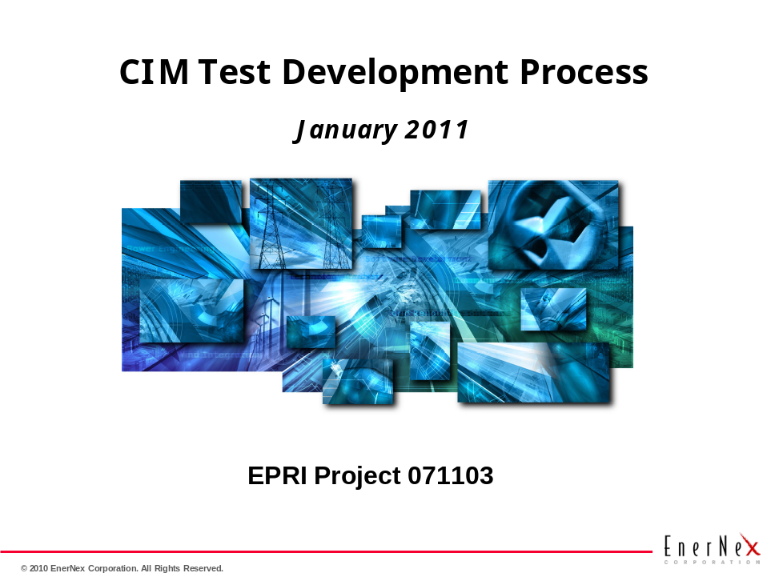
.

General Issues Discussion
- Use of Example Test Scenarios / Test Cases developed during Joint Edge/Ente rprise Conformity Session at Fort Lauderdale, November 2010 as format for abstract test cases.
- John talking with venders Elster and Telvent and InterGraph and MilSoft.

Expected work output during next week
- Continued work on abstract test case, with more detailed material moved to the detailed test procedures.
- See Actions Item below.

Action items for individuals

Name | Action
John Simmins | Talk Elster, Yelvent, InterGraph, MillSoft. Work with internal resources to eparate lab network completely from the EPRI operational network.
Mark Ortiz | Have Shawn Hu send ADR/ADE info links. Set up EPRI server at EPRI.
Zahra Makoui
Frank Wilhoit
Bruce Muschlitz | Set up Tuesday meeting, post minutes. Post minutes. Send out new invite for 3PM EST
Kay Stefferud | Kay to update Abstract Use Case with features from the Ft. Lauderdale abstract use case.
Margaret Goodrich
Clint Powell | Find SCE representative for this group

