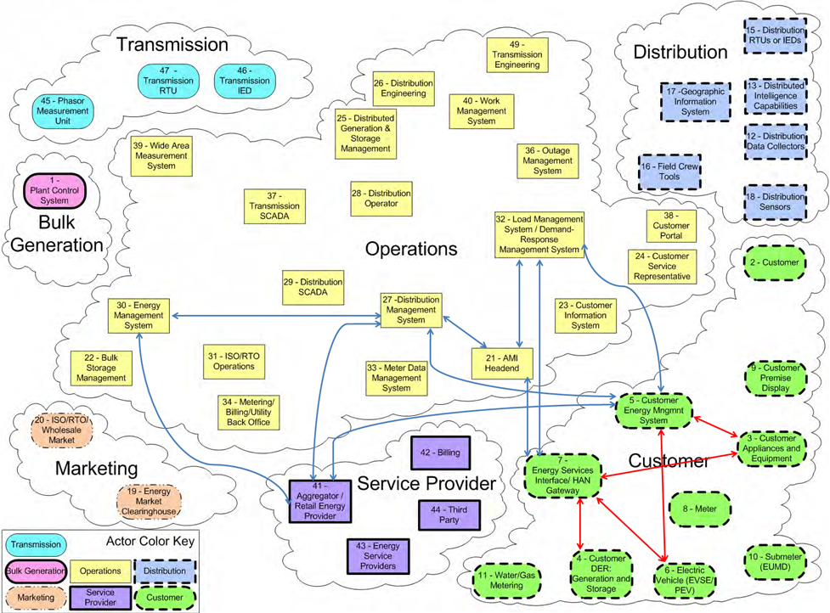
  - NIST IR 7628 Actors to Open ADR Roles Mapping
NIST IR 7628 Actor Number | NIST IR 7628 Actor |  | Open ADR Role
27 | Distribution Management System | DR Controlling Entity
41 | Aggregator/Retail Energy Provider | DR Controlling Entity/DR Resource
32 | Load Management Systems/Demand Response Management System | DR Controlling Entity
30 | Energy Management System (EMS) | DR Controlling Entity
5 | Customer Energy Management System | DR Resource
3 | Customer Appliances and Equipment | DR Asset
4 | Customer Distributed Energy Resources: Generation and Storage (DER) | DR Asset

  - NIST IR 7628 Security Objectives to Open ADR Security Principles Mapping

NIST IR 7628 Scenario | Cyber Security Objective / Requirements | Open ADR Security Principle
Real-Time Pricing (RTP) for Customer Load and DER/PEV | Integrity, including non-repudiation, of pricing information is critical, since there could be large financial and possibly legal implications  Availability, including non-repudiation, for pricing signals is critical because of the large financial and possibly legal implications  Confidentiality is important mostly for the responses that any customer might make to the pricing signals
Time of Use (TOU) Pricing | Integrity is not critical since TOU pricing is fixed for long periods and is not generally transmitted electronically  Availability is not an issue  Confidentiality is not an issue, except with respect to meter reading
Net Metering for DER and PEV | Integrity is not very critical since net metering pricing is fixed for long periods and is not generally transmitted electronically  Availability is not an issue  Confidentiality is not an issue, except with respect to meter reading
Feed-In Tariff Pricing for DER and PEV | Integrity is not critical, since feed-in tariff pricing is fixed for long periods and is generally not transmitted electronically  Availability is not an issue  Confidentiality is not an issue, except with respect to meter reading
Critical Peak Pricing | Critical Peak Pricing builds on TOU pricing by selecting a small number of days each year where the electric delivery system will be heavily stressed and increasing the peak (and sometime shoulder peak) prices by up to 10 times the normal peak price. This is intended to reduce the stress on the system during these days.
Load Management | Integrity of load control commands is critical to avoid unwarranted outages  Availability for load control is important – in aggregate (e.g. > 300 MW), it can be critical  Confidentiality is not very important

  - NIST IR 7628 Technical Requirements Mapped Open ADR Controls

NIST IR 7628 Requirement | NIST IR 7628 Short Name | Open ADR Control | Coverage
SG.AC-3
SG.AC-5 | Information Flow Enforcement
SG.AC-6 | Separation of Duties
SG.AC-7 | Least Privilege
SG.AC-8 | Unsuccessful Login Attempts
SG.AC-11 | Concurrent Session Control
SG.AC-12 | Session Lock
SG.AC-13 | Remote Session Termination
SG.AC-14 | Permitted Actions without Identification or Authentication
SG.AC-15 | Remote Access
SG.AC-16 | Wireless Access Restrictions
SG.AC-17 | Access Control for Portable and Mobile Devices
SG.AC-21 | Passwords
SG.AU-2 | Auditable Events
SG.AU-3 | Content of Audit Records
SG.AU-4 | Audit Storage Capacity
SG.AU-15 | Audit Generation
SG.AU-16 | Non-Repudiation
SG.CM-7 | Configuration for Least Functionality
SG.CM-8 | Component Inventory
SG.IA-4 | User Identification and Authentication
SG.IA-5 | Device Identification and Authentication
SG.IA-6 | Authenticator Feedback
SG.SC-2 | Communications Partitioning
SG.SC-3 | Security Function Isolation
SG.SC-4 | Information Remnants
SG.SC-5 | Denial-of-Service Protection
SG.SC-6 | Resource Priority
SG.SC-7 | Boundary Protection
SG.SC-8 | Communication Integrity
SG.SC-9 | Communication Confidentiality
SG.SC-10 | Trusted Path
SG.SC-11 | Cryptographic Key Establishment and Management
SG.SC-12 | Use of Validated Cryptography
SG.SC-15 | Public Key Infrastructure Certificates
SG.SC-16 | Mobile Code
SG.SC-17 | Voice-Over Internet Protocol
SG.SC-18 | System Connections
SG.SC-19 | Security Roles
SG.SC-20 | Message Authenticity
SG.SC-21 | Secure Name/Address Resolution Service
SG.SC-29 | Application Partitioning
SG.SC-30 | Smart Grid Information System Partitioning
SG.SI-2 | Flaw Remediation
SG.SI-7 | Software and Information Integrity
SG.SI-8 | Information Input Validation
SG.SI-9 | Error Handling
SG.AC-5 | Information Flow Enforcement
SG.AC-6 | Separation of Duties
SG.AC-7 | Least Privilege

