OpenSG OpenADR 1.0 System Requirements Specification - v.06 - This is the version posted on the NAESB SmartGrid Standards & Strategies site.
Version: Draft v0.6
Issued for review prior to Draft 2 on: 7/06/2010
[Draft 2] Release Date: 07/06/2010
Acknowledgements
The following individuals and their companies have contributed and/or provided support to the work of the OpenADR System Requirements Specification:

The OpenADR Task Force wishes to thank all of the above-mentioned individuals and their companies for their support of this important endeavor, as it sets a key foundation for an interoperable Smart Grid.

Document History
Revision History
Date of this revision: April 13, 2010

Revision Number | Revision Date | Revision  By | Summary of Changes | Changes marked
0.1 | 4/13/2010 | Bruce Bartell | Initial draft “shell” based on OpenADE SRS | N
0.2 | 4/20/2010 | Bruce Bartell | Updated through sections 3.2.1 | N
0.2 | 4/30/2010 | Bruce Bartell | Updated through sections 3.2.2 | N
0.3 | 5/1/2010 | Ed Koch | Scope update and comments for F2F | N
0.4 | 5/7/2010 | Bruce Bartell | Incorporate feedback from OSG Quarterly | N
0.4 | 5/14/2010 | Bruce Bartell | Added Integration Service Messages based on Entity, Priorities. | N
0.4 | 5/18/2010 | Bruce Bartell | Added attributes & definitions for Priority 1 messages | N
0.5 | 6/11/2010 | Bruce Bartell | Attributes & definitions for priorities 2,3. Revised process model to match current PAP09 Retail. Moved open items to issues/open items log. | N
0.5 | 6/23/2010 | Bruce Bartell | Incorporated comments for Open Items log.  Corrected some items in data requirements. | N
0.5 | 6/29/2010 | Bruce Bartell | Added SEP2.0 elements to Event message. | N
0.6 | 07/06/2010 | Bruce Bartell for Ed Koch. | Revised some OpenADR Comm. Spec. mappings. | N
Open Items and Issues Log
Last updated: June 23, 2010

As open items and issues are addressed in new versions of this document, they are removed from this list.

Item No. | Date | Provided By | Summary of the Issue | Status / Disposition
1 | 6/11/2010 | B. Bartell | Publishing Interval removed from Pricing Signal. Implementation item.  Need a Use Case. Where would this be available if not in the DR signal?
2 | 6/11/2010 | B. Bartell | PAP09 Wholesale Data Requirements from “Smart Grid Communication Standards for Demand Response Data Requirements – (IRC) ISO/RTO Council for PAP09” which did not map to existing Retail requirements are out of scope. Common model will be addressed as part of PAP09 Phase 2 effort.
3 | 6/11/2010 | B. Bartell | SEP2.0 Data elements for DLC not in the data requirements: DR Program Type, DR Group. Do they need to be supported? Is DR group = DR Resource?  Optional SEP 2.0  HAN Device IDs  HAN Device Class  Heating Temperature  offset/setpoint  Cooling Temperature  offset/setpoint  Load adjustment offset  Duty cycle  Event control  DR event cancel control  Cancel effective date/time  Compare Duty Cycle definition to Objective based DR signal.  Load Percentage value is id DLC signal for SEP.  Requesting input from the SEP2.0 Team.  Added SEP Technical Requirements as external reference. | Added offset&setpoint types to list of Direct Load  Control Types,  Added mandatory elements to DLC list in section 3.4.2
4 | 6/11/2010 | B. Bartell | Is there are requirement for Dispatch type for temperature based dispatch?  Possibly. Used as part of Day ahead pricing market.  Possible “Trigger” as 4th type of DR Signal. “Trigger Type” and “Trigger Value”.
5 | 6/11/2010 | B. Bartell | Is Customer Enrollment in scope? Removed from PAP09 Retail.
6 | 6/11/2010 | B. Bartell | Detail diagrams from PAP09 Retail contain message for Scheduling, Forecasting, Nominations, Capability, Aggregated Capability, Telemetry Data, Aggregated Telemetry Data. No content was defined for these messages. Are they in scope of this or future releases?  In scope of future releases. Cover as part of Phase 2.
7 | 6/11/2010 | B. Bartell | Figure for REC-VEN operations is from EPRI Concepts to Enable Advancement of Distributed Energy Resources. Do we need explicit permission to use as is?
8 | 6/11/2010 | B. Bartell | Source-Authentication removed as data requirement. Included in Technical Architecture requirements.  The recipient must have some assurance that the message was produced by a reliable, authoritative party. This will require some ability to validate the authenticity of the source and integrity of the data (e.g., digital signature applied to a price message).  Must address in context of non-repudiation. May be use case specific.

Contents
1 Introduction 7
1.1 Purpose 7
1.2 Scope 8
1.2.1 Scope of This Release 8
1.2.2 Scope of Subsequent Releases 9
1.3 Acronyms and Abbreviations 9
1.4 External Considerations and References 10
1.4.1 RFC 2119 Keyword interpretation 10
1.5 Document Overview 11
2 Architecture Vision 13
2.1 Architectural Goals and Guiding Principles 15
2.2 Architectural Considerations 15
3 OpenADR Systems Architecture 17
3.1 OpenADR Business Architecture View 17
3.2 Integration Requirements Specification 21
3.2.1 Functional Requirements – Business Processes 21
3.2.2 Functional Requirements – Integration Services 23
3.2.3 Technical Requirements – Integration Services 28
3.3 OpenADR Application Architecture View 28
3.4 OpenADR Data Architecture View 29
3.4.1 Temporal Model of a DR Event 30
3.4.2 DR Event - Data Requirements 31
3.4.3 Notify DR Event - Data Requirements 39
3.4.4 Asset / Resource Status (State) – Data Requirements 41
3.4.5 DR Resource – Data Requirements 43
3.4.6 DR Asset – Data Requirements 49
3.4.7 Demand Response Customer Enrollment – Data Requirements 51
3.5 OpenADR Technical Architecture View 52
3.5.1 Networking Standards 52
3.5.2 Security Standards 52
3.5.3 Service / Resource Patterns 52
3.6 Governance 54
4 Appendices 55
4.1 Terms and Definitions 55
4.2 Integration Services – Detailed Messages by Use Case 56
List of Figures
Figure 1. The Open Group Architecture Framework (TOGAF) architecture development cycle. 11
Figure 2. OpenADR SRS component diagram showing the actors and components. 13
Figure 3. OpenADR Stakeholders Overview 17
Figure 4. Overview of Business Process Flows 18
Figure 5. Overview of Business Process Flows Using Logical Components. 24
Figure 6. Overview diagram of Logical Components 25
Figure 7. REC-VEN Operations ³ 26
Figure 8. Temporal Model of a DR Event and its Associated Data 30

Introduction
The Open Smart Grid Open Automated Demand Response (OpenADR) is an industry-led initiative under the Open Smart Grid (OpenSG) subcommittee within the UCA International Users Group (UCAIug). The OpenADR Task Force defines systems requirements, policies and principles, best practices, and services, required for business and data requirements for standardizing control and pricing signals for Demand Response (DR) and Distributed Energy Resources (DER) as part of the Smart Grid implementation. OpenADR, as an open user group forum, is developing a set of utility-ratified requirements and specifications for utilities and 3rd Parties to adopt and implement. The end-state of this effort will contribute to the development of open and interoperable Demand Response solutions.
This will be achieved by defining and making the following OpenADR related items available to the market:
- Common business processes and functional requirements
- Common architecture principles and patterns
- Common information requirements and model
- Common integration services (functional & informational)

Purpose
The purpose of this document is to provide both the functional and technical guidance and requirements needed to serve as the “rules of engagement” for messaging and data exchange to achieve interoperability. This would lead to open and interoperable components that can be delivered with different vendor products and/or solutions within the scope of OpenADR. The functional requirements will be driven by business processes and the technical requirements will be driven by desired architectural principles and best practices.

Scope
The SRS focuses on the requirements to support the interactions and exchange of information for the purposes of Demand Response (DR) and includes the exchanges of DR related information between various entities dealing with the Utilities, such as Independent System Operators (ISO’s), Aggregators, Energy Service Providers and end use customers. The scope of OpenADR SRS includes standardizing dispatch, control and pricing signals for DR and Distributed Energy Resources (DER) as part of the Smart Grid implementation as defined in Section 1.4 External Considerations and References.
Demand Response is defined as the temporary modification of customer energy usage for a defined duration which is triggered by some condition on the grid such as reliability or market conditions. These DR events result in the exchange of “DR signals” between service providers such as Utilities, ISO’s, Aggregators, ESP’s, etc. and their customers. The information in the DR signals causes modifications to the end users load profiles. The requirements in the SRS are from the perspective of the enterprise systems of the service providers that are publishing the DR signals to their customers (i.e. Utility). This is in contrast to the customer’s systems or perspective which is covered in other efforts such as OpenHAN and SEP. The thing that all the various efforts have in common is the need to exchange the DR related information in some standardized form. Furthermore this SRS does not cover many of the administrative aspects of managing a DR program such as measurement and verification and settlement. The SRS is focused on only those aspects of DR management that is required to facilitate the exchange of DR signals with their customers.
The SRS defines the logical components and business functions in order to identify the interfaces that must be specified to enable interoperability across different implementations, for many utilities to many 3rd Parties. It includes architectural aspects and specific requirements. The inputs include OpenADR use cases, as well as industry best practices and standards, including information models and other specifications.

Scope of This Release
OpenADR SRS 1.0 addresses the following functional areas:
- Direct Load Control Signals
- Dispatching of Load Profiles
- DR Related Pricing Signals
- DER applications (limited to the context of grid-connected DR)
- DR Program Management (Limited to data required to support DR Signals)
  - Program and Customer Registration
  - DR Resource Registration

Scope of Subsequent Releases
- Utility internal systems integration for DR purposes
- DR Bidding
  - DR Offer to Supply (Retail Offers)
  - DR Bid to Buy
- Forecasting

The OpenADR SRS does not include the following items that are typically a part of solution architecture. Some of them are or have been addressed by other parts of the OpenSG initiative. Others will need to be dealt with specifically for each implementation.
- Network and hardware infrastructure architecture
- Operational architecture
- Testing methodology and architecture
- Internal application architecture

Acronyms and Abbreviations
This subsection provides a list of all acronyms and abbreviations required to properly interpret the OpenSG OpenADR System Requirements Specification.
Acronym | Name
ADE | Automatic Data Exchange
ADR | Automated Demand Response
AMI | Advanced Metering Infrastructure
CIM | IEC TC57 Common Information Model
DLC | Direct Load Control
DR | Demand Response
EMS | Energy Management System
ESP | Energy Service Provider
ESI | Energy System Interface; Energy Services Interface
HAN | Home Area Network
IETF | Internet Engineering Task Force
IHD | In-Home Display
ISO | Independent System Operator
IT | Information Technology
M&V | Measurement and Verification
NERC | North American Electric Reliability Corporation
PHEV | Plug-In Hybrid Electric Vehicle
RTO | Regional Transmission Organization
RTP | Real Time Pricing
SDO | Standards Development Organization
SEP 2.0 | Smart Energy Profile
SLA | Service Level Agreement
SRS | System Requirements Specification
TOGAF | The Open Group Architecture Framework

External Considerations and References
The work of the OpenADR SRS is dependent upon the requirements defined in the following sources:

- Open ADR Functional Requirements and Use Case Document (OpenSG)
- Requirements Specifications for Wholesale Standard DR Signals - for NIST PAP09
- Requirements Specifications for Retail Standard DR Signals - for NIST PAP09
- OPEN AUTOMATED DEMAND RESPONSE COMMUNICATIONS SPECIFICATION - Public Interest Energy Research (PIER), California Energy Commission
- Requirements Specifications for Common Electricity Product and Pricing Definition - for NIST PAP03
- Requirements Specifications for Common Scheduling Mechanism for Energy Transactions - for NIST PAP04
- ZigBee Smart Energy Profile™ 2.0 Technical Requirements Document
- Smart Energy Profile Specification ZigBee Profile: 0x0109 Revision 15
- Energy Information Standards (EIS) Alliance Customer Domain Use Cases
- Energy Information Standards (EIS) Alliance Customer Domain Energy Services Interface (ESI) Requirements
- Energy Interoperation Version 1.0 - © OASIS® 2010
- Smart Grid Communication Standards for Demand Response Data Requirements – (IRC) ISO/RTO Council for PAP09
- Transactional Energy Market Information Exchange (TeMIX) An Information Model for Energy Transactions in the Smart Grid - By Edward G. Cazalet, PhD on behalf of the OASIS Energy Market Information Exchange Technical Committee

The work of OpenADR SRS is dependent upon the best practices available from the following entities and standards organizations:

- IETF Internet Suite - Internet Standards, including the following
          - [RFC-793] IETF Transmission Control Protocol (TCP)
          - [RFC-791] IETF Internet Protocol (IP)
          - [RFC-2616] Hypertext Transfer Protocol -- HTTP/1.1
- [IEC-61968] IEC TC57 Working Group 14 (IEC 61968) (Common Information Model)
- [ASAP-SG-3P] Security Profile for Third Party Access (ASAP-SG)
- W3C XML, XML Schema related standards
- OASIS Web Services related standards

RFC 2119 Keyword interpretation
The key words "MUST", "MUST NOT", "REQUIRED", "SHALL", "SHALL NOT", "SHOULD", "SHOULD NOT", "RECOMMENDED", "MAY", and "OPTIONAL" in this document are to be interpreted as described in RFC 2119.

Document Overview
TOGAF 9.0 defines four architecture domains that are commonly accepted as subsets of overall enterprise architecture, all of which TOGAF is designed to support, see Figure :
- Architecture Vision defines overall architecture guiding principles, goals and objectives and desired traits.
- The Business Architecture defines the business strategy, governance, organization, and key business processes.
- The Information Systems Architecture, including the following.
  - The Data Architecture describes the structure of an organization's logical and physical data assets and data management resources.
  - The Application Architecture provides a blueprint for the individual application systems to be deployed, their interactions, and their relationships to the core business processes of the organization.
- The Technology Architecture describes the logical software and hardware capabilities that are required to support the deployment of business, data, and application services. This includes IT infrastructure, middleware, networks, communications, processing, standards, etc.
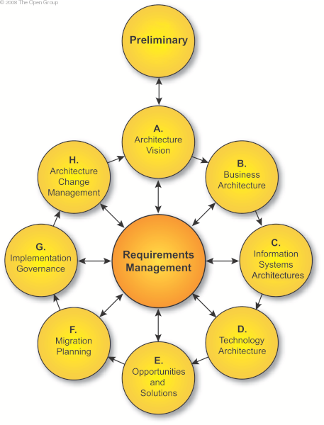
Figure 1. The Open Group Architecture Framework (TOGAF) architecture development cycle.

As such, the document will be structured as follows:

Section 2 describes the overall Architecture Vision for the system, including Guiding Principles, Architectural Considerations, and the OpenADR Reference Model, all relevant to providing a consistent framework within which the four architecture components can be developed.

Section 3 provides details on the following:
- Business Architecture: This will refer to work products produced by the Use Case and Service Definition Teams of OpenADR, which includes the list of use cases and integration requirements and business services at the functional level.
- Data Architecture: This provides the technical level requirements relative to how the OpenADR data should be modeled and represented consistently across all integration services to ensure semantic interoperability.
- Application Architecture: This provides the technical level requirements relative to how applications are modeled as logical components, and what services each logical component may provide or consume. This should be an instantiation of the business services identified within the Business Architecture.
- Technology Architecture: This provides the technical level requirements relative to how services will interact with each other to support end-to-end AMI business processes.

Section 4 contains the Appendices, which includes terms and definitions, logical components list, integration requirements list, and integration services view.

Architecture Vision
The Architecture Vision articulates the Architectural Goals and Principles that enables the business goals and addresses the stakeholder concerns and objectives. As stated in the Introduction, the goal is the development of open and interoperable Demand Response solutions.

Demand Response systems consist of the hardware, software and associated system and data management applications that create a communications network between end systems at customer premises (including meters, gateways, and other equipment) and diverse business and operational systems of utilities and third parties, see Figure 2.
The Demand Response system components are defined as part of the Systems Architecture later in this document. The components in Figure 2 show the controlling components the Utility Enterprise and Operational Systems that communicate with the Assets and Resources of the Customer through public or private networks.
Although not shown in the diagram below the architecture does not preclude the use of intermediaries such as aggregators or third party control companies that may receive DR signals on behalf of the end user facilities. This is discussed in more detail in section 2.1 Architectural Goals and Guiding Principles where the concepts of a Resource Energy Controller and Virtual End Node are introduced.
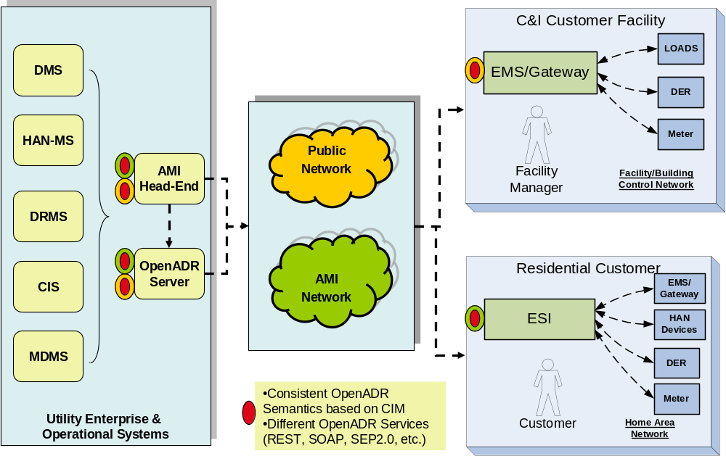
Figure 2. OpenADR SRS component diagram showing the actors and components.
Components | Description / Key Business Functions
Energy Management System | A system that helps a customer to manage their energy usage within a facility.
Energy Service Interface | Energy System Interface; Energy Services Interface  Provides communications, security and, often, coordination functions that enable secure interactions between relevant Home Area Network Devices and the Utility. Permits applications such as remote load control, monitoring and control of distributed generation, in home display of customer usage, reading of additional meters (e.g. water, gas, renewables, PEVs), and integration with building management systems. Also provides auditing/logging functions that record transactions to and from Home Area Networking Devices. The ESI is assumed to have at least two interfaces: one which provides connectivity to the Home Area Network, and one which provided connectivity to the utility.  (ZigBee Smart Energy Profile™ 2.0 Technical Requirements Document)
Distribution Management System | A system that manages the distribution network operations.
HAN Management System | A system that allows utilities to send messages (such as pricing, billing, usage or alarms) to customer display devices (IHDs). Manages the enrollment of devices in specific home area networks, management the enrollment of those devices in programs, manages the de-enrollment in programs and from the HAN
Demand Response Management | A system that manages the demand response programs from utility point of view. Includes load control, integration with DMS, and DR program management. Uses historical and externally input data to make predictions and what-if analysis for DR purposes
Customer Information System | A system that manages customer interaction, billing and issues resolution.

Architectural Goals and Guiding Principles
Architecture guiding principles are rules of engagement designed to ensure that all aspects of the implementation fit within a well-defined framework. These principles, discussed and agreed upon with all stakeholders of OpenADR, are used to drive the architectural approach and patterns to be implemented. These principles should not be taken lightly as they imply what and how the overall goals of OpenADR will be met. Each of the principles has a level of effort and cost implications for utilities and 3rd Parties looking to adopt this specification. Adherence to these principles can be adjusted for specific cases driven by time and budget constraints. These exceptions should be approved by all stakeholders and must be documented.
- Exchanges of data cross enterprise boundaries
  - Industry best practices must be followed
  - The most interoperable and widely supported technologies should be used to ensure adoption regardless of development and deployment platforms used
  - The technologies chosen shall be well specified, with active communities and tools and/or frameworks available. For example, WS-I, or RESTful in conjunction with AtomPub, OData or GData.
  - Technologies chosen shall be compatible and interoperable with technologies specified for access to on premise or HAN resources.
  - Security and privacy of customer information is of utmost importance, since transfers must support the secure use of public networks, and sensitive customer information may be exchanged across enterprise boundaries.
- Recommendations must promote and enable interoperability
  - Many utilities need to be interoperable with many 3rd Parties, so there are significant efficiency savings possible by defining a common interface for the OpenADR message exchanges. Therefore, recommendations must be specific and prescriptive, actionable and testable
- Must meet the goals of several different types of stakeholders
  - Requires an open process to allow discussion and negotiation of the recommendation
- Forwards and backwards version compatibility is needed
  - Existing implementations must remain operational when either side adds future extensions

Architectural Considerations
OpenADR as a system needs to be architected with requirements that cover the entire spectrum of business, technical, and market needs. The following list of architectural attributes will be used as guidelines for OpenADR systems requirements development.
- System quality attributes discernable at runtime
  - Performance - Services SHALL provide and consume data in a timely manner as defined by the requirements.
  - Security –
    - Parties involved in any DR event SHALL be authenticated and authorized;
    - Command/message exchanged between parties involved in any DR event SHALL be secure from end to end.
    - Results of the DR event execution SHALL be auditable.
  - Authorization – Protected resources SHALL be authorized individually by the user(s) associated with those resources.
  - Availability – Services SHALL be highly available as defined by the requirements.
  - Functionality – SHALL meet the functional needs of customers and regulators
  - Usability – SHALL require only commonly available tools and technologies
  - Scalability – SHALL be able to add additional servers to meet performance
- System quality attributes requiring assessment for evaluation
  - Modifiability – SHALL allow additions without affecting existing systems
  - Portability – SHALL be possible to implement on a variety of platforms
  - Reusability – SHALL use standard industry object representations
  - Integrability – SHALL be possible to map to a variety of other interfaces
  - Testability – SHALL be possible to perform testing using a variety of methods
- Business Qualities
  - Cost – SHALL not be cost-prohibitive
  - Projected life time of the system – SHALL allow growth
- Qualities directly related to the architecture
  - Conceptual integrity – Semantics of defined elements SHALL be consistent across objects that use those elements
  - Correctness and completeness - Is aligned with common application architectures and addresses all considerations required for interoperability.
Note that desired, minimum and maximum levels for performance, availability, functionality, acceptable use, and other characteristics will likely be specified and negotiated in Service Level Agreements (SLAs) between DR Signal consumers and providers. Regulators may also require certain service levels. Each side will likely have some number of terms required for use of their services. This is not part of the standardization effort, just a note to prepare for these agreements.

OpenADR Systems Architecture

OpenADR Business Architecture View
The key stakeholders to be addressed by the business architecture are shown in the figure below. The stakeholders all perform business roles and represent a subset of the Actors from the use cases which fill business roles in the OpenADR business processes, as described in the DR Functional Requirements and Use Case Document.
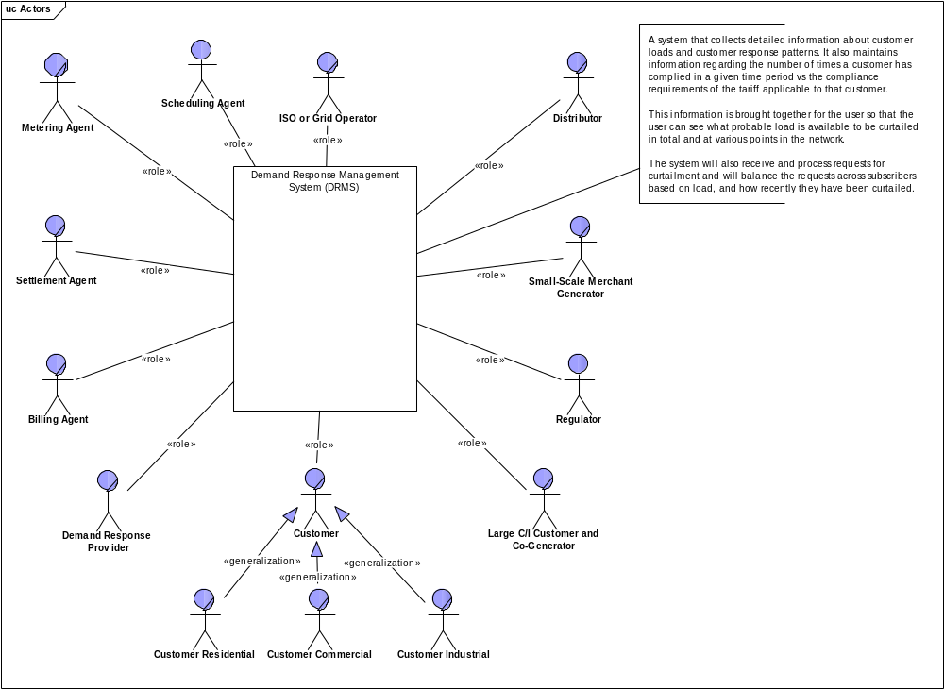
Figure 3. OpenADR Stakeholders Overview

The primary business flows include DR Program Administration, Bidding, and Execution as shown in the following diagram. The swim lanes represent business roles and the blocks within the swim lanes correspond to a business process carried out by that business role. Business roles are related to the Actors identified earlier; however, in some cases multiple different Actors may carry out the same business role. For example, an ISO/RTO, Utility Distribution Company (UDC), Load Serving Entity, or DR Aggregator can all perform the business role of Controlling Entity. The business processes shown are those that involve the exchange of information between business roles.

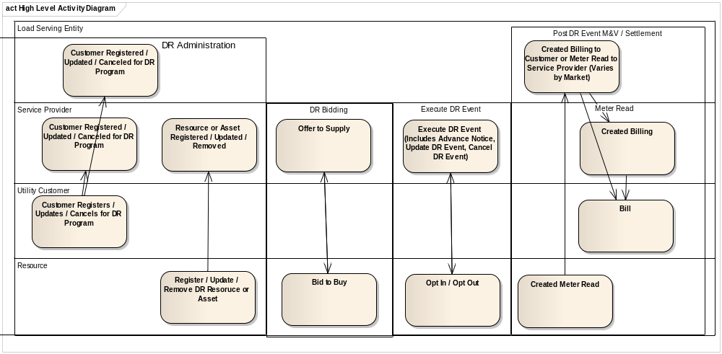
Figure 4. Overview of Business Process Flows
The Business Roles used in the Business Process Flow shown in Figure 4 are summarized from the Use Cases and represent activities performed at the business level. Section 3.2.2 Functional Requirements – Integration Services maps these business roles into integration roles as described in that section.
The Demand Response process flow is broken into four phases: DR Administration, DR Bidding, Execute DR Event, and Post DR Event Measurement and Verification / Settlement. The DR Execution processes includes DR Program types of Direct Load Control, Dynamic Price Based / Real Time Pricing, and Notification (Objectives) Based.
Following is a table listing all major Business Roles that will provide some functions to support ADR business processes.
Business Role | Description / Key Business Functions | Map to NIST | Map to LBNL
Load Serving Entity | A role which carries the responsibility of serving end-users and selling electric energy to end-users. (PAP09 Retail dated 2/11/2010 v 1.5)  The entity that is responsible for serving the Electricity Customers Electricity needs. An LSE may also perform the role of DR Aggregator. (Base Use Case) | Load Serving Entity
Electricity Consumer | The end users of electricity. May also generate, store, and manage the use of energy. Traditionally, three customer types are discussed, each with its own domain: home, commercial/building, and industrial. | Utility Customer | Participant
Service Provider | A role which carries the responsibility of coordinating resources to deliver electricity products and services to a market or distribution operator. | Service Provider
Demand Response Provider (DRP) | An entity or role with the responsibility to coordinate demand resources to deliver demand response services. A DRP includes entities that have acquired curtailment rights from electricity consumers, and manage the aggregation of capacity that is curtailable as an eligible energy or capacity resource for participating in Demand Response programs.  (PAP09 Retail dated 2/11/2010 v 1.5)
DR Controlling Entity | This is a generalized actor class and represents all the different entities that may need to manage and interact with wholesale and/or retail DR resources. It includes the following actors: ISO/RTO, Distribution Company, Load Serving Entity, DR Aggregator. (PAP09 Retail dated 2/11/2010 v 1.5) |  | DRAS - Demand Response Automation Server
DR Asset | An energy resource that is capable of shedding load in response to Demand Response Events, Electricity Price Signals or other system events (e.g. under frequency detection).  Examples of Demand Response Assets are: Smart Appliances, entire buildings that are under the control of an Energy Management System, Electric Vehicles.  (PAP09 Retail dated 2/11/2010 v 1.5)
DR Resource | A DR resource is a virtual representation of one or more DR assets.  It is similar to a DR Asset in that it is capable of shedding load in response to a triggering event. Unlike a DR Asset, which is autonomous, a DR Resource may consist of multiple DR Assets that have been aggregated to form a larger capacity or energy resource.  An apartment building with multiple electricity consumers, each one having one or more DR Assets may be considered one large DR Resource by aggregating the total load shedding capacity of all the DR Assets in the apartment building and representing the sum total of this capacity as one DR Resource.  A DR Resource may also consist of different types of Assets (e.g., a wind Turbine and an electric motor that work in combination to meet DR program obligations).  (PAP09 Retail dated 2/11/2010 v 1.5) |  | DRAS Client
System and Market Operator | A System Operator is a Balancing Authority, Transmission Operator, or Reliability Coordinator whose responsibility is to monitor and control an electric system in real time (based on NERC definition). The System Operator is responsible for initiating Demand Response Events (e.g., Advance Notifications, Deployment, and Release/Recall instructions).  The Market Operator manages the bulk electricity market and produces prices for various products.  ISO New England and PJM Interconnection are examples of Market and System Operators that perform this function.  (PAP09 Retail dated 2/11/2010 v 1.5)

Integration Requirements Specification

Functional Requirements – Business Processes
The business processes that have been developed as part of OpenADR are listed as follows. Note that the requirements documents summarized in section 1.4 External Considerations and References contain the details of each business process (use case).
The following requirements are identified based the use cases defined in Requirements Specifications for Retail Standard DR Signals - for NIST PAP09.
- Administrate Customer for DR (Limited to data required to support DR Signals)
  - Register / Enroll Customer for DR Program
  - Remove Customer from DR Program
- Administrate DR Resource (Limited to data required to support DR Signals)
  - Administrate Distribution DR Resource
  - Update DR Resource
  - Register DR Resource
- Administrate DR Asset (Direct Load Control)
  - Register DR Asset
  - Update DR Asset
  - Remove DR Asset
- DR Bidding
  - DR Bid to Supply (Retail Offers)
  - DR Bid to Buy
- Execute DR Event
  - Notify DR Event
    - Advanced Notification for DR
    - Update a DR Event
    - Cancel a DR Event
    - DR Resource Confirmation
  - Dispatch DR Objectives
  - DR Direct Load Control
    - Monitor DR Event (DR Resource)
    - Monitor DR Event (DR Asset)
  - DR Real Time Pricing (RTP)
  - Operational Coordination
    - Post DR Event Management (out of scope, handled by other groups: AMI-ENT and M&V Settlement Standards)
    - Post DR Event M&V / Settlement (No Open Retail)
    - Post DR Event M&V / Settlement (Open Retail)

Functional Requirements – Integration Services

Logical Components
Logical Components are used in this document to organize interfaces (integration services) for OpenADR. These logical components represent IT systems which exchange information to carry out the business processes and implement the use cases identified earlier. They may be mapped to specific physical components for a particular implementation. The Logical Components in some cases consolidate multiple Business Roles/Actors to represent entities which perform a common integration role in exchanging information. For example, a DR Controlling Entity is a generalized actor class which represents all the different entities that may need to manage and interact with wholesale and/or retail DR resources. It represents actors such as an ISO/RTO, Distribution Company, Load Serving Entity, and DR Aggregator.
Following is a table listing all major logical components that will provide some functions to support ADR business processes. All services will be organized accordingly.
Logical Components | Description / Key Business Functions | Map to NIST | Map to LBNL
Electricity Consumer | The end users of electricity. May also generate, store, and manage the use of energy. Traditionally, three customer types are discussed, each with its own domain: home, commercial/building, and industrial. | Utility Customer | Participant
DR Asset Owner | The entity that is responsible for the DR Resource or Asset in the retail market.
DR Controlling Entity | This is a generalized actor class and represents all the different entities that may need to manage and interact with wholesale and/or retail DR resources. It includes the following actors: ISO/RTO, Distribution Company, Load Serving Entity, DR Aggregator. (PAP09 Retail dated 2/11/2010 v 1.5)
DR Asset | An energy resource that is capable of shedding load in response to Demand Response Events, Electricity Price Signals or other system events (e.g. under frequency detection).  Examples of Demand Response Assets are: Smart Appliances, entire buildings that are under the control of an Energy Management System, Electric Vehicles.  (PAP09 Retail dated 2/11/2010 v 1.5)
DR Resource | A DR resource is a virtual representation of one or more DR assets.  It is similar to a DR Asset in that it is capable of shedding load in response to a triggering event. Unlike a DR Asset, which is autonomous, a DR Resource may consist of multiple DR Assets that have been aggregated to form a larger capacity or energy resource.  An apartment building with multiple electricity consumers, each one having one or more DR Assets may be considered one large DR Resource by aggregating the total load shedding capacity of all the DR Assets in the apartment building and representing the sum total of this capacity as one DR Resource.  A DR Resource may also consist of different types of Assets (e.g., a wind Turbine and an electric motor that work in combination to meet DR program obligations).  (PAP09 Retail dated 2/11/2010 v 1.5)
System and Market Operator | A System Operator is a Balancing Authority, Transmission Operator, or Reliability Coordinator whose responsibility is to monitor and control an electric system in real time (based on NERC definition). The System Operator is responsible for initiating Demand Response Events (e.g., Advance Notifications, Deployment, and Release/Recall instructions).  The Market Operator manages the bulk electricity market and produces prices for various products.  ISO New England and PJM Interconnection are examples of Market and System Operators that perform this function.  (PAP09 Retail dated 2/11/2010 v 1.5)
The following figure represents the Business Process Flows consolidated using the Logical Components.
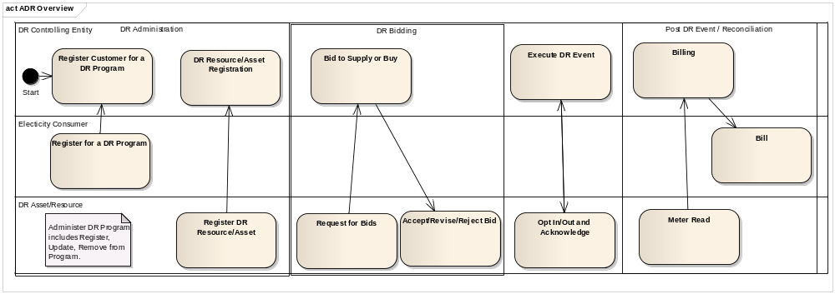
Figure 5. Overview of Business Process Flows Using Logical Components.
The following diagram shows the logical components involved in data exchanges. The exchanges are identified at a high level in order to show the major types of functions carried out.
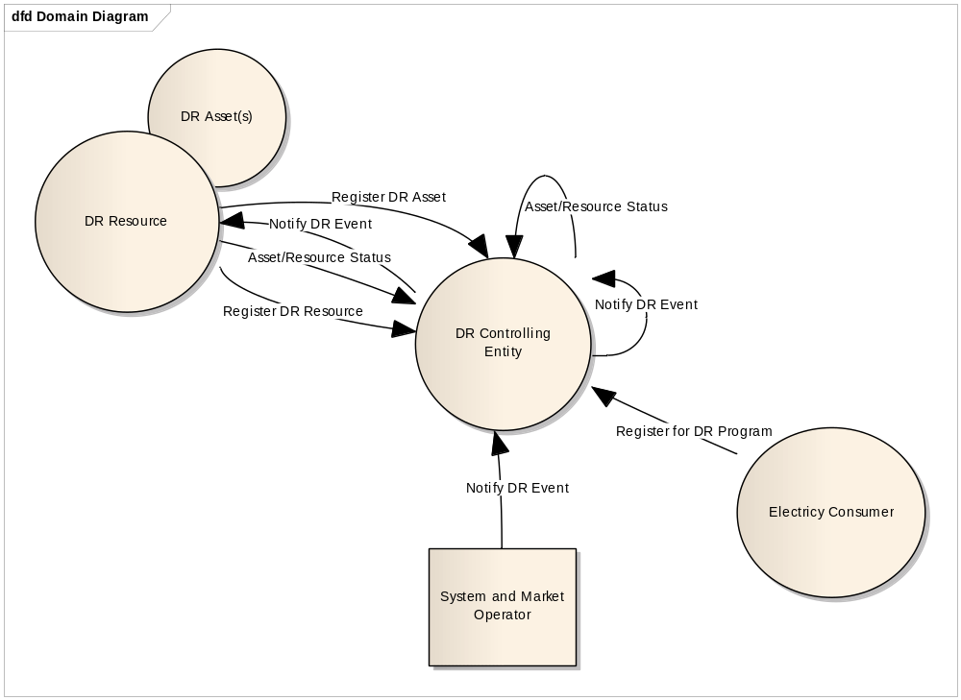
Figure 6. Overview diagram of Logical Components

Note that a DR Controlling Entity may represent a single Actor, such as a Utility Distribution Company in the business role of a Load Serving Entity. However, a DR Controlling Entity may also represent a hierarchy of entities, such as an ISO/RTO dispatching DR instructions to a Transmission Operator, who in turn sends the dispatch instructions on to a UDC, who sends instructions to a DR Aggregator, who then directs a specific DR Resource to execute the instruction. This can be modeled as a recursive relationship with DR Controlling Entity which represents each of these Actors in an integration role. The goal is to minimize the number of different logical components and hence the number of different services and message payloads that need to be defined through reuse of the standard services and payload definitions.

This concept is elaborated more extensively in a recent EPRI report titled Concepts to Enable Advancement of Distributed Energy Resources. This approach is made possible as we shift from designing control systems which issue direct load controls to system viewed as a grid resource which “has the ability to handle to handle a situation in an effective manner”, where the “how” of the response is replaced by a description of the situation requiring a change in energy consumption, leaving it to the final DR Resource to know how to control DR Assets to effect the desired change in energy use. The concept put forward by the EPRI report is called the REC-VEN concept, where the REC (Resource Energy Controller) determines when and why to send specific grid messages to the resources it manages, which are represented as a VEN (Virtual End Node). A VEN can in turn also function as a REC to another VEN which is lower down in the control hierarchy.
DR
Controlling
Entity
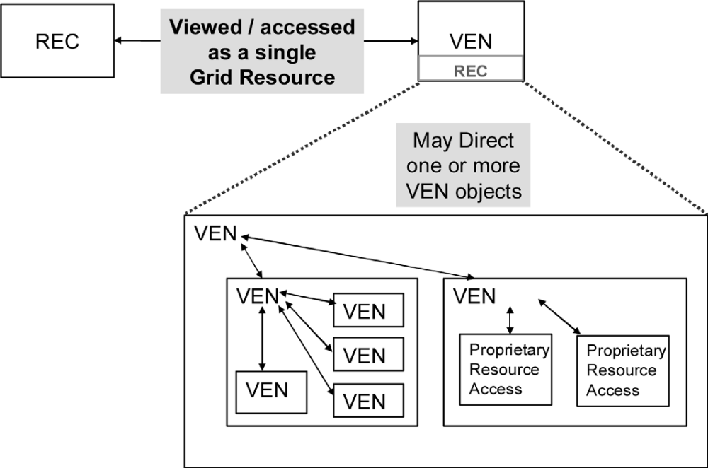
Figure 7. REC-VEN Operations Error: Reference source not found

In the diagram above, the DR Controlling Entity can be thought of as a VEN-REC object, thus representing all the entities in series from the System and Market Operator to the DR Resource. This is modeled by adding a recursive relation to a DR Controlling Entities, so that the DR Controlling Entity in the diagram represents one or more entities. This approach ensures a scalable architecture for all future Smart Grid developments.

Integration Services
The following Integration Services were derived from the Use Cases, Business Processes, and Functional Specifications documents defined earlier (Section 3.2.1) and represent the services needed to carry out the necessary data exchanges between logical components. The data required for the data exchange is defined in Section 3.4.1 Data Architecture View.

Specific Service Operations and Resource Patterns are defined as part of the OpenADR Service Definition document and the associated artifacts. The operations are defined based on the methods defined in Section 3.4 OpenADR Data Architecture View.

A detailed list of individual messages in Use Case Context is provided in Section 4.2.

Use Case Scenario | Service Name | Provider | Functional Description of the Service | Priority
Administrate Customer for DR | DR Customer Agreement | DR Controlling Entity | Customer is Registered for, Updated or Removed from a DR Program. | 3
Administrate DR Resource | DR Resource | DR Resource Owner | DR Resource is registered and associated with a DR Program and Customer. The Resource is updated and/or removed from DR Program. | 2
Administrate DR Asset | DR Asset | DR Asset Owner | DR Asset is registered and associated with a DR Resource. The Resource is updated and/or removed from DR Program. | 2
Execute DR Event | Notify DR Event | DR Controlling Entity | DR Event information is sent to participants prior to the DR Event start based on defined intervals and is Updated, and/or Canceled. | 1
Execute DR Event | DR Event | DR Controlling Entity | DR Event is a polymorphic message type that supports Direct Load Control, DR Instructions (Objectives), Price Schedule | 1
Execute DR Event – Operational Coordination | Forecast Demand | DR Controlling Entity | Multiple levels of aggregated DR Demand and Telemetry data is provided for the purpose of coordinating a DR Event and to provide checks against circuit limits. | 6
Execute DR - Event Monitoring / Confirmation | Asset / Resource Status (State) | DR Resource or Asset | The DR Resource or Asset (in the event of DLC) provides status for opt in / out or other state that impacts Demand Response.  The Status message may be as a confirmation reply to a DR Signal or as an update resulting from a state/status change or in response to a Get message. | 1
Post DR Event – M&V / Settlement | Meter Read & Billing |  | The process and messages used for settlement of a DR event are the same as defined in the Utility AMI AMI-ENT System Requirements Specification, Utility AMI-ENT Task Force.  The meter read interval is determined by the interval of DR Event participation. | 4
DR Bidding |  |  |  | 5

Technical Requirements – Integration Services

Integration services that are well defined, understood and managed are the linchpin of an open and interoperable implementation between the utility enterprise and other business entities. Following is a list of guiding principles for integration services design:
- Common protocol and business semantics SHALL be used to achieve loose coupling of end-point service (directly or indirectly)
- Services SHALL be representative of a unique unit of work and reusable across business functions.
- Services SHALL be reusable across common practices of utilities.
- Service design SHALL be driven by business requirements and reflected in the architecture.
- Service design SHALL be governed with a common approach and framework to achieve conceptual integrity.
- Service level agreement should be defined to support key architecture qualities: security, reliability, performance, availability, scalability, data quality, information fidelity, etc.

OpenADR Application Architecture View
- Audit information SHOULD be maintained, so that a report could be produced containing details (who, what, when, etc.) about authorizations, transfers, and other significant events.
- OpenADR Application Architecture SHALL provide measures that protect and defend information and information systems by ensuring their availability, integrity, authentication, confidentiality, and non-repudiation.

OpenADR Data Architecture View
Based on OpenADR use cases, the following data objects have been identified. The OpenADR services SHALL implement methods to make requests related to these objects.
- DR Customer Enrollment
  - Register Customer for DR Program
  - Update Customer for DR Program
  - Remove Customer from DR Program
- DR Asset (End Device)
  - Register Asset for DR Program
  - Update Asset for DR Program
  - Remove Asset from DR Program
- DR Resource (Device Group)
  - Register Resource for DR Program
  - Update Resource for DR Program
  - Remove Resource from DR Program
- Notify Demand Response Event
  - Advance Notification
  - Update Event
  - Cancel Event
- Demand Response Event
  - Types:
    - Direct Load Control Signal
    - Demand Response Instructions / Objectives (DR Dispatch)
    - Price Signal / Schedule
  - Updates
  - Cancel
- Forecast Demand (out of scope)
- Asset / Resource Status (Monitor Demand Response Event)
  - Response to Signal
  - Get Status/State
  - Continuous Response

Temporal Model of a DR Event
An Event consists of the time periods, deadlines, and transitions during which Demand Resources perform. A DR Event Schedule a Notification Period, Active Event Period, Ramp Period and Recovery Period. The Ramp Period is considered part of the Active Event Period. A DR Event can be partitioned into a continuous block of consecutive time periods called intervals. Events can also be open-ended. i.e. a Start Time without duration or end-time.
An instance of DR instructions represents a specific type of instruction that was defined specifically for the DR program and is effective for a specific interval or open-ended. Each type of instruction may have a schedule of values that are valid across the entire period for which the DR event is active. Therefore, a single type of instruction may have multiple values, each of which are valid during a different time period during the event.
The Temporal Model of a DR Event is shown in Figure 8 below (Based upon OpenADR model).
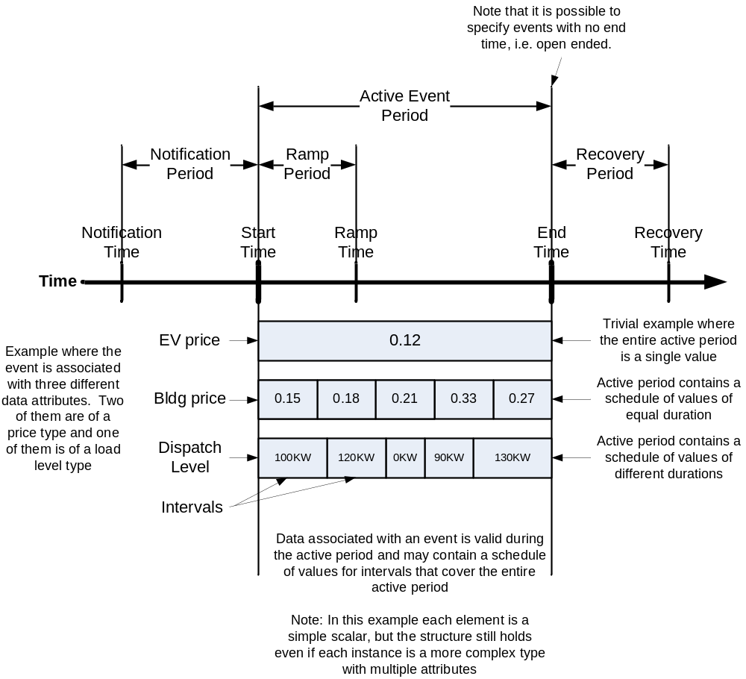
Figure 8. Temporal Model of a DR Event and its Associated Data

DR Event - Data Requirements
A DR Event data object is used to initiate a DR Dispatch types of Price Plus, Objectives, and Direct Load Control.  An Event consists of the time periods, deadlines, and transitions during which Demand Resources perform. (PAP09 Wholesale) |  | Map To
Data Element | Description | PAP09 Retail | PAP09 Wholesale | OADRCS | Map to SEP 2.0 TRD
 | All DR Events
DR Program Name | An identifier of the program for which a DR event was issued. | DR Program Name |  | EventState.programName | DR event name
Service Provider ID | An identifier for the Service Provider issuing the DR event. | Service Provider ID |  | EventState.drasName
Event ID | An identifier for the DR event that was created when the DR event was first issued. | Event ID |  | EventState.eventIdentifier | DR event ID
Event Modification Number | A modification number for the DR event. This is used to indicate if the DR Event has been modified by the Utility. Each time it is modified, this number is incremented. | Event Modification Number |  | EventState.eventModNumber
Test Event Flag | This attribute signifies whether this is a test event or not. Test events may be issued by the Utility/ISO like other DR Events. | Test Event Flag |  | EventState.testEvent
Simple Signal Levels | Used as an alternate and simplified representation of the DR signal, whether it be price based or a dispatch. Takes on a small number of finite levels such as NORMAL, MODERATE, and HIGH, SPECIAL |  |  | EventState.simpleDRModeData.OperationModeValue  EventState.simpleDRModeData.OperationModeSchedule
 | All Price Plus Information Dispatches
DR Dispatch Type | Identifies the type of the DR Price Plus Dispatch.  PRICE_ABSOLUTE - Price number  PRICE_RELATIVE - Change in price  PRICE_MULTIPLE - Multiple of current price | Instruction Type |  | EventState.drEventData.eventInfoInstances.eventInfoTypeID  EventState.DrEventData.eventInfoInstances.eventInfoName
 | All Price Plus Information Intervals
Currency | Identifier used to interpret the price element. MUST follow ISO 4217 standard. | Currency
Price | Expressed in decimal notation with a precision up to 6 decimal places. Prices MAY be either positive or negative.  Single or multiple valued price (e.g., for energy, demand, etc.) | Price |  | EventState.DrEventData.eventInfoInstances.eventInfoValues.value
Unit-of-Measure | Indicates the unit of measure for which the price pertains. MUST be complaint with the International System of Units as defined by NIST SP 330, ref: http://physics.nist.gov/Pubs/SP330/sp330.pdf  Examples of NIST compliant units of measure include:  kWh  MWh | Unit-of-Measure |  | EventState.DrEventData.eventInfoInstances.eventInfoTypeID
Duration | The amount of time for which this price is valid, commencing at the Effective-Date-Time specified. A value of zero means price is valid until next price broadcast override.  Specified in decimal notation where integers represent minutes and decimals represent fractions of minutes. | Duration
Effective-Date-Time | The date and time which the price is in effect. In ISO 8601 standard format.  The date and time interval which the price is in effect. | Effective-Date-Time |  | EventState.drEventData.startTime/endTime/notificationTime  EventState.DrEventData.eventInfoInstances.eventInfoValues.timeOffset
Location Identifier | An identifier used to indicate an area which this price is in effect. A value of "null" indicates that the price is in effect for all areas. | Location
Location-type | A value used to interpret the value contained in the Location element. Examples of Location-type include:  Address  Zone  GPS Coordinates  Grid Location / USNG  Electrical Node  Zip-code | Location-type
Product Type | Identifies the type of product to which this price pertains. Contains an enumeration of various products that may be offered. Extensibility MUST be supported in order to accommodate multiple jurisdictions and markets.  Product types include the following:  energy,  regulation,  spinning reserve. | Product-Identifier
 | All DR Objective Dispatches
DR Dispatch Type | Identifies the type of DR Objectives:  • LOAD_LEVEL  • LOAD_AMOUNT  • LOAD_PERCENTAGE | Dispatch Instructions |  | EventState.DrEventData.eventInfoInstances.eventInfoTypeID  EventState.DrEventData.eventInfoInstances.eventInfoName
 | All DR Objective Intervals
Interval Start Time | Start time of the dispatch interval. | Event Schedule | Event Day  Event Start Time  Event End Time | EventState.drEventData.startTime  EventState.drEventData.eventInfoInstances.eventInfoValues.timeOffset
Interval Duration | Period of time the Control Command is in effect.
 | All DR Load Level Objective Intervals
Load Level Value | Value of the load level to be achieved based on a set of enumerated values.  (i.e. moderate, high, etc) | Dispatch Instructions |  | EventState.drEventData.eventInfoInstances.eventInfoValues.value
 | All Load Amount Level Objective Intervals
Load Amount Value | Fixed amount of load to shed in kW. | Dispatch Instructions |  | EventState.drEventData.eventInfoInstances.eventInfoValues.value
 | All Load Percentage Objective Intervals | Dispatch Instructions
Load Percent Value | Percentage of load to shed. | Dispatch Instructions |  | EventState.drEventData.eventInfoInstances.eventInfoValues.value | Average Load Adjustment Percentage (expressed as signed integer, e.g -10 is 10% reduction from average load)
All Direct Load Control Dispatches
Direct Load Control is a Dispatch type that requests an Asset to be in a specific state.
DR Dispatch Type | Identifies the objective type as Direct Load Control. | DR Dispatch Type
DR Asset ID | An identifier of the DR Asset for which the control is intended. | DR Asset ID |  | EventState.drasClientID | HAN Device ID
Status Check | A signal to require the DR resource status to be sent back. | Status Check |  |  | SEP 2.0 Req[DRLC-3]  No specific data requirement
 | All Direct Load Control Intervals
Direct Load Control Type | The type of DR Direct Load Control Command:  e.g. Set Point  Open/Close  Heating Temperature -offset/setpoint  Cooling Temperature -offset/setpoint  Load adjustment offset | DR Control Command |  |  | Heating Temperature  (offset/  setpoint),  Cooling Temperature  (offset/  Setpoint),  Load adjustment offset
Direct Load Control Value | Value associated with the Direct Load Control Type. | DR Control Command
Interval Start Time | Start time of the dispatch interval. | Event Schedule |  | EventState.drEventData.startTime/endTime/notificationTime  EventState.drEventData.eventInfoInstances.eventInfoValues.timeOffset | DR event start date/time
Interval Duration | Period of time the Control Command is in effect. |  |  |  | DR event duration
Duty cycle | “Duty Cycle (optional): Defines the maximum On state duty cycle as a percentage of time. Example, if the value is 80, the device would be in an “on state” for 80% of the time for the duration of the event. Range of the value is 0 to 100. A value of  0xFF indicates the field is not used.” |  |  |  | Duty cycle
Event control | Event Control options for randomized start or end times:  1= Randomize Start time, 0=Randomized Start not Applied  1= Randomize End time, 0=Randomized End not Applied. Error: Reference source not found |  |  |  | Event control
Criticality Level | This field defines the level of criticality of this  event. The action taken by load control devices for an event can be solely based on this value, or combination with other Load Control Event fields supported by  this device. For example, additional fields such as Average Load Adjustment Percentage, Duty Cycle, Cooling Temperature Offset, Heating Temperature  Offset, Cooling Temperature Set Point or Heating Temperature Set Point can be used in combination with the Criticality level.  Criticality Level Level Description Participation  0 Reserved  1 Green Voluntary  2 1 Voluntary  3 2 Voluntary  4 3 Voluntary  5 4 Voluntary  6 5 Voluntary  7 Emergency Mandatory  8 Planned Outage Mandatory  9 Service Disconnect Mandatory  0x0A to 0x0F Utility Defined Utility Defined  Error: Reference source not found |  |  |  | Criticality Level
Device Class | Bit encoded field representing the Device Class to  apply the current Load Control Event.  0 HVAC compressor or furnace  1 Strip Heaters/Baseboard Heaters  2 Water Heater  3 Pool Pump/Spa/Jacuzzi  4 Smart Appliances  5 Irrigation Pump  6 Managed Commercial & Industrial (C&I) loads  7 Simple misc. (Residential On/Off) loads  8 Exterior Lighting  9 Interior Lighting  10 Electric Vehicle  11 Generation Systems  12 to 15 Reserved  Footnote: Error: Reference source not found |  |  |  | Device Class

Notify DR Event - Data Requirements
Notify DR Event is an advance notification of a DR Event on a day-ahead or hour-ahead basis. Advance notification-based DR is used for economic purposes and reliability events when the system operator expects a contingency or operating condition (e.g., congestion or planned outage) on the distribution or the transmission grid that requires a reduction (or an increase) on the load at a given location. |  | Map To
Data Element | Description | PAP09 Retail | PAP09 Wholesale | OADRCS | Map to SEP 2.0 TRD
 | Notify DR Event includes all of the elements of Event with the following additional elements.
Event Status | Gives the current status of an upcoming or active event. |  |  | EventState.simpleDRModeData.EventStatus  FAR, NEAR, ACTIVE
Event Modification Number  . | This is Modification number of the DR event. It is used to indicate that the DR Event has been modified by the Utility. Each time a DR Event is modified, this number is incremented. | Event Modification Number |  | EventStateventModNumber
Modification reason code | The reason the event was modified. | Modification reason code
Cancellation reason code | The reason the event is being cancelled. | Cancellation reason code |  |  | DR event cancel control
(Cancel) Effective date/time | The date and time a cancellation takes effect. | (Cancel) Effective date/time |  |  | Cancel effective date/time
PAP09 Wholesale includes attributes for Baseline Calculation and other.
Out of scope for this release.
Baseline Dates | Dates of days used to calculate the Energy Baseline |  | Baseline Dates
Baseline Exclusion Dates | Dates of days Excluded from the calculation of the Energy Baseline |  | Baseline Exclusion Dates
Energy Baseline Value | Calculated Energy Baseline |  | Energy Baseline Value
Energy Baseline Timestamp | Timestamp of Energy Baseline |  | Energy Baseline Timestamp
Reporting Interval | Interval size required for Reporting |  | Reporting Interval

Asset / Resource Status (State) – Data Requirements
Asset/Resource Status (State) data object is sent by a DR Resource to a DR Controlling Entity in response to receipt of a DR Event or a Notify DR Event. It is be used as an acknowledgement of the receipt of the DR signal, but it may also contain various information used to signify how the DR Resource will respond to the DR Signal. |  | Map To
Data Element | Description | PAP09 Retail | PAP09 Wholesale | OADRCS | Map to SEP 2.0 TRD
DR Resource ID | The identifier of the DR Resource. | DR Resource ID
Exception Conditions | This is used to report that the load controller may not behave as commanded because of a variety of conditions including:  - Faults in device  - Customer override. | Exception Conditions
Load Control State | The state of the load, which includes both commanded states and user settings. This may include a schedule of future states if a particular control algorithm for the load controller is being executed. | Load Control State |  |  | Req[DRLC-3]  No specific data requirement
Operational Constraints | Constraints on how the load may be controlled. This may include limits on the state of the load controller as well as schedules upon those constraints. | Operational Constraints
DR Assets Characteristics | The expected response characteristics of each DR Asset that is part of the DR Resource. These may be needed for aggregated DR Assets and may be as simple as whether a DR Asset is participating or its actual load profile. For each DR Asset, the following should be given:  - Location of Asset, either geographic or grid location  - Asset schedule of participating  Asset load profile (schedule). | DR Assets Characteristics
DR Resource Load Profile Response | The load profile response characterization of the DR Resource in response to getting the DR signal. | DR Resource Load Profile Response
Notification Received Acknowledgement | This is an acknowledgement of the receipt of a DR notification or dispatch. It should include any necessary provisions for non-repudiation. | Notification Received Acknowledgement |  | EventStateConfirmation
Opt in/out | This is used to temporarily opt in/out of DR Events and to override the normal operational constraints. The opt-in/out can be specified using the following criteria:  - All events in a program indefinitely  - Specific DR Event  - All events in a specific time period.  In addition, there may be a schedule associated with the opt in/out state. | Opt in/out |  | EventStateConfirmation.OptInState  Also separate service for OptOutState | Req[DRLC-1]  No specific data requirement

DR Resource – Data Requirements
A DR Resource is used during the enrollment process. A DR Resource as a logical entity is a group of Assets that represents a dispatchable entity. |  | Map To
Data Element | Description | PAP09 Retail | PAP09 Wholesale | OADRCS | Map to SEP 2.0 TRD
DR Resource Identifier | This identifies the DR Resource that is being registered. | DR Resource Identifier | Resource ID
Resource Type | Type of Resource.  Valid types are: load reduction, generation, combination. |  | Resource Type
Resource Qualification Test Date | Date the Resource demonstrated its ability to deliver a product or service |  | Resource Qualification Test Date
Requalification Test Date | Date the Resource will retest its ability to deliver a product or service |  | Requalification Test Date
Available-Capacity | The total amount of power (megawatts) available from the asset/resource, expressed in integer format representing the amount of kilowatts available. | Available-Capacity
Customer Identifier | This is a customer identifier (e.g., account number) that signifies the owner of the DR Resource to the Utility. | Customer Identifier |  | participantID
The following attributes are used for a DR Resource to enroll in a DR Program.
DR Program Identifier | This identifies the DR program in which a DR Resource is participating. | DR Program Identifier | Program ID | program
DR Resource Qualification | This shows the qualification of a DR resource for certain type(s) of DR programs | DR Resource Qualification
DR Resource Operational Constraints | These are constraints that define the amount load that can be made available during a DR event and includes the following:  - Minimum load  - Maximum load. | DR Resource Operational Constraints
DR Resource Schedule Constraints | These are a set of constraints that specify when the DR Resource will be available. It may contain such information as:  - Time of day schedule constraints  - Black out dates  - Maximum consecutive days of participation  - Maximum duration of DR event participation  - Minimum duration of DR event participation  - Max number of times per day the DR Resource may be called  - Minimum advanced notification necessary.  Provide details if DR asset or DR resource is in any other DR programs (wholesale and retail) | DR Resource Schedule Constraints |  | programConstraint
Effective-Start-Date-Time | The start date and time which an asset/resource is available. | Effective-Start-Date-Time | Effective Enrollment Date | programConstraint
Program Enrollment Status | Status of the Program Enrollment for the Facility or Resource |  | Program Enrollment Status
Location | An identifier to indicate the location of the asset/resource. | Location | PAP09 Wholesale (Mandatory)  Address1  Address2  City  Facility State/Province  Facility Zip/Postal Code  Facility Country  GPS Coordinates  Weather Station  Zone ID  Zone (from CIM)  Electrical Node ID  Electrical Node Name  Electrical Node Type  PNode  PNode ID | locationInformation
Location-type | A value used to interpret the value contained in the Location element. Examples of Location-type include:  Address  Zone  GPS Coordinates  Grid Location / USNG  Electrical Node  Zip-code | Location-type
Maximum-Duration | The maximum amount of time the asset/resource is capable of delivering power (megawatts), this may be expressed in hours using decimal notation. For example, a value of 0.5 indicates a maximum duration of 30 minutes which the asset/resource can reduce power consumption by the level indicated in Available Capacity. | Maximum-Duration |  | programConstraint. maxEventDuration
Minimum-Duration | The minimum amount of time that an Asset/Resource Owner is willing to allow the resource/asset to be utilized during a DR event. It may be expressed in decimal format representing hours. For example, a value of 1.5 indicates that an asset/resource must be utilized for no less than one hour and 30 minutes during any DR event. | Minimum-Duration
Parent-Resource ID | This is used by an Asset to indicate that it "belongs to" a particular Resource. Assets may be aggregated into a Resource, but are not required to be so aggregated. Resources are autonomous and may not be aggregated. | Parent-Resource ID
Report-type | This indicates the type of report being issued by the Asset or Resource Owner. This is an enumerated value containing one of the following:  - REGISTRATION (to register a new asset/resource)  - CHANGE (refers to permanent changes)  - RETIREMENT. | Report-type
Response-time | The amount of time before an asset/resource is capable of meeting its full performance, in response to a request by a Service Provider to shed load, expressed as minutes in decimal format. | Response-time
Hourly-Capacity-Availability | The amount of capacity available for interruption by hour for the period defined by the effective start/end date, expressed in kW or MW with appropriate precision. | Hourly-Capacity-Availability
Monthly-Capacity-Availability | The average capacity available for interruption by month for the period defined by the effective start/end date, expressed in Megawatts with appropriate precision. | Monthly-Capacity-Availability
Temporary Opt-Out | This is used to temporarily opt out of DR Events and to override the normal operational constraints. The opt-out can be specified using the following criteria:  - All events in a program indefinitely  - Specific DR Event  - All events in a specific time period.  - Other triggered programs for which an asset or DR resource is already called upon (reduce double counting of available capacity) | Temporary Opt-Out |  | OptOutState
Removal Effective Date/time | Date/time when the DR resource is no longer available.  Date of Termination of Enrollment | Removal Effective Date/time | Enrollment End Date
Resource / DR Program Attributes from PAP09 Wholesale
Currently out of scope
Lead Time | Time between the advanced notification and deployment |  | Lead Time
Day Ahead Flag | Flag set if the Resource will be participating in the Day-Ahead market |  | Day Ahead Flag
Real Time Flag | Flag set if the Resource will be participating in the Real-Time market |  | Real Time Flag
Self-Schedule Flag | Flag set if the Resource is Self-Deploying |  | Self-Schedule Flag
Response Method Type | Type of Response Method |  | Response Method Type
Response Method ID | Identifier assigned to the Response Method |  | Response Method ID
Response Method Name | Name of the Response Method |  | Response Method Name
Response Method Value | Value of the Response Method |  | Response Method Value
Verified Capability | Audited Capability |  | Verified Capability
Verified Capability Factor | Ratio of the Verified Capability to the qualified capability |  | Verified Capability Factor
Performance Evaluation Method Type Code | Code representing the Type of Measurement |  | Performance Evaluation Method Type Code
Performance Evaluation Method | Method used to Evaluate the Performance of a Resource |  | Performance Evaluation Method
Mandatory General Asset/Resource Attributes from PAP09 Wholesale |  |  | Mandatory General Asset/Resource Attributes from PAP09 Wholesale
Loss Factor Type | Type of Loss Factor |  | Loss Factor Type
Loss Factor (value) | Loss Factor |  | Loss Factor (value)

DR Asset – Data Requirements
The DR Asset object is used during the enrollment process. A DR Asset as a logical entity has a reportable interval level of consumption. Examples include a site that has its own meter, a neighborhood of homes that has a net meter, or an estimate of consumption of an aggregation of retail customers. Also referred to as Response Method Aggregation (RMA) in PAP09 Wholesale and PAP09 Retail definitions. |  | Map To
Data Element | Description | PAP09 Retail | PAP09 Wholesale | OADRCS | Map to SEP 2.0 TRD
DR Asset Identifier | The unique identifier and name of the DR Assets. | DR Asset Identifier | Response Method Aggregation ID | EventState.drasClientID
DR Asset group ID | Grouping of Assets that can respond to the same DR Signal within a DR Resource. (See DR Resource Specification) | DR Asset group ID
Asset Operator | The business entity that operates the DR assets | Asset Operator
Asset Owner | The business entity that owns the DR assets | Asset Owner
Location-type | A value used to interpret the value contained in the Location element. Examples of Location-type include:  Address  Zone  GPS Coordinates  Grid Location / USNG  Electrical Node  Zip-code | Location-type
Asset Physical Location | The location of where the DR assets reside | Asset Physical Location |  | locationInformation
Authorized Asset Servicers | The authorized service providers of the operation and maintenance of DR assets | Authorized Asset Servicers
Date of Registration and Last Update | Date of which the DR Assets registered for DR purpose. | Date of Registration and Last Update
State of Registration Process | The state/status of the registration process of the DR assets. | State of Registration Process
DR Asset Administrator | - System and Operator  - Distribution Utility  - Load Serving Entity  - Service Providers | DR Asset Administrator
DR Asset Availability and Status | Run Status, Set point, Override status, etc. | DR Asset Availability and Status
DR Asset Physical Capabilities | Ramp Up/Down Rate, Maximum Capacity | DR Asset Physical Capabilities
DR Asset Product | Manufacturer, Model, Version, Date of Manufacturer | DR Asset Product
DR Asset Type | (DG, renewable, storage, curtailable or interruptible load) | DR Asset Type
DR Resources | The identifier of DR resources that the DR Assets belong to. | DR Resources
Authorized Asset Servicers | The authorized service providers of the operation and maintenance of DR assets | Authorized Asset Servicers
Contractual Agreements | Contractual agreement under which the DR assets could be removed. | Contractual Agreements
Third Party Participation | The identification of third parties involved in the removal of DR assets. | Third Party Participation

Demand Response Customer Enrollment – Data Requirements
Demand Response customer enrollment is used to register a customer for a DR Program. |  | Map To
Data Element | Description | PAP09 Retail | PAP09 Wholesale | OADRCS | Map to SEP 2.0 TRD
Demand Response Program Identifier | Identifier assigned to the Program | DR Program Identifier | Program ID | UtilityProgram.name
Customer Identifier | This is a customer identifier (e.g., account number) that signifies the owner of the DR Resource to the Utility. | Customer Identifier |  | participantID

OpenADR Technical Architecture View
Given a large variety of integration technologies that exist in the market place and in the utility enterprises, it would be up to each utility to implement the OpenADR systems requirements specification that fit with their chosen technology infrastructure and architecture goals. However, regardless of the technologies, the following architectural issues are important and needs to be addressed when it comes to achieving interoperability.

Networking Standards
- OpenADR services SHALL be provided via TCP/IP (internet) networks. (See [RFC-1122])
- OpenADR services SHALL be exposed primarily using the HTTPS protocol. (See [RFC-1123])
- OpenADR services MAY support Secure FTP. Since OpenADR requires HTTPS, FTP is only an option if both parties implement and agree to use FTP. (Note that requiring support is in discussion.)

Security Standards
A major component of OpenADR is ensuring that protected resources, including data, can and will be secured to prevent unauthorized access. This responsibility originates with the utility, where the data is obtained, and is passed to 3rd Party providers when customers authorize their use of specific utility data. To ensure that data is not provided to unauthorized parties, the constraints and controls documented in [ASAP-SG-3P] are to be complied with for OpenADR installations.
Using the terminology specified in the ASAP-SG Third Party Data Access document, the customer is the Resource Owner, the Data Service Provider is the Resource Custodian. (The 3rd Party is still called the Third Party)

Service / Resource Patterns
Service and/or resource naming standards are important to achieve a level of “plug & play” at the run time environment. It implies the semantics of the service and its operations.
The OpenADR services naming convention has the following rules:
- Information Object – Collection of entities (classes and attributes) to describe an object in a business context.
- Service / Resource Name – Service naming convention follows the information object in a business process for an interface definition.
- Operation Name – Operation name indicates a specific action that will be performed to the Information Object. Here is a list of operation naming patterns utilizing IEC 61989 verbs (See IEC61968-1 Specification for details):
- The following verbs are used for service/operation provided by the master system that owns the Information Object to entertain the request for the specified action implied by the verb.
    - Create
    - Change
    - Cancel
    - Close
    - Delete
- The following verbs are used for service/operation provided by systems that are interested in receiving the Information Object as the result of the specified action implied by the verb. This can be invoked by the master system or an intermediary to supply the Information Object.
    - Created
    - Changed
    - Closed
    - Canceled
    - Deleted
- The following verbs are used for query type services provided by the master system of the Information Object.
    - Get
    - Show
- The following verbs are not used within OpenADR.
    - Subscribe
    - Unsubscribe

Governance
Governance defines the rules by which parties participating in interoperability (integration, or data exchange) efforts can change the interfaces and components providing and consuming them, in order to maintain efficient operation. For OpenADR, governance includes guidelines recommended for addition or extension of standard interfaces, as well as modifications to or extensions to become part of the standard.
- Changes shall be made to be backwards compatible (optional additions only), to allow existing implementations to continue to operate.
- Participants are encouraged to submit extensions to the working group as business requirements, with additional recommendations as necessary, to be discussed, ratified, and added to periodic updates.

Appendices

Terms and Definitions
This subsection provides the definitions of all terms required to properly interpret the OpenSG OpenADR SRS.
Term | Definition
Advanced Metering Infrastructure (AMI) | The infrastructure built around advanced metering allowing the utility and consumer to communicate in real time with respect to energy consumption. Based on the information collected, the utility is able to obtain an accurate reading of demands, while consumers are able to modify their usage to save energy.
Demand Response | Demand Response is defined as the temporary modification of customer energy usage for a defined duration which is triggered by some condition on the grid such as reliability or market conditions.
Demand Response Program | A Demand Response Program is a program that is created to provide incentive to customers to reduce or shift demand.
IEC | The International Electrotechnical Commission (IEC). The IEC TC57 maintains an electric utility focused information model called CIM (Common information model).
IEC 61968 | International standards for Energy Distribution Managements Systems, respectively, specify a Common Information Model (CIM) for utility data exchange, Applications Programming Interfaces (API) for application integration (GID), and XML messaging standards.
Logical Data Model | A representation of an organization’s data based upon entities and attributes of those entities. A logical data model is often a logical representation of a business’ integration or business requirements.
SLA | Service Level Agreement: the part of a service contract where the level of the services are agreed upon between two systems.

Integration Services – Detailed Messages by Use Case
The list of Integration Services defined in section 3.2.2.2 was derived from the sequence interaction defined in the supporting Use Cases. This subsection is a detailed list of each interaction / message in the context of the supporting Use Case.
The source of the requirement is defined in the “Requirements Source” column. Since the Service names are based the PAP09 Retail and OpenADR Use Case documents, only the remaining requirements sources are cited individually.
Each service is assigned a priority within the current release or defined for a future release as defined in the “Priority/Release” column.

Use Case Scenario | Service Name | Provider | Functional Description of the Service | Priority/  Release | Requirements Source
Create DR Program | Created DR Program | DR Controlling Entity | DR Program is created and published. |  | OADRCS 7.1.3  Program Services
Update DR Program | Updated DR Program | DR Controlling Entity | DR Program is updated and updates published. |  | OADRCS 7.1.3
Cancel DR Program | Cancelled DR Program | DR Controlling Entity | DR Program is terminated and notice published. |  | OADRCS 7.1.3
Register Customer for DR Program | Register Customer for a DR Program | DR Controlling Entity | Register a Customer for a DR Program. Customer registers with DR Controlling Entity (Utility or DRP). |  | OADRCS 7.1.3
Update Customer for DR Program | Update Customer for a DR Program | DR Controlling Entity | Updates to Customer registration information are provided for Utility or DRP. |  | OADRCS 7.1.3
Remove Customer from DR Program | Cancel Customer for DR Program | DR Controlling Entity | Customer notifies Utility or DRP of cancellation/removal from DR program. (Contingent on contractual obligations) |  | OADRCS 7.1.3
Register DR Resource | Register DR Resource | DR Controlling Entity | The Resource is registered and associated with a Customer and DR Program
Remove DR Resource | Remove DR Resource | DR Controlling Entity | The Resource is removed from DR Program.
Register DR Asset | Register DR Asset | DR Controlling Entity | The Asset is registered and associated with a Customer and DR Program
Update DR Asset | Update DR Asset | DR Controlling Entity | The Asset is updated.
Remove DR Asset | Remove DR Asset | DR Controlling Entity | The Asset is removed from DR Program
DR Bidding |  |  | Process currently out of scope | Phase II | OADRCS 7.1.2
DR Event Advance Notification | Notify DR Event | DR Controlling Entity | DR Controlling Entity provides the advance notification of a DR Event to a DR Resource to provide scheduled Operation Mode and Event Information |  | OADRCS 7.1.1
DR Event Advance Notification | Confirm DR Resource for Event | DR Resource | DR Resource opts in/out for DR Event. Response to DR Event Advance Notification and Update DR Event. |  | OADRCS 7.1.1
Update DR Event | Update DR Event | DR Controlling Entity | Update of Event Notice for Resource. |  | OADRCS 7.1.1
Cancel DR Event | Cancel DR Event | DR Controlling Entity | Cancellation notice from DR Controlling Entity to DR Resource. |  | OADRCS 7.1.1
DR Broadcast Message (Price Plus) | Broadcast DR Message | DR Controlling Entity | DR Broadcast Message to DR Resource for Pricing Information. (May include other attributes of Energy Delivery)
Dispatch DR Instructions (Retail) | Dispatch DR Instruction | DR Controlling Entity | DR Controlling Entity provides specific objectives to the DR Resource.
Dispatch DR Instructions (Retail) | Confirm DR Resource | DR Resource | DR Resource Confirms DR Instruction (with opt in/out) Non-repudiation required. |  | OADRCS 7.3.1
DR Direct Load Control (Retail) | Created Direct Load Control | DR Controlling Entity | Direct interactions between the DR Service Provider and a specific DR Asset for the purposes of putting that asset into a specific load control state (e.g., to turn it on or off). In this case, the DR Asset is a DR Resource with only one DR Asset, and thus, the interaction is directly with the DR Asset. |  | SEP2TRD 10.4
Monitor DR Event (DR Resource) | Monitor DR Event (DR Resource) | DR Resource | Response from DR Resource to DR Controlling Entity used to monitor a DR Resource's behavior. It may be executed as a result of the DR Resource receiving a DR signal or it may be conducted continuously. |  | SEP2TRD 10.4
Monitor DR Event (DR Asset) | Publish DR Asset Status | DR Asset | Response from DR Asset to DR Controlling Entity used to monitor a DR Asset's behavior. It may be executed as a result of the DR Asset receiving a DR signal or it may be conducted continuously. |  | SEP2TRD 10.4
DR Execution – Real Time Pricing (RTP) / Dynamic Price Based | Forecast Load By Circuit | DR Controlling Entity | DR Controlling Entity provides Load Forecast to UDC and MO. [Content undefined] | Low compared to execution phase
DR Execution – Real Time Pricing (RTP) / Dynamic Price Based | Broadcast Locational Wholesale Price | SO or MO | Wholesale Locational Price Information provided by the SO or MO to the LSE | Work with wholesale guys, touchpoint
DR Execution – Real Time Pricing (RTP) / Dynamic Price Based | Broadcast Locational Retail Price | LSE | Retail Locational Price Information provided by the LSE to the Customer and DR Controlling Entity after aggregation and uplift. | touchpoint | EIS-UC-19,ID3
DR Execution – Real Time Pricing (RTP) / Dynamic Price Based | Update Load Forecast (Forecast DR) | DR Controlling Entity | DR Controlling Entity provides Load Forecast adjusted by expected DR to LSE. | Open issue on how modeled (PAP03) gap | EIS-ID15 (Customer to DRCE)
DR Execution – Real Time Pricing (RTP) / Dynamic Price Based | Update Load Forecast by Circuit (Forecast DR by Circuit) | DR Controlling Entity | DR Controlling Entity provides Load Forecast by Circuit adjusted by expected DR to UDC.
DR Execution – Real Time Pricing (RTP) / Dynamic Price Based | Schedule Approved, No violations | UDC | UDC approves DR Schedule based on check against circuit limits
DR Execution – Real Time Pricing (RTP) / Dynamic Price Based | Suggested Schedule Adjustment | UDC | UDC sends suggested schedule adjustments based on circuit limits. (Process for reprocessing schedule is not defined)
DR Execution – Notification Based | Load Forecast | DR Controlling Entity | DR Controlling Entity provide Load Forecast to SO/MO
DR Execution – Notification Based | Load Forecast by Circuit | DR Controlling Entity | DR Controlling Entity provides Load Forecast by Circuit to UDC
DR Execution – Notification Based | DR Capability | Customer | Customer notifies DRP of DR Capability  (Same as Status/State)
DR Execution – Notification Based | DR Nomination | DR Controlling Entity | DR Controlling Entity Nominates DR Capability to LSE and SO/MO  From PAP09 Retail – “The DR capabilities are specified by the DR Provider to the System Operator based on a DR Program, a price curve, or other nomination protocol.”  Message attributes include Dispatch instructions.
DR Execution – Notification Based | DR Dispatch Instructions | SO/MO | SO/MO sends DR Dispatch Instructions to DRP and LSE
DR Execution – Notification Based | DR Schedule by Circuit | DR Controlling Entity | DR Controlling Entity provides DR Schedule by Circuit to UDC.
DR Execution – Notification Based | Schedule Approved, No violations | UDC | UDC approves DR Schedule based on check against circuit limits
DR Execution – Notification Based | Suggested Schedule Adjustment | UDC | UDC sends suggested schedule adjustments based on circuit limits. (Process for reprocessing schedule is not defined)
DR Execution – Notification Based | Final DR Schedule | DR Controlling Entity | DR Controlling Entity sends final DR Schedule to LSE based on Approved Schedules.
DR Execution – Notification Based | Notify Customer of DR Schedule | DR Controlling Entity | DR Controlling Entity Notifies Customer of DR Schedule
DR Execution – Direct Load Control (DLC) | DR Capability | Customer | Customer notified DRP of DR capability.
DR Execution – Direct Load Control (DLC) | DR Capability Aggregated by Network Location | DR Controlling Entity | DR Controlling Entity provides DR Capability aggregated by network location to UDC.
DR Execution – Direct Load Control (DLC) | DR Capability Aggregated by Location | DR Controlling Entity | DR Controlling Entity provides DR Capability aggregated by network location to SO/MO.
DR Execution – Direct Load Control (DLC) | DR Dispatch Instructions | SO/MO | SO/MO sends DR Dispatch Instructions to DRP and LSE
DR Execution – Direct Load Control (DLC) | Advisory Information on pending DR | DR Controlling Entity | DR Controlling Entity send advisory to LSE of pending DR Event
DR Execution – Direct Load Control (DLC) | DR Control Schedule by Circuit | DR Controlling Entity | DR Controlling Entity provides DR Schedule by Circuit to UDC.
DR Execution – Direct Load Control (DLC) | Schedule Approved, No violations | UDC | UDC approves DR Schedule based on check against circuit limits and notifies DRP.
DR Execution – Direct Load Control (DLC) | Suggested Schedule Adjustment | UDC | UDC sends suggested schedule adjustments based on circuit limits to DRP. (Process for reprocessing schedule is not defined)
DR Execution – Direct Load Control (DLC) | Control Signal | DR Controlling Entity | DR Controlling Entity send control signal to Customer asset.
DR Execution – Direct Load Control (DLC) | Telemetry Data | Customer Asset | Customer Asset provides telemetry data to DR Controlling Entity.
DR Execution – Direct Load Control (DLC) | Aggregated DR Telemetry | DR Controlling Entity | DR Controlling Entity provides aggregated telemetry data to SO/MO
Post DR Event M&V / Settlement (Open Retail) | Request Meter Read | LSE | LSE requests meter read from Customer Resource
Post DR Event M&V / Settlement (Open Retail) | Created Meter Read | Resource | Resource provides meter read to LSE
Post DR Event M&V / Settlement (Open Retail) | Created Meter Read | LSE | LSE provides meter read to DR Controlling Entity
Post DR Event M&V / Settlement (Open Retail) | Created Billing | DR Controlling Entity or LSE | DR Controlling Entity or LSE provides Billing information to Customer.
Post DR Event M&V / Settlement (No Open Retail) | Request Meter Read | LSE | LSE requests meter read from Customer Resource
Post DR Event M&V / Settlement (No Open Retail) | Created Meter Read | Resource | Resource provides meter read to LSE (Read interval must match interval of DR Event)
Post DR Event M&V / Settlement (No Open Retail) | Created Billing | LSE | LSE provides Billing information to Customer.

The OpenADR Task Force of the Open Smart Grid Users Group acknowledges the work coordinated by the Demand Response Research Center and funded by the California Energy Commission (Energy Commission), Public Interest Energy Research (PIER) Program in development of the Open Automated Demand Response Communications Specification, also known as OpenADR or Open Auto-DR. For the purposes of this document the specification will be cited using the full title. The term OpenADR SRS or SRS refers to the OpenSG OpenADR System Requirements Specification.
Requirements Specifications for Wholesale Standard DR Signals - for NIST PAP09, Requirements Specifications for Retail Standard DR Signals - for NIST PAP09
Concepts to Enable Advancement of Distributed Energy Resources: White Paper on DER. EPRI, Palo Alto, CA : 2010. 1020432.
Abbreviation for OPEN AUTOMATED DEMAND RESPONSE COMMUNICATIONS SPECIFICATION
Smart Energy Profile Specification ZigBee Profile: 0x0109 Revision 15, December 1, 2008
Abbreviation for OPEN AUTOMATED DEMAND RESPONSE COMMUNICATIONS SPECIFICATION
Abbreviation for OPEN AUTOMATED DEMAND RESPONSE COMMUNICATIONS SPECIFICATION
Abbreviation for OPEN AUTOMATED DEMAND RESPONSE COMMUNICATIONS SPECIFICATION
Abbreviation for OPEN AUTOMATED DEMAND RESPONSE COMMUNICATIONS SPECIFICATION
Abbreviation for OPEN AUTOMATED DEMAND RESPONSE COMMUNICATIONS SPECIFICATION
Abbreviation for OPEN AUTOMATED DEMAND RESPONSE COMMUNICATIONS SPECIFICATION
Abbreviation for ZigBee Smart Energy Profile™ 2.0 Technical Requirements Document
Abbreviation for Energy Information Standards (EIS) Alliance Customer Domain Use Cases

