AMI Use Case:
P1 – Utility provides services to Plug-in Electric Vehicle (PEV) Customer
08/11/08

Document History
Revision History

Revision Number | Revision Date | Revision / Reviewed  By | Summary of Changes | Changes marked
0.1 | 080627 | Jerry Melcher | Initial Draft document | N
0.2 | 080702 | Jerry Melcher | Draft document - JCMb | Y
0.3 | 080724 | Jerry Melcher | Addition of S2, Utility provides billing services scenario | Y
1.0 | 080811 | Bryan Lambird | Includes modifications required by taking binding and re-binding scenarios out of Use Case P2; S2 and S3 removed at this time for socialization purposes; will be included in v2.0 | Y
Approvals
This document requires following approvals.
Name | Title

Contents
1. Use Case Description 4
1.1 Use Case Title 4
1.2 Use Case Summary 4
1.3 Use Case Detailed Narrative 4
1.4 Business Rules and Assumptions 5
2. Actors 7
3. Step by Step analysis of each Scenario 9
3.1 Primary Scenario: Customer enrolls in PEV program and completes initial setup for PEV – Utilities communications 9
3.1.1 Steps for this scenario 9
3.2 Primary Scenario: PEV and Utility establish/re-establish communications session at the time of charging 11
3.2.1 Steps for this scenario 12
4. Requirements 14
4.1 Functional Requirements 14
Non-functional Requirements 16
5. Use Case Models (optional) 18
5.1 Information Exchange 18
5.2 Diagram 19
5.2.1 System Diagram 19
5.2.2 Sequence Diagram: Scenario 1 20
6. Use Case Issues 21
7. Glossary 22
8. References 23
9. Bibliography (optional) 24

Use Case Description

Use Case Title
Utility provides services to Plug-in Electric Vehicle (PEV) Customer

Use Case Summary
Customers are interested in fueling vehicles with electricity. Electric Vehicles (EV) and Plug-in Electric Vehicles (PEV) are emerging transportation options for consumers. Electric utilities desire to support these emerging loads with electricity at “off peak” times when energy costs are low and generation and power delivery assets are underutilized. PEV manufacturers are interested in working with utilities to develop customer rates/programs which could provide consumers with an increased incentive to purchase a PEV. To enable utility customer rates/programs specifically to customers with PEVs, the utility must offer special services for these customers. These services include the ability to enroll, register, and initially setup communications between a PEV and the utility (one-time setup), the ability to repeatedly re-establish communications for each PEV charging session (repeat communications/re-binding), the ability to provide PEV charging (and other) status information to customer information channels (e.g. web, display devices), and the ability to correctly bill PEV customers according to their selected rates/programs.

Use Case Detailed Narrative
Customers are interested in fueling vehicles with electricity. Electric Vehicles (EV) and Plug-in Electric Vehicles (PEV) are emerging transportation options for consumers. Electric utilities desire to support these emerging loads with electricity at “off peak” times when energy costs are low and generation and power delivery assets are underutilized. PEV manufacturers are interested in working with utilities to develop customer rates/programs which could provide consumers with an increased incentive to purchase a PEV. To enable utility customer rates/programs specifically to customers with PEVs, the utility must offer special services for these customers. These services include the ability to enroll, register, and initially setup communications between a PEV and the utility (one-time setup), the ability to repeatedly re-establish communications for each PEV charging session (repeat communications/re-binding), the ability to provide PEV charging (and other) status information to customer information channels (e.g. web, display devices), and the ability to correctly bill PEV customers according to their selected rates/programs.

Within a utility service territory, the consumer can plug in a PEV to receive a charge of electrical energy at their premise or plug in at another premise location. The Utility may offer the Customer a PEV tariff that provides a low rate for off-peak charging and a higher rate for on-peak charging. The utility must provide services to support energy supplied to customer PEV. These services include enrollment into a PEV program, PEV communications session binding, PEV energy billing, and PEV information services. The utility will implement an enrollment system for Customers with a PEV including registration and commissioning. The utility’s Energy Services Communication Interface (ESCI) shall allow for the establishment of a communications session (communications binding), at a premise location each time a PEV plugs in for charging. Energy supplied to the PEV is reported to the utility for billing and presentation to the Customer. Information related to utility PEV programs, energy usage, and PEV charging status/information will be made available to the Customer for viewing via a website or other customer provided display equipment. This use case covers three scenarios:

- Customer enrolls in PEV program and completes initial setup for PEV – Utilities communications
- PEV and Utility establish/re-establish communications session at the time of charging
- Utility provides billing services for PEV charging to Customer
- Utility provides Customer access to PEV charging and status information

Business Rules and Assumptions
- PEV Customer has an account with utility and electrical service at a premise served by the utility.
- PEV and utility have communications capabilities, enabled by utility provided Energy Services Communication Interface (ESCI).
- The utility offers PEV programs and services for its customers and will provide the necessary support processes for enrollment, communications, and billing.
- In the absence or failure of PEV-utility communications, or if PEV ID validation fails, PEV charging will always proceed; however, without the incentive rates and with all energy charges accruing to the premise customer according to the premise customer’s default rate/service plan.
- The actual PEV charging processes, including scenarios for intra- and inter- utility roaming, are covered in use case P2.
- End Use Measurement Device (EUMD) is always available for PEV charging. If not available, charging will proceed without incentive rates and with all energy charges accruing to the premise customer. This may or may not prevent certain charging status indicators / metrics being available to customer for presentation/display purposes.
- EUMD function can be inclusively located anywhere in a zone from the PEV and the branch circuit panel connection.
- To allow for possibility of the EUMD being a part of/within the PEV, PEV is a sub-meter to the primary utility billing meter at any premise (as opposed to being a separate service account with dual meter socket adapter.)

Actors
Describe the primary and secondary actors involved in the use case. This might include all the people (their job), systems, databases, organizations, and devices involved in or affected by the Function (e.g. operators, system administrators, customer, end users, service personnel, executives, meter, real-time database, ISO, power system). Actors listed for this use case should be copied from the global actors list to ensure consistency across all use cases.
Actor Name | Actor Type (person, device, system etc.) | Actor Description
Customer | Person | Customer is the operator of a PEV and an electric customer of the home utility. Customer enrolls in an electric utility PEV program and has selected a PEV rate tariff. Customer is responsible for connecting PEV to an Energy Portal for charging.
PEV | System | Plug-in Electric Vehicle (PEV). Plugs into an Energy Portal (see actor definition below) at a premise to charge vehicle. Capable of two-way communications with the utility through the Energy Services Communications Interface (ESCI).
Energy Portal | Device | Energy Portal is any charging point for a PEV. At a minimum, the Energy Portal is a 120V, 15A outlet but can also be a 240V Electric Vehicle Supply Equipment (EVSE) outlet connected to the premise circuit.
Utility | Organization | Utility typically refers to a collection of systems, business functions, and organizations’ which make up the electric utility that include the Customer Information System (CIS), the Advanced Metering Infrastructure (AMI), Rates and Revenue Services, etc.
Energy Services Communication Interface (ESCI) | System | Energy Services Communication Interface (ESCI) communicates with and exchanges information between utility, PEV, and End Use Measurement Device (EUMD). ESCI shall provide PEV charging session information to the utility – PEV ID, interval kWhr consumption. Passes energy information, including price signals, schedules, event messages, configuration, and security data from the utility to the PEV. This interface may or may not be facilitated by an Advanced Metering Infrastructure (AMI) that includes a Home Area Network (HAN).
End Use Measurement Device (EUMD) | Device | End Use Measurement Device (EUMD) measures and communicates energy usage information payload to Energy Services Communication Interface (ESCI). PEV EUMD shall provide PEV charging session info – PEV ID, interval kWhr consumption. Receives configuration information (e.g., interval for metering kWhr consumption) from utility.
Electric Vehicle Supply Equipment | Device | Electric Vehicle Supply Equipment (EVSE) is the physical electrical cord and connectors that are specified by applicable SAE standards (e.g., SAE 2293, SAE 1772, SAE J2836, etc.) that provide transfer of electrical energy from energy portal to PEV. This can be 120V or 240V AC depending upon type and size of energy portal. EVSE may or may not have communication capability. EVSE may or may not have EUMD and/or ESCI communications capability.
Roaming Utility | Organization | Electric Service Provider that is supplying energy to PEV when PEV is outside of the Customer’s Utility service territory
Clearinghouse | Organization | Organization that provides global PEV account services. Maintains information necessary to facilitate account validation and billing transaction when Customer is charging PEV at a location not served by the Utility that the Customer is enrolled with.
Customer Energy Management System | System | Customer Energy Management System can provide communication interface to PEV for communication of PEV status information (e.g. charging state, state-of-charge, charging rate, time to complete charge) on Customer viewable displays.
Customer Account | System | Customer Account is assigned to Customer to collect charges for billing of energy usage
Guest | Person | Guest is a friend or family member who has permission to use a Customer Premise for charging a PEV. May be liable for PEV charging costs depending upon Customer preferences set up within PEV program.

Step by Step analysis of each Scenario
Describe steps that implement the scenario. The first scenario should be classified as either a “Primary” Scenario or an “Alternate” Scenario by starting the title of the scenario with either the work “Primary” or “Alternate”. A scenario that successfully completes without exception or relying heavily on steps from another scenario should be classified as Primary; all other scenarios should be classified as “Alternate”. If there is more than one scenario (set of steps) that is relevant, make a copy of the following section (all of 3.1, including 3.1.1 and tables) and fill out the additional scenarios.

Primary Scenario: Customer enrolls in PEV program and completes initial setup for PEV – Utilities communications
This scenario describes the most common sequence of the utility enrolling a PEV customer into a utility program / service specifically for customers with PEVs. As described in the main Narrative section, the customer is enrolling in a PEV program / service that may provide for the opportunity to fuel a vehicle at a lower cost during off-peak periods. This scenario involves both enrollment of the PEV and steps needed to establish initial an communications session with the utility.

Triggering Event | Primary Actor | Pre-Condition | Post-Condition
(Identify the name of the event that start the scenario) | (Identify the actor whose point-of-view is primarily used to describe the steps) | (Identify any pre-conditions or actor states necessary for the scenario to start) | (Identify the post-conditions or significant results required to consider the scenario complete)
The Customer acquires a PEV and contacts the Utility to enroll in a PEV program | Customer | Customer has a PEV and wishes to enroll in PEV program; Utility offers PEV Programs to its customers. | The Utility has successfully enrolled a Customer PEV in a PEV Program and PEV has established initial communications session with the utility.

Steps for this scenario
Describe the normal sequence of events that is required to complete the scenario.

Step # | Actor | Description of the Step | Additional Notes
# | What actor, either primary or secondary is responsible for the activity in this step? | Describe the actions that take place in this step. The step should be described in active, present tense. | Elaborate on any additional description or value of the step to help support the descriptions. Short notes on architecture challenges, etc. may also be noted in this column..
1 | Customer | Customer initiates request to enroll PEV in a PEV Program by contacting Utility and provides Customer and PEV information (i.e. Customer Account information, PEV ID, etc.). | Customer uses phone, Internet, or other communications channel.  Preference for PEV is PEV VIN #
2 | Utility | Utility authenticates Customer, Customer account, and Premise information, and collects PEV information including PEV ID.
3 | Utility | Utility presents Customer with PEV Program information and PEV Program selections.
4 | Customer | Customer selects PEV Program and Service Plan, sets PEV program parameters (i.e. guest charging, allow roaming, etc.). The Customer and PEV are now enrolled in a utility PEV program.
5 | Customer | Customer connects PEV to Energy Portal at their premise location.
6 | PEV | PEV senses power to on-board charging unit and activates ‘On Plug’ state.
7 | PEV/ Energy Services Communications Interface (ESCI) | PEV and Energy Services Communications Interface (ESCI) initiate a secure communications session. | Implementation could have PEV or ESCI as initiator of session.
8 | PEV | PEV ID is transmitted to ESCI. | Unique PEV ID will ultimately support portability of charging, among other purposes.
9 | ESCI | ESCI maintains communication session and security between PEV and Utility. ESCI transmits request for validating PEV ID to Utility, includes Premise ID.
10 | Utility | Utility identifies and authenticates PEV ID and Premise ID.
11 | Utility | Utility transmits confirmation message via ESCI to PEV indicating successful binding with premise ESCI. Confirmation message includes authentication parameters for PEV. | Authentication parameters would include utility rate program information.
12 | PEV | PEV receives confirmation message and sets authentication parameters.
13 | PEV | PEV transmits via ESCI message to Utility acknowledgement of receipt of valid confirmation message and setting of authentication parameters.
14 | Utility | Utility transmits message via ESCI to discover EUMD at Customer Premise; message includes authentication parameters for EUMD. | Authentication parameters would include utility rate program information (e.g. interval size, etc.).
15 | EUMD | EUMD receives discovery message and sets authentication parameters.
16 | EUMD | EUMD transmits via ESCI message to Utility acknowledgement of receipt of valid discovery message and setting of authentication parameters.

Primary Scenario: PEV and Utility establish/re-establish communications session at the time of charging
This scenario describes the steps required to establish a PEV – Utility communications session each time that a PEV is plugged in for charging (or simply for information exchange). This scenario assumes that initial PEV – Utility communications have completed successfully, including the setup of authentication parameters in the PEV and EUMD,

Triggering Event | Primary Actor | Pre-Condition | Post-Condition
(Identify the name of the event that start the scenario) | (Identify the actor whose point-of-view is primarily used to describe the steps) | (Identify any pre-conditions or actor states necessary for the scenario to start) | (Identify the post-conditions or significant results required to consider the scenario complete)
Customer plugs in a PEV for charging (or simply for information exchange) | Customer | Enrollment and Initial Setup steps (as described in Scenario 1) have been completed. | PEV and Utility have established a communications session upon PEV being plugged in.

Steps for this scenario
Describe the normal sequence of events that is required to complete the scenario.

Step # | Actor | Description of the Step | Additional Notes
# | What actor, either primary or secondary is responsible for the activity in this step? | Describe the actions that take place in this step. The step should be described in active, present tense. | Elaborate on any additional description or value of the step to help support the descriptions. Short notes on architecture challenges, etc. may also be noted in this column..
1 | PEV | PEV senses power to on-board charging unit and activates ‘On Plug’ state.
2 | PEV/ Energy Services Communications Interface (ESCI) | PEV and Energy Services Communications Interface (ESCI) initiate a secure communications session. | Implementation could have PEV or ESCI as initiator of session.
3 | PEV | PEV ID is transmitted to ESCI. | Unique PEV ID will ultimately support portability of charging, among other purposes.
4 | ESCI | ESCI maintains communication session and security between PEV and Utility. ESCI transmits request for validating PEV ID to Utility, includes Premise ID.
5 | Utility | Utility verifies PEV ID and Premise ID.
6 | Utility | Utility transmits confirmation message via ESCI to End Use Measurement Device (EUMD) indicating successful binding with premise ESCI.
7 | ESCI | ESCI transmits confirmation message to PEV indicating successful communication session binding of PEV to Utility, meaning that charging can proceed according to enrolled PEV program.

Requirements
Detail the Functional, Non-functional and Business Requirements generated from the workshop in the tables below. If applicable list the associated use case scenario and step.

Functional Requirements
Req ID | Functional Requirements | Associated Scenario #  (if applicable) | Associated Step #  (if applicable)
1 | The Utility has Plug-in Electric Vehicle (PEV) program enrollment methods and processes available and known to customer. | 1 | 1
2 | The Utility has operational PEV programs and services for Customer to enroll in. | 1 | 1,3
3 | PEV has a unique ID which can be stored within and communicated from PEV. | 1 | 1, 2, 8
4 | The Utility shall maintain information on all Customers and PEVs enrolled in the PEV programs, including associated PEV IDs, Customer IDs, premise IDs, and parameters of the program enrolled in (e,g, allow roaming ,guest charging, etc.) | 1 | 2, 4, 10
5 | The Utility shall be able to determine customers/premises not enrolled in PEV program. | 1 | 2, 4, 10
6 | PEV shall be plugged into Energy Portal (i.e. PEV in ‘On Plug’ state) prior to participating in communications session with ESCI. | 1  2 | 5, 6  1
7 | PEV shall be able to charge upon plugging into Electric Vehicle Supply Equipment (EVSE) enabled 120V or 240V AC Energy Portal (with or without communications established with utility). | 1 | 5 ,6
8 | The Energy Services Communication Interface (ESCI) shall exist at the customer premise and be capable of communicating to the Utility and can communicate to the PEV and End Use Measurement Device (EUMD) to facilitate exchange of authentication and charging session information. | 1  2 | 7, 8, 9, 11, 13, 14, 16  2, 3, 4, 6, 7
9 | PEV, EUMD, and Energy Services Communication Interface shall be able to establish a secure communications link. | 1  2 | 7  2
10 | If ESCI communications cannot be established between PEV and Utility within a configurable period of time after ‘on plug’ state, charging will proceed (according to customer preferences) with all charges accruing to premise customer account according to that customer’s regular utility rate. | 1  2 | 7  2
11 | PEV shall be capable of communicating with ESCI. | 1  2 | 8, 11, 13  3, 7
12 | PEV is capable of communicating with the Utility through an ESCI. | 1  2 | 8, 11,13  3, 7
13 | PEV shall be capable of providing to the ESCI its unique PEV ID upon initiation of a communications session between PEV and ESCI. | 1  2 | 8  3
14 | ESCI shall be able to provide the Premise ID to the Utility (along with PEV ID provided by PEV) for validation/verification. | 1  2 | 9  4
15 | The Utility shall be able to verify that usage attributable to PEV charging is sourced from the same customer/premise that has provided the ESCI for PEV-to-Utility communications (e.g., Load correlation to ESCI communications). | 1  2 | 9  4
16 | The Utility shall be able to send a confirmation message via ESCI to PEV to indicate authentication of PEV ID and Premise ID information, establishing a successful PEV/ESCI binding. | 1  2 | 11  6, 7
17 | PEV is capable of receiving a confirmation message from Utility via ESCI establishing valid charging session. This indication can in turn be made available to customer to indicate that communications session has been successfully established. | 1  2 | 12  7
18 | PEV shall be able to receive utility authentication parameters (as necessary) upon initial binding with ESCI, or upon change of utility authentication parameters. | 1 | 12
19 | PEV shall be able to send message to Utility via ESCI acknowledging successful authentication and completion of initial setup of PEV according to utility PEV program. | 1 | 13
20 | EUMD is required to discretely measure usage provided for PEV charging. | 1  2 | 14  6
21 | EUMD function can be inclusively located anywhere in a zone from the PEV and the branch circuit panel connection. | 1  2 | 14  6
22 | EUMD shall be capable of communicating with the Utility through an ESCI | 1  2 | 14, 16, 17  6
23 | The Utility shall be able to send a discovery message via ESCI to EUMD to indicate authentication of PEV ID and Premise ID information, establishing a successful PEV/ESCI binding. | 1 | 14
24 | EUMD is capable of receiving a discovery message from Utility via ESCI establishing valid charging session. This indication can in turn be made available to customer to indicate that communications session has been successfully established. | 1  2 | 15  6
25 | EUMD shall allow for remote reconfiguration of energy measurement interval length. | 1 | 15
26 | EUMD shall be able to receive utility authentication parameters (as necessary) upon initial binding with ESCI, or upon change of utility authentication parameters (e.g. usage measurement interval). | 1 | 15
27 | EUMD shall be able to send message to Utility via ESCI acknowledging successful authentication and completion of initial setup of EUMD according to utility PEV program. | 1 | 16
28 | Re-establishment of PEV – Utility communications session (following initial enrollment and setup) can be achieved without full authentication and discovery steps as required for initial session. | 2 | 6, 7

Non-functional Requirements
Non-func. Req ID | Non-Functional Requirements | Associated Scenario #  (if applicable) | Associated Step #  (if applicable)
NF.1 | Time will be maintained by each device in the system to UTC with 1 sec resolution. | 1  2 | 8, 11-16  3, 6, 7
NF.2 | PEV attempts to initiate communication session before initiating charging. | 1  2 | 7  2
NF.3 | PEV waits a minimum time (i.e. 1 minute) to allow for communications session to be established before charging activation. | 1  2 | 7  2

Use Case Models (optional)
This section is used by the architecture team to detail information exchange, actor interactions and sequence diagrams

Information Exchange
For each scenario detail the information exchanged in each step

This will need to be updated given step and reqts update…..should be in synch with sequence diagram also.

Diagram
The architecture team shall use this section to develop an interaction diagram that graphically describes the step-by-step actor-system interactions for all scenarios. The diagrams shall use standard UML notation. Additionally, sequence diagrams may be developed to help describe complex event flows.

System Diagram
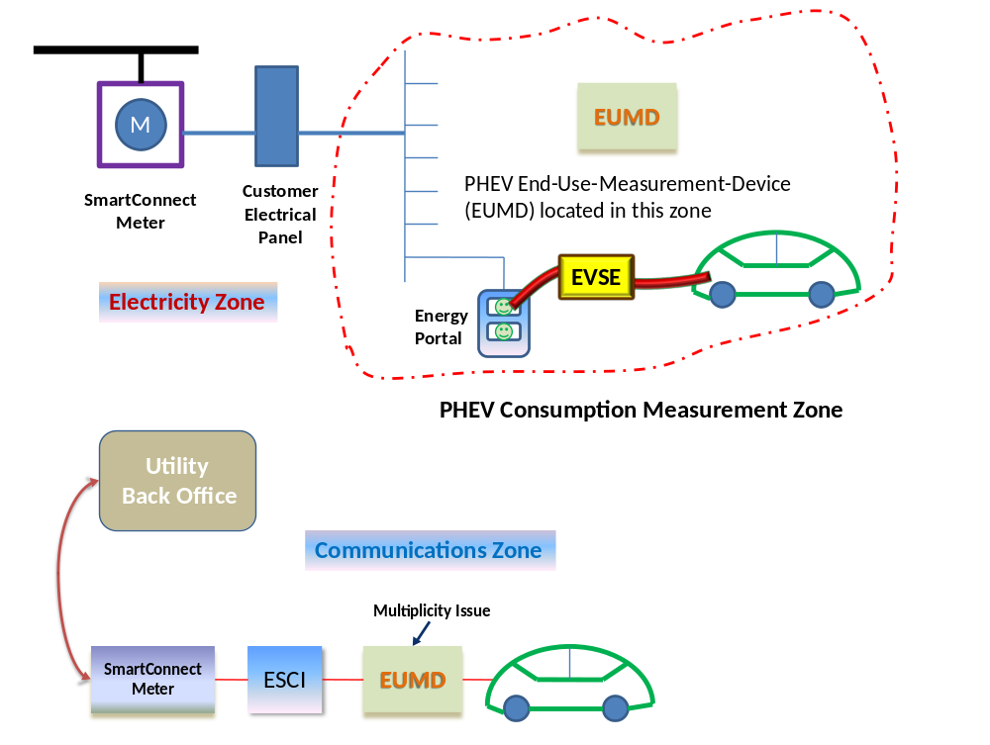

Sequence Diagram: Scenario 1

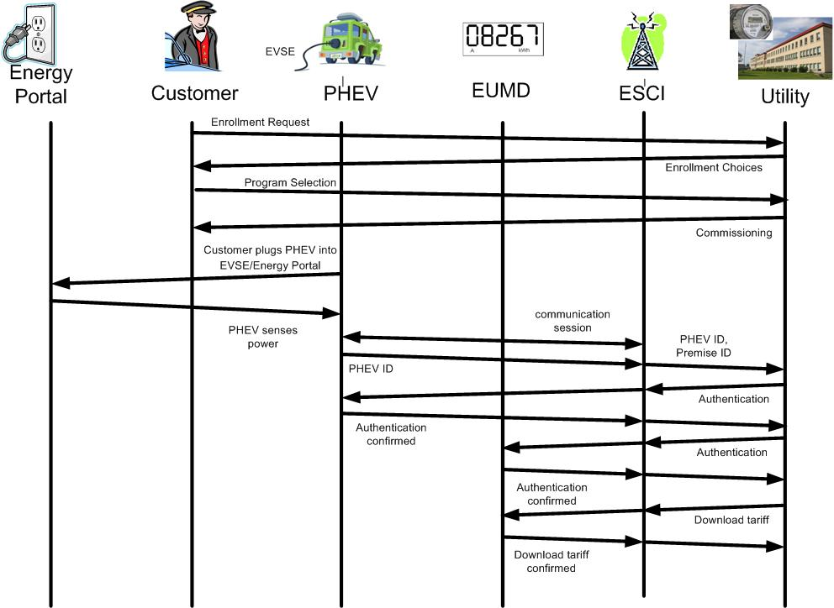

Use Case Issues
Capture any issues with the use case. Specifically, these are issues that are not resolved and help the use case reader understand the constraints or unresolved factors that have an impact of the use case scenarios and their realization.
Issue
Describe the issue as well as any potential impacts to the use case.
\

Glossary
Insert the terms and definitions relevant to this use case. Please ensure that any glossary item added to this list should be included in the global glossary to ensure consistency between use cases.

Glossary
Term | Definition
Tariff | Energy cost schedule to customer. Can be time-of-day, flat rate, seasonal rate, critical peak price rate, etc.
PEV | Plug-in Electric Vehicle. Includes all vehicles that have ability to receive electrical energy from Utility
EUMD | EUMD, revenue measuring device
ESCI | Energy Services Communication Interface
charging | Act of electrically charging a battery on-board a Plug-in Electric Vehicle or Electric Vehicle
VIN | Vehicle Identification Number

References
Reference any prior work (intellectual property of companies or individuals) used in the preparation of this use case.

Bibliography (optional)
Provide a list of related reading, standards, etc. that the use case reader may find helpful.

