OpenHAN SRS v1.91- clean
Google modified – 6 Apr 2010

A Work Product of the OpenHAN Task Force of the SG Systems Working Group under the Open Smart Grid (OpenSG) Technical Committee of the UCA® International Users Group

Version 2.0 – ______ , 2010

Version 1.04 Ratified by the UtilityAMI OpenHAN Membership on August 19, 2008

© Copyright, UCA® International Users Group, All Rights Reserved

DISCLAIMER OF WARRANTIES AND LIMITATION OF LIABILITIES
THIS DOCUMENT WAS PREPARED BY A TASK FORCE OF THE UCA® INTERNATIONAL USERS GROUP COMPRISED OF INDIVIDUAL MEMBERS FROM MULTIPLE ORGANIZATIONS NAMED BELOW. NEITHER THE UCA® INTERNATIONAL USERS GROUP, ANY MEMBER OF THE UCA® INTERNATIONAL USERS GROUP, THE PERSONS OR ORGANIZATION(S) NAMED BELOW, NOR ANY PERSON ACTING ON BEHALF OF ANY OF THEM:
(A) MAKES ANY WARRANTY OR REPRESENTATION WHATSOEVER, EXPRESS OR IMPLIED, (I) WITH RESPECT TO THE USE OF ANY INFORMATION, APPARATUS, METHOD, PROCESS, OR SIMILAR ITEM DISCLOSED IN THIS DOCUMENT, INCLUDING MERCHANTABILITY AND FITNESS FOR A PARTICULAR PURPOSE, OR (II) THAT SUCH USE DOES NOT INFRINGE ON OR INTERFERE WITH PRIVATELY OWNED RIGHTS, INCLUDING ANY PARTY'S INTELLECTUAL PROPERTY, OR (III) THAT THIS DOCUMENT IS SUITABLE TO ANY PARTICULAR USER'S CIRCUMSTANCE; OR
(B) ASSUMES RESPONSIBILITY FOR ANY DAMAGES OR OTHER LIABILITY WHATSOEVER (INCLUDING ANY CONSEQUENTIAL DAMAGES, EVEN IF THE UCA INTERNATIONAL USERS GROUP OR ANY UCA® INTERNATIONAL USERS GROUP REPRESENTATIVE OR MEMBER HAS BEEN ADVISED OF THE POSSIBILITY OF SUCH DAMAGES RESULTING FROM YOUR SELECTION OR USE OF THIS DOCUMENT OR ANY INFORMATION, APPARATUS, METHOD, PROCESS, OR SIMILAR ITEM DISCLOSED IN THIS DOCUMENT.
THE CONTENTS OF THIS DOCUMENT REPRESENT THE OPENHAN TASK FORCE MEMBERS BEST UNDERSTANDING OF THE HAN AT THE TIME OF COMPLETION. THIS UNDERSTANDING EITHER COLLECTIVELY OR BY INDIVIDUAL MEMBERS MAY CHANGE OVER TIME.

Authors
The following individuals and their companies participated in the OpenHAN 2.0 Task Group and contributed substantially to the drafting of this document:

Acknowledgements
Ratification and Endorsement

Document History
Revision History

Revision Number | Revision Date | Revision  By | Summary of Changes | Changes marked
1.9 | 1-30-10 | Document Editing Team | Revisions were made to v1.04 by incorporating requirements from SEP2.0 MRD and Retail DR requirements from NAESB use cases | Yes for added requirements
1.91 | 3-22-10 | Document Editing Team | Includes comments from BC Hydo, Itron, CenterPoint Energy, Oncor, People Power. Cisco, Google, Reliant Energy, I’m in Control, Trilliant, and GE | Yes
Contents
1. Introduction 10
1.1 Purpose 11
1.2 Scope 12
1.3 Acronyms and Abbreviations 13
1.4 Definitions 14
1.5 Policy Directives and References 19
1.6 Overview 21
2. Overall Description 23
2.1 Guiding Principles 23
1.7 Architectural Considerations 27
1.7.1 Energy Services Interface (ESI) 28
1.7.2 Device Ownership 29
1.7.4 Cohabitation 29
1.7.5 Deregulated Electric Markets 30
1.7.6 External Interfaces 30
1.7.8 Architectural Scenarios 33
2. OpenHAN System Requirements 37
2.1 Requirements Framework 37
2.2 Requirements Assumptions 41
2.3 Application Requirements 42
2.3.1 Control 42
2.3.2 Measurement and Monitoring 43
2.3.3 Processing 43
2.3.4 Human-Machine Interface 44
2.4 Communication Requirements 45
2.4.1 Commissioning 45
2.4.2 Control 47
2.5 Security Requirements 48
2.5.1 Access Controls and Confidentiality 48
2.5.2 Integrity 50
2.5.3 Accountability 51
2.5.4 Registration 51
2.6 Performance Requirements 52
2.7 Operations, Maintenance, and Logistics Requirements 55
2.7.1 Manufacturing and Distribution 55
2.7.2 Manage, Maintain 56
3. Appendices 57
3.1 UCAIug OpenHAN Task Force Use Cases 57
3.1.1 Introduction 57
3.1.2 Definitions / Assumptions / Actors 58
3.1.3 Use Case Assumptions 59
3.1.4 Load and Energy Management 60
3.1.5 Energy Management System 66
3.1.6 User Information 68
3.1.7 Energy Storage and Generation 69
3.1.8 Fixed HAN Devices with Metering Capability 71
3.1.9 Mobile HAN Device with Metering Capability 72
3.1.10 System Configuration and Management 73
3.2 UCAIug OpenHAN Task Force Logical Device Mappings for Utility-Registered Devices 83
3.2.1 Mapping Introduction 83
3.2.2 Logical Device Mappings 85
4. Appendix A – Units 102
5. Appendix B – ESI specific requirements 104
6. Appendix C – Recommendations for Writing RFI/RFP’s with Respect to the Utility ESI and HAN devices 105
4.2.2 Logical Device Mappings 94

Introduction
In 2007, the UtilityAMI established the OpenHAN Task Force to develop guiding principles, use cases, and platform independent requirements for the utility Advanced Metering Infrastructure (“AMI”) home-area-network (“HAN”). The core development team included more than a dozen investor-owned North American utilities serving more than 28 million electric and gas customers in 17 states and provinces, as well as contributors from EnerNex Corporation, Tendril Networks, Mulligan Labs, LLC, Itron, and Silver Spring Networks. The OpenHAN Task Force collaborated throughout 2007 and 2008 to draft the UtilityAMI 2008 Home Area Network System Requirements Specification and received ratification of v1.04 in August 2008 (“UtilityAMI 2008 HAN SRS”).

Since August 2008, additional HAN related use cases were developed and the UCAIug OpenSG Technical Committee re-established the OpenHAN Task Force under the SG Systems Working Group in October 2009. The OpenHAN Task Force was directed to begin work on the next version of the HAN SRS document, i.e. UCAIug HAN SRS v2.0. The work to produce this document was a collaborative effort with meetings open to all interested parties. Those that participated in developing this document include utilities, energy service providers, vendors, appliance manufacturers, software developers, etc.

This document consists of four sections: Introduction, Overall Description, System Requirements, and Appendices.

Section 1 describes the purpose, scope, and policy directives that have shaped the HAN SRS. Section 1 also includes a comprehensive list of acronyms and definitions to help the reader interpret the HAN SRS.

Section 2 describes the overall premises energy ecosystem, the guiding principles for the system and architectural considerations relevant to understanding the system.

Section 3 gives context for and lists all platform-independent OpenHAN system requirements by category but does not map them to specific logical devices. The requirements categories are:

- Application
- Communication
- Security
- Performance
- Operations, Maintenance, and Logistics

Section 4 contains the appendices, which include high-level system use cases, requirements mappings for logical HAN Devices, and deployment scenario examples.

Although this document is a system requirements specification, it follows the IEEE 830-1998 Recommended Practice for Software Requirements Specifications given the focus on Home Area Network (HAN) applications for utilities and consumers.

Purpose
One of the key outcomes of Smart Grid deployments is enabling informed participation by end-use consumers in retail and wholesale electricity markets. When consumers are given timely information about their electrical usage, this will empower them to manage their electricity usage, promote energy efficiency, and lower overall energy costs. Home Area Networks will play a role in achieving these goals by giving consumers more information than they have ever had before on how they use electricity and the cost of their usage. In addition, by using interoperable standards utilities, device manufactures, vendors, and energy service providers can develop innovative and cost effective solutions and products which help consumers manage and optimize their electricity usage.

To reach these goals and to bring the benefits of the Smart Grid to consumers, the OpenHAN Task Force undertook the development of the initial version of the OpenHAN SRS, the UtilityAMI 2008 Home Area Network System Requirements Specification v1.04 (“UtilityAMI 2008 HAN SRS”). By providing common architectures, language, and requirements, use of the UtilityAMI 2008 HAN SRS will ensure a competitive market place by driving down costs, increasing interoperability, and maximizing longevity and maintainability.

Utilities interested in AMI deployments with two-way communication into the premises are encouraged but not required to use and include sections of this document when evaluating or procuring AMI systems that interact with HANs.

- The purpose of this HAN SRS is:Promotes open standards-based HANs that are interoperable
- Provides the vendor community with a common set of principles and requirements around which to build products
- Ensures reliable and sustainable HAN platforms
- Supports various energy policies in a variety of states, provinces, and countries
- Empowers consumers to manage their electricity consumption by giving them the information and control they need to make informed decisions with regard to their energy use and to effectively control their usage

The audience for this HAN SRS is:
- Utilities considering deploying AMI systems that interact with a HAN
- Vendors that make AMI systems for Utilities that interact with a HAN
- Vendors that make consumer products (e.g. programmable communicating thermostats, energy management systems, load control switches, in-home displays, smart appliances, PEV, distributed generation resources, etc.)
- Service Providers developing smart grid enabled programs for consumers (e.g. demand response, energy management, pre-pay, PEV, distributive generation, etc.)
- Policy makers looking to understand how Utility AMI deployments benefit consumers Industry alliances and standards organizations
- NIST Smart Grid Interoperability Panel (SGIP) activities (e.g. Smart Grid Architectural Committee (SGAC), Cyber Security Working Group (CSWG), Smart Grid Testing and Certification Committee (SGTCC), etc.)
As AMI and HAN systems continue to evolve, the UCAIug OpenHAN TF maintains an open door policy and encourages all interested parties (e.g. utilities, regulators, service providers, software vendors, original equipment manufacturers, etc.) to join the discussion.

Scope
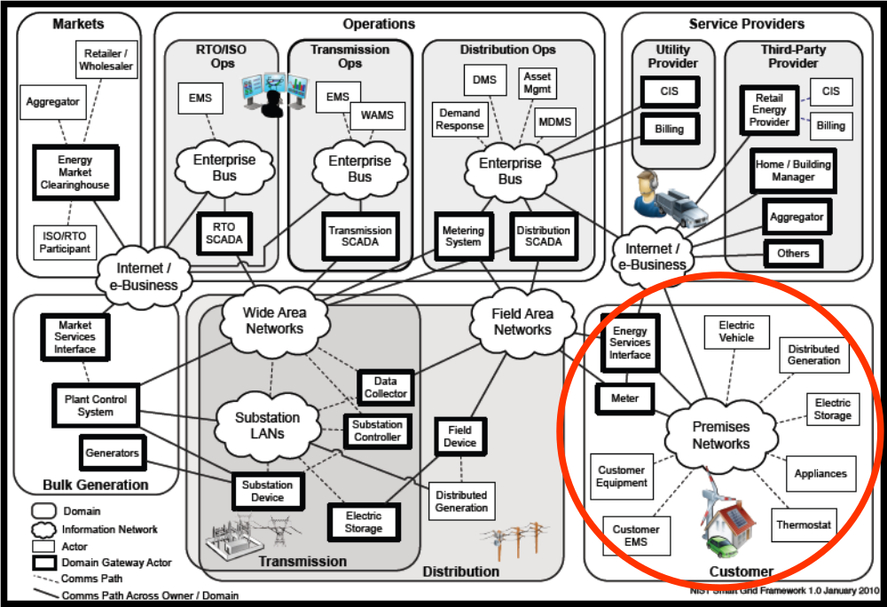

Figure 1 NIST Conceptual Reference Diagram for Smart Grid Information Networks

The scope of this SRS is the devices, networks, and interfaces in the Customer domain which interact with the Service Provider and Distribution domains. This is graphically displayed by the red circle in Figure 1 NIST Conceptual Reference Diagram for Smart Grid Information Networks.

This document includes Guiding Principles, Use Cases, System Requirements, Architectural Drawings, and Logical Device Mappings for platform-independent HAN Devices regardless of the ownership of the devices. This document provides platform-independent requirements and systems that Service Providers, Utilities, and vendors can use regardless of the technology they select.

This SRS does not apply to, but has inherent implications for, certain Utility Enterprise Systems (e.g. Utility AMI communications network, Meter Data Collection and Management Systems, etc.), which are beyond the Customer domain. It also does not apply to devices in the premises that are not part of the Home Area Network, as defined in this document (described in more detail in Section 2.2 – Architectural Considerations). Some examples of these devices not covered in the scope of this specification are home automation, home health monitoring, and security system products.

While the residential consumer has the most to gain from the HAN SRS, the requirements in this SRS are applicable and may be used by commercial and industrial customers as well.

As developed through Guiding Principles, Use Cases, and System Requirements, this SRS establishes the initial requirements and framework for the development of well managed and secure HAN communications systems. This is important and necessary given the increased risk to the electricity grid by the installation of an in-premises HAN Devices (e.g. gateway, Energy Management System, etc.) that can engage in two-way communications using more than one communication media (e.g. Utility AMI network, internet, cell phone network, etc.) and may be commissioned to both a third party ESI (e.g. third party Energy Management System) and the Utility ESI. As part of the Utilities’ mandate to ensure a reliable electricity supply, security requirements have been included in this specification.

Acronyms and Abbreviations
This subsection provides a list of all acronyms and abbreviations used in this document.
.

AMI | Advanced Metering Infrastructure
CPP | Critical Peak Pricing
CSS | Customer Service System
EMS | Energy Management System
ESI | Energy Services Interface
ESU | Energy Supplying Unit
EUMD | End-Use Measurement Device
EVSE | Electric Vehicle Supply Equipment
FHDMC | Fixed Home Area Network Devices with Metering Capability
HAN | Home Area Network
HMI | Human / Machine Interface
IHD | In-Home Display
ISO | Independent System Operator
MHDMC | Mobile Home Area Network Devices with Metering Capability
PCT | Programmable Communicating Thermostat
PEV | Plug-in Electric Vehicle
SRS | System Requirements Specification
TOU | Time of Use

Definitions
This subsection provides the definitions of all terms used in this document.

Active Event | Refers to an event (e.g. demand response, price, emergency, etc.) that is underway
Advanced Metering Infrastructure (AMI) | Advanced Metering Infrastructure refers to systems that measure, collect, and analyze energy usage from advanced devices (e.g. electricity meters, gas meters, and/or water meters), through various communication media on request (i.e. on-demand) or on a pre-defined schedule. This infrastructure includes hardware, software, communications, customer-associated systems, meter data management software, Metering System, network distribution business systems, etc.
Advanced Metering Infrastructure System | “The big picture” - includes the Energy Services Interface, meter, Utility Communications Network, Meter Data Management, Utility business processes  Note: Is this the same as the AMI?
Audit | A methodical examination or review of a condition or situation within a Home Area Network Device
Automated Data Collection System | A system that can communicate with Advanced Metering Infrastructure meters remotely (e.g., to program meters, test meters, retrieve data); the System is a component of the Advanced Metering Infrastructure.  Note: Not used in document. Consider deleting.
Capacity Billing Rates | Demand charges based in the rate of consumption (e.g. kWh demand, cubic feet per minute)
Charging Interval | The period of time that is bound by a start and stop of charging
Commissioning | The network process of adding or removing a Home Area Network Device (i.e. a node) to the Home Area Network. This process is sometimes called provisioning and is decoupled from the Registration process.
Consumer | A person who consumes electricity, natural gas, water, or other utility and who has the greatest potential to conserve and manage the consumption of those utilities. The Consumer may participate in Service Provider programs (e.g., Demand Response, pricing, PEV, pre-pay, pricing, etc.) by registering for those programs. Consumers may also manage demand response events and daily usage by controlling HAN Devices manually or via other devices (e.g. EMS, etc.). Consumers are distinct from Customers because the Consumer of the utility isn’t always the Utility Customer that pays for the consumption.
Consumer Home Area Network | A non-Utility Home Area Network (e.g. EMS, etc.) in a premises that may have a HAN Device that is also part of another Home Area Network (e.g. Utility Home Area Network).
Consumer Override | Refers to a consumer adjusting the functional behavior of a device to ignore or modify a Service Provider’s control messages
Control | The runtime configuration of the Home Area Network that causes interactions among the Energy Services Interface and targeted Home Area Network devices to occur
Critical Peak Pricing | A monthly or seasonal schedule of energy charges which vary based upon a predetermined schedule of hours of the day and days of the week. In addition, the consumer receives real-time notification of critical hours subject to special higher prices for 1 to 2% of the hours in the year.
Customer Representative | Person or intelligent system with which the Consumer interacts to work with a business (e.g., Utility, Service Provider, demand response aggregator, etc.)
Customer Service System | A system (e.g. system used by the call center) that provides Service Provider employees the ability to view Consumer-specific information (e.g. account information, billing, tariffs, programs, metering, interval usage, etc.).
Distributed Generation | Small-scale power generation technologies (typically in the range of 3 to 10,000 kW) located close to where electricity is used (e.g., a home or business) to provide an alternative to or an enhancement of the traditional electric power system. May also be referred to as Distributed Energy Resource (DER).
Emergency Event | An Independent System Operator or Utility initiated reliability event
Energy Cost Application | Calculates Home Area Network Device energy consumption cost. The application may use information from multiple sources including: Advanced Metering Infrastructure meter(s), the Advanced Metering Infrastructure System, , other application(s), other Home Area Network Device(s), and/or Human Machine Interface(s), etc.
Energy Management System | An application used for controlling multiple energy-controllable devices (e.g., pool pump, Programmable Communicating Thermostat, light switches, PEV charging, etc.). This application may reside within a HAN Device (e.g. Programmable Communicating Thermostat, In-Home Display, computer, cable set-top box, other computing device, etc.). This application may also control other devices or systems in the home providing integrated automated services for the Consumer.
Energy Services Interface | A secure interface to a premises communications network which facilitates relevant energy applications (e.g. remote load control, demand response, monitoring and control of distributed generation, in-premises display of customer usage, reading of energy and non-energy meters, PEV charging and roaming coordination, and integration with energy management systems, etc.), provides auditing / logging functions that record transactions to and from HAN Devices, and, often, coordination functions that enable secure transactions between the HAN Devices commissioned on its network and the Service Provider.  Note: There may be more than one ESI in a premises or more than one ESI in a HAN Device.
Energy Supplying Unit | An energy storage device (e.g., battery storage unit, electric vehicle battery) capable of providing power to a premises or the electric grid
End-Use Measurement Device (EUMD) | The device that measures and communicates energy usage information from an end-device
Electric Vehicle Supply Equipment (EVSE) | The physical electrical cord and connectors that are specified by applicable SAE (Society of Automotive Engineers) standards that provide transfer of electric energy from the charging point to the PEV. The PEV connects to the electricity supply using an EVSE.
External Interface
Fixed Home Area Network Devices with Metering Capability
Home Area Network (HAN) | Within the scope of this SRS, a HAN is an energy related network, contained within a premises used for communicating with devices within the premises. HANs do not necessarily require connectivity outside the premises, but may be connected to one or more external communication networks (e.g. Utility AMI, internet, cell phone network, etc.) using gateways, bridges and interfaces
Home Area Network Device (HAN Device) | Within the scope of this specification, any device whose functionality can be accessed via the HAN
Health Check | Operation performed by Home Area Network Device to determine proper functionality  Note: not used in document. Recommend deleting
Hourly Energy Rate | Energy charges which vary on an hourly or less than hourly basis. This may also be called Real-Time pricing.
In-Home Display | A HAN Device that receives data and displays data and may display more advanced information that has been calculated by applications in the device.
Independent System Operator | Coordinates controls and monitors the operation of the electrical power system, usually within a single US State, but often encompassing multiple states
Installed Service Point | Uniquely identifies the service delivery point  Note: not used in the document; recommend deleting. Is this the same as “point of service”?
Installer | The entity who installs and commissions a Home Area Network Device in the Consumer’s premises; Installer may be a 3rd party or the Consumer
Labeling | Compliance and standards labeling
Least Privilege | The concept of least privilege is to operate using the least set of privileges necessary to complete a given task. The ultimate goal is to eliminate damage that can occur from accidental errors or malicious intent.
Manufacturer | Defined broadly to include Original Equipment Manufacturers, Distributors, and Value-added retailers and is accountable for ensuring proper out-of-box operation of the HAN device
Measure | Determination of dimension, quantity, or capacity
Meter | The point of service meter (e.g. electric, water, gas, revenue grade, non-revenue, etc.) permanently associated with the unique premises
Metering System | A system that can communicate with AMI meters remotely (e.g. program meters, test meters, retrieve data); this system is a component of the AMI
Mobile Home Area Network Devices with Metering Capability (MHDMC) | A mobile end-use meter, downstream from the premises electric meter (i.e., point of service meter), that is communicated to via the Home Area Network (e.g.,PEV)
Mobile Home Area Network Devices with Metering Capability Owner | A Consumer who is the person or organization responsible for Mobile Home Area Network Devices with Metering Capability account
Mode | A condition of the operational state (e.g., charging, discharging, power save)
Monitor | A device or arrangement for observing, detecting, or recording the operation of a machine or system
Mutual Authentication | A process in which both entities in a communications link authenticate each other
Network Management | The ability to remotely diagnose system components, and to monitor and control the communication system
Orphaned Charge | A billing charge that is incurred by a Mobile Home Area Network Device with Metering Capability at a premise other than its registered, “home” premise. This billing charge needs to be reconciled through the Service Provider billing system and associated with the proper customer account (e.g., a Plug-in Hybrid-Electric Vehicle that charges at a grocery store or at a friend’s house).
Pending Event | Refers to an event (e.g. demand response, emergency, etc.) that is scheduled but has not yet happened
Plug-in Electric Vehicle (PEV) | An electric vehicle that may solely rely on electric propulsion (EV) or may include an alternative source of propulsion power (PHEV).
Pool Pump Controller | The controller is a separate device that resides between the timer and the pool pump, has minimal intelligence, and sends and receives signals through the Home Area Network  Note: not used in the document, recommend deleting
Pre-Commissioning | Depot level configuration setting
Premises | A geographical location (e.g., house, apartment, building, etc.) where the meter permanently resides
Price Event | An event (e.g. demand response, emergency, etc.) based upon price
Purchasing | Supports multiple distribution channels (e.g., retail, wholesale, Service Provider, etc.)
Rate Tiers/Blocks | Energy charges which vary based on the accumulated consumption / production during a period of time
Registration Process | The process by which a Consumer enrolls a HAN device in a Service Provider’s program (e.g. demand response, energy management, pre-pay, PEV, distributed generation, pricing, messaging, etc.) and gives certain rights to the Service Provider to communicate with their HAN device.
Remote Upgrade | The ability to correct defects, enable new features and applications, change recording and reporting intervals, refresh security, and optimize network operation without the cost of sending personnel to the customer site
Security | Those measures that protect and defend information and information systems by assuring their confidentiality, integrity, access controls, availability, and accountability
Service Provider | An entity (e.g. utility, retail electric provider, demand response aggregator, etc.) which provides energy services to consumers
Smart Appliance | A white good or household appliance, that has HAN communication capability and is capable of receiving signals from authorized parties (e.g. Utility, Service Provider, EMS, Consumer, etc.) and of adjusting its operational mode based on Consumer preferences (e.g., energy saving mode, delayed turn on/off)
State | A condition of the device (i.e., on/off)
System Operator | The entity responsible for operation and control of the electricity grid for a specific and defined geographic / service area
System Owner | The entity responsible for oversight and control of the entire system  Note: not used in the document; recommend deleting
Time of Use Rates | Energy charges which vary based upon a predetermined schedule of hours of the day and days of the week
Time of Day Demand Rates | Demand charges which vary based upon a predetermined schedule of hours of the day, days of the week, and seasons of the year
Utility Public Broadcast Channel
Utility | The entity which owns and provides the Utility ESI, AMI meter, and AMI communication network.
Utility Enterprise System | Includes Advanced Metering Infrastructure system, Distributed Automation, and all other enabling technologies of the Utility operation
Utility Energy Services Interface | An ESI, owned by the Utility, which enables secure interactions between HAN Devices commissioned on its network and the Utility AMI. This ESI is the unique interface providing real-time energy usage information from the AMI meter to HAN Devices and applications.

Policy Directives and References

The development of the UtilityAMI 2008 HAN SRS was motivated by legislative and regulatory policy directives and the proliferation of multiple technology standards for HANs. Regulatory policy directives played a key role in pushing utilities to deploy AMI systems that provide consumers with more detailed energy consumption information and demand-reduction capabilities, including the California Public Utilities Commission Energy Action Plan and AMI Directives, the California Energy Commission J45 Reference Design for Programmable Communicating Thermostats (PCTs), the Public Utility Commission of Texas (PUCT) Advanced Metering rule, and the Michigan 21st Century Energy Plan. Another motivating factor driving the development of the UtilityAMI 2008 HAN SRS was to guide and direct the alliances who are responsible for developing HAN technology standards by providing a standard set of requirements. The UtilityAMI OpenHAN TF also leveraged and, in particular the work of Electric Power Research Institute and the GridWise Architecture Council. These organizations provided a template and a foundation which was used to approach the development of the UtilityAMI 2008 HAN SRS.

Since the ratification of the UtilityAMI 2008 HAN SRS in August 2008, the national focus and attention on the Smart Grid, especially as it relates to enabling informed participation by end-use customers, has been intensified. The Energy Independence and Security Act of 2007 (ESIA) made the development of a Smart Grid a national policy goal. ESIA authorized DOE to solicit applications for the Smart Grid Investment Grant Program (SGIG) and assigned the National Institute of Standards and Technology (NIST) the responsibility to coordinate the development of an interoperability framework between Smart Grid devices and systems that is “flexible, uniform and technology neutral”. In February 2009, the U.S. Congress passed the American Recovery and Reinvestment Act (“ARRA”), which provided funding for DOE Smart Grid grants, other DOE incentives and NIST for NIST to fulfill its ESIA obligations.

In 2009 NIST began its work and by January 2010 NIST published the NIST Framework and Roadmap for Smart Grid Interoperability Standards, Release 1.0. In this framework document, NIST recognized the UtilityAMI 2008 HAN SRS as a set of requirements for the Smart Grid data communications interface to customer devices. The UtilityAMI 2008 HAN SRS sets forth the requirements for secure communication between the Distribution and Customer domains and between the Service Provider and Customer domains as graphically depicted in Figure 2 of the NIST conceptual reference model.

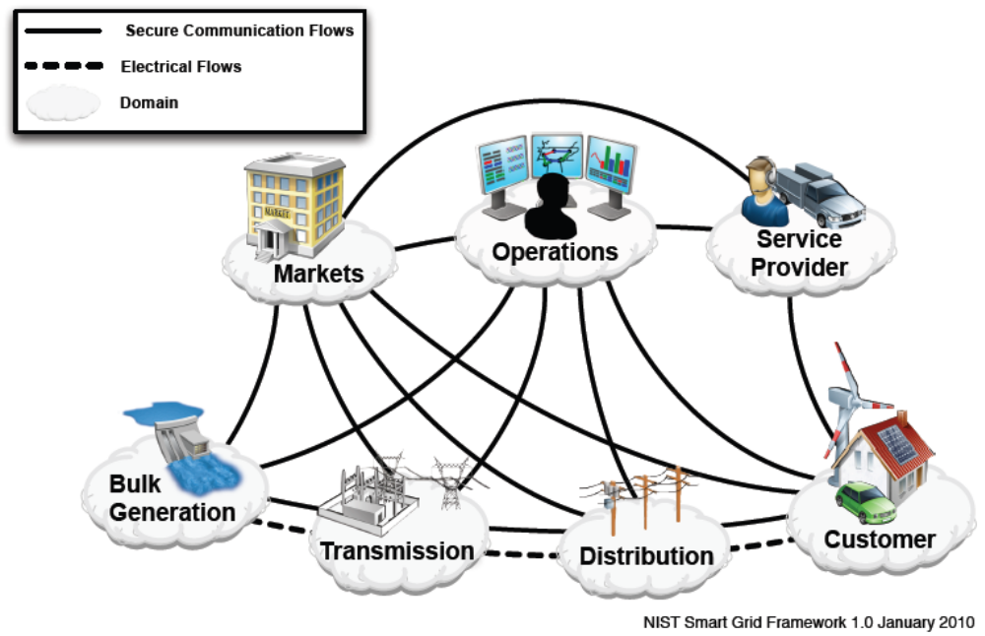
Figure 2 Interaction of actors in different Smart Grid Domains through Secure Communication Flows and Electrical Flows.

In mid 2009, DOE issued the Smart Grid Investment Grant (SGIG) Program Funding Opportunity with specific goals including enabling informed participation by consumers in retail and wholesale electricity markets, enabling new products, services, and markets, and optimizing asset utilization and operating efficiency of the electric power system. Reimbursement for project expenditures was contingent upon a project’s compliance with relevant technical standards and the project’s support for and compatibility with NIST’s emerging smart grid framework for standards and protocols. DOE selected 100 projects to fund and many of those projects include providing customers usage information, dynamic pricing, demand response programs, smart appliances, and in home displays. Use of the OpenHAN SRS by these utilities and vendors will help them to meet the DOE standards requirement, to further the development of Smart Grid functions, and to bring the benefits of the Smart Grid to consumers.

The Department of Energy has also funded projects to demonstrate advanced Smart Grid technologies and integrated systems that will help build a smarter, more efficient, more resilient electrical grid. The Smart Grid Demonstration Grants (SGDGs) provided funding for thirty two demonstration projects, which include large-scale energy storage, smart meters, distribution and transmission system monitoring devices, and a range of other smart technologies. These projects are to act as models for deploying integrated Smart Grid systems on a broader scale. The largest of these projects is being undertaken in the Pacific Northwest Smart Grid Demonstration Project. The project engages twelve regional utilities and providers, spanning five states and affecting more

Overview

This document follows a top-down approach to system decomposition and conforms to the GridWise Architecture Council’s framework as shown in the figure below: This figure also provides the layout for the rest of this specification following the top-down approach.

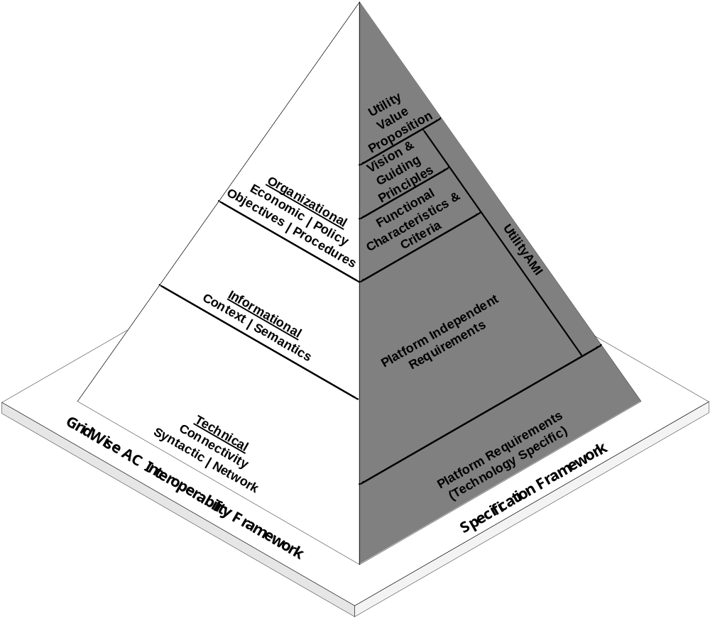

2. Overall Description

The UCAIug HAN SRS provides the foundation of the home energy ecosystem in which HAN Devices operating within a premises are able to engage with the Service Provider as much or as little as the Consumer wishes. The HAN may be deployed in different physical environments (e.g. multi-dwelling units, large single or two story house, strip mall, etc.) and should be able to operate within those environments.

This section defines the Guiding Principles the OpenHAN Task Force adopted to frame the capabilities and constraints of the system, the Architecture for HAN Device interaction with the Service Provider that permits a highly adaptable and flexible system depending on consumer preference, and the assumptions for the system used as a starting point for drafting the Use Cases and Requirements found in Appendix 4.1 and Section 3, respectively.

2.1 Guiding Principles

The Guiding Principles represent high level expectations used to guide and frame the development of the functional and technical requirements in this document. These expectations include the capabilities which are necessary to support policy directives, interoperability, and smart grid functionality..

The principles are authoritative and define the HAN implementation starting point. A complete implementation will provide technical methods and processes which meet or exceed a stated capability and adhere to the stated constraints. These principles, as stated, drive and define the functional characteristics and are the basis for the HAN Use Cases.

- The HAN has Zero Physical Security with respect to Consumer Tampering

Description

Any device in the home can be tampered with at any time. Short of physical inspection, it may be impossible to determine whether physical tampering of a HAN device has occurred. Once an attacker has physical access to a device and a (basically) infinite amount of time to modify the device, all devices on the network (and the network itself) becomes suspect.

Rationale
Lack of physical security for HAN devices has implications regarding what can be expected from the HAN network. From a security perspective, it is important to assume the HAN environment is hostile to the smart grid and make requirement, design and policy decisions accordingly.

- Secure Two-way Communication Interface between Service Provider and ESI

Description
The Service Provider has secure two-way communication to the Utility Energy Services Interface (Utility ESI), regardless of where the Utility ESI is located.

The ESI also possesses a two-way communication interface for HAN Devices which can use encryption to provide protection from eavesdropping.

Rationale
The two-way communications expectation defines the Service Provider-to-HAN interface and creates and enables all other capabilities within the system. This interface may carry various data types (e.g. sensitive data, confidential data, control data, publicly broadcast data, usage information, Service Provider program information, etc.). Appropriate levels of security must be provided for these types of communications. Security is critical; the security implementation of the ESI protects Utility and Consumer assets while enabling the next generation of applications and capabilities.

- Supports Load Control Integration

Description
Load control is the concept of load being managed (e.g. deferred, eliminated, cycled, etc.). A load control device (e.g. PCT, Smart Appliance, pool pump, EMS, etc.) has the capability to limit the duty cycle of equipment under control. These devices within the Consumer’s premises can receive a request to shed load directly (“please turn off”) or indirectly (“The price of power is high, you might want to turn off”). Control requests should not in anyway compromise safety systems built into HAN Devices or compromise the ability of the HAN Device to complete the task previously initiated. Smart Appliances have the ability to reduce different percentages of their peak load (watts) based on pricing information provided by the Service Provider and/or perform other functions to defer or reduce peak load as communicated to the Smart Appliance.

Rationale
A capability to communicate with load control systems enables the Service Provider to help consumers adjust their energy usage based on events external to the consumer (such as grid demand stress or generation failure). Allowing Load Control Integration via the HAN will provide consumers with more choices with respect to energy management and energy management services.

- Direct Access to Usage Data

Description
The Utility ESI provides the HAN with access to Consumer-specific usage data directly from the AMI meter and enables a new class of energy services and products.

Rationale
One of the main requirements for energy conservation is a better informed Consumer. By providing Consumers with more timely and detailed information, Consumers will be able to make better choices about when and how they consume energy. Applications may use the data to automatically optimize premises consumption (e.g. EMS, PEV, etc.). With direct usage data access, Consumers need not wait until the end of the month to see how their bill is affected by their choices in energy consumption. Since the energy usage from the AMI meter is recorded in smaller increments, the Consumer can more readily observe the impact of changing energy usage patterns.

- Provides a Growth Platform for Future Products Which Leverage the HAN and Meter Data

Description
A growth platform is typically a specifically named initiative selected by a business organization to fuel their revenue and earnings growth. The HAN is an example of a strategic growth platform. Strategic growth platforms are longer term initiatives where the initiative and results span years. While AMI enables the Utility to exchange information with a HAN via the ESI, the growth platform is not limited to the Utility, but extends to any organization that wants to develop products or services leveraging the HAN and AMI meter data.

Rationale
The HAN is expected to support many innovative applications including the next generation of applications (e.g. distributed generation, PEV, Smart Appliances, EMS, other energy applications, etc.) as the technology, information, and communication capabilities of the HAN matures. By supporting open standards (see Principle 8), it is expected that many Service Providers and vendors will be able to expand the capabilities of the HAN by developing innovative products for an emergent HAN market.

- Supports Three Types of Messaging: Public Price Messaging, Consumer-Specific Messaging, and Control Messaging

Description
To support the anticipated growth in the HAN market, the system must provide for various types of communication. These communication types may include public price messaging, consumer-specific messaging, and control messaging. Public price messaging is the communication of material which is publicly available and of general interest to all consumers. Consumer-specific messaging is information which is specific to a particular consumer (e.g. usage, billing, load control, smart appliance, etc.) and is provided through registration in a Service Provider program (e.g. Demand response, pre-pay, PEV, EMS, etc.). Control Messaging are signals used to support load-shedding (see Principle
3).

Rationale
Each message type is required to support the HAN as a growth platform (see Principle 5). Each message type warrants individual security and privacy analysis and treatment. Consumer-specific information messaging implies a level of privacy requirement. Demand Response messaging for load control and direct Utility communications requires validation that the message was received by the target HAN device but (see Principle 1) there is no expectation the HAN will take any action nor is there an expectation that the HAN device is even the same HAN device that was initially provisioned.

- Supports End-Use Metering and other Utility Meters

Description
End-use metering is when an additional meter may be installed in the premises to record distributed generation production or to measure discrete loads (e.g. PEV, etc.). Distributed generation systems are small-scale power generation technologies used to provide an alternative to or an enhancement of the traditional electric power system.

Additionally, the OpenHAN architecture does not presume use of only electric meters. The Utility ESI may also communicate with gas and water meters and transmit their data through the HAN (e.g., to an IHD) or through a backhaul network (e.g. AMI network, internet, etc.) for transfer to an appropriate entity (e.g., an electric utility could gather water meter information and pass that information to the water utility).

Rationale
The ability to support communication to multiple HAN Devices provides greater value to the Consumer and Service Provider by facilitating automation and reducing redundancy in the systems required to capture metering information. As more homes and business become “green” it is anticipated that the HAN will need to support distributed generation sources such as solar panels, small wind turbines, or PEVs that may discharge energy back into the grid. In addition, non-revenue grade metering of end-use devices can provide consumers with additional information on the energy and cost associated with end-uses such as individual circuits, appliances, or plug loads.

- Consumer Owns the HAN

Description
The Consumer owns and controls the HAN and its data within their premises. The Consumer for various reasons may concede control for limited periods of time of specific HAN applications in accordance with a Service Provider's program. The only way a Service Provider may gain access to the Consumer’s HAN is for the Consumer to register a HAN Device in a Service Provider’s program.

Rationale
The Utility owns the AMI meter and the Utility ESI. The Utility ESI provides the HAN direct access to AMI meter data. Service Providers may offer Consumers innovative applications and programs which utilize the HAN and the AMI meter data. However, the Consumer is the one who decides which applications, products, information, programs, etc. are best suited to meet the Consumer’s energy goals and needs.

- The HAN Supports Smart Grid Interoperability Standards

Description
From the IEEE P1003.0 Committee:

"An open system is: A system that implements sufficient open specifications for interfaces, services, and supporting formats to enable properly engineered applications software to be ported across a wide range of systems with minimal changes, to interoperate with other applications on local and remote systems, and to interact with users in a style which facilitates user portability.”

Key elements of this definition are the terms, “open specification” and “interoperate”, which are defined as follows:

Open specification: “A public specification that is maintained by an open, public consensus process to accommodate new technology over time and that is consistent with standards.”

Interoperability: The capability of two or more networks, systems, devices, applications, or components to exchange and readily use information—securely, effectively, and with little or no inconvenience to the user.

Rationale
The use of open standards is a key to accessibility, availability, innovation, and wide-spread adoption. Standards provide for (1) competitive markets which drive down the price of Consumer goods, (2) interoperable components that enable a “plug and play” experience, (3) cyber security that protects systems and data, and (4) a common understanding of exchanged information and the agreed-upon types of response this information will elicit. Requiring the use of non-proprietary interoperable standards puts competitive pressure on the market place and reduces maintenance and support costs caused by proprietary solutions.

Service Providers and Consumers are constrained by the relative value of the HAN and any investments in HAN technology need to be interoperable and upgradeable to readily adapt to changes in technology. For this reason, this specification is written as platform and technology independent.

Architectural Considerations

The architectural consideration section is not binding. That is, this section of the document is not considered “requirements.” Rather, this section of the document provides context and shows the OpenHAN task force architectural considerations during the development of this HAN SRS document.

Each of the following sections addresses various architectural designs. In general, this HAN SRS is architecture agnostic. The requirements are targeted at logical devices. The following section simply provides additional clarifications and context.

Energy Services Interface (ESI)
The ESI provides a particular logical function in the HAN. It is an interface which enables interactions between authorized parties (e.g. Utility, Consumer, non-Utility Service Providers, EMS, etc.) and all HAN Devices that are commissioned to it that are protected from eavesdropping. The HAN architecture allows for more than one ESI in a Consumer premises. The ESI creates logical segmentation within the premises. This logical segmentation can be viewed as separate networks: the Utility-provisioned network and all other external networks. HAN Devices (e.g. EMS, internet gateway, etc.) which are active on both networks must have a logical separation between the two networks.

The primary ESI is the Utility ESI which enables interactions between HAN Devices commissioned to it and the Utility AMI which are protected from eavesdropping. Security on this interface is robust and comprehensive in order to protect Utility assets (e.g. electric grid, AMI, etc.). This ESI is the unique interface providing real-time energy usage information from the AMI meter to HAN Devices. Who (e.g. Utility, Consumer, non-utility Service Provider, etc.) has access to communicate with the Utility ESI is a matter of law or regulatory policy. In addition, what access an authorized party has is subject to the program which the Customer has registered their HAN Device in.
Additional ESIs may be installed in the Consumer premises to create addition HANs (e.g. EMS, a Service Provider program, etc.). These ESIs must provide protection from eavesdropping to protect Consumer assets and data. Communication to HAN Devices commissioned these ESIs may be through alternative communication networks (e.g. internet, cell phone network, EMS, etc.).

In some jurisdictions, the Utility ESI may provide for two interfaces to the premises, the Utility-Provisioned Interactive Interface and the Utility Public Broadcast Channel. The Utility-Provisioned Interactive Interface provides protection from eavesdropping. The second interface, the Utility Public Broadcast Channel, allows for anonymous receipt of information provided by the Utility. Further, the second interface is not protected from eavesdropping by the Utility. This second interface is based on the assumption that users need information for conservation and awareness and do not want to exchange information with the Utility (i.e. one way communication).

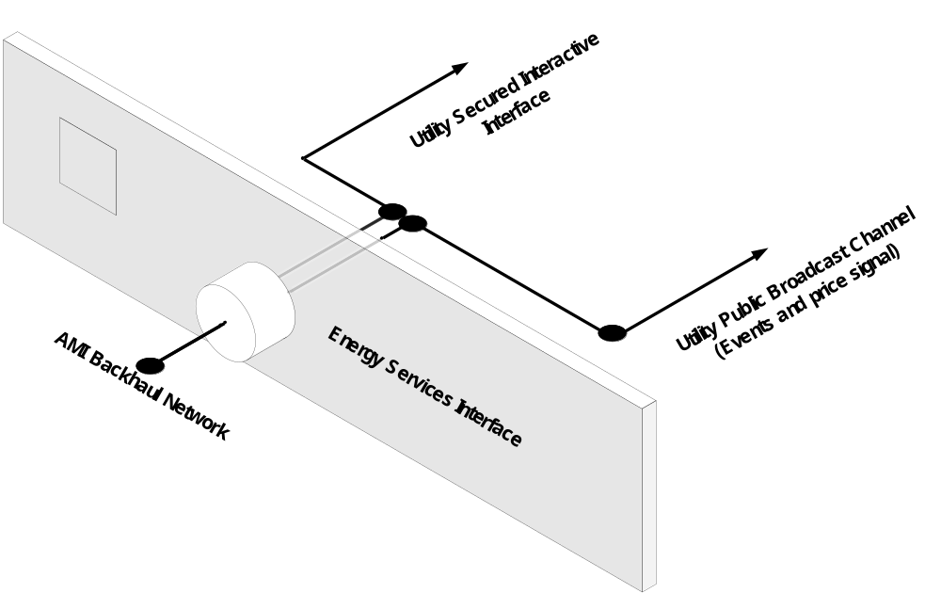

Device Ownership
The HAN SRS as a whole is agnostic to device ownership. OpenHAN recognizes consumer rights, and this sentiment is stated explicitly in the Guiding Principles section of this document. With that being said, the architectural section does touch on additional aspects of ownership and control. The architecture section makes a further assumption beyond the Guiding Principle that devices in the premises can be supplied by the Utility, a non-utility Service Provider, or the Consumer. This HAN SRS provides for architecture flexibility and supports any desired configuration.

    - Utility Public Broadcast Channel
Some jurisdictions may require a public broadcast channel to supply public information to the consumer premises. The type of information supplied by this channel should public and not be viewed as secret or private in any way (e.g. wholesale price information, relative price information, general alerts, etc.). This interface is not required to be protected from eavesdropping by the Utility.

Cohabitation
Some HAN Devices may reside on a third party network and may also be commissioned to the Utility ESI. It is the responsibility of the Utility to provide security protection for the Utility ESI as part of their overall responsibility for grid security. However, the Utility is not responsible to provide security, beyond commissioning and providing meter information to the HAN, for any non-Utility HAN Device, non-Utility ESI, or third-party HAN network within the premises. For example, a HAN Device may have security flaws that are discovered subsequent to the installation of the device (e.g., a programmable communicating thermostat, IHD, etc.) and may or may not be upgradeable to fix the security flaw. The Utility is not responsible for the security flaw in the HAN Device. Since there is can be vulnerabilities related to HAN Devices, the Utility ESI should always assume that a HAN Device is not to be trusted and always provide a means for protecting the Utility AMI.

Deregulated Electric Markets
The electric market structure varies from jurisdiction to jurisdiction and country to country. In certain deregulated markets, retail energy sales and the actual delivery of electricity are segmented. In such markets the Utility is the entity which delivers the electricity and the Service Provider is the entity which provides Consumer programs for HAN devices and may or may not provide retail energy sales to the Consumer. From an OpenHAN and architecture perspective, the Utility is responsible for (1) providing the AMI meter and the Utility ESI, (2) securing the AMI network, (3) enabling the commissioning of HAN Devices to the Utility ESI, (4) enabling Service Provider communication over the Utility AMI network to HAN Devices commissioned to the Utility ESI, if such access is allowed by law or Public Utility commission rule. The Utility is not responsible for HAN Device registration or for providing Consumer programs which communicate with HAN Devices. The Service Provider is responsible for (1) providing programs (e.g. Demand Response, load control, EMS, billing information, usage information, pre-pay, PEV, DER, etc.) that communicate with HAN Devices in the premises, (2) providing a means for the Consumer to register for these programs, and (3) providing an alternative means to communicate with the HAN Devices registered in its programs, if the Service Provider chooses not to use the Utility AMI communication network.

External Interfaces

The HAN SRS was written to support external interfaces to the HAN. The ESI requirements specified in the HAN SRS do not presuppose an architecture in which the only interface to the HAN is the Utility ESI. Pricing information, control signals, and messaging may be provided from a non-Utility Service Provider (e.g. Retail Energy Provider, Demand Response Aggregator, etc.). In this model, the AMI meter would continue to provide premises consumption information (e.g., real-time metrology) through the Utility ESI and would be part of the HAN. Customers may also have an external interface (e.g. internet, cell phone network, etc.) into their HAN to enable remote configuration, monitoring, and other applications.

In the case of an external interface, there is still a need for a Utility ESI in order to provide consumption information (e.g. real-time metrology) and to maintain grid reliability, stability, and security.

    - Special Applications

- PEV

This OpenHAN SRS focuses on the use case for charging a vehicle at the primary residence. SAE <doc name?> provides a summary of several anticipated use cases for plug-in electric vehicles (PEV) that use the specifications provided in J1772. J1772 provides electrical and mechanical specifications for the physical connection used to transfer electricity to the vehicle, as well as safety mechanisms relating to safely charging the vehicle energy storage unit. This specification does not include communications capabilities.

Assumptions
- The vehicle does not contain HAN communications capabilities.
- The EVSE contains HAN communications capabilities.
- The EUMD may contain HAN communications capabilities.
- The EVSE may reside in the vehicle or in an external charging station.
- The EVSE and EUMD are logically separate, and may be either a single device or two physically separate devices. If EVSE and EUMD are a single physical device, a single representative HAN communications is anticipated; however dual communications in the single physical device may exist.

From an information and networking perspective, the additional possible devices introduced to the HAN are the EVSE and the EUMD since these are the only two devices that may contain HAN communications capabilities.

There are several technical implementation aspects that influence interaction with the HAN:
- Location of EVSE
- Fixed installation at the residence, e.g. a permanently installed charging station in a garage.
- Portable in the car
- Metering accuracy
  - Revenue grade
  - Not revenue grade
- Metering type
  - Sub-meter to the whole house meter
  - A dedicated meter in parallel with the whole house meter.

These provide the following possible scenarios:
- Scenario A
  - Vehicle has integrated EVSE and EUMD.
  - HAN has periodic connectivity to EVSE, as vehicle is utilized by driver - i.e. network connectivity is not constant.
- Scenario B
- Vehicle has integrated EVSE.
- Residence has permanent EUMD.
- Scenario C
- Vehicle only has J1772 receptacle.
- Residence has a single device with integrated EVSE and EUMD.
- Scenario D
a. Vehicle only has J1772 receptacle.
b. Residence has separate physical devices, an EVSE and an EUMD.
5. Scenario E
a. Residence has separate physical devices, an EVSE and an EUMD
b. EVSE is connected to an Energy Management System (EMS) that is connected to a premise meter.

- EMS [need language]

- Distributed Generation [need language]

<For all of the diagrams below, change “Registered Consumer Device (Secured)” with “Registered Consumer Device (Provisioned)”>

Architectural Scenarios
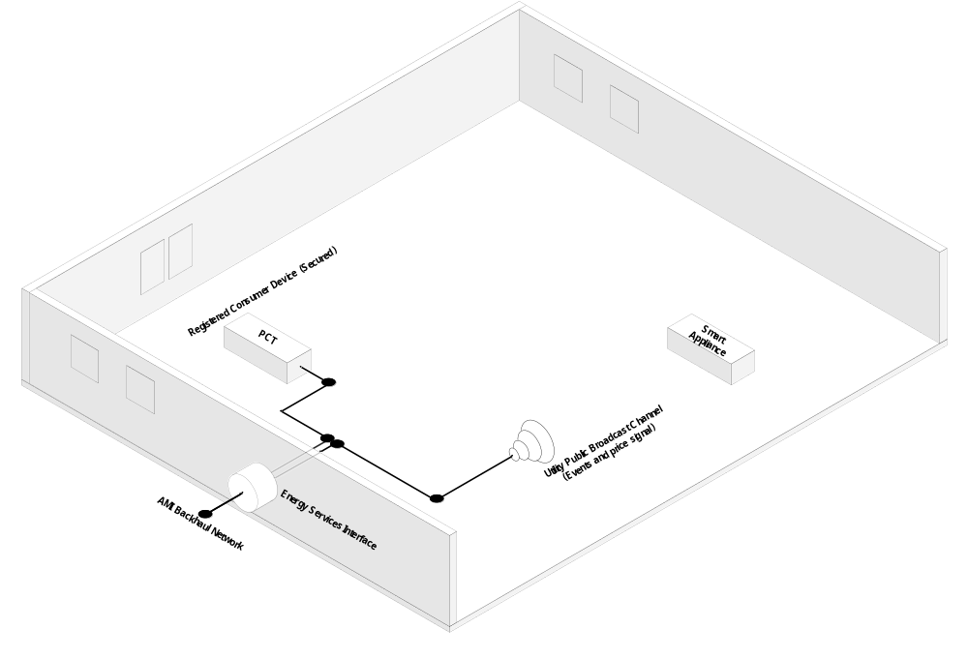
Figure 1: Scenario One (Inception) – Utility interacts with a registered (Voluntary) PCT. The Public Broadcast Channel interface is used to provide price signals and grid event messages to the Consumer’s unregistered Smart Appliance. The ESI is located in the meter under glass.
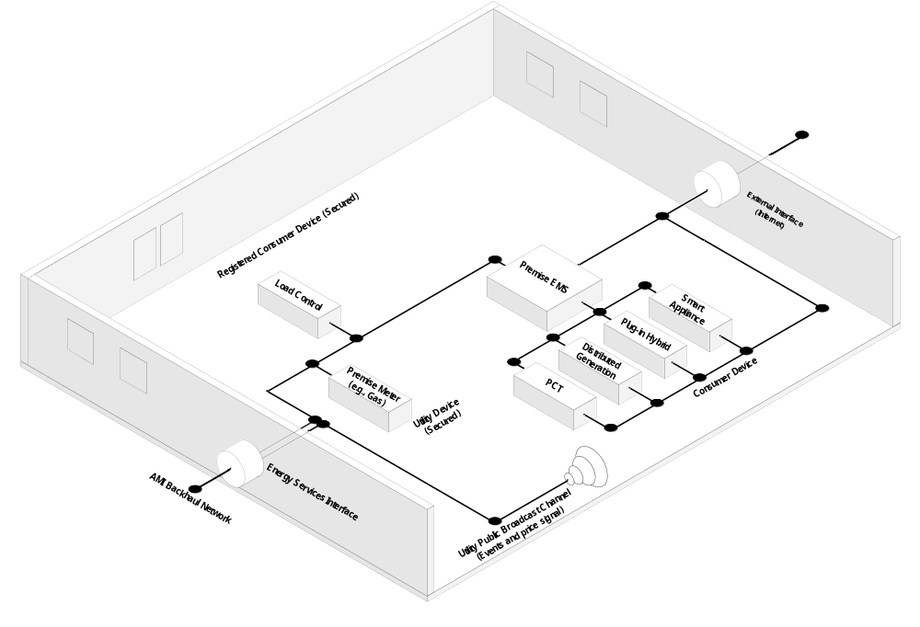
Figure 2: Scenario Two (Consumer Choice Example) – Consumer has placed the PCT and other devices on a third party network but chosen to register a load control device with the Utility. The Utility is also using the HAN for communications to a gas meter. The Utility Public Broadcast Channel is available but not used.
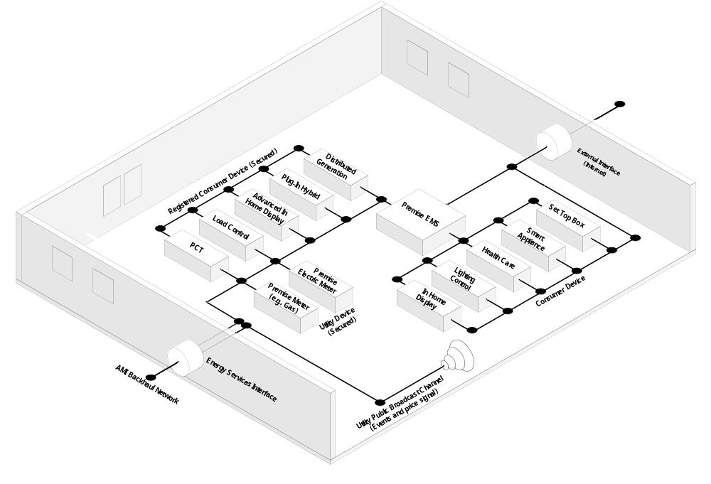
Figure 3: Scenario Three (Mature System) - Several Consumer and Utility devices, several of which are registered with the Utility. HAN Devices are accessible to the external interface/gateway (Internet). The Utility Public Broadcast Channel is available but not used.
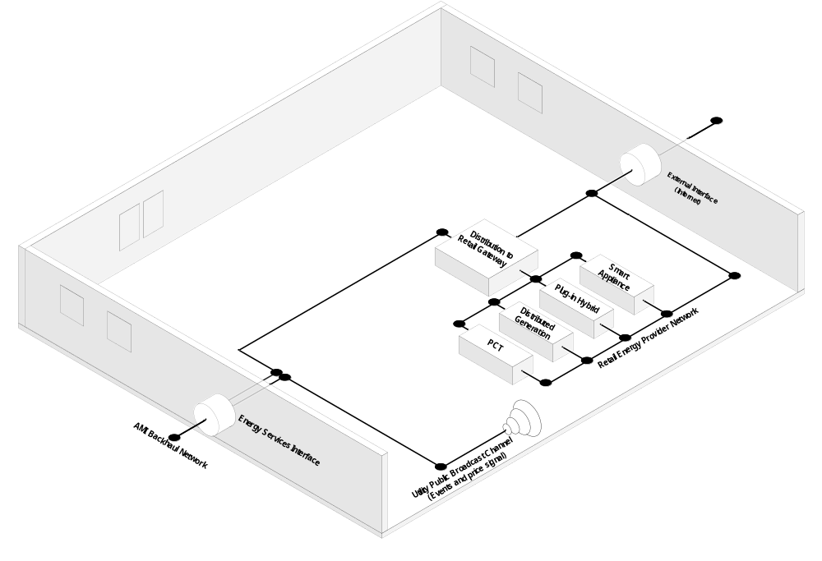
Figure 4: Scenario Four (Deregulated Example) - All devices sit on the third party network. The electric distribution company provides information through its Energy Services Interface. The distribution company’s accountability boundary ends at the Utility ESI. The Utility Public Broadcast Channel is available but not used.

OpenHAN System Requirements
The OpenHAN System Requirements are the main focus of this document and provide the most important information to the various HAN stakeholders. They define and constrain the system to enable successful functionality for Consumers, Utilities, Service Providers, and vendors.

Requirements Framework
In designing the system, the OpenHAN Task Force considered a number of criteria, such as:

- HAN Applications
- Communications
- Security
- Performance
- Operations-Maintenance-Logistics

HAN Applications are one of the most important categories from the Utility, Service Provider, vendor, and Consumer’s perspective. Any application that is enabled through the HAN will have one or more of the following characteristics: Control, Measurement and Monitor, Processing and Human-Machine Interface (HMI).

Control applications respond to control signals. The simplest control application is direct control, which turns loads on or off. Control applications can also cycle, which means they turn the load on and off at configurable time intervals. More sophisticated control applications can limit the load of a device (e.g. Smart Appliance, etc.) based on configurable thresholds. Control may also be exerted from within the HAN to fulfill Consumer objectives (e.g. manual, EMS, etc.).

Measurement and Monitor applications generally provide internal data and status. These applications include distributed generation functionality where local energy input and output is measured and monitored. It can also have end-use metering functionality to measure and monitor device-specific energy consumption or production. A Consumer PEV, for example, can have end-use metering functionality as well as distributed generation. Applications can be as simple as measuring and monitoring the environmental state or whether a device is on or off.

Processing applications consume, process and act on external and internal data. These applications accept data from external systems and HAN measurement and monitoring applications. Applications with processing capability are generally more complex and costly. The following applications require processing:
- Energy Cost - Calculates current and overall energy cost
- Energy Consumption - Calculates current and overall energy consumption
- Energy Production - Calculates current and overall energy production
- Energy Optimization - Utilizes external and HAN data to determine desired response based on a consumer-configurable profile
- Energy Demand Reduction - Uses external and HAN data to reduce load based on a consumer configurable profile (e.g. profiles based on various triggers such as occupancy (home/away/vacation), schedule (day/night/weekend), price (low/med/high), demand response requests(voluntary/mandatory)
- Environmental Impact - Calculates environmental impact of current energy consumption (e.g. based on the CO₂ emission profile of a Utility’s generation portfolio)

Human Machine Interface (HMI) – Most applications will need an HMI in order to provide local user input and/or output. These applications are based on the data type.
- User Input - Provides Consumers with a means to input data into an application (e.g., touch screen, keypad, mobile phone, computer, etc.)
- User Output - Provides an Application with a means to output data to the Consumer (e.g., message, browser, mobile phone, display, etc.)

Communications is one of the most challenging categories of the AMI systems. The OpenHAN Task Force has identified communications criteria for discovery, commissioning and control.

Discovery of a node is simply the identification of a new node within the HAN and it generally involves the following:
- Announcement – Both active and passive device notification methods
- Response - Includes both endpoints (e.g., announcing entity and recipient entity)
- Initial Identification - Device-type and address identification

Commissioning is the network process of adding or removing a node on the HAN with the expectation that the system is self-organizing (i.e., initial communication path configuration). This process is decoupled from Utility registration. Commissioning involves the following:
- Identification - Uniquely identifying the device
- Authentication - Validation of the device (e.g., the network key)
- Configuration - Establishing device parameters (e.g., network ID, initial path, bindings)

Control of a node is enabled by the platform specific technology and it involves:
- Self-Organization – network must be self-forming and self-organizing
- Optimization - Path selection
- Mitigation - Ability to adapt and work in response to interference or range constraints

Security goes hand-in-hand with Communications. Introduction of a communications technology for the home requires enhanced security in the ESI to protect the overall AMI system. The OpenHAN Task Force expects the UCAIug AMI Security Task Force to address the security requirements of the AMI system in greater detail. However, due to the importance of this category, the OpenHAN Task Force addresses specific security criteria that pertain to the ESI (e.g. Utility ESI, other ESI).

Since there

is a lack of physical security from tampering in the HAN environment, there is a limit as to the level of security one can expect. Specifically, provisioning, privacy (prevention of eavesdropping), end-to-end message integrity, end-to-end message authentication and confirmation of message receipt.

Provisioning (aka Commisioning) involves associating a HAN device with an ESI. During the provisioning process, the HAN device and the ESI exchange information that will allow them to communicate in the future with a low chance of an external entity being able to eavesdrop on the communication. Information intended for public consumption does not need provisioning.

Provisioning (commissioning) involves the following:
- Initialization – Establishes the application/device as a validated node (i.e., logical join to the ESI)

- Correlation – Correlates an account (e.g., Consumer) with a HAN Device, application, or program (e.g., demand response programs, peak time rebate, etc.)

- Revocation – Removes an established node, correlation, or authorization

Note that there is a distinction between provisioning and trust. Provisioning says that at the time of the provisioning, the device was known and in a known state. However, keys can be duplicated, MACs can be cloned, and the device provisioned today may not be the same device responding tomorrow.

Privacy involves using encryption or other mechanisms to help make sure only the sender and receiver of a message are able to understand the message. Information intended for public consumption does not need privacy.

End to End Message Integrity will allow an ESI to know that a message intended for a specific HAN device was not intercepted or modified in transit. Conversely, a HAN device can know that a message intended for a specific ESI was not intercepted or modified in transit. Note that there is a distinction between knowing a message was not tampered with and trusting that the sender of the message is telling the truth.

End to End Message Authentication will allow a device to know that a request was made from an ESI. Conversely, it allows an ESI to know that a message came from a particular device. Note that there is a distinction between knowing a message came from a particular sender and trusting that the sender of the message is telling the truth.

Confirmation of Message Receipt allows an ESI to know that a message intended for a specific HAN device was received. Note that there is a distinction between knowing a message was received and knowing that the message was acted upon.

Performance requirements ensure applications or other factors do not limit the performance of the system. Since the OpenHAN SRS is written at a platform-independent level, these criteria are higher level than the others found in this document. The requirements associated with these criteria are also less detailed than others for the same reason that, depending on Utilities’ technology selection, their performance requirements will differ. Performance of the system is usually dependent on the following:

Availability - The applications and devices are consistently reachable. In a wireless environment, there is no guarantee of availability.

Reliability - The applications and devices are designed and manufactured to be durable and resilient

Maintainability - The applications and devices are designed to be easily diagnosed and managed

Scalability - The system supports a reasonable amount of growth in applications and devices

Upgradeability - The applications and devices have a reasonable amount of remote upgradeability (e.g., patches, updates, enhancements). For low cost HAN devices, there is no guarantee of upgradability.

Quality - The applications and devices will perform as advertised

Latency - The applications will respond in an appropriate amount of time

Operations, Maintenance and Logistics criteria address the challenges around deploying HAN Devices in a new market segment. The OpenHAN Task Force’s goal is to make the design, maintenance, and operation of the system as easy and inexpensive as possible while not compromising security and performance. There are many activities involved in reaching this goal:

Manufacturing and Distribution - Vendor’s pre-installation activities
- Pre-commissioning - Depot level configuration setting
- Application configuration - Any required Service Provider specific configurations or applications

- It is assumed that a HAN device will be labeled as such so there is no need to include those elements here.

Installation - Physical placement of the device

- It is assumed that a HAN device will come with installation instructions and documentation so there is no need to include those elements here.
Manage, Maintain
- Logging – There may be a desire for the ESI to log communication between the Service Provider and the HAN.

- Device reset - Resets the device to the installation state, Rest the device to the factory default state
- Monitoring – device and application heartbeat

- It is assumed that the HAN device will be tested so there is no need to include those elements here.

Requirements Assumptions
This section documents the assumptions on which the requirements are based. It will be helpful to refer back to these throughout the rest of the specification.

- Service Providers are granted access rights to HAN Devices in a Consumer premises by the Consumer.
- Service Providers expect vendor differentiation and innovation in the marketplace.
- Devices do not prioritize commands (e.g., last command overrides previous).
- Assume orderly shutdown of operations during control signal execution (e.g., shutdown could be delayed until current process completes, shutdown is such that it does not compromise safety systems built into HAN Devices, etc.).
- Does not presume source of message (e.g., Service Provider, Consumer, EMS, etc.).
- Does not cover the consequences or incentives associated with demand response participation or compliance (e.g., overriding mandatory control signals).
- EMS may proxy as the controller (e.g. Utility, Service Provider, Consumer, etc.).
- EMS devices are viewed as aggregating functions within the system.
- EMS can aggregate data from multiple sources.
- Rate and consumption information can pass from the ESI (e.g. Utility ESI, or other ESI) to the Energy Cost application.
- Energy Cost applications are not intended to reconcile costs displayed on HAN Devices with bills generated by a Service Provider billing system. There are other elements associated with billing and revenue-grade metering that are outside the scope of these requirements (e.g., revenue-grade certification, Utility rate recovery).
- The Energy Cost applications may be components of an Energy Management System.
- Existence of alarm features may be part of separate energy optimization applications (e.g., signal an alarm when the accumulated cost for the month is greater than $100).

- The HAN provides end to end communication integrity with multiple HAN Devices and different device types to support scalability and growth.
- The HAN device shall come with default configurations to allow the Consumer to use the HAN device following installation and commissioning to the greatest degree possible.
- An interface (e.g. Utility Public Broadcast, Utility Provisioned Interactive Interface, third party provided interfaces) shall be available to the Service Provider to communicate pricing information to the HAN Devices in such a way that the HAN Device can group the information according to Consumer set price thresholds.

All requirements comprise a “shall…” statement that clearly outlines the requirement and minimizes the potential for confusion. The requirements listed in these sections are not prioritized by criticality or sophistication and include some fairly advanced functional capabilities that may be beyond the current state of the market. This is intentional.

<It is not clear what the advantage is of describing an “extended” set of devices Do extended need to include all of the extended attributes listed to be extended? Given there are no basic devices available, it seems the market should determine which optional elements are useful before defining an which optionals are mandatory for an “extended” devices. For this reason, all requirements below that were listed as “extended” have been turned into “optional”.>

<For any requirement below that was listed as optional for all devices, it was removed completely>

Readers should refer to Appendix 4.2 – Logical Device Mappings for HAN Devices – for guidance on which requirements are mandatory for logical devices to be considered OpenHAN compliant.

Application Requirements

Application requirements are the heart of Service Provider-to-HAN interactions and define what HAN Devices do. These applications include: Control, Measurement & Monitoring, Processes, and Human-to-machine interfaces and are broadly described here. Other functions and programs supported by applications include: demand response, messaging, bi-directional consumption sharing (metering data) and price delivery, off-the-shelf HAN device installation and configuration by Consumers, multi-dwelling unit (MDU) deployments, consumer energy conservation, control, etc.)

Control
Control applications respond to control commands from authorized parties (e.g. Utility, Service Providers, EMS, Consumers, etc.). Commands typically tell a device to turn ON or OFF at configurable time intervals or thresholds or enter into an energy saving mode.

Requirements:
App.Control.1 HAN Device shall accept control signals from one or more authorized parties (e.g. Utility, Service Provider, EMS, Consumer, etc.)
App.Control.2 HAN Device shall respond to requests to cease operational state (e.g., open contact).
App.Control.3 HAN Device shall respond to requests to resume operational state (e.g., close contact).
App.Control.4 HAN Device shall acknowledge receipt of control signal.

App.Control.8 HAN Device shall respond to request to cease operation state at a specific time.
App.Control.9 HAN Device shall respond to request to resume operation state based at a specific time.
App.Control.10 HAN Device shall delay restoration of operational state based on a pre-configured time (e.g., random number).

App.Control.12 HAN Device shall respond to request to limit operational mode based on thresholds, set-points, or triggers (e.g., price points, device safety configurations, relative price (high, medium, low) etc.).

App.Control.15 HAN Device shall appropriately respond to a cancellation of an advanced scheduled demand response event.
App.Control.16 The application shall support message prioritization (e.g. High Priority for HAN Device commissioning, customer opt-out of demand response; Low Priority for meter reads, etc.)
App.Control.17 The HAN device shall appropriately respond to a cancellation of a demand response event which is either in progress or has not yet started.

    - Measurement and Monitoring
Measurement and monitoring applications provide data and status from HAN devices. These are functional requirements on the device. They do not speak to the organization of the system (e.g., net versus sub).
If a HAN device is designed to measure something, then it should measure it. Thus, trying to list all the possible ways of measuring something is outside the scope of this document.

Requirements:

App.Measure.1 The HAN device shall present measurements to other HAN devices in a standard unit and format so that other HAN devices can consume the measurement. The standard units allowed are specified in appendix B below. The format of the data is defined based on the underlying protocol standards.

Processing
Processing are applications that consume, process, and act on external (e.g. data coming from outside the HAN, rate, billing, etc.) and internal data (e.g. data from within the HAN environment). These applications accept data from external systems and HAN measurement & monitoring applications.

Requirements:

App.Process.1 The HAN device shall present processing results to other HAN devices in a standard unit and format so that other HAN devices can consume the result of the processing. The standard units allowed are specified in appendix B below. The format of the data is defined based on the underlying protocol standards.

Human-Machine Interface
Human-Machine Interface are applications that provide local user input and/or output. These applications may be limited and may be depend upon the device type. They provide a method for users to interact with the HAN, enter preferences, configure the HAN and its devices, and obtain useful information from the HAN and its devices. It is up to the device manufacturer to decide whether physical elements (like an LCD) are needed or whether a different mechanism can serve a similar purpose (for example, a web page can take the place of an LCD for some consumers and device manufacturers).

Requirements:
App.HMI.1 HAN Device shall provide visual indicators which indicate operational state (e.g., commissioned, registered, event status, device state).
App.HMI.2 HAN Device shall provide a power cycle input, which reboots the device.
App.HMI.3 HAN Device shall provide a user reset input, which returns the device to its pre-installation state (e.g., button).

App.HMI.10 HAN Device shall provide alarm notifications (e.g., price threshold, event messages).

App.HMI.13 HAN Device shall display application-specific information (e.g., cost, consumption, environmental impact, payment credit, remaining account credit).
App.HMI.14 HAN Device shall accept application-specific configurations (e.g., preconfigured periods (e.g., hour, day, week), configurable periods (e.g., interval length, TOU period), variable periods (e.g., Critical Peak Price period).
App.HMI.15 For battery-powered devices, HAN Device shall provide a battery life indicator.

App.HMI.19 The HAN device shall a mechanism whereby the user can understand the demand response event that is occurring (ie display, web page, lights, etc).
App.HMI.20 The HAN device shall display information using units that are common for the user’s locale. It is the responsibility of the HAN to translate from the “wire format” into the local human readable representation.
App.HMI.21 The HAN device shall provide a user reset input which will cause the HAN device to be returned to the factory default state (e.g., button).

Communication Requirements
Communication requirements of OpenHAN are designed to provide reliable message transmissions between the authorized parties (e.g. Utility, Service Provider, EMS, etc.) and the consumer’s HAN Devices. These requirements cover Commissioning, Control, and Information Transfer. Commissioning requirements describe how a new HAN Device is added to the communication network. Control requirements detail how the communication network and HAN Device work together to maintain a reliable communication network. Information Transfer requirements detail two-way data communication (e.g. requests, responses, events, messages, etc.) between an authorized party and the Consumer’s HAN Devices.

Commissioning
Commissioning is defined as the network process of identifying and adding or removing a node on the HAN with the expectation that the system is self-organizing (i.e., initial communication path configuration). This process is decoupled from Utility registration.

Requirements:
Comm.Commission.1 HAN Device shall accept network configuration data which allows for Service Provider networking (e.g., private address/ID)
Comm.Commission.2 HAN Device shall accept commissioning configuration data by the manufacturer (e.g., link key).
Comm.Commission.3 HAN Device shall accept commissioning configuration from the Installer.
Comm.Commission.4 When Energy Services Interface is triggered (e.g., Allow Join Command), HAN Device location-/contact-specific data shall be provided to other HAN Devices in the premises.
Comm.Commission.5 When a HAN Device is triggered (e.g. Power-on, button), HAN Device shall provide the Energy Services Interface with device-specific information (e.g. device ID, device type, networking details, network ID, gateway ID, Service Provider ID, etc.) needed for commissioning.
Comm.Commission.6 Energy Services Interface shall have the ability to accept or reject a request based on device type and ID.
Comm.Commission.7 Energy Services Interface shall have the ability to accept or reject device requests based on Service Provider-specific information (e.g., network ID, gateway ID, or Service Provider ID).
Comm.Commission.8 ESI shall acknowledge successful commissioning requests (i.e., provide acknowledgement to the requesting HAN Device).
Comm.Commission.9 When a HAN Device is communicating with the Energy Services Interface, HAN Device shall indicate link connectivity.
Comm.Commission.10 HAN Device shall provide notification to the Installer of the commissioning status (e.g. successful, unsuccessful, in process, etc.).
Comm.Commission.11 Energy Services Interface shall maintain an updated list of commissioned (i.e., connected) HAN Devices.
Comm.Commission.12 Energy Services Interface shall have the ability to remove HAN Devices from the HAN.
Comm.Comission.13 HAN Devices shall be individually addressable without the need for an additional gateway (other than the ESI)
Comm.Commission.14 An authorized user shall be able to commission a HAN Device either locally or remotely (e.g. through a Web Portal or other 3rd Party commissioning service [i.e. retail store, depot, or other]).
Comm.Commission.15 HAN Device shall be commissioned to the ESI using relevant unique identifiers (e.g. service point location, customer account ID, meter number, HAN Device networking details, AMS meter security credentials, etc.).
Comm.Commission.16 ESI shall send an error message to the Service Provider when a request to commission a HAN Device has not been successfully completed within a configurable amount of time.
Comm.Commission.17 ESI shall transmit the status of the HAN Device commissioning (e.g. commissioned, pending commissioning, failed commissioning, etc.) to the Service Provider (e.g. the party who is requesting the commissioning).
Comm.Commission.18 ESI shall be uniquely identified (e.g. meter number, service point location, customer id, ESI ID, etc.)
Comm.Commission.19 HAN Device shall be uniquely identified (e.g. networking details, MAC Address, Installation codes etc.)
Comm.Commission.20 ESI shall store a list of all HAN Devices commissioned to it and make that list available to the Service Provider upon request.
Comm.Commission.21 An authorized user (e.g. Utility, Service Provider, Consumer, etc.) shall be able to remotely or locally de-commission a HAN Device commissioned to the ESI.

Control
Autonomous functions enabled by the platform-specific technology. These requirements speak to the efficient functioning of HAN communications and are intended to provide robust and reliable communication paths in the HAN.

Requirements:
Comm.Control.1 HAN Device shall accept network organization messages from the Energy Services Interface (e.g., gateway location, routing table, address).
Comm.Control.2 HAN Device shall accept network organization messages from peer devices (e.g., hidden node).
Comm.Control.3 HAN Device shall use the most reliable path to the Energy Services Interface (e.g., based on signal strength/quality).

Comm.Control.5 HAN Device shall have the ability to automatically adapt to communications interference through detection and analysis of environmental conditions (e.g., channel hopping, channel avoidance, signal-to-noise ratio).
Comm.Control.6 HAN Device shall include a data integrity mechanism for all communications (e.g., checksum).
Comm.Control.7 Energy Services Interface shall have the ability to activate and deactivate its HAN communication.
Comm.Control.8 HAN Device shall communicate its availability (i.e., ‘heartbeat’) to the Energy Services Interface at least once per day.

Comm.Control.10 HAN shall support broadcast messaging to all HAN devices.

Comm.Control.14 HAN Device shall be able to attach to one or more ESIs, temporarily, habitually, etc. (e.g. PEV mobility, EMS, gateway, etc.).
Comm.Control.15 HAN Device shall have the ability to communicate directly or indirectly with another HAN Device within the HAN (subject to security policies).
Comm.Control.16 HAN Device shall be able to initiate communication with the ESI.
Comm.Control.17 The ESI shall support time stamp logging of communication to/from HAN Devices.

Comm.Control.19 Authorized users (e.g. Utility, Consumer, Service Provider, etc.) shall be provided secure two-way access to commissioned HAN Devices.
Comm.Control.20 HAN shall support messaging to individual HAN Devices.
Comm.Control.21 HAN shall support messaging to groups of HAN Devices.
Comm.Control.22 ESI shall resend a message upon failure of a requested confirmation from HAN Device and the HAN Device shall appropriately handle receipt of retries.

Security Requirements
The OpenHAN security requirements are designed to help ensure that HAN communications are used for their intended purposes. These security requirements help to verify users’ identities, maintain user privacy, and assure responsible use. These security requirements are divided into four sections: Access Controls and Confidentiality, Integrity, Accountability, and Registration.

Access Controls and Confidentiality
The goal of access control is to prevent the unauthorized use of HAN resources. Access control includes resource control; for example, preventing logon to local HAN Devices. For the purposes of this discussion, access control is not concerned with denying physical access. Access control is applied to an entity based on an identity or an authorization. An identity may represent an actual user, a process with its own identity (e.g., a program making a remote access connection), or a number of users represented by single identity (e.g., role-based access control).

Confidentiality refers to the security services, which prevent unauthorized disclosure of data (both stored and communicated). Confidentiality services prevent disclosure of data in transit and data at rest. Confidentiality services also include “anonymity”, a service which prevents disclosure of information which leads to the identification of the source or end-user of the information. Because of its role in limiting authorized disclosure of information, confidentiality services are closely linked with access control services.

Requirements:
Security.Access.1 Energy Services Interface shall provide access control (i.e., logical segmentation) to Service Provider applications, data, and services (e.g., control data, consumer-specific consumption data).

Security.Access.5 HAN Device shall control access to data in accordance with a managed security policy when logically linking one or more networks (e.g., users, applications, devices, data access-read/write, EMS, etc.).
Security.Access.6 Energy Services Interface shall provide mechanisms to enforce a policy based on least privilege (i.e., explicit authorization).
Security.Access.7 Energy Services Interface shall have the ability to enforce policy periods (time constraints) for security policy elements (e.g., maintenance/firmware window).
Security.Access.8 HAN Device shall provide methods to query and report access control data settings.
Security.Access.9 HAN Device shall provide access control methods which prevent known attacks, including replay, man-in-the-middle, delay, spoofing, sequence change, and deletion attacks.

Security.Access.12 HAN Device shall support confidentiality and access controls that employ cryptographic operations (e.g., digital signatures).
Security.Access.13 HAN Device shall support confidentiality and access controls that employ cryptographic keys (e.g., encryption authentication, or digital certificates).
Security.Access.14 The application shall provide a means for authorized users to configure HAN Devices to communicate with one or more HANs (e.g., authorized users can select which portions of an application are available to devices not commissioned to the Utility ESI).
Security.Access.15 The HAN shall follow NIST SP 800-57, Recommendation for Key Management. (Note: This Recommendation provides guidance when using the cryptographic features of current systems. It is intended to help system administrators and system installers adequately secure applications based on product availability and organizational needs, and to support organizational decisions about future procurements. The guide also provides information for end users regarding application options left under their control in the normal use of the application).
Security.Access.16 Utility ESI shall comply with UtilityAMI System Security Requirements Specification v1.0.
Security.Access.17 Only HAN Devices that are commissioned with the ESI will be able to communicate directly with the ESI.
Security.Access.18 The ESI will be the clear information boundary between the secure provider network (e.g. AMI, internet, broadband, local area network, gateway to local devices, etc.) and the HAN Device(s) that are commissioned to it.

Integrity
The integrity security service addresses prevention of unauthorized modification of data (both stored and communicated). Modification of both stored and communicated data may include changes, insertions, deletions or duplications. Additional potential modifications that may result when data is exposed to communications channels include sequence changes. The integrity service also addresses the problem of ensuring that communicating components can correctly identify those that they are communicating with.

Requirements:
Security.Integrity.1 HAN Device shall protect the integrity of the HAN system (e.g., shall not adversely impact the operations of the HAN system by introducing malicious or unintended activity).
Security.Integrity.2 Energy Services Interface shall provide a configurable HAN filtering function that filters based on allowable message types.
Security.Integrity.3 Energy Services Interface shall provide a configurable HAN filtering function that filters messages based on structural integrity of the message.
Security.Integrity.4 Energy Services Interface shall provide a configurable HAN filtering function that filters based on allowable message rates.

Security.Integrity.6 HAN Device shall detect unauthorized modification of data during network transit (e.g., check sums and hashes).
Security.Integrity.7 HAN Device shall detect unauthorized modification of data attributes (e.g., modification to a message type).
Security.Integrity.8 HAN Device shall attempt to correct unauthorized modification of data and/or data attributes (e.g., NAK, resend, retry).
Security.Integrity.9 HAN Device shall accept data from authorized trusted sources (e.g., ESI, EMS, other HAN Devices, etc.).
Security.Integrity.10 HAN Device shall protect the HAN from malicious code (e.g., buffer overflow protection, limit executable code exposure).

Security.Integrity.12 HAN Device shall validate the source of HAN security policy.

Security.Integrity.15 HAN Device shall validate the integrity of all software updates, including source, structure, and version.

Security.Integrity.19 The ESI shall be configurable to detect and take appropriate action towards HAN devices that are impairing the performance of the ESI (e.g. repeatedly sending degraded (Error) messages or repetitive messages at a high rate).

Accountability
Accountability can be considered a special type of non-repudiation. The accountability security service holds each network entity responsible for its actions on that network.

Because there is no physical security for the HAN devices themselves, any accountability that is desired is handled in the ESI.

Requirements:

Security.Account.5 Energy Services Interface shall provide non-repudiation that a message was sent from the ESI to a HAN device.
Security.Account.10 Energy Services Interface shall provide non-repudiation that a reply was received from a HAN device back to the ESI.
Security.Account.6 Energy Services Interface shall provide a mechanism for source identification of data (e.g., HAN and AMI System data).
Security.Account.7 Energy Services Interface shall provide the capability to audit system policies.

Registration
The registration and authenticating requirements are used in conjunction with most other security services. The first step of most security services is to determine the identities of one or more of the parties participating in an action. A trusted identity must be used for access control decisions and to provide accountability evidence. Knowing the identity of an entity and the existence of a peer relationship is also fundamental to establishing communication with confidentiality and integrity. If the identity of the peer in a secure communications path is not properly established, it leaves open the possibility that an unauthorized principal (an adversary) could masquerade as an authorized principal, exposing the data to disclosure or manipulation.
NOTE: In the HAN setting, the ESI must assume that an unaurthorized principal is part of the HAN network and limit assumptions appropriately.

Requirements:
Security.Reg.1 HAN Device shall support mutual authentication.
Security.Reg.2 HAN Device shall authenticate the source of all control signals.
Security.Reg.3 HAN Device shall provide a mechanism which allows for multiple and configurable authentication materials (e.g., device ID, device type, key, serial key, Utility ID, and device configuration).
Security.Reg.4 HAN Device shall be configured with authentication materials (e.g., certificate, key).
Security.Reg.5 HAN Device shall not store or send authentication materials over the network in an insecure fashion (e.g., do not transmit passwords or keys in the clear).
Security.Reg.6 HAN Device shall be compatible with a Service Provider-defined registration process.
Security.Reg.7 HAN Device shall provide a means to update (i.e., change, reconstitute, rollover) authentication materials.
Security.Reg.8 Energy Services Interface shall allow registration revocation for connected HAN Devices.
Security.Reg.9 Energy Services Interface shall support a configurable registration and expiration period (e.g., registration timeout, registration persistence).
Security.Reg.10 HAN Device shall use security services (i.e., cryptographic services) which are either FIPS-approved or NIST-recommended.
Security.Reg.11 HAN Device shall support a registration method that employs cryptographic operations (e.g., digital signatures).
Security.Reg.12 Energy Services Interface shall provide an authentication mechanism which proxies for the Service Provider (e.g., negotiates on behalf of the Service Provider).
Security.Reg.13 HAN Device shall provide notification to the Installer of the registration status (e.g. registered, not registered, etc.).
Security.Reg.14 Shall enable remote network and security configuration/control including the ability to remotely configure the rules (i.e., policies) which govern the networking and application interactions.
Security.Reg.15 Provide unique identification materials for each HAN device (e.g., Vehicle Identification Number, Electronic Serial Number, MAC address, etc.)

Performance Requirements
The OpenHAN performance requirements are intended to maintain the quality of the Service Provider to HAN communications over the short and long term. Often performance of a system is characterized by reliability, availability and scalability.
Performance requirements are designed to insure HAN applications and devices are:
- consistently reachable,
- designed and manufactured to be durable and resilient,
- easy to diagnose and manage,
- expandable to support future growth,
- remotely upgradeable (e.g., patches, updates, enhancements) without a field visit, and
- performing as advertised (i.e., quality).

Requirements:
Perf.1 HAN Device shall supply functionality that maintains communications availability to the Energy Services Interface.
Perf.2 HAN Device shall supply functionality that maintains application availability to the ESI.
Perf.3 After loss of power, HAN Device shall return to its post-configuration state (i.e., shall persist communication and registration configurations).
Perf.4 HAN Device shall supply adequate computational performance (i.e., Device shall not hamper overall operational state of the HAN)
Perf.5 HAN Device shall supply adequate communications performance (e.g., bandwidth and throughput).
Perf.6 HAN Device shall supply accurate time keeping and counter functions.
Perf.7 HAN Device shall not act on expired signals (e.g., message validity duration or sequence).
Perf.8 HAN Device shall provide configurable communications such that system is scalable (e.g., heartbeat and request frequency).
Perf.9 For battery-powered HAN Devices, HAN Device shall function for a minimum of 1 year without requiring replacement of the battery.
Perf.10 HAN Device shall supply a field-programmable software upgrade function (i.e., firmware upgrade).
Perf.11 HAN Device shall supply a remote software upgrade function (i.e., firmware upgrade, application upgrade).
Perf.12 HAN Device shall meet the quality, interoperability, and testing (i.e., certification) requirements of its respective technology platform body.
Perf.13 HAN Device shall accept network time synchronization from the Energy Services Interface.
Perf.14 Energy Services Interface shall accept time synchronization from a Service Provider-approved source.
Perf.15 It is important to reuse and support existing utility investments in IT systems (e.g. back office, grid operations, billing, etc), therefore the technology shall interoperate with utility commercial infrastructures:
- To the extent possible will enable IP based applications (e.g., SNMP)
- Shall interoperate with utility services adhering to IEC 61970/61968 (CIM) or subsequent IEC standards
Perf.16 Shall support secondary and peripheral services which enable smart energy networking (e.g., management, bridging, registration, etc.).

Perf.18 The application shall use a structured, extensible information message schema.
Perf.19 HAN Devices shall support discrete (self contained) data.
Perf.20 HAN Devices shall support unordered data exchange.
Perf.21 HAN Devices shall support self-describing data across versions (e.g. device types, device attributes, device functions, etc.). Note: requirements 19-21 are necessary in order to ensure forward compatibility.

Perf.24 The application shall support a valid date/time/duration for each piece of information or message and shall not respond to expired messages. Configuration data for date/time/duration shall be in a standard and self-describing format. Also used for displaying new information based on scheduled changes to information. For messages with time boundaries they must have an expiration to provide graceful failures.
Perf.25 The application shall support variable length text messages (e.g., freeform messages conveying information, configuration, status, control).
Perf.26 The HAN shall provide adequate communications performance (e.g., bandwidth, throughput, range, latency, reliability, etc.) from the ESI to the HAN Device for multiple deployment scenarios (e.g. large single or two story house, medium apartment, small apartment, multi-dwelling unit, strip mall store, etc.).
Perf.27 The application shall support multiple deployment scenarios (e.g. large single story house, medium two story house, medium apartment, small apartment, multi-dwelling unit, strip mall store, etc.). See Appendix 4.3 Deployment Scenario Examples for guidance.
Perf.28 The application shall provide adequate feedback in a reasonable amount of time (e.g., 0.1 second, 1.0 second, 10 second requirements found at: http://www.useit.com/papers/responsetime.html>)

Perf.30 HAN Devices (including ESI) shall be able to support delivery of messages in near real-time within the HAN (e.g., High Priority messages to/from a HAN Device).
Perf.31 ESI shall accept mean and operational tolerances for time resolution and time synchronization of messages and data from the authorized provider's time source.
Perf.32 ESI shall report the failure to deliver HAN messages to the requesting party.

Perf.34 HAN Devices (including ESI) shall provide sufficient standard error messages for a range of device and communication failures (e.g., unrecognized message, out of range/low signal strength, low battery level, feature not supported, meter faults, HAN device faults, communication errors, etc) that facilitate effective troubleshooting by the authorized user (e.g. Utility, Installer, third party, or automated systems)

Operations, Maintenance, and Logistics Requirements
OpenHAN requirements for operations, maintenance, and logistics speak to supply chain standards for HAN Devices, including manufacturing, configuring, labeling, and packaging as well as standards for installation assistance, user manuals, online support, and device self-testing and troubleshooting.

Manufacturing and Distribution
These requirements speak to a vendor’s pre-installation activities, including manufacture, depot, distribution, and point-of-sale. The goal of these requirements is to clearly establish responsibilities and enable the widest diversity of supply chain options for Utilities and their customers.

Requirements:
OML.ManuDist.1 Prior to installation (e.g., factory, depot), HAN Device shall support placement of commissioning data (e.g., pre-placed device credentials).
OML.ManuDist.2 Prior to installation (e.g., factory, depot), HAN Device shall support placement of registration data (e.g., pre-placed registration credentials).
OML.ManuDist.3 HAN device shall support pre-placed methods or materials that support commissioning and registration by multiple Service Providers (does not imply simultaneous registration).
OML.ManuDist.4 HAN Device shall support pre-placement of application-specific configurations (e.g., cost, consumption, environmental impact, configurable time/rate intervals, etc.).

OML.ManuDist.6 HAN Device shall have and display appropriate commissioning information on its packaging and body (e.g., serial number, installation code, MAC IDs for network interfaces, etc.).

Manage, Maintain
These requirements speak to vendor responsibilities for customer support. They ensure HAN Devices enable diagnostic, management, and troubleshooting capabilities. The goal of these requirements is to grant Service Providers the ability to remotely resolve problems with HAN Devices to quickly determine whether a Consumer needs to contact the Manufacturer’s customer support for further assistance.

Requirements:
OML.Maintain.1 HAN Device shall have a self-check (initialization) function that notifies the Installer the HAN Device is functioning properly.
OML.Maintain.2 Energy Services Interface shall have a configurable ability to log all ESI-to-HAN System communications.
OML.Maintain.3 When the HAN Device is rebooted, HAN device shall reset to its configured (i.e., post-installation commissioning and registration) state and shall reestablish communication with the Energy Services Interface.

OML.Maintain.8 For battery-powered devices, HAN Device shall communicate low battery state to the Consumer and Service Provider.

OML.Maintain.10 HAN Device shall support a communications feedback mechanism (i.e., ping).
OML.Maintain.11 HAN Device shall provide methods to service communication components, which are transparent to the consumer (e.g., Meter or other ESI replacement, device communication card replacement) – that is, don't require manual re-commissioning of HAN Devices with the ESI.
OML.Maintain.12 Provide methods to manage and update authentication materials (e.g. digital certificates) in HAN Devices, which require no Consumer intervention.
OML.Maintain.13 Application shall support diagnostic messages when errors (e.g. HAN device faults, communications errors, etc.) are detected (Note: Need an additional requirement on what diagnostic messages may be received from the meter (i.e. C12.19 data))
OML.Maintain.14 ESI shall have the information needed to troubleshoot where a communication fault occurred.

Appendices
- reference use cases from ZigBee SEP2.0 Marketing Requirements Document (MRD)
- reference use cases from NAESB Smart Grid Task Force for Retail DR

UCAIug OpenHAN Task Force Use Cases

Introduction
The UCAIug OpenHAN Task Force developed these Use Cases as a way to bound the development of the system decomposition and requirements. They are written at a very high level and are by no means comprehensive. They are highly dependent on other utility back office systems and processes that are assumed to exist and be in place. Each utility looking to implement a HAN will want to expand upon these Use Cases.

Scope
The scope of the Use Cases is to define and limit the use case scenarios between the Utility AMI Network and the HAN.

Methodology
These Use Cases focus on functional capabilities rather than device-specific capabilities. Use case actors and scenarios may refer to a device, but the working group generally strove to describe the use case by its function.

Use Case Categories
Use cases are broken into four general use case categories:
- Load (kW) and Energy (kWh) Management
  - Voluntary Load Reduction
  - Mandatory Load Reduction
  - Energy Management System
- User Information
  - Complex Interactive
  - Simple One-way
- In-premises Metering
  - Energy Storage and Generation
  - Fixed HAN Device with Metering Capability
  - Mobile HAN Device with Metering Capability
- System Configuration and Management
- HAN Installation & Commissioning
- HAN Utility Registration (e.g. application/devices)
- HAN Device Remote Diagnostics and Troubleshooting
- HAN Device Diagnostics and Maintenance
- HAN Device Depot Configuration (optional)

Use Case Template
The template for Use Cases is as follows:
- Use Case Title
- Use Case Description
- Use Case Business Rules and Assumptions
- Use Case Scenarios (sequenced)

Definitions / Assumptions / Actors
Actor Name | Actor Type
Consumer | Person
HAN Devices | Devices
AMI | System
Metering System | System
Energy Services Interface (ESI) | Device
Customer Service System (CSS) | System
AMI and/or HAN Trust Center | System
Automated Data Collection System | System
Utility HAN | Devices
Consumer HAN | Devices
Pool Pump Controller | Devices
Customer Representative | Person or System
HAN Device Registration Application | Application
In-Home Display (IHD) | Device
Energy Management System (EMS) | Application

Use Case Assumptions
This section documents the assumptions on which the Use Cases are based. It will be helpful to refer back to these throughout the rest of the specification.

- An ESI exists for service provider to HAN communication.
- All communications between the Service Provider and the HAN devices pass through the ESI.
- A process exists to connect/bind the Consumer’s HAN Devices to the ESI.
- HAN communications are limited to the Consumer’s HAN Devices connected and provisioned on the ESI

- provisioned network.
- The ESI provisioning includes a method to prevent eavesdropping by non-provisioned devices.
- If net metering, the premises’ electric panel upgrade has occurred and the electrical circuits and wiring can handle the discharging process.

- Consumers can override all curtailment requests (e.g., pricing events).
- Non-Interoperable HAN Devices will not participate in Utility-sponsored rates and programs.

- The HAN SRS requirements apply to all Consumers, specifically to those under 200kW in demand.

- Load control device(s) at the Consumer site will take action based on price or specific event (dependent on presence of the control devices and compliance with Utility requirements).
- The Consumer shall have the ability to pre-program the load control device at their site to respond to event messages and/or pricing.

- Consumers may, but do not have to, negotiate another communication method (e.g., Internet) for price, consumption, load, event messages between their HAN devices and the Utility.
- Consumers will have the choice of which HAN Devices participate in any offered demand response program (subject to technical conformance with the offered demand response program from the Utility). For example, the Consumer may have door open/close sensors attached to the same HAN as their lights and thermostat but may choose to only enroll the lights and thermostat in the demand response program.
- If a HAN Device requires registration with the ESI, the device is expected to contain volatile and non-volatile memory. A portion of the non-volatile memory will retain registration information in case there is a loss of power. Once power and communication is restored to the device, it will automatically re-register itself based upon the last known “good” registration.
- The
- Service Provider supports meter device-specific, Consumer-specific and location-specific rates/billing. (e.g., PEV).
- Display options are supported as required for the specific application including, but not limited to, display of Utility-provided data.
- FHDMC have a certification process for meter accuracy as required by the Utility or jurisdiction.
- FHDMC may supply capabilities beyond basic metering (e.g., measurement, monitoring, and device state information).
- Service Providers may provide data to the FHDMC.
- MHDMC has a certification process for meter accuracy as required by the Utility or jurisdiction.
- The MHDMC and premises are properly authorized to operate within the jurisdiction and Utility.
- Service Providers may provide data to the MHDMC.
- MHDMC records bi-directional MHDMC usage for audit purposes.

- Individual Service providers may only require a subset or additional requirements from those provided in this document.
- This is not a static document and the list of requirements may be updated from time to time.
- Specific examples given in the document are exactly that. Innovation in the market place is always encouraged.

Load and Energy Management

Voluntary Use Case for Registered HAN Devices

Description
A major benefit of the ESI is that it supports Consumer awareness of his instantaneous kWh electricity pricing, consumption, projected costs, rate tiers, and voluntary load reduction program events, and it can support the Utilities in the achievement of load reduction needs. As Utilities see increased electricity demand on the grid, energy shortages may result, therefore triggering the need for Utilities to reduce energy consumption in support of grid stability. The ESI will help facilitate load reduction at the consumer’s site by communicating instantaneous kWh pricing and voluntary load reduction program events to the Consumer and to various enabling devices connected to the ESI, each of which contains the requisite service provider’s functionality at the Consumer’s site. Voluntary load reduction events may be scheduled with a large amount of advanced notice (24 hrs) or near real-time. For the Utility to receive the desired Consumer response, it must provide timely pricing, event, and usage information.

Related to this scenario is the measurement of the response to financial incentives, energy price adjustments, and other voluntary demand response programs. The measurement of consumer response will be based on the actual load reduced as measured by the utility meter.

This scenario includes the actual mechanism to distribute price signals and voluntary load reduction events to Consumers (direct electronic delivery to the Consumer meter or display device within the home/business, automated telephone calls, e-mail, pager, commercial broadcast radio, newspapers, etc.). It includes the mechanism by which the HAN will display current pricing and voluntary load reduction event information within the consumer’s home/business. The service provider will initiate automatic load reduction at the Consumer’s premises by communicating event and pricing information to Consumer HAN Devices, which will take action based on the Consumer’s predefined settings. The Consumer will be able to program their load control specifications and refuse Utility load reduction requests. The Consumer will also be able to manually curtail load based upon informational messages communicated to them through the ESI.
This scenario also includes the actual Home Area Network functionality for Consumer HAN Devices and describes the scenario for separate HAN Devices classes and AMI-related behavior of the HAN Devices.
Troubleshooting for installation, registration, and event failure should refer to the HAN Use Case – Maintenance

Use Case Business Rules and Assumptions
- If the HAN Device offers a display, it is capable of displaying actual price of power for a unit of time and/or providing an indication of relative price (e.g., low, medium, high, critical).
- The HAN Device is capable of differentiating between emergency/reliability and/or price-response event signals.
- If the HAN Device offers a display, it is able to display messages comprised of alphanumeric characters, as delivered or triggered remotely from the ESI System.
- Certain HAN Devices can distinguish or support various event types and take appropriate action based on the event.
- HAN Devices do not need to register with the ESI system to obtain Utility messaging (e.g., price or event signals). However, the Consumer must enroll in a demand response program or tariff and must register the HAN Device with the Utility for the HAN Device to confirm its successful reception message and response related to the event.
Use Case Scenario
Utility initiates a voluntary demand response event (e.g., Critical Peak Pricing Event).

Triggering Event | Primary Actor | Pre-Condition | Post-Condition
The Utility determines the need for a demand response event. | HAN Device | The Installation Use Cases are successfully completed.  The Registration Use Cases are successfully completed.  The ESI has either been pre-programmed to respond appropriately to price, consumption, load or event messages and/or the Consumer has manually programmed or used the ESI to program the HAN Device. | The Consumer will have been notified of an event, the event will have been autonomously launched by the Service Provider, the HAN Devices will have actuated and the event will have ended and the Consumer equipment returned to its original state.

Steps for this scenario
These steps apply for both event actuation and restoration to initial HAN Device state.

Step # | Actor | Description of the Step
1 | Service Provider | Service Provider sends a message to the Consumer’s display device and/or control equipment, via ESI for Consumer viewing, that an event start time has arrived.
2 | ESI/HAN Devices | The Consumer’s HAN Device receives the message, update the event status (e.g. to active) and the HAN Device will take Consumer preprogrammed action (e.g. raise thermostat by 4 degrees, lower thermostat to original state) reacting to pricing and/or event type.
3 | Consumer | The Consumer's HAN Device shall send a reply that it received the event message to Service Provider (dependent on type of Consumer equipment), via the ESI.
4 | Consumer | Consumer may choose not to participate in economic or pricing event. Consumer overrides the automatic HAN Device actuation sequence.
5 | Utility | Curtailment period ends and ESI sends the command to restore HAN Devices to previous state.
6 | HAN Devices | HAN Devices may restore load on a random restoration schedule so as to create minimal impact to the distribution system.
7 | HAN Devices | HAN Devices shall send a reply back to the ESI confirming the receipt of event end notification.

High Priority Use Case

Description
The high priority load and energy management use case refers to demand response resources dispatched for reliability purposes. These events are hight priority due to the potential of the demand for power exceeding supply as a result of unexpected power plants going offline or congestion in transmission and/or distribution lines. The Consumer may be (1) enrolled in, or (2) as condition of service, be defaulted on a high priority demand response program used for grid management. For voluntary enrollment in a Utility’s program, the Consumer is generally compensated with a credit on her monthly bill.

Control of a Consumer’s HVAC can be accomplished via a ESI OpenHAN-compliant PCT as the HAN Device. Other HAN Devices may include an EMS, a pool pump switch, A/C switch, or even a passive device (one that does not actually shed load) such as an IHD that warns of potential power shortages in the near future or a load shed event in progress. The PCT may act as both a load shedding and passive/informational device. The ESI will forward curtailment messages to the HAN Device(s) capable of receiving this. Upon receipt the HAN Device(s) may return an acknowledgement back to the ESI, including logging and device status.

High priority load and energy management events will allow Consumers the option to override the load shed request, but only through HAN device “reset to factory defaults” which will – in essence for the device to unenroll from the utiliy ESI provisioned HAN. The Utility relies on firm load shed to avert rotating outages. Giving Consumers the option to override a high priority load shed request increases the possibility a complete power outage, however, since the utility does not know the reason why a consumer desires to opt-out it is better to understand the reason for the opt-out after the high priority event is over rather than trying to have a consumer contact the utility during a high priority event when the utility may be occupied on other matters.
Since the only way for a consumer to “opt-out” of a high priority event is to have the device removed from the utility ESI provisioned HAN, then the consumer must contact the utility to get the device re provisioned (and thus, re-enrolled in any compensation program). The utility can then choose to re-provision the HAN device or determine that provisioning that HAN device (for compensation purposes) is not viable and make that decision in a non-emergency setting.

The Utility will be informed by at least two levels of advanced warning:
- Long term (24 hours) and short term (few hours notice) predicted energy shortages
- Emergency shortage (few minutes notice)
The following is a list of use case scenarios:
- Predicted mandatory load curtailment for grid management – Warnings are issued for possible electrical system overload or potential lack of generation resources.
- Consumer requires an immediate opt-off due to a medical emergency.

Use Case Business Rules and Assumptions
- Medical Opt-out devices are pre-registered or may register upon Consumer contacting the Utility to exclude their HAN device from mandatory events.

Use Case Scenarios
Scenario 1
Utility initiates a mandatory demand response event due to a possible electrical system overload or potential generation/demand imbalance. Warnings issued to Consumers are optional.

Triggering Event | Primary Actor | Pre-Condition | Post-Condition
The Utility determines the need for a demand response event. | HAN Device | The Installation Use Cases are successfully completed.  The Registration Use Cases are successfully completed.  The HAN Device has been programmed by the Utility to shed load on command. | The Consumer may have been notified of an event, the event will have been autonomously launched by the AMI System, the HAN Devices will have actuated and the event will have ended and the Consumer equipment returned to its original state.

Steps for this scenario
These steps apply for both event actuation and restoration to initial HAN Device state.
Step # | Actor | Description of the Step
1a | Utility | Utility anticipates the need to dispatch a high priority curtailment program.
1b | Utility | Utility anticipates the need to dispatch a high priority curtailment program and sends a warning message to the Consumer.
2 | HAN Devices | HAN Devices receive the warning message that a high priority event occurred and displays the appropriate message (e.g., lights the appropriate LED) (** optional step **)
3 | Utility | Utility sends a high priority load shed message.
4 | HAN Devices | HAN Devices receive the high priority load shed notification of the scheduled curtailment.
5 | HAN Devices | HAN Devices respond back to the ESI, confirming the receipt of the high priority load shed notification.
6 | HAN Devices | Han Devices enter appropriate “off” and/or “energy minimum” state(s).
7 | Utility | Curtailment period ends and ESI sends the command to restore HAN Devices to previous state.
8 | HAN Devices | HAN Devices respond back to the ESI, confirming the receipt of event end notification.
9 | HAN Devices | HAN Devices restore load on a random restoration schedule so as to create minimal impact to the distribution system.

Scenario 2
Utility initiates a mandatory demand response event due to a possible electrical system overload or potential lack of generation resources. Consumer opts-out of the program due to a medical emergency.

Triggering Event | Primary Actor | Pre-Condition | Post-Condition
The Utility determines the need for a demand response event. | HAN Device | The Installation Use Cases are successfully completed.  The Registration Use Cases are successfully completed.  The HAN Device has been programmed by the Utility to shed load on command. | The Consumer is opted-off the program and device is no longer part of the utility ESI provisioned HAN
Steps for this scenario
These steps apply for both event actuation and opting the Consumer off the program.

Step # | Actor | Description of the Step
1 | HAN Devices | HAN Devices receive the notification from the Utility Services Interface to start the curtailment.
2 | HAN Devices | HAN Devices enter appropriate “off” and/or “energy minimum” state(s).
3 | HAN Devices | HAN Devices enter appropriate “off” and/or “energy minimum” state(s).
4 | Consumer | Consumer presses “manufacture reset” button
6 | HAN Devices | HAN Devices immediately restore load.
7 | HAN Devices | HAN Device clears keys/tokens/authentications
8 | HAN Devices | HAN Device is effectively removed from the utility ESI provisioned netowrk
9 | Consumer | If the consumer desires the HAN device to be reprovisioned on the utility ESI network, they must contact the utility.

Energy Management System
Description
Energy Management System (EMS) integrates with the respective HAN, the Service Provider and the ESI, and responds to commands to drop load for grid reliability, price responsive programs.

Use Case Business Rules and Assumptions
- The EMS is aware of or can retrieve the types of HAN Devices and the status of those devices connected to the HAN upon registration or change-out. (e.g., fridge on/off).
- EMS controls production, consumption, and storage within the HAN (e.g., Controls charging/discharging of an Electric Vehicle).
- The EMS can be pre-programmed to respond to Utility signals and commands (e.g., reliability event).
- Use case does not imply the Utility’s preferred configuration or communication for reliability programs (e.g., Utility may still require HAN device registration).

Use Case Scenario
Utility calls a demand response event and controls load by communicating with the EMS through the ESI.

Triggering Event | Primary Actor | Pre-Condition | Post-Condition
The Utility determines the need for a demand response event. | EMS | The Installation Use Cases are successfully completed.  The Registration Use Cases are successfully completed. | EMS curtails load until event is concluded.

Steps for this scenario

Step # | Actor | Description of the Step
1 | Utility | Utility sends notification of event and for price response case, the appropriate pricing information to the EMS.
2 | EMS | The EMS sends a signal to all connected HAN devices and attempts to control consumption or production.
3 | EMS | The EMS responds back with an acknowledgment of the message to the ESI.
4 | AMI System | The Service Provider sends a restore signal to the ESI upon conclusion of the event.
5 | EMS | The EMS is restored to the pre-event state.
6 | EMS | The EMS responds back with an acknowledgment of the message to the ESI.

User Information
Consumer receives Utility initiated messages and electric usage updates via an In Home Display (IHD)

Description
An IHD integrates with the respective HAN and the Utility AMI System and provides usage information and Utility-initiated messages to the Consumer.

Use Case Scenarios
A simple IHD provides basic display of Utility-generated price and Consumer-specific usage information

Triggering Event | Primary Actor | Pre-Condition | Post-Condition
Consumer obtains IHD. | Consumer | The Installation Use Cases are successfully completed.  The Registration Use Cases are successfully completed  Installer installs IHD in the premises  The IHD has either been pre-programmed to respond appropriately to price, consumption, load or event messages and/or the Consumer has manually programmed the IHD. | none

Steps for this scenario
Step # | Actor | Description of the Step
1 | IHD | The IHD indicates the status of the communication link with the ESI.
2 | IHD | Displays Utility-generated messages. (e.g. emergency event)
3 | IHD | The registered IHD requests Consumer-specific data (e.g., demand, electric energy usage) from the ESI.
4 | ESI | ESI provides usage data as requested. (e.g., demand (watts) every 6 seconds)

Energy Storage and Generation
Consumer uses a storage or generation unit to provide energy to their home or the grid.

Description
The Energy Supplying Unit (ESU) connects with the premises HAN, the ESI, and the electric system (home, vendor, or Utility’s). The ESU identifies itself and the account it is associated with, and provides energy to the home or grid. This use case also describes the scenarios documented in The Sub Metering Use Case and The Load and Energy Management Use Cases, in that the ESU behaves according to these use cases.

Use Case Business Rules and Assumptions
- Energy Supplying Unit (ESU) already contains energy.
- All Utility safety measures and rules are in place to provide power to the grid.

Use Case Scenario
The following scenario addresses storage and generation for the purpose of providing energy to the home or grid.

Triggering Event | Primary Actor | Pre-Condition | Post-Condition
Incentives or Utility requirements are in place for providing energy to the home or grid. | ESU | The Installation Use Cases are successfully completed.  The Registration Use Cases are successfully completed.  Units are transfer ready and properly connected. | Energy is successfully transferred.

Steps for this scenario
Step # | Actor | Description of the Step
1 | EMS, ESI, other entity, ESU (Consumer acts on EMS or ESU) | Signals ESU to transfer energy.
2 | ESU | Performs a self-check for sufficient capacity and generation readiness.
3 | ESU | Transfers energy.
4 | EMS, ESI, other entity, ESU (Consumer acts on EMS or ESU) | Signals to end transfer event. (e.g., due to drop in price, inadequate energy availability, Consumer preference, or Utility preference)
5 | ESU | Ceases transfer of energy.

Fixed HAN Devices with Metering Capability

Description
The FHDMC connects with the premises HAN and identifies itself and the account it is properly associated with to the Utility, where premises owner’s charges are reconciled. This use case also describes the scenario documented in The Load and Energy Management Use Cases, in that the FHDMC may behave according to that use case. The following scenario is defined: bi-directional metering (i.e., distributed generation) and third-party (i.e., gas meter).

Use Case Scenario
The following scenario addresses FHDMC, where bi-directional electric and third-party metering takes place.

Triggering Event | Primary Actor | Pre-Condition | Post-Condition
FHDMC is connected and enabled | FHDMC | The Installation Use Cases are successfully completed.  The Registration Use Cases are successfully completed. | Device owner meters the device and gets billed for the appropriate amount on their electricity bill or other third-party bill.

Steps for this scenario
Step # | Actor | Description of the Step
1 | FHDMC | Device indicates positive status of the communication link with the appropriate ESI.
2 | FHDMC | Device provides the Consumer (end user) with the appropriate information. (e.g. current rate of consumption, etc)
3 | FHDMC | Device accumulates usage (delivered or received) and returns the information to the ESI.
4 | FHDMC | (optional) The device provides the ESI with additional state information if applicable (e.g. state of charge of a storage device).

Mobile HAN Device with Metering Capability

<According to the SAE at the last openHAN face to face, wasn’t there a conclusion that the first generation electric vehicles were basically dryer’s on wheels? If so, then these use cases should be removed and defined when there is a better understanding of what is actually happening with PEV’s,>
Description
The MHDMC connects with the premises Home Area Network (HAN), identifies itself and the account it is properly associated with the Utility. MHDMC’s and premises owner’s charges are reconciled, as applicable. This use case also describes the scenario documented in The Load and Energy Management Use Cases, in that the MHDMC may behave according to that use case. The mobile (e.g. any Consumer PEV) scenario is defined in this document.

Use Case Scenario
The following scenario addresses MHDMC, where bi-directional electric metering takes place.

Triggering Event | Primary Actor | Pre-Condition | Post-Condition
MHDMC is connected and enabled temporarily | MHDMC | The Installation Use Cases are successfully completed.  The Registration Use Cases are successfully completed. | MHDMC owner and premises owner bills are properly reconciled.

Steps for this scenario
Step # | Actor | Description of the Step
1 | MHDMC | Device indicates positive status of the communication link with the appropriate ESI.
2 | MHDMC | (optional) Device provides the Consumer (end user) with the appropriate information. (e.g., percentage of charge, current rate of consumption, etc)
3 | MHDMC | Device indicates to the user whether the MHDMC is recognized by the Utility (i.e., for billing purposes)
4 | MHDMC | Device accumulates usage (delivered or received) and returns the information to the ESI.
5 | MHDMC | (optional) The device provides the ESI with additional state information if applicable (e.g., state of charge of a storage device).

System Configuration and Management

HAN Installation and Commissioning

Description
The installation and commissioning use cases covers the activities associated with physical installation and the admission to the local HAN. Admission to the local network establishes the communication path to the ESI. This interface can then be used to register devices with the Utility. This implies that the registration and commissioning processes are actually discrete operations.

Devices that are commissioned have the ability to receive public information from the ESI but do not have the ability to communicate with the Utility. Utility communication requires registration.

This use case covers all HAN Devices including, but not limited to, PEV, PCT, pool pump switch, EMS, etc. Premises commissioning ignores mobility related functions (e.g., PEV moving from premises to premises). That is, Mobility is an aspect of registration.

The Installer may perform other diagnostics that the meter and HAN Devices cannot perform by itself. These steps are specific to the underlying technology and not covered in the high level use of the system.

It is important to note this Use Case covers all the staging scenarios, including Utility HAN Devices (e.g., PCT), Utility delivers additional HAN Devices and attaches to the existing Consumer HAN Devices at time of meter installation, and Consumer connects HAN Devices to the ESI after Utility installation of an AMI System.

Use Case Business Rules and Assumptions
- For control devices, device is installed in-line at the appropriate control point (e.g., in series with the information or energy flow).
- All appropriate safety precautions are taken (e.g., qualified electrician is required for certain installation routines).
- Devices and applications are procured or provided through multiple distribution channels (e.g., retail, Utility-provided, etc.).
- Devices meet all applicable electrical, safety, and communications laws.
- Pre-commissioning routines have been successfully executed (e.g., pre-placed network key has been loaded).

Use Case Scenario

Triggering Event | Primary Actor | Pre-Condition | Post-Condition
Consumer takes possession of HAN Device. | Consumer or Installer | ESI with two-way communications capability is present. | The Consumer device has been added to the local network and has established communications with the ESI (i.e., the HAN has been established).

Step | Actor | Description of the Step | Additional Notes
1 | Installer | Installer locates appropriate installation point. | Appropriate installation point considerations includes: signal strength at location, appropriate control point, etc.)
2 | Installer | Device is installed. | Installation includes removing previous equipment and connecting the device to external power (if necessary)
3 | HAN Device | HAN Device performs self-check and reports results to installer. | In certain installation instances, a field tool can assist in the device initialization and configuration.
4 | Installer | Installer inputs any required pre-commissioning materials (e.g., physical location, LAT/LONG, etc),
5 | Installer | Installer enters commissioning data (e.g., network key) or performs any necessary commissioning actions (e.g., proximity)
6 | HAN Device | HAN Device notifies the ESI or other network coordinator of its presence on the network. | This process is part of the technology-specific beaconing and discovery process. If a third-party device performs the actual commissioning, then the ESI needs to be notified through a separate process.
7 | ESI | ESI acknowledges notification and authenticates network credentials | Authentication failures should be logged and a notification sent to authorized user. This is necessary due to possible security implications
8 | ESI | Sends HAN Device any necessary configuration data (e.g., preferred communication paths, updates, etc.)
9 | ESI | Device is added to the network. The device is added to the list of commissioned devices.
10 | HAN Device | HAN device notifies the Installer (successful commissioning)
11 | Consumer | Consumer contacts Service Provider and Service Provider provides Consumer the registration instructions *Optional*

HAN Service Provider Registration (e.g. application/devices)

Description
The Registration use case covers device–to-Service Provider registration. As a prerequisite to the use case, the device has already been commissioned to the local network. Whereas, the installation and commissioning use case resulted in admission to the local HAN, the registration use case covers the steps necessary to register a HAN Device in a Service Provider’s program. This implies the registration is a higher level function.
From a security point of view, the commissioning process creates an encrypted network to prevent eavesdropping. The registration process allows for end-to-end message integrity and authentication) The Registration use case does not cover details associated with account retrieval, bindings, billings, etc. These back office steps, while necessary, are outside the scope of this activity. Along these lines, mobility related functions associated with devices moving from premises to premises (e.g., PEV) have special back office accounting requirements. These requirements are not discussed; rather, the registration that all devices have in common are discussed.

Use Case Business Rules and Assumptions
- Command and control communications (e.g., load control) require Utility participation and imply accountability (i.e., require registration).
- Consumer specific communications (e.g., consumer consumption) require Utility participation and imply accountability (i.e., require registration).
- Local HAN commissioning establishes the base communication capability, Service Provider registration rides on top of this commissioning.

Use Case Scenario

Triggering Event | Primary Actor | Pre-Condition | Post-Condition
Consumer wants to participate in a Service Provider program. | HAN Device | The Installation and Network Commissioning Use Cases have been successfully completed. | The Consumer device will be registered with the Service Provider. All communications with the device will be protected, authenticated and acknowledged.

Steps for this scenario
Step | Actor | Description of the Step | Additional Notes
1 | Consumer | Consumer makes decision to participate in a Service Provider program.
2 | Customer Representative | Customer Representative receives notification from Consumer that Consumer is ready to have one (or more) of their HAN Devices registered for program purposes. | This process can be automated through a web based interface. (i.e., the web application is the Customer Representative)
5 | Customer Representative | Customer Representative gets appropriate Consumer information (address, verification information, etc) and locates Consumer information from CSS
6 | Customer Representative | Customer Representative activates HAN Device Registration process
7 | HAN Device Registration process | HAN Device Registration initiates Service Provider HAN discovery process which identifies the Consumer’s HAN Device. | If this process fails then the device has not been commissioned.
8 | Consumer | Consumer provides unique registration information from HAN Device (e.g., registration key, serial number).
9 | Customer Representative | Customer Representative and Consumer determine the appropriate program(s) the Consumer and his HAN Devices will participate in. | This sequencing could occur prior to step 8.
10 | HAN Device Registration process | HAN Device Registration process attempts to create an authenticated link with HAN Device using registration information. | This step can be staged. Depending on several performance and design constraints the ESI can participate in the registration.
11 | HAN Device Registration process | HAN Device Registration process sends appropriate registration, configuration, and initiation messages to all applicable HAN and ESI devices. | To reduce AMI load, the meter can be updated and act on behalf of the Utility (e.g., registration materials are pushed down to the ESI)
12 | HAN Device(s) | HAN Device(s) acknowledges activation and readiness state(s) to HAN Device Registration process.
13 | HAN Devices Registration Tool | HAN Device Registration process communicates all necessary information to CSS and other applicable systems for storage and any required internal registrations
14 | Customer Representative | Customer Representative confirms with the Consumer that HAN Devices have now been initialized into the Service Provider program and the applicable program(s) are now activated.

HAN Device Remote Diagnostics and Troubleshooting

Description
This use case discusses the scenario associated with remote Utility diagnostics. This use case does not cover all resolution scenarios. Resolution scenarios are specific to the underlying technology and based on warranties, ownership and accountability. These discussions are outside the scope of the base use case.
The Registration use case does not cover details associated with account retrieval, bindings, billings, etc. These back office steps, while necessary, are outside the scope of this activity.

Use Case Business Rules and Assumptions:
- The scope of Utility responsibility for diagnostics and maintenance is limited.
- Accountability for troubleshooting is driven by several factors not addressed in these use cases.
Use Case Scenario
Triggering Event | Primary Actor | Pre-Condition | Post-Condition
A Utility-configured device fails or does not initialize. | HAN Device | The Installation and Network Commissioning and Registration Use Cases have been successfully completed. | The Consumer device is returned to an operational state.

Steps for this scenario
Step | Actor | Description of the Step | Additional Notes
1 | Consumer | Contacts Customer Representative.
2 | Customer Representative | Identifies Consumer (verifies) and records Consumer issue. | Any other back office related work would appear here as well (validation of account status, corrections, etc)
3 | Customer Representative | Starts remote diagnostics application.
4 | Customer Representative | Validates account status
5 | Customer Representative | Attempts to connect to HAN Device
8a | Remote Diagnostic Application | Connection successful – commissioning confirmed,
8b | Remote Diagnostic Application | Connection unsuccessful – repeat installation commissioning use case
9 | Customer Representative | Notifies Consumer that the Utility can or can not communicate with the HAN Device
10a | Customer Representative | Schedules onsite maintenance | See HAN Device Diagnostics and Maintenance use case
10b | Customer Representative | Starts Registration Diagnostics Application
11 | Remote Diagnostic Application | Check application layer communication (e.g., send registered control signal)
12 | Customer Representative | Notifies the Consumer that the device is functioning or is not functioning correctly
13a | Customer Representative | Registration communication unsuccessful – execute registration use case | See HAN Device Diagnostics and Maintenance use case
13b | Customer Representative | Schedules onsite maintenance | See HAN Device Diagnostics and Maintenance use case

HAN Device Diagnostics and Maintenance

Description
This use case discusses the scenario associated with Utility maintenance and onsite diagnostics. This use cases does not cover all resolution scenarios. Resolution scenarios are specific to the underlying technology and based on warranties, ownership, and accountability. These discussions are outside the scope of the base use case.

Use Case Business Rules and Assumptions
- The scope of Utility responsibility for diagnostics and maintenance is limited.
- Accountability for troubleshooting is driven be several factors not addressed in these use cases.

Use Case Scenario
Triggering Event | Primary Actor | Pre-Condition | Post-Condition
A Utility configured device fails or does not initialize | HAN Device | The Installation/Commissioning and Registration Use Cases have been successfully completed or attempted | The Consumer device is returned to an operational state.

Steps for this scenario
Step | Actor | Description of the Step | Additional Notes
1 | HAN Device | HAN Device(s) cannot communicate with ESI.
2 | HAN Device | HAN Devices notifies installer of communication failure.
3 | Consumer or Installer | Installer or Consumer uses field tool or HAN Device diagnostic capabilities to test network communication.
4a | Consumer or Installer | Installer validates whether device is faulty.
4b | Consumer or Installer | Installer validates adequate HAN network connectivity exists.
5a | Consumer or Installer | Installer replaces HAN Devices, if appropriate.
5b | Consumer or Installer | Reports marginal coverage if appropriate.
6 | Consumer or Installer | Performs problem and device specific resolution (e.g., installs a bridging device to mitigate poor signal strength, installs a higher power or more capable device, etc.)

HAN Device Depot Configuration (optional)

Description
The device depot configuration use case discusses the steps associates with the preparation of the HAN Device (e.g., required certifications, pre-placed materials, or support modes). The depot (e.g., factory) steps show any necessary Utility to manufacturer interactions.

Use Case Business Rules and Assumptions
- HAN Devices can be configured prior to installation.
- Compliance implies compatibility.

Use Case Scenario
Triggering Event | Primary Actor | Pre-Condition | Post-Condition
A HAN Device has been produced. | Manufacturer | Device supports required configurations and materials. | The HAN device is ready for installation and commissioning.

Steps for this scenario
Step | Actor | Description of the Step | Additional Notes
1 | Manufacturer | Checks Utility registration and authentication requirements (utility ESI).
2 | Manufacturer | Determines any special destination-specific configurations (Optional)
3 | Manufacturer | Request Utility materials (e.g., Keys, certificates, methods/functions)
4 | Manufacturer | Adds registration specific materials/methods.
5 | Manufacture | Adds appropriate compliance/certification labeling.
6 | Manufacturer | Notifies or provides destination Utility with materials (e.g., keys) (Optional)

UCAIug OpenHAN Task Force Logical Device Mappings for Utility-Registered Devices
This section maps requirements to logical HAN Devices and should be used as guidance to vendors. The term “logical device mappings for Utility-registered devices” has been chosen carefully to indicate the devices should be thought of as a function rather than as a physical device. This allows vendors to design and build physical “containers” that include one or more logical devices or functions. When reviewing this section, it will be helpful for the reader to think in terms of logical functionality rather than the physical embodiment of the device.

It is hoped this approach will foster innovation with time. The first generation products are likely to be one function per box. Over time, it is hoped that price efficiencies will allow for a physical box to have many functions. These boxes could perform as two or more logical devices or functions. For example:

- A combined PCT and EMS
- EMS and Display integrated into a PC Software Package
- A smart appliance with EMS, PCT and Display capabilities.

Innovation and vendor differentiation are encouraged!

Mapping Introduction

The following letters indicate how the specific requirement maps to a logical device:

- B or Basic – Minimum compliance threshold. These are requirements basic to the function or logical device. Logical devices must comply with all basic requirements to be considered UCAIug OpenHAN Basic-compliant.

- O or Optional – Suggested requirement; some Utilities may require. These are requirements that are suggested to be included for this logical device. Vendors are encouraged to include optional functionality in a logical device where appropriate or cost effective. It is possible that some Utilities may choose to include these as Basic or Enhanced requirements in their procurements.

- NA or Not Applicable - This requirement is not applicable to this logical HAN Device.

By mapping the devices, the UCAIug OpenHAN Task Force has provided a template for Service Providers to incorporate this material into their procurements in whatever way they deem most useful and relevant. Vendors are also able to plan their product roadmaps and offerings to meet a wide number of Utilities’ common requirements for HAN Devices registered on their network regardless of the ownership of the devices.

Device Types

The OpenHAN Task Force has limited the scope of HAN Devices to HAN Devices which have Utility applications and therefore must be registered with the Utility and communicate on the Utility-Secured Interactive Interface (refer to Section 2.2 – Architectural Considerations). This list is intended to expand and grow as new classes of devices and ideas for energy management become available. The logical HAN Devices are described along with their primary functionality in the chart below:

Object | Description | Primary Functionality
Energy Services Interface | The device responsible for providing gateway, bridging, and general AMI connectivity between the Energy Service Provider and the HAN | Network Control and Coordination
PCT | Programmable Communicating Thermostat | HVAC Control
Display | In Home Display, especially of consumer HAN status and electric usage and cost | Energy Information Display
EMS | Energy Management System - Provides premises management of HAN Devices; can proxy for many Utility-registered HAN Device (e.g., not revenue grade HAN Devices); aggregates HAN coordination functions | Premises Control
Load Control | Limits connected electric load based on user-configuration. | Resource Control
HAN Electric Meter | Meter that measures specific electric loads in the premises. | Energy Measurement
HAN Non-Electric Meter | Meter that measures specific non-electric loads/flows in the premises. | Resource Measurement
Smart Appliance | A self-aware appliance that communicates and reacts to Utility and other control signals based on user configuration | Energy Awareness
PEV
ESU

Energy Services Interface

The Energy Services Interface (ESI) is a special class of device. The ESI is network centric and can also be thought of as a gateway. The ESI will provide a secure path between the in-premises HAN and the Utility network. As such, it has additional unique requirements that don’t apply to other logical devices. All of these requirements are network related in the areas of:

- Communications
- Network management
- Security
- Performance

The same rules apply to the ESI as other logical devices in that the ESI functions could be coupled with another logical device, if appropriate.

Logical Device Mappings

The logical HAN Device list covers a broad range of uses. While defining the application requirements, all logical devices were considered. As a result only a subset of the broader requirements may apply to a logical device. Please refer to the specific mappings for more detail.

In general, Application requirements apply most granularly due to the different primary functionalities of HAN Devices. Almost all other requirements apply uniformly to all HAN Devices with the exception of the Energy Services Interface, which is a unique class of HAN Device. The Energy Management System also shares some requirements with the ESI due to it being a higher order HAN Device.

The requirements are labeled with descriptive identifiers that provide context to their intended function.
Requ. ID | OpenHAN System Requirements | Energy Services Interface | PCT | Display | EMS | Load Control | HAN Electric Meter | HAN Meter (non-electric) | Smart Appliance
App.Control.1 | HAN Device shall accept control signals from the Utility. | NA | B | B | B | B | B | B | B
App.Control.2 | HAN Device shall respond to requests to cease operational state (e.g., open contact). | NA | B | NA | B | B | NA | NA | O
App.Control.3 | HAN Device shall respond to requests to resume operational state (e.g., close contact). | NA | B | NA | B | B | NA | NA | O
App.Control.4 | HAN Device shall acknowledge receipt of control signal. | NA | B | NA | B | B | NA | NA | O
App.Control.8 | HAN Device shall respond to request. | NA | B | NA | B | O | NA | NA | O
App.Control.9 | HAN Device shall respond to request (i.e., exceptions). | NA | B | NA | B | O | NA | NA | O
App.Control.7 | HAN Device shall signal any consumer-initiated overrides. | NA | B | NA | B | O | NA | NA | O
App.Control.8 | HAN Device shall respond to request to cease operation state at a specific time. | NA | B | NA | B | O | NA | NA | O
App.Control.15 | HAN device shall appropriately respond to a cancellation of a an advanced scheduled demand response event. | NA | B | NA | B | O | NA | NA | O
App.Control.16 | The application shall support message prioritation.
App.Control.17 | The HAN device shall appropriately respond to a cancellation of a demand response event which is either in progress or has not yet started.
Requ. ID | OpenHAN System Requirements | Energy Services Interface | PCT | Display | EMS | Load Control | HAN Electric Meter | HAN Meter (non-electric) | Smart Appliance
App.Measure.1 | The HAN device shall present measurements to other HAN devices in a standard unit and format so that other HAN devices can consume the measurement. | NA | NA | NA | B | O | B | B | O
Requ. ID | OpenHAN System Requirements | NA | NA | NA | E | NA | O | NA | O
App.Process.1 | The HAN device shall present processing results to other HAN devices in a standard unit and format so that other HAN devices can consume the result of the processing | B | B | B | B | O | O | O | O
Requ. ID | OpenHAN System Requirements | Energy Services Interface | PCT | Display | EMS | Load Control | HAN Electric Meter | HAN Meter (non-electric) | Smart Appliance
App.HMI.1 | HAN Device shall provide visual indicators which indicate operational state (e.g., commissioned, registered, event status, device state). | NA | B | B | B | O | O | O | B
App.HMI.2 | HAN Device shall provide a power cycle input, which reboots the device. | NA | B | B | B | B | B | B | B
App.HMI.3 | HAN Device shall provide a user reset input, which returns the device to its pre-installation state (e.g., button). | NA | B | B | B | B | B | B | B
App.HMI.4 | HAN Device shall provide alarm notifications (e.g., LCD screen). | O | B | B | B | O | O | O | O
App.HMI.5 | HAN Device shall provide non-visual sensory feedback (e.g., motion, vibration, audible). | NA | B | B | B | O | O | O | O
App.HMI.15 | For battery-powered devices, HAN Device shall provide a battery life indicator. | NA | B | B | B | B | B | B | B
App.HMI.19 | The HAN device shall include a mechanism whereby the user can understand the demand response event that is occurring (i.e. display, web page, led’s, etc). | O | B | B | B | O | O | O | O
App.HMI.20 | The HAN device shall display information using units that are common for the user’s locale. It is the responsibility of the HAN device to translate from the HAN to HAN format into the local human readable representation. | B | B | B | B | O | O | O | O
App.HMI.21 | The HAN device shall provide a user reset input which will cause the HAN device to be returned to the factory default state | B | B | B | B | B | B | B | B
Requ. ID | OpenHAN System Requirements | Energy Services Interface | PCT | Display | EMS | Load Control | HAN Electric Meter | HAN Meter (non-electric) | Smart Appliance
Comm.Commission.1 | HAN Device shall accept network configuration data which allows for private Utility networking (e.g., private address/ID) | B | B | B | B | B | B | B | B
Comm.Commission.2 | HAN Device shall accept commissioning configuration data by the manufacturer (e.g., link key). | B | B | B | B | B | B | B | B
Comm.Commission.3 | HAN Device shall accept commissioning configuration from the Installer. | B | O | O | O | O | O | O | O
Comm.Commission.4 | When Energy Services Interface is triggered (e.g., Allow Join Command), HAN Device location-specific/contact-specific data shall be provided to other HAN Devices in the premises. | B | NA | NA | NA | NA | NA | NA | NA
Comm.Commission.5 | When a HAN Device is triggered (e.g. Power-on, button), HAN Device shall provide the Energy Services Interface with device specific information including device ID and device type. | NA | B | B | B | B | B | B | B
Comm.Commission.6 | When a HAN Device is triggered (e.g. power on, button), HAN Device shall provide the Energy Services Interface with device specific Utility information, including network ID, gateway ID, and Utility ID, if pre-configured with Utility information. | NA | B | B | B | B | B | B | B
Comm.Commission.7 | Energy Services Interface shall have the ability to accept or reject the request based on device type. | B | NA | NA | NA | NA | NA | NA | NA
Comm.Commission.8 | Energy Services Interface shall have the ability to accept or reject device requests based on Utility-specific information (e.g., network ID, gateway/ Utility ID) | B | NA | NA | NA | NA | NA | NA | NA
Comm.Commission.9 | HAN Device shall acknowledge successful commissioning requests (i.e., provide acknowledgement to the requesting HAN Device). | B | NA | NA | B | NA | NA | NA | NA
Comm.Commission.10 | When a HAN Device is communicating with the Energy Services Interface, HAN Device shall indicate link connectivity. | NA | B | O | B | O | O | O | O
Comm.Commission.11 | HAN Device shall provide notification to the Installer of the commissioning status. Status conveyed shall be either: successful/unsuccessful. | NA | B | O | B | O | O | O | O
Comm.Commission.12 | Energy Services Interface shall maintain an updated list of commissioned (i.e., connected) HAN Devices. | B | NA | NA | NA | NA | NA | NA | NA
Comm.Commission.13 | Energy Services Interface shall have the ability to remove HAN Devices from the Utility HAN. | B | NA | NA | NA | NA | NA | NA | NA
Comm.Commission.14
Comm.Commission.15
Comm.Commission.16
Comm.Commission.17
Comm.Commission.18
Comm.Commission.19
Comm.Commission.20
Comm.Commission.21
Requ. ID | OpenHAN System Requirements | Energy Services Interface | PCT | Display | EMS | Load Control | HAN Electric Meter | HAN Meter (non-electric) | Smart Appliance
Comm.Control.1 | HAN Device shall accept network organization messages from the Energy Services Interface (e.g., gateway location, routing table, address). | NA | B | B | B | B | B | B | B
Comm.Control.2 | HAN Device shall accept network organization messages from peer devices (e.g., hidden node). | NA | O | O | O | O | O | O | O
Comm.Control.3 | HAN Device shall use the most reliable path to the Energy Services Interface (e.g., based on signal strength/quality). | NA | B | B | B | B | B | B | B
Comm.Control.5 | HAN Device shall have the ability to automatically adapt to communications interference through detection and analysis of environmental conditions (e.g., channel hopping, channel avoidance, signal-to-noise ratio). | B | B | B | B | B | B | B | B
Comm.Control.6 | HAN Device shall include a data integrity mechanism for all communications (e.g., checksum) | B | B | B | B | B | B | B | B
Comm.Control.7 | Energy Services Interface shall have the ability to activate and deactivate its HAN communication. | B | NA | NA | NA | NA | NA | NA | NA
Comm.Control.8 | HAN Device shall communicate its availability (i.e., ‘heartbeat’) to the Energy Services Interface at least once per day. | NA | B | B | B | B | B | B | B
Comm.Control.10 | Energy Services Interface shall store a list of available, commissioned HAN Devices in the premises and make that list available to the AMI System upon request. | B | NA | NA | NA | NA | NA | NA | NA
Comm.Control.14
Comm.Control.15
Comm.Control.16
Comm.Control.17
Comm.Control.19
Comm.Control.20
Comm.Control.21
Comm.Control.22
Requ. ID | OpenHAN System Requirements | Energy Services Interface | PCT | Display | EMS | Load Control | HAN Electric Meter | HAN Meter (non-electric) | Smart Appliance
Security.Access.1 | Energy Services Interface shall provide access control (i.e., logical segmentation) to Utility applications, data, and services (e.g., control data, consumer-specific consumption data). | B | NA | NA | NA | NA | NA | NA | NA
Requ. ID | ESI Device shall control access to data in accordance with a configurable Utility security policy (e.g., users, applications, devices, data access-read/write). | B | NA | NA | NA | NA | NA | NA | NA
Security.Access.6 | Energy Services Interface shall provide mechanisms to enforce a policy based on least privilege (i.e., explicit authorization). | B | NA | NA | NA | NA | NA | NA | NA
Security.Access.7 | Energy Services Interface shall have the ability to enforce policy periods (time constraints) for security policy elements (e.g., maintenance/firmware window). | O | NA | NA | NA | NA | NA | NA | NA
Security.Access.8 | ESI e shall provide methods to query and report access control data settings. | B | NA | NA | NA | NA | NA | NA | NA
Security.Access.9 | HAN Device shall provide access control methods which prevent known attacks, including replay, man-in-the-middle, delay, spoofing, sequence change, and deletion attacks. | B | B | B | B | B | B | B | B
Requ. ID | OpenHAN System Requirements | Energy Services Interface | PCT | Display | EMS | Load Control | HAN Electric Meter | HAN Meter (non-electric) | Smart Appliance
Security.Access.12 | HAN Device shall support confidentiality and access controls that employ cryptographic operations (e.g., digital signatures). | B | B | B | B | B | B | B | B
Security.Access.13 | HAN Device shall support confidentiality and access controls that employ cryptographic keys (e.g., encryption authentication, or digital signatures). | B | B | B | B | B | B | B | B
Security.Access.14
Security.Access.15
Security.Access.16
Security.Access.17
Security.Access.18
Requ. ID | OpenHAN System Requirements | Energy Services Interface | PCT | Display | EMS | Load Control | HAN Electric Meter | HAN Meter (non-electric) | Smart Appliance
Security.Integrity.1 | HAN Device shall protect the integrity of the HAN system (e.g., shall not adversely impact the operations of the HAN system by introducing malicious or unintended activity). | B | B | B | B | B | B | B | B
Security.Integrity.2 | Energy Services Interface shall provide a configurable HAN filtering function that filters based on allowable message types. | B | NA | NA | NA | NA | NA | NA | NA
Security.Integrity.3 | Energy Services Interface shall provide a configurable HAN filtering function that filters messages based on structural integrity of the message. | B | NA | NA | NA | NA | NA | NA | NA
Security.Integrity.4 | Energy Services Interface shall provide a configurable HAN filtering function that filters based on allowable message rates. | B | NA | NA | NA | NA | NA | NA | NA
Security.Integrity.6 | HAN Device shall detect unauthorized modification of data during network transit (e.g., check sums and hashes). | B | B | B | B | B | B | B | B
Security.Integrity.7 | HAN Device shall detect unauthorized modification of data attributes (e.g., modification to a message type). | B | B | B | B | B | B | B | B
Security.Integrity.8 | HAN Device shall attempt to correct unauthorized modification of data attributes (e.g., NAK, resend) | B | B | B | B | B | B | B | B
Security.Integrity.9 | HAN Device shall only accept data from an authorized, trusted source (e.g., Energy Services Interface, EMS). | B | B | B | B | B | B | B | B
Security.Integrity.10 | HAN Device shall protect the HAN from malicious code (e.g., buffer overflow protection, limit executable code exposure). | B | B | B | B | B | B | B | B
Security.Integrity.12 | HAN Device shall validate the source of HAN security policy. | B | O | O | O | O | O | O | O
Security.Integrity.15 | HAN Device shall validate the integrity of all software updates, including source, structure, and version. | B | B | B | B | B | B | B | B
Security.Integrity.19
Requ. ID | OpenHAN System Requirements | Energy Services Interface | PCT | Display | EMS | Load Control | HAN Electric Meter | HAN Meter (non-electric) | Smart Appliance
Security.Account.5 | ESI shall provide non-repudiation that a message was sent from the ESI to the HAN. | B | E | E | B | E | E | E | E
Security.Account.6 | Energy Services Interface shall provide a mechanism for source identification of data (e.g., HAN and AMI System data). | B | NA | NA | NA | NA | NA | NA | NA
Security.Account.7 | Energy Services Interface shall provide the capability to audit both system and user operations as defined by the HAN security policy. | B | NA | NA | NA | NA | NA | NA | NA
Security.Account.10 | ESI shall provide non-repudiation that a reply was received from the HAN back to the ESI. | B | NA | NA | NA | NA | NA | NA | NA
Requ. ID | OpenHAN System Requirements | Energy Services Interface | PCT | Display | EMS | Load Control | HAN Electric Meter | HAN Meter (non-electric) | Smart Appliance
Security.Reg.1 | HAN Device shall support mutual authentication. | B | B | B | B | B | B | B | B
Security.Reg.2 | HAN Device shall authenticate the source of all control signals. | B | B | B | B | B | B | B | B
Security.Reg.3 | HAN Device shall provide a mechanism which allows for multiple and configurable authentication materials (e.g., device ID, device type, key, serial key, Utility ID, and device configuration). | B | B | B | B | B | B | B | B
Security.Reg.4 | HAN Device shall be configured with Utility-approved or Utility-provided authentication materials (e.g., certificate, key). | B | B | B | B | B | B | B | B
Security.Reg.5 | HAN Device shall not send authentication materials over the network in an insecure fashion (e.g., do not transmit passwords or keys in the clear). | B | B | B | B | B | B | B | B
Security.Reg.6 | HAN Device shall be compatible with a Utility-defined registration process. | B | B | B | B | B | B | B | B
Security.Reg.7 | HAN Device shall provide a means to update (i.e., change, reconstitute, rollover) authentication materials. | B | B | B | B | B | B | B | B
Security.Reg.8 | Energy Services Interface shall allow registration revocation for connected HAN Devices. | B | NA | NA | NA | NA | NA | NA | NA
Security.Reg.9 | Energy Services Interface shall support a configurable registration and expiration period (e.g., registration timeout, registration persistence). | B | NA | NA | NA | NA | NA | NA | NA
Security.Reg.10 | HAN Device shall use security services (i.e., cryptographic services) which are either FIPS-approved or NIST-recommended. | B | B | B | B | B | B | B | B
Security.Reg.11 | HAN Device shall support a registration method that employs cryptographic operations (e.g., digital signatures). | B | B | B | B | B | B | B | B
Security.Reg.12 | Energy Services Interface shall provide an authentication mechanism which proxies for the AMI System (e.g., negotiates on behalf of the Utility). | B | NA | NA | NA | NA | NA | NA | NA
Requ. ID | OpenHAN System Requirements | O | B | O | B | O | O | O | O
Security.Reg.14
Security.Reg.15
Requ. ID | OpenHAN System Requirements | Energy Services Interface | PCT | Display | EMS | Load Control | HAN Electric Meter | HAN Meter (non-electric) | Smart Appliance
Perf.1 | HAN Device shall supply functionality that maintains communications availability to the Energy Services Interface. | NA | B | B | B | B | B | B | B
Perf.2 | HAN Device shall supply functionality that maintains application availability to the AMI System (e.g., software/hardware application watchdog). | B | B | B | B | B | B | B | B
Perf.3 | After loss of power, HAN Device shall return to its post-configuration state (i.e., shall persist communication and registration configurations). | B | B | B | B | B | B | B | B
Perf.4 | HAN Device shall supply adequate computational performance (i.e., Device shall not hamper overall operational state of the HAN) | B | B | B | B | B | B | B | B
Perf.5 | HAN Device shall supply adequate communications performance (e.g., bandwidth and throughput). | B | B | B | B | B | B | B | B
Perf.6 | HAN Device shall supply accurate time keeping and counter functions. | B | B | O | B | O | B | O | O
Perf.7 | HAN Device shall not act on expired signals (e.g., message validity duration or sequence). | B | B | O | B | O | B | O | O
Requ. ID | OpenHAN System Requirements | Energy Services Interface | PCT | Display | EMS | Load Control | HAN Electric Meter | HAN Meter (non-electric) | Smart Appliance
Perf.8 | HAN Device shall provide configurable communications such that the system is scalable (e.g., heartbeat and request frequency). | B | B | O | B | O | B | B | O
Perf.9 | For battery-powered HAN Devices, HAN Device shall function for a minimum of 1 year without requiring replacement of the battery. | B | O | O | O | O | O | O | O
Perf.10 | HAN Device shall supply a field-programmable software upgrade function (i.e., firmware upgrade). | B | O | O | O | O | O | O | O
Perf.11 | HAN Device shall supply a remote software upgrade function (i.e., firmware upgrade). | B | O | O | O | O | O | O | O
Perf.12 | HAN Device shall meet the quality, interoperability, and testing (i.e., certification) requirements of its respective technology platform body. | B | B | B | B | B | B | B | B
Perf.13 | HAN Device shall accept network time synchronization from the Energy Services Interface. | NA | B | O | B | O | B | O | O
Perf.14 | Energy Services Interface shall accept time synchronization from a Utility-approved source. | B | NA | NA | NA | NA | NA | NA | NA
Perf.15
Perf.16
Perf.18
Perf.19
Perf.20
Perf.21
Perf.24
Perf.25
Perf.26
Perf.27
Perf.28
Perf.29
Perf.30
Perf.31
Perf.32
Perf.34
Requ. ID | OpenHAN System Requirements | Energy Services Interface | PCT | Display | EMS | Load Control | HAN Electric Meter | HAN Meter (non-electric) | Smart Appliance
OML.ManuDist.1 | Prior to installation (e.g., factory, depot), HAN Device shall support placement of commissioning data (e.g., pre-placed device credentials). | B | B | B | B | B | B | B | B
OML.ManuDist.2 | Prior to installation (e.g., factory, depot), a HAN Device shall support placement of registration data (e.g., pre-placed registration credentials). | B | B | B | B | B | B | B | B
OML.ManuDist.3 | HAN device shall support pre-placed methods or materials that support commissioning and registration by multiple Utilities (does not imply simultaneous Utility registration). | B | B | B | B | B | B | B | B
OML.ManuDist.4 | HAN Device shall support pre-placement of application-specific configurations (e.g., cost, consumption, environmental impact, configurable time/rate intervals). | B | O | O | O | O | O | O | O
OML.ManuDist.6 | HAN Device shall have and display appropriate commissioning and registration information on its packaging and body (e.g., serial number, registration code). | B | B | B | B | B | B | B | B
Requ. ID | OpenHAN System Requirements | B | B | B | B | B | B | B | B
OML.Maintain.1 | HAN Device shall display its HAN network technology compatibility on its outside packaging and body. | B | O | O | O | O | B | O | O
OML.Maintain.2 | Energy Services Interface shall have a configurable ability to log all AMI System-to-HAN System communications. | B | NA | NA | NA | NA | NA | NA | NA
OML.Maintain.3 | When the HAN Device is rebooted, HAN device shall reset to its configured (i.e., post-installation commissioning and registration) state and shall reestablish communication with the Energy Services Interface. | NA | B | B | B | B | B | B | B
OML.Maintain.8 | For battery-powered devices, HAN Device shall communicate low battery state to the ESI. | B | B | B | B | B | B | B | B
OML.Maintain.10 | HAN Device shall support a communications feedback mechanism (i.e., ping). | B | B | B | B | B | B | B | B

OML.Maintain.11
OML.Maintain.12
OML.Maintain.13
OML.Maintain.14

Appendix A – Units
Many HAN devices will be used to measure things (energy, water, time, temperature, etc). To facility interoperability between HAN devices as well as HAN devices and external applications, the HAN devices which incorporate measurement facilities should report those measurements using the following units where appropriate. Further, HAN devices may want to incorporate price information into their presentation. The price information should also be provided on the HAN network in terms of the following units.
- Temperature (shall be selectable)
  - C
- Electricity
  - Kwh
  - Kw
- Gas
m³?
- Water
- Quality
  - Power factor
  - ?? Other measurements of quality of physical element?
- Containment status
  - Absolute - Full/Empty/% Full
  - Changes – Filling/Emptying
  - Can use units above to indicate rates of changes and absolute quantities of fullness
- Time
  - Seconds (relative time)
  - Seconds since 1970 (absolute time)
- Count
  - In essence, unitless – some event occurred N times
- Price
  - Local currency($, Euro’s, etc)
- Cost per time at current consumption
  - Currency / ??? (second, minute, hour)
- Cost per unit of physical consumption
  - Currency / kwh
  - Currency / m³?
  - Currency / ???
- Estimated Cost
  - Currency consumed per day
  - Currency consumed per month
  - Currency consumed per billing cycle

All of the units here are based on the International Systems of Units as defined by NIST SP 330, ref: http://physics.nist.gov/Pubs/SP330/sp330.pdf. For units not listed here, the NIST document to determine if the units desired is listed there. By aiming for a single reference for units, it is hoped that HAN devices which need units other than the ones listed above have a higher likelihood of interoperability.
Note: There is a distinction between units for display (aka human consumption) and units for machine interoperability. Specifically, the units listed above are for machine interoperability and the HAN device that intents to display a human readable result is responsible for converting from the units used for HAN communication into local units. Thus, for temperature, all transmission of measurements would be in Celsius and it would be the responsibility of the device that presents temperature in a human readable form to convert from Celsius into another unit based on human preferences. Conversely, it is the responsibility of the device doing the temperature measurement to convert from its measurement units into Celsius before transmitting the data to other HAN devices.

Appendix B – ESI specific requirements
Since the ESI is the interface between the HAN and external networks (such as the utility AMI network), it is important to recognize that the requirements for an ESI may be significantly stricter than the requirements for a HAN device. If we assume the HAN network is hostile then the level of protection the ESI must provide between the HAN and the service provider will vary depending on the underlying assumptions of the service provider network. For example, a utility ESI that is bridging the AMI network with the HAN must take significantly more precautions than an ESI that is bridging the HAN with a consumers wifi network (and ultimately leads to a service provider via a consumers broadband connection).
Specifically, a utility ESI needs to be more robust in the face of physical tampering than a traditional HAN device and it needs to be more robust in defense of the utility grid with respect to wireless attacks (attacks on the HAN from an external source as well as attacks from HAN devices which were provisioned and subsequently compromised). Below is an initial list of requirements that are specific for a utility ESI that needs to protect an AMI network. This list is known to be incomplete and as technology advances, the requirements on this list should be updated and/or security experts should be contacted to determine the current state of the art.
Physical security:
- Tpm
- Tamper proof screws
- Tamper switch and/or indication of access to internals of the box
- … <Talk to CSWG for best practices for physical security>
Non-physical security:
- White-list of messages allowed from the HAN. All other messages are ignored.
- Validation against buffer overrun
- Zero belief that when a device says it did (or did not do) something that it is telling the truth
- … <Talk to CSWG for best practices for wireless security>

Appendix C – Recommendations for Writing RFI/RFP’s with Respect to the Utility ESI and HAN devices
When generating an RFI/RFP with respect to the utility ESI as well as HAN devices, there are many common engineering practices which are desired which are not explicitly called out in this document. Below is a list of elements people may want to explicitly call out in an RFI/RFP which are not detailed in this document
- User documentation
- Maintenance information
- Measurement accuracy
- Measurement precision
- Environmental tolerances
- Display and presentation of data
- Box logo’s
- Box colors
- Device logo’s
- Device colors
- Installation instructions

NIST Framework and Roadmap for Smart Grid Interoperability Standards, Release 1.0, page 35
Section 1306 of the Energy Independence and Security Act of 2007, Public Law 110-140 (EISA)
EISA Title Xiii, Section 1305
NIST Framework and Roadmap for Smart Grid Interoperability Standards, Release 1.0., page 33
U.S. Department of Energy Office of Electricity Delivery and Energy Reliability Smart Grid Investment Grant Program: DE-FOA-0000058, page 7
Adapted from Southern California Edison (SCE) Edison SmartConnect’s™ Lifecycle Hierarchy
Recovery Act Financial Assistance, Funding Opportunity Announcement. U. S. Department of Energy, Office of Electricity Delivery and Energy Reliability, Smart Grid Investment Grant Program Funding Opportunity Number: DE-FOA-0000058.
Adapted from Southern California Edison (SCE) Edison SmartConnect™
Adapted from Southern California Edison (SCE) Edison SmartConnect™
Adapted from Southern California Edison (SCE) Edison SmartConnect™
Adapted from Southern California Edison (SCE) Edison SmartConnect™

