Section 2.2.1 Energy Services Interface (ESI) Page 30 of OpenHAN SRS v1.95 clean

In some jurisdictions, the Utility ESI may provide for two modes of communication to the premises, one which requires Registration for two-way communication over the Utility AMI communication network and another which does not require Registration and only allows on-way communication (i.e. public broadcast).

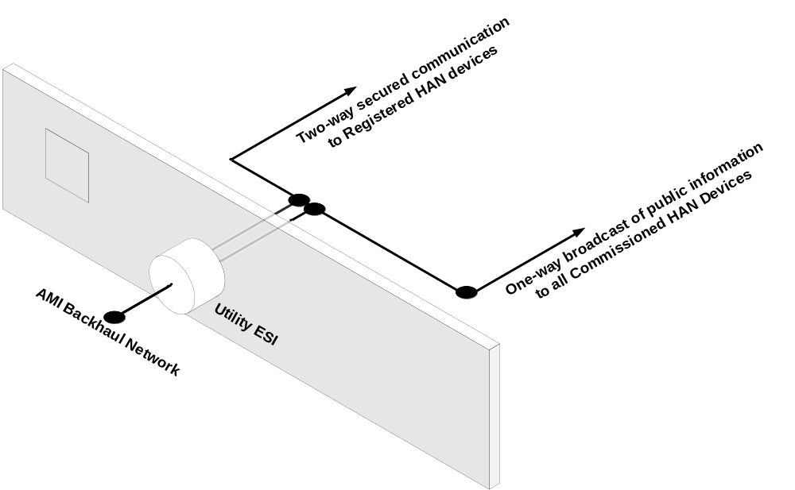

Section 2.2.9 Architectural Scenarios
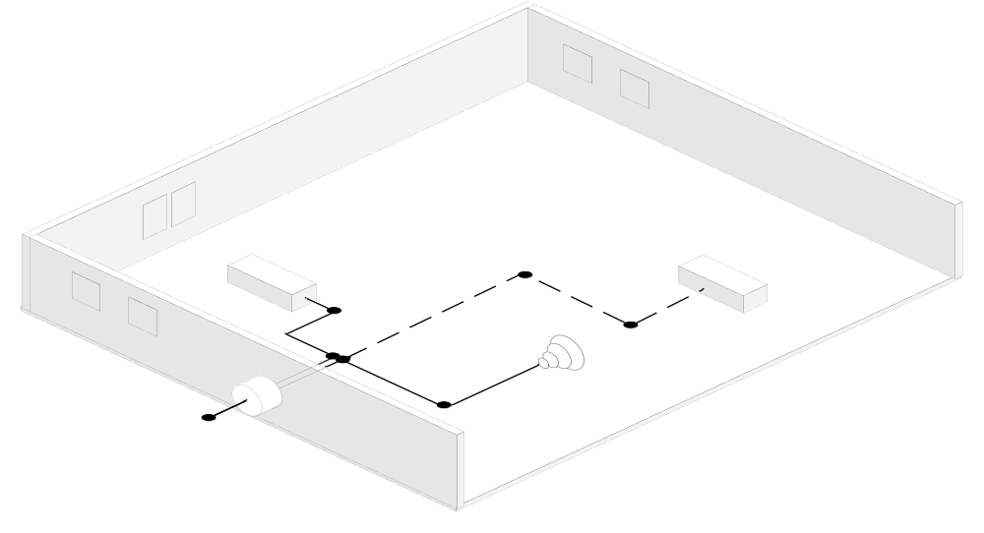
Figure 3: Scenario One (Inception) – Utility communicates with a Registered and Enrolled PCT. The Public Broadcast Channel is used to provide public information to all Commissioned HAN Devices (i.e. PCT and Smart Appliance). The Utility ESI is located in the AMI meter.
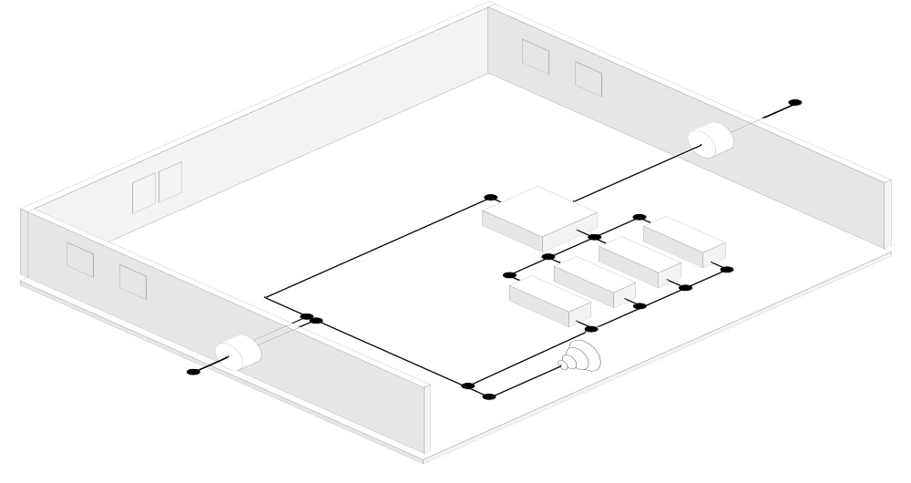
Figure 4: Scenario Two (Consumer Choice Example 1) - HAN Devices are Registered with the Utility ESI to receive usage information. HAN Devices are Enrolled in Service Provider programs. Service Provider communicates to Enrolled HAN devices using the Internet and Utility AMI. The Public Broadcast Channel is available but not used
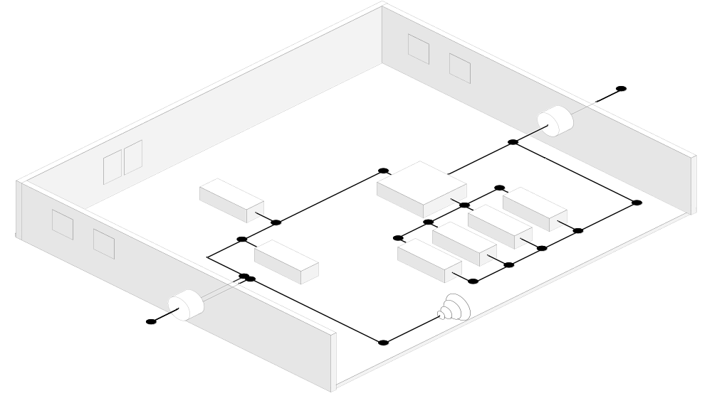
Figure 5: Scenario Three (Consumer Choice Example 2) – Consumer has Registered the PCT and other devices on another ESI with an EMS managing the devices. Consumer has also chosen to Register the EMS and a load control device with the Utility ESI. The Utility is using the HAN for communications to a gas meter. The Public Broadcast Channel is available but not used.
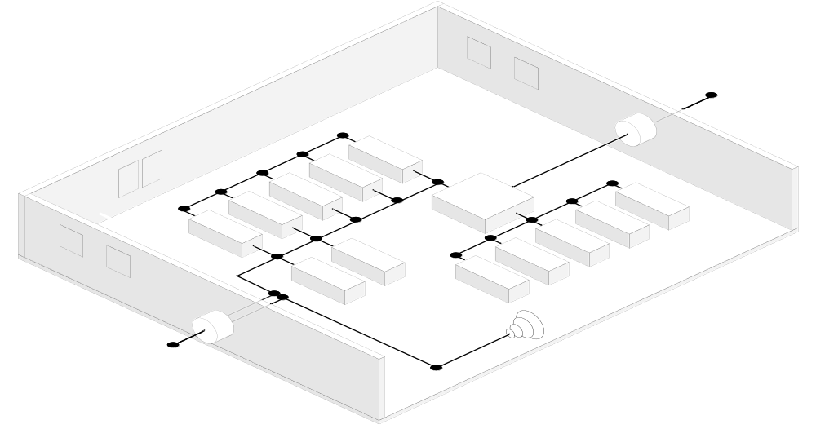
Figure 6: Scenario Four (Advanced System) – Many HAN devices are Registered with the Utility ESI and managed by an EMS, which is Registered with the Utility ESI and another ESI. The Utility ESI is not in the AMI meter. Other HAN Devices are Registered with another ESI, managed by the EMS, and accessible through an external network (e.g. Internet). The Public Broadcast Channel is available but not used.

Adapted from Southern California Edison (SCE) Edison SmartConnect™
Ibid
Ibid
Ibid

